In your groups, determine what kind of food is the closest to the food the birds eat. (marshmallows, gummy bears, wild rice, juice, wet noodles) Then, try to move the food to your bird stomach (a Dixie cup) with the tools provided. Which tool works best for that type of food? Put an “X” in the best tool for each bird. Note that each tool is only used once!

Bird | Food | Tweezers | Scissors | Straw | Chopsticks | Slotted Spoon
Hummingbird  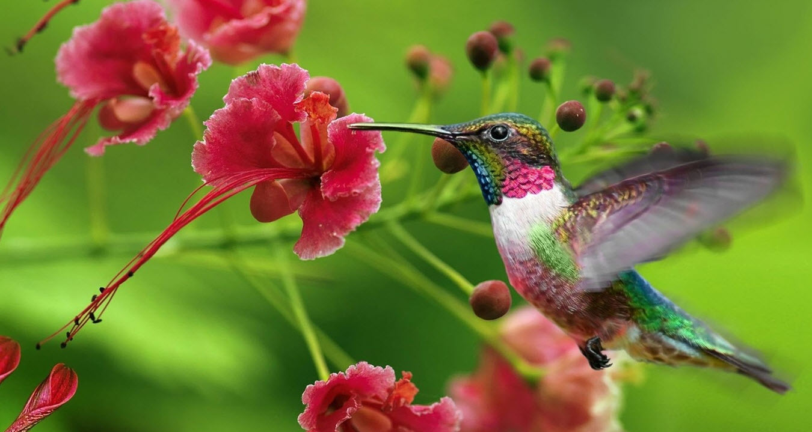 | Nectar  Our food:  ___________________
Mourning Dove  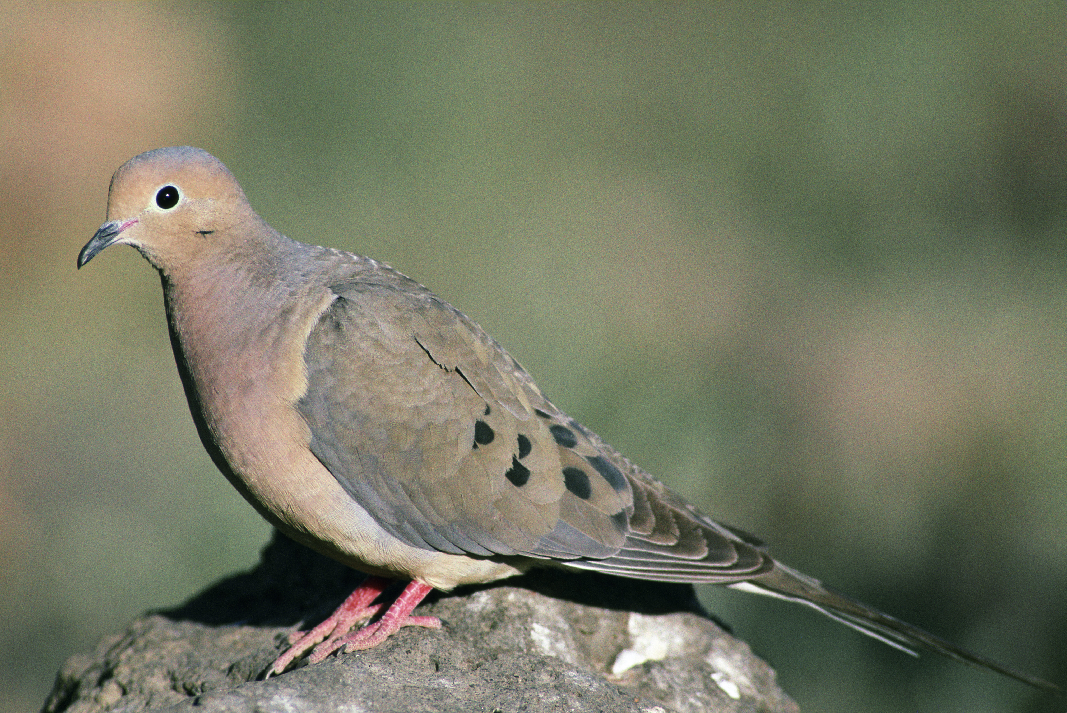 | Seeds  Our food:  ___________________
Duck  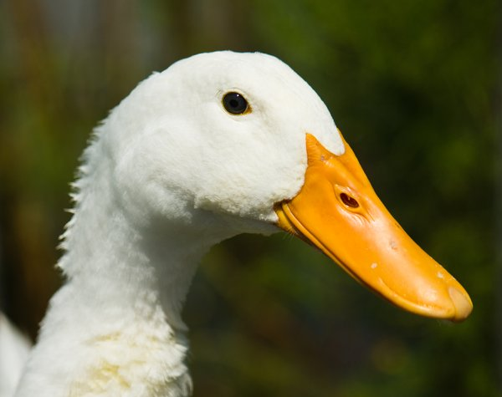 | Aquatic bugs/animals  Our food:  ___________________
Robin  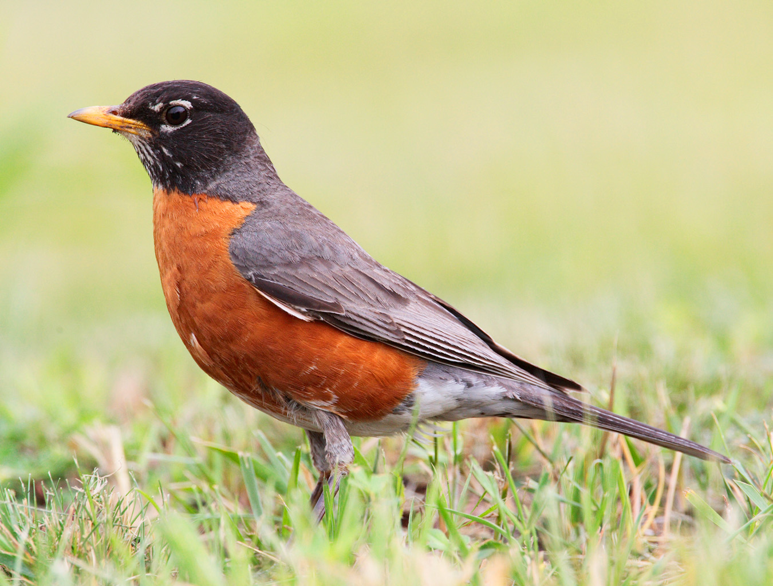 | Berries  Our food:  ___________________
Eagle  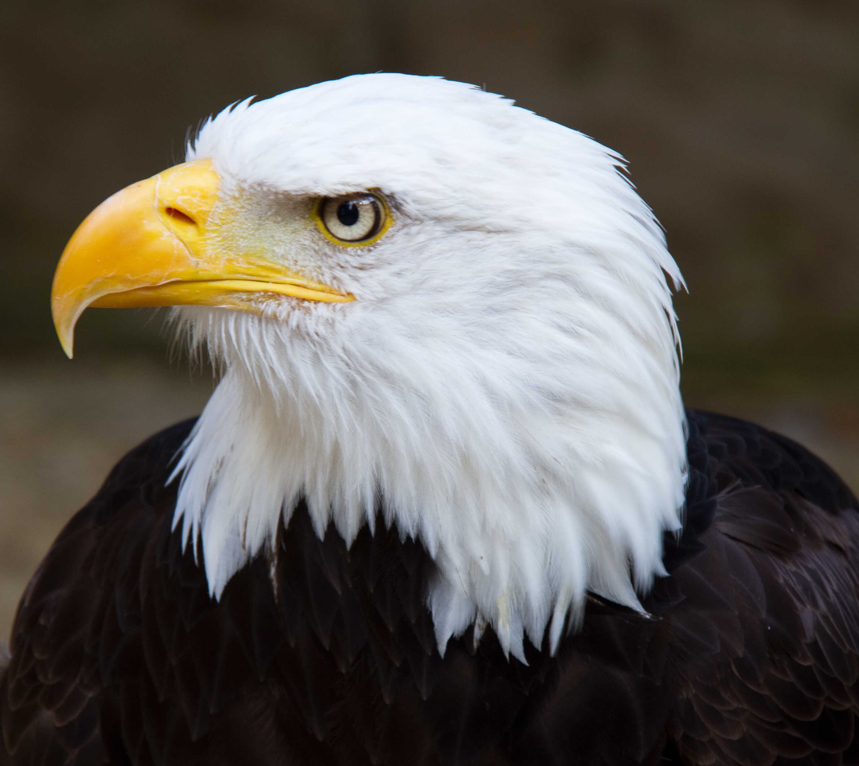 | Meat  Our food:  ___________________
