Biology project Loetbos

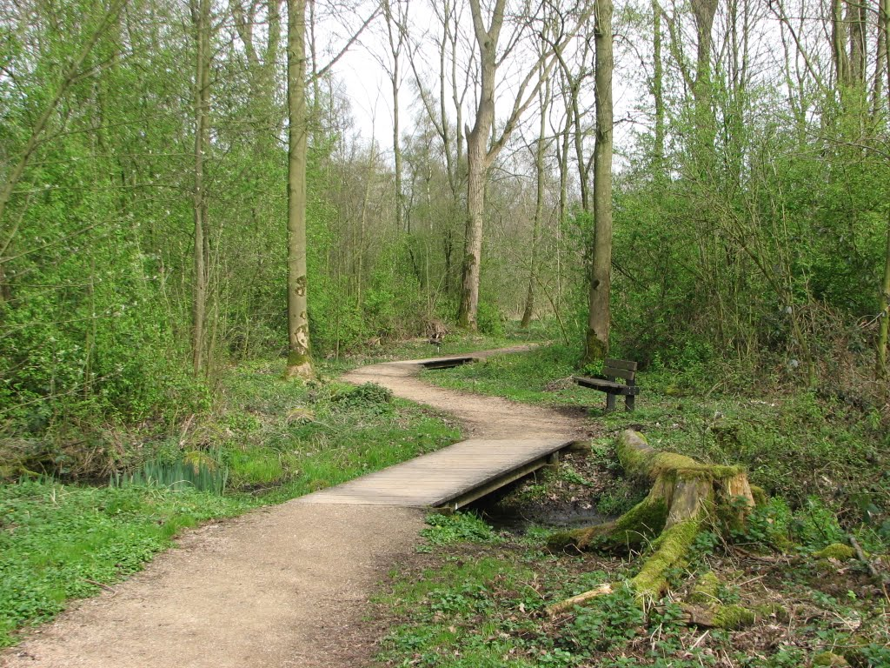
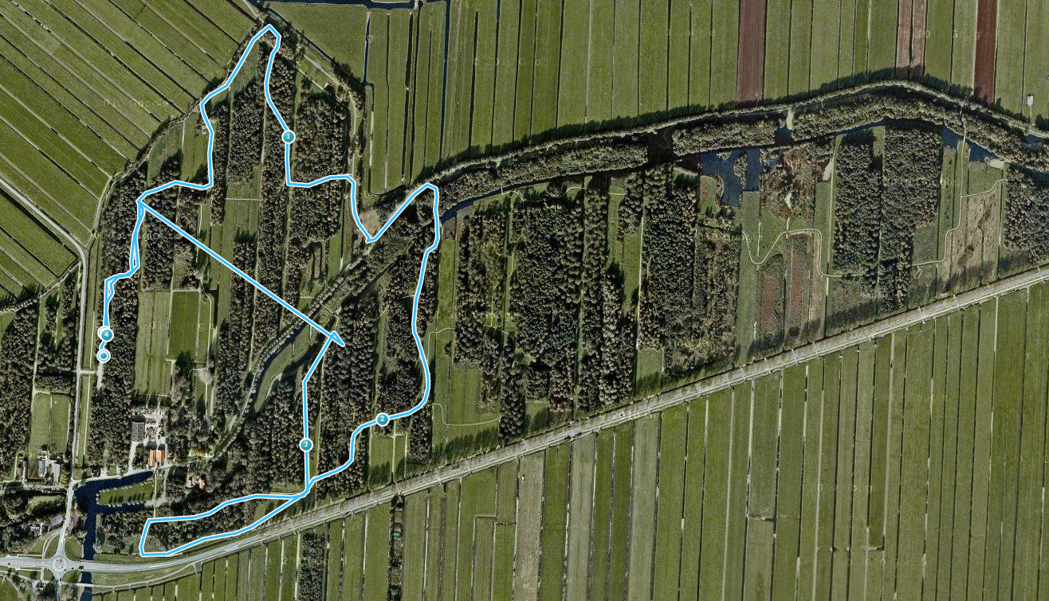Made by Jorian van der Plaats, Stefan Aantjes, Floris van der Kwaak and Bart Jan Stolk
Content
help effe met practicums zijn bijna af
- General research
- research question
- hypothesis
- our comparison
- table of biodiversity
- explanation
- conclusion of general research
- practicum 1
- introduction
- findings
- conclusion
- practicum 2
- introduction
- working method
- findings
- conclusion
- practicum 3
- introduction
- findings (drawings)
- conclusion
- practicum 4
- introduction
- findings
- conclusion
- sources
- task division
- cooperation
- logbook

General Research
Research question:
What influence does farming have on the biodiversity?

Sub question:
What chemicals do farms produce?

Hypothesis:
Farmers influence an area in many different ways. They grow crops where certain animals come to eat these crops. Mainly tiny insects and some birds will come to these crops. The biodiversity will grow with the farmers, but now a days farmers mainly use fertilisers which will poison all these insects, the birds eating these insects will get poisoned as well, other animals eating these birds will get poisoned too and so on. A lot of animals will get poisoned and might even die, this is not good for the biodiversity. So, when farmers use fertilisers the biodiversity will shrink and be smaller than places without farmers. But when farmers do not use fertilisers, the biodiversity will be bigger and better than places without any farmers. Unfortunately, most farmers use fertilisers so the biodiversity will be smaller than places without any farmers.
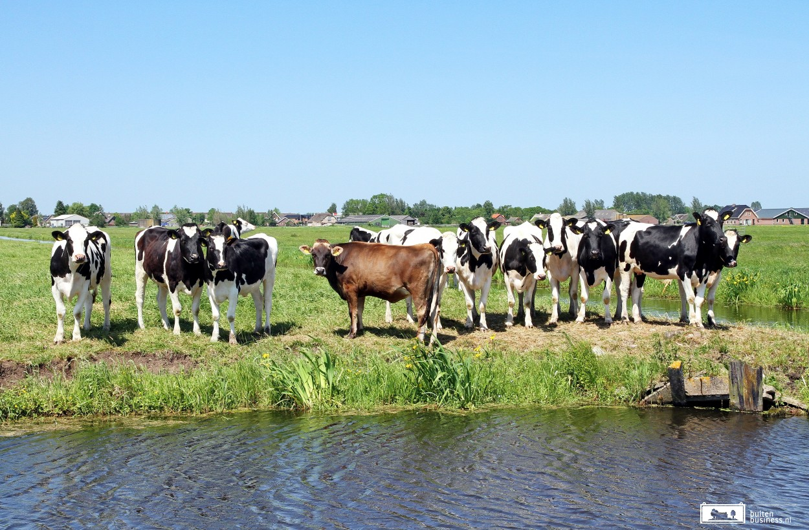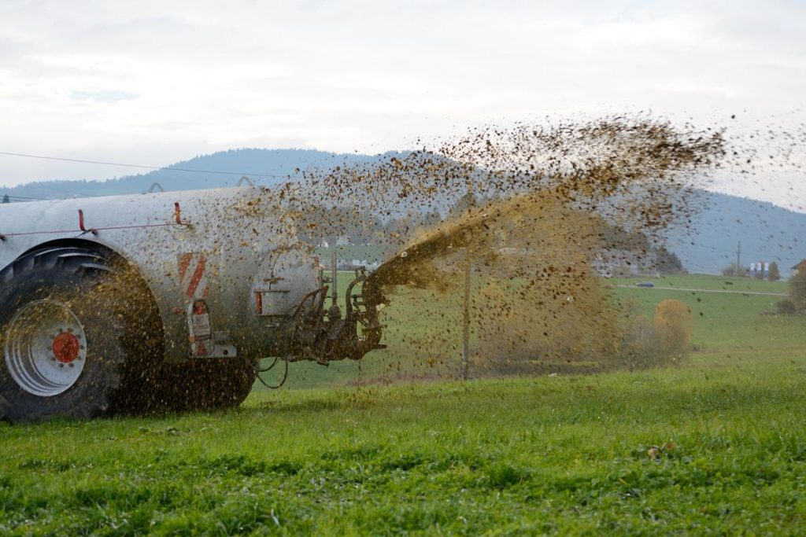

Things needed:
- Chemicals to measure the ph, nitrate, phosphate
- waternet
- temperature measurer
- depth metre

Our comparison:
Because there is a lot of agriculture in this area and farmers use a lot of chemicals, we want to compare our results to an area with less to no agriculture using chemicals. Because of this we chose to compare our findings in the loetbos with the findings of multiple schools around the world both with agriculture in the area as areas without large agriculture. In the table below you are able to see that (especially with the last 3) there are many more macroinvertebrates when there is no farming compared to when there is farming. This can be caused by the fact that there are more chemicals in the water close to farming land.

Table with biodiversity

place | agriculture | macroinvertebrates (different species)
Alaska | no | 3
Netherlands | yes | 3
Kenia | yes | 2
Thailand | yes | 3
Costa Rica | no | 3
Croatia | no | 5
Russia | no | 6
US | no | 6

What substances does farming cause?
When there is farming in the area the fertilizer that goes in the water contains a lot of phosphates as well as nitrates. This can cause some animals to die because of the high concentration. Another effect of the nitrates is that they make algae grow more rapidly. They cause them to spread over the whole ditch

Conclusion
Many animals die because of the high concentration of chemicals that’s in the water. Some of the organisms that don’t die immediately die because of eutrophication which means that light can’t enter the water any more due to enormous algae growth. This shows that the amount of algae increases but the amount of other organisms decreases in the water because of the toxic levels of chemicals and because of the eutrophication.

Practicum 1
Introduction:
In this part of the experiment we measured the abiotic factors in the environment of the loetbos. there a lot of things which can be measured in the ditch for example, the amount of some substances, the clarity of the water but also the temperature and the depth. You can look at how fast the water is streaming or on which kind of soil the ditch is situated. In a ditch are also many places which differentiate, on the sides of the ditch , factors can be way different than for example in the middle of the ditch. Difference can be for example in the depth, in the temperature or the speed of the water.

Things needed:
The things that were needed for this experiment were:
- Thermometer (for water)
- Depth meter
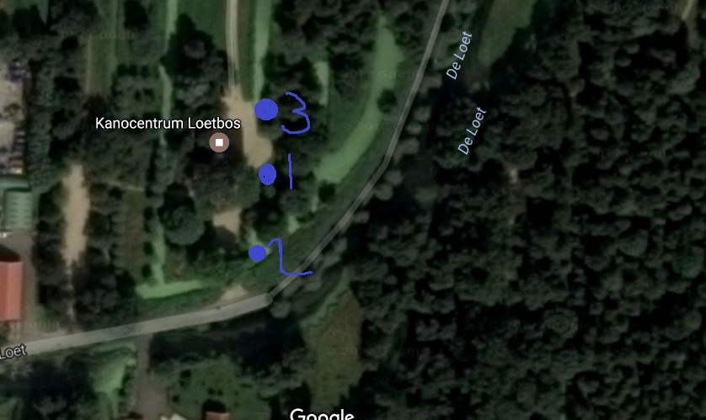
- Tablets for measuring the amount of phosphate, nitrate, and the Ph
- paper with colours of amounts
- A waternet
Method
measuring the water temperature
- Put the thermometer in the water for about 30 sec and note the given temperature.
- Do this at 3 different spots
measuring the phosphate/nitrate/ph concentration
- Take a water sample with the net
- Fill 3 test tubes with the water
- Put in each of these the given pills which will give you a colour
Measuring the depth
- Put a line with an weight in the water and look when it hits the ground.
- Repeat this at 3 different spots
Measuring the light permeability
- Put a disk with black and white stripes in the water and look how far it goes down until yoy can’t see it anymore.
- repeat this at 3 different spots

Places
Place 1= was a place in the sun of a wide ditch and was pretty shallow but quite clear. The wind was quite strong here.

Place 2=Corner of a ditch in the sun
Most heavy wind, clear water. The places we used

Place 3=Place in the shadow (trees) close to a bridge. Almost no wind

Table with measurements

 | 1 | 2 | 3
Temperature | 10 *c | 11*c | 9*c
Depth | 60cm | 54cm | 58cm
Brightness | 45,5 cm | >54cm | >58cm
nitrate | 3 | 2 | 4
Ph | 6ppm | 6,75ppm | 8ppm
Phosphate | 1,25ppm | 1,5ppm | 1ppm

Conclusion

Explain that it is more accurate to measure every abiotic factor multiple times.
If every abiotic factor is measured multiple times, the chances of being it by chance are smaller than being measured only ones. Because of this, the research becomes a lot more reliable. And wrong incidental measurements can be excluded
An abiotic factor can change from place to place. What influences this?
This can be influenced by multiple things, like temperature, sunlight, other organisms etc.
Which consequences does this have for the organism living in the ditch?
They might be different than other organisms in the ditch because they get a different amount of warmth or sunlight etc.
Determine the quality of the water with help of your found measurements of these factors
The water quality was reasonably well, the amounts of most chemicals were limited and the diversity of animals and temperature were also good.

Practicum 2
There are also a lot of bacteria in a ditch which can kind of recycle the minerals so that plants can grow better. More bacteria means more different minerals which are reused and this makes the ditch able to develop more different species. The first place in a ditch where you can expect lots of fungi and bacteria are close to the bottom where all the death materials go to. Because there are a lot of recyclable materials here, lots of decomposers can be situated here. These make minerals again for the plants. Secondly under the ground of the ditch are also a lot of bacteria. This is because some roots of plants ( organisms) cooperate with the bacteria. This makes it possible for the bacteria to get the needed things to stay alive and sometime also help the water plants. The last place where we expected to find a lot of bacteria was close to the top because the temperature is the highest here and this causes them to be in a more ideal situation to grow.

Which places in the ditch can you expect bacteria and fungi? Name a minimal of 3 places.
- on the ground
- on the surface
- close to (roots) water plants.

Things needed:
- Dishes for the growing of the bacteria
- Plastic pipet
- A bottle for the water sample

Working method
For this experiment, we first collected water from places in the ditch from where we expected fungi and bacteria could be found. We used a pipet to put a droplet of this water on the dishes so that the organisms can grow under better circumstances. Furthermore, the dishes were put in a warm place where they had ideal circumstances to multiply. Because of this the colonies grew quite fast resulting in a measurable. From here on the differences could be seen and the colonies could be counted.
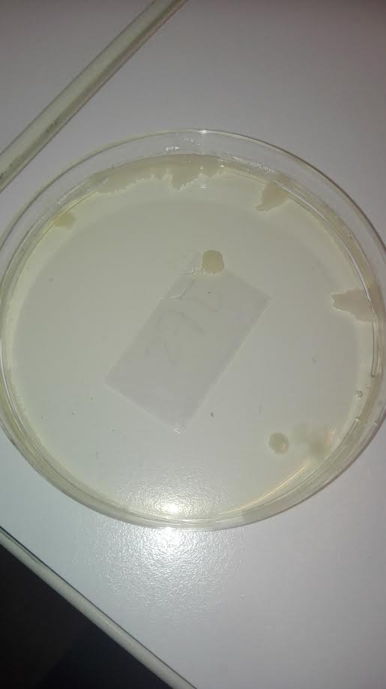
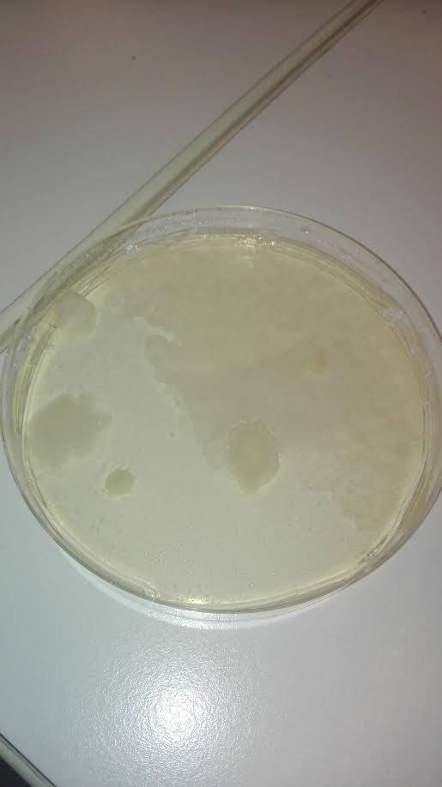
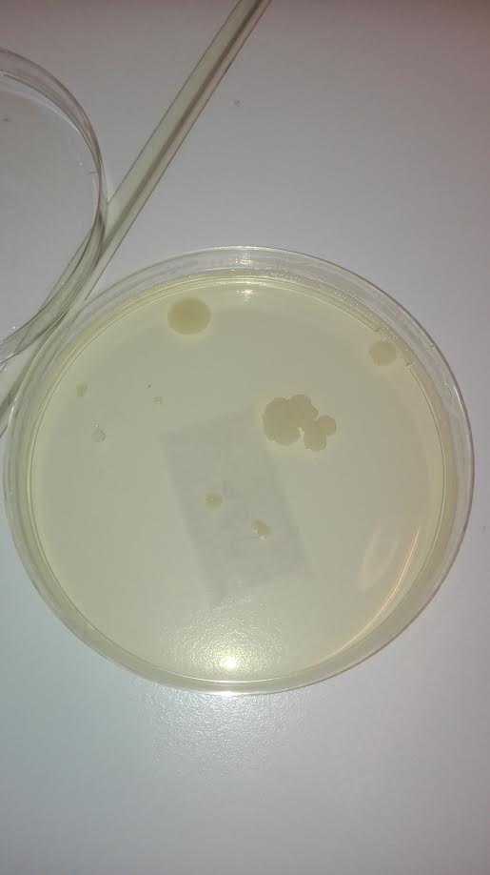
(The three petri dishes that were used for the growing of the colonies (fungi/ bacteria))

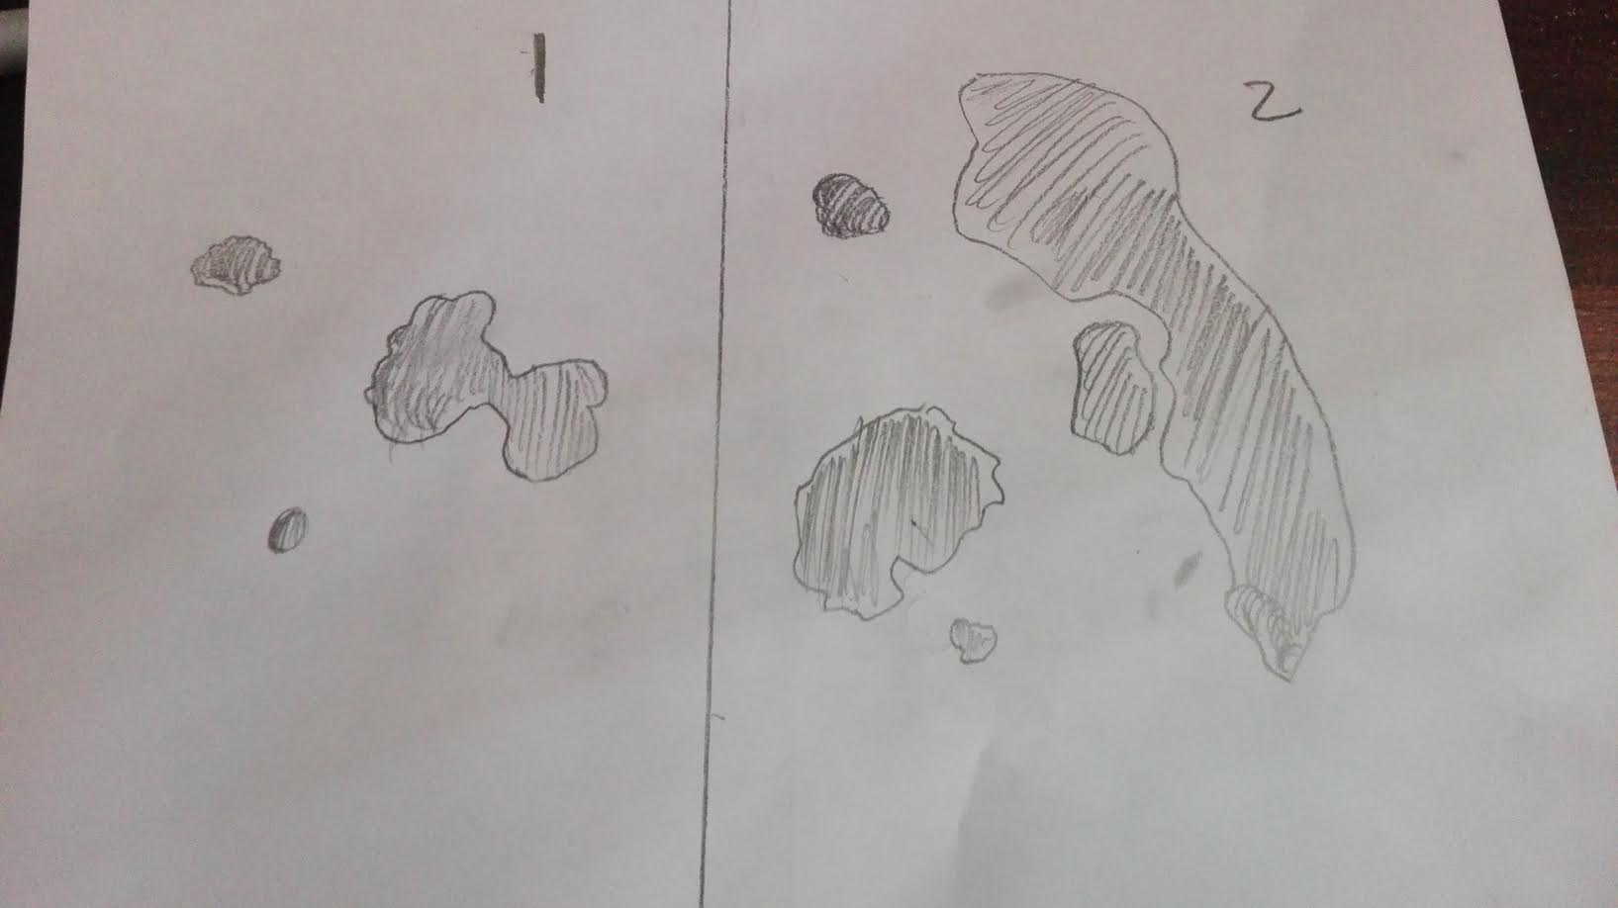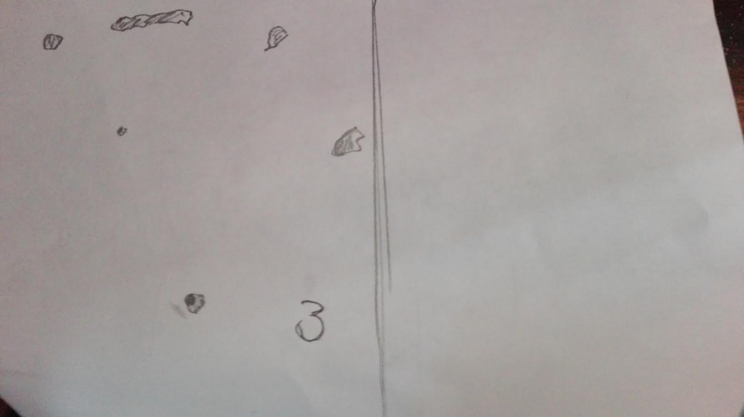
(Drawings of the shape of the colonies)

The three colonies
- The first colonie was taken in the middle of the ditch close by the water plants
- The second dish contained water from water close to the bottom
- The third place was from the top of the water,

Are there differences in bacterial strains and fungi, if so how do you see that?
Fungi have different and more cell organelles . Some fungi also tend to grow hairs (for spores) and tend to be bigger than bacteria colonies.

Is there a difference in the appearance of bacteria and fungi at the different places where samples were taken.
In the three places in the ditch where we took the samples were differences between the bacteria/fungi colonies. This can be seen by the way in which the organisms grew in the dish. Some of the colonies were way bigger than the ones taken at other places. Another difference that could be seen is that some formed a lot of really small colonies while the bacteria on the other petri dishes grew a couple big ones. Another contrast that could be that some colonies were darker in colour (darker yellow) which can also indicate on different organisms.

Practicum 3: Plants in and around the ditches (60 minutes).

During this practicum we collected plants in and around ditches in the loetbos. We made sure to pick the entire part of the plant that stood out from the ground. We searched for plants on the water but also situated close to the shore of the water. We also found some plants that lived on the water.

Things needed:
- Bottle for water sample (1 per group)
- Flora
- Plant seeking maps
- Net
- Net for water sample.

Assignments: (material & method + results)
1) Collect 5 plants in and around the ditch with your group.
2) Hypothesise from what you’ve learned about plants to which group they belong.
3) Look if there are plants belonging to the missing groups.
4) With the help of the flora look for the names of the species of the found plants..

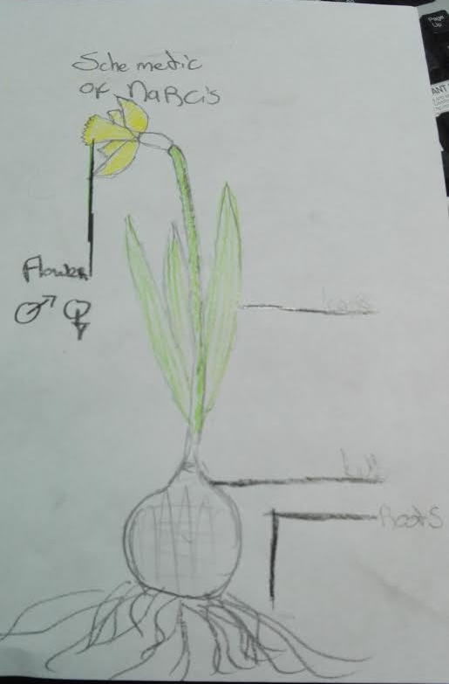
(schematic view of a Narcis)
The plant of a narcis consists of a bulb (with roots). From the flower which grows from this narcis plant will grow a flower which emits seeds later in its life cycle. Making the narcis a seed plant. the stamp of the flower is both male and female. From this seed (when transported), will grow another bulb.
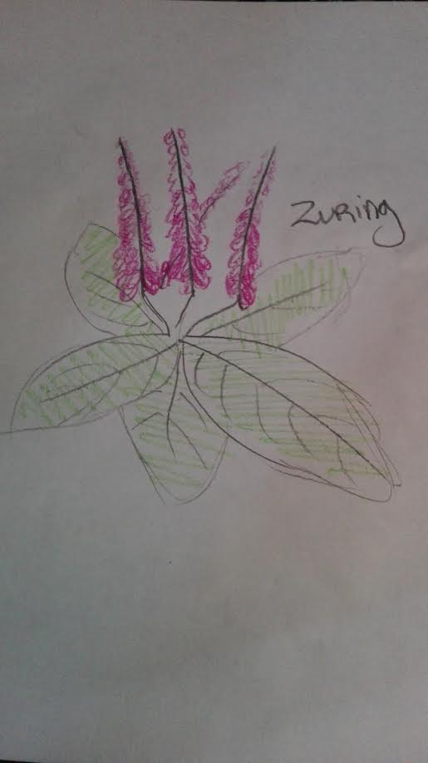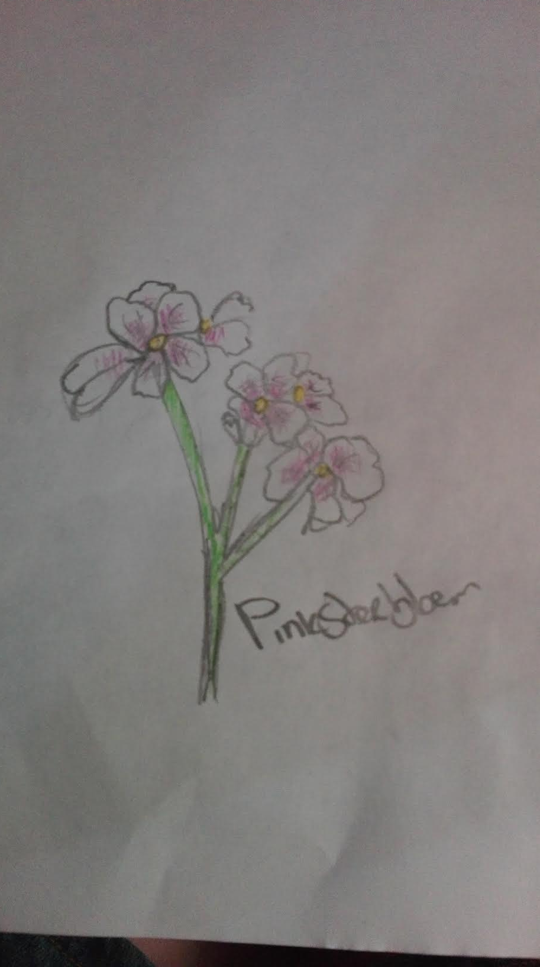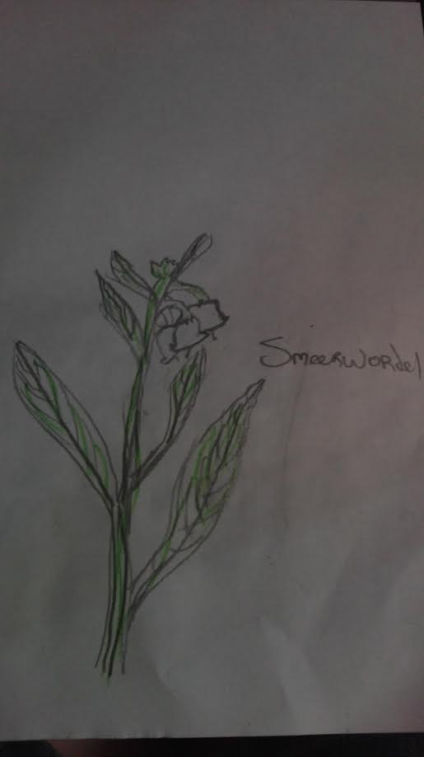
(zuring) (pinksterbloem) (smeerwortel)
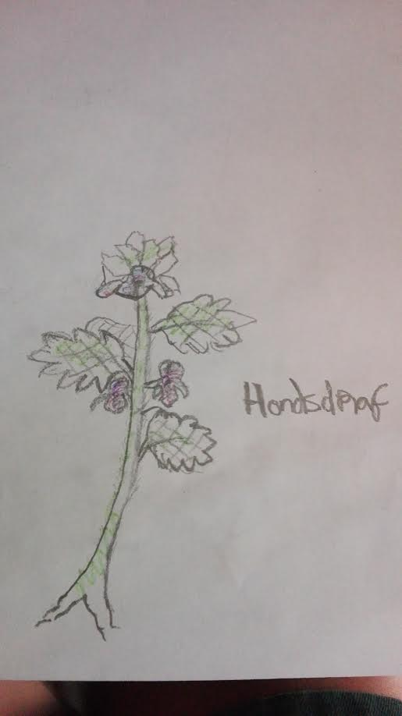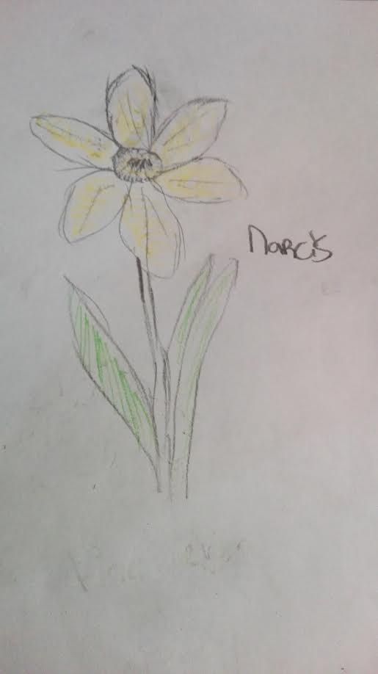
(hondsdraf) (narcis)

(drawings of some of the present plants we found)
Explanation of plants
Hondsdraf: This is a creeping plant that belongs to the Lamiaceae family. The plant can reach the size of 15-60 cm big.
Narcis: This is a plant from the family Amaryllidaceae narcissus can be found in different colours like red, pink, orange, white, yellow or spotted, but we found the yellow version.
Pinksterbloem: This is a plant from the Brassicaceae family. This species can grow up to 50 cm tall, and it has a hollow stem.
Smeerwortel:This plant stems from the Boraginaceae family. In the low lying Europe this plant is often found in berms on dikes or around ditches, the plant has also been brought to america.
Zuring: This plant is one of the most common plants from the Polygonaceae family. It often grows on acidic grounds and some species of this plant can be used for salads.

Questions afterwards: (conclusion + discussion)
Which group(s) of plants didn’t you find? Try to give an explanation for this.
The plants we didn’t find were probably not flourishing as well as the other plants in that area so we didn’t see them. It is also possible that we didn’t see them or that because of the time of year they weren’t growing as well yet.

Practicum 4: Animals in the ditch
Differences in numbers and appearances of species of animals in different parts of the ditch.

Introduction
In this practicum we looked for different species of macrofauna. We took some water samples and looked them under the microscope while doing this we found out there were tubifex, water fleas, and a water beetle.

Three different methods to find and catch animals in the ditch.
- Observing
- Catching ( with net )
- attract with food

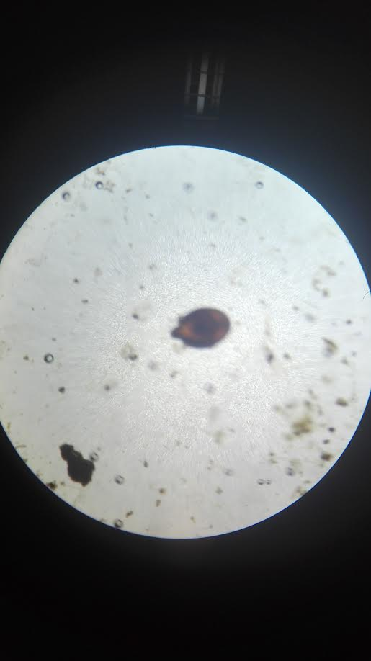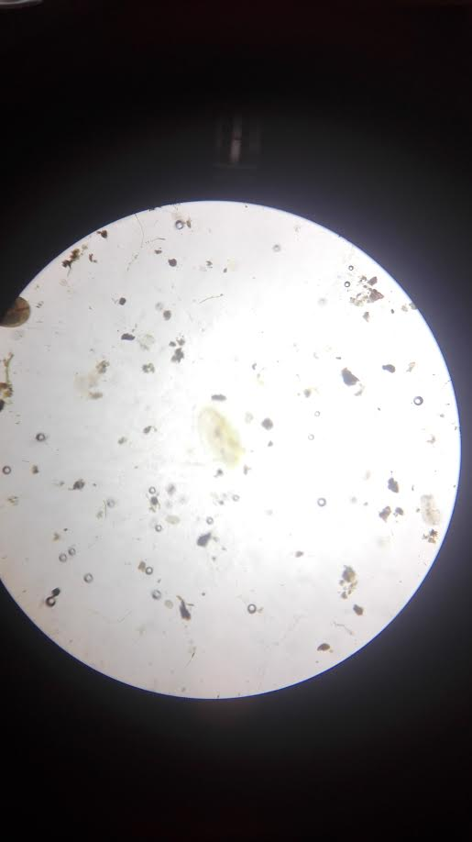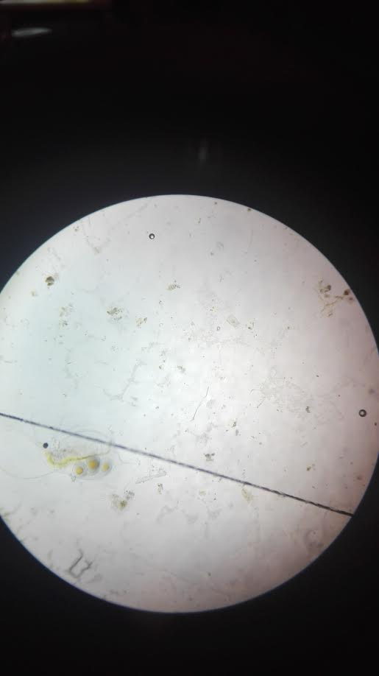
(some of the animals we found when observing through microscope)

Things needed:
- Map for water animals.
- Buckets
- White trays
- Nets

There will be a difference in the different ways of finding and catching animals in a ditch that you mentioned explain your answer.
To get different species of animals into your research, you need to first look at where they are situated and how big they are. Big animals for example don’t have to be caught before because it is possible to look at them. Because of this the first way to find them is to walk around and observe. Secondly, some organisms are so small that they can’t be seen from a far distance. This is why they can beforehand be caught. For instance when fish need to be found, they first need to be caught with the help of a net before they can be observed since they are otherwise not visible or too fast. Also small microfauna can be caught in this way by having a net with a water container at the bottom The last way is to attract the organisms with food. Because of this more and more different organisms will come which causes them to flock together in one place which means it is easier to get different and more organisms concentrated(because predators will also be attracted).

Assignments: (materials & methods + results)
We have been looking for different animal species in different parts of the ditch, close to side, in between some plants and in open water. At these 3 different locations in the ditch samples must be taken of the water surface but also from the water floor. Per place the organisms of the sample that were taken must be kept separate to get a better and clearer vision of the distribution of the organisms.
- Sample three times every single place: 3x the water surface and 3x the waterfloor.
- Collect the sample in the white trays.

The goal is to get an image of all the animals (macrofauna) that live in the ditch. You also learn to determine the characteristics of different classes in the animal kingdom. That’s why it is important that everyone looks at as many animals as possible.

Assignments: (material & methods results)
1) Using the present determine materials try to find and share in the scheme (table 2) as many animals as possible from the water sample, watch for the appearance characteristics!
2) Make two schemes per sample places, one for the water layer and one for the bottom layer.

Our findings.

Near the side of the ditch ( surface)
Number | Sketch | Phylum | Class | Further classing ,( order, the family, er, species) | Amount p per s sample
1 | 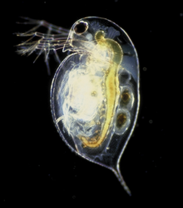 | Arthropoda | Branchiopoda | cladocera | >
2 | 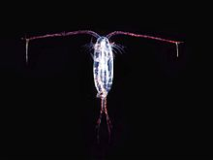 | Arthropoda | Maxillopoda | Copepod | 3

Near the side of the ditch (bottom)
Number | Sketch | Phylum | Class | Further classing ,( order, the family, er, species) | Amount p per s sample
1 | 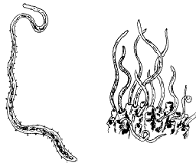 | Annelida | Clitellata | tubifex | 1

Between plants (surface)
Number | Sketch | Phylum | Class | Further classing ,( order, the family, er, species) | Amount p per s sample
1 |  | Arthropoda | Branchiopoda | cladocera | 2
2 | 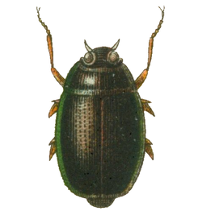 | Arthropoda | insecta | Gyrinus marinus | 1

Between plants (at the bottom of the water)
Number | Sketch | Phylum | Class | Further classing ,( order, the family, er, species) | Amount p per s sample
1 |  | Annelida | Clitellata | tubifex | 1

Open water ( surface)
Number | Sketch | Phylum | Class | Further classing ,( order, the family, er, species) | Amount p per s sample
1 |  | Arthropoda | Branchiopoda | cladocera | 1

Open water (bottom)
Number | Sketch | Phylum | Class | Further classing ,( order, the family, er, species) | Amount p per s sample
- | - | - | - | - | -

Conclusion
a. In which spots do you find the most animals?
The water bank.
b. In which spots do you find the most species?
The water bank.
c. Give an explanation for the answers on questions a and b.
Because it is close to the surface with a lot of sunlight, and it is a hybrid of the water and the land. Because of the low water depth.

In total more than 40 marine organisms were discovered. Furthermore 4 different species were found, this has probably been more but because of the amount of things we had to search through and the size of some of the animals causes us to have missed some organisms.

Sources
www.bioplek.org.
www.globe.gov
https://wilde-planten.nl/wilde%20narcis.htm

Coöperation
All participants of this project made plans beforehand to divide the tasks as equal as possible. There was some consternation on when it needed to be handed in and because some were on vacation this didn’t go as planned. But at the we we solved this problem

Logbook

Who? | Where? | What? | When? | How long?
Floris  Jorian  Stefan | Loetbos | Experiments | 18th of April | 5 hours
Jorian | Home | Tables | May vacation | 2 hours
Stefan | Home | Report | May vacation | 2 hours
Floris | School | Report | 30th of May | 1 hour
Floris | Home | Report | 31th of May | 3 hours
Floris | School | Report | 1st of June | 1 hour
Floris | Home | Report | 2nd of June | 3 hours
Jorian | home | Report |  | 2 hours
Jorian | home | Report |  | 4 hours
Jorian | home | Report |  | 2 hours
Jorian | home | report | 1st of June | 1 hour
Jorian | home / school | Report(drawing) | 2nd of June | 6 hours
Stefan | home | Comparison  report | 2nd of June | 4 hours
Floris | home | Report | 2nd of June | 1,5 hours

