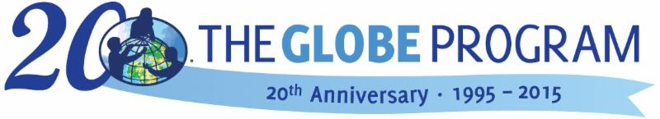
INVITATION
2015 GLOBE Annual Meeting for Europe and Eurasia
23–27th November 2015, Warsaw, Poland

Dear GLOBE country coordinators, teachers, trainers and partners,

We are very pleased to invite you to the 2015 GLOBE Annual Meeting for Europe and Eurasia.
The event will consist of two parts:
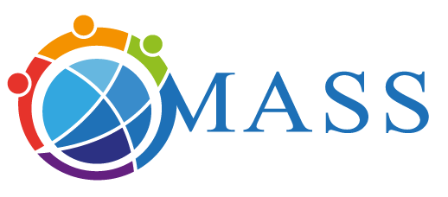
- country coordinators meeting on 23–24 November
- “Motivate and Attract Students to Science” workshop and training
on 25–27 November 2015 (organized in cooperation with
the team of MASS project www.mass4education.eu/conference2015).

The program and more info can be found on
http://www.globe.gov/web/europe-and-eurasia/documents

Deadline for registration: June 28th.

After the deadline subscription for the meeting is still possible, but we cannot guaranty a room in the same hotel as other participants.

We very much hope to see you in Warsaw, Poland!

GLOBE Poland  Magdalena Machinko-Nagrabecka  Elżbieta Wołoszyńska-Wiśniewska  Gabriela Kuc  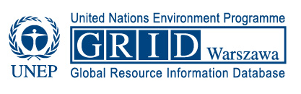  UNEP/GRID-Warsaw Centre | GLOBE Europe and Eurasia Board  Matthijs Begheyn (Netherlands)  Diana Garasic (Croatia)  Costas Cartalis (Greece)  Farid Hamdan (Israel)  Magda Machinko-Nagrabecka (Poland)  Juliette Vogel (Switzerland)  GLOBE Europe and Eurasia Coordination Office  Dana Votapkova (Czech Republic)  Bara Semerakova (Czech Republic) | GLOBE Program Office, USA  Anthony Murphy  The GLOBE Program Director

