The Dirty Facts of Soil
Landon Henthorn and Gavin Zheng
Jaime Moss
Parkersburg South High School
United States of America
2/20/24

Table of Contents – Page 1
Abstract – Page 2
Research Question and Hypothesis – Page 2
Research Methods and Materials (Including GLOBE Data!) – Page 3
Data Summary – Page 4
Analysis and Results – Page 5
Conclusion – Page 5
Discussion – Page 5
Acknowledgements – Page 5
Bibliography/Citations – Page 6

Abstract:

We gathered and studied soil samples from Florida, New Jersey, Utah, and West Virginia. Farmers must study soil fertility because it is one of the most important soil characteristics when it comes to growing crops. We wanted to learn about this subject because we were curious under what conditions plants grew best. To further our knowledge on how soil affects plant development and growth we started by collecting soil samples and running various tests on them. Among these tests were fertility and composition. The results of these tests showed that soil from closer together did not substantially differ, however when the samples are from a further distance the composition and fertility. These findings do support our hypothesis and we would like to keep studying samples to find out the fertility and composition of other places around the United States or even other places around the world.

Research Question and Hypothesis:
This research experiment was done because we were interested in many of the characteristics of soil; we wanted to learn what in soil makes plants grow and how do they effect plants, why do farmers use fertilizer, is soil made of different things based on location, and how does soil composition and fertility affect the overall plant’s growth?

We believe that soil composition and fertility greatly differ in different areas of the United States. We received soil samples from Florida, Utah, New Jersey, and West Virginia. We believe that Florida will have the highest fertility and will be best for plant growth because we know that they are known for their high production of citrus fruits and overall larger receipt of crop production over the other samples. The terrain of the different state is vastly different, with a couple of them near the ocean and some from mountainous region with mesas.
Research Methods and Materials (Including GLOBE Data!):

We first had to extract the dirt samples from selected sites which were Florida, New Jersey, Utah, and West Virginia. We gathered samples from our selected sites and began testing using the GLOBE binder provided to us. We began by preparing our preparing our samples for the soil fertility tests. We first added thirty milliliters of distilled water to a cylindrical test tube, then added two Floc-Ex tablets and mix until dissolved, we add this to speed up the process of the soil settling out of the water. After that was completed, we then began testing the soils for nitrogen, phosphorus and potassium.
We tested Nitrogen by filling the square test tube to the shoulder, nearly filled then added one Nitrate WR CTA tablet to the solution, mixed the solution until the tablet is dissolved and waited five minutes. Then we compared the pink solution to the nitrogen section of the color chart that was provided with the kit. After we finished our test for Nitrogen, we began testing for Phosphorus by adding twenty-five drops of the clear solution to the square test tube. We finished filling the square test tube with distilled water until it reaches the shoulder, we then added a Phosphorus tablet to the clear solution. We mixed until the tablet is dissolved and waited five minutes. Once five minutes was up, we then compared the blue solution to the phosphorus section of the color chart like we did for nitrogen. Our last test for fertility was Potassium, we began by filling the square test tube up to the shoulder with the clear solution, added one potassium tablet to the solution, and mixed until the tablet is dissolved. We then compare the cloudy solution to the potassium section of the color chart by placing the tube in front of the black squares and seeing how dark it makes the liquid appear and comparing that to the grey squares.
After we finished testing the soil fertility, we began our tests on the soil's composition. We tested the moisture estimate, the structure estimate, the primary and secondary color, consistency, texture field estimate, root and rock estimate. We began testing the moisture estimate by taking out a small amount and examined the soil. We noted where it fit on a scale of dry to wet, then tested the structure estimate by taking out a scoop of our samples. We then compared our sample to the pictures of different structures. We then tested the primary and secondary colors of the samples; we took out a small clump of soil from our sample, broke it apart in our hands, compared the sample to the color chart, and noted the color that best matches. Next, we tested the soil’s consistency by taking out a small amount of soil from the sample, gently squeezed it between our thumb and forefinger until it broke apart, then we compared it to the consistency chart on a scale from loose to extremely firm. After we finished that test, we began testing the soil texture field estimate. We took out enough soil from the sample to be about the same amount as a small egg, sprayed the sample with a spray bottle to moisten it and once moist tried to form the soil into a ball. We placed the soil between our thumb and forefinger and gently pressed it into a ribbon. We followed a dichotomous key that was provided in the GLOBE binder to identify the soil’s texture. Our final tests were the Rock and Root Estimate, we observed the entire sample looking for rocks and roots and noted how many of each is in the sample on a scale from none to many. There weren’t many risks at all, except extracting the dirt with an auger, none of the chemicals were hazardous unless it would to be ingested or drank.
Data Summary
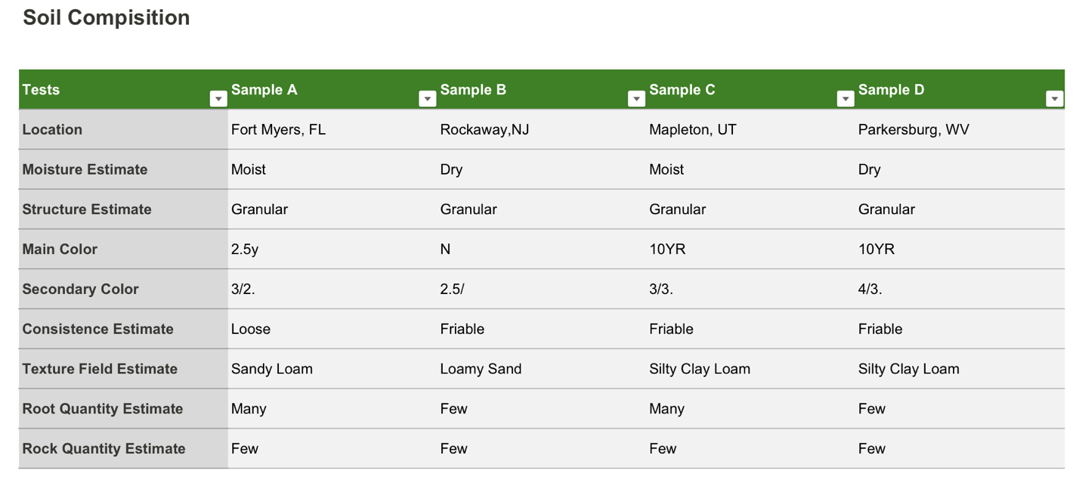
Soil Fertility
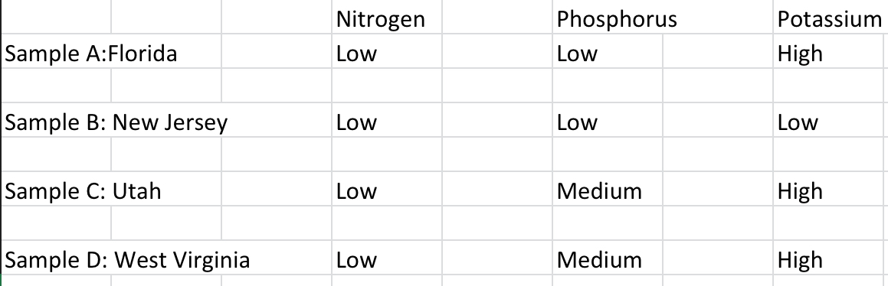

Analysis and Results:

From this project, we discovered that the soil taken from locations closer together are more likely to be similar than samples taken from places farther away; they will have relatively the same level of nutrients and have similar compositions.
Our results from our fertility results turned out to be not to our expectations, the nitrogen is necessary for plant leaf and stem growth, the amino acids help build plant protein. Phosphorus used for seed and root production. Potassium is important for the vascular system of the plant; it moves the nutrients throughout the plant. It also makes fruits and vegetables taste appealing. The samples we have from Florida had low nitrogen, low phosphorus and high potassium. Our results from New Jersey were similar to Florida except the potassium was also low, Utah and West Virginia had the same with low nitrogen, medium amounts of phosphorus, and high in potassium.
Our results in the composition testing were also more or less pretty similar. The soil moisture in Florida and Utah were moist, New Jersey and West Virginia were dry. The structure of all the soil were granular, the color of the soil varied from lighter shades of brown to darker ones. All of the consistently of the soil were friable except for the soil in Florida which were loose. The texture of all the soil did vary, with Florida being sandy loam, New Jersey being loamy sand, and West Virginia and Utah being the same with silty clay loam.
Conclusion:

From our experiments, we found that all the samples wee collected had relatively similar amounts of nitrogen, phosphorus, potassium, as well as similar compositions. We believe that is due to the samples being collected in urban areas and not rural areas.

Discussion:

When doing this experiment, we were limited to where we could collect samples from. We put forth as much effort possible to get samples from many places but were only able to get four. If we were to improve our experiment, we would get samples from other states and potentially get more samples from other countries as well. Many people in agriculturally based professions could use our data and other data in the database to research where they would be best off.

Acknowledgements

We would like to acknowledge Jaime Moss. She was our advisor, encouragement, assisted us in getting our materials to perform our tests. We would also like to acknowledge NASA IV and V Facility Education Resource Center for providing us with the resources to carry out our experiment.

Bibliography/Citations:

Cash receipts by commodity State ranking. (2018). Usda.gov. https://data.ers.usda.gov/reports.aspx?ID=17844

‌Data, M. N. (2019, December 9). GLOBE Pedosphere (Geosphere) Overview. My NASA Data. https://mynasadata.larc.nasa.gov/globe-connections/globe-pedosphere-geosphere-overview

‌Pedosphere - Pedosphere - GLOBE.gov. (n.d.). Www.globe.gov. Retrieved February 28, 2024, from https://www.globe.gov/web/soil/protocols

Soil Characterization - Pedosphere - GLOBE.gov. (n.d.). Www.globe.gov. Retrieved February 28, 2024, from https://www.globe.gov/web/soil/protocols/soil-characterization

Soil Fertility - Pedosphere - GLOBE.gov. (n.d.). Www.globe.gov. Retrieved February 28, 2024, from https://www.globe.gov/web/soil/protocols/soil-fertility

