The Effects of Different Precipitation on Soil pH

to

The Ohio Academy of Science

by

Noora Khan-Akbani and Anna Hertlein
Ottawa Hills, Ohio 43606

10th grade

Research Supervisor: Dr. KG

Ottawa Hills High School
2532 Evergreen Rd
Ottawa Hills, Ohio 43606

1-28-2026

Table of Contents
Abstract……………………………………………………………………………………………3
Introduction………………………………………………………………………………………..4
Experimental Design………………………………………………………………………………5
Results………………………………………………………………………………………….….8
Discussion………………………………………………………………………………………....9
Acknowledgment………………………………………………………………………………...12
References…………………………………………………………………………………….….13

Abstract:
Soil pH plays a critical role in the amount of nutrients, plant growth, and ecosystem stability. This study investigated how different types of precipitation, snow, rain, simulated acid rain, and distilled water, affect the pH of soil. Initial soil pH was measured before each precipitation was added, and final pH was recorded after a set exposure time. Acid rain caused the greatest decrease in soil pH, while distilled water and rain water resulted in minimal change. Snow produced a smaller pH change compared to liquid precipitation, suggesting that lower temperature and delayed infiltration slowed the chemical interactions between precipitation and soil. These results indicate that both the chemical composition and physical state of precipitation influence soil acidity. Understanding these interactions is important for predicting environmental impacts of different precipitations.

Introduction:
How does soil ph differ in different precipitations? Soil pH is a main factor in determining soil health and ecosystem productivity. The pH of soil influences nutrient solubility, micro organism activity, and plant growth. Even small changes in soil acidity can significantly affect agricultural systems and natural environments. One major factor that can alter soil pH is precipitation, which brings in water and dissolved substances into the soil.
Different types of precipitation vary in both chemical composition and physical characteristics. Distilled water is neutral and lacks dissolved ions, making it a useful control when studying soil chemistry. Rain water contains hydrogen ions, sulfuric acid, and nitric acid, which are often from pollution, and replace basic nutrients in the soil, causing acidification. Acid rain, however, forms when sulfur dioxide and nitrogen oxides released from industrial factories react with water vapor in the atmosphere, producing sulfuric and nitric acids. When acid rain enters the soil, it introduces excess hydrogen ions, which can lower soil pH and disrupt natural buffering systems.
Snow differs from rain not only chemically but physically. Snow is a solid form of precipitation and is typically much colder than rain. Before interacting with soil, snow must melt, which reduces immediate contact time and slows chemical reactions. Lower temperatures also decrease the kinetic energy of ions, further slowing reaction rates. Because of these factors, snow may affect soil pH differently than liquid precipitation.
The experiment is crucial for agricultural practices, since knowing how different types of precipitation can affect the soil pH, will in turn, affect the crops. The purpose of this experiment was to determine how snow, acid rain, and distilled water affect soil pH and to compare the difference and rate of pH change caused by each precipitation type.

Experimental Design:

Research Question:
How do different types of precipitation (snow, acid rain, and distilled water) affect the pH of soil?

Hypotheses:
- Soil exposed to acid rain will experience the greatest decrease in pH due to the introduction of hydrogen ions.
- Soil exposed to distilled water will show little to no change in pH.
3. Soil exposed to snow will experience a smaller or slower pH change compared to liquid precipitation because of lower temperature and delayed infiltration.

Variables:
Independent Variable: Type of precipitation (snow, acid rain, rain water, distilled water)
Dependent Variable: Soil pH
Controlled Variables:
- Type and amount of soil
- Amount of precipitation added
- Time allowed before final pH measurement
- pH testing method
- Container size and environmental conditions
Materials:
Loamy soil (same type for all)
7 grams of distilled water
7 grams of simulated acid rain solution
7 grams of rain water
7 grams of snow (at solid state)
pH test strips
Containers for soil samples

Procedure:
1. Equal amounts of soil were placed into separate jars
2. The initial pH of each soil sample was measured and recorded
3. Equal amount of precipitation were added to each sample:
- Distilled water to one sample
- Simulated acid rain to a second sample (While wearing gloves and safety glasses, vinegar used as the simulated acid rain)
- Snow to a third sample
- And rain water to a fourth sample
4. All samples were left for the same amount of time (to wait for the snow to melt completely).
5. After a certain period of time (12 minutes), the final pH of each soil sample was measured.
6. The experiment was repeated for 3 trials to increase reliability.
7. All data were recorded and averaged.

Results:

Type of Water | Original pH | pH after
Distilled Water | 6 | 5
Rain water | 6 | 5
Acid rain | 6 | 4
Snow | 6 | 5.5

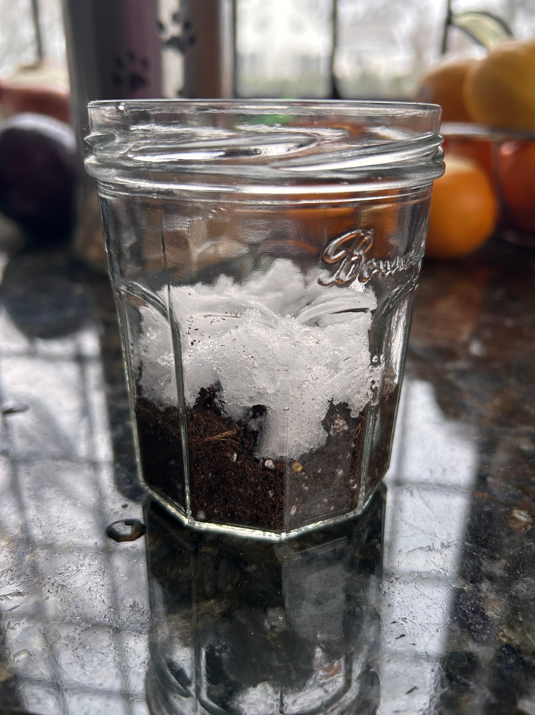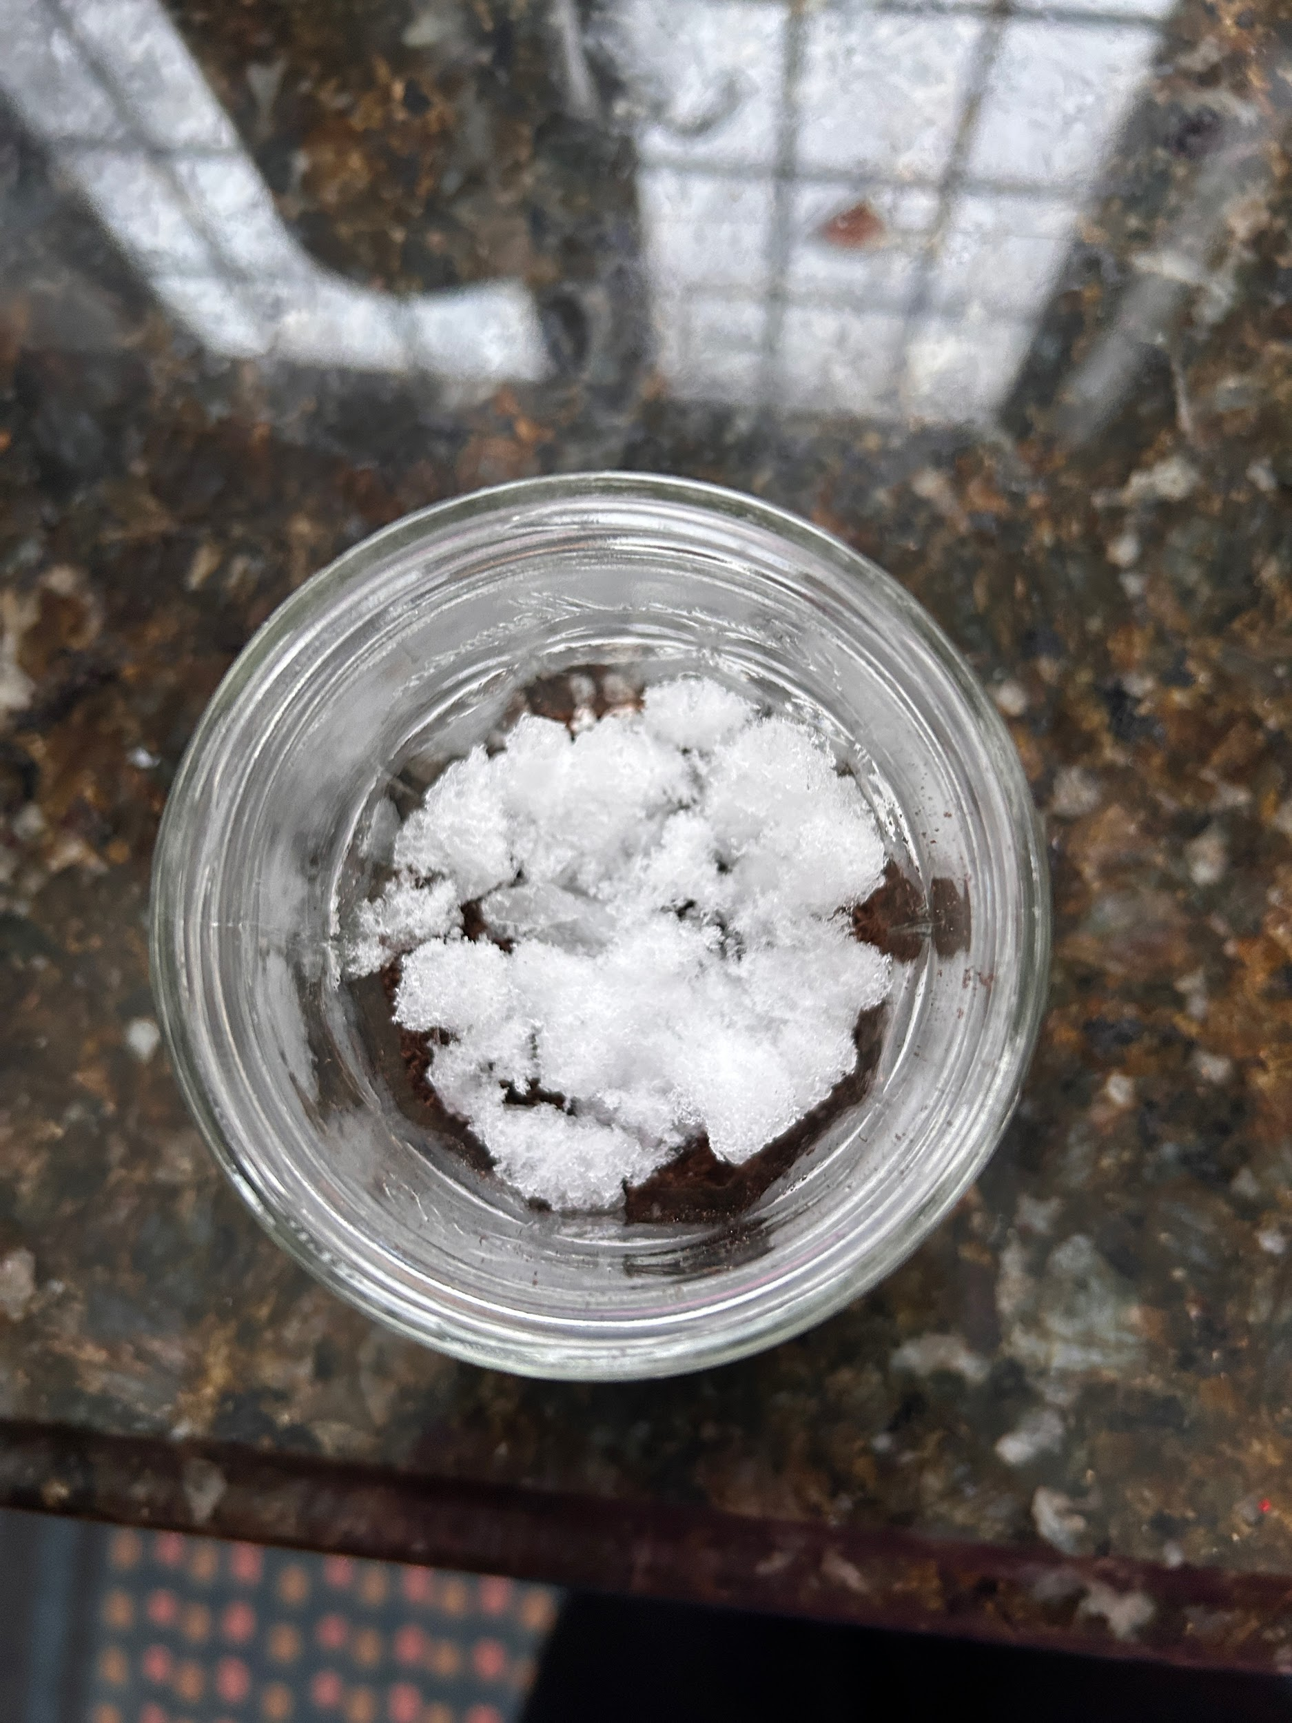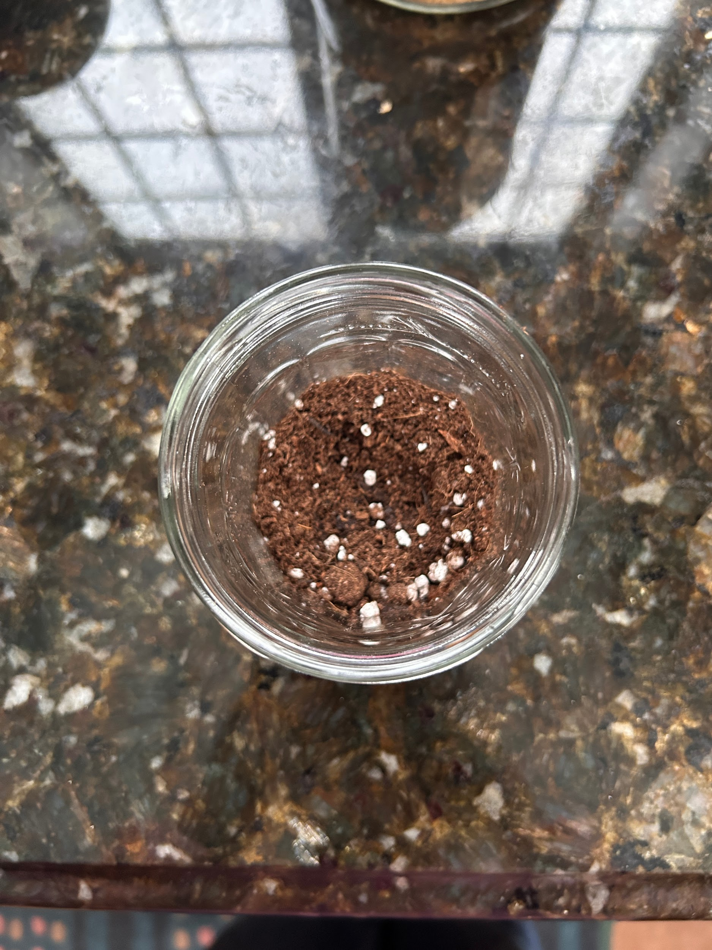
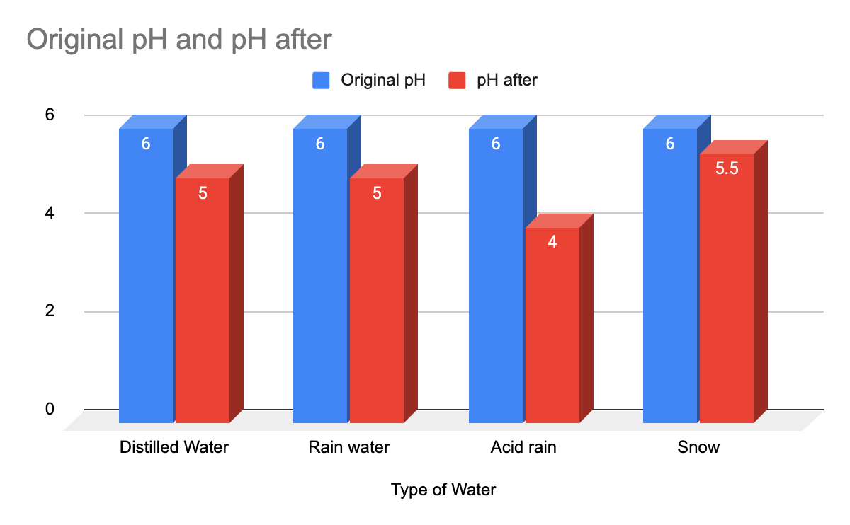






Discussion:
The results supported the hypothesis that acid rain would cause the greatest decrease in soil pH, as shown in the data where other precipitation showed only a change of 0.5-1 pH levels, whereas acid rain showed a significant jump, going from 6 to 4. This is likely due to the presence of hydrogen ions introduced by sulfuric and nitric acids, which take over the soil’s natural buffering capacity. As hydrogen ion concentration increased, soil pH decreased.
Distilled water and rain water caused a 1 pH scale drop going from a pH of 6 to a pH of 5, supporting the hypothesis that neutral precipitation has minimal chemical impact on soil. Any slight change observed may be due to dilution of existing ions or experimental error.
Snow caused a smaller change in soil pH of only a change from 6 to 5.5 compared to acid rain and distilled water. This suggests that snow slowed the soil acidity process. One reason for this is that snow must melt before fully interacting with the soil, reducing immediate contact time. Additionally, the lower temperature of snow decreases molecule motion, slowing ion exchange and chemical reactions. Because all samples were measured after the same time period, the reduced pH change indicates a slower rate of reaction.
Soil buffering also played a role in limiting pH changes. Components such as carbonates and organic matter can neutralize added acids, preventing extreme pH changes in the short term. This explains why soil pH did not drop as dramatically as it might in long-term environmental exposure.
Our results differ from other experiments like the experiment carried out through the U.S. Department of Agriculture Forest Service department based on “Acid Precipitation Effects on Soil pH and Base Saturation of Exchange Site”. In this experiment, they found a less significant change in pH, only lowering by around 0.6 units rather than our change which consisted of 2.0 units.
This experiment can help in agriculture, since farmers and people who work in that field need to know the pH of their original soil and how the precipitation in the area they choose to settle affects the crops and soil fertility.

Limitations:
- The experiment measured short term effects only, measuring longer term effects would allow us to provide data of how it affects environments in the real world rather than a mini simulation we made ourselves.
- Soil type was limited to one, showing a less proficient data analysis and less diversity in proving that a similar change happens in all soils rather than just a singular soil type which could have been an error.
- pH was measured only before and after exposure, measuring in the transition phase of pH could showcase a more in depth analysis of the transition period and how it got to what it is, rather than a point A to point B analysis.

Improvements and Future Research:
Future studies could test multiple different soil types, measure pH changes over longer periods of time, measure the amount of nutrients after pH change, and study plant growth in the soils.

Conclusion:
This experiment demonstrated that different types of precipitation affect soil pH in different ways. Acid rain caused the greatest decrease in soil pH, while distilled water and rain water caused minimal change. Snow resulted in a smaller pH shift, suggesting that lower temperature and delayed contact time slowed the chemical interactions between precipitation and soil. These findings highlight the importance of both chemical composition and physical state in environmental processes affecting soil health

Acknowledgments
Thank you to Dr. Kg, who has been supporting us throughout our scientific journey.
Thanks to our parents who helped us with our supplies to conduct our experiment.

References
McFee, W. W., Kelly, J. M., & Beck, R. H. (1977). Acid precipitation effects on soil pH and base saturation of exchange sites. Water, air, and soil pollution, 7(3), 401-408.
Whittinghill, K. A., & Hobbie, S. E. (2012). Effects of pH and calcium on soil organic matter dynamics in Alaskan tundra. Biogeochemistry, 111(1), 569-581.
Dong, Q., Ji, Z., Wang, H., Duan, W., Cao, W., Li, W., & Jia, Y. (2025). Interactive Effects of Precipitation and Nitrogen on Soil Microbial Communities in a Desert Ecosystem. Microorganisms, 13(6), 1393.
Prakash, J., Agrawal, S. B., & Agrawal, M. (2023). Global trends of acidity in rainfall and its impact on plants and soil. Journal of Soil Science and Plant Nutrition, 23(1), 398-419.

