Analysis of the environmental quality of the banks of the Urussanga River in Içara – SC through the Globe Protocols

Alisson Porto de Jesus
EMEF Alaíde Tabalipa
Rua Cecília Chechinel - Esplanada, Içara - SC, 88820-000 700268@profe.sed.sc.gov.br

Josué de Matos Idalino
EMEF Alaíde Tabalipa
Rua Cecília Chechinel - Esplanada, Içara - SC, 88820-000 pedagogicoeatabalipa@gmail.com

Kayrine Soratto Teixeira
EMEF Alaíde Tabalipa
Rua Cecília Chechinel - Esplanada, Içara - SC, 88820-000 pedagogicoeatabalipa@gmail.com

Maria Vitória Toretti Cardoso
EMEF Alaíde Tabalipa
Rua Cecília Chechinel - Esplanada, Içara - SC, 88820-000 pedagogicoeatabalipa@gmail.com

Pedro Luiz de Souza
EMEF Alaíde Tabalipa
Rua Cecília Chechinel - Esplanada, Içara - SC, 88820-000 pedagogicoeatabalipa@gmail.com

ABSTRACT

The Urussanga River Hydrographic Basin (BHRU), in Southern Santa Catarina, is known for both water scarcity and critically poor water quality, resulting from historical coal mining and modern anthropogenic pressures. This citizen science study, conducted at the Alaíde Tabalipa Municipal Elementary School in Içara, aimed to analyze the environmental quality of the Urussanga River banks using the GLOBE Observer hydrology and land use protocols. The main objective was to diagnose the physical and chemical conditions of the water (pH, Dissolved Oxygen, Electrical Conductivity, Nitrate and Nitrite, Salinity, and Transparency) and map the occupation of Permanent Preservation Areas (APP) in river sections within Içara, alongside soil and atmospheric parameters. The methodology involved field data collection using a laboratory kit with equipment selected by the students and the GLOBE Land Cover and Land Use (LULC) Protocol. Preliminary results, entered into the global GLOBE database, reaffirmed the impact of Acid Mine Drainage (DAM) in the region, potentially identifying pH values below legal limits. Furthermore, land use mapping provided insights into vegetation fragmentation and the advancement of urbanization and pasture areas, factors accelerating erosion and APP degradation (Oliveira, 2021). The study concludes that citizen science, in collaboration with academic knowledge (e.g., UNESC support), is a powerful tool for environmental awareness and generating localized data, which can be of great importance for the planning and management of the BHRU's water resources.

KEYWORDS. 1. Urussanga River. 2. Protocolos GLOBE. 3. Water Quality. 4. Land Use. 5. Coal Mining.

- Research Questions/Research Problem
The Urussanga River is one of the most severely compromised coal basins in southern Santa Catarina, facing a double crisis: quantitative water scarcity and chronic qualitative degradation (Albuquerque Junior et al., 2020). The central problem of the Urussanga River Basin (BHRU) is Acid Mine Drainage (DAM), a historical liability of coal mining that acidifies shallow surface and groundwater (Castilhos et al., 2007). This process results in pH values often below 3.0 and high concentration of heavy metals (Fe, Al, Mn, Zn). This geochemical contamination is aggravated by contemporary vectors of pollution, such as the release of untreated domestic effluents and the use of pesticides in agriculture, which add organic and diffuse contamination to the water system (Albuquerque Junior et al., 2020).
The municipality of Içara, which is part of the BHRU (State Decree No. 4934, 2006), suffers the consequences of these multiple impacts. In the study area, land use is marked by rice farming, livestock (cattle) and clay extraction, which, added to the expansion of the Urban Area, increase the pressure on water resources (Oliveira, 2021). In addition to water pollution by surface runoff and contamination by domestic effluents that arrive through tributaries such as the Linha Anta River and the Içara River, the region surveyed also faces serious flooding problems.
In this context, citizen science, through initiatives such as the GLOBE program, offers an effective approach to involve the local community, especially young people, in the production of localized data and awareness of water resources management. In view of the geochemical complexity and anthropogenic pressure on the Urussanga River in Içara, this study seeks to answer the following questions:
  - What is the current state of water quality (pH, Dissolved Oxygen, Electrical Conductivity, Nitrate and Nitrite, Salinity and Transparency) and soil (pH and Moisture) of the Urussanga River in the Içara section, and how do these parameters compare to the reference values and known impacts of Acid Mine Drainage (DAM) in the basin, considering the influence of land use and land cover (LULC) on the river banks?
  - Can the scientific projects produced by students through the GLOBE Protocols contribute to raising awareness in the community and supporting the management and planning actions of the Urussanga River Basin Committee?

Introduction
The conservation of water resources in environments under intense anthropogenic pressure requires integrated strategies of management, monitoring and social engagement. The Urussanga River Basin (BHRU), located in the South Atlantic Hydrographic Macro-region (SGB, 2020), is an emblematic case in Brazil (Citadin, 2014). Historically, the extraction of coal, a central economic activity in the south of Santa Catarina since the 1930s, has generated a massive environmental liability (Castilhos et al., 2007). The most critical consequence is Acid Mine Drainage (DAM), a geochemical phenomenon that acidifies rivers and streams, making them biologically unviable and contaminated by heavy metals.
Despite the judicial reorganization efforts and the planning established by BHRU's Water Resources Plan (PRH) (horizon 2021–2033), the diagnosis remains alarming, with low availability and quality of water. The municipality of Içara, which is part of the area of operation of the Basin Management Committee, directly faces these impacts, aggravated by urban growth, rice farming, and the absence of adequate basic sanitation (Albuquerque Junior et al., 2020).
In this context, the present study proposes the use of the GLOBE Observer Protocols as a scientific and pedagogical research tool. Promoting science in education

is essential for the training of young researchers and critical citizens. The GLOBE (Global Learning and Observations to Benefit the Environment) program is an international initiative that empowers students to collect real environmental data, contributing to scientific research and understanding of local and global issues. By focusing on the banks of the Urussanga River in Içara, the research seeks to link water quality variables (GLOBE Hydrological Parameters) to land occupation and use (LULC Protocol), transforming citizen science instrumentalized by students in the region into a driving force for the environmental diagnosis of the micro-basin.

3.Theoretical Reference

aThe Critical Scenario of the Urussanga River Basin:

The Urussanga River Basin (BHRU) is one of the three coal basins that concentrates the largest environmental liability in judicial execution in the country (Viana Filho, 2017). The main polluting vector is the Acid Mine Drainage (DAM), resulting from the oxidation of pyrite, which generates sulfuric acid and solubilizes metals (Castilhos et al., 2007). pH measurements in the region often remain below 3.0, with levels of Sulfate, Iron (Fe), Aluminum (Al), Manganese (Mn) and Zinc (Zn) above legal limits. This contamination causes acute toxicity to aquatic biota and is aggravated by organic pollution resulting from the discharge of untreated domestic effluents (Schnack et al., 2018).

b. Land Use and Land Cover Dynamics and Anthropogenic Pressure in Içara

Between 1986 and 2020, there was a great expansion of the Urban Footprint and the Pasture and Undergrowth class (associated with livestock), while Agriculture suffered the greatest reduction in area. Rice farming also remains an activity with high water demand (Oliveira, 2021 ; Conto et al., 2017). In Içara, land use is characterized by rice farming, cattle ranching and clay extraction, activities that, together with urbanization, increase pressure on the banks and intensify erosion. The degradation of these areas increases the speed of surface runoff (Back, 2014) and accelerates the entry of sediments and pollutants into the water body. Water quality is severely impacted by untreated domestic effluents that drain from the urbanized regions of Içara and Criciúma through tributaries, such as the Linha Anta River and the Içara River (Schnack et al., 2018). In addition, local water planning must deal with serious flooding problems that occur in areas such as Rio Acima and Urussanga Velha. Such events are influenced by the physiology of the basin, where the characteristics of size, shape and slope impact the speed of surface runoff (Back, 2014).

Os Protocolos GLOBE Observer como Ferramenta de Monitoramento Integrado

The GLOBE Observer is a citizen science tool that allows students to collect real environmental data by integrating information from different subsystems:
Hydrology Protocol: Evaluates pH (direct indicator of DAM), DO and Conductivity (indicators of ecological stress and ionic load). The measurement of Nitrate and Nitrite works as an indirect indicator of organic pollution and agricultural runoff, when laboratory tests of coliforms are not available.
Soil and Atmosphere Protocols: Soil pH and moisture parameters, along with the Globe Observer Land Use and Land Cover (LULC) mapping, help assess the potential for acid leaching and margin erosion (Back, 2014). Atmospheric data provide the meteorological context necessary for the interpretation of hydrological processes, such as the dilution of pollutants. LULC allows the mapping of margins, identifying the

presence of Pasture, Urban Spot or Tree Vegetation. This data collection in the field provides the basis for correlating the state of the APPs with the quality of the monitored water.

4.Materials and Methods

- Field of Study

The study was conducted in the localities of Esplanada, Olho Dágua, Rio Acima, São Pedro and Urussanga Velha in the municipality of Içara and Balneário Torneiro in the municipality of Jaguaruna, Santa Catarina. Içara is one of the nine municipalities that make up the BHRU (State Decree No. 4934, 2006) and is under the influence of the geochemical liabilities of the coal region, in addition to facing land use pressures, such as urban expansion and agricultural activities (Oliveira, 2021).

Figura 1 – Studied stretch of the Urussanga River between the municipalities of Içara and Jaguaruna (SC)
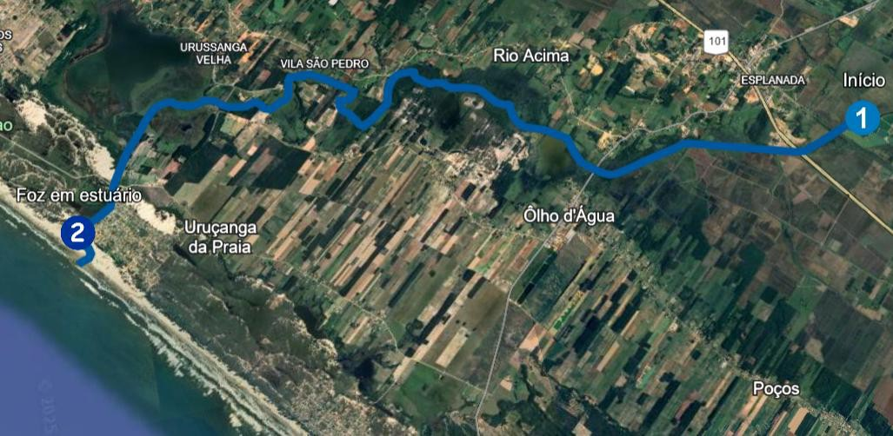
Source: Authors (2025), based on data from Google My Maps and Google Earth satellite imagery

b. Data Collection – GLOBE Protocols

Data were collected at 6 sample collection points by students from EMEF Alaíde Tabalipa using the following GLOBE program protocols:

- Hydrology Protocols (Water Quality):
- Parameters: pH, Dissolved Oxygen (DO), Electrical Conductivity (EC), Nitrate and Nitrite, Salinity, Water Temperature and Water Transparency.
- Method: Use of laboratory test kit and field equipment according to GLOBE guidelines.
- Soil and Atmosphere Protocols (Environmental Conditions):
- Soil Parameters: Soil Temperature, Soil pH and Soil Moisture. Atmospheric Parameters: Air Temperature, Wind, Barometric Pressure and Relative Humidity.
- Method: Data collection using the GLOBE Soil and Atmosphere protocols. Land Cover and Land Use Protocol (LULC):
- Parameters: Determination of the dominant and secondary cover in the study area (e.g., Tree and Shrub Vegetation, Pasture and Undergrowth, Urban Area) (Oliveira, 2021).
Figure 2 – Sample collection points.

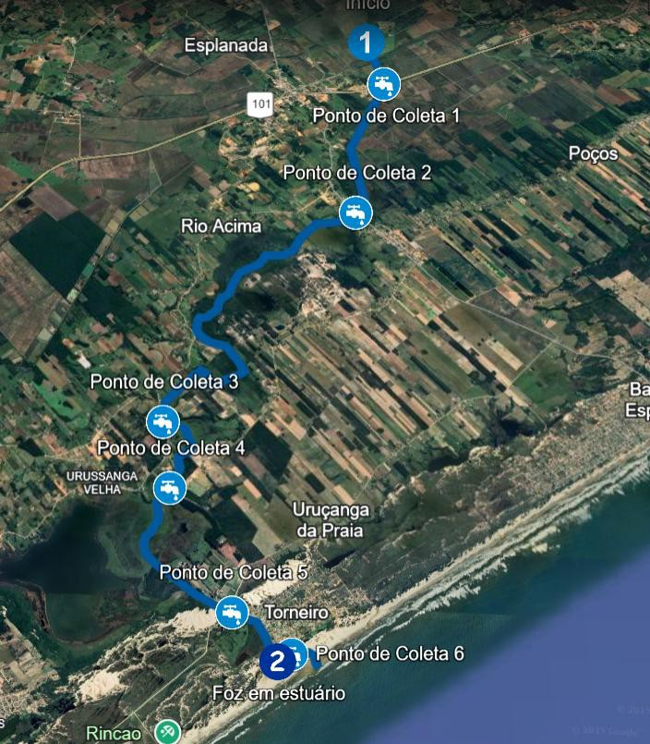
Source: Authors (2025), based on data from Google My Maps and Google Earth satellite imagery

Method: Data collection from the Globe Observer application, classifying the land use of the banks and Permanent Preservation Areas (APP), according to the GLOBE methodology for classification of the type of cover. The mapping of the course of the Urussanga River, including the collection points, estuary mouth, riparian vegetation, flooded areas and various land uses near the river (such as clay extraction, agriculture and eucalyptus plantation), was developed by the students using the Google My Maps tool (https://www.google.com/maps/d/edit?mid=1NCivLUSnwhH4v01yR09PjmycYUI4TFU&usp=s haring). This geoprocessing tool allows the visualization and spatial analysis of land use over APPs and areas near the river.

Data Processing and Analysis
To assist in the interpretation of dates of the students, Table 1 presents both the reference values obtained in previous research and expected data as well as the results of the field research at the six collection points:

Analysis of data/results
Through the data collected during the research, the following table was elaborated:
Table 1 – Environmental Parameters of the Urussanga River / Içara Region-SC

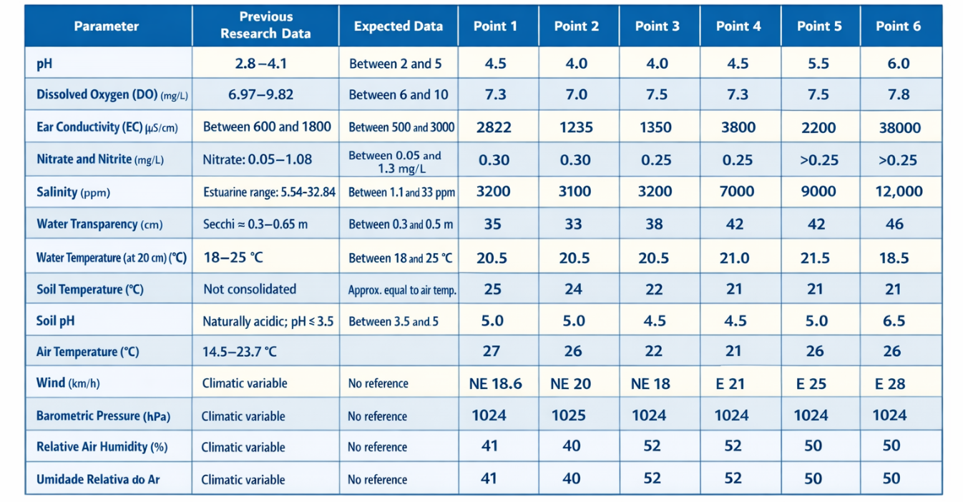Source: authors, 2025

6.Discussion
The analysis of the data collected by the students (Table 1), in comparison with the reference parameters and the mapped geographic context (Google My Maps), allows us to answer the first research question about the state of the environmental quality of the Urussanga River in the Içara stretch and the influence of land use.

6.1 Evidence of Chemical Pollution and Estuary Influence
The results show serious problems in water quality, with a strong influence of both the pollution of the basin and coastal conditions:
Acidity (pH): The pH of the water ranged from 4.0 to 6.0. The values of 4.0 (Points 2, 3) are in the most acidic and dangerous range, confirming that the water suffers from the chronic problem of drainage

Ácida de Mina (DAM) (Castilhos et al., 2007). This acidity makes it easier for heavy metals to dissolve in water, making it potentially toxic (Schnack et al., 2018 2).
Graph 1: pH of the water at the different collection points of the Urussanga River (SC).
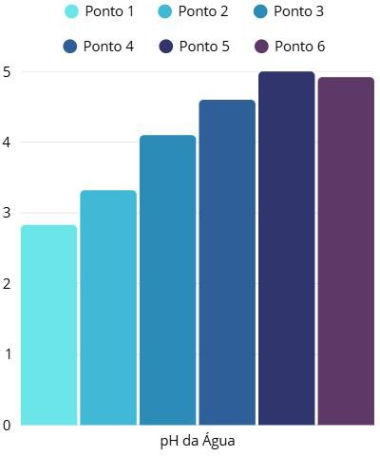
Source: Authors, 2025.

Conductivity and Salinity (EC): Electrical Conductivity (EC) and Salinity registered very high peaks at Points 5 and 6 (EC from 22,000 to 38,000 μS/cm).

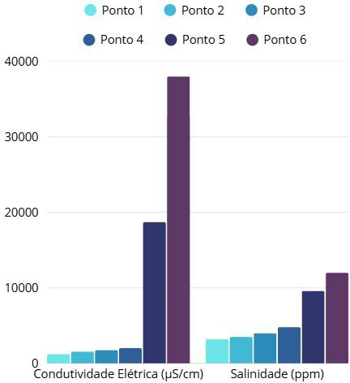
Graph 2 – Electrical conductivity and salinity of the water at the different collection points of the Urussanga River (SC).

Source: Authors, 2025.

This high concentration of salts and minerals is mainly explained by the location of these points close to the sea. The intrusion of high tide into the estuary injects salt water into the river, dramatically raising the EC and Salinity. This influence of the sea also impacted the pH, raising it to 5.5 and 6.0 at the closest points, as the seawater is slightly alkaline and helps neutralize the acidity of the AMD.
Dissolved Oxygen (DO): Dissolved Oxygen has remained at healthy levels (between 7.0 and 7.8 mg/L), suggesting that organic pollution is not consuming all the oxygen needed by aquatic life.
Nitrate and Nitrite: The presence of Nitrate and Nitrite indicates a nutrient contribution that comes from agricultural runoff (rice farming and pastures) and untreated domestic effluents, which arrive through the Criciúma and Içara tributaries (Schnack et al., 2018).

6.2. Land Use and Environmental Pressures
Degradation of Banks (PPAs) and Erosion: The Google My Maps map produced by the students identified the presence of livestock, rice farming and clay extraction in areas close to the river. The removal of riparian vegetation for these activities facilitates soil erosion, the entry of sediments, and the worsening of flooding, a serious problem in the region (Albuquerque Junior et al., 2020).
Soil pH: The soil pH at some points (4.5) is acidic. This low pH, added to the degradation of the banks, contributes to the acidity of the water and the discharge of sediments.

6.3. Temperature Variations (Air, Soil and Water)

Temperature analysis provides context on the influence of vegetation cover and coastal environment on the data.
Air and Soil Temperature: The collection showed a variation in air and soil temperature. In Points 3 and 4, where the measurement was made in the shade (riparian vegetation), the air temperature (21°C to 22°C) and soil temperature (21°C to 22°C) remained lower. The lower temperatures at point 6 are probably due to the albedo effect on the beach sand that reflects sunlight and maintains a lower temperature at a depth of 10cm.
Water Temperature: The variation in water temperature is small, but the coldest point (Point 6: 18.5°C) is consistent with the influence of seawater which, at high tide, tends to be cooler than freshwater from the river, reinforcing the influence of the estuary at these points.

Conclusão

This present study, using the GLOBE Protocols and the production of a digital map through Google MyMaps by the students, provided a concrete local diagnosis of the environmental quality of the Urussanga River in the Içara section, allowing to answer the two research questions:
- What is the current state of water quality (pH, Dissolved Oxygen, Electrical Conductivity, Nitrate and Nitrite, Salinity and Transparency) and soil (pH and Moisture) of the Urussanga River in the Içara section, and how do these parameters compare to the reference values and known impacts of Acid Mine Drainage (DAM) in the basin, considering the influence of land use and land cover (LULC) on the river banks?
The Urussanga River presents a picture of severe chemical pollution. The pH data confirm that the water still suffers from the acidity of the Acid Mine Drainage (DAM). At points close to the sea, the very high values of Electrical Conductivity and Salinity are caused by tidal intrusion, a natural factor that, at the same time, reduces acidity in these stretches. The analysis

of land use (livestock and clay extraction) shows that the degradation of the banks increases erosion and the discharge of pollutants, making the river vulnerable to pollution and flooding.
- Can the scientific projects produced by students through the GLOBE Protocols contribute to raising awareness in the community and supporting the management and planning actions of the Urussanga River Basin Committee?
Yes. The project demonstrates that citizen science in basic education is a powerful tool for awareness. The collection of real data (such as acidic pH and conductivity peaks) and the mapping of risks carried out by the students themselves transform the environmental problem into practical knowledge. Providing students with direct contact with science, through scientific initiation and the use of active methodologies, stimulates student protagonism and meaningful learning. By acting as young researchers, students develop observation, critical analysis and decision-making skills, understanding how the scientific method can be applied to the local reality. This experience arouses interest in research and forms more aware and participatory citizens, capable of contributing to the actions of the Urussanga River Basin Committee and to the preservation of the region's water resources.

References

ALBUQUERQUE JUNIOR, C. L.; FARIAS, P. M.; SILVA, R. N. e; RAGGHIANTI, V. T.;
FERREIRA, L. S. P. (Ed.). (2020). Plano de Recursos Hídricos da Bacia Hidrográfica do Rio Urussanga : relatório síntese 2019. Palhoça: Ed. Unisul. ISBN 978-85-8019-230-8. Disponível em: https://www.aguas.sc.gov.br/jsmallfib_top/DHRI/Planos%20de%20Bacias/Plano%20da%20Baci a%20Hidrografica%20do%20Rio%20Urussanga/RelatorioSintese.pdf. Acesso em: 21 out. 2025.

CASTILHOS, Z. C. et al. Avaliação dos impactos ambientais associados à drenagem de minas em três bacias hidrográficas da região carbonífera sul catarinense. In: CONGRESSO BRASILEIRO DE GEOQUÍMICA, 10., 2007, Ouro Preto. Anais... Rio de Janeiro: CETEM, 2007. Disponível em: https://www.cetem.gov.br/antigo/images/congressos/2007/CAC01160007.pdf . Acesso em: 21 out. 2025.
CITADIN, Paulo Roberto. Bacia hidrográfica do rio Urussanga, sul de Santa Catarina: realidade socioambiental e evolução histórica na formação do arcabouço jurídico hídrico brasileiro. 2016.
156 f. Dissertação (Mestrado em Ciências Ambientais) – Universidade do Extremo Sul Catarinense – UNESC, Criciúma, 2016. Disponível em: http://repositorio.unesc.net/handle/1/3796 . Acesso em: 21 out. 2025.

DIAS, Adriano de Oliveira; LADWIG, Nilzo Ivo; DE CONTO, Danrlei. Mapeamento temático na análise da paisagem: bacia hidrográfica do Rio Urussanga, Santa Catarina, Brasil. Geosul, Florianópolis, v. 35, n. 75, p. 418-440, jun./ago. 2020. Disponível em: https://periodicos.ufsc.br/index.php/geosul/article/view/1982-5153.2020v35n75p418/43435 . Acesso em: 21 out. 2025.
OLIVEIRA, Alessandra Jaine Moraes de. Cobertura e uso da terra na bacia hidrográfica do Rio Urussanga, Santa Catarina, Brasil. Criciúma: Universidade do Extremo Sul Catarinense – UNESC, [2021]. Disponível em: http://repositorio.unesc.net/handle/1/10484 . Acesso em: 21 out. 2025.

SANTANA, W. de O.; PEZENTE, D. P. Análise estatística multivariada de águas subterrâneas na bacia do rio Urussanga. Tecnologia e Ambiente, v. 23, p. 43–60, 2017. Disponível em: https://doi.org/10.18616/ta.v23i0.3905 . Acesso em: 21 out. 2025.
SCHNACK, C. E.; MENEZES, C. T. B. de; CENI, G.; MUNARI, A. B. Qualidade da água no
estuário do rio Urussanga (SC, Brasil): um ambiente afetado pela drenagem ácida de mina. Revista Brasileira de Biociências, v. 16, n. 3, 2018. Disponível em: https://seer.ufrgs.br/index.php/rbrasbioci/article/view/114593 . Acesso em: 21 out. 2025

VIANA FILHO, D. R. Membro do Comitê participa de audiência sobre mineração. Águas SC, 10 set. 2019. Disponível em: https://www.aguas.sc.gov.br/base-documental-rio-urussanga/noticias-rio-urussanga/item/6687-membro-do-comite-participa-de-audiencia-sobre-mineracao/6687-membro-do-comite-participa-de-audiencia-sobre-mineracao. Acesso em: 21 out. 2025.

ZOCCHE, J. J. Arqueologia entre rios: do Urussanga ao Mampituba. Registros arqueológicos pré-históricos no extremo sul catarinense. Cadernos do LEPAARQ – Textos de Antropologia, Arqueologia e Patrimônio, v. 10, n. 20, 2013. Disponível em: https://periodicos.ufpel.edu.br/index.php/lepaarq/article/view/2127. Acesso em: 21 out. 2025.

