Particulate matter

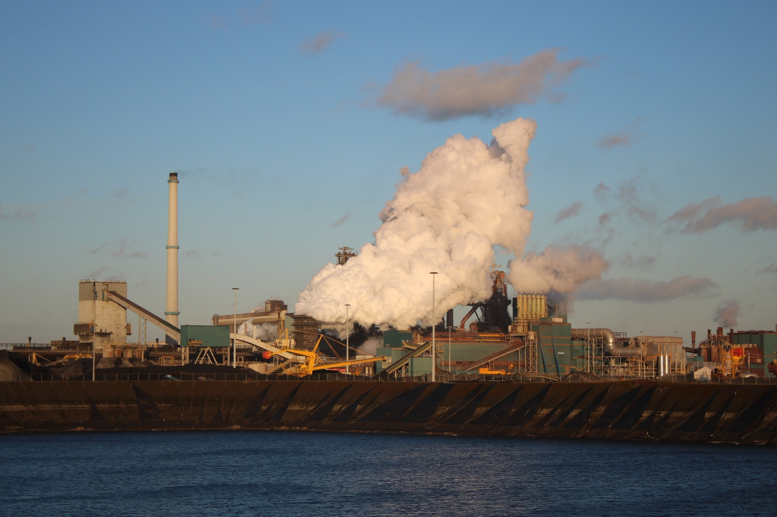
©Britt de Boer
Names: Britt de Boer, Lise Breunis, Oscar van Ling & Jasmijn Soeting
Classes: V51, V52, H45, V41
Date: 03/05/2024
Teachers: Joris ten Barge & Maaike Vollebregt
Table of Contents
Description of the situation 2
Infographic for Germany 3
Research plan 4
Casing 5
German team 6
Logbook 6
Results (graphs)+observations 7
Road to School 7
TATA-steel (steel factory) 9
North of the terrain 9
South-west of the terrain 11
East of the terrain 13
South of the terrain 15
Extra measurements, New Year's Eve 17
Conclusion 21
Discussion 22
Further research 23
Sources (volgens APA) 24
Attachments 25

Introduction
Climate change is a big hazard in our current society. Research has shown that particulate matter is a big factor in this change. And besides its influence on our climate particulate matter can also be very damaging to our health. That is why we are doing research into how much particulate matter is in the air and if there is a difference between measurements at different distances. We are doing our research in collaboration with German students who are doing the same research as us, but in Germany. We hope that in the end, we can all learn something from the results.

Description of the situation
What is the problem?
The problem is that the amount of fine dust is very high. It can damage nature, but also humans and other animals. The high amount of particulate matter is caused by cars and industrial sources due to burning fuel and other materials. The smoke that comes from these factories contains high amounts of particulate matter. Our own houses can also produce a lot of particulate matter.

Why and how is this relevant
Exposure to fine dust can increase the risk of heart attacks, stroke, certain cancers, and birth defects. Because of the small size (less than 10 micrometers), it is easy to penetrate the airways and lungs when inhaled. Approximately 2.8 million people die each year from inhaling fine dust. It is especially for people with heart or lung diseases, old people, and children.

What is known about this topic?
Fine dust is a name for all the dust in the air. The biggest part is made from ammonia, sulfur dioxide, and nitrogen oxides. Carbon is also a small part of fine dust. Fine dust can cause climate problems like global warming, creating many bad consequences.

Scientifical relevance
We must investigate this subject because the climate is worsening very fast, and it must be taken seriously. This investigation can make people aware of the problem and its consequences and maybe it is going to be more important for people to solve the problem.

Where is the problem occurring?
Fine dust is everywhere. Not all types are as bad, but the fine dust from industries, for example, can cause global warming and health issues. Industries are not the only source of particulate matter, but our woodstoves are part of the problem too.

Fine dust (chemical details)
Fine dust includes sulfate, nitrate, ammonium, elemental carbon, organic carbon, silicon, and sodium ion. These are chosen from the findings of (Bell et al.,⁷, 05-02-2016).

Infographic for Germany
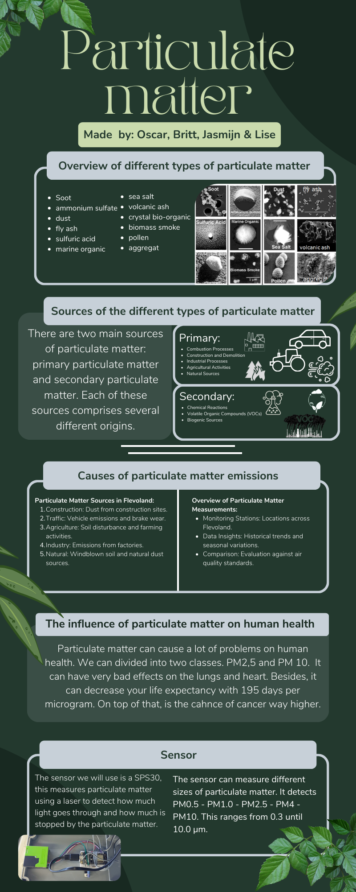
This is our preliminary research before we started measuring. We took this information to Germany where we spoke to the German students that were in our group and then we made our research plan.

Research plan
Instrumentation
For this research, we will use the SPS30 sensor for particulate matter measurements. The SPS30 sensor, while not necessarily the most advanced device, we use it because it's practical and provides a baseline reading of particulate matter concentrations in the air. This sensor offers a reasonable level of accuracy suitable for our research objectives.
Sampling Intervals:
We will measure particulate matter concentrations at intervals of 5 meters along a straight line from the particulate matter source. This distance is chosen to capture variations in PM levels, especially in areas of interest such as those near factories, highways, and agricultural fields.
Sampling Duration
Each measurement session will last for 5 minutes, and data will be recorded at 1-second intervals during this period. This allows us to capture short-term fluctuations and identify any rapid changes in PM levels, providing a more comprehensive understanding of the air quality dynamics.
Industrial Proximity
Focusing on areas near factories, our research aims to assess the impact of industrial activities on particulate matter concentrations. Specific attention will be given to areas adjacent to manufacturing facilities to gauge the influence of industrial emissions on air quality.
Road Type Considerations
Our study will target areas with high traffic volume, particularly along highways featuring three lanes on each side. This choice reflects the potential contribution of vehicular emissions to the overall particulate matter levels in the air.
Agricultural Influence
To comprehend the impact of different types of particulate matter, our measurements will also extend to areas near fields or farms. This includes regions where practices such as plowing, harvesting, or livestock farming may contribute to particulate matter emissions.
Weather Documentation
In addition to particulate matter measurements, we will simultaneously document weather conditions. Screenshots from reliable weather apps will be taken at the beginning and end of each measurement session, capturing information such as temperature, humidity, wind speed, and direction. This weather data will be crucial for correlating environmental conditions with observed variations in particulate matter concentrations.
Data Analysis
The collected data will undergo thorough statistical analysis to identify trends, patterns, and potential correlations between particulate matter levels and various environmental factors and distances between the place measured and the PM source. This analysis will contribute to a comprehensive understanding of the sources and the way particulate matter moves.

Casing
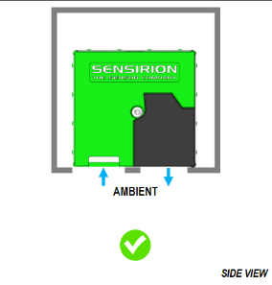
Casing Design and Iteration:
In the making of an effective casing for the SPS30 sensor, several steps were taken to ensure optimal functionality and ease of accessibility. The following outlines the key research, design process, and challenges encountered during the casing development.
Understanding the SPS30 Sensor:
The initial step involved a comprehensive examination of the SPS30 sensor, considering its dimensions, functionality, and performance requirements. Factors such as airflow, spatial limits, and the sensor's orientation were identified as crucial elements impacting its optimal operation.
Design Considerations:
Taking into account the specific requirements for the sensor's performance, the casing design aimed at providing a balance between protection, accessibility, and efficient airflow. Recognizing the need for easy access and space optimization, an open-box design was made. This design featured four supporting pillars with corresponding holes, allowing for a snug fit while maintaining accessibility.
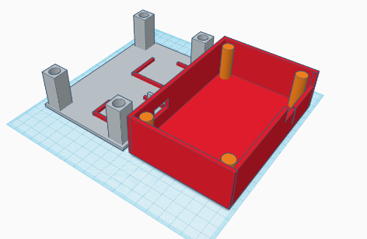
Structural Features:
The casing was constructed with an open top, supported by four pillars, facilitating convenient access to the sensor. Within the box, two small ledges were incorporated to securely hold the sensor in place, preventing unnecessary movement during operation. Special attention was given to the creation of holes to accommodate airflow and allow the connection of wires from the sensor to external devices such as laptops.
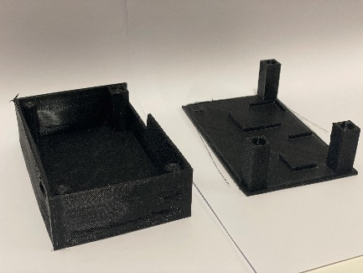
Iterative Prototyping:
Despite meticulous planning, the initial prototype faced challenges during the printing process. An oversight in the printer mode resulted in a casing that, while accurately shaped, proved structurally weak and prone to breakage. This setback prompted a reassessment of the printing parameters and a subsequent adjustment to ensure the final casing would meet both the structural and functional requirements.
Enhancements with Proposed Magnetic Stabilization:
As part of our ongoing commitment to refining the casing design for the SPS30 sensor, we are considering the incorporation of magnets. Recognizing the potential benefits in terms of preventing sensor movement during operation and enhancing accessibility, this enhancement is currently under evaluation as part of our future development plan.
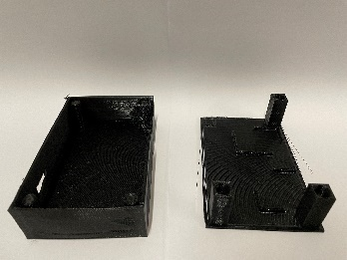
Lessons Learned:
The iterative nature of the casing design process highlighted the importance of precision in 3D printing settings. It underscored the need for a careful balance between structural integrity and the overall size of the casing. Additionally, the experience emphasized the significance of proper printer configuration to avoid compromising the durability of the final product.

German team
International Collaboration and Knowledge Exchange:
In our pursuit of comprehensive research on particulate matter, collaboration with the German research team has been a pivotal aspect of our strategy. Establishing and maintaining effective communication channels are essential elements in ensuring a good exchange of information and measurement results.
Regular Contact: We maintain regular communication with our German counterparts to share insights, discuss methodologies, and exchange valuable data regarding particulate matter measurements. This ongoing dialogue serves as a foundation for mutual learning and a unified approach to addressing air quality challenges.
Information Sharing: An important part of our collaboration involves the sharing of information, methods, and findings. By staying connected, both teams benefit from a broader perspective, helping each other's expertise to enhance the overall quality and depth of our research outcomes.
Measurement Results: Regular updates on measurement results are exchanged between the teams, allowing for cross-verification and validation of findings. This collaborative approach ensures a more trustworthy analysis of particulate matter concentrations in different geographical locations, contributing to a comprehensive understanding of air quality dynamics.
Coordinated Meetings: Scheduled meetings between the teams provide a platform for in-depth discussions on research progress, challenges faced, and potential areas of improvement. These meetings serve not only as a means to align methodologies but also to foster a sense of unity in our shared mission to contribute valuable insights to the global understanding of air quality issues.

Logbook
planning en logboek.xlsx

Results (graphs)+observations

Road to school
5 meters from the source:

10 meters from the source:

15 meters from the source:

Observations
What you can see is that there are more parts of bigger types of PM. For example, the PM₁₀ level is higher than the PM₄. Besides, the PM₄ and PM₁₀ are way closer to each other 5 meters from the road and the 15 meters. On the other hand, is the distance in the graphic for the other sizes way bigger than each other. The next interesting thing is that at 5 and 15 meters from the road are some points that are way higher than the rest of it. On the graphic for 10 meters from the road is this not visible. Outside the peaks, the lines are very fluent and a little bit flat.

TATA-steel (steel factory)

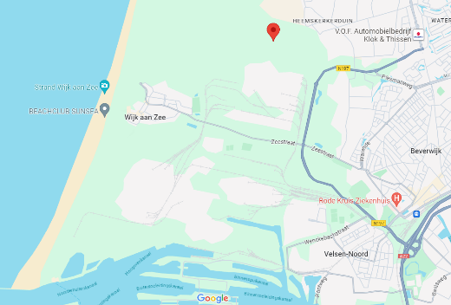
North of the terrain

Next to the fence:

5 meters from the fence:

10 meters from the fence:

15 meters from the fence:

Observations
What you can see is that those lines are less fluent than the lines from other graphics. What’s interesting is that those lines genuinely follow each other except in the graphic from 5 meters. You can see that PM_{2,5} follows the line but has a strange peak. Last of all, the different sizes of PM are in the same order in how much they appear.

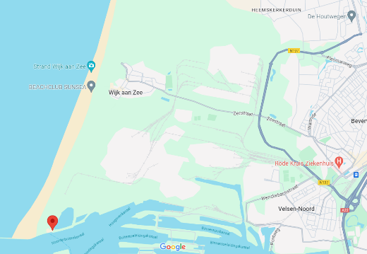
South-west of the terrain

Next to the fence:

5 meters from the fence:

10 meters from the fence:

15 meters from the fence:

Observations
What took my attention is that every graph has a little wave in it and some of them have more waves. Besides, there are barely any sharp angles in the graphics. That’s different from the other places. Another thing is that PM₁₀ and PM_{4,0} are way closer to each other in the graphics, while there is more distance between the other sizes.

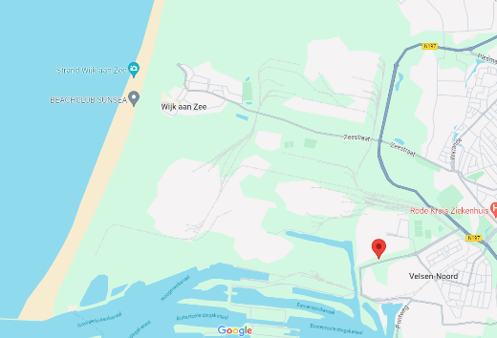
East of the terrain

As close as we were allowed:

5 meters from the original point:

10 meters from the original point:

15 meters from the original point:

Observations
What took some attention is that every line follows each other, while most graphs had some sizes that had peaks in the graphs. Also, the first two graphs are a little bit alike, they are almost the same. The third and fourth graphs are different from the first two and each other. PM₁₀ and PM₄ are very close to each other again.

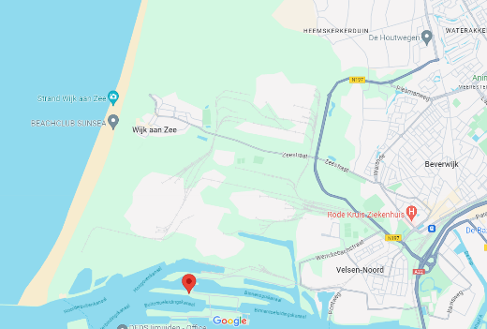
South of the terrain

As close as possible:

5 meters from the original point:

10 meters from the original point:

We couldn’t do 15 meters because we ran out of space on land

Observations
These graphs are very different from each other while most of the time, two graphs were alike. I also see more straight lines but also a lot of waves and peaks. In these measurements, the lines follow each other again, and the PM₁₀ and PM₄ lines are way closer together than the other ones. What was interesting to see is that the other lines are also way closer to each other and the upper lines.

Extra measurements, New Year's Eve
Point 1:

Point 2:

Point 3:

Point 4:

Point 5:

Point 6:

Point 7:

Observations
What you can see is that most measurements have kind of fluent lines without big peaks, except for measurements 3 and 5. What’s also interesting to look at is that PM₁₀ is always in the highest concentrations except for measurement 7. Something that also gets our attention is that in measurement 6 the PM_{1,0} lays way further down in the graphs while the other lines are way further close together. The last thing was that in the first few measurements, the PM_{1,0} and PM₁₀ followed each other while in the last ones they were way more apart.

Conclusion
Answer to the Research Question and Hypothesis Evaluation: Our research question aimed to investigate the impact of distance on particulate matter (PM) concentrations around sources and potential differences between these sources. Based on the analyzed data, we find a subtle trend regarding the influence of distance on PM concentrations. While we exercise caution in making definitive statements about a substantial impact, there is a noticeable decline in PM concentrations with increased distance from the sources.
Explanation of Results: An intriguing observation relates to the temporal relationship between measurements at different distances, such as 0 and 5 meters. If a peak is identified at 0 meters, a corresponding peak is observed at 5 meters a few seconds later. This synchronicity suggests that we are indeed capturing the same particulate matter, reinforcing the reliability and functionality of the sensors to a certain extent.
Comparison with Existing Data: In comparison with existing data, our research contributes to the understanding that distance does have an impact on PM concentrations. While the observed impact may not be prominently evident in the graphs, the acknowledgment of a decline in PM concentrations provides valuable insights into the interplay between distance and air quality.
Significance of Findings and Research Outcome: The findings contribute to a deeper understanding of particulate matter dynamics concerning distance from sources. While the observed trend may not be pronounced, the research provides a small but noticeable relationship between distance and PM concentrations. Additionally, the correlation between measurements indicates a level of reliability in our sensor data, enhancing confidence in our findings.
In conclusion, our research provides a foundation for further investigations into the intricate factors influencing PM concentrations. The acknowledgment of a subtle impact of distance contributes to the ongoing discourse on air quality dynamics, and the insights gained enhance our understanding of both PM behavior and the functionality of the sensors employed in our study.

Discussion
Inaccuracies and Limitations: An inherent challenge in our research lies in potential inaccuracies introduced during measurements, such as external disturbances like someone breathing directly into the sensor. Such interferences could disrupt the measurements and possibly introduce additional particulate matter, impacting the reliability of our results.
Validity Concerns: While our research demonstrates reliability in measuring the intended variables, the validity is somewhat compromised as we did not conduct repeated measurements. The absence of a second measurement makes it challenging to ascertain the consistency and accuracy of our findings, leaving room for potential errors in the data.
Sensor Reliability: It's crucial to acknowledge that the sensor itself may introduce uncertainties. While the sensor used in our study is reliable to a certain extent, it is not invalid. External factors, calibration variations, or sensor sensitivity could contribute to changes in measurements, impacting the overall reliability of our study.
Considerations for Future Research: To address the limitations identified in this study, future research should include measuring the same locations multiple times to enhance the validity of the findings. Additionally, expanding the range of distances between the sensor and sources could provide a more comprehensive understanding of the relationship between distance and particulate matter concentrations.
Expanding Sampling Locations: Diversifying the sampling locations is crucial for obtaining a representative understanding of particulate matter distribution. This entails measuring at various sites with different environmental conditions to capture the complexity of air quality dynamics. Our future plans include expanding the scope of our research to broaden our range of locations.
Our project fulfils the requirements of collaboration and innovation in addressing environmental challenges. Through scientific inquiry, we are pioneering a approach to safeguarding public health and promoting environmental sustainability. By developing a formula to ascertain safe distance from particulate matter sources, we ensure the safety of future residence.
Through our dedication to Earth system science, we are not only unravelling the complexity of air quality dynamics but also fostering a culture of environmental stewardship. This badge serves as a testament to our commitment to using scientific knowledge for the betterment of our world, one formula at a time.
Our interdisciplinary team, comprising a designer (Oscar van Ling), data analyst (Lise Breunis), physician (Jasmijn Soeting), and engineer (Britt de Boer), embodies the spirit of collaboration in tackling complex environmental issues. Together, we synergize our diverse expertise to develop innovative solutions for understanding and mitigating particulate matter pollution.
Furthermore, our collaboration extends beyond borders, as we partner with a dedicated team in Germany, that , comprising a designer (Sarah-Katharina Wolff), data analyst (Sarah-Katharina Wolff), physician (Kian Amir Ahmadi), and engineer (Florian Runge) Their unique insights and additional data sources enrich our project, providing valuable perspectives and enhancing the depth of our analysis. This collaboration shows the power of international cooperation in advancing scientific knowledge and addressing global environmental challenges.
Through our collective efforts, we strive to not only advance scientific understanding but also empower communities with actionable information to safeguard public health and promote environmental sustainability. This badge symbolizes our commitment to leveraging Earth system science for a better, healthier world.
Conclusion: In light of the discussed limitations, it is essential to recognize the need for continuous refinement and expansion in our research approach. By addressing these challenges and incorporating suggested improvements, future investigations can contribute to a more robust understanding of the factors influencing particulate matter concentrations in diverse settings. The ongoing commitment to refining methods and enhancing the reliability and validity of our research remains most important in advancing our understanding of air quality dynamics.

Further research
Building on the insights gained from our current study, we are actively planning further research to broaden the scope of our investigation and enhance the depth of our understanding regarding particulate matter (PM) concentrations.
Exploring Agricultural Environments: One notable expansion in our research plan involves extending our measurements to agricultural areas. Recognizing the unique set of challenges and potential PM sources in such environments, this extension aims to uncover the impact of agricultural activities on air quality. By including locations near farms or fields, we anticipate gaining valuable insights into the specific dynamics of particulate matter associated with agriculture. This also gives a broader understanding of different types of particulate matter.
Investigating Highways: Another crucial addition to our research agenda involves measuring air quality near highways. Highways are known to be significant sources of particulate matter emissions, from vehicular traffic. Examining PM concentrations in proximity to highways will provide a comprehensive understanding of the influence of this specific source on air quality. This expansion aligns with our commitment to exploring diverse environments to capture a holistic view of particulate matter dynamics.
Increased Sampling Frequency: Recognizing the importance of repeated measurements for ensuring the reliability and validity of our findings, we plan to increase the sampling frequency in our future research. Conducting measurements at each location multiple times allows us to detect potential variations or short-term fluctuations, thereby enhancing the robustness of our data. This approach contributes to a more thorough and dependable analysis of particulate matter concentrations.

Sources (volgens APA)
Particulate Matter (PM) Basics | US EPA. (2023, 11 juli). US EPA. https://www.epa.gov/pm-pollution/particulate-matter-pm-basics
Myong, J. P. (2016). Health effects of particulate matter. The Korean Journal of Medicine, 91(2), 106-113.
Sacks, J. D., Stanek, L. W., Luben, T. J., Johns, D. O., Buckley, B. J., Brown, J. S., & Ross, M. (2011). Particulate matter–induced health effects: who is susceptible? Environmental health perspectives, 119(4), 446-454.

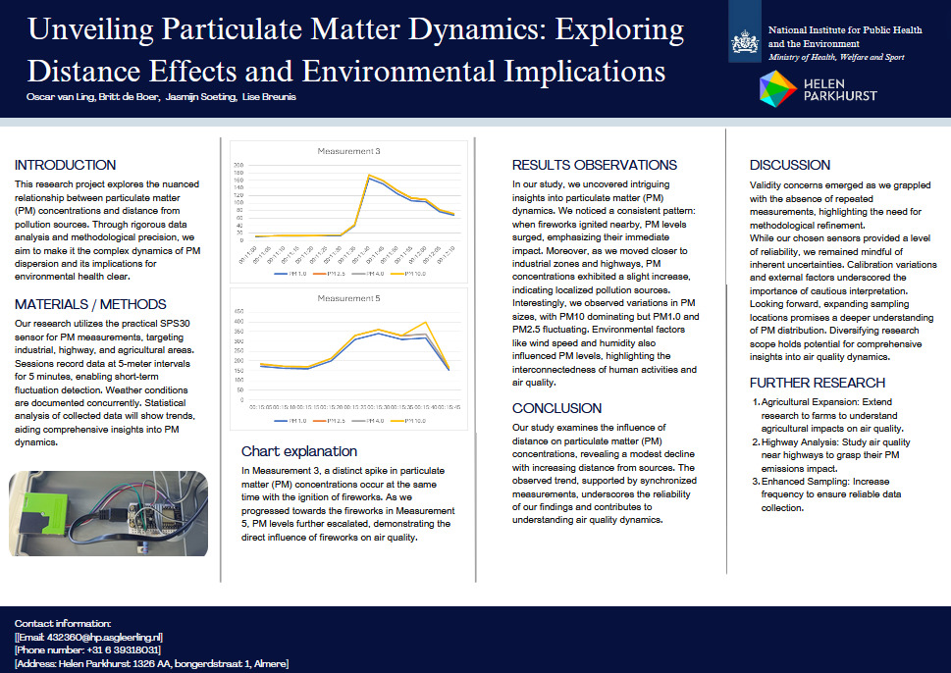
Attachments

