
Lycée Andohalo Antananarivo

Observing how Household water can fertilize the soils

Names of the group members:
- RAMAHAFINARITRA Fitahiana Anjara Fanomezana
- FANOMEZANTSOA Gerard Rias
- RAZAFIMANANA Jean Marino

Teacher’s name:
- RABENANDRASANA Doris

Table des matières
Summary 3
I. Introduction 3
II. Our research question : 3
• Our hypothesis: 3
III. Study site description 4
IV. Research and result 4
1. Expérimentation 4
2. Observation 5
a) Soil and plant observation 5
b) Soil and earthworm observation 5
c) Water observation 6
3. Data collection 6
4. Results 8
5. Discussion 9
V. Background and supporting information 9
VI. Expected outcomes and goals 9
VII. References 9
10

Summary
This book talks about the observations and experiments we did in a small garden where some plants grow quickly unless in some part of the garden. We decided to test a hypothesis we have formulated about the relationship between the soil and the household water we used to water the garden. We did experiments and observations for two (02) weeks and collected data that helped us answer our questions.And we combine all the database after two weeks and compared the database from the same type of soil but the first one, the soil before the experiment and the second one,the soil after the experiment. We got results, discussed tem, and compared them with other sources we used during the study. We concluded that the soil’s sterility was caused by its acidity.

Introduction
Two weeks ago we noticed that many plants in our garden grow quickly. However, there ar one some areas where no plants grow, even if most of the garden were covered by plants.
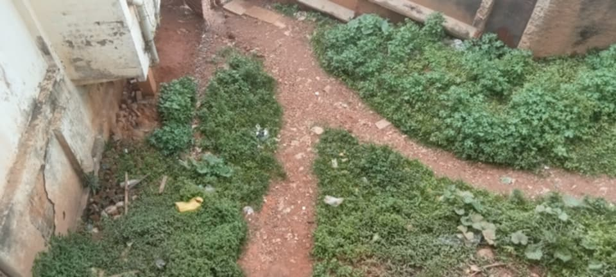

Our research question :
Why do plants not cover some parts of the garden even if the surfaces seem the same?

Our hypothesis:
« Household water (for example dishwashing and laundry water) may help fertilize the soil, and only the areas watered with this water are covered by plants ».

To verify this hypothesis, we did an experiment for two weeks.

Study site description
The study took place in a small garden in Antananarivo, a city in Madagascar. It is an urban area that has Madagascar’s two seasons.

Research and result

Expérimentation
First, we cleared the area by removing all plants.
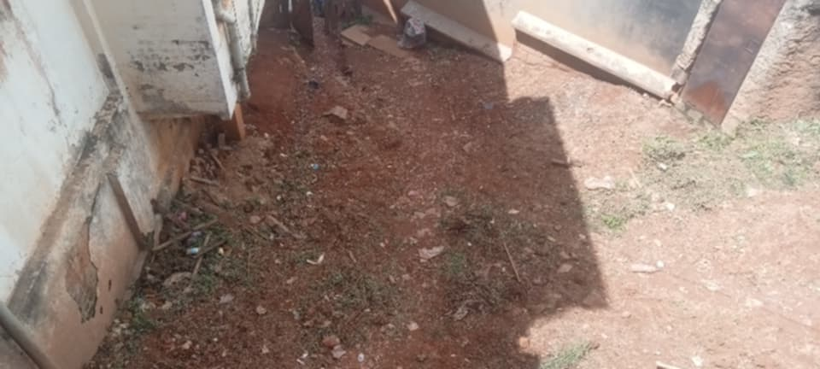

Then we made a container from a plastic bottle and took a sample of soil from a patch that looked sterile. We made several holes in the bottle to allow water to pass through.
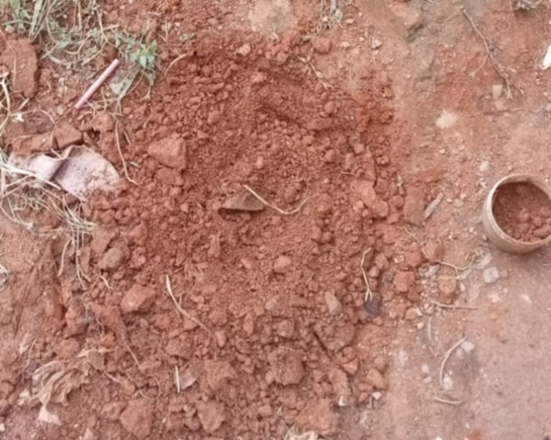

We dug a hole the same size as the bottle in the sterile area and watered it at least three (03) times a day with « dishwashing and laundry water » to make sure the plant would receive the same water.
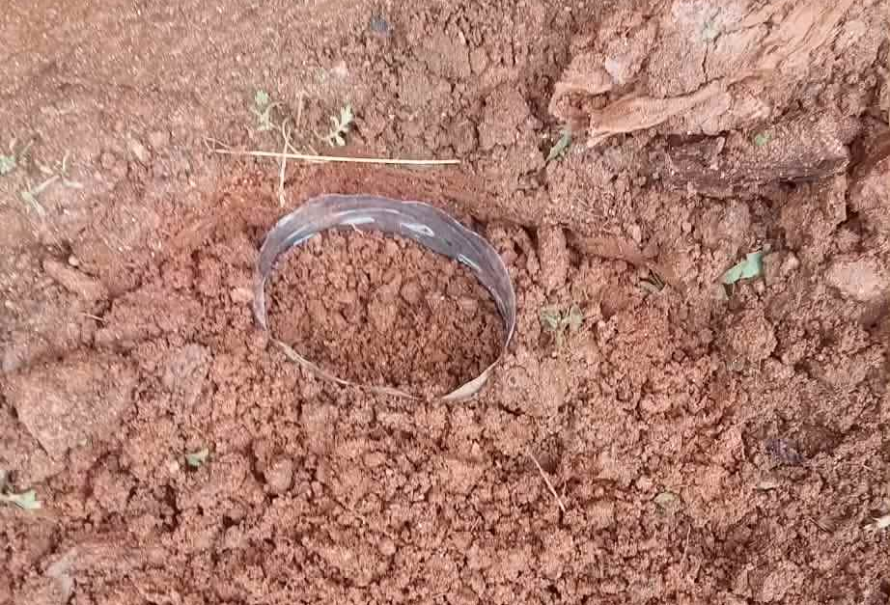

We buried the bottle in the hole and put a bean seed 5 cm deep inside the bottle.
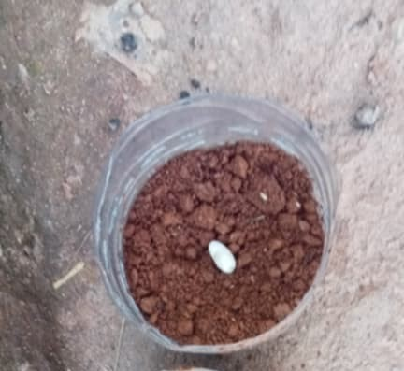

Observation

Soil and plant observation
During these two (02) weeks we followed the weather and we have seen that in the first week it rained every afternoon and every evening except the last day of that week. So the soil was also watered by rain.
We took a photo and saw that the plant had already started to grow and had stems (the length of the plant about 5 cm).
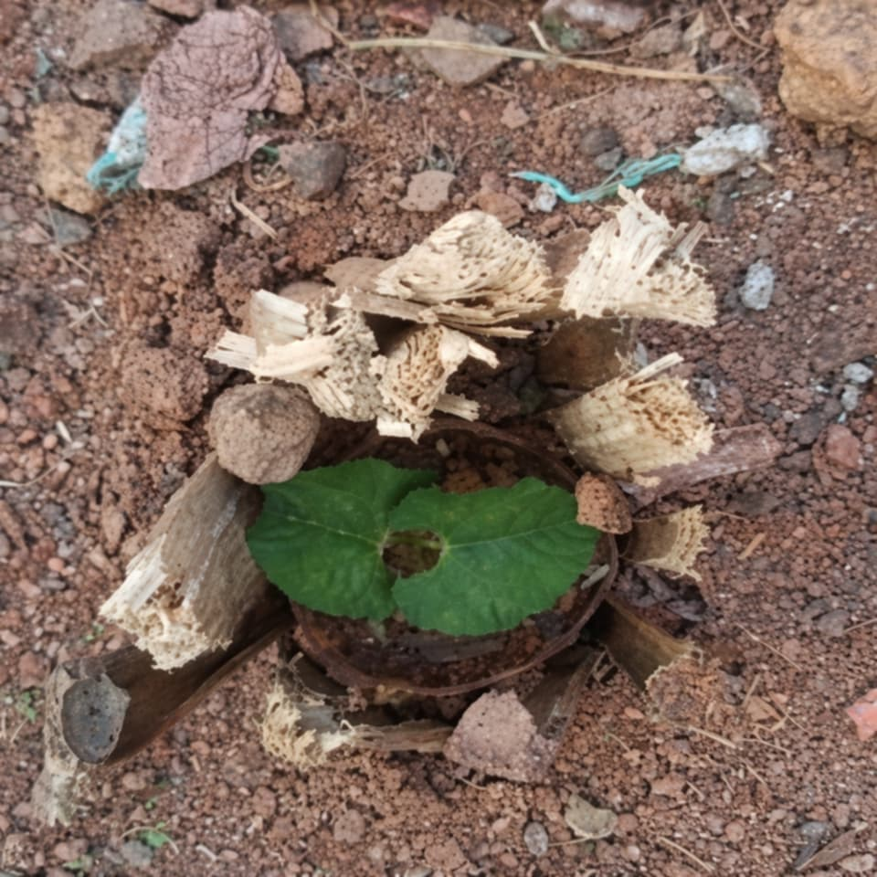
In the second week it did not rain at all, except on the last day of the week when it rained at night.

Soil and earthworm observation
From the second observation we also checked for earthworms. It was easy to find earthworms in the fertile soil: we only needed to dig 5 cm or less to find them. However, even after digging a 19.5 cm hole in the sterile soil, we did not find a single earthworm.

Water observation
We have done an experiment to identify the water from the rain and the household water. We can observe that the water number one (the rainwater) is acid because its color looks like the number 6 on the PH paper which means that it’s acid
The water number 2(the household water) is a basic water because its color is like the number 8 in the PH paper, that means that it is a basic water.
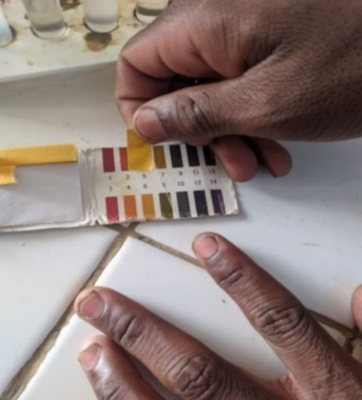
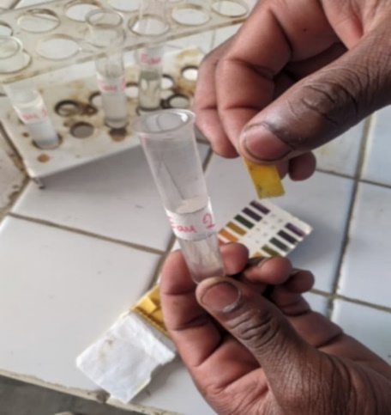

Data collection
We took soil samples at the start and at the end to compare them. We also checked the acidity (pH) of the water used for watering and the rainwater.
Fitahiana collected the soil samples for NPK and pH tests. Then we tested them together once in the school laboratory. We used Globe tools for data collection. Since soil is part of the pedosphere protocol, we used NPK and pH testers (powder tests).
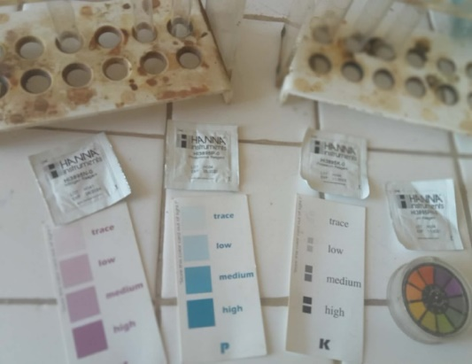

We observed the Nitrogen (N) rate. In the first soil (the sterile soil) the nitrogen rate was higher than in soil number 2 (the one used in the experiment). Using the color chart, nitrogen in soil 1 was “low” and in soil 2 it was “trace”.
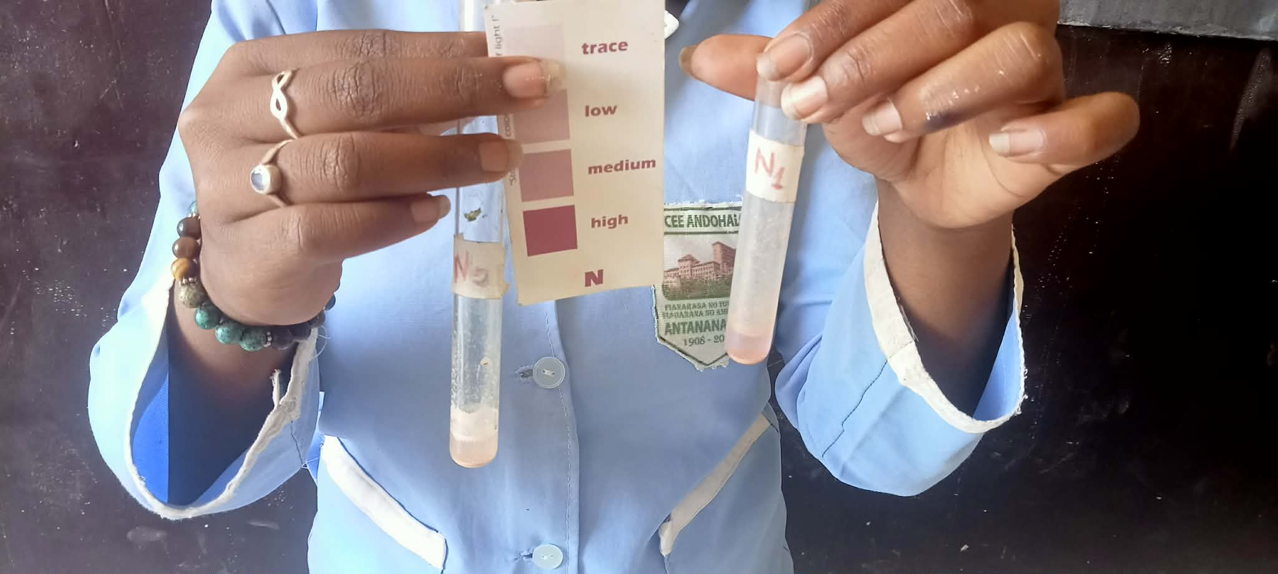

We checked Phosphorus (P). In the first soil, phosphorus was “high.” In the second soil, phosphorus didn’t change and stayed “high” as well.
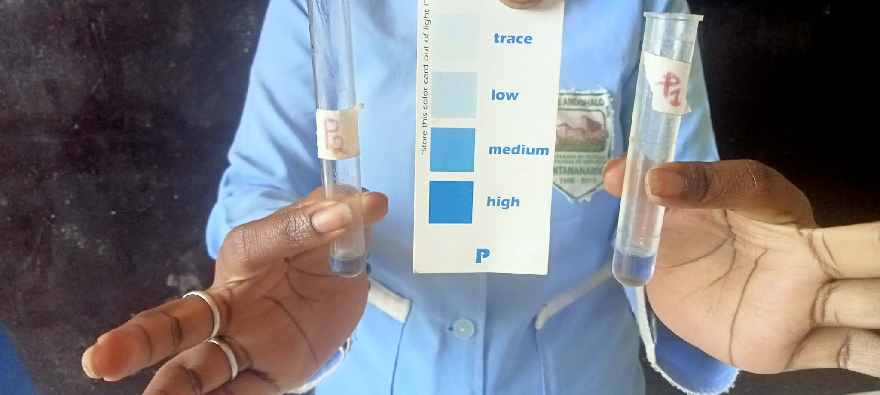

Then, we observed potassium (K) in both soils. We saw that in the first soil, the K test did not change color, which means that the potassium level is very low in soil number 1. According to the observation, the potassium level in soil number 2 is low, because based on the meaning indicated on the color indicator and compared with the color of the water in the test tube, the K level is “low” in this soil.
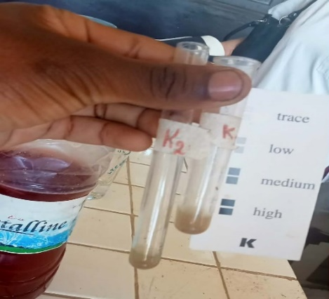

We also tested soil texture using the ribbon (roll) method and found that both soils are clayey because they are smooth and fine.
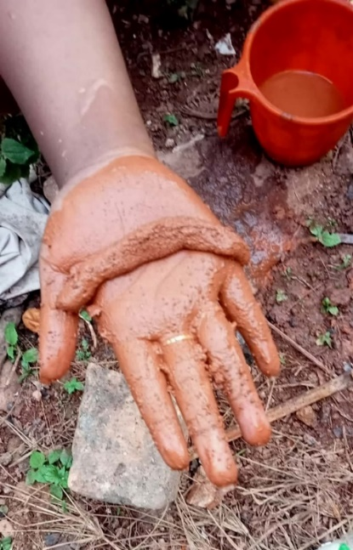
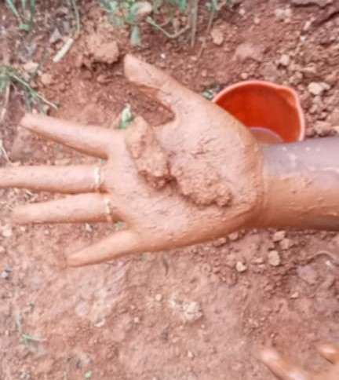

Fertil soil
steril soil

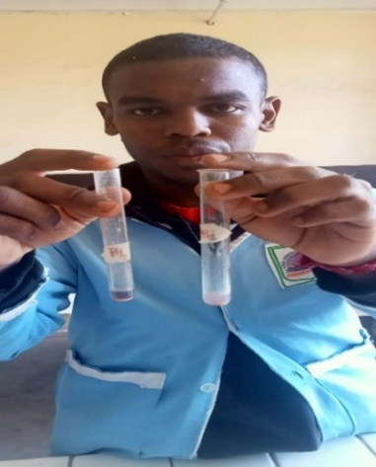
Finally, we measured soil pH. The pH of soil number 1 is very acidic: the pink color on the indicator matched number 1 on the color chart, which means very acidic. The pH of soil number 2 is basic (alkaline): the blue-violet color matched number 12 on the chart, which means basic.

Results
We observed that the bean seed grew very fast and was already three times its size from the first week. The plants in the fertile parts of the garden also started to grow.
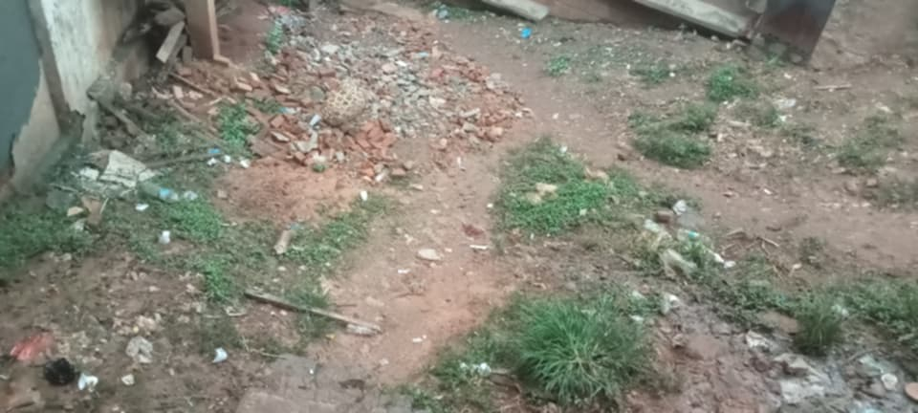
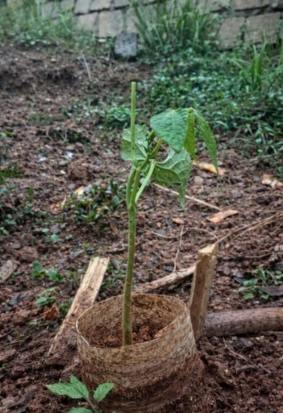

Discussion
From all observations and results, we saw that even though nitrogen in soil number 2 dropped to “trace,” the plant still grew quickly. This can be because the soil pH became basic, which is a suitable environment for earthworms and other microorganisms that help make soil fertile. According to additional research, earthworm casts (turricules) are richer in nitrogen (about 5 times), phosphorus (7 times) and potassium (11 times) than the surrounding soil. This explains why more plants grow in areas watered by basic household water. In contrast, soil watered only by rain is not covered because earthworms do not tolerate very acidic or very basic environments. So, even if soil number 1 has balanced NPK levels, it remains sterile because it lacks microorganisms and earthworms.
Basic (alkaline) household water can help neutralize soil acidity, but watering must be regulated so the soil does not become too alkaline. Our research also showed that clay soils are rich in nutrients but, when compacted or too acidic, these nutrients become unavailable and the soil cannot feed plants. Acidic soil then has no earthworms and its nutrients are blocked by the soil’s acidity.

Background and supporting information
We chose this topic because it can help us find the causes of sterile soil. If we know the causes of this sterilization, it will be easy for us to find a solution to fertilize the soils again. There can be many cases that face the same problem as our garden, so if we find the solution to the problem that we are trying to discover, it can save a lot of surfaces and maybe can save a lot of families and communities that face famine. We have done a lot of research that helps us answer many questions and also helps us solve our mystery.

Expected outcomes and goals
We hope that our research will continue and help us find many causes of sterile soil and then try to solve the problem and reduce the factors of sterile soil, and gradually guide us toward a world far from famine. This can contribute great help to science in our community, because we can solve the problems of famine little by little through this project.

References
Sites and articles used during this project:
- Wiki.tripleperformances.fr
- INRAE
- Vers de terres de France
- ADEME
- Unifa
- FAO
- Arvalis
- BioActualités.ch
- FiBL

Badge for VSS Projects





I AM A PROBLEM SOLVER

I AM A DATA SCIENTIST
I AM A GLOBE RESEARCHER

