TITLE OF PROJECT
CLIMATIC CHANGE IMPLICATIONS ON GEOSPATIAL DISTRIBUTION AND MORPHOLOGY OF MOSQUITO LARVAE FOR MALARIA CONTROL

Grade Level: Grades 9 – 12; ages 14 – 18; Senior Secondary School
Report Type: 2022 GLOBE International Virtual Science Symposium

Student Names
- Favour Semudara  - Goodness Morakinyo  3) Dominion Oloda | - Semire Victor  - Princewill Orungbemi  - Nneka Obigwu

GLOBE Teacher
Mr. Olawunmi Fasakin (GLOBE Certified)

School Name
St. Peter’s Unity Secondary School, Akure (SPUSSA), Ondo State

Country
Nigeria

Date
11th March 2022

Principal of School: Mrs. F. M. Arowosade
Table of Content

- Abstract ………………………………………………………………………….2
- Research Questions ……………………………………………………………3
- Introduction and Literature Review ……………………………………………3
- Research Methods and Materials ……………………………………………..5
- Results ……………...…………………………………………………………..11
- Discussion ………………………………………………………………………23
- Conclusion ………………………………………………………………………26
- Recommendation ………………………………………………………………27
- Limitation ………………………………………………………………………..28
- Bibliography/Citations ………………………………………………………….28
- Acknowledgments ……………………………………………………...………29
- Badges ………………………………………………………………………….30

Abstract (300 words)

Remote Sensing technology and geospatial distribution of mosquito larvae were applied to identify morphological features with respect to larval development sites for malaria control in ‘SPUSSA’ community, Akure, Nigeria. The objectives are to carry out land use classification, locate breeding sites, collect samples of larvae, identify different parts of mosquito larva, and assess physico-chemical properties of the habitat.
Larval survey was carried out in nine breeding sites. Three sites from the Girls’ hostels, two from the Boy’s hostels, while four are within the Staff Quarters. The larvae collection was done within six weeks. Various parts were identified and photographed using the micro-clip on lens attached to an android camera phone with installed GLOBE Observer app. Landsat 8 was acquired from USGS Earth Explorer for the study area. MultiSpec software was used to carry out unsupervised land use classification for the study area.
The study identified seven different land use class types. The results also reveal that morphological features of mosquito larvae are divided into three main parts – head, thorax and abdominal segments. Three larvae genera were identified which are Aedes, Culex and Anopheles species. Other important features studied and identified include siphon, anal segment, pecten, saddle, caudal hair and anal brush. A total of 198 mosquito larvae were sampled. The data shows a total of 5 Anopheles (3%), 90 Aedes (45%) and 103 Culex (52%) larvae by proportion. Hence, Culex is the most abundant. Certain climatic parameters contributed to the survival of these larvae. The parameters measured from the sites are water temperature ranging from 27.0 – 28.9⁰C, air temperature ranging from 28.6 – 30⁰C and pH ranging from 7.1 – 7.5. It is necessary to develop control strategies that will target the vector species. Therefore, effective vector control programmes on human activities that encourage mosquito breeding are recommended.

Keywords: Remote sensing, Anopheles, Aedes, Culex, climatic parameters

Research Questions and Hypothesis:
- What are the hyper spectral images of the mosquito larvae development sites?
- What are the key morphological features that distinguish those larval species that are found in the study area?
- What are the climatic parameters that are favourable for breeding mosquito larvae in the study area?
- What are the land use types in the study area?
Introduction and Review of Literature:
Remote Sensing/Geographic Information System (GIS) techniques and geospatial distribution of mosquito larvae have been used to identify morphological features of mosquito larvae with respect to their development sites for malaria control purposes in St. Peter’s Unity Secondary School, Akure (SPUSSA) community in Akure, Nigeria. Akure city has experienced significant changes in climate conditions over the past decades. The potential impact climatic changes have on the spread of mosquito-borne diseases pose a risk to the inhabitants of Akure metropolitan city. Morphological identification is the convectional and most accurate approach to identify mosquito species based on their external features or characters (Chan et al., 2014).

Changes in climatic factors such as temperature, rainfall, precipitation, air quality, wind nature and extreme weather conditions have been attributed to transmission of mosquito-borne diseases (Bai, Mortons & Liu, 2013). Climatic extremes such as bushfires, heat waves, flash floods, hurricanes and cyclones are highly impacted by changing climate.

Remote sensing/GIS or geospatial engineering is fast evolving and it is at least equivalent to and more cost-effective than mapping larval habitat manually (Tokare & Novak, 2018).
Larval habitats vary from species to species, but are frequently exposed to sunlight and commonly found in association with early stages of vegetation, such as grass, uncultivated plots of land or mats of floating vegetation or algae. Certain environmental and behavioural factors make humans easily attacked by malaria infection. Some of these factors include temporary pools of water and water containers which provide conducive breeding habitats for mosquitoes (Oluwafemi et al., 2013).
Bhattacharya et al. (2016) identified the Culex species as the most widespread mosquito species around the world. Afolabi et al. (2019) carried out an investigation on the identification, abundance and biodiversity on five locations in Akure city. They recorded thirteen species of mosquitoes which are 5 Aedes, 6 Culex, a species of Anopheles and Toxorhynchites belonging to four genera. The study revealed Culex spp. having the highest abundance while Toxorhnchites spp. have the lowest abundance. In addition, the climatic or physico-chemical parameters that favour the breeding sites include pH range of 7.14 – 7.4, temperature range of 27.3 – 30⁰C, electrical conductivity range of 65.6 – 98.0 μs and dissolved oxygen range of 2.43 – 3.84 mg/l.

St. Peter’s Unity Secondary School, Akure (SPUSSA), Ondo State, Nigeria lies in the tropics where mosquitos breeding sites are naturally found or could be observed artificially. The school consists of girls' and boys’ hostels or dormitories with staff quarters. In addition, other physical structures include classroom blocks, administrative blocks, school clinic, science laboratories, dining halls and library.

This study evaluates an approach for obtaining high resolution, contemporary imagery of ‘SPUSSA’ community for identifying land use classification and larval development sites. The objectives are to process MultiSpec imagery capturing for extracting the required information and entomological sampling. The entomological sampling involves a comparative morphological investigation with the aim to identify mosquito species based on their external features using clip-on macro lens of X60 – 100 given to us by the GLOBE program coupled with GLOBE Mosquito Habitat Mapper (MHM) app, GLOBE Mosquito Larvae Identification chart and The Animalfiles.com mosquito larvae anatomy. Larva data collected and sampled were uploaded to the GLOBE website via the GLOBE Observer app. The goals are to locate and delimit larval developing sites, collect various samples of larvae as specimens, identify different parts of mosquito larva, and assess physico-chemical properties of the area of investigation. The accurate determination of these morphological features of larvae of various mosquito genera is significant for surveillance and mosquito-borne diseases control programmes.

Geographical Location of Akure City
Akure metropolitan city in south-western Nigeria, and is the largest city and capital of Ondo State. It lies about 7°25’ north of the equator and 5°19’ east of the Meridian (Figure 1). It is about 700 km Southwest of Abuja and 311 km north of Lagos State. Residential districts are of varying density, some areas such as Arakale, Ayedun Quarters, Ijoka, and Oja-Oba consist of over 200 persons per hectare, while areas such as Ijapo Estate, Alagbaka Estate and Idofin have between 60-100 people per hectare. The town is situated in the tropic rainforest zone in Nigeria (Ayeni, 2011).

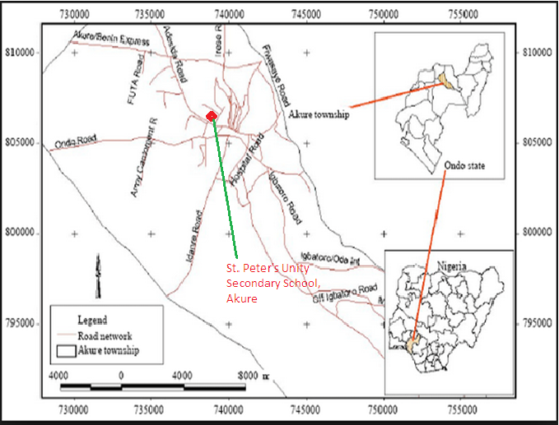
Figure 1. Geographical map of Akure city, Nigeria showing the location of the study area – St. Peter’s Unity Secondary School, Akure (SPUSSA) (Ayeni, 2011)

Research Methods and Materials:
Figure 2. Google map showing the location of St. Peter’s Unity Secondary School, Akure (SPUSSA), Ondo State, Nigeria
- Research Methods
- Data Collection
- Mapping and recognizing potential Mosquito Larvae breeding sites and Land use classification.
Nine breeding sites or experimental locations were observed within the study area from which mosquito larvae were collected. They are the GHT-1, GHT-2 and GHT-3 sites (three artificial breeding habitats within the Girls’ hostels), BOH-1 and BOH-2 sites (two artificial breeding sites around the Boys’ hostels), while four sites QRTS-1, QRTS-2, QRTS-3 and QRTS-4 are artificial breeding habitats within the Staff Quarters. Each surveyed site was geo-referenced using a hand held Global Positioning System (GPS) device (Garmin eTrex). The coordinates of the mosquito larvae experimental locations were stored in excel (CSV formats) and imported to ArcGIS 10.5 software via the layer import XY data tool. All the locations were overlaid on the very high-resolution Spot satellite imagery and exported in BMP file format. MultiSpec open source remote sensing software was used to carry out unsupervised (calculated by software) land use classification for the study area.
The larvae collection was done within six weeks from middle September to October 2021. Samples of larval developmental habitats or breeding sites used in this study are displayed in Figures 2 – 5.
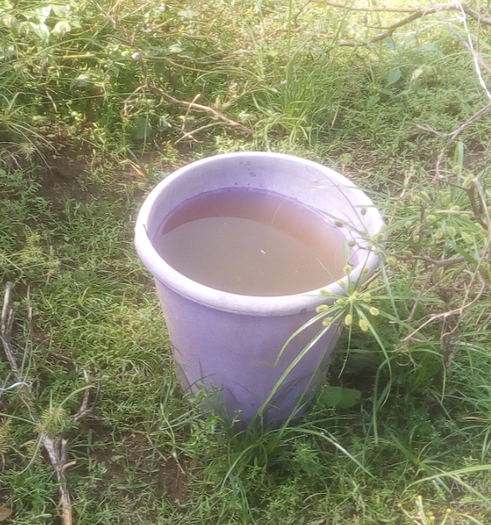
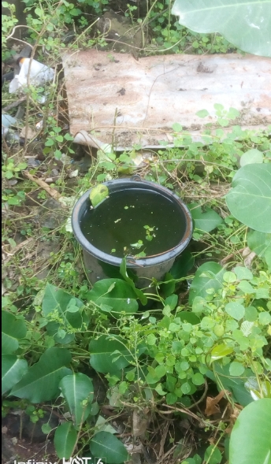
Figure 3. Breeding site at Staff Quarters QRTS-3
Figure 2. Breeding site at Staff Quarters QRTS-4

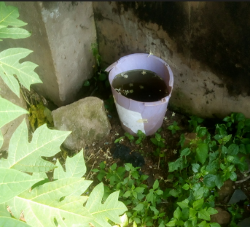
Figure 5. GLOBE students collecting larvae samples at breeding site staff quarters QRTS-1
Figure 4. Larvae development site at Girls’ hostel GHT-2

- Sampling and counting/sorting of mosquito larvae.
All larvae were taken to the school science laboratory for counting and sampling. We sampled water for mosquito larvae by using simple sampling tool such transparent plastic containers. Physical counting or numerical estimation was done from these containers. A plastic spoon was used for isolating the larvae into the petri dishes. Figure 6 shows two petri dishes containing sampled larvae.

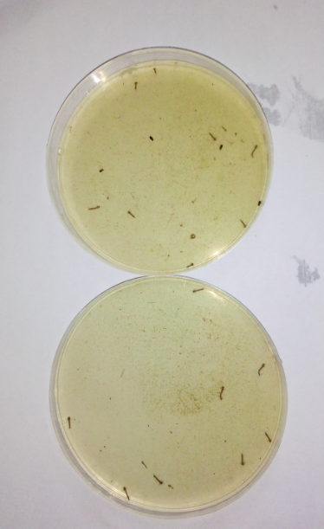
Figure 6. Samples of Mosquito Larvae in two petri-dishes before observing them under the micro-clip lens

- Identification of the specimen, determining the species of mosquito larvae and examining the anatomy of the larvae in the sample.
This step was achieved by using the GLOBE Mosquito Habitat Mapper (MHM) app, GLOBE
Mosquito Larvae Identification chart and The Animalfiles.com mosquito larvae anatomy/key. We identified the morphology of the mosquito larvae and differentiated between Aedes spp., Anopheles spp. and Culex spp. as obtained from the hydrosites by attaching the macro clip-on lens to an android camera phone. A tooth pick was used to position the larvae so that the diagnostic features could be seen properly with the clip-on lens. Each larva was suspended in a small drop of water. Excess water was removed with a blotting paper. Methanol was used to demobilize the larvae.
Figure 7 show some members of SPUSSA GLOBE Team identifying and determining the species of mosquito larvae from collected samples obtained from the larva development sites.
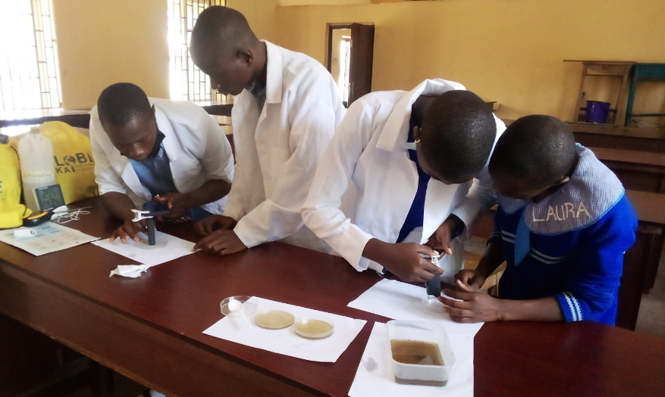
Figure 7. A section of the School GLOBE Team identifying and examining larvae specimen

- Picture capturing or photograph of the entomological features with the aid of Clip-on lens attached to an android camera.
The already attached clip-on lens with the android device was used to take photographs of the various morphological or entomological features of the observed larvae. Figures 8 and 9 show members of SPUSSA GLOBE team photographing and capturing morphological features of mosquito larvae with the aid of clip-on lens in the school science laboratory.

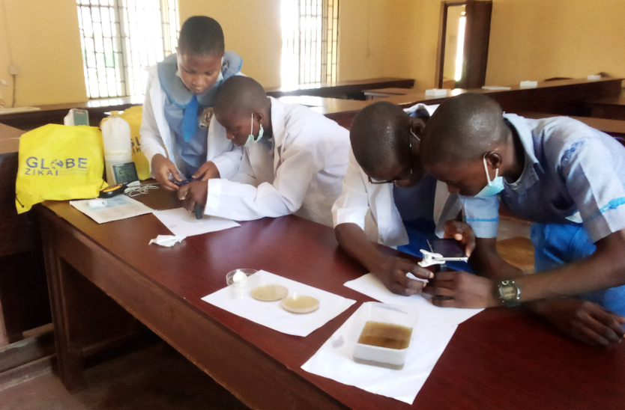
Figure 8. Members of SPUSSA GLOBE Team capturing entomological features of mosquito larvae

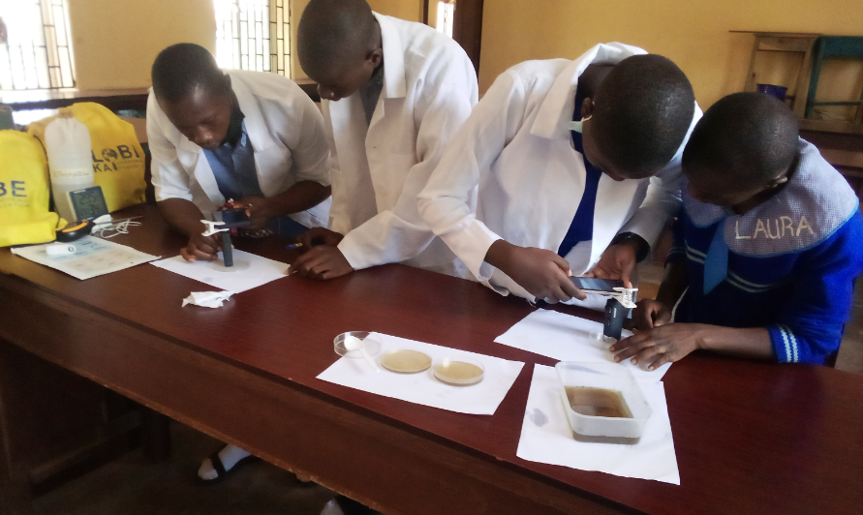
Figure 9. Another section of the GLOBE Team in School science laboratory photographing anatomical parts of larvae

- Measurement of the Physico-chemical Properties
Water samples obtained from the habitats were analysed for Physico-chemical properties. Properties which favour the breeding sites were measured by using digital hygro-thermometer (air temperature) and 4-in-1 soil tester (water temperature and pH). The 60x – 100x clip-on macro lens was provided by GLOBE program.

- Elimination of the breeding sites.
All larval development habitats or hydrosites sampled as specimens for the research work were immediately discarded and destroyed.
- Data Analysis
The Landsat 8 Imagery OLI/TIRS C2 L2, Path: 190, Row: 055 was acquired from USGS Earth Explorer. The bands 543 were combined to form a false color composite sing open source MultiSpec remote sensing. The study area was extracted from the image scene using open source MultiSpec remote sensing software through which the unsupervised classification analysis was performed. The unsupervised classification is where the outcomes are based on the software analysis of an image without the user providing sample classes.
Mean statistics was used to compute the percentage proportions of the collected larvae from the breeding sites.

Safety Precautions
- We took extra care not to damage the larva before taking their photographs.
- We sampled the larvae at or near solar moon.

The GLOBE protocols associated with this study are Hydrosphere (water temperature and water pH), Atmosphere (air temperature) and Mosquito protocols.

b) Research Materials
The materials used in this study to obtain and interpret data are as follows:
- MultiSpec software (a tool for multispectral hypersectral image data analysis)
- ArcGIS 10.5 software
- Landsat 8 Imagery acquired from USGS Earth Explorer
- GLOBE Mosquito Larvae Protocol Identification chart (Figure 10)
- Garmin eTrex GPS outdoor device
- Digital Hygro-thermometer device
- 60x – 100x Clip-on macro lens device provided by GLOBE Program
- 4-in-1 Digital soil meter (for measuring pH)
- Plastic buckets/containers – for collecting specimen samples
- Petri-dishes
- Android camera phone with GLOBE Mosquito Mapper app
- The Animalfiles.com key (Figure 11)
- Tooth pick and blotting paper
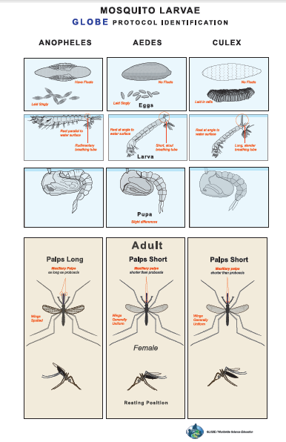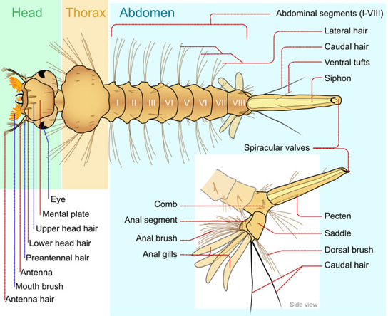
Figure 11. The anatomy of a Larva adapted from Animal.com

Figure 10. GLOBE Mosquito Larvae protocol identification chart

Results and Data:
- What are the hyper spectral images of the mosquito larvae development sites from the study area?
Figure 12 shows the ArcGIS 10.5 software imagery of the area of investigation (SPUSSA) with the nine geo-referenced mosquito larvae breeding or experimental location sites while
Figure 13 represents the Landsat 8 Imagery OLI/TIRS C2 L2, Path: 190, Row: 055 from United States Geological Society (USGS) Earth Explorer of the study area while Figure 14 shows Unsupervised Classification of the study area indicating different classification types both on MultiSpec Windows Application. The observed seven class types are Vegetation, Light Forest, Waterbodies, Farmland, Impervious Surface, Open Surfaces and Built-up Areas.
Table 1 displays the names of the geo-referenced breeding sites and their remotely-sensed GPS coordinates in Universal Transverse Mercator (UTM).

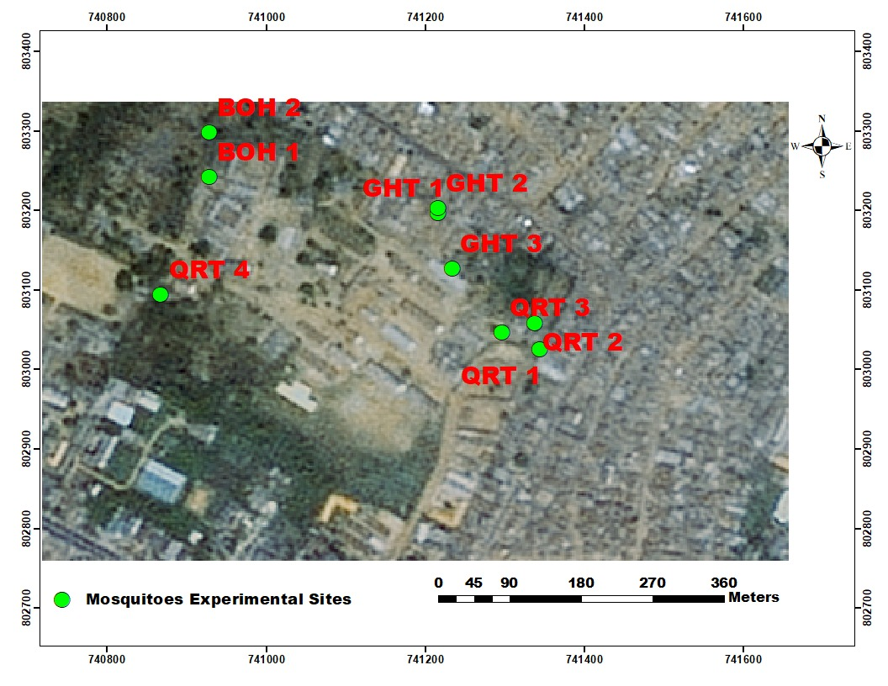
Figure 12. ArcGIS 10.5 software imagery of the study area (SPUSSA) showing the nine geo-referenced mosquito larvae breeding sites

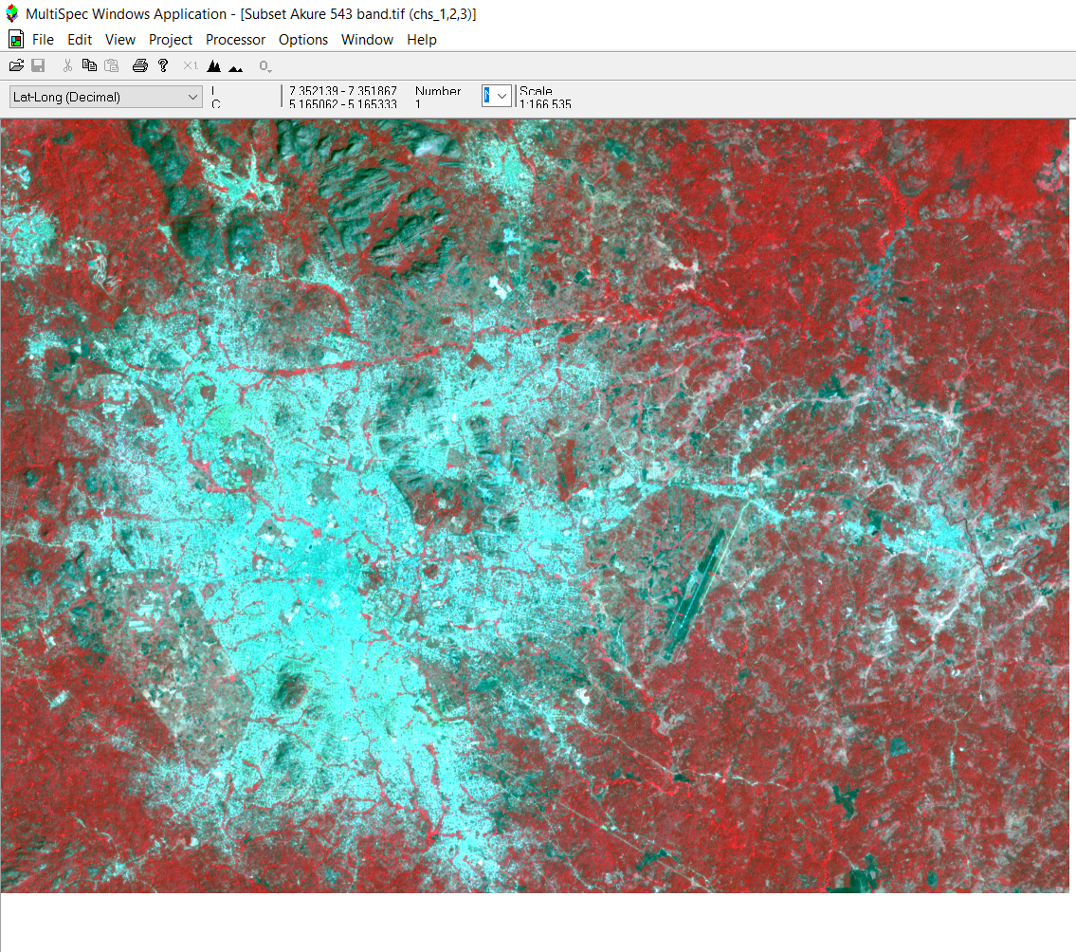
Figure 13. Landsat 8 Imagery OLI/TIRS C2 L2, Path: 190, Row: 055 from USGS Earth Explorer showing map of the study area (SPUSSA)

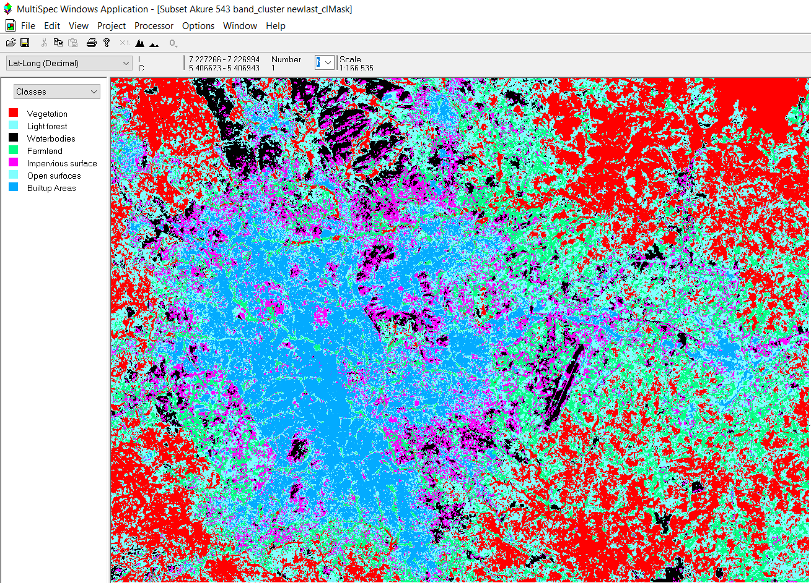
Figure 14. Unsupervised Classification of the study area showing different class types

Table 1 Geo-referenced breeding sites and their remotely-sensed GPS coordinates in Universal Transverse Mercator (UTM)
No | Name of Larvae Sites | GPS Coordinates in Universal Transverse Mercator (UTM) | Altitude Range above Sea Level in Meters (m)
1 | QRT 1 | N0741344  0803026 | ±7
2 | QRT 2 | N0741338  0803058 | ±6
3 | QRT 3 | N0741296  0803047 | ±5
4 | QRT4 | N0740867  0803094 | ±5
5 | GHT 1 | N0741216  0803197 | ±9
6 | GHT 2 | N0741216  0803203 | ±5
7 | GHT 3 | N0741234  0803127 | ±13
8 | BOH 1 | N0740928  0803243 | ±5
9 | BOH 2 | N0704928  0803299 | ±9

- What are the key morphological features that distinguish these larval species that are found in the study area?
The different observable morphological features as seen with the aid of the clip-on lens and phone camera from the larvae collected are shown in Figures 22 to 29.
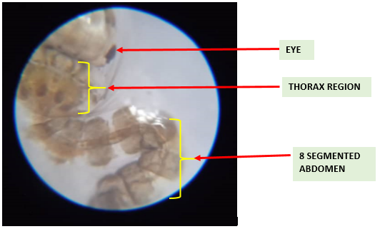
Mosquito Larvae Anatomy
Figure 15. A Mosquito Larva showing anatomical parts such as the Eye, Thorax and the eight segmented Abdomen
Figure: yyy
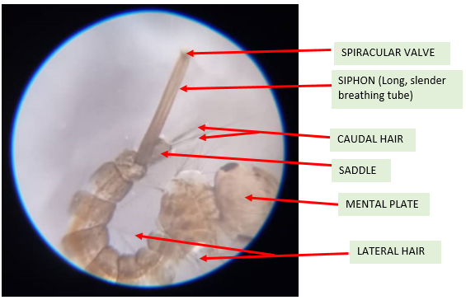
Figure 16. Finer or Anatomical parts of a Culex larva illustrating long, slender Siphon tube, Spiracular valve, Caudal hair, Saddle, Mental plate and Lateral hair

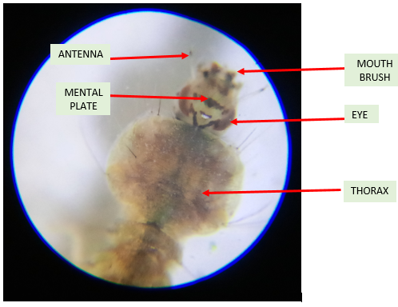
Figure 17. Head anatomy of Anopheles spp. showing Antenna, Mouth brushes, Mental plate, Eye and Thorax

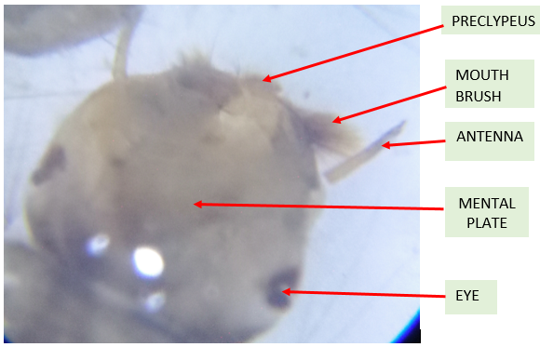
Figure 18. Finer anatomical parts illustrating the larval head - Aedes spp

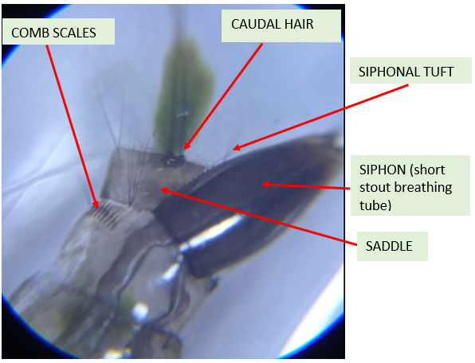
Figure 19. Finer anatomical parts showing Aedes spp. Siphonal tuft, Comb scales or teeth, Siphon with characteristics short and stout shape and Saddle

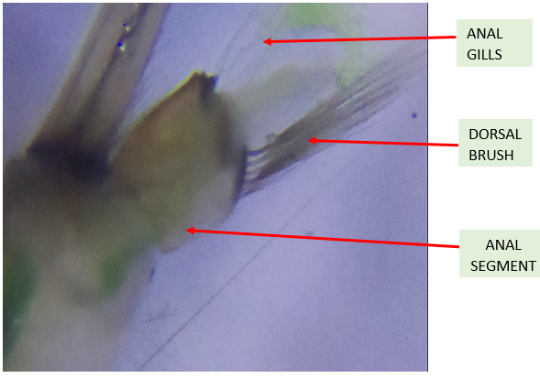
Figure 20. Side view of anatomical parts illustrating showing Anal gills, Dorsal Brush and Anal Segment (Culex spp)

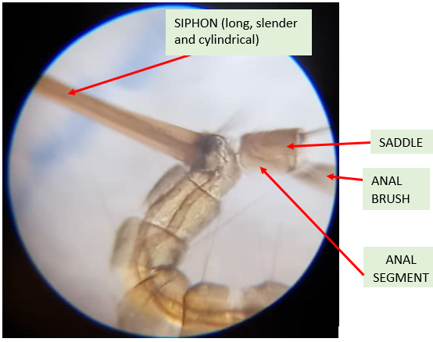
Figure 21. View of finer anatomical parts illustrating Culex spp. Anal brush, Saddle and Anal Segment

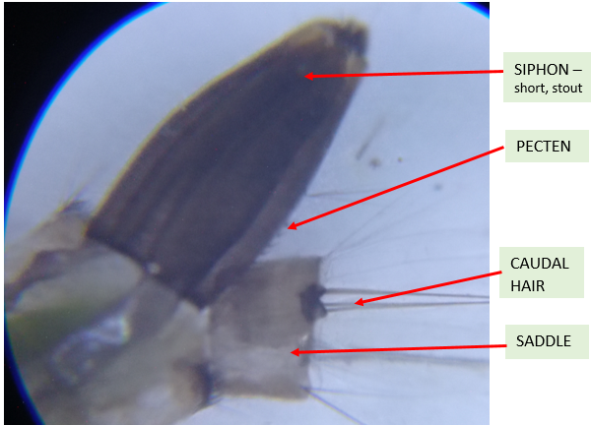
Figure 22. View of anatomical parts illustrating Aedes spp. Siphon (short, stout breathing tube), Pecten (comb-like part), Caudal hair and Saddle

Further samples of the fine anatomical parts of Anopheles spp., Aedes spp. and Culex spp. larvae as captured at the breeding sites are presented in Figures 23 - 25.

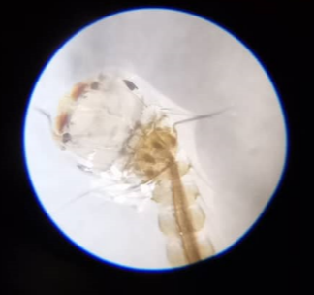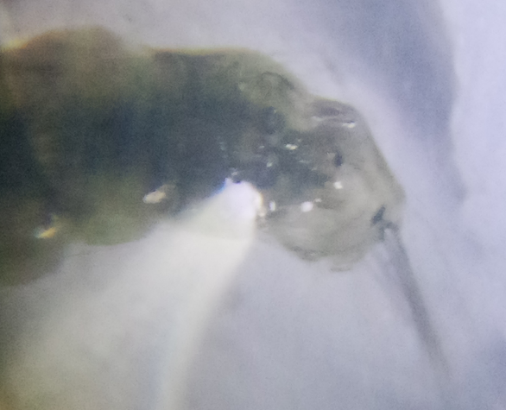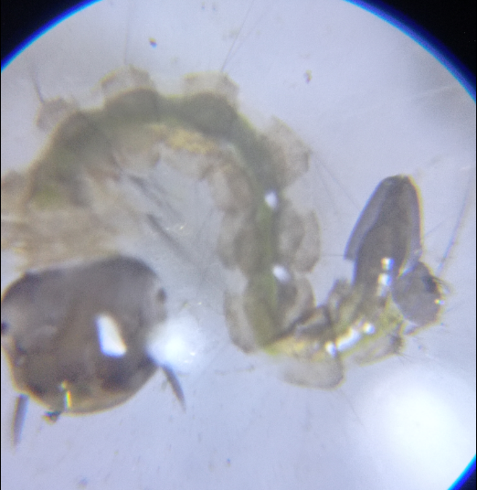
Figure 25. Aedes spp.
Figure 24. Anopheles spp.
Figure 23. Culex spp.

Table 2 displays the significant anatomical features of mosquito larvae species and their physical description or shapes as observed by the clip-on macro lens attached with the camera phone.
Table 2 Morphological features of mosquito genera and their shape description
 | Morphological features of Larvae | Observations |  |  | Description of shape
 |  | Aedes spp. | Culex spp. | Anopheles spp.
 | Siphon – air or breathing tube | Yes | Yes | No | (Long, slender and cylindrical for Culex; short and stout for Aedes)
 | Pecten presence | Yes | Yes | No | tiny spines found on the side of the siphon
 | Siphonal hair or tuft | Yes | Yes | No | Single collection of hair or thread-like parts held together
 | Saddle | Yes | Yes | No | Partially covers the anal segment
 | Comb scales or teeth | Yes | Yes | No | Spine-like; Pitch fork
 | Ventral Tufts | Yes | Yes | No | Flexible outgrowths at the base of siphon
 | Anal brush | Yes | Yes | No | Next to saddle;
 | Anal gills | Yes | Yes | Yes | Found beneath the anal segment
 | Precratal Tufts | Yes | Yes | No | Next to the saddle above the anal brush
 | Spiralcular valves | No | Yes | Yes | At the end of the siphon
 | Dorsal brush | No | No | Yes | Below the saddle next to the caudal hair
 | Caudal hair | Yes | Yes | No | Behind the ventral tuft on the siphon
 | Preclypeus | Yes | Yes | Yes | Found in front of the head
 | Mouth brushes | Yes | Yes | Yes | Brush-like
 | Eye | Yes | Yes | Yes | Black in colour
 | Thorax region | Yes | Yes | Yes | Wider than the head
 | Abdomen | Segment  ed | Segment  ed | Segment  ed | Long, cylindrical & dorso-ventrally flat
 | Lateral hair | Yes | Yes | Yes | Located on the abdominal segment

The mosquito larvae that were seen in this study from SPUSSA community are Aedes spp., Anopheles spp. and Culex spp. as identified from the various samples collected from the breeding sites.
- What are the climatic parameters that are favourable for breeding mosquito larvae and larvae statistics in the area of investigation?

Tables 3 – 11 show the numbers of larvae from all the breeding sites (Larvae statistics), corresponding physico-chemical properties (remotely-sensed data) and the mosquito larvae genera sampled and identified from those sites.

Table 3 Remotely-sensed Data and Larvae Statistics from Girls’ hostel 1 Site (GHT-1)
Duration | Physico-chemical Parameters |  |  | No. of Larvae collected | Aedes spp. | Anopheles spp. | Culex  spp.
 | Water temp. (ºC) | Water pH (%) | Air Temp. (ºC)
Week 2 | 27.2 | 7.2 | 29.1 | 3 | 3 | - | -
Week 4 | 28.3 | 7.3 | 28.9 | 7 | 7 | - | -
Week 6 | 27.4 | 7.5 | 28.0 | 10 | 10 | - | -
Total Larvae |  |  |  | 20 | 20 | - | -

Table 4 Remotely-sensed Data and Larvae Statistics from Girls’ hostel 2 Site (GHT-2)
Duration | Physico-chemical Parameters |  |  | No. of Larvae collected | Aedes spp. | Anopheles spp. | Culex  spp.
 | Water temp. (ºC) | Water pH (%) | Air Temp. (ºC)
Week 2 | 27.0 | 7.5 | 28.9 | 4 | 4 | - | -
Week 4 | 26.9 | 7.1 | 29.0 | 7 | 7 | - | -
Week 6 | 27.0 | 7.2 | 29.1 | 10 | 10 | - | -
Total Larvae |  |  |  | 21 | 21 | - | -

Table 5 Remotely-sensed Data and Larvae Statistics from Girls’ hostel 3 Site (GHT-3)
Duration | Physico-chemical Parameters |  |  | No. of Larvae collected | Aedes spp. | Anopheles spp. | Culex  spp.
 | Water temp. (ºC) | Water pH (%) | Air Temp. (ºC)
Week 2 | 27.9 | 7.4 | 29.5 | 15 | 15 | - | -
Week 4 | 27.5 | 7.3 | 29.0 | 10 | 10 | - | -
Week 6 | 28.0 | 7.5 | 29.7 | 6 | 6 | - | -
Total Larvae |  |  |  | 31 | 31 | - | -
Table 6 Remotely-sensed Data and Larvae Statistics from Boys’ hostel 1 Site (BOH-1)
Duration | Physico-chemical Parameters |  |  | No. of Larvae collected | Aedes spp. | Anopheles spp. | Culex  spp.
 | Water temp. (ºC) | Water pH (%) | Air Temp. (ºC)
Week 2 | 27.4 | 7.3 | 29.8 | 8 | - | - | 8
Week 4 | 27.1 | 7.2 | 28.4 | 5 | - | - | 5
Week 6 | 28.7 | 7.1 | 29.9 | 6 | - | - | 6
Total Larvae |  |  |  | 19 | - | - | 19

Table 7 Remotely-sensed Data and Larvae Statistics from Boys’ hostel 2 Site (BOH-2)
Duration | Physico-chemical Parameters |  |  | No. of Larvae collected | Aedes spp. | Anopheles spp. | Culex  spp.
 | Water temp. (ºC) | Water pH (%) | Air Temp. (ºC)
Week 2 | 27.3 | 7.5 | 29.1 | 4 | - | - | 4
Week 4 | 27.7 | 7.4 | 28.6 | 3 | - | - | 3
Week 6 | 28.9 | 7.2 | 29.1 | 8 | - | - | 8
Total Larvae |  |  |  | 15 | - | - | 15

Table 8 Remotely-sensed Data and Larvae Statistics from Staff Quarters 1 Site (QRTS-1)
Duration | Physico-chemical Parameters |  |  | No. of Larvae collected | Aedes spp. | Anopheles spp. | Culex  spp.
 | Water temp. (ºC) | Water pH (%) | Air Temp. (ºC)
Week 2 | 28.1 | 7.5 | 29.1 | 8 | 6 | 2 | -
Week 4 | 27.4 | 7.2 | 30.0 | 7 | - | - | 7
Week 6 | 27.5 | 7.5 | 29.0 | 2 | - | 2 | -
Total Larvae |  |  |  | 17 | 6 | 4 | 7

Table 9 Remotely-sensed Data and Larvae Statistics from Staff Quarters 2 Site (QRTS-2)
Duration | Physico-chemical Parameters |  |  | No. of Larvae collected | Aedes spp. | Anopheles spp. | Culex  spp.
 | Water temp. (ºC) | Water pH (%) | Air Temp. (ºC)
Week 2 | 27.0 | 7.2 | 29.1 | 5 | - | - | 5
Week 4 | 27.5 | 7.4 | 28.7 | 7 | - | - | 7
Week 6 | 28.5 | 7.2 | 28.6 | 10 | 1 | 1 | 8
Total Larvae |  |  |  | 22 | 1 | 1 | 20

Table 10 Remotely-sensed Data and Larvae Statistics from Staff Quarters 3 Site (QRTS-3)
Duration | Physico-chemical Parameters |  |  | No. of Larvae collected | Aedes spp. | Anopheles spp. | Culex  spp.
 | Water temp. (ºC) | Water pH (%) | Air Temp. (ºC)
Week 2 | 28.0 | 7.3 | 30.0 | 20 | - | - | 20
Week 4 | 27.4 | 7.4 | 29.0 | 10 | - | - | 10
Week 6 | 28.3 | 7.1 | 29.0 | 12 | - | - | 12
Total Larvae |  |  |  | 42 | - | - | 42

Table 11 Remotely-sensed Data and Larvae Statistics from Staff Quarters 4 Site (QRTS-4)
Duration | Physico-chemical Parameters |  |  | No. of Larvae collected | Aedes spp. | Anopheles spp. | Culex  spp.
 | Water temp. (ºC) | Water pH (%) | Air Temp. (ºC)
Week 2 | 27.4 | 7.3 | 29.0 | 7 | 7 | - | -
Week 4 | 27.5 | 7.2 | 28.9 | 1 | 1 | - | -
Week 6 | 28.1 | 7.4 | 29.0 | 3 | 3 | - | -
Total Larvae |  |  |  | 11 | 11 | - | -

Discussion:
- What are the hyper spectral images of the mosquito larvae development sites from the study area?
Geospatial images of the study area have been developed to identify environmental characteristics which are related to larval breeding locations while the hypersectral image data are presented in Figures 18 – 20. ArcGIS imagery of the geo-referenced remotely-sensed data collection locations are shown in Figure 18. Landsat 8 image maps of the study area (SPUSSA) are represented in Figures 20. MultiSpec remote sensing image produced from unsupervised land use classification for the study area, on Windows application, identified seven different land use class types (Figure 20). The classes are vegetation, light forest, waterbodies, farmland, impervious surface, open surfaces and built-up areas.
- What are the key morphological features that distinguish these larval species that are found in the study area?
The Mosquito larvae sampled in the study have three major body regions which are the head, thorax and abdomen (Figure 15). Anatomy of larval head, mental plate, antennae, siphon, thorax region, segmented abdomen, comb scales, pecten, mouth brushes, caudal hair, saddle, lateral hair, siphonal tuft, ventral tuft, anal gills and anal segment (Figures 15 - 20) were observed and photographed with the clip-on macro lens attached to an android camera phone. The heads of all larvae identified consists of two small, simple eyes, two fine antennae and brush- or comb-like mouthparts (Figures 15 and 16). These eyes are located on either sides of the head region. The larval thorax section is wider than the head or elliptical wider while the abdomen is segmented into eight parts or structures (Figures 15 and 16). The comb scales are spine-like projections found in a row or patch on the abdomen (Figure 18). Pecten represents developed row of tiny spines or spicules extending from the ventral base of the siphon (Figure 21). At the terminal portion of the larvae abdomen is the anal segment (Figures 18 - 21). It has ventral brush and anal gills. Siphonal tufts are fine hair-like structure found on the siphon (Figure 19). Anal segment has saddle. The saddle is a thickened band on the anal segment (Figures 19, 20 and 22). The anal gills are protrusions on the anal segment which perform osmotic regulation of the larva. The genera of mosquito larvae can be indicated from the length of the siphon.

Table 11 displays the distinguishing characteristic morphological features of the mosquito genera seen and observed at the breeding habitats in the area of investigation. The key features are generally found on the anal or terminal abdominal segment and the siphon. The siphon is an air tube used by some species of larvae to breadth. It is located on the 8th abdominal segment. All mosquito larva genera except Anopheles spp. have a siphon. Anopheles spp. lay parallel to the water surface and breaths through openings on its 8th abdominal segment. The placement and number of hairs on the abdomen can be diagnostic.
The morphological features of the mosquito larvae represent the basic larval anatomy with emphasis towards parts used in species identification. The observed larva samples showed the presence of Anopheles spp., Aedes spp. and Culex spp. (Figures 31, 36 and 43) in the larval development sites. The GLOBE Mosquito Larvae Identification chart, GLOBE Mosquito Mapper app and the Animal.com keys were used to identify and indicate the genera of the mosquito larva. A total of 198 mosquito larvae were sampled. The sampled data (Tables 1 - 9) shows a total of 5 Anopheles spp., 90 Aedes spp. and 103 Culex spp. larvae, that is, Anopheles has 3%, Aedes (45%) and Culex (52%) by proportion. Therefore, Culex spp. is the most abundant in the study area. This result is in agreement with Afolabi et al. (2019).
Mosquito larvae were used in this study compared to other developmental stages of the mosquitoes because they are very easy to trap, handle and collect. This larval stage consists of observable morphological features which can be seen with the aid of the micro-lens and are generally used to identify the various mosquito species or genera. Furthermore, the larvae are harmless and they do not transmit diseases or serve as pathogens for diseases. The adult mosquitoes are known to be vectors to different diseases and sickness.
- What are the climatic parameters that are favourable for breeding mosquito larvae in the area of investigation?
Certain physico-chemical parameters would have contributed to the survival of these larvae. The results indicate that the Culex spp. has the highest abundance in the SPUSSA community compared with Anopheles and Aedes species. This is in accordance with the findings of Afolabi et al. (2019). The climatic parameters measured from the breeding sites are water temperature ranging from 27.0 – 28.9⁰C, air temperature ranging from 28.6 – 30⁰C and pH range of 7.1 – 7.5. These readings relatively fall within the values obtained by Afolabi et al. (2019). Many research findings have found out that climate change has greatly impacted pathogen-vector-host relationships especially in temperature, high altitude, peri-Artic and Artic areas (Caminade, Mcintyre & Jones, 2017).
iv. What are the land use types in the study area?
The findings of the unsupervised land use classification shows that the classification process identified seven land use/cover types namely: Built-up areas, vegetation, light forest, water bodies, impervious surfaces, farmlands and open surface. The breeding sites were all located in the built-up areas.

Conclusion:
The study has established that multispectral hyperspectral images can be used to accurately identify environmental characteristics associated with larval sites. Morphological identification of mosquito larvae was carried out in St. Peter’s Unity Secondary School, Akure (SPUSSA), Ondo State, Nigeria with the aim to identify mosquito species based on their external features or characters. The accurate determination of morphological features of larvae of various mosquito genera is significant for surveillance and mosquito-borne diseases control programmes.
Nine breeding sites were surveyed within the study area from which mosquito larvae were collected. They are the GHT-1, GHT-2 and GHT-3 sites from the Girls’ hostels, BOH-1, BOH-2, and BOH-3 from the Boy’s hostels, while four sites are located within the Staff Quarters (QRTS-1, QRTS-2, QRTS-3 and QRTS-4). Each surveyed site was geo-referenced using an outdoor Global Positioning System (GPS) device (Garmin eTrex). The larvae collection was done within six weeks from middle September to October 2021. Their various parts were identified and photographed using the micro-clip on macro lens attached to an android camera phone with installed GLOBE Observer app. Landsat 8 was acquired from USGS Earth Explorer while MultiSpec open source remote sensing software was used to carry out unsupervised land use classification for the study area.

The three genera (Aedes spp., Anopheles spp. and Culex spp.) sampled in this study are of interest because they contain species that can transmit pathogens to humans and cause diseases. The mosquito larva anatomy is divided into three major parts namely the larva head (which is round or slightly oblong and slightly flattened), the thorax (which appears distinct from the head, separated by a very narrow neck) and the abdomen (which is segmented section behind thorax).

A total of 198 mosquito larvae were sampled. Certain physico-chemical parameters would have contributed to the survival of these larvae. The sampled data shows a total of 5 Anopheles spp., 90 Aedes spp. and 103 Culex spp. larvae, that is, Anopheles has 3%, Aedes (45%) and Culex (52%) by proportion from the study area. The climatic parameters measured from the breeding sites are water temperature ranging from 27.0 – 28.9⁰C, air temperature ranging from 28.6 – 30⁰C and pH range of 7.1 – 7.5. The geographic range and occurrence of the larvae could have been impacted by the climate characteristics. In addition, the abundance or prevalence of Culex spp. more than Aedes spp. and Anopheles spp., in the study area, could possibly be attributed to high temperatures brought about by climate-driven weather and parameters.

The outcomes of the unsupervised land use and cover classification reveals that the classification process identified seven land use types which are built-up areas, vegetation, light forest, water bodies, impervious surfaces, farmlands and open surface. The experimental sites were all located in the built-up areas which imply shortest flying capacity for mosquitoes to the residential buildings.
.
Recommendation
Further research studies should be encouraged to better understand the relationship between climate change and transmission of mosquito-borne diseases. Adaptive policies should be formulated to reduce unexpected climate-related risk at global, regional or local level. It is therefore recommended to develop effective control strategies that will target the vector species.
a) Prevention and Control of the Adult Mosquitoes
- Personal protection: Personal protection methods should be used by individuals or small groups of people to protect themselves from biting mosquito insects and the diseases they may carry. The screening of doors, windows and other openings in houses prevents mosquitoes from entering while maintaining some ventilation.
- The use of Repellents and mosquito coils could be adopted while the use of Mosquito nets should be encouraged
- Insecticide vaporizers. Insecticides should be selected for its effectiveness against the target mosquito species. Insecticidal aerosols are sometimes used for the killing of flying and resting adult mosquitoes in situations where immediate results are needed.
b) Prevention of Larva Breeding Sites
- Eliminating larvae development sites. Such measures include covering or screening water containers, draining ponds and marshes, and possibly filling in ditches, pools, etc. Also, making the breeding places inaccessible to adult mosquitoes.
- Larvicides. These could be used for killing immature mosquitoes by applying agents - Insect growth regulators (IGRs) - Microbial larvicides - Organophosphates (OPs) - Surface oils and films - Habitats in and around houses - Habitats in the field
c) Biological Control
The biological control of mosquitoes involves introducing into the environment their natural enemies such as parasites, disease organisms and predatory animals. Examples include the following:
- Predatory mosquitoes of the genus Toxorhynchites, the larvae of which feed on other mosquito larvae can be injected into the hydrosites, where possible.
- The larvae of Dragonflies feed on mosquito larvae.
- Cyclopoid copepods. These are small crustaceans that attack first- and second-instar larvae of mosquitoes.
- Nematode worms that are parasites of mosquito larvae can be introduced to the breeding sites.

Limitation
We did not distinguish the gender of the mosquito larvae observed. We couldn’t measure other physico-chemical parameters such as dissolved oxygen, electrical conductivity and turbidity to further determine their impact on the larval distribution in the study area due to lack of equipment or device.

Bibliography/Citations:
- Ayeni, A. (2011). Malaria morbidity in Akure, Southwest, Nigeria. A temporary
observation in a climate change scenario, Trends in Applied Sciences Research, 6, 488–494.
- Afolabi, O. J., Akinneye, J. O., & Igiekhume, A.M.A. (2019). Identification, abundance
and diversity of Mosquitoes in Akure South local Government Area, Ondo State, Nigeria. Journal of Basic and Applied Zoology, 80(39), 1–7.
- Bai, L., Morton, L.C., & Liu, Q. (2013). Climatic change and Mosquito-borne diseases
in China: A review. Globalization and Health, 9(10), 1-22.
- Bhattacharya, S., Basu, P., & Sajal, Bhattacharya, C. (2016). The Southern house
mosquito, Culex quinquefasciatus: Profile of a smart vector. Journal of Entomological Zoology Studies, 4(2), 73–81.
- Caminade, C., Mclntyre, K.M., & Jones, A.E. (2018). Impact of recent and future
climate change on vector-borne diseases. Annals of the New York Academy of Science, 1436(2019), 157-173.
- Chan, A., Chiang, L.P., Hapuarachchi, H.C., Tan, C.H., Pang, S.C., Lee. R., Lee, K.S.,
Ng, L.C., & Lam-Phua, S.G. (2014). DNA barcoding: complementing morphological identification of mosquito species in Singapore. Parasites & Vectors, 7, 567. https://doi.org/10.1186/s13071-014-0569-4.
- Oluwafemi, O.A., Babatimehin, O.L., Oluwadare, T.S., & Mahmud, U.M. (2013).
Mapping malaria case event and factors of vulnerability to malaria in Ile-Ife, Southwestern Nigeria: Using GIS. Ethiopian Journal of Environmental Studies and Management. 6(4), 1–11.
- Tokare, R., & NovaK, R.J. (2018). Spatial-temporal distribution of Anophele larval habitats in Uganda using GIS/remote sensing technologies. Malaria Journal, 17, 420.
(APA 6th edition Referencing Style Format was used in this research work)

Acknowledgments

- We expressed our profound gratitude to Mrs. Lola Amuda, the Permanent Secretary, Ministry of Education, Science and Technology, Akure, Ondo State, for her constructive advice and assistance to the implementation of GLOBE programs in schools in Ondo State.
- Our gratitude and appreciation go to Mrs. F.M. Arowosade, Principal of St. Peter’s Unity Secondary School, Akure (SPUSSA), Ondo State, Nigeria for her technical support, moral advice and assistance during the research study.
- We also appreciate the efforts and dedication of our GLOBE Teacher in person of Mr. O. O. Fasakin. He is focused towards the attainment of the vision and mission of the GLOBE Programme. We salute his courage and time in the course of the research project.
- Our GLOBE Country Coordinator (Mrs. Modupe Aminulai), State GLOBE Coordinator (Mrs. Ayannuola) and supporting Teachers are also appreciated.
Badge Descriptions/Justifications:
Be an Engineer: The concept and idea of remote sensing/GIS technology was agreed upon by the School GLOBE Team. This is in response to finding engineering solutions to variability of the climatic conditions as it impacts the geospatial distribution of mosquito larva breeding sites and land cover. The Team also seeks to characterize the land cover and land use of the study area through multispectral and high resolution image data analysis. This has informed the use of engineering software such as ArcGIS 10.5, Landsat 8 and MultiSpec engineering processing systems.
I am a STEAM Professional: The project work was in association with Mr. Olawale Oluwafemi, a GLOBE Scientist, from the Department of Geography and Planning, University of Toledo, Toledo, Ohio, United States. Also, the study was in collaboration with Dr. A.A. Komolafe, Department of Remote Sensing and Geoscience Information System, Federal University of Technology, Akure, Nigeria. A lot of experiences have been shared among the School GLOBE members or students.
Be a Collaborator: Working together as a team to identify potential mosquito larvae breeding hydro sites and creating hydrosites, collection of samples from each site and using the macro clip on lens to study distinct parts of the larvae and how they contribute to our research. Moreover, we have four teams working as a group.
The first team was responsible for ensuring that water is placed in each breeding sites, to check when the larvae in each site is matured, bringing the water to the laboratory for our observations and getting rid of the mosquito larva infested water (destroying the breeding sites) after being observed. Their names include Semire Victor, Ojo Gbemisola and Orungbemi Princewill. The second team was responsible for collection of larvae from the experimental sites and taking the geo-referenced coordinates of the sites. Their names include Ozuem Joseph, Adelugba Lily and Semudara Favour. The third team was responsible for viewing, studying and observing the structure of the larvae in order to identify if the larvae collected are Aedes spp., Culex spp. or Anopheles spp. and some general features like presence of siphon, siphon hair, saddle etc. Their names are Oloda Dominion, Olamobisi Seyi, Folayan Favour. The fourth team was responsible for recording the results obtained from our observation and creating a database record of the results analysis. These identified morphological parts were sent to GLOBE database server through the GLOBE app. Their names include Obiogba Nneka, Odunjo Adeola and Oloda Dominion.

