Abstract
Research Title | Diversity of biological of Plankton from Kaphang Surin lagoon,
 | Trang province
Provider | Miss Farida Rittimun
 | Mr. Thanakrit Kamhangkij
 | Mr. Wittawat Thummacharoenrach
Grade | Secondary 5
Adviser | Miss Wanatsanan Wongwairot and Mrs Sawitree Duangsook
School | Wichienmatu Scool

This research intends to study the physical and biological water quality using Plankton from water source in Kaphang Surin Public Park, Muang District, Trang Province. By collected samples In February 2023, the water was analyzed for physical quality was Average acid-bass Value, Water Temperature, Dissolved Oxygen (DO), Water Turbidity and the amount of clouds cover in the sky Including biological water quality was finding Plankton biodiversity index, Applied Algal Research Laboratory-Phytoplankton (AARL-PP) score and Phytoplankton density. The result of study water quality of Plankton diversity was follows:
Average acid-bass pH Value was pH 7, Water Temperature was 30.00 (℃), Dissolved Oxygen
(DO) was 10.50 mg/L, Water Turbidity was 0.30 m., Amount of Clouds cover in the sky was
Cirrus average 12.67 and Cirrocumulus average 11.67, Plankton biodiversity index was 1.03,
Applied Algal Research Laboratory-Phytoplankton (AARL-PP) score was 6.267 and
Phytoplankton density was 80 cell/L. Kaphang Surin lagoon found of amount lots of
Phytoplankton that found the first dominant feature was Navicula spp. The second was Oscillatoria sp. And the last was Pseudanabaena sp. As a result, when the value obtained calculated Algal Research Laboratory-Phytoplankton (AARL-PP) score was medium quality water to polluted

Key word: Kaphang Surin lagoon, Plankton, Phytoplankton, water quality

Introduction
Plankton are the organisms found in water and they are unable to propel themselves against a current. As well, they are very small that cannot be seen by eyes only. Plankton are the group of organisms that are diversity in highest number of species. In addition, it was observed that the Plankton found from each water source had different compositions and amounts of each species. Such as, the composition of the Plankton in the water that are good quality is not the same as in the waste water. This difference occurs because different species of Plankton have different food requirements and can grow in different environments. Plankton are divided into two groups namely Phytoplankton and Zooplankton. The both groups play an important role in being a food source for other aquatic animals, With Phytoplankton playing a major role as primary producer of the food chain. And as food for Zooplankton. Zooplankton are then eaten by aquatic larvae. Follow by other aquatic animals continued until humans, Human beings have a great influence in changing the balance of this chain in various ways that are evident. The daily routine of human being is the primary cause. That cause is making the properties of water changed until making species composition and the amount of Plankton have changed from the original. This will be affected to other organisms in the food chain.
Kaphang Surin Public Park is the first old park of Trang Province and there is a natural lagoon. The bottom of water looks like a limestone cavity so there is a water logged all year round, even in the hot season. Kaphang Surin Public Park located in a community area. As a result, the responsibilities are interested in researching the water quality and diversity of Plankton in Kaphang Surin lagoon.

Objectives
- To study the physical factors affecting the diversity of Plankton in the Kaphang Surin lagoon.
- To analyze biological water quality from water quality indicators or Phytoplankton in Kaphang Surin lagoon.
Research Question: The quality of water is effective to diverse of Plankton?
Research Hypothesis: The quality of water is effective to diverse of Plankton.

Equipment
- 4-5 liter water tank
- Bottle 250 ml
- Secchi disk
- Microscope
- Litmus paper
- Thermometer
- Tape measure
- Slide
- Slide cover
- Dropper
- Coordinate measuring machine
- Plankton Net
- Dissolved Oxygen (DO)

Principle of measure method of GLOBE
Hydrosphere
Atmosphere
Biosphere

Determinate of education piont
Set the distance are straight about 50 m. Along the line of poolside, collect 3 points along the way that set, Using Geographic Coordinates from application. Around of Kaphang Surin Public Park, Thaptiang, Muang District, Trang Province 92000

Methodology
- Research Preparation
  - fix an issue to choose the topic want to study
  - Research and data collection about knowledge and the hypothesis connect with research.
  - Determine the objective to study
  - Determine the sampling area to study
- Procedure
  - Research planning
  - Survey the area to research
  - Collect the samples water for research species Phytoplankton by microscope.
  - Research the physical factor that affecting to Plankton diversity in the lagoon.
  - Analyze biological water quality from Phytoplankton in the lagoon by calculate Applied Algal Research Laboratory-Phytoplankton (AARL-PP) score.

Collection the samples water
1.Determine the area to collect the samples water.
2.Collect the samples water around the lagoon side 3 points, 3 times each by using Plankton net and bottles. Along with observing clouds cover in the sky and reporting.
3.Measuring the pH value of water by pH meter then Reading and Report.
4.Measuring the temperature water by thermometer then wait for 5 seconds to Reading and Reporting.
5.Measuring Dissolved Oxygen (DO) from the samples water then Reading and Reporting.
6.Measuring Turbidity value of water by using Secchi disk with dipping it into the lagoon for 3 points, 3 times each. Then Reading and Reporting.

Analysis
1.Take the data by collected to analyze and compare relations. The statistics used to analyze the data are Average (x̅) and Standard Deviation (S.D.).
2.Measuring cloud cover how many percent of 100 percent.
3.Measuring biodiversity index, Applied Algal Research Laboratory-Phytoplankton (AARL-PP) score and Phytoplankton density and Plankton biodiversity index.

Result
Geographic Coordinates Study at Kaphang Surin Public Park, Thaptiang, Muang
District, Trang Province 92000
Table 1 Geographic Coordinates
Zone | Geographic Coordinates
 | Latitude (N) | Longitude (E)
Kaphang Surin lagoon | 7.572666 | 99.624598

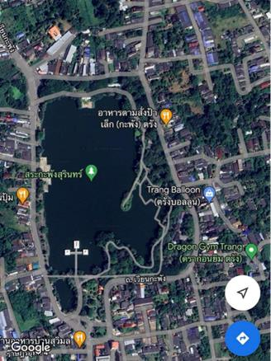
picture1 satellite imagery of Kaphang Surin Public Park

analyze Physical water quality Table 2 Physical water quality
Type | Area1 | Area2 | Area3 | Average (x̅) ±S.D.
pH value | 7.00 | 7.00 | 7.00 | 7.00±0.00
Temperature (℃) | 29.50 | 30.50 | 30.00 | 30.00±0.50
Turbidity value (m.) | 0.32 | 0.30 | 0.30 | 0.30±1.00
Dissolved Oxygen (DO) | 10.25 | 11 | 10.25 | 10.50±0.43

From the table 2 showing analysis physical water quality. Found that all 3 areas had
Average acid-bass pH value 7 it was medium value, the average Temperature value was
30.00±0.50 (℃), The average water turbidity value was 0.30±1.00 and the average Dissolved Oxygen (DO) value was 10.50±0.43. It was found that the water had high oxygen.

cloud cover analysis
Table 3 shows the amount of cloud mass.
Type | The first | The second | The third | Average (x̅) ±S.D.
Cirrus | 10% | 15% | 13% | 12.67±2.52
Cirrocumulus | 10% | 8% | 17% | 11.67±473

From the table 3 showing the cloud cover, it was found that the clouds were cluster and clearly separated. That found high level cloud 2 types: Cirrus (Ci) and Cirrocumulus (Cc).

Biological water quality analysis
Analysis water source of three areas of the lagoon by measured every 10 maters for a period of 3 weeks. And once a week found that species and quality of Phytoplankton and Zooplankton.
Table 4 shows the number of Phytoplankton
Type |  | Quality(cell) |  | Total
 | Area1 | Area2 | Area3
Navicula spp. | 5 | 7 | 5 | 17
Cosmarium sp. | 0 | 2 | 0 | 2
Scenedesmus spp. | 2 | 1 | 1 | 4
Oscillatoria sp. | 3 | 5 | 2 | 10
Microcystis sp. | 1 | 1 | 0 | 2
Planktolyngbya sp. | 0 | 0 | 1 | 1
Aphanocapsa spp. | 2 | 0 | 0 | 2
Pseudanabaena sp. | 2 | 2 | 3 | 7
Tetraedron spp. | 1 | 3 | 1 | 5
Chlorella sp. | 0 | 2 | 1 | 3
Cymbella sp. | 2 | 3 | 1 | 6
Oocystis sp. | 1 | 1 | 0 | 2
Pediastrum spp. | 0 | 0 | 1 | 1
Trachelomonas spp. | 0 | 1 | 0 | 1
Aphanothece sp. | 1 | 0 | 0 | 1
 |  |  |  | N=64

According to the Plankton count table, there are 15 species of Plankton in total. The predominant Plankton are Navicula spp. with 17 cells, followed by two species, Oscillatoria sp. with 10 cells and Pseudanbaena sp. 7 cells and the least common Plankton is Planktolygbya sp. 1 cell, Pediastrum spp. Trachelomonas spp. Aphanothece sp. 1 cell.

Shows pictures of Phytoplankton

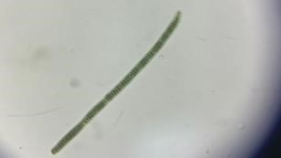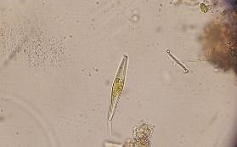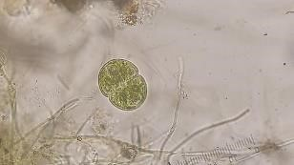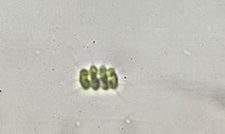

Navicula spp. Cosmarium sp. Scenedesmus spp. Oscillatoria sp.

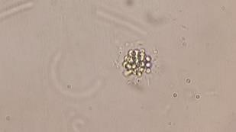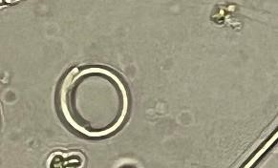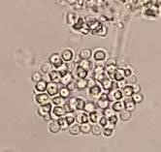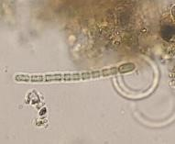
Microcystis sp Planktolyngbya sp Aphanocapsa spp. Pseudanabaena sp.

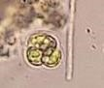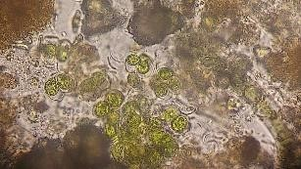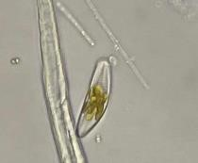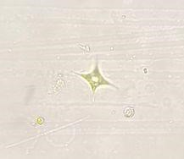
Tetraedron spp. Chlorella sp. Cymbella sp. Oocystis sp.

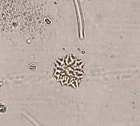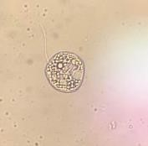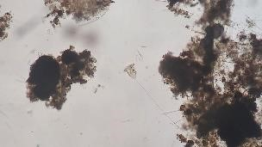
Pediastrum spp. Trachelomonas spp. Aphanothece sp. Vorticella sp.

Table 5 Diversity of Zooplankton in the 3 areas
Type |  | Quality(cell) |  | Total
 | Area1 | Area2 | Area3
Coleps sp. | 0 | 1 | 0 | 1
From the table showing the number of Zooplankton Found one species of Zooplankton, Coleps sp. There is 1 cell in total.

Conclusion and debate
The research from water source in Kaphang Surin Public Park That was Average acidbass pH value 7, it was medium value, the average Temperature value was 30.00±0.50 (℃), The average water turbidity value was 0.30±1.00 and average Dissolved Oxygen (DO) value was 10.50±0.43. It was found that the water had high oxygen and the clouds were cluster and clearly separated. That found high level cloud 2 types: Cirrus (Ci) and Cirrocumulus (Cc).
That found of amount lots of Phytoplankton that found the first dominant feature was
Navicula spp. The second was Oscillatoria sp. And the last was Pseudanabaena sp. By
Plankton biodiversity index was 1.03, Applied Algal Research Laboratory-Phytoplankton (AARL-PP) score was 6.267 that was medium quality water to polluted and Phytoplankton density was 80 cell/L, it was found that the water had high of Phytoplankton density. In addition, that was found Protozoa, Ancylostoma ceylanicum, Paramecium aurelia and Cyanobacteria was Vorticella sp.

Conclusion
In conclusion, The water quality from Kaphang Surin lagoon has high Diversity of Plankton and medium quality water.

Acknoeledgement
This work was successful. Due to receiving great from Teacher Mrs Sawitree
Duangsook for giving advice to collect samples and data about water. Many thanks to Teacher Mrs Khanjai Karnchanasrimek for supporting various equipment in scientific operations. Thanks a lot to Teacher Miss Wanatsanan Wongwairot for facilitating the process in different places as well as giving advice and recommending various suggestion with great care. And finally thank you to Wichienmatu Scool for supporting scientific operations in research, making the research successfully accomplished. The responsibilities thank for hard work on this.

Reference
Mr. Kitiroj Wantala , Mr. chanwit Saiyodthong , Mrs. Siriwan Srisorachat Project to study pollution contamination in raw water used as a water supply source http://thesis.swu.ac.th/ 2550 Source https://l.facebook.com/l.php?u=http%3A%2F%2Fthesis.swu.ac.th%2Fswufac%2FEng%2FKittir ote_H_R354399.pdf%3Ffbclid%3DIwAR18YI4ke6vOkB6EeQHhuQeovQKkmzTLiM92y5PeH5XcY Awx9n5TS57Nhjo&h=AT24MYSM7ENspxaiWsfCV7bygbQzPkXEpUHsRD4GMu9Ue1LFY1qKBEQO ZFcX1ZkebEKaGX63j3nkKn2_KmhBeOb8dG5up4EM4cToCNAuIALQb1gmxjnGwMd6WcXBIb7sZ W8WyCMjz17qrPU Search on March 9, 2023.
Wannapa Somboonsamran, Water quality and plankton in Chao Phraya River from Chainat
Province to Nonthaburi Province during 1992 to 1993. https://kukr.lib.ku.ac.th/2538 Source https://kukr.lib.ku.ac.th/kukr_es/kuk Search on March 9, 2023.
Professor Ladda Wongrat . (1999). Phytoplankton .Bangkok: Kasetsart University Press.
Professor Ladda Wongrat . (1998). Zooplankton. .Bangkok : Kasetsart University Press.

