Analysis of Urban Thermal Comfort in Puxinanã/PB and creation of Garden Benches as a Measure of Socio-environmental Promotion

Raquel Gomes da Silva
Estudante vinculada a Escola Cidadã Integral Técnica Plínio Lemos
R. Costa e Silva - Centro, Puxinanã - PB, 58115-000
quelot4@gmail.com

Flávia Alexandra Santos de Almeida
Estudante vinculada a Escola Cidadã Integral Técnica Plínio Lemos
R. Costa e Silva - Centro, Puxinanã - PB, 58115-000
flaviaalexandrasantosdealmeida@gmail.com

Andrea dos Santos Dantas
Estudante vinculada a Escola Cidadã Integral Técnica Plínio Lemos
R. Costa e Silva - Centro, Puxinanã - PB, 58115-000
andreasantos2022321@gmail.com

Andressa da Silva Guimarães Moura
Mestre em Biotecnologia, Doutoranda do programa de pós-graduação em desenvolvimento e inovação tecnológica de medicamentos – DITM
Universidade Federal da Paraíba – UFPB
Professora vinculada a Escola Cidadã Integral Técnica Plínio Lemos
R. Costa e Silva - Centro, Puxinanã - PB, 58115-000
profa.andressabio@gmail.com

ABSTRACT
The present study evaluated the influence of urban tree cover on thermal comfort at Ecit Plínio Lemos School, located in the municipality of Puxinanã (PB), with the aim of understanding how different levels of vegetation coverage affect air temperature and local microclimate conditions. The research was motivated by the need to scientifically analyze the relationship between arborization and thermal comfort in a semi-arid context, where high temperatures and the scarcity of green areas directly impact quality of life. For this investigation, the Atmosphere and Biosphere protocols of the GLOBE Program were applied to conduct standardized measurements of air temperature, surface temperature, relative humidity, and tree characteristics across three sites with varying degrees of vegetation cover. Data collections were carried out on consecutive days, at the same time, following standardized measurement and recording procedures.The results indicated that the most vegetated area recorded the lowest temperatures (28 °C and 27 °C), while the area without trees presented the highest values (29 °C and 27.8 °C), confirming the moderating role of vegetation through shading and evapotranspiration processes. Areas with intermediate vegetation cover showed median temperatures, demonstrating a gradual and directly proportional relationship between tree density and microclimatic cooling. Beyond environmental benefits, the study highlights the social and inclusive potential of planting native and semi-arid-adapted fruit tree species, which can contribute to food security and provide nutritional support to vulnerable populations, such as individuals experiencing homelessness. Based on the results, future perspectives include the implementation of garden benches and the planting of fruit trees in public spaces as strategies for thermal mitigation, carbon sequestration, and socio-environmental promotion. It is also recommended to expand temporal and spatial sampling, incorporate additional variables (such as solar radiation, wind, and soil temperature), and employ complementary GLOBE protocols (Soil and Land Cover) to enhance analysis and strengthen the connection between science, education, and community engagement.

KEYWORDS. Urban arborization; Carbon sequestration; Climate change; Social and environmental vulnerability.
1. Research Questions / Research Problem
The municipality of Puxinanã, located in the Agreste region of Paraíba, currently faces a conflict between the need for urban arborization aimed at environmental comfort and the structural problems resulting from the inappropriate selection of tree species. The central issue of this study lies in the removal of trees, especially Azadirachta indica (neem), a species widely present in the city. This removal represented an attempt to mitigate damage caused by the extensive and deep root system of this tree, which affected sidewalks, walls, and water supply networks (Marchioni et al., 2022). However, the suppression of vegetation cover led to an increase in average local temperatures and a reduction in thermal comfort, intensifying the effects of urban heat islands. The lack of adequate environmental planning, combined with the scarcity of green areas and high temperatures, directly compromises quality of life and environmental balance in the region.
Historically, the process of urban arborization in Brazil has been marked by political and technical decisions that have not always considered ecological and social aspects in an integrated manner. Over the decades, species selection has been guided primarily by aesthetic criteria (Betoni, 2022; Marchioni et al., 2022) and, in some cases, by implicit mechanisms of social control. This process has resulted in urban landscapes dominated by exotic or socio-environmentally inefficient species. Inadequate planning leads to conflicts between built spaces and vegetation, generating structural problems and, consequently, reducing the ability of trees to provide essential ecosystem services (Marchioni et al., 2022; Milano & Dalcin, 2000).
Recent studies indicate that, in several Brazilian cities, the planting of fruit trees has been deliberately avoided (Marques et al., 2024). The most common technical justification for this exclusion is the need to prevent litter on public roads, fruit accumulation, and the attraction of undesirable vectors (Milano & Dalcin, 2000; Rodrigues & Aoki, 2022). However, underlying this technical rationale is a socially exclusionary dimension, as it restricts free access to food for vulnerable populations, such as people experiencing homelessness. This practice reveals a bias in urban planning, contradicting the principle of the human right to food and nutritional security, recognized as fundamental by the Brazilian Federal Constitution (Souza, 2020).
The literature indicates that arborization with fruit-bearing species constitutes an effective strategy for socio-environmental promotion and public health (Lima & Costa, 2024; Marques et al., 2024). In addition to supporting healthy and free food access for vulnerable populations, this practice aligns with the guidelines of the Food and Agriculture Organization of the United Nations (FAO), which recommends planting fruit trees in urban and peri-urban environments as part of efforts to eradicate hunger (Sustainable Development Goal 2) (FAO, 2016, cited in Rodrigues & Aoki, 2022).
In this context, the microclimatic changes observed in Puxinanã prompted an interest in understanding, through the methodology of the GLOBE Program protocols, the influence of urban arborization on air temperature at different locations within a school environment. Such investigation is essential, since, according to Dorigon and Pagliari (2013), it is necessary to choose the right tree for the right place in order to maximize ecosystem benefits—such as thermal comfort—without compromising urban infrastructure (Milano & Dalcin, 2000).

2. Introduction / Theoretical Framework
The influence of urban arborization on average urban temperature is a highly relevant topic in light of the challenges posed by the global climate crisis (Marchioni et al., 2022). The contemporary context is marked by the intensification of extreme events, such as heat waves, which compromise urban quality of life and reinforce the need to adopt Nature-Based Solutions (NbS) and strengthen green infrastructure as strategies for building more resilient cities (Marchioni et al., 2022; Fraga, 2021).
Urban arborization represents one of the main components of this infrastructure, as it provides essential ecosystem services for both the population and the structural balance of cities. Among its most significant functions are microclimate regulation and mitigation of the urban heat island effect, characterized by higher temperatures in densely built areas with limited vegetation (Milano & Dalcin, 2000). Through shading and evapotranspiration, trees directly contribute to reducing air temperature, with potential decreases of up to 5 °C in compact urban areas (Fraga, 2021). The need for such interventions becomes even more evident in cities located in the Brazilian semi-arid region, where temperatures are naturally high and green spaces are scarce.
Studies conducted in the semi-arid region of Paraíba, particularly in the immediate region of Princesa Isabel, reveal a deficit in the Green Area Index per Inhabitant (GAIH), with values below the minimum of 15 m² per inhabitant recommended by the Brazilian Society of Urban Arborization (SBAU) (Brazilian Society of Urban Arborization, 1996). This lack of vegetation cover significantly reduces the provision of ecosystem services, directly affecting population health and well-being. Projections indicate that, if the minimum index were achieved, carbon stocks and environmental valuation could increase by up to 26 times on average, reinforcing the urgency of expanding urban green areas.
Addressing this deficit requires strategic planning and efficient urban space management. Arborization should not occur randomly but should be conducted as a systematic, continuous process guided by objectives that maximize environmental, social, and economic benefits (Dorigon & Pagliari, 2013; Milano & Dalcin, 2000). The systematization of information on ecosystem service provision is therefore essential for sustainable urban development and can be enhanced through the use of standardized scientific protocols, such as those of the GLOBE Program.
The GLOBE Program (Global Learning and Observations to Benefit the Environment) is an international citizen science and environmental education initiative that integrates land-based measurements conducted by students, educators, and citizens in collaboration with scientists. According to the GLOBE Program (2014), the Biosphere protocols encompass the study of living components and interactions between organisms and the environment. These protocols aim to quantify vegetation, land cover, carbon cycling, and landscape change, providing a technical framework for ecological dynamics analysis. Among the main protocols is the Biometry Protocol, which involves measuring and classifying vegetation at land cover sample sites by determining tree height and circumference, as well as assessing canopy and ground cover. The resulting data support classifications such as Moderately Undisturbed Cover (MUC) and enable structural vegetation analyses, including density, biomass, and solar radiation interception capacity—factors directly related to thermal comfort and the carbon cycle (GLOBE Program, 2014).
Within this framework, the present study aims to diagnose vegetation cover in the municipality of Puxinanã and propose sustainable solutions to optimize local green infrastructure. The objective is to enhance territorial adaptive capacity and reduce climate vulnerability, contributing to more balanced, resilient, and environmentally inclusive urban planning.

3. Materials and Methods
The study was conducted in the municipality of Puxinanã, located in the Agreste region of Paraíba. The main objective was to analyze the influence of arborization on average air temperature and relative humidity by comparing environments with different levels of vegetation cover. To achieve this purpose, the Atmosphere and Biosphere protocols of the GLOBE Program (Global Learning and Observations to Benefit the Environment) were applied, enabling standardized environmental data collection and supporting scientific analysis and integrated environmental education.
The research involved measurements of air temperature, surface temperature, and relative humidity, conducted according to the Atmosphere Protocol. Three distinct observation sites were selected: an area without arborization, an area with dense tree cover, and an area with sparse vegetation. Measurements were performed using a chemical thermometer positioned at chest height and attached to the observer’s wrist, who remained stationary for three minutes to allow temperature stabilization.

Figure: pH and temperature measurement of the Puxinanã/PB lagoon
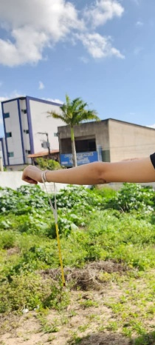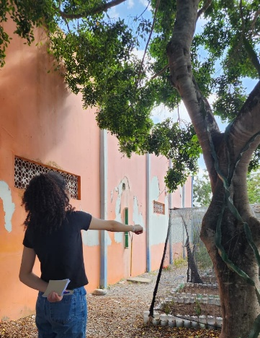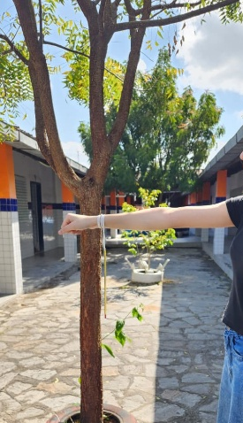
Source: Project author (2025).
After this interval, a new reading was performed one minute later; if the difference between the readings exceeded 0.5 °C, the procedure was repeated until the value stabilized. Data collection took place over three consecutive days, always at the same time, in order to ensure data comparability. In each measurement, information regarding the date, time, place and temperature obtained was recorded, complemented by notes in a logbook. Simultaneously with the atmospheric measurements, the Biosphere Protocol was applied, with emphasis on the Trees Protocol, through the GLOBE Observer Trees application, which aims to quantify and characterize tree cover. The trees selected for analysis were located in the schoolyard and were measured according to the standard of the GLOBE Program, using a height of 1.35 m to determine the Diameter at Breast Height (DBH). Trunk circumference was measured with a tape measure, and all data, including photographs and geographic coordinates obtained via GPS, were recorded on the GLOBE platform. This information helped in the identification of species and in the understanding of the distribution of vegetation in the school space, allowing the relationship of tree characteristics to the local microclimate.

Figure: pH and temperature measurement of the Puxinanã/PB lagoon
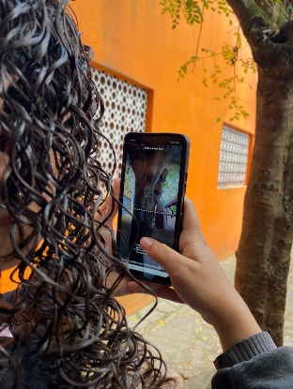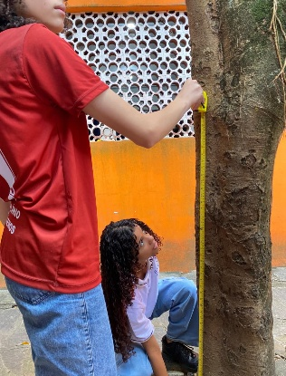
Source: Project author (2025).

Throughout the process, simple and low-cost instruments were used, such as a chemical thermometer, tape measure, notebook, logbook, cell phone for photographic records and access to the GLOBE platform, as well as a shovel, container and scale for collecting and weighing soil samples when necessary. After collection, the data were organized in electronic spreadsheets and analyzed comparatively between wooded and non-wooded environments, seeking to identify significant variations in temperature and relative humidity of the air. This analysis allowed us to understand the influence of afforestation on urban thermal comfort and the importance of vegetation cover in microclimatic regulation at Ecit Plínio Lemos in Puxinanã/PB.

4. Analysis of data/results

Places with a greater presence of trees have milder temperatures. Site 2, with the highest afforestation, had the lowest temperatures on the two days analyzed. This confirms that the vegetation cover exerts a moderating effect on temperature, thanks to shade and the evapotranspiration process. The absence of trees is associated with increased temperatures. Site 1, without trees, recorded the highest temperatures, evidencing the effect of heat islands in areas devoid of vegetation. Areas with intermediate afforestation had median temperatures. Location 3 confirms the gradual relationship: the smaller the number of trees, the higher the temperature.
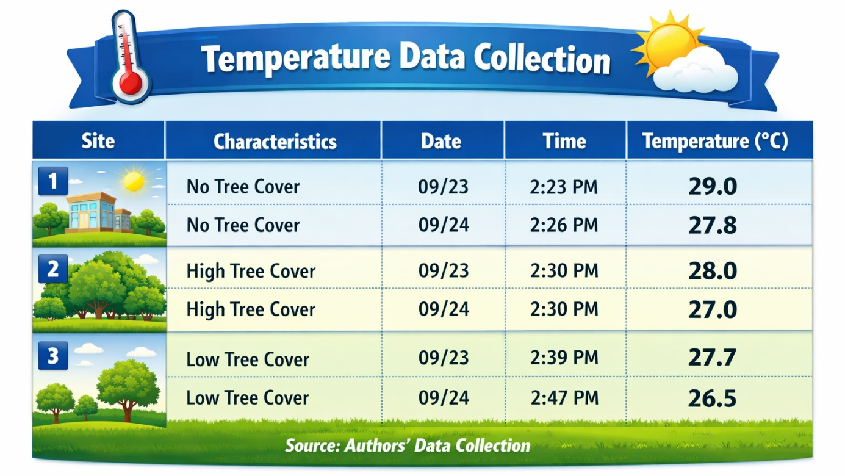Source: Project author (2025)
The presence of trees has been shown to significantly reduce the ambient temperature, contributing to thermal balance and mitigating the effects of heat islands. Thus, Site 2, characterized by greater afforestation, presented better thermal comfort conditions, evidencing the relevance of urban afforestation for local climate regulation. However, there is a need for further studies with a larger number of samples and variables, in order to obtain more conclusive results. Based on these results, the students proposed the creation of a carbon sequestration garden bench as a strategy for mitigating climate change. This proposal aims not only to reduce the ambient temperature, but also to capture carbon dioxide (CO₂) from the atmosphere. So far, the physical prototype has not been developed, only a 3D model prepared with the use of artificial intelligence.
Figure: Carbon sequestro bench-garden model developed by AI. 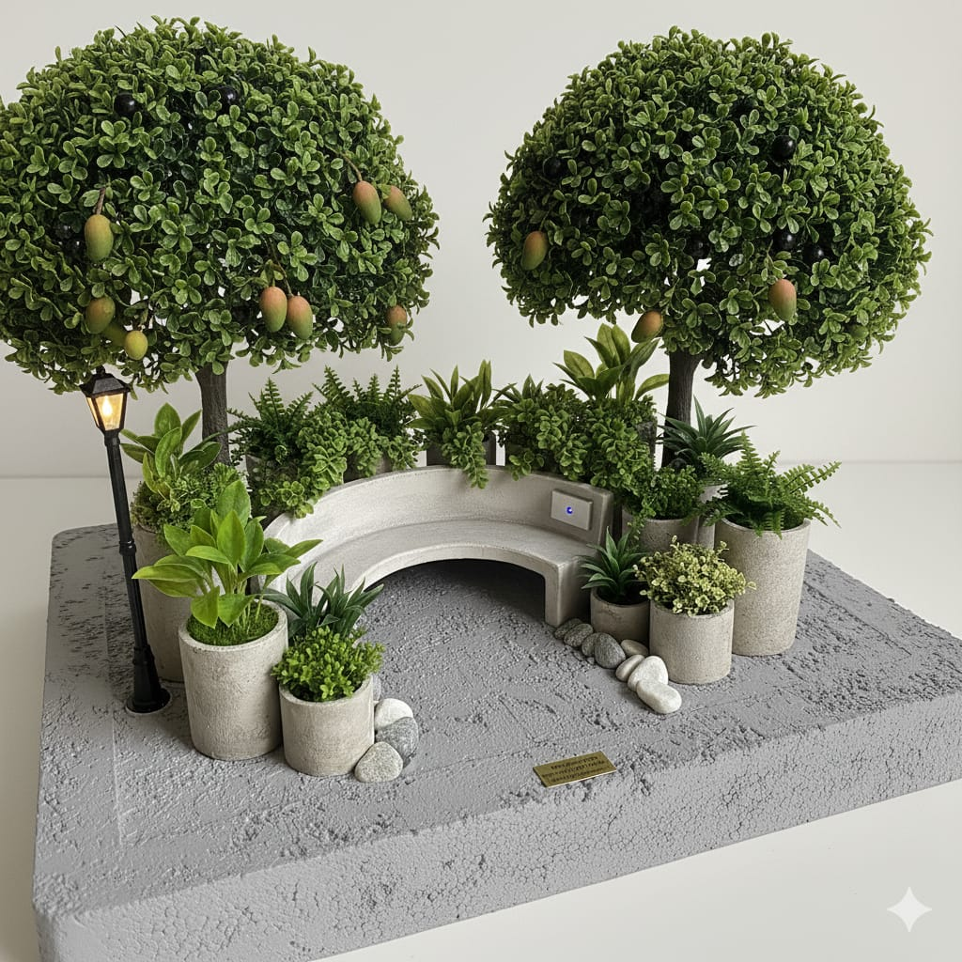
Source: Project author (2025).

- Discussion

The results obtained in this study clearly demonstrate the influence of urban tree cover on thermal regulation within the urban environment of the municipality of Puxinanã. Location 2, characterized by a greater presence of trees, recorded the lowest temperatures (28.0 °C on 09/23 and 27.0 °C on 09/24), confirming that vegetation cover exerts a moderating effect on the microclimate (Pinheiro & Souza, 2017). The importance of vegetation for thermal comfort is widely recognized in the literature, with atmospheric cooling being achieved mainly through two fundamental processes: shading and evapotranspiration. The former involves the interception of solar radiation by tree canopies, reducing surface heating and heat accumulation, while the latter corresponds to the use of thermal energy in the conversion of water into vapor, cooling the surrounding air and improving thermal comfort (Da Silva & De Mendonça Pimentel, 2019).
In vegetated environments, a perceptible reduction in air temperature is observed when compared to open areas, which confirms the mitigating role of vegetation on urban heat (Martini et al., 2016). Studies conducted in semi-arid regions, where thermal stress is more severe, indicate that areas under vegetative shade—known as Shaded Coverage Areas (SCA)—present milder and more stable temperature conditions. In this sense, the presence of trees not only improves the microclimate but also contributes to urban energy efficiency and environmental sustainability, as it reduces the need for artificial cooling (Zorzi & Grigoletti, 2016).
By contrast, Location 1, characterized by the absence of tree cover, presented the highest temperatures (29.0 °C and 27.8 °C), evidencing the formation of Urban Heat Islands (UHI)—a phenomenon directly associated with unplanned urban expansion and the replacement of green areas by impervious surfaces (Duarte et al., 2018). Materials such as asphalt and concrete, widely used in urban infrastructure, have high thermal absorption coefficients, storing heat during the day and releasing it slowly at night, which intensifies thermal discomfort (Mohajerani, Bakaric, & Jeffrey-Bailey, 2017). The lack of vegetation exacerbates this process, resulting in higher temperatures and climatic conditions that are less favorable to human health (Copque et al., 2011; Esteves, 2018; Lisboa et al., 2024).
Location 3, with limited tree cover, showed intermediate temperatures, reinforcing the gradual relationship between vegetation density and thermal cooling (Project Author, 2025). The intensity of the cooling effect is directly associated with the quantity, height, and density of trees (Rahman, Armson, & Ennos, 2014). Thus, locations with intermediate levels of tree cover tend to record median temperatures between treeless areas and those with dense vegetation, demonstrating that even small-scale green interventions can generate perceptible microclimatic benefits.
The analyzed data reinforce that urban tree planning should be considered a strategic tool for environmental quality rather than merely an aesthetic element (Gonçalves et al., 2018). The literature emphasizes that qualitative and quantitative information on urban forestry is fundamental to supporting sustainable urban planning (Alves, Costa, & Costa, 2023). In this context, public policies become essential. Bill No. 3,113/2023, currently under consideration in the Federal Senate, proposes the creation of the National Urban Arborization Policy (PNAU), which would make the development of municipal urban forestry plans mandatory in cities with more than 20,000 inhabitants (Federal Senate, 2023). Such measures are aligned with the Cities + Green Program, promoted by the Ministry of the Environment (Brazil, 2021), which seeks to expand urban green areas and strengthen the climate resilience of Brazilian cities.
In this manner, the results of this study reaffirm that urban arborization plays a decisive role in mitigating urban heat islands and promoting thermal comfort. Investment in adequate tree-planning strategies and policies aimed at expanding vegetation cover represents a sustainable approach to addressing contemporary climate challenges and fostering collective well-being in urban spaces.

- Conclusion
The analysis of urban thermal comfort at Ecit Plínio Lemos, in the municipality of Puxinanã, PB, allowed to prove the direct relationship between vegetation cover density and microclimatic regulation. The results showed that the areas with a greater presence of trees had milder temperatures, while places devoid of vegetation recorded significantly higher values. These findings confirm the fundamental role of afforestation in mitigating urban heat islands and promoting thermal comfort, corroborating previous studies that highlight shading and evapotranspiration as essential mechanisms for atmospheric cooling. This work contributes to the advancement of knowledge about the microclimate in small cities and in semiarid regions, where thermal vulnerability tends to be more pronounced. By employing standardized protocols of the GLOBE Program, the study reinforces the importance of participatory methodologies in the collection and analysis of environmental data, bringing science closer to education and promoting the training of young researchers with socio-environmental awareness. The use of simple and accessible instruments demonstrated that relevant climate research can be carried out in school and community contexts, promoting social engagement and scientific learning. The results obtained support the proposal to create a garden bench for carbon sequestration, integrating ecological and social functions such as reducing ambient temperature and capturing CO₂, in addition to serving as a space for coexistence and environmental education. This initiative represents a low-cost, sustainable solution with the potential to replicate in other communities.
Future prospects
One of the main future perspectives of this project consists of the implementation of garden benches and the expansion of the planting of fruit trees in public areas of the municipality of Puxinanã. This proposal, in addition to contributing to the improvement of thermal comfort and the mitigation of urban heat islands, has an important socio-environmental and educational character. Garden benches represent a sustainable and multifunctional solution, which combines green infrastructure, carbon sequestration and social well-being, transforming urban spaces into places of coexistence, learning and environmental balance.

Refererences

- Alves, L. P., Costa, J. A. S., & Costa, C. B. N. (2023). Arborização urbana dominada por espécies exóticas em um país megadiverso: falta de planejamento ou desconhecimento? Revista Brasileira de Geografia Física, 16(3), 1304–1375.
- Brasil. Ministério do Meio Ambiente. Secretaria de Qualidade Ambiental. (2021). Programa Cidades + Verdes. Ministério do Meio Ambiente. https://www.gov.br/mma/pt- br/assuntos/agendaambientalurbana/cidadesmaisverdes/ProgramaCidadesmaisVerdes.pdf.
- Copque, A. C. da S. M., Souza, F. A., Santos, D. V. de C., & Paixão, R. C. da. (2011). Expansão urbana e redução de áreas verdes na localidade do Cabula VI Região do miolo da cidade do Salvador, Bahia. In Anais do Simpósio Brasileiro de Sensoriamento Remoto (15th, pp. 706–713). Instituto Nacional de Pesquisas Espaciais.
- Da Silva, LHG, & De Mendonça Pimentel, RM (2019). Estrutura morfológica foliar da arborização urbana na manutenção do conforto térmico. Jornal de Análise e Progresso Ambiental , 104–109.
- Duarte, T. E. P. N., Angeoletto, F., Santos, J. W. M. C., Silva, F. F. da., Bohrer, J. F. C., & Massad, L. (2018). Reflexões sobre arborização urbana: desafios a serem superados para o incremento da arborização urbana no Brasil. Revista em Agronegócio e Meio Ambiente, 11(1), 327–341.
- Esteves, M. C., & Corrêa, R. S. (2018). Natividade da flora usada na arborização de cidades brasileiras. Paranoá, (22), 159–171.
- Gonçalves, LM, Monteiro, PH da S., Santos, LS dos, Maia, NJC, & Rosal, LF (2018). Arborização Urbana: a Importância do seu Planejamento para Qualidade de Vida nas Cidades. Ensaios e Ciência C Biológicas Agrícolas e da Saúde, 22 (2), 128–136.
- Lisboa, MAN, Silva, LVA, Nascimento, AS, Silva, AO, Teixeira, MRA, Ferreira, MFR, Ferreira, SC, Silva, ACV, Colares, AV, & Calixto Júnior, JT (2024). Diversity, structure, and carbon sequestration potential of the woody flora of urban squares in the Brazilian semiarid region. Árvores, Florestas e Pessoas, 16, 100561. https://doi.org/10.1016/j.tfp.2024.100561.
- Martini, A., Biondi, D., Batista, A. C., & Silva Filho, D. F. (2016). Microclima em diferentes tipologias de floresta urbana. Revista da Sociedade Brasileira de Arborização Urbana, 10(4), 12–22.
- Mohajerani, A., Bakaric, J., & Jeffrey-Bailey, T. (2017). O efeito de ilha de calor urbana, suas causas e mitigação, com referência às propriedades térmicas do concreto asfáltico. Journal of Environmental Management , 197 , 522–538. https://doi.org/10.1016/j.jenvman.2017.03.095.
- Pinheiro, C. R., & Souza, D. D. (2017). A importância da arborização nas cidades e sua influência no microclima. Revista Gestão & Sustentabilidade Ambiental, 6(1), 67–82.
- Rahman, MA, Armson, D., & Ennos, AR (2014). Uma comparação do crescimento e da eficácia de resfriamento de cinco espécies de árvores urbanas comumente plantadas. Ecossistemas Urbanos , 18 , 371–389.
- Senado. (2023). Senado pode aprovar Política Nacional de Arborização Urbana. Agência Senado. https://www12.senado.leg.br/noticias/materias/2023/07/25/senado-pode-aprovar-politica-nacional-de-arborizacao-urbana.
- Zorzi, LM, & Grigoletti, GC (2016). Contribuições da arborização para o conforto ambiental e a eficiência energética urbana. Revista de Arquitetura IMED , 5 (2), 75–84.
- GLOBE Program. (2014). Biosphere Protocols: Biometry, Land Cover, and Phenology. GLOBE Implementation Office, University Corporation for Atmospheric Research (UCAR). Retrieved from https://www.globe.gov/web/biosphere
- Betoni, L. G. A. (2022). Arborização Urbana de Dourados/MS: Direitos, Responsabilidades e Efetivação [Dissertação de Mestrado]. Universidade Federal da Grande Dourados.
- Dorigon, E. B., & Pagliari, S. C. (2013). Arborização urbana: importância das espécies adequadas. Unoesc & Ciência - ACET, 4(2), 139–148.
- Food and Agriculture Organization [FAO]. (2016). Guidelines on urban and peri-urban forestry (FAO Forestry Paper n. 178). Rome: FAO.
- Fraga, R. G., & Sayago, D. A. V. (2021). Soluções baseadas na Natureza: uma revisão sobre o conceito. Parcerias Estratégicas, 25(50), 67-82.
- Lima, I. C. F. de, & Costa, L. J. da. (2024). Valoração da cobertura vegetal da arborização urbana quanto ao sequestro de carbono da região geográfica de Princesa Isabel, Paraíba. Revista Acsa, 20(2).
- Marchioni, M., Raimondi, A., Silva, J. C. A., Yazaki, L. F. O. L., Velasco, G. D. N., Brazolin, S., Silva Filho, C. A., & Becciu, G. (2022). Soluções Baseadas na Natureza como Instrumento de Melhoria da Arborização Urbana, Auxiliando na Construção de Cidades Sensíveis à Água e Resilientes às Mudanças Climáticas.
- Marques, L. R., Bucco, N. C., Brum, A. A., & Brum, A. N. (2024). A importância da arborização urbana com árvores frutíferas para a qualidade de vida da população. Brazilian Journal of Health Review, 7(9).
- Milano, M., & Dalcin, E. (2000). Arborização de vias públicas (1. ed.). Light.
- Rodrigues, A. C., & Aoki, C. (2022). Das ruas para a mesa: espécies vegetais alimentícias utilizadas na arborização urbana de Mato Grosso do Sul, Brasil. Interações (Campo Grande), 23(3).
- Souza, P. J. L. (2020). [Trabalho sobre segurança alimentar e constitucionalidade em contexto de vulnerabilidade socioambiental].

