Has the Red Drum Population in the Gulf of Mexico Recovered Following Deepwater Horizon?
Jakobey Johnson, Devin Lowe, Simcha McGee, Melissa Vereker. Lillian Wallace
Mrs. Melissa Wedel
Christian Collegiate Academy
United States
March 17, 2021

Abstract

In 2010 The Deepwater Horizon Oil Spill in The Gulf of Mexico caused widespread damage to the Gulf of Mexico ecosystem (White et al., 2017). The Red Drum fish population had been thriving before the spill. Following the spill, scientists found that fish exposed to oil showed stunted growth, enlarged livers, changes in the heart and lungs, fin erosion, and impairment in reproduction (NOAA, n.d.). Oil exposure can also affect baby fish whether a lethal and sublethal amount of oil. When affected by oil, even if it is a little bit, the fish is unsafe for humans to consume (NOAA, n.d.). Oil floating in the water can also affect what fish eat. It can contaminate things like plankton, algae, fish eggs, and larvae of various invertebrates. If these species are affected and consumed by fish, the fish will also be affected by the oil that is on their food or by the direct toxic effects of the oil. The same thing would happen to humans if we consumed fish with oil in or on them (NOAA, n.d.). GLOBE hydrology data helped to show how resilient The Gulf of Mexico is. It is important to remember that human harm could change that someday. Further research is needed and a better statistical analysis of the existing data to fully understand the impact on the Red Drum population and how long it will take the fish to fully recover. Our findings show that humans can be poor stewards of the environment and are not respecting and obeying God’s command to take care of the earth.

Research Question and Hypothesis

Research Question: How has the red drum population in the Gulf of Mexico recovered following the Deepwater Horizon?

Hypothesis: There has been a severe decrease in the red drum population and the red drum population has not fully recovered.

Introduction and Review of Literature

On April 20, 2010, the Deepwater Horizon oil drilling rig which was operating in the Macondo Prospect in the GOM exploded and sank. The result of the explosion resulted in the death of 11 workers on the rig and the largest oil spill in history, dumping 4 million barrels of oil into the GOM over 87 days (EPA, n.d.). 68,000 miles of the GOM were directly impacted by the spill, an area as large as the State of Oklahoma (Amos, 2010). To clean up the oil spill, BP used the dispersant Corexit which caused additional unmeasurable harm to animals and the ecosystem of the GOM (White et al., 2017).

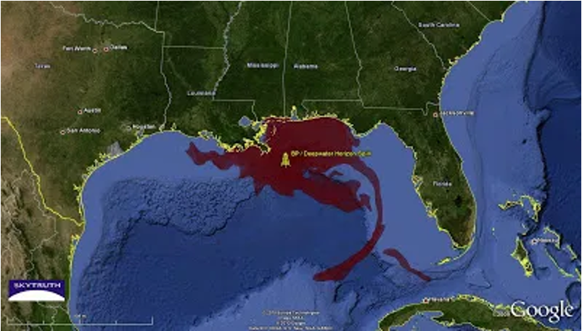

Photo Credit: Amos, 2010. Google map showing the cumulative oil slick footprint from BP/Deepwater Horizon Oil Spill

The Red Drum (Sciaenops ocellatus) fish has a silver body that has a reddish tint and one black spot at the base of its tail. The Red Drum makes a drumming sound which is how it got its name. Red Drum eats crabs, shrimp, and small fish as adults but young Red Drum eats tiny invertebrates and zooplankton (Chesapeake Bay Program, n.d.). .). Red Drum like shallow water usually along the edges of bays or shores with seagrass or other vegetation. They like submerged vegetation and mud and are often found around oyster reefs (Texas Parks & Wildlife, n.d.).

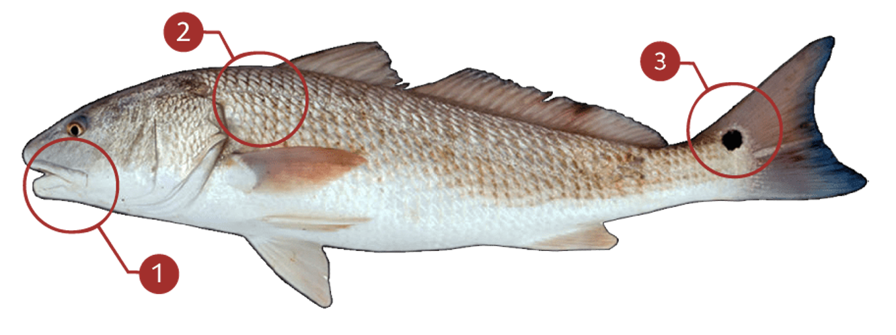
Photo Credit: Fish Buoy, n.d. According to Fish Buoy (n.d.). you can identify a Red Drum by 1. No chin barbels and an elongated body 2. Copper reddish color over the silver body and 3. A large black spot on the tail.

Since the 2010 BP oil spill, marine scientists have sampled more than 2,500 individual fish representing 91 species from 359 locations across the Gulf of Mexico and found evidence of oil exposure in all of them, including some of the most popular types of seafood (Prueitt, 2018). The highest levels were detected in Red Drum. Fish with the highest concentrations of PAH were found in the northern Gulf of Mexico, a region of increased oil and gas activity and in the vicinity of the Deepwater Horizon spill that gushed nearly four million barrels of oil over three months in 2010. Oil-rich sediments at the bottom where much of the oil settled are resuspended by storms and currents, re-exposing bottom-dwelling fish (Prueitt, 2018).
Research Methods and Materials

Research methods included GLOBE water quality measurements from the Florida Keys from 2010 forward, available scientific data, and literature review. It was important to look for a dataset that went back just before the oil spill. We reviewed NOAA data sets, EPA water quality data sets, and other data sets. Looking at the water quality measurements in the GOM reports about the overall health of the Red Drum population in the GOM. Our team will attempt to determine whether the effects of the Deepwater Horizon Oil Spill were on the Red Drum population in the GOM while note of confounding variables that may make measuring long-term harm from Deepwater Horizon alone difficult.
GLOBE Data Summary and Analysis
Our team used GLOBE data from the Marine Resource Development Foundation and The University of South Florida. This data was chosen because it was the only GLOBE data available for the GOM dating from 2010 (time of Deepwater Horizon) forward. Marine Biology ran summary statistics on the pH, Dissolved Oxygen, and Salinity which were the water quality measurements recorded in GLOBE and extracted using the GLOBE data retrieval tool. The following table summarizes the summary statistics of the continuous data for each variable. There were no obvious fluctuations in any of the recorded GLOBE variables from either organization that would explain harm to the Red Drum from Deepwater Horizon. There is little fluctuation as shown by the mean and standard deviation for any of the water quality variables and The University of Southern Florida only recorded water pH. The GLOBE data did show the resilience of the GOM following Deepwater Horizon.
The Marine Biology class at our school collected ocean samples for GLOBE hydrology to learn how to collect the samples, run the water quality per GLOBE protocols, and to better understand our project. Our team ran water temperature, water pH, alkalinity, salinity, nitrates, water transparency, and dissolved oxygen. The measurements from January to March and none of the test results our team collected were out of the normal range. While it did not explain what changed in water quality since 2010, it did help us understand the importance of using a standard protocol for water quality.
Marine Biology Summary Statistics Data Table & Visualizations
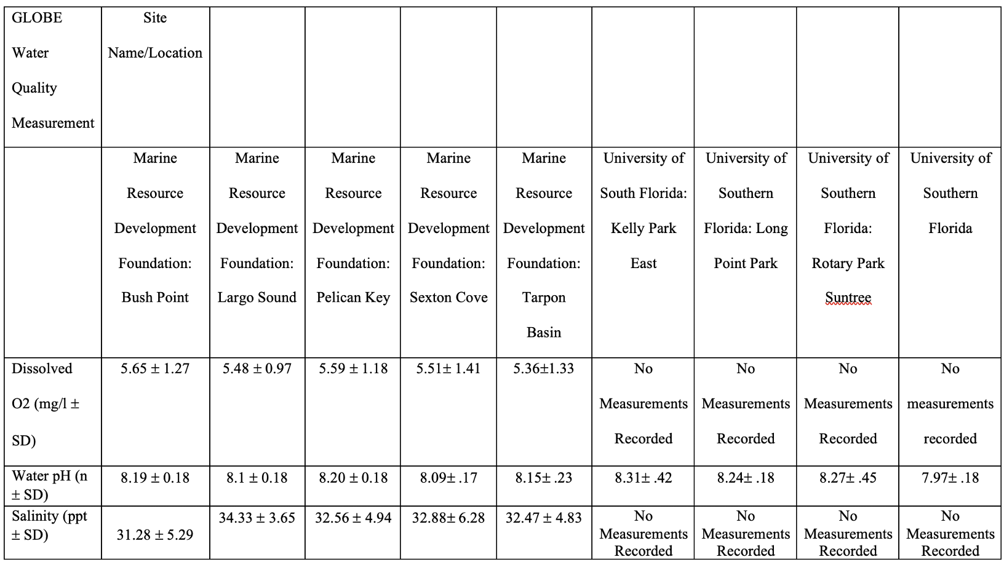
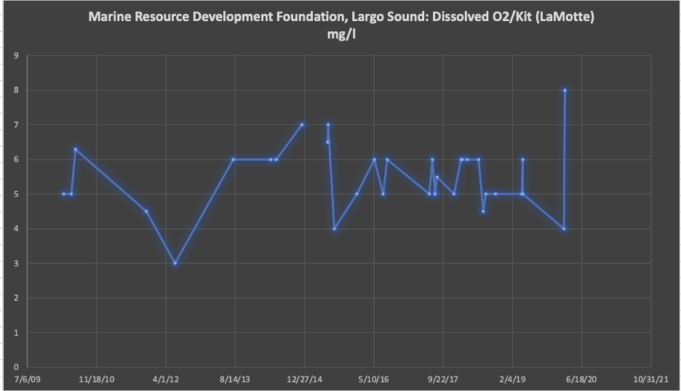

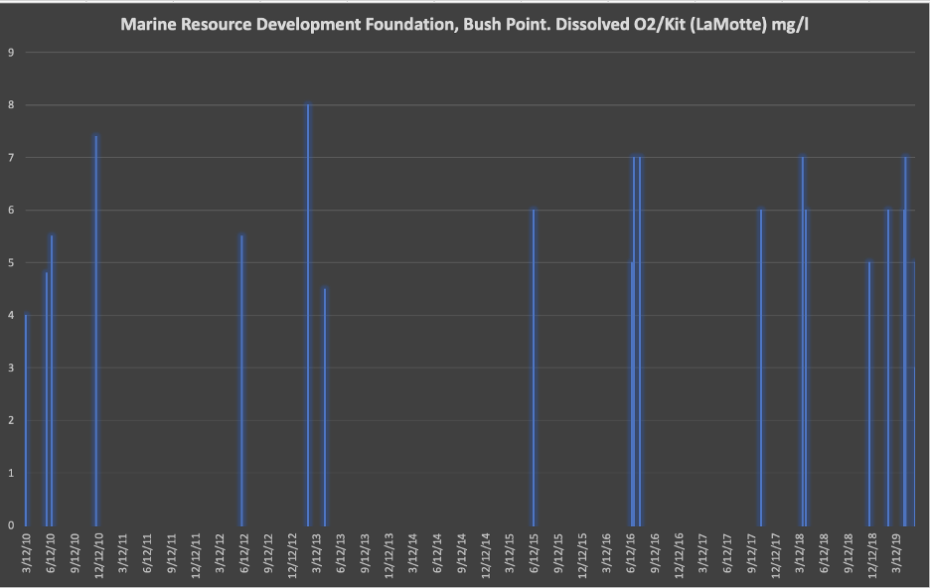

Discussion, Results, and Conclusions

The results of our research show that scientists and experts in Red Drum believe that Deepwater Horizon caused significant harm to the population in the GOM. GLOBE data helps to show the resilience of the GOM after a disaster like Deepwater Horizon. Despite the literature, data, and facts, confounding variables previously discussed, limits understanding of the extent of the problem and how long it will take the Red Drum population to fully recover. Water pH is important to monitor because marine organisms can only tolerate a range of between 6.5 – 8.5. Dissolved oxygen is a measurement of the oxygen in a liquid, and it affects the organisms in a body of water, and it should not be too high or too low. If the dissolved oxygen falls below 6 mg/L it can become unhealthy for animals (Fondriest, n.d.). The temperature of the water, pressure (in psi), and salinity (the amount of salt in water) affect the amount of dissolved oxygen (Fondriest, n.d.).
When exposed to oil these damages may occur to all kinds of fish like stunted growth, enlarged livers, changes in the heart and lungs, fin erosion, and impairment in reproduction (NOAA, n.d.). It can also affect baby fish on lethal and sublethal amounts of oil. When affected by oil, even if it is a little bit, the fish is unsafe for humans to consume (NOAA, n.d.). Oil floating in the water can also affect what fish eat. It can contaminate things like plankton, algae, fish eggs, and larvae of various invertebrates. If these species are affected and consumed by fish, the fish will also be affected by the oil that is on their food or by the direct toxic effects of the oil. The same thing would happen to humans if we consumed fish with oil in or on them (NOAA, n.d.).
Another effect that oil has on fish is that it makes them react a lot slower to predators and more likely to act risky. If the young fish are exposed to oil, they may die an early death because their organs are not fully formed and when they are formed, they have a lot of defects (NOAA, n.d.). Not only does the oil affect their hearts and spines but it also affects their brains. The oil affected them in similar ways that alcohol affects our brains. No matter how little the oil spill is, if it is a drop or a huge gallon, the oil will still affect the fish or other marine life (NOAA, n.d.). Scientists are working on a solution to help the fish, but the oil problem is still huge. They still have to learn how it affects the brain exactly and how many other species the oil affects. Like does it affect the predators that eat the oil-filled fish and how does the oil hurt the predators (NOAA, n.d.).
In conclusion, the Red Drum population was affected by the spill and more research is needed to fully understand the harm and how long it will take them to fully recover. Additionally, more needs to be done to prevent human harm to Red Drum to ensure that their populations can fully recover.

References

Amos, J. (2010, July 27). BP/GulfOil Spill – 68,000 Square Miles of Direct Impact. SkyTruth. https://skytruth.org/2010/07/bp-gulf-oil-spill-68000-square-miles-of/
Chesapeake Bay Program. (n.d.). Red Drum: Sciaenops ocellatus. https://www.chesapeakebay.net/S=0/fieldguide/critter/red_drum
EPA.gov. (n.d.). Enforcement: Deepwater Horizon – BP Gulf of Mexico Oil Spill. https://www.epa.gov/enforcement/deepwater-horizon-bp-gulf-mexico-oil-spill
Fikes, R. (2014). BP spill impacts on red snapper - what we know, what we don’t. National Wildlife Federation Blog. https://blog.nwf.org/2014/04/bp-spill-impacts-on-red-snapper-what-we-know-what-we-dont/
Fish Buoy. (n.d.). Red Drum. https://www.fishbuoy.com/fish-species/saltwater-sports-fish/red-drum.html
Fondriest. (n.d.). Dissolved Oxygen: What is dissolved oxygen? https://www.fondriest.com/environmental-measurements/parameters/water-quality/dissolved-oxygen/
MASGC. (n.d.). Impacts from the deepwater horizon oil spill on Gulf of Mexico fisheries.[pdf].http://masgc.org/oilscience/oil-spill-science-fish-impacts.pdf
NOAA. (n.d.). How does oil impact marine life? National Ocean Service: National Oceanic and Atmospheric Administration. https://oceanservice.noaa.gov/facts/oilimpacts.html#:~:text=When%20exposed%20to%20oil%2C%20adult,fin%20erosion%2C%20and%20reproduction%20impairment.&text=Even%20when%20lethal%20impacts%20are,unsafe%20for%20humans%20to%20eat
Prueitt, B. (2018, March 27). A missing generation of fish from the Deepwater Horizon oil spill. The University of South Florida. https://www.usf.edu/news/2018/missing-generation-fish-deepwater-horizon-oil-spill.aspx
Texas Parks & Wildlife. (n.d.). Red Drum (Sciaenops ocellatus). https://tpwd.texas.gov/huntwild/wild/species/reddrum/
White, N. D., Godard-Codding, C., Webb, S. J., Bossart, G. D., Fair, P. A. (2017, June). Immunotoxic effects of in vitro exposure of dolphin lymphocytes to Louisiana sweet crude oil and Corexit. J Appl Toxicol. 2017 Jun;37(6):676-682. doi: 10.1002/jat.3414.

