Samantha Nuñez
Gabriel Cárdenas
Studying the favorable conditions for Aedes albopictus reproduction
Abstract
As one of the fastest spreading mosquito in the world, Ae. albopictus is a knowledgeable vector of many viruses. Its ability to easily reproduce lead to conduct experimentation aimed to study its reproduction in urban and rural environments of Puerto Rico. To comply with the extent of this research, two mosquito habitats (Experiment #1 and Experiment #2), were set up using artificial containers as water sources. Experiment #1 took place in an open area of suburban San Juan and Experiment #2 in a controlled area of rural Barceloneta, Puerto Rico. Samples were obtained and the number of larvae was counted. Using the GLOBE Observer app, the Larva type was identified. Experiment #2 had an average of 4.7 larvae per container whilst those of Experiment #1 averaged 2 larvae. The Ae. Albopictus mosquito is able to reproduce successfully in both suburban and rural areas of Puerto Rico. In order to control this species reproduction, water sources, especially in abandoned areas and sites of semipermanent ground, must be eliminated. As pollinators, mosquitoes play and essential ecological role in the ecosystem. It is evident the need to conserve the environment in the face of degrading natural resources, pollution and increasing human population growth.
Introduction
The tiger mosquito Aedes albopictus is a knowledgeable vector of many viruses. This produced the interests to develop experimentation on its reproduction in different environments. This research aims to study the reaction of Ae. albopictus in urban and rural environments of Puerto Rico as it is probably the fastest-spreading mosquito in the world. Abandoned buildings and semipermanent dumping grounds are known to increase critical sites for their breeding in urban areas. Ae. albopictus, native to East Asia, has been confirmed to transmit dengue and chikungunya in Europe and Asia. “Several reasons contributed to the rapid spreading of this mosquito species; among the most important, certainly, are the resistance of its desiccated, dormant eggs and their efficient passive transport around the world, often used tires”. (Bruno Arcà, Fabrizio Lombardo, Ivo M.B. Francischetti, Van My Pham, Montserrat Mestres-Simon, John F. Andersen, José M.C. Ribeiro, 107-127).
The extent of this research is to understand the relationship between the environment and Ae. albopictus since “a significant contribution to the current widespread distribution came from the ability of Ae. albopictus populations to survive to relatively low temperatures (10˚C or lower) and to exploit for oviposition a large variety of breeding sites originated by human activities”. (Bruno Arcà, Fabrizio Lombardo, Ivo M.B. Francischetti, Van My Pham, Montserrat Mestres-Simon, John F. Andersen, José M.C. Ribeiro, 107-127). As this experimentation studies the favorable conditions for Ae. albopictus reproduction, it expects to determine those that would prevent disease transmitting mosquitoes in the vein of, currently, being the most invasive mosquito in the world.
Two different mosquito habitats were developed in a pair of different locations in Puerto Rico. In order to consider the rural and urban aspect of the locations, the effect of pollution on mosquito reproduction and development rate in each site was examined by evaluating the air quality. This research intends on understanding the need to control the rapid spreading of Ae. albopictus whilst maintaining awareness of the importance of conserving the environment in the face of degrading natural resources, pollution and increasing human population growth.
Methodology
In order to comply with the extent of this research, mosquito habitats were set up using artificial containers as water sources and were placed on humid and warm locations. A pair of experiments were developed in Barceloneta (Experiment #1) and San Juan (Experiment #2), Puerto Rico, respectively. Observations were made during each week and recorded using the GLOBE Observer App. During both experiments, modifications were made in order to achieve and have a successful breeding ground. Using the GLOBE Observer Mosquito Habitat Mapper App, the range and spread of Ae. albopictus were tracked.
2.1 Research Design
With the aim of comparing urban and rural Ae. albopictus reproduction, two mosquito habitats were set up. The habitats were identified as water sources with the potential to c since it’s a stage that does not transmit disease to humans. Samples were obtained and the number of larvae was counted. Using the GLOBE Observer app, the Larva type was identified by selecting a representative larva for closeup photos using a microscope. The breeding habitats were eliminated to prevent the reproduction of disease transmitting mosquitoes.
2.2. Resources (Materials):
Measuring Cup
Globe Observer App
Microscope
2.2.1. Experiment #1
1.5-liter of tap water
2 soda bottles
Black Tape
2.2.2. Experiment #2
3 colored plastic containers
2 liters of water for each container
45 mL of honey for each container
2.3. Procedure
Build mosquito habitat by using artificial containers.
2.3.1. Experiment #1
3 traps were set up in a period of 5 weeks. The traps were build using soda bottles covered with black tape while leaving its original orifice opened for mosquitoes. For stability, they placed a rock inside the container. Two of the bottle traps were positioned in San Juan, Puerto Rico (latitude: 18.353492, longitude: -66.083676), and left them 38 ft (12 m) apart, one without any kind of cover (Trap A) and one under trees (Trap B). After each experiment, the breeding ground was eliminated.
2.3.2. Experiment #2
As part of the study of Aedes albopictus reproduction, the SEES interns conducted two different experiments in Puerto Rico. Experiment #1 was located in Barceloneta, Puerto Rico (latitude: 18.4155, longitude: -66.553). Three traps were created using the sweet and viscous honey substance as bait for all the traps and three different plastic-colored containers. The traps were filled with two liters of water and 15 ml of honey each. Data was recollected using the GLOBE Observer App.

3. Results
Figure 1 specifies the quantity of larvae found in each mosquito habitat after a certain period of time. Results recorded with the GLOBE Observer App.

Figure 2 (upper right corner) shows the presence of other mosquitoes in stages of development different from larvae.
 | Experiment 1 | Experiment 2
Eggs | No | Yes, Trap BB
Pupae | Yes, Trap B | Yes, Trap BB
Adult Mosquitoes | Yes, Trap B | Yes, Trap CC

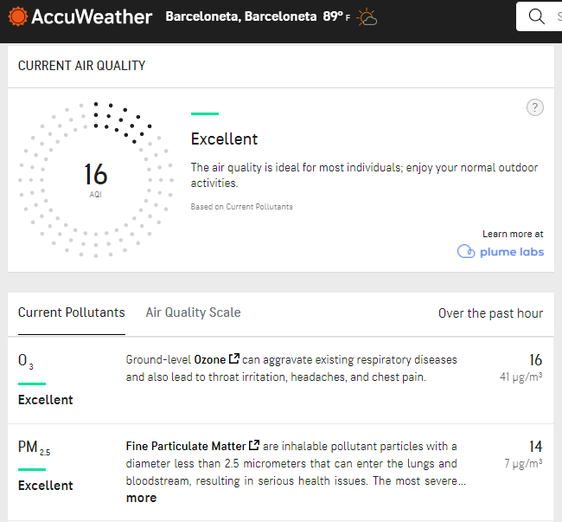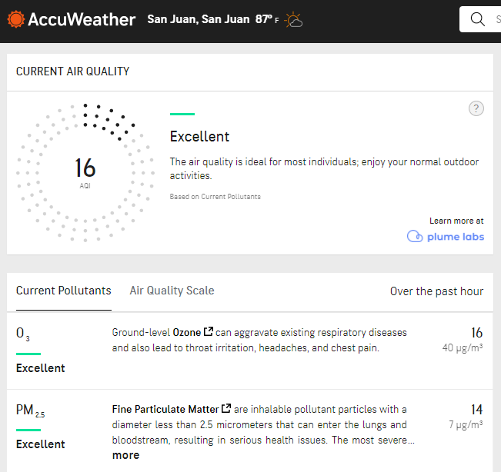
Figure 3 (left) shows the air quality of the area where Experiment #2 took place. Figure 4 (right) shows the air quality of the area where Experiment #1 took place.
Discussion
In Experiment #1, throughout the first weeks no larvae were observed. The third week the water sources were observed and transferred into a plastic bag to check for larvae or eggs. Trap B contained 5 pupae, 2 larvae and a mother mosquito in the imago stage. However, no larvae were found in Trap A, except cat hairs and dirt. In order to improve data accuracy, another trap (Trap C) was set following Trap B’s conditions. At the end of a 2-week period, 4 larvae were observed in Trap C.
In Experiment #2 seven observations were made; the first was made on 07/07/2021, the day the traps were set up. After a week, the second, 07/18/2021, and third observation, 07/19/2021, were made, but rather unsuccessful. Consequently, the traps were moved to a darker and more humid place in the same location.
Two weeks after the first observation, larvae, mosquito eggs and pupae were observed on 07/22/2021 in the first trap, royale blue colored container (Trap AA). Six larvae were counted along with mosquito eggs and pupae. Using the GLOBE Observer app, the mosquitoes were identified as Aedes albopictus. On 07/24/2021, Aedes albopictus was also found in the second trap, light blue colored (Trap BB). The same species was observed in the third trap, black colored (Trap CC), on 07/26/2021.
The results presented showed the number of larvae found in the mosquito habitats of each experiment. The habitats of Experiment #2 (Trap AA, Trap BB and Trap CC) had an average of 4.7 larvae per container whilst those of Experiment #1 (Trap A, B and C) averaged 2 larvae. Having bait, shade and humidity in the habitats’ location favored Ae. albopictus reproduction. As shown in Figure 2 and 3, air quality did not show to differ between locations; therefore, it is taken as a controlled variable.
The Ae. Albopictus mosquito is able to reproduce successfully in both suburban and rural areas of Puerto Rico. Larval samples were collected in each experiment as a means to identify the favorable conditions to inhibit this species. To be able to control this species reproduction, water sources, especially in abandoned areas and sites of semipermanent ground, must be eliminated
Conclusion
Ae. Albopictus is one of the fastest spreading mosquito species. Native to East Asia, they are known transmitters of diseases like chikungunya and dengue. To study the effect of suburban and rural environments in Ae. Albopictus reproduction, artificial mosquito habitats were set up. Although mosquitoes can live in almost any environment, they are attracted to carbon dioxide, heat, and light; reproduction increases in stagnant water. Therefore, the mosquito habitats developed in this research followed such characteristics in order to create a sustainable breeding ground. Thereafter, this experimentation understands the need to control the spread; nevertheless, maintaining an environmental balance in the biome.
As pollinators, mosquitoes play and essential ecological role in the ecosystem. Studying and recollecting such environmental data can help determine outbreaks of diseases such as malaria and dengue that affect hundreds of communities. It is evident the need to conserve the environment in the face of degrading natural resources, pollution and increasing human population growth.

Bibliography
Arcà, B., Lombardo , F., Francischetti, I. M. B., My Phan, V., Mestres-Simon, M., Andersen, J. F., & Ribeiro, J. M. C. (2006, November 7). An insight into the sialome of the adult female mosquito Aedes albopictus. Science Direct. Retrieved July 2021, from https://www.sciencedirect.com/science/article/abs/pii/S0965174806002190?via%3Dihub
Little, E., Biehler, D., Leisnham, P. T., Jordan, R., Wilson, S., & LaDeau, S. L. (2017, June 12). Socio-Ecological Mechanisms Supporting High Densities of Aedes albopictus (Diptera: Culicidae) in Baltimore, MD . Journal of Medical Entomology. Retrieved June 2021, from https://academic.oup.com/jme/article/54/5/1183/3859807?login=true

