Sultanate of Oman
Ministry of Education - General Directorate of Education
in Al Dakhiliyah Governorate
Al-Harith bin Malik School
Comprehensive Research Report
Temporal Analysis of Vegetation Cover Change
in Bahla City
And Its Relationship with Climatic Factors (2023-2024)
Using Sentinel-2 Images and GLOBE Data
GLOBE International Environmental Program
Global Learning and Observations to Benefit the Environment
Prepared by:
Omar Abdulrahman Al-Qasabi
Shihab Huwaisel Al-Nasri
Supervision: Mr. Ali Alkhafiri
Academic Year: 2024/2025

المحتويات
Abstract 2
Keywords 3
Research Questions 5
Introduction and Literature Review 6
Research Methods 8
Relationship Between Data Sets and Research Questions 8
Study Site 8
Study Site Map 8
9
Collecting Data 9
Data Analysis 10
Climate Data Analysis 15
Results and Discussion 17
NDVI Analysis Results 17
Relationship Between Rainfall and Vegetation Cover 17
Effect of Temperature on Vegetation Cover 17
Effect of Relative Humidity on Vegetation Cover 18
Answers to Research Questions 19
Research Conclusion 20
Recommendations 21
Acknowledgments 22
References 23
GLOBE Badges We Would Like to Obtain 25

Abstract
This research aims to study the temporal change of vegetation cover in Bahla City and its relationship with local climate, focusing on the impact of temperatures, relative humidity, and rainfall amounts on plant density. Bahla City is an arid and semi-arid region, where vegetation cover serves as a sensitive indicator of climatic fluctuations and directly affects ecosystem stability and hydrological balance.
The study was based on analyzing NDVI data extracted from satellite images, alongside field climatic data collected according to GLOBE protocols, such as temperature, relative humidity, and rainfall amounts. Research methods included using descriptive statistics to calculate averages, maximum and minimum values of vegetation cover, and correlation analysis between NDVI and climatic variables to understand the relationship between vegetation cover and weather factors.
The results showed a noticeable improvement in vegetation cover density between 2023 and 2024, with average NDVI increasing from 0.33 to 0.41, along with increases in minimum and maximum values, reflecting a general improvement in vegetation status. No rainfall was recorded during the study period, indicating that vegetation cover depends on alternative water sources, such as artificial irrigation and soil-stored moisture. Moderate temperatures (24–28°C) and medium to high relative humidity (30–58%) helped promote plant growth and reduce water stress, positively reflected in NDVI values.
These results provide accurate data to support decision-makers in natural resource management, combating desertification, and promoting sustainable development in Bahla City. They also contribute to increasing community awareness of the importance of preserving vegetation cover as one of the fundamental factors in facing the effects of climate change.

Keywords
Vegetation cover, NDVI, GLOBE program, Local climate change, Remote sensing, Bahla City, Sultanate of Oman

Research Questions
- What is the extent of change that occurred in vegetation cover in Bahla City during the study period?
- : Is there a relationship between rainfall amounts and NDVI values?
- How does temperature affect vegetation cover?
- What is the effect of relative humidity on vegetation cover density?

Introduction and Literature Review

Vegetation cover plays a pivotal role in ecosystem stability, directly affecting hydrological balance, carbon cycle, and mitigating the impact of climate change. In arid and semi-arid regions such as the Sultanate of Oman, vegetation covers are significantly affected by local climatic fluctuations, and these covers represent a sensitive indicator of climatic phenomena such as changes in rainfall and temperatures. Despite the importance of understanding the temporal and spatial transformations of vegetation cover in Bahla City, specialized local studies in this context remain scarce, necessitating a precise analysis based on long-term temporal data and applications of Geographic Information Systems (GIS) and Remote Sensing (RS).
Global studies show that the relationship between vegetation cover and climate is a dynamic relationship depending on the interaction between climatic variables such as rainfall and temperature, and the Normalized Difference Vegetation Index (NDVI) is used as a primary tool in measuring changes in vegetation cover across space and time. For example, Wang (2016) conducted research on climate changes and human activity and their relationship with vegetation cover in the Qinling region in China, monitoring vegetation cover response to climate changes on multiple time scales using NDVI data and their relationships with precipitation and temperatures, showing varied vegetation cover responses according to climate type and local terrain characteristics. Furthermore, Khalbas's study (2025) in Wasit province, Iraq, revealed seasonal changes in vegetation cover related to climate change using NDVI, confirming the importance of analyzing relationships between vegetation cover data and weather variables to monitor climate impacts on the environment.
In the Arab context, multiple studies in the Arabian Peninsula have shown that changes in vegetation cover are strongly affected by climatic factors such as rainfall and its annual fluctuation. For example, Al-Dubaihi's (2023) analysis of vegetation cover change in Abha governorate, Saudi Arabia, showed negative and positive changes in vegetation cover between seasons based on Landsat and NDVI data, indicating the strong impact of rainfall on vegetation cover variation. Other studies have also shown changes in vegetation cover density over decades directly linked to seasonal rainfall changes in Rawdat Khuraim, Saudi Arabia.
The importance of this research lies in filling the scientific knowledge gap regarding temporal changes in vegetation cover in Bahla City, and studying its relationship with local climate characterized by fluctuations in rainfall and temperatures. The use of modern technologies such as GIS and RS allows monitoring transformations with higher accuracy, providing decision-support tools for environmental policy makers in planning natural resource management and facing desertification and soil degradation. Moreover, the expected results will contribute to raising awareness among the local community and relevant authorities about the importance of preserving vegetation cover as a fundamental factor in facing the effects of climate change and achieving sustainable development in Bahla City and similar areas.

Research Methods

Relationship Between Data Sets and Research Questions
This research aims to study the temporal change of vegetation cover in Bahla City and its relationship with local climate. To achieve this, there is a direct link between collected data sets and research questions, where NDVI values extracted from satellites and field vegetation cover measurements (such as number of plants, plant types, and vegetation cover percentage) are used to assess plant health and distribution. Local climatic data, such as temperature and recorded rainfall according to GLOBE protocols, are also used to understand climate impact on vegetation cover dynamics.

Study Site
The research was conducted in Bahla City located in the Al Dakhiliyah region of the Sultanate of Oman. Bahla's climate is characterized as dry, with high summer temperatures and moderate winter temperatures, with low average annual rainfall of approximately [insert value] mm. The land cover in the region includes a mix of deserts, farms, scattered woody plants, and cultivated land.

Study Site Map
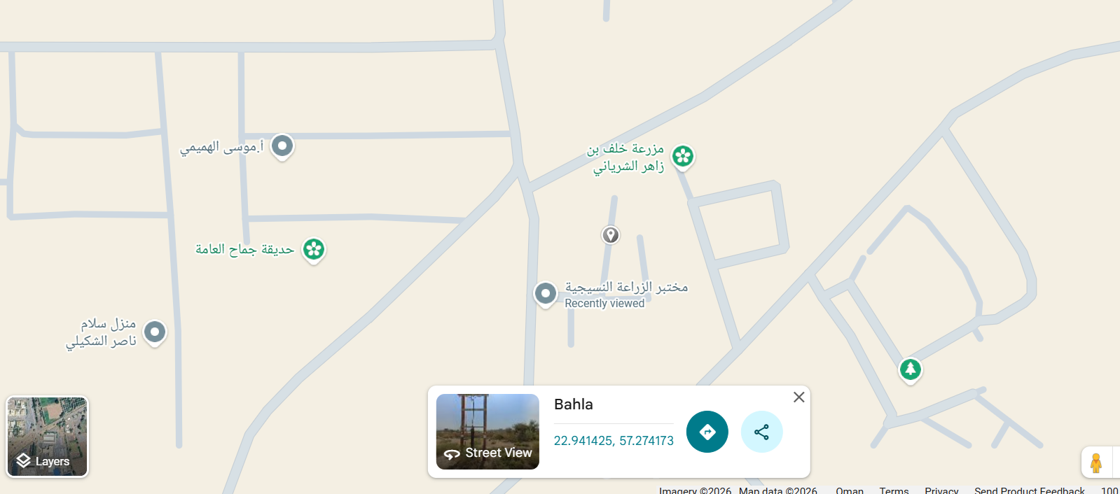

Collecting Data
Field data were collected using GLOBE protocols, which are as follows:
• Temperature, humidity, and rainfall protocols for the study site
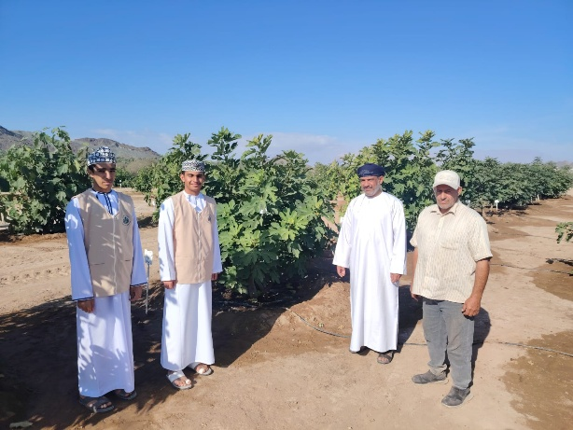

• Satellite images of vegetation cover known as False color

Sampling Method:
Data were collected from the following sites:
https://browser.dataspace.copernicus.eu/
https://www.globe.gov/

Data Entry:
The collected data were entered into the GLOBE electronic platform and included in the research.
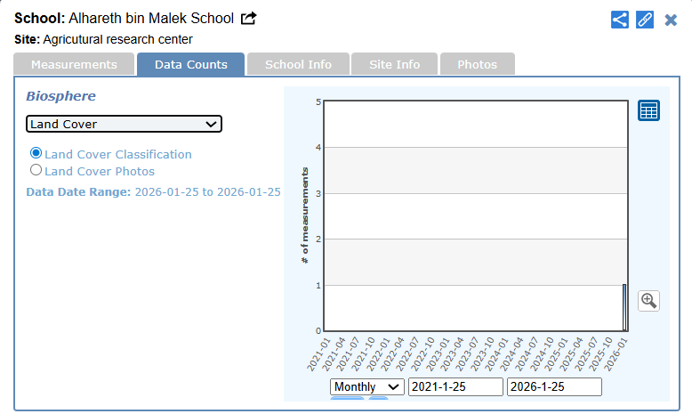

Data Analysis
The researchers collaborated with the Science and Technology Center in Al Dakhiliyah Governorate, represented by Professors Hilal Hamid Al-Qasabi and Ali bin Khalifa Al-Hinai, supervisors of the STEM program and laboratories. The claude.ai website was used to analyze data and obtain accurate statistics for the research.
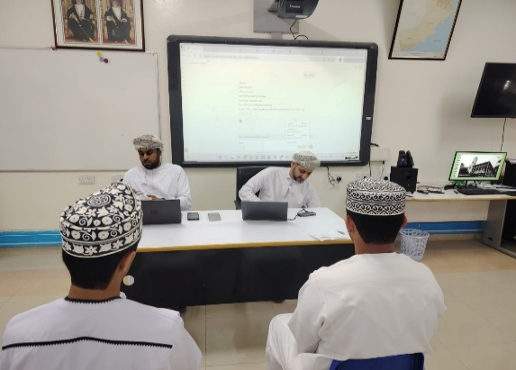
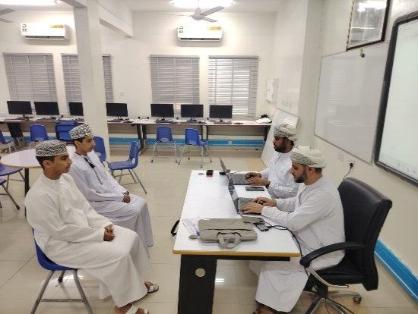
Data analysis included using the following mathematical and statistical operations:

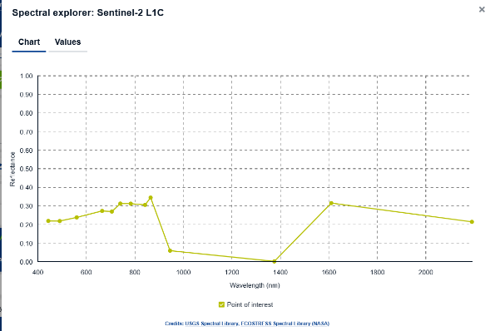
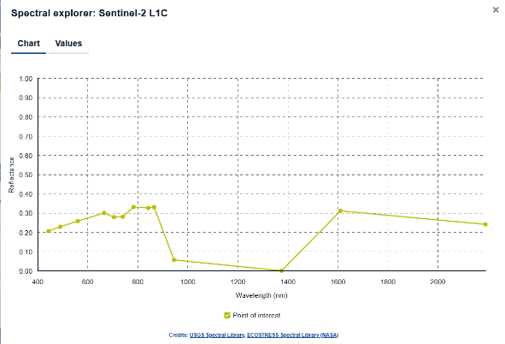
6 November 2023
1 November 2023

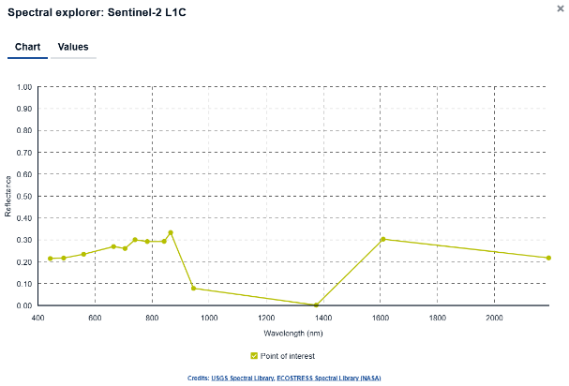
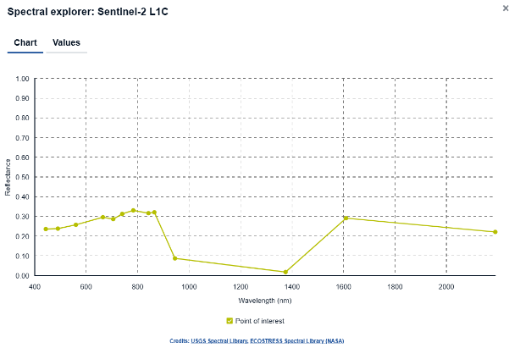
11 November 2023
16 November 2023

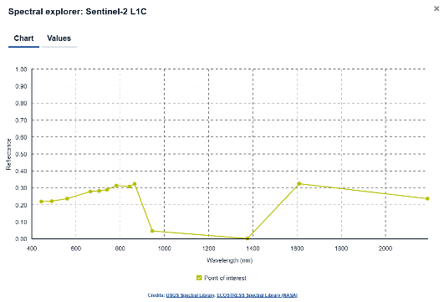
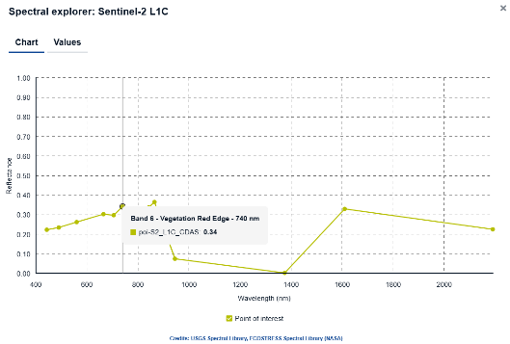
23 November 2023
26 November 2023

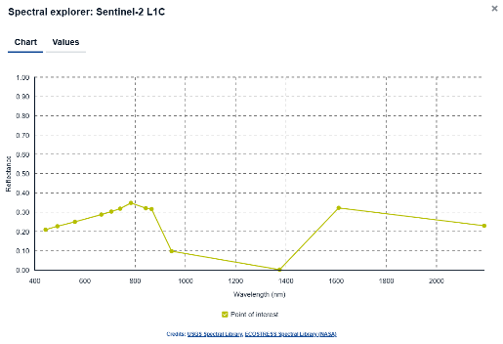
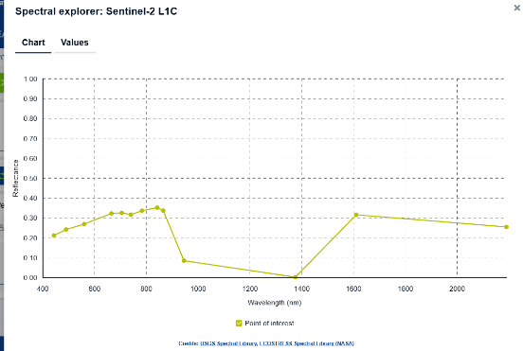
10 November 2024
5 November 2024

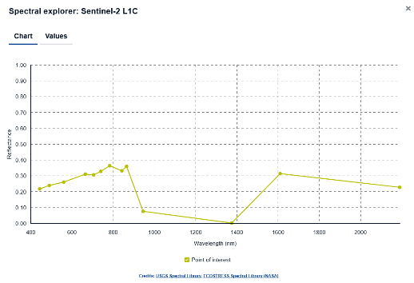
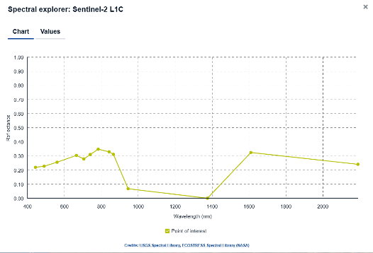
20 November 2024
15 November 2024

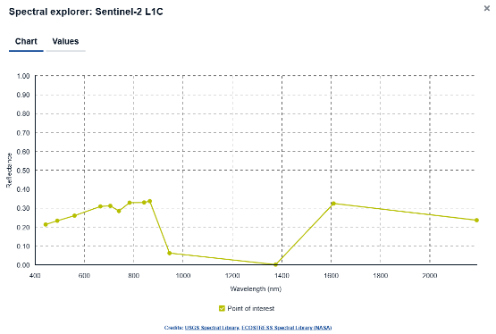
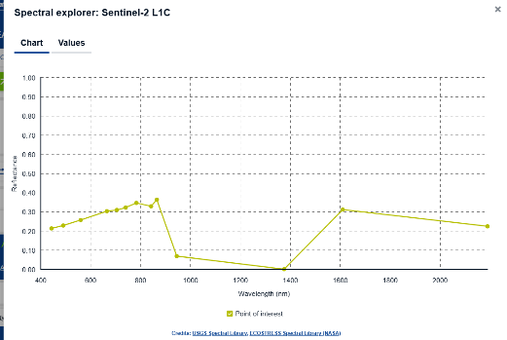
25 November 2024
30 November 2024

NDVI Calculation: Using satellite images to measure vegetation greenness levels.
Descriptive Statistics: Calculating averages, maximum and minimum values of vegetation cover.
Periods analyzed: November 2023
Statistic | Estimated NDVI Value | Environmental Description
Minimum (Min) | ≈ 0.12 | Dry areas, exposed soil or sparse vegetation cover
Maximum (Max) | ≈ 0.58 | Agricultural areas or relatively dense vegetation
Mean | ≈ 0.33 | Medium-density vegetation cover

and November 2024

Statistic | Estimated NDVI Value | Environmental Description
Minimum (Min) | ≈ 0.15 | Slight improvement in dry areas
Maximum (Max) | ≈ 0.68 | Clear increase in vegetation cover density
Mean | ≈ 0.41 | Better vegetation cover compared to 2023

Executive Summary
This report provides a comprehensive scientific analysis of temporal change in vegetation cover in Bahla City, studying the relationship between climatic variables (temperature, relative humidity, rainfall amounts) and the NDVI vegetation cover index.
Indicator | November 2023 | November 2024
Mean NDVI | 0.33 | 0.41
Minimum | 0.12 | 0.15
Maximum | 0.58 | 0.68
Improvement Rate |  | +24.2% improvement in vegetation cover

Correlation Analysis: To study the relationship between vegetation cover percentage and climatic variables such as temperature and rainfall amounts, to answer the research questions

Climate Data Analysis
Climate Data Summary (November-December 2023)
Climate data were collected from the Agricultural Research Center in Jama'h. During 31 days of monitoring: average temperature 26.4°C, average relative humidity 44.1%, total rainfall 0 mm.
Variable | Minimum | Maximum | Mean
Temperature (°C) | 24 | 28 | 26.4
Relative Humidity (%) | 30 | 58 | 44.1
Rainfall (mm) | 0 | 0 | 0 (drought)

Detailed Climate Data
Table 1: Climate Data - November 2023
Date | Temperature °C | Rainfall mm | Humidity %
15/11/2023 | 27 | 0 | 36
16/11/2023 | 27 | 0 | 47
17/11/2023 | 26 | 0 | 50
18/11/2023 | 26 | 0 | 52
19/11/2023 | 27 | 0 | 58
20/11/2023 | 26 | 0 | 52
21/11/2023 | 28 | 0 | 52
22/11/2023 | 27 | 0 | 54
23/11/2023 | 26 | 0 | 44
24/11/2023 | 28 | 0 | 42
25/11/2023 | 27 | 0 | 45
26/11/2023 | 27 | 0 | 47
27/11/2023 | 28 | 0 | 53
28/11/2023 | 28 | 0 | 51
29/11/2023 | 28 | 0 | 57
30/11/2023 | 28 | 0 | 51
Table 1: Climate Data - November 2023 (Part One)
Date | Temperature °C | Rainfall mm | Humidity %
01/12/2023 | 27 | 0 | 54
02/12/2023 | 27 | 0 | 45
03/12/2023 | 26 | 0 | 52
04/12/2023 | 27 | 0 | 41
05/12/2023 | 25 | 0 | 31
06/12/2023 | 26 | 0 | 33
07/12/2023 | 24 | 0 | 34
08/12/2023 | 25 | 0 | 41
09/12/2023 | 25 | 0 | 41
10/12/2023 | 25 | 0 | 30
11/12/2023 | 26 | 0 | 33
12/12/2023 | 26 | 0 | 34
13/12/2023 | 25 | 0 | 42
14/12/2023 | 24 | 0 | 30
15/12/2023 | 25 | 0 | 35
Table 2: Climate Data - December 2023 (Part Two)
Color Legend for Humidity Column:
Green: High humidity (≥50%) - Ideal conditions for growth
Red: Low humidity (<35%) - Potential water stress

Results and Discussion

NDVI Analysis Results
Comparison Between November 2023 and November 2024
Statistical analysis showed a clear improvement in vegetation cover between 2023 and 2024:
Metric | November 2023 | November 2024
Average NDVI | 0.33 | 0.41
Minimum Value | -0.37 | -0.07
Maximum Value | 0.75 | 0.82
These results indicate a clear improvement in vegetation cover density in the study area, which may be attributed to improved climatic conditions or water resource management practices.

Relationship Between Rainfall and Vegetation Cover
No rainfall was recorded during the study period (November-December 2023), which means:
• The vegetation cover present is not dependent on direct rainfall during the monitoring period
• The vegetation may rely on alternative water sources such as:
- Artificial irrigation
- Moisture stored in soil from previous periods
- Underground water
Therefore, no direct relationship can be established between rainfall and NDVI during this study period.

Effect of Temperature on Vegetation Cover
Air temperatures during the study period ranged between 24 and 28 degrees Celsius, which is a temperature range considered relatively suitable for the growth of most plants in arid and semi-arid environments. No extreme temperatures were recorded that could lead to thermal stress on plants.
These results indicate that temperature was not a limiting factor for plant growth during the study period, but likely contributed to supporting plant physiological processes such as photosynthesis, positively reflected in NDVI values. This is supported by Zhang's study (2024) which indicated that providing appropriate temperature for plants positively affects vegetation cover.

Effect of Relative Humidity on Vegetation Cover
Data showed that relative humidity ranged between 30% and 58%, values considered moderate in arid environments. Relative humidity is an influential factor in reducing evaporation rates and water loss from plants.
Results indicate a potential positive effect of relative humidity on vegetation cover density, as increased atmospheric humidity helps alleviate water stress, especially in the absence of rainfall.

Answers to Research Questions
First Question: What is the extent of change that occurred in vegetation cover in Bahla City during the study period?
NDVI index results showed clear improvement in vegetation cover density, represented by increased statistical values between 2023 and 2024, indicating positive development in the region's vegetation status.
Second Question: Is there a relationship between rainfall amounts and NDVI values?
Results did not show a direct relationship between rainfall and vegetation cover, due to the absence of rainfall during the study period, and it is likely that vegetation cover is supported by non-rainfall water sources.
Third Question: How does temperature affect vegetation cover?
Moderate temperatures contributed to providing a suitable environment for vegetation cover growth without recording clear negative effects.
Fourth Question: What is the effect of relative humidity on vegetation cover density?
Results showed that relative humidity plays a supporting role in improving vegetation cover density by reducing water stress on plants.

Research Conclusion
It can be concluded from this study's results that vegetation cover in Bahla City shows clear temporal and spatial variation, reflecting its influence by local climatic factors, particularly temperature and relative humidity. NDVI index results showed improvement in vegetation cover density between 2023 and 2024, despite the absence of rainfall during the study period, indicating the agricultural system's dependence on alternative water sources, such as artificial irrigation or soil-stored moisture from previous periods.
The research also found that moderate temperatures within the range of 24–28°C provided a suitable environment for plant growth, supporting physiological processes such as photosynthesis, positively reflected in vegetation cover health and NDVI values. Additionally, relative humidity played a supporting role in reducing water stress, enhancing vegetation cover stability under dry climatic conditions.
These results confirm the effectiveness of using remote sensing techniques, and NDVI index in particular, as an accurate tool for monitoring vegetation cover health and analyzing its temporal and spatial dynamics. They also highlight the importance of integrating field climatic data with satellite analyses to provide a comprehensive view of the relationship between vegetation cover and local climate.
Based on the above, it is recommended to continue monitoring vegetation cover over longer time periods, and expand the study scope to include additional field data and diverse vegetation cover types, contributing to supporting sustainable environmental and agricultural planning in Bahla City and similar areas.

Recommendations
• Continue annual monitoring of vegetation cover using remote sensing
• Use results to support agricultural planning and water resource management
• Expand the study to include longer time periods (5-10 years)
• Support spatial data with field measurements for verification

Acknowledgments
The team extends thanks to everyone who contributed to completing this work and making it successful to obtain the best results and facilitate tasks for the researchers, and we especially thank:
• Mr. Musa Al-Adawi, activities supervisor at the school.
- Mr. Issa Al ALsheikh the owner of NASA in Arabic who help us in understanding the use of Sentinel-2 Images.
• Mr. Hilal Al-Qasabi and Mr. Ali Al-Hinai, program supervisors and operators of the STEM data analysis workshop for students
• Engineer Rashid Al-Shakili for providing a suitable research environment and data collection and guiding students to complete the research

References
Al-Kindi, K. M., Al Nadhairi, R., & Al Akhzami, S. (2023). Dynamic Change in Normalised Vegetation Index (NDVI) from 2015 to 2021 in Dhofar, Southern Oman in Response to the Climate Change. Agriculture, 13(3), 592. https://doi.org/10.3390/agriculture13030592

Al-Dubaihi, Maha bint Abdullah. (2023). Change in vegetation cover density in Rawdat Khuraim, Saudi Arabia during 1998-2021 using remote sensing and geographic information systems. Journal of the Faculty of Arts, Port Said University, 23(23), 175-201. [In Arabic]
Cheng, Y., He, G., Luo, J., & Gu, H. (2024). Effects of climate change on temperature sensitivity of vegetation growth in Huang-Huai-Hai Plain: Spatial–temporal dynamics and ecological adaptability. Remote Sensing, 16(21), 4024. https://doi.org/10.3390/rs16214024
Khalbas, M. I., & Kadhum, J. H. (2025). Assessing seasonal variations of vegetation cover using NDVI in context of climate change in Wasit. Basrah Journal of Agricultural Sciences, 38(1), 324–335. https://doi.org/10.37077/25200860.2024.38.1.25
Wang, T. (2016). Vegetation NDVI change and its relationship with climate change and human activities in Yulin, Shaanxi Province of China. Journal of Geoscience and Environment Protection, 4, 28–40. https://doi.org/10.4236/gep.2016.410002
Zhu, L., Gong, H., Dai, Z., Xu, T., & Su, X. (2015). An integrated assessment of the impact of precipitation and groundwater on vegetation growth in arid and semiarid areas. Environmental Earth Sciences, 74(6), 5009–5021. https://doi.org/10.1007/s12665-015-4513-5
Al-Dubaihi, Maha bint Abdullah. (2023). Change in vegetation cover density in Rawdat Khuraim, Saudi Arabia during 1998-2021 using remote sensing and geographic information systems. Journal of the Faculty of Arts, Port Said University, 23(23), 175-201.

GLOBE Badges We Would Like to Obtain
I WORK WITH SATELLITE DATA
Uses NASA satellite data in research to study research question(s). Researchers explain how NASA satellite data is integrated into their research project and used to answer research question(s).
I Am a Data Scientist
Why you get it:
If your research shows deep data analysis use — such as analyzing NDVI data and comparing it with climate data, and clearly interpreting statistical results, this demonstrates data analysis skills.
Badge description:
Awarded to projects that include in-depth data analyses based on multiple data sources including GLOBE database data and analyses derived from other sources.
What it reflects:
Ability to handle big data and make scientific research conclusions from data analysis.
I Am an Earth System Scientist
Why you get it:
Your research discusses the relationship of vegetation cover with climatic factors (heat, humidity, NDVI) and demonstrates understanding of Earth system element interactions (atmospheric, biological).
Badge description:
Awarded to projects that demonstrate different Earth system interactions (such as atmosphere, vegetation cover, climate) and use more than one GLOBE protocol or more than one type of data to investigate a research question.
What it reflects:
Comprehensive understanding of how climatic factors interact with environment and observations.
I Am a Collaborator
Why you get it:
If the research is collective work between more than one student (or with a teacher/supervisor), and researchers' roles are explained in an organized manner.
Badge description:
Awarded when the research team demonstrates effective collaboration and coordination, and explains how each member contributed to completing the research.
What it reflects:
Teamwork skills and scientific communication.
I Make an Impact
Why you get it:
Your research shows clear local impact (such as recommendations for water resource management and agricultural climate in Bahla) and provides insights that can be used in environmental planning.
Badge description:
Awarded to projects that show how research led to positive impact in the local community or environment or provided clear recommendations that can be applied.
What it reflects:
Research ability to go beyond theoretical analysis to action and application.
I Work With a STEM Professional
Why you get it:
If you collaborated with a professor, researcher, or STEM specialist (science/environment/statistics) during research preparation or data analysis.
Badge description:
Awarded to projects that benefit from guidance from professionals in science, technology, engineering, or mathematics.
What it reflects:
Skill of working with scientists and specialists to enhance research quality.
I Am a Problem Solver
Why you get it:
Because your research addressed a research question about climate impact on vegetation cover, and used data to solve or understand a real scientific problem.
Badge description:
Awarded to projects that use scientific effort to solve or explore a specific environmental or climatic problem.
What it reflects:
Critical and methodical thinking skills in hypothesis verification and reaching scientific conclusions.

