*Cottonwood Creek Water Quality Assessment*

High School Ecology/AK Wildlife Classes 2024-25

Main Authors: Jameson Kalis, Lyra Abruska, Josh Olsen.

Contributors: Rebecca Brower, Roberto Leyva, Freda Oenga, Avery Palaniuk

Knik Charter School

**Abstract**

The purpose of this project is to monitor the temperature, pH, turbidity, and dissolved oxygen levels of the water in Cottonwood Creek to determine if the creek can sustain healthy salmon populations. We are learning about the lifecycle of salmon and salmon habitat through the *Salmon in the Classroom* curriculum, and we are participating in the Climate Change and My Community: Water and Fish Project through the IARC Arctic and Earth SIGNs Program at UAF.

Water quality data from Cottonwood Creek shows increasing temperatures and decreasing dissolved oxygen levels over time, indicating a growing risk to salmon habitat and long-term sustainability.

This research helps the community by identifying changes in water quality that threaten salmon habitat, supporting efforts to protect local ecosystems and subsistence resources.

**Background Information**

Our study site is located at Pedersen Park, Wasilla AK, latitude N 61.57460, longitude W -149.4173, and elevation was 384 meters. We named our site *L’ashch’i Betnu*, the traditional Dena’ina name given to this area according to *Shem Pete’s Alaska,* which means “Silt (Mud) Place Creek or Ashes Creek.”

The lower 1 mile of Cottonwood Creek is open to salmon fishing (except king salmon) on weekends, June 14 to April 15. Several thousand people fish here each summer and catch primarily sockeye salmon and to a lesser extent, coho salmon. All lakes of the Cottonwood Creek drainage, including Wasilla Lake are Closed year-round to all salmon fishing.  (http://www.adf&g.alaska.gov)

Salmon spawn in the upper portion of Cottonwood Creek, at our study site and into Wasilla Lake.  Spawning takes place late July through August with some salmon remaining into early fall.

According to the Alaska Department of Fish and Game *Salmon in the Classroom* curriculum, the water temperature must be between 5º C and 9º C, pH levels between 6.0 and 8.5, and the dissolved oxygen levels above 8-9 mg/L for adults or above 11 mg/L for developing eggs, for the creek to be healthy enough to sustain and rear salmon.

We decided to do this research because we wanted to make sure that the water was habitable for salmon to live in.  We knew that fish needed dissolved oxygen, little light, cool and clean water, which is uncontaminated, and having a steady flow.

According to the Alaska Department of Environmental Conservation Waterbody Field Report, Cottonwood Creek, the water is impaired with levels of fecal coliform and *E. coli* exceeding water quality criteria. Unfortunately, due to new developments, our site is worse than it was in 2009. While we were studying, we saw a large quantity of foam as well as trash in the park and in the water. Sometime between our last research trip of the 2023-2024 school year and our first research trip of this school year, the trees around our research site were cut down to expand the park area.

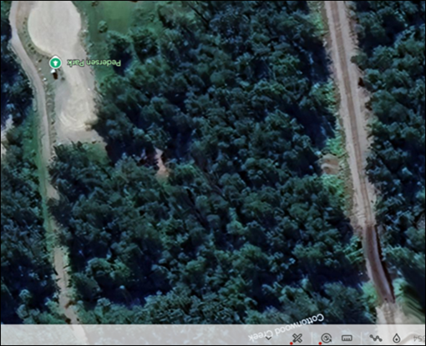 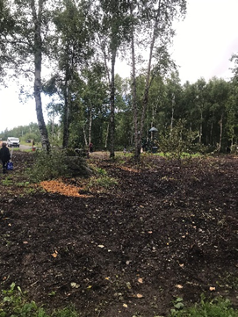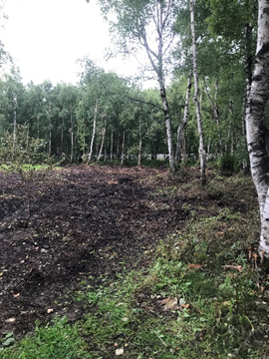

**Figure 1:** Aerial photo of Pedersen Park prior **Figure 2:** Creek-level photo of Pedersen Park after trees were

to removing trees. removed. *Photo credit: Faith Lussow. August 29, 2024*

Retrieved from *Google Earth October 29, 2024*

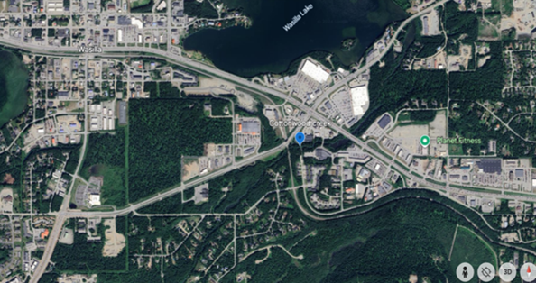

**Figure 3**: Map of the study site location (blue) Pedersen Park on Cottonwood

Creek, Wasilla, AK. *Google Earth October 29, 2024*

**Research Question & Prediction**

Our research question: Is the water habitable for salmon to live in, and if it isn’t habitable, why? In the past 21 years, what has changed?

We predict that if the water temperature is between 5ºC and 9ºC, the pH levels between 6.0 and 8.5, and the dissolved oxygen levels are above 8-9 mg/L for adults or above 11 mg/L for developing eggs, then the creek should be healthy enough to sustain and rear salmon, although there are other contributing factors as to why the creek is healthy or unhealthy.

**Research Methods**

We collected our data according to the GLOBE Hydrosphere Protocols for water temperature, pH, and dissolved oxygen with probes, and transparency using a transparency tube.

Data was collected for 7 weeks in the Spring of 2024 by the High School AK Wildlife Class and the Middle School Science Class, and 7 weeks this Fall 2024 by the Ecology Class. AK Wildlife class collected data for 7 weeks in the spring 2025.

We compared our data sets with data from the Alaska Department of Environmental Conservation that was collected at various times of the year: in 2003-2005, 2006 (year-round), 2010-2012 (spring and summer), 2023 (summer and fall).

We used the GLOBE app for data entry and retrieval.

**Data**

Figure 4: Plot of all DEC and student temperature data over time shows a gradual increase. Several data were above 30° C, which we questioned for Alaska waters, even in summer. Each data set has its own trend line. The student data was taken during the Spring and Fall, whereas the DEC data was taken at various times of the year. Many of the DEC data points were reported in degrees F and it was difficult to know what to do with this data.

Figure 5: Plot of temperature data below 20° C.  In the 2023 DEC Report, the maximum temperature was 20.7, so we eliminated possible sources of error. The plot shows a steeper increase in temperature than Figure 4, however, the y-axis scale is different on this plot.

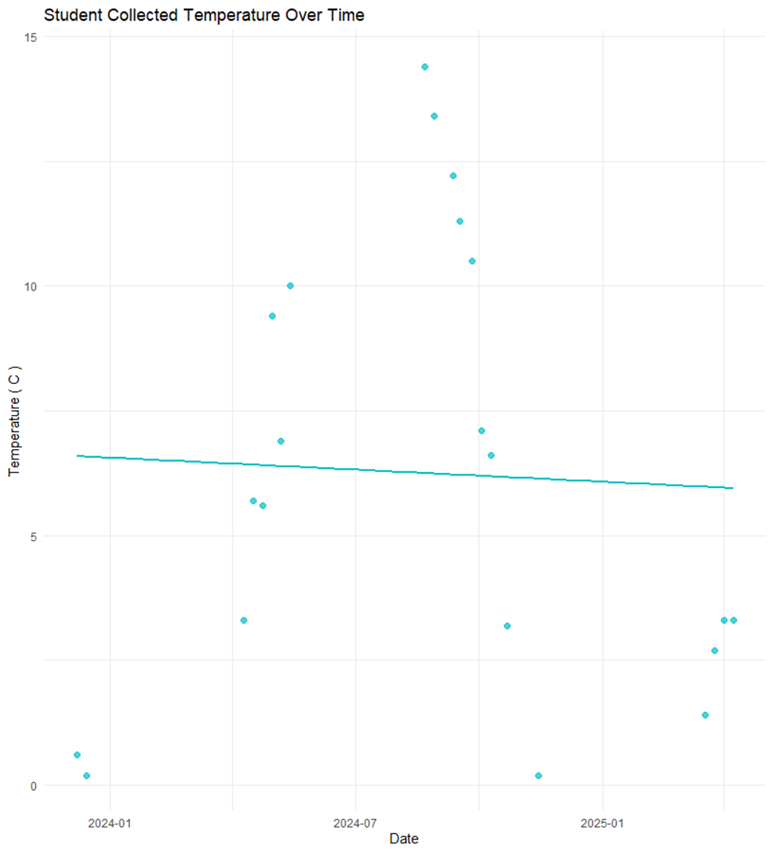

Figure 6. Plot shows the student data taken during the Spring of 2024, Fall of 2024, and Spring of 2025. No data was collected during the Summers, so our data does not reflect the same overall trend that the DEC data shows.

Figure 7: Plot of Dissolved Oxygen data over time shows a steady decrease from 2003 to 2025. This follows our expect pattern that as the temperature increases, dissolved oxygen decreases. The DEC data taken between 2010 and 2015 were reported in percent DO, whereas all other data was reported in mg/L oxygen, so we converted all data to percent DO to compare.

Figure 8: Plot shows student dissolved oxygen data taken during the Spring 2024, Fall 2024, and Spring 2025 that we converted from mg/L DO to percent DO. Our data shows that the amount of dissolved oxygen is gradually decreasing over time.

Figure 9: Plot shows the DEC and student data for pH taken over time. The DEC data shows that the pH is gradually increasing over time.

Figure 10: Plot showing the student pH data collected Spring 2024, Fall 2024, and Spring 2025. The trend line shows that the pH is decreasing slightly over time.

Figure 11: Plot showing transparency data collected by the DEC and students over time. The DEC had collected turbidity data, so we converted that data to transparency.

Figure 12: Plot shows student transparency data collected Spring 2024, Fall 2024, and Spring 2025. The variance in the student transparency data was due to the water freezing over in the transparency tube.

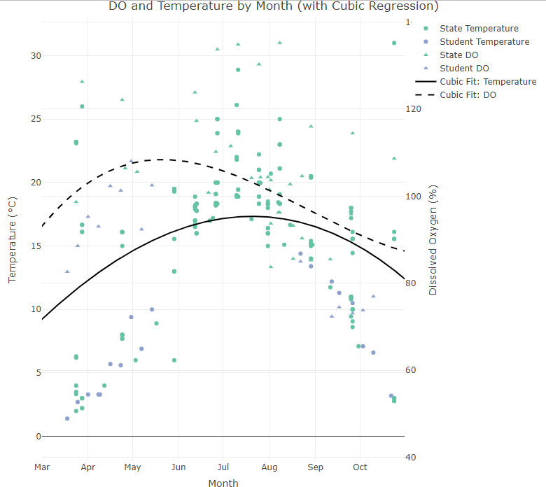

Figure 13: Plot shows temperature and DO for student and DEC collections. It groups by month, ignoring years, to allow for visualization of seasonal trends. I apply a cubic regression (anything less would be meaningless for seasonal trends) on each variable (temp and DO).

This plot (slightly) reflects the inverse relationship between temperature and DO. It's non-obvious from looking at a temporal graph like this, but the relationship is there. (Ky Friedman)

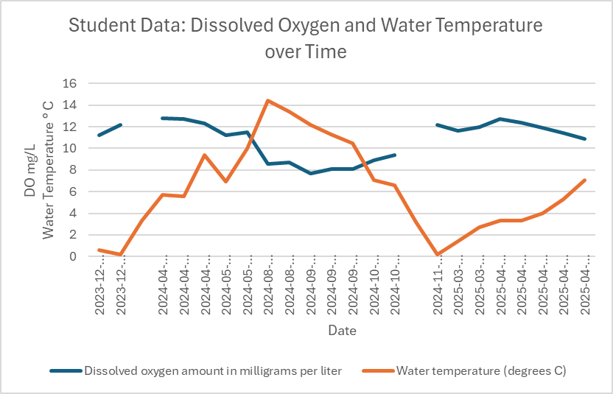

Figure 13: Plot shows the trend that when water temperatures increase, DO levels decrease. Gaps in DO data are due to cold temperatures that prevented the probe to work properly.

**Discussion**

We analyzed the DEC and our temperature data in two ways.  First we included all of the raw data.  The DEC had recorded temperatures above 30°C.  According to the 2023 DEC Field Report, the temperature ranged was 11.75° - 20.7°C for the data collected in 2023. The temperature range for our data was 0.6° - 14.4°C.  Because of that we analyzed the data again looking just at temperatures below 20°C.  Our analysis of the DEC data and our data showed that the water temperature is steadily increasing over time.

According to the 2023 DEC Field Report, the dissolved oxygen range was 8.48 - 9.93 mg/L.  The dissolved oxygen range for our data was 7.7- 12.8 mg/L.  The DEC data that was recorded between 2010 and 2012 was recorded in % DO, whereas, the rest of the data was recorded in g/mL, so we converted all data to % DO.  Our results show that the dissolved oxygen is steadily declining, making the creek less habitable for the salmon as more time passes.

This is important because there are fewer places for salmon to spawn and can eventually make the salmon population decline which will make subsistence less for the people who rely on the salmon to live.

This study was also a great lesson in analyzing large historical data sets and making sense of it all.

**Possible Sources of Error and Limitations**

While doing this study, we had sources of error, including seasonal changes in water temperature and Dissolved Oxygen, timeframe (seasonal and time of day) of data collected, protocols different from the Department of Environmental Conservation, errors in recording data (ex: recorded as Fahrenheit, unable to find out/ ask about past data)

Our school schedule limited our time for data collection, due to class times and summer break.

**Next Steps**

* We plan on taking action and spreading awareness about the declining quality of the water and finding what’s causing this decline then eventually bring our data to the city.
* We will publish our full report including an analysis of the surface temperature, air temperature, clouds and macroinvertebrate data that we collected.
* The class will continue to monitor the creek

Suggestions:

* Replant trees and shrubs to increase shade
* Have trash cleanup days to decrease the amount of trash
* Septic tank inspections (residents and businesses)

**References**

**GLOBE.gov**

**Kraus, Fritz**. (1999).  A Guide to Classroom Salmon Egg Incubation in Alaska. Alaska Department of Fish and Game Special Publication No 99-2, Anchorage, Alaska.

**Matanuska-Susitna Basin Salmon Habitat Partnership**. (2009) Healthy Salmon Healthy Communities.

**Anchorage School District**. (2009). Salmon in the Classroom Curriculum. Anchorage, Alaska.

**Kari, James and Fall, James A**. (2016). Shem Pete’s Alaska: The Territory of the Upper Cook Inlet Dena’ina. Fairbanks, Alaska: University of Alaska Press.

**Oleksiak, A.** 2023. Alaska Department of Environmental Waterbody Field Report Cottonwood Creek: Wasilla, Alaska.

**Acknowledgements**

***We acknowledge the Dena’ina People on whose traditional lands we gather in Wasilla.  We also acknowledge all Indigenous people of Alaska.  Thank you for your past and present stewardship of the waters, plants and animals of this place.***

**Ky Friedman,** DOE Energy Innovator Fellow, Knik Tribe

**Jackie McConnell**, Environmental Project Coordinator, Knik Tribe

**Meghan Montagne**, Aquatic Wildlife Project Manager, Knik Tribe

**Laura Eldred,** Section Manager, Nonpoint Source Water Quality Alaska Department of Environmental Conservation

**Christi Buffington,** Science Education Director and Manager of Geographic Information Network of Alaska, University of Alaska, Fairbanks

**Tori Brannan,** Science Education Specialist & Program Coordinator, University of Alaska, Fairbanks

**Katie Villano Spellman,** Research Associate Professor, International Arctic Research Center, University of Alaska, Fairbanks

**Elena Sparrow,** GLOBE Alaska Partnership Director, University of Alaska, Fairbanks

**Lulu Chamblee,** Knik Tribe Liaison, Knik Charter School

**Benteh STEAM Academy Staff: Komisa, Kat, Lily, Brock** and others for transportation to the study site.