Theme of 2024 IVSS: - Climate Investigations: Understanding Earth as a System.

Title of Project: Evaluating Urban Heat Island and Climate Parameters
Grade Level: Secondary School (grades 9 -12, ages 14 – 18 years)
Report Type: 2024 International Virtual Science Symposium Report

Student Names
- Ayomiposi Ojumu
- Adedemeji Odunjo
- Titilayo Olatunji
GLOBE Teacher Name
Mr. Olawunmi Fasakin (GLOBE Certified)

School Name
St. Peter’s Unity Secondary School, Akure (SPUSSA), Ondo State

Country
Nigeria

Date
6th March 2024

Table of Content

- Abstract ……………………………………………………………..……….…….3
- Research Questions ………………………………………………………...……4
- Introduction and Literature Review …………………………………..…….……4
- Research Materials and Methods ……………………………………..….……..4
- Results and Data …………………………....…….……………..………,….…..10
- Discussion …………………………………………………….………………..…15
- Conclusion ……………………………………………………………..…………16
- Bibliography/Citations …………………………………………………..……….17
- Acknowledgments ……………………………………………………...……..…18
- Badge Descriptions/Justifications …………………….……………….…..… 18

Abstract:
The land transformation or land use effects such as human population growth, increase in physical buildings, road and bridge construction, development of factories and industrial estates in urban communities have impacted local or regional climates of most towns and cities. The transformation of cities into heat islands is one of the most important results of microclimate change. In this investigation, variations of some important climatic factors which are air temperature, surface temperature, ambient or room temperature, relative humidity, atmospheric pressure, wind speed, wind direction and wind gust were carried out with the view to observe microclimate changes. The infra-red thermometer (IRT) was used to measure the surface temperatures, the digital hygro-thermometer was used to record the relative humidity values, ambient and air temperatures, digital aneroid barometer was used to measure atmospheric pressure while digital anemometer app was used to measure wind speed, wind gust and wind direction. Cloud cover and surface conditions were also taken. Climatic data collected were uploaded to the GLOBE website via the GLOBE Observer app. The result of this investigation shows that the ambient temperatures range from 26.50 – 34.60 (^{O}C), air temperature (27.10 – 36.40 ^{O}C), surface temperature (30.6 – 37.8 ^{O}C), humidity (10 – 35%), atmospheric pressure (756.3 – 760.6 mmHg and 1008.3 – 1014.0 mBar), wind speed (0.7 – 4.8 mps) and wind gust (1.0 – 5.4 mps). A maximum surface temperature of 37.8 ^{O}C was recorded. The sharp decreases and increases observed in the graphs, that is, variations observed, could be attributed to what is referred to as ‘energy budget’ effects or urban heat island characteristics. Furthermore, the thermal contrasts could be attributed to radiation influences and the surface thermal properties; and sensible heat density emanating from increased absorption of radiation and anthropogenic heat sources. A moderate correlation between surface temperature and air temperature (correlation coefficient of R² = 0.2576, thus R = 0.5075) was established. This means that as air temperature increases, surface temperature also tends to increase changes showed the effect of heat island on urban climate parameters. The surface temperature across the sites suggests that this data set might be showing temperature variations that could be indicative of climate change within the short period of days. The findings of this study highlight the importance and necessity of considering urban heat island in understanding the local climate dynamics and how they might be influenced by or contribute to broader climatic trends.
Keywords: Climate change, urban heat island effect (UHIE), urban microclimate, climatic parameters.
This investigation is in support of the Year of Climate and Carbon (YCC), a GLOBE action and awareness campaign from August 2023 – August 2024.

Research Questions:
- Does urban heat island cause climate change?
- Is there any relationship between surface temperature and the other climatic parameters?
Introduction and Review of Literature:
The land transformation or land use effects such as human population growth, increase in physical buildings, road and bridge construction, development of factories and industrial estates in urban communities have impacted local or regional climates of most towns and cities. The transformation of cities into heat islands is one of the most important results of microclimate change.
In this investigation, variations of some important climatic factors which are air temperature, surface temperature, ambient or room temperature, relative humidity, atmospheric pressure, wind speed, wind direction and wind gust were carried out with the view to observe microclimate changes. The infra-red thermometer (IRT) was used to measure the surface temperatures, the digital hygro-thermometer was used to record the relative humidity values, ambient and air temperatures, digital aneroid barometer was used to measure atmospheric pressure while digital anemometer app was used to measure wind speed, wind gust and wind direction. Cloud cover and surface conditions were also taken.
The aim of this study was to determine how the earth systems are impacted by climatic changes. Data collected by the measuring device were uploaded to the GLOBE website via the GLOBE Observer app. The objectives are to visualize the relationships between carbon dioxide and the predictor variables.
Research Materials and Methods:
- Research Materials
Surface (Land) Temperature @ SPUSSA Atmosphere Study and Soil Moisture Sites, Akure, Nigeria
Figures 1 and 2 show surface temperature measurements on cemented interlocking pavers floor while Figures 3 and 4 illustrate surface temperature measurements on bare soil surface. GLOBE students from St. Peter’s Unity Secondary School, Akure (SPUSSA), Ondo State, Nigeria participating in the December UHIE campaign for the month of December 2023. The infrared thermometer (IRT) was used by the GLOBE students. The device measures temperature by sensing the infrared radiation (light) coming from a surface. All observed measurements or our ground observations were sent to the GLOBE database via the GLOBE observer app for satellite comparisons and matching reports. Protocols: Surface Temperature Protocols.
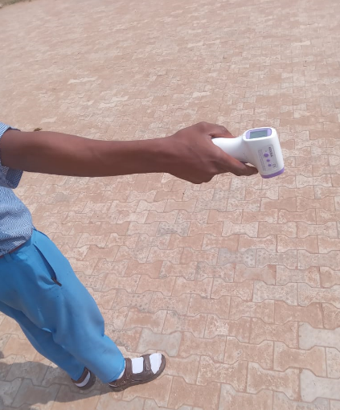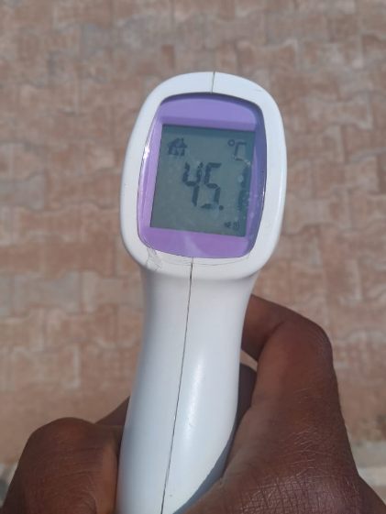
Figure 1. GLOBE Student taking surface temperature measurement from a cement floor within the school compound.
Figure 2. GLOBE Student taking surface temperature data from a cement floor in the school site.

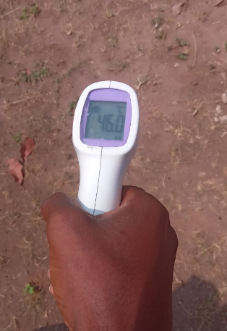
Figure 4. Proper positing of the IRT for surface temperature measurements.
Figure 3. SPUSSA GLOBE Students taking surface temperature from a bare soil in the Atmosphere study site.

Air Temperature and Relative Humidity Measurements @ SPUSSA Atmosphere Study and Land Cover Sites, Akure, Nigeria
The air temperature and relative humidity data were taken with the aid of the digital hygro-thermometer as shown in Figures 5 – 7. The combination of surface temperature with other climatic data such as air temperature and humidity help to investigate impact of land transform and other environmental studies at the rural or urban region.
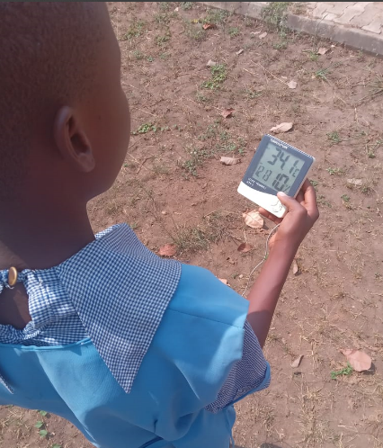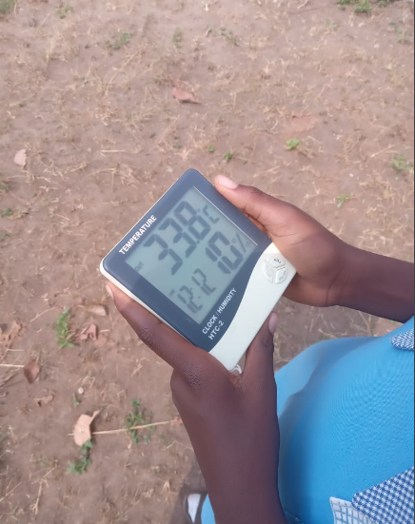
Figure 5. A GLOBE Student taking Air and Humidity measurements at the atmosphere sample site.
Figure 6. The digital hygro-thermometer device measures the air temperature and relative humidity values at the local solar noon.

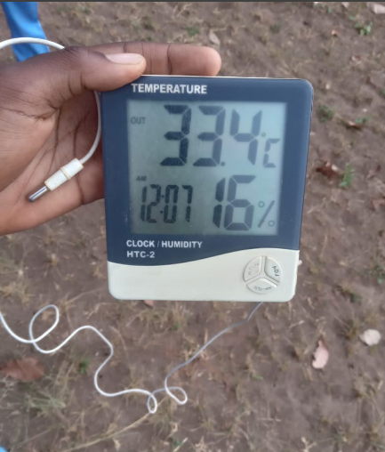
All observed measurements were sent to the GLOBE database via the GLOBE observer app.
Protocols: Atmosphere – air temperature and relative humidity.
Figure 7. A GLOBE Student taking air temperature and humidity at solar noon. site. The device sensor is also shown.

Soil Temperature and Soil pH Measurements @ SPUSSA Land Cover Sample Study and Soil Moisture Study Sites, Akure, Nigeria
The digital soil tester device, as shown in Figures 8 – 10, was used to collect soil temperature and soil pH data. These measurements could be integrated with surface temperature for various climatic studies on UHIE. Protocols: Pedosphere – soil temperature and soil pH.
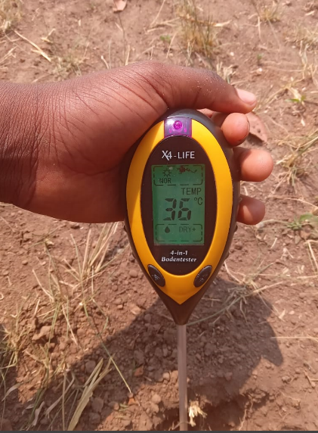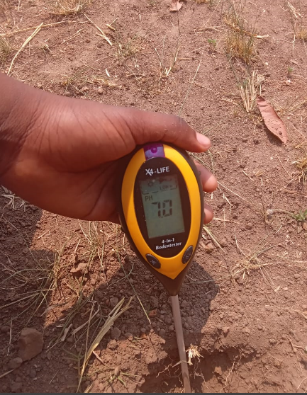
Figure 9. SPUSSA GLOBE Student taking soil pH from the Soil sample study site.
Figure 8. GLOBE Student observing soil temperature at a depth at the soil study site.

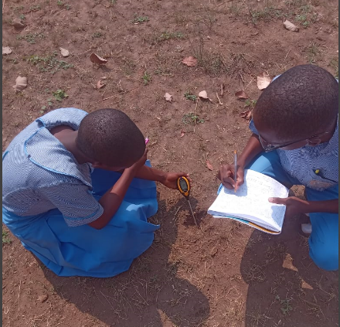
Soil temperature is the function of heat flux in the soil as well as heat exchanges between the soil and atmosphere. Soil temperature varies seasonally and daily which may result from changes in radiant energy and energy changes taking place through soil surface.
Figure 10. SPUSSA Students taking soil temperature and soil pH values at the Soil study site.

Measurements from soil study sites, that is, soil temperatures and temperatures from soil surfaces were not used or incorporated in this project write up. They were taken with other climatic data as daily or routine GLOBE activities in the school.
- Research Methods
The infra-red thermometer (IRT) was used to measure the surface temperatures, the digital hygro-thermometer was used to record the relative humidity values, ambient and air temperatures, digital aneroid barometer was used to measure atmospheric pressure while digital anemometer app was used to measure wind speed, wind gust and wind direction. Cloud cover, sky and surface conditions were also recorded. Climatic data collected were uploaded to the GLOBE website via the GLOBE Observer app.
- Data Analysis
The team was assisted with the data interpretation, analyses and processing procedures by STEAM Professionals and our GLOBE Techer. Statistical graphs were used to illustrate the trends or pattern of surface temperature, ambient temperature, air temperature, atmospheric pressure, wind speed, wind gust wind direction and humidity from the atmospheric sites over time in days in the month of December 2023.
We applied the following GLOBE Protocols in this research work: Atmosphere protocols – air temperature and relative humidity; Surface Temperature Protocols - surface temperature; Clouds protocols – surface and sky conditions.

Geographical Location of Akure City
Akure is the capital of Ondo state which is located along latitude 7º15’00” N to 7º18’22”.32N and longitude 5º 09’12” E to 5º 14’10” E. The city is situated in the tropical rainforest zone in Nigeria. The city comprises of two local government areas - Akure South and Akure North (Figure 11a). Akure city is the trade centre for a farming region where cocoa, yams, cassava, corn and tobacco and cotton are grown. At the time of the colonial rule in Nigeria, Owo, Ondo and Ekiti regions were merged to form a new province with its headquarters in Akure metropolitan city. Akure became the capital of Ondo State in 1976 when the state was created. As the state capital, Akure city is the centre of commercial and administrative activities and has witnessed a steady increase in population since creation.
Climate of Akure City
Akure metropolitan city is situated in the southern geopolitical zone of Nigeria. The tropical climatic environment is basically separated into two weather seasons namely: - dry season (November – March) and rainy season (April - October). The average yearly temperature ranges between 20 ⁰C – 31⁰C while humidity is relatively high but during dry season temperatures tend to go higher. Its annual rainfall is about 1150 mm and its vegetation is present in the rainforest zone (Afolabi & Aladesanmi, 2018).
Study Area (SPUSSA Community)
St. Peter’s Unity Secondary School, Akure (SPUSSA) is situated in the central region of Akure city in Akure South local government area (Figure 11b). SPUSSA community population consists of staff/teachers and their families living on the school’s compound with the male and female students.
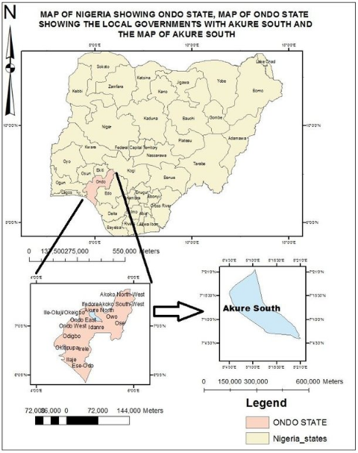
Figure 11a. Map of Nigeria showing Ondo State, map of Ondo State showing the local governments with Akure South and the map of Akure South (Babalola et al., 2019).
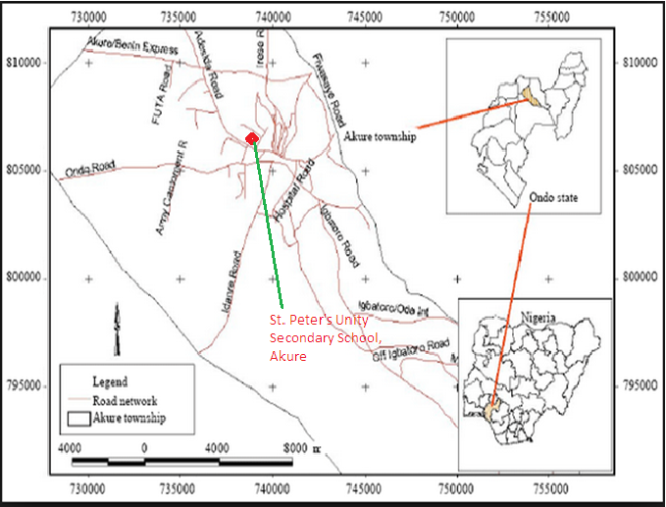
Figure 11b. Geographical map of Akure city, Nigeria showing the location of the study area – St. Peter’s Unity Secondary School, Akure (SPUSSA). Adapted from Ayeni (2011).

Results and Data: (Including GLOBE Data!)
Tables 1 and 2 illustrate the climatic data obtained from surface temperature, ambient temperature, air temperature, atmospheric pressure, wind speed, wind gust, wind direction and relative humidity with the corresponding summarized cloud cover observations – sky and surface conditions for the month of December 2023.
Table 1. Climatic Data/Observations at SPUSSA Atmosphere Study Sites December 2023.
DATE | AMBIENT TEMPERATURE  (°C) | AIR  TEMPERATURE (°C) | SURFACE  TEMPERATURE  (°C) | RELATIVE HUMIDITY  (%) | SURFACE/ CLOUD  COVER CONDITIONS
9/12/2023 | 32.80 | 33.00 | 33.6 | 35.00 | Leaves on tree, dry ground, cloud: scattered
10/12/2023 | 29.10 | 30.20 | 34.4 | 26.00 | Clouds: broken, leaves on tree, dry ground
11/12/2023 | 29.80 | 30.10 | 35.6 | 24.00 | Leaves on tree, dry ground, cloud: scattered, contrails found
12/12/2023 | 28.50 | 29.40 | 30.6 | 10.00 | leaves on tree and dry ground
13/12/2023 | 31.30 | 33.50 | 36.0 | 18.00 | leases on tree and dry ground
14/12/2023 | 26.50 | 27.10 | 37.8 | 10.00 | leaves on tree, dry ground and clear cloud
15/12/2023 | 31.20 | 31.00 | 34.1 | 18.00 | leaves on tree and dry ground
16/12/2023 | 31.40 | 32.10 | 34.2 | 19.00 | leaves on tree and dry ground
17/12/2023 | 33.70 | 34.40 | 36.8 | 17.00 | leaves on tree, dry ground, no clouds found
18/12/2023 | 34.60 | 35.20 | 37.0 | 15.00 | leaves on tree, dry ground, no clouds
19/12/2023 | 32.80 | 35.00 | 37.3 | 15.00 | leaves on tree, dry ground
20/12/2023 | 33.50 | 34.10 | 36.4 | 16.00 | leaves on tree, dry ground, no clouds
21/12/2023 | 33.90 | 34.60 | 37.0 | 15.00 | leaves on tree, dry ground
22/12/2023 | 34.10 | 34.60 | 36.7 | 17.00 | leaves on tree, dry ground, no clouds
23/12/2023 | 33.60 | 34.00 | 35.7 | 21.00 | leaves on tree, dry ground, no clouds found
24/12/2023 | 34.20 | 34.70 | 37.2 | 14.00 | leaves on tree and dry ground
25/12/2023 | 34.50 | 34.60 | 37.1 | 13.00 | leaves on tree, dry ground, no clouds found
26/12/2023 | 34.00 | 36.40 | 37.0 | 15.00 | leaves on tree, dry ground,
27/12/2023 | 34.30 | 35.70 | 37.6 | 14.00 | leaves on tree, dry ground, no clouds found
28/12/2023 | 32.20 | 33.90 | 36.0 | 13.00 | leaves on tree, dry ground, no clouds found
29/12/2023 | 32.50 | 33.90 | 36.4 | 14.00 | leaves on tree, dry ground, no clouds found
30/12/2023 | 32.40 | 34.00 | 36.5 | 14.00 | leaves on tree, dry ground
31/12/2023 | 33.70 | 34.20 | 36.5 | 16.00 | leaves on tree, dry ground, no clouds

Table 2. Climatic Data/Observations at SPUSSA Atmosphere Study Sites (December 2023).
DAYS | ATMOSPHERIC PRESSURE  (mmHg) | ATMOSPHERIC  PRESSURE  (mbar) | WIND SPEED  meters per second  (mps) | WIND GUST (mps) | WIND DIRECTION
9/12/2023 | 760.6 | 1014.0 | 1.7 | 5.4 | SE
10/12/2023 | 758.3 | 1011.0 | 1.0 | 1.4 | SE
11/12/2023 | 759.4 | 1012.5 | 1.6 | 2.5 | S
12/12/2023 | 758.3 | 1011.0 | 4.8 | 5.0 | SW
13/12/2023 | 758.3 | 1011.0 | 1.9 | 2.4 | SW
14/12/2023 | 758.8 | 1011.7 | 2.0 | 3.2 | W
15/12/2023 | 758.0 | 1010.6 | 1.9 | 3.1 | SW
16/12/2023 | 757.9 | 1010.5 | 2.3 | 3.6 | NW
17/12/2023 | 756.3 | 1008.3 | 1.7 | 2.5 | W
18/12/2023 | 756.4 | 1008.5 | 1.7 | 2.9 | W
19/12/2023 | 756.6 | 1008.7 | 1.3 | 2.5 | NW
20/12/2023 | 757.9 | 1010.4 | 1.9 | 2.6 | SE
21/12/2023 | 757.9 | 1010.5 | 0.9 | 2.4 | NW
22/12/2023 | 758.2 | 1010.8 | 2.0 | 3.4 | W
23/12/2023 | 759.4 | 1012.5 | 2.3 | 3.3 | W
24/12/2023 | 758.4 | 1011.1 | 0.7 | 2.4 | SW
25/12/2023 | 757.9 | 1010.4 | 1.5 | 2.3 | W
26/12/2023 | 760.0 | 1010.3 | 0.8 | 1.0 | NW
27/12/2023 | 759.1 | 1011.2 | 0.9 | 1.6 | NW
28/12/2023 | 760.1 | 1013.4 | 1.5 | 1.9 | W
29/12/2023 | 759.6 | 1012.7 | 1.0 | 1.9 | SW
30/12/2023 | 759.7 | 1012.9 | 1.0 | 1.8 | NW
31/12/2023 | 758.2 | 1010.8 | 1.4 | 2.5 | SW

The daily variations of the urban heat differences with respect to trends in climatic parameters over time in days are presented in Figures 12 – 16.
Figure 12. Surface Land and Air Temperature Variations over time (days) from 'SPUSSA' Atmosphere Study Site, Akure, Nigeria (December 2023).
Temp (ºC)

Figure 13. Surface Land and Humidity Variations over time (days) from 'SPUSSA' Atmosphere Study Site, Akure, Nigeria (December 2023).

Figure 14. Atmospheric pressure (mmHg) Variations over time (days) from 'SPUSSA' Atmosphere Study Site, Akure, Nigeria (December 2023).

Figure 15. Atmospheric pressure (mBar) Variations over time (days) from 'SPUSSA' Atmosphere Study Site, Akure, Nigeria (December 2023).

Figure 16. Wind speed variation over time (days) from 'SPUSSA' Atmosphere Study Site, Akure, Nigeria (December 2023).

Figure 17 shows the correlation coefficient between surface temperature and air temperature over the study area.
AIR TEMP (^{O}C)
Figure 17. Correlating between surface temperatures and air temperatures.

Discussion:
- Does urban heat island cause climate change?
From Tables 1 and 2, the ambient temperatures range from 26.50 – 34.60 (^{O}C), air temperature (27.10 – 36.40 ^{O}C), surface temperature (30.6 – 37.8 ^{O}C), humidity (10 – 35%), atmospheric pressure (756.3 – 760.6 mmHg and 1008.3 – 1014.0 mBar), wind speed (0.7 – 4.8 mps) and wind gust (1.0 – 5.4 mps). A maximum surface temperature of 37.8 ^{O}C was recorded. The wind movements were majorly observed towards the western direction of the area of investigation. The significant surface and cloud conditions observed were leaves on trees, dry ground, no clouds found. It should however noted that the investigation was carried out during the harmattan period where no or less amount of rainfall was experienced. This explains the reason for the low values of relative humidity.
Figure 12 illustrates the daily variations of surface land and air temperature changes. Between 11/12/2023 and 15/12/2023 the two graphs depict ‘sharp decreases and increases’ after which both started to have similar trend. This sharp decreases and increases could be attributed to what is referred to as ‘energy budget’ effects. Furthermore, the thermal contrasts could be attributed to radiation influences and the surface thermal properties; and, sensible heat density emanating from increased absorption of radiation and anthropogenic heat sources, mainly obtained from industrial activities and vehicles, could also be responsible for this heat differences.
Figure 13 presents the surface land temperature and relative humidity changes for the period of 9th – 31st December 2023. The decreasing trend of the humidity measurements compared with the relative increase in the values of the surface temperature is due to the harmattan season experienced in the southwestern part of Nigeria during the period of intensive observation. The surface temperature across the sites suggests that this data set might be showing temperature variations that could be indicative of climate change within the short period of days (Figure 5).

Figures 14 and 15 depict daily atmospheric pressure variations. The variations in these cases are do give any striking effects.
- Is there any relationship between surface temperature and the other climatic parameters?
Figure 17 illustrates a fair positive correlation between surface temperature and air temperature (correlation coefficient of R² = 0.2576, thus R = 0.5075). This means that as air temperature increases, surface temperature also tends to increase, which is statistically significant. Overall, the data suggests a moderate correlation between surface temperature and air temperature at the study area. There is a moderate positive correlation between relative humidity and air temperature, which is statistically significant.

Conclusion:
The charts illustrate daily variations of urban thermal or heat differences during the period of study 9th – 31st December 2023. The variations observed may be because of different causes of the urban heat island characteristics or energy budget. Major properties responsible for thermal contrasts could be attributed to radiation influences and the surface thermal properties. In addition, sensible heat density derived from increased absorption of radiation and anthropogenic heat sources, mainly obtained from industrial and vehicles, could also be responsible for this heat differences. A moderate correlation between surface temperature and air temperature (correlation coefficient of R² = 0.2576, thus R = 0.5075) was established.
The combined analysis of these graphs can provide insights into the environmental conditions at the study area and how they might be interrelated. For instance, higher surface and air temperature values could be indicative of increased surface heat attributes, which is a significant contributor to climate change. The relative humidity and air temperature data can help in understanding the local climate dynamics and how they might be influenced by or contribute to broader climatic trends.
.
Recommendation
How to prevent global warming include the following:
- Adoption of renewable energies such as solar, wind, biomass and geothermal, that is, moving away from fossil fuels.
- Reducing our consumption of energy and water by using more efficient devices such as Light Emitting Devices (LED) light bulbs, innovative shower systems.
- Promoting sustainable transportation system. Examples are electric trains.
- Building sustainable infrastructure to reduce the CO2 emissions from buildings and building new low energy physical structures.
- Sustainable agriculture and forest management.

Bibliography/Citations:
- Afolabi, O.J., & Aladesanmi, C.O. (2018). Seasonal variation in distribution and
abundance of mosquitoes (Diptera: Culidae) in Akure North local government area, Ondo State, Nigeria, Uttar Pradesh Journal of Zoology, 38, 149–159.
- Amuka, J.I., Asogwa, F.O., Ugwuanyi, R.O., Omeje, A.N., and Onyechi, T. (2018).
Climate change and life expectancy in a developing country: Evidence from
greenhouse gas (CO2) emission in Nigeria. Ecojournals, 8(4)
- Ayeni, A., (2011). Malaria morbidity in Akure, Southwest, Nigeria. A temporary
observation in a climate change scenario, Trends in Applied Sciences Research, 6, 488–494.

- Lindsey, R. (2023). Climate change: Atmospheric carbon dioxide
Acknowledgments
- We expressed our profound gratitude to Mrs. O. Adegoke, the Permanent Secretary, Ministry of Education, Science and Technology, Akure, Ondo State, for her constructive advice and assistance to the implementation of GLOBE programmes in schools in Ondo State.
- Our gratitude and appreciation go to Mrs. F.M. Arowosade, Principal of St. Peter’s Unity Secondary School, Akure (SPUSSA), Ondo State, Nigeria for her technical support, moral advice and assistance during the study.
- We also appreciate the efforts and dedication of our GLOBE Teacher in person of Mr. O. O. Fasakin. He is focused on the attainment of the vision and mission of the GLOBE programme. We salute his courage and time in the course of the research project.
- We thank and appreciate the support of the Country Coordinator, in person of Mrs. Aminulai Modupe Salamotu.

Badge Descriptions/Justifications
I am a Collaborator: Working together (in collaboration) as a team has contributed to our research by evaluating climatic parameters for climate change. Moreover, we have three connected GLOBE teams working as a group. The members include Feranmi Ehindero, Ayodeji Ayotunde, and Olayinka Oloda. The second team was responsible for collection data such as, air temperature, surface temperatures and relative humidity measurements. The team members are Bukola Adewole, Faith Adedugbe and Esther Oluborode. The third team was responsible data gathering and collation. The members include Ojumu, Olatunji and Michael Solomon. They create a database record of the results analysis before sending to GLOBE database server through the GLOBE app.

I make an Impact: By advising the school management on how to mitigate the effects of climate change and possible hazards.

I am a STEM Professional:
Dr. S. O. Oladele from the Agricultural Engineering Department, School of Engineering and Engineering Technology (SEET), Federal University of Technology, Akure, Ondo state, Nigeria is a Lecturer who assisted in the aspect of data interpretation and analyses. Prof. Babasola Williams from Federal University of Technology, Akure, Ondo state, Nigeria who assisted in procuring the measuring device.
Mr. Olawunmi Fasakin (GLOBE Teacher) from St. Peter’s Unity Secondary School, Akure, Nigeria, who is an Educational Physicist, led the GLOBE team through taking improved precision while taking the data/observations with assistance in the areas of project write-up, editing and constructive ideas. These professionals tutored the students on precautionary steps taken during our research so as to maintain GLOBE standardized protocols and rubrics.

I am a DATA Scientist:
The research work was data driven. GLOBE SPUSSA team members collected various data measurements on environmental variables or physicochemical parameters that influence the climate change. Data analyses and data interpretations were carried out using statistical charts, tabular presentation of figures/numbers, statistical techniques.

