Analysis of Precipitation and Select Water Quality Parameters
on Crayfish Activity in the Rouge River

Student Researchers:
Samer Ayache, Mohammed Harp, Razan Shams

School:
Crestwood High School,
Dearborn Heights, MI 48127

High School Science Teacher:
Mrs. Diana R. Johns

March 7, 2023

Table of Contents

- Abstract ………………………………………………….……………..……………………………. 3
- Research Questions…………………………………………….…….…………………….………… 3
- Introduction and Review of Literature……………………………….…..……………………………3-4
- Null Hypothesis ………………..………………………………………………….……..……………4-5
- Research Methods ……………….………………………………………………….………..……… 5-9
- Results ……………….……………………………………………………………………………… 9-13
- Discussion ……………………………………………………………………………………...……13-15
- Conclusion ………………...…………………………………………………………………………15-16
- Research Limitations …………………...…………………………………………………………...16-17
- Citations/Bibliography ………………………………………...…………………………………… 17-18
- Acknowledgements …...……………………………………………………………………………. 18
- Badges …………………………………………………………………………………………….…18-19

Abstract: The crayfish research in this study focused on a section of the Middle Branch of the Rouge River that flows through a portion of the Crestwood School District in Dearborn Heights, Michigan. Crayfish traps were deployed at two locations in order to investigate the possible effect of lentic versus lotic habitats on crayfish populations. During the two months that this project collected data, no crayfish were found in the lentic (pond) floodplain site whereas there were a total of 29 crayfish trapped in the lentic (flowing) habitat of the river. A variety of atmospheric and water quality parameters were measured including air and water temperature, precipitation, conductivity, stream velocity, turbidity, and total solids. GLOBE protocols were used where available. The virile crayfish (Faxonius virilis) was the only species of crayfish that was collected during the project. In this investigation we noted that as air temperature increases, crayfish activity decreases. Low amounts of precipitation were noted during the dry summer of 2022. However, when precipitation increased, crayfish activity decreased. It was also noted that as precipitation increased, turbidity increased. A statistical analysis of the data failed to show any direct correlation between turbidity and crayfish activity. These conclusions are based on late summer and early fall data suggesting that additional research is needed for spring and early summer. Increasing the frequency that data is collected might improve the reliability of the data. This type of baseline research is essential as more extreme weather events continue to cause disruptions in local watersheds.

Key Words: Crayfish, Lentic, Lotic, Precipitation, Turbidity

Research Questions:
The following questions were asked in this research:
1. How do crayfish population numbers vary due to factors related to precipitation such as
water velocity, total solids, turbidity, and temperature?

2. Is there a difference in the population numbers of crayfish caught between the Middle
Rouge River and a pond located in its floodplain?

Introduction and Review of Literature:
The Rouge River, located in Southeastern Michigan, is composed of the main river along with its three main tributaries of the Upper, Middle, and Lower Rouge Rivers (Beam & Braunscheidel, 1998). With the growing population of the Detroit Metropolitan area and the process of urban sprawl of the 20th century, the watershed system became fragmented due to barriers in its stream network (Napieralski et al., 2015). This has negatively impacted biodiversity within the aquatic ecosystems of the watershed. Additionally, along with an increase in impervious surfaces, the river has become more susceptible to flooding (Feng, Zhang, Bourke. 2021). Within this watershed, freshwater crayfish (Astacidea), can be considered a keystone species which is categorized based on its importance within a food web where a decline in a keystone species can negatively impact biodiversity of an entire ecosystem (Jordán. 2009). Freshwater crayfish have a varied diet including insects, tadpoles, snails, plants, and decaying materials as detritivores (Helfrich & DiStefano. 2003). The presence of crayfish ensures that otherwise inaccessible forms of energy can be consumed by larger organisms, such as fish, kingfisher, mink, and raccoons. Their presence makes it possible to transfer energy to higher trophic levels within the Rouge ecosystem. Their niche as keystone species within the Middle Rouge food web is essential (Weinländer & Füreder. 2016). However, freshwater crayfish within the Rouge River Watershed are increasingly under threat due to the changing climate of Southeastern Michigan caused by anthropogenic climate change. Though it is still unclear precisely how climate change will affect Southeastern Michigan, and the Midwest in general, recent projections are in agreement that precipitation intensity will increase (Winkler, Arritt, Pryor. 2014). Additionally, current and longitudinal data indicate that precipitation and temperature have already increased in Michigan (Andresen, Hilberg, Kunkel. 2012). As a result, with the prospect that these trends will continue, it is imperative to investigate the possible effects that increased precipitation may have on crayfish activity within the Middle Rouge River. Other researchers have observed that increased precipitation amounts have correlated with a decreased yield of crayfish per trap during harvest months (Brown et al. 2020).

Null Hypothesis:
1. There is no significant difference in crayfish activity found in the river and pond sites of the Middle Branch of the Rouge River.

2. There is no significant correlation between the number of crayfish captured and air temperature.

3. There is no significant correlation between the number of crayfish captured and water temperature.

4. There is no significant correlation between the number of crayfish captured and water conductivity.

5. There is no significant correlation between the number of crayfish captured and the turbidity of the water.

6. There is no significant correlation between the number of crayfish captured and the total dissolved solids levels of the water.

7. There is no significant correlation between the number of crayfish captured and water velocity.

8. There is no significant correlation between the number the number of crayfish captured and precipitation

9. There is no significant correlation between precipitation and turbidity measured by the turbidity tube.

Research Methods:
Our previous crayfish research utilized cylindrical traps made of chicken wire. Since this design was successful, we used the same design but this time we constructed a mesh bag to put the bait in to prevent the rapid dispersal of the contents. Previously, we opened a can of cat food right into the trap and plunged it into the water. This reduced the bait’s effectiveness as it quickly moved out of the trap and into the river. Another change we implemented was the type of bait used. We reviewed our past research with Dr. Nathan Lucas, a fisheries and wildlife researcher at Michigan State University. He recommended using dog food based on his past experience trapping the invasive red swamp crayfish (Procambarus clarkii). We wanted to achieve the greatest possible success with our research, so we took his suggestions and implemented them.

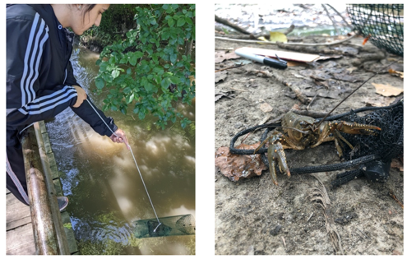
Figures 1 and 2. Trap mechanics. Figure 1 (left) shows the trap was to be lowered into the river using a piece of string and zip tied to a sturdy branch. Figure 2 (right) displays a crayfish next to the mesh bags that were used to contain the bait used in the study.

Once the trap design and bait mechanics were established, we determined the trap locations. It was decided that we would have two separate locations to study. Both of the sites were located within the Middle Rouge floodplain. Within this area, we decided to study two sites - a pond within the Rouge floodplain and a segment of the Middle Rouge River nearby.

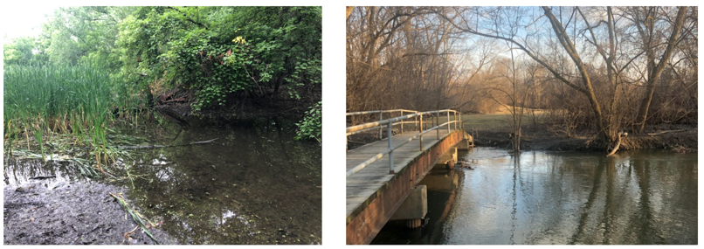

Figures 3 and 4. River and Pond Sites. The Pond site (left) shows shallow and still water with abundant vegetation growing within its boundaries. The Middle Rouge River site (right) shows a deeper body of water with water flowing faster and carrying various amounts of woody debris.
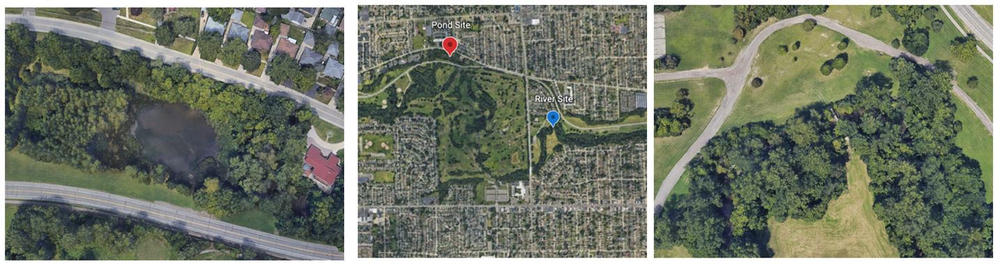
Figures 5 – 7. Site Satellite View. Figure 5 (left) contains the pond site (42°21'09"N 83°18'06"W) which is situated within a strip of forest between two roads. Figure 7 (right) contains the river site (42°20'49"N 83°17'26"W) located within Wallaceville floodplain of Hines Park. Figure 6 (middle) situates the two sites within the surrounding urban area. This segment of the Middle Rouge River is surrounded by a park, housing, schools, and a golf course.

The water quality parameters we measured were based on how precipitation might likely cause variations in the data collected. These water quality parameters we selected to measure included: precipitation, water velocity, total solids, conductivity, and turbidity. Turbidity was measured with the Vernier Turbidity sensor and a turbidity tube. The sensor measured the quantity of light that was reflected by a sample and the turbidity tube measured the minimum distance at which a pattern located at the bottom of the tube could be seen when filled by a sample of water from the body of water. Once measured, these parameters allowed us to assess the possible effect rainfall has on rivers and ponds within the Middle Rouge Watershed and its consequences on crayfish activity.

Additionally, water and air temperatures were taken to measure the potential effects of changing weather from July to September. Precipitation was measured daily at our school’s atmosphere site. Precipitation was not measured at the study site due to potential theft of the equipment. Our school and the study site are approximately 2.8 kilometers away from each other. Although precipitation amounts can vary over small distances, we believe our values were fairly accurate given the close proximity to the study sites. The water quality parameters were measured on the same day as the trap was deployed. When water temperature, air temperature, and turbidity tube measurements were made, the data was collected 3 times and averaged following GLOBE protocols.
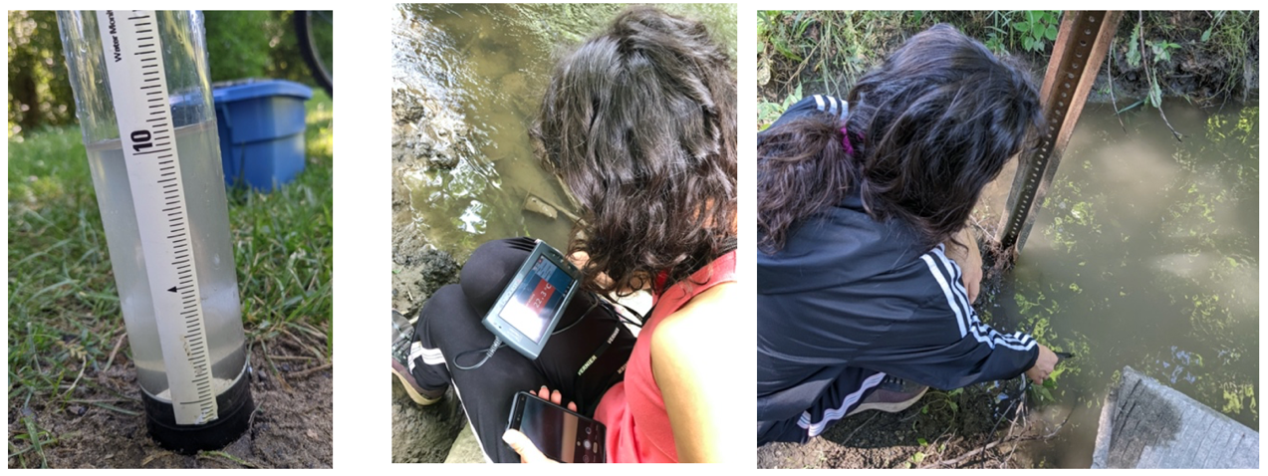
Figures 8 – 10. Equipment utilized. Figure 8 (left) shows the turbidity tube used where the depth of the water was measured by looking at the meniscus. Figure 9 (middle) and Figure 10 (right) illustrate the Vernier LabQuest 2 along with a temperature probe used to measure air and water temperature using GLOBE protocols.

Water velocity and conductivity were recorded over a period of 30 seconds due to data variability and then those values were averaged.
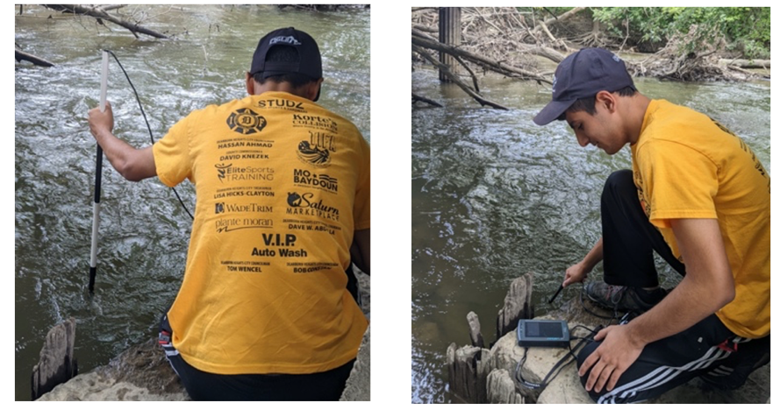
Figures 11 and 12. Additional equipment. Figure 11 (Left) and Figure 12 (right) demonstrates how the water velocity and conductivity were measured using their respective probes in conjunction with a LabQuest 2.

Finally, a water sample of approximately 500-mL was collected to be used to analyze a 40-mL total solids sample using a drying oven and laboratory balance capable of measuring to the nearest milligram. The analysis was carried out using procedures outlined by the Rouge Education Project (Mitchell & Stapp, 1994). Additionally, the water sample was also used to complete a turbidity measurement using the Vernier Turbidity Sensor indoors in order to compare with the turbidity tube measurement made at the river using GLOBE protocols.

The following day, approximately 24 hours later, traps were retrieved at solar noon. The crayfish found in these traps were counted, sex determined, length measured from their tail fan to rostrum, and species noted. Data was collected biweekly during the months of July and August and weekly in September. This time frame, the parameters tested, and the amounts of crayfish caught were used to determine the effects rainfall might have on crayfish activity within the Middle Rouge River Watershed.
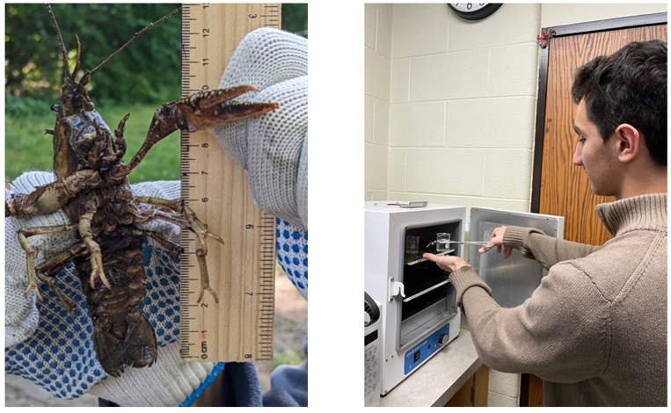
Figures 13 and 14. Data Collection. Figure 13 (left) displays how crayfish were measured from the end of their tail fan to their rostrum. Figure 14 (right) demonstrates how the 40-mL samples of river and pond water samples were taken to determine the total solids present. A pair of tongs were used to place the samples within a drying oven to evaporate any water within the sample leaving only the mass of the solids.

All data was entered into the GLOBE database for further analysis and to be archived. Additional data from the Crestwood Highschool rain gauge was used for the precipitation data. Then, the correlation coefficients were calculated using Google Sheets, and the p-values were found using a TI-84 Plus CE calculator to determine the correlation’s significance.
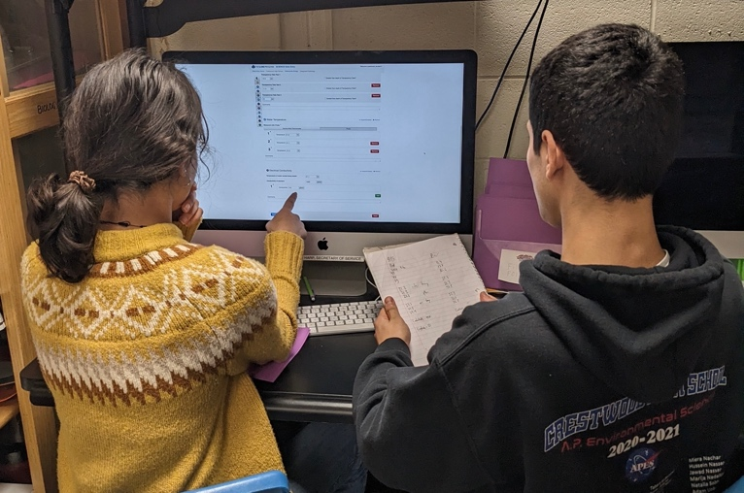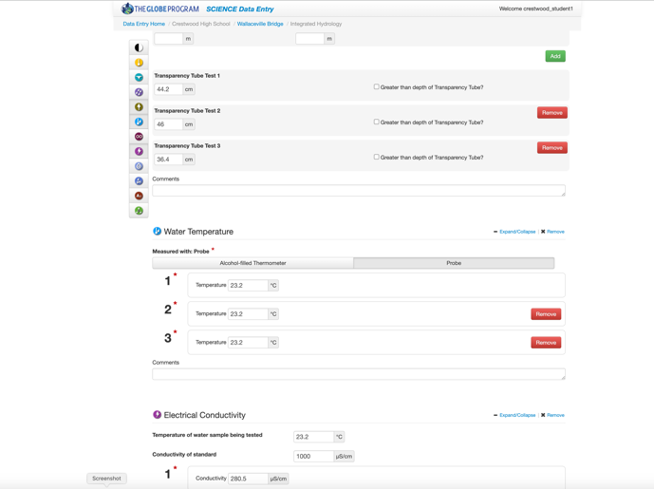

Figures 15 and 16. Submission of data to the GLOBE website. Data on air and water temperature, turbidity (using a turbidity tube), and conductivity were collected and analyzed during summer and fall of 2022.

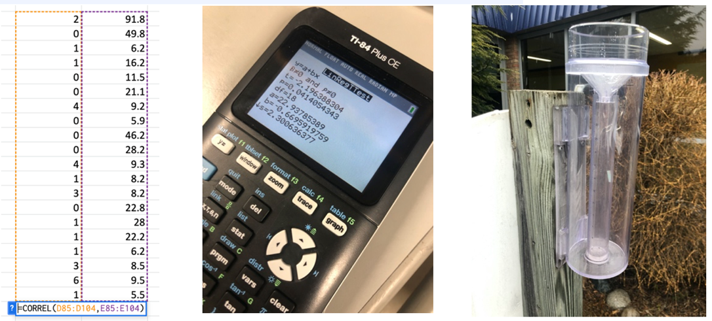
Figures 17 - 19. Data analysis. Figure 17 (left) shows the use of the Pearson Product-Moment Correlation Coefficient (CORREL) tool within Google Sheets. Figure 18 (middle) indicates the use of a linear regression t-test to calculate the p-value to use to accept or reject our null hypotheses. Figure 19 (right) contains the rain gauge located within a courtyard at Crestwood High School.

Results:

Within the Middle Rouge River Site only two negative correlations between air temperature and crayfish caught and precipitation and crayfish caught were found at a confidence interval greater than 95%. This indicates that crayfish activity decreased as precipitation and air temperature increased. There was also a significant negative correlation between the precipitation and the clarity of the water as measured with a turbidity tube meaning that an increase in precipitation decreased the water’s clarity or increased turbidity.
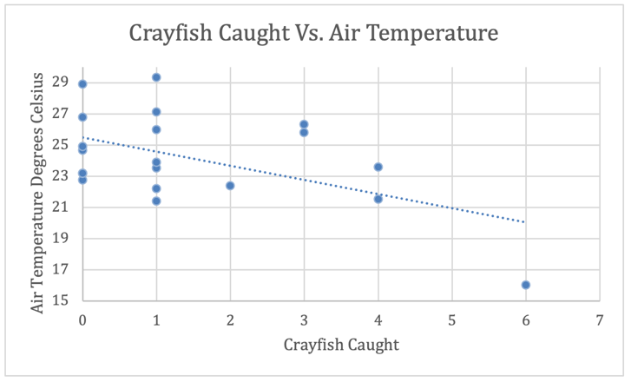

Figure 20. Crayfish Caught and Air Temperature. The scatterplot between crayfish caught and air temperature shows a linear negative correlation. This model can be accepted due to the correlation between the crayfish caught and air temperature was significant with a p-value of .018. As air temperature increases, crayfish activity decreases.

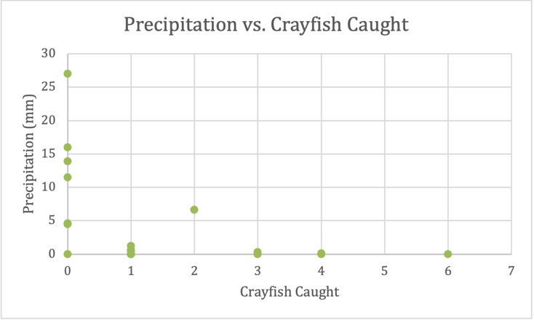
Figure 21. Crayfish Caught and Precipitation. The scatterplot between crayfish caught and precipitation events shows a negative correlation. This model can be accepted due to the correlation between the crayfish caught and precipitation being significant due to a p-value of .041. As precipitation increases, crayfish activity decreased.
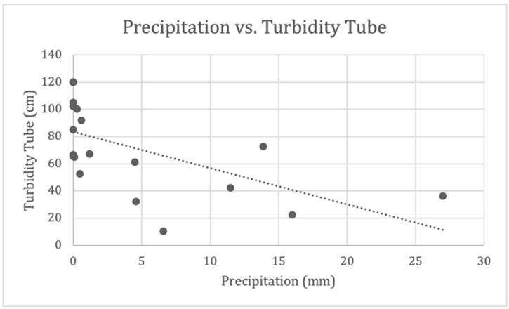
Figure 22. Precipitation and Turbidity Tube. The scatterplot between crayfish precipitation and turbidity measured from the turbidity tubes shows a negative correlation. This model can be accepted due to the correlation between the crayfish caught and precipitation being significant due to a p-value of .006.

There was a weak positive correlation between crayfish caught and the water quality parameters of water temperature, conductivity, and turbidity sensor measured in NTU that exceeded a p-value of .05 meaning there was not a significant correlation. There was no significant statistical correlation between crayfish activity and the water quality parameters of conductivity, water temperature, and the Vernier turbidity sensor.
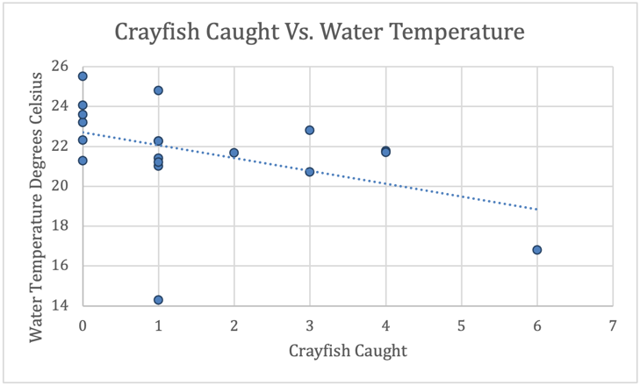
Figure 23. Crayfish Caught and Water Temperature. The scatterplot between crayfish caught and water temperature shows a linear negative correlation. This model cannot be accepted due to the correlation between the crayfish caught and water temperature not being significant due to a p-value of .0502. There was no significant relationship in this research between crayfish caught and water temperature.

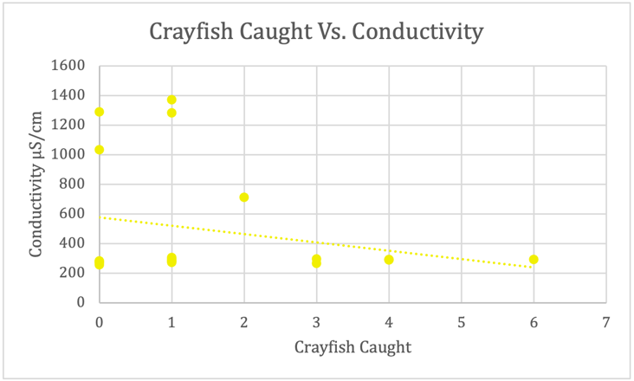
Figure 24. Crayfish Caught and Conductivity. The scatterplot between crayfish caught and conductivity shows a linear negative correlation. This model cannot be accepted due to the correlation between the crayfish caught and conductivity not being significant due to a p-value of .624. There was no significant relationship between crayfish caught and conductivity.

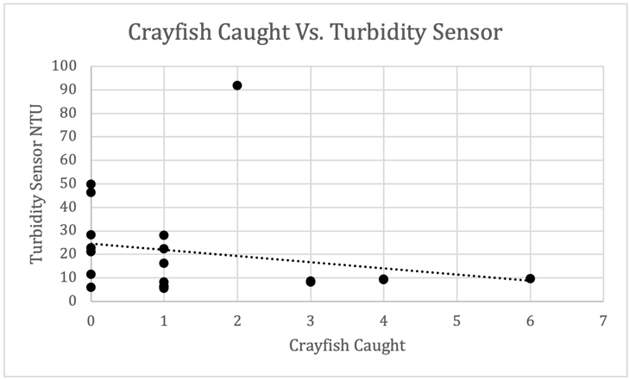
Figure 25. Crayfish Caught and Turbidity Sensor. The scatterplot between crayfish caught and turbidity measured by the turbidity sensor shows a linear negative correlation. This model cannot be accepted due to the correlation between the crayfish caught and turbidity in NTU not being significant due to a p-value of .291. There was no significant relationship between crayfish caught and turbidity values measured by the Vernier turbidity sensor.

There were weak positive correlations between water velocity, total solids, and the turbidity tube measurements with p-values that exceeded .05 meaning that the correlations were not significant as well.
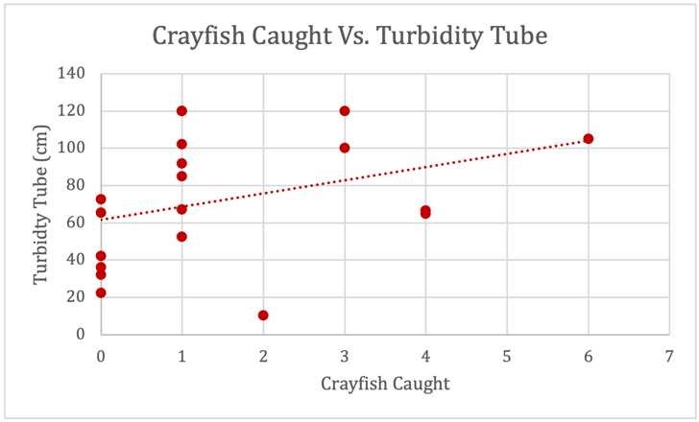
Figure 26. Crayfish Caught and Turbidity Tube. The scatterplot between crayfish caught and turbidity measured by the turbidity tube shows a positive correlation. This model cannot be accepted due to the correlation between the crayfish caught and the turbidity tube readings not being significant due to a p-value .164. This data showed no significant statistical relationship between crayfish caught and turbidity tube measurements.

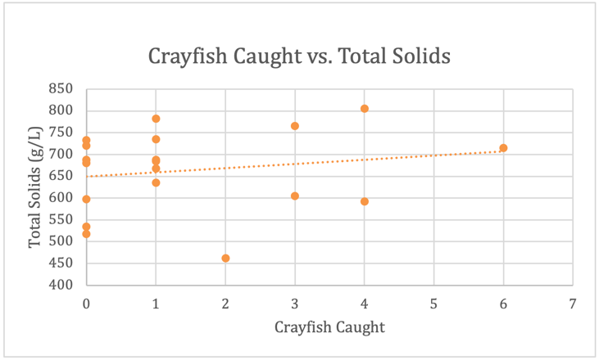
Figure 27. Crayfish Caught and Total Solids. The scatterplot between crayfish caught and total solids shows a positive correlation. This model cannot be accepted due to the correlation between the crayfish caught and total solids (g/L) not significant due to a p-value of .898. There was no correlation between crayfish caught and total solids data collected and analyzed.

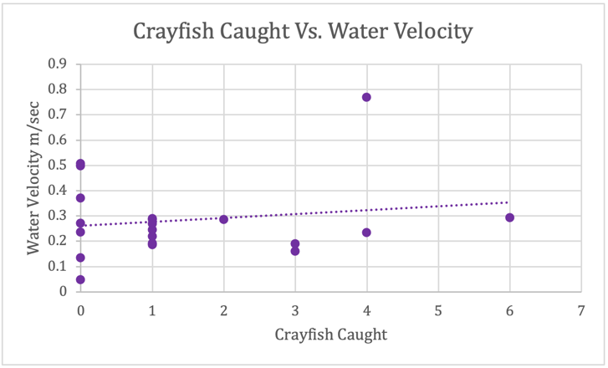
Figure 28. Crayfish Caught and Water Velocity. The scatterplot between crayfish caught and water velocity showing a positive correlation. This model cannot be accepted due to the correlation between the crayfish caught and water velocity not being significant due to a p-value of .608. No relationship between crayfish caught and water velocity was noted in the data.

29 Crayfish were captured over a period of 20 total trapping sessions. All of the crayfish were the Virile crayfish (Faxonius virilis) but some exhibited unique visual qualities. The majority of crayfish caught measured between 7-12 cm. All crayfish trapped were adults except one juvenile crayfish that was caught.
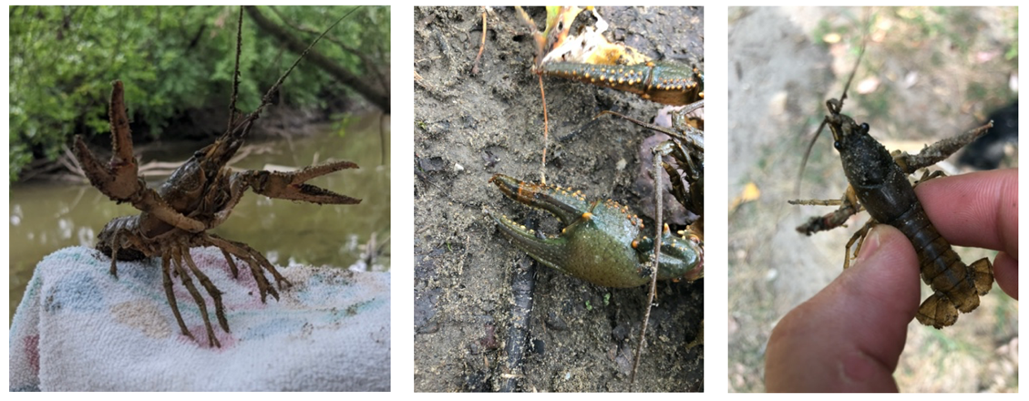
Figures 27 - 29. Crayfish Caught. Figure 27 (left) has a crayfish standing with its claws held up defensively. Figure 28 (middle) contains a unique pattern on its chelae with black and orange bands on the bottom claw only. Figure 29 (left) is the only juvenile crayfish trapped found within the mesh bag with the bait, and was significantly smaller than the adult crayfish.

At the pond site there were no crayfish trapped throughout the 18 trapping sessions. As a result, no correlation is possible between water quality parameters of ponds and the crayfish caught.
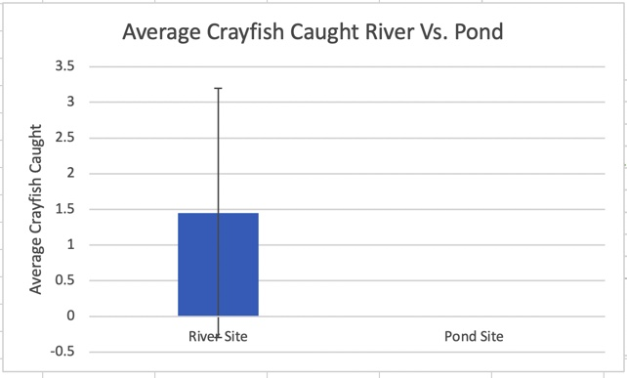
Figure 30. Comparison between river and pond sites. This graph compares the average amount of crayfish caught between the river and pond sites. Statistically there is a was no significant difference between the number of crayfish caught between each site. However, there were no crayfish caught at the pond site while at the river site an average of 1.45 crayfish caught per observation.

Discussion:

When comparing precipitation to the number of crayfish caught, a strong negative correlation was found. This means that an increase in precipitation decreases crayfish activity; this allows us to reject our associated null hypothesis. However, water conditions associated with precipitation (water velocity and turbidity) throughout the study period did not show any significant correlation to crayfish caught. This means that we accepted two of our null hypotheses that said there would be no significant correlation between water velocity and/or turbidity and crayfish numbers caught. Perhaps a reason why there was no positive correlation could be that each of the rain events were minimal during the study period. This meant that most of the precipitation was fully absorbed by the watershed’s permeable surfaces rather than running off like what usually happens during significant rainfall events.

It was expected that precipitation events would increase water velocity and turbidity. A river’s increase in turbidity during precipitation events is due in part to increased runoff and agitation of water and bottom sediments during times of heavy rain. The methods used to measure turbidity were a transparency tube and a Vernier turbidity sensor. However, the differing methods to measure turbidity gave inconsistent results even though each of the correlations among these water quality parameters and crayfish caught were weak ones. We were able to accept our null hypothesis associated with the relationships between the data from the Vernier turbidity sensor, total solids, and conductivity with their lack of correlation with crayfish activity. However, the lack of major rainfall events during the period of the study could have could have reduced the normal seasonal variability present within these water quality parameters. Our findings can offer some insight on extreme weather events’ possible effects on these water quality parameters as noted by the unexpectedly dry summer of 2022 in Southeastern Michigan.

Additionally, there was a significant negative correlation between air temperature and crayfish caught, and a weak negative correlation between water temperature and crayfish caught. As a result, we can reject our null hypothesis associated with the correlation between air temperature and crayfish activity. However, we must accept our null hypothesis for the correlation of water temperature and crayfish activity. This potentially indicates that air temperature has a greater impact on crayfish activity compared with water temperature. It was expected that air temperature would decrease during cloudy rain events. However, the weak positive correlation found between precipitation and air temperature might be explained by the lack of rain events during September. These cooler temperatures found during September along with the lack of rain could have resulted inability to find a relationship between these two factors.

The data from this research determined that the effects of lower air temperatures and precipitation contributed the most to crayfish activity, addressing one of our initial research questions. Air temperatures and precipitation both affected crayfish activity independently. Lower air temperatures resulted in greater crayfish activity while precipitation decreased crayfish activity. However, other effects of precipitation such as water velocity and turbidity did not have a significant effect on crayfish activity meaning that the combinations of these factors or other factors not accounted for could have resulted in the decrease of crayfish activity in response to rainfall. One thing that should be considered in all of this research is that we must be careful to consider that other factors other than what we monitored could have affected our data and results. For example, we are basing our findings on the relatively small sample of data points taken through a small segment of the total year. These results also are only applicable to the one species of crayfish that we successfully sampled – the Virile (Faxonius virilis) crayfish.

During our 20 collections sessions from July to the end of September 2022, we trapped 29 crayfish at the river site, but there were no crayfish caught at the pond site. This was initially unexpected, but on further investigation it seems possible that the pond selected for this research may have been too isolated from the river. This might have made it difficult for crayfish to travel on land to the pond from the Middle Rouge River Branch. The presence of two larger roads surrounding the pond may also isolate this body of water even further from the introduction of new species. This might negatively affect the productivity of the pond ecosystem since the presence of the crayfish fills an important niche of detritivores in many aquatic ecosystems. As result, there was a significant difference in the quantity of crayfish caught between the two sites allowing us to answer the first research question. Our results indicate that further research should be completed to investigate the lack of crayfish in the pond. Many other local ponds have large numbers of crayfish, especially at some golf courses. The golf course that was closest to the study site was closed this summer making it inaccessible for research. Because there was a large difference in crayfish activity between the pond and river sites, the first null hypothesis was rejected.

Conclusion:

Our research indicates that precipitation appeared to significantly decrease crayfish activity. However, the water quality associated precipitation such as water velocity, conductivity, turbidity, and total solids did not have a significant impact on crayfish activity in the Middle Rouge River. Since these factors are commonly affected by precipitation it is certainly warranted to investigate what levels of precipitation might result in a decrease in crayfish activity. Temperature, especially air temperature, had the most significant effect on crayfish activity. These discoveries can further our local understanding of crayfish behavior which allow for better predictions of crayfish activity in response to a changing climate. This is potentially of great significance because of the crayfish’s major role in the environment as detritivores. Their varied diet along with the recreational and commercial trapping means that all local crayfish species need to have more research into their behavior and ecological requirements.

Though no crayfish were caught in the pond site, it provides possible insight into the issue of the ecological isolation of the pond from the rest of the Middle Rouge River. This illustrates the necessity of eco-bridges also known as wildlife crossings. The introduction of these crossings could possibly provide a way for terrestrial and semi-aquatic animals such as crayfish, toads, and frogs to cross the roads dividing the Middle Rouge Watershed. Specifically, the introduction of these crossings along Hines Drive which divides Hines Parkway down the middle could positively benefit the Middle Rouge Watershed as a whole.

A stronger correlation between crayfish activity and precipitation could be established by more longitudinal research methods. If the duration of the study along with the frequency of observations in further investigations it would be more likely that a significant correlation between crayfish activity and the water quality parameters of water velocity, turbidity, conductivity, and total solids (g/L) could be found. Additionally, the use of a more direct way to measure rainfall to then compare it to the simultaneous collection of air temperature, water temperature, turbidity, conductivity, and water velocity. However, the risk associated with leaving equipment such as a rain gauge within a public park prevented the researchers from conducting this research method. Finally, the improvements to the constructed traps could always be made with greater experience. The introduction of new components such as extended openings to the trap could lower the risk of crayfish escaping the traps before the traps are collected the following day.

The information gained from this study and suggestions for improvements in experimental design moving forward, could significantly aid in the functional understanding of the keystone role of crayfish in aquatic environments. This information allows scientists and local land managers to better understand how the actions of humans can affect the success of crayfish populations. By working together with all local stakeholders, a clear path for the protection and conservation of crayfish populations can be achieved.

Research Limitations:
The researchers also faced many challenges during their study that could have negatively impacted the reliability of their results. Most notably, the location of the sampling sites had been moved after their third time trapping. This was due to the greater traffic bystanders in the park the river site had been located within. Since the traps were more easily visible when tied to the bridge, this led to the traps being stolen without any traces of their whereabouts. This prompted the researchers to move their location by approximately 30 meters to ensure that they would not need to replace any traps. The researchers had also planned to use two traps per observation to increase the reliability of their collected data, however the lost traps stated previously resulted in the researchers lacking the resources to make two traps per site. Also, there were inconsistencies in the values measured for conductivity during the investigation when compared to other researchers simultaneously measuring downstream from the researchers’ site in the Middle Rouge River. This can be due to errors involved in the calibration of the Vernier Conductivity Probe. The combination of these can be sources of error could have impacted the discovered correlations between the water quality parameters measured and the crayfish caught. Additionally, the data for precipitation during the trapping period is not necessarily representative of the total rainfall of the entire Middle Rouge Watershed. Though the rain gauge was located within 3 kilometers of the river site, the rain gauge data does not indicate how widespread the rain event was or the total rainfall that had entered the Middle Rouge River Watershed. The rain gauge simply generalizes the precipitation observed which compared to crayfish caught can offer insight on the correlation between precipitation and crayfish activity rather than being completely conclusive.

Finally, this research was a mere snapshot of crayfish activity within a narrow time period. To make any conclusions, more data would need to be collected over more months and years to really understand the potential effects of an increasingly warmer climate with extreme weather events on the biology and ecology of crayfish within the Rouge River Watershed. In addition, other trapping methods should be considered as when we sampled directly with aquatic dip nets, we discovered larger numbers of crayfish than expected. Direct sampling is disruptive to the bottom sediments and has the risk of potential harm to the crayfish.

Citations/Bibliography:

Andresen, J., S. Hilberg, K. Kunkel, 2012: Historical Climate and Climate Trends in the Midwestern USA. In: U.S. National Climate Assessment Midwest Technical Input Report. J. Winkler, J. Andresen, J. Hatfield, D. Bidwell, and D. Brown, coordinators. Available from the Great Lakes Integrated Sciences and Assessments (GLISA) Center, http://glisa.msu.edu/docs/NCA/MTIT_Historical.pdf.
Beam, Jennifer D. and Jeffrey J. Braunscheidel. 1998. Rouge River Assessment. Michigan Department of Natural Resources, Fisheries Division, Special Report 22. Ann Arbor, Michigan.
Brown, V. M., Shirley, M. G., Keim, B. D., Marx, B. D., & Lutz, C. G. (2020). Effect of meteorological variables on crawfish harvest in Louisiana, USA. Climate Research, 81, 15–28. https://doi.org/10.3354/cr01608
DiStefano, Robert. (2003). Helfrich, L. A.. and R. J. DiStefano. 2003. Crayfish biodiversity and conservation. In "Sustaining America's Aquatic Biodiversity: A Teacher's Guide. Edited by L. A. Helfrich, R. J. Neves and J. Parkhurst. U.S. Fish & Wildlife Service and Virginia Cooperative Extension Service Publication..
Feng, B., Zhang, Y., & Bourke, R. (2021). Urbanization impacts on flood risks based on urban growth data and coupled flood models. Natural Hazards, 106(1), 613–627. https://doi.org/10.1007/s11069-020-04480-0
Jordán, F. (2009). Keystone Species and food webs. Philosophical Transactions of the Royal Society B: Biological Sciences, 364(1524), 1733–1741. https://doi.org/10.1098/rstb.2008.0335
Napieralski, J., Keeling, R., Dziekan, M., Rhodes, C., Kelly, A., & Kobberstad, K. (2015). Urban stream deserts as a consequence of excess stream burial in urban watersheds. Annals of the Association of American Geographers, 105(4), 649–664. https://doi.org/10.1080/00045608.2015.1050753
Mitchel, M. K., & Stapp, W. B. (1994). Field manual for water quality monitoring An environmental education program for schools (8th ed., pp. 70-73). : Thomas-Shore Printers.
Weinländer, M., & Füreder, L. (2016). Native and alien crayfish species: Do their trophic roles differ? Freshwater Science, 35(4), 1340–1353. https://doi.org/10.1086/689031

Acknowledgements: We appreciate the opportunity to thank the GLOBE program for the opportunity to conduct this exciting research. We’d also like to thank Dr. Kevin Czajkowski and his GLOBE Mission Earth staff for providing some of the water quality monitoring equipment we used. Thank you also to Mr. David Bydlowski of the NASA GLOBE AREN project for the Vernier LabQuest and probes we utilized in our project. During our research, we also met over ZOOM with Dr. Lucas Nathan, a fisheries biologist of the Michigan Department of Natural Resources. With his support we were able to clarify several questions we had, and he also provided us with copies of a Guide to Michigan Crayfish authored by the Michigan Department of Natural Resources and Michigan State University. Finally, we would like to thank our advisor, Mrs. Diana Johns. Mrs. Johns provided us with all the necessary instruments and guidance as we pursued our investigation.

Badges:
I Make an Impact: We hope to earn the “I Make an Impact” badge with their investigation into the recent issue of invasive crayfish species within nearby ecosystems. Specifically, during their research, they monitored for the Red Swamp Crayfish (Procambarus clarkia) and the Rusty Crayfish (Orconectes rusticus). With the use of identification guides provided by the Michigan Department of Natural Resources, they were able to identify species caught within their traps during their research. Thankfully, the researchers had not identified any invasive species and all crayfish identified were native Michigan species within the Rouge River. Investigations such as these by researchers and by ordinary citizens allow a quick response to detected invasive species which gives a chance to stop invasive species from gaining a foothold within an environment
preventing these invasive crayfish species competing against native species. By continuing to monitor crayfish species found within the Rouge River, native species can be protected allowing the Rouge to have a stable ecosystem and food web.

I Am a Collaborator: The researchers hope to earn the “I Am A Collaborator” badge upon their collaboration with Dr. Nathan Lucas, a Crayfish Specialist Researcher at Michigan State University. Following their meeting with Dr Nathan Lucas via Zoom, the team took his insight and experience trapping crayfish into their following year’s research. This allowed them to confidently change their bait to dry dog food and introduce mesh bags to place the bait within. Additionally, Dr. Nathan Lucas was able to provide them with three copies of Field Guide to Michigan Crayfish which improved the team’s ability to accurately identify the species of crayfish caught. Overall, the meeting between Dr. Nathan Lucas and the research team enhanced the team’s understanding of their research and research paper. We were able to plan a meeting on a video call on ZOOM. He was able to provide us with three copies of the Field Guide to Michigan Crayfish. The guide contained crayfish anatomy along with the notable characteristics of the 8 native crayfish species and 2 invasive species. Additionally, there was an identification key which allowed us to determine the species crayfish caught with efficiency.

I Am An Engineer: The researchers hope to earn the “I Am An Engineer” badge for their own design of a crayfish trap. We used a similar design to last year with a few modifications based on our experience from last year. This year’s trap had a cylindrical trap design made of ½ inch wire mesh. It was held together using zip ties. The trap had two openings on its sides with a latch on the top to allow us to easily insert bait within the trap. This year we introduced new changes in their trapping design with more experience behind us. We switched ourr bait to dry dog food along with mesh bags to place the bait within. This improved the performance of the traps since the bait dissolved more slowly compared what happened with the canned cat food used last year. We found that more crayfish were attracted to the trap since the lasted longer than before.

