Are there red soil in the Labin area?
Students: Evelin Baćac, Ema Kos i Ivana Stojšić & GLOBE group
Mentor: prof. adviser Olivera Tadić, GLOBE teacher
Secondary school Mate Blažine Labin, Croatia
. School year: 2025/2026

Table of Content:

Abstract | 1
Introduction and Review of Literature | 2
Research Question and Hypothesis | 3
Research Methods and Materials | 4
Results and data analysis | 5 - 8
Discussion & Conclusion | 9
Bibliography/Citations | 10
Acknowledgements | 10
Badge Descriptions | 11

Abstract

Based on geological composition, Istria is divided into three relief units: the hilly northern margin (White Istria), the lower flysch foothills (Grey Istria), and the low limestone plateaus (Red Istria).

The Labin area is largely located within Red Istria, named after its characteristic red soil (terra rossa). According to the pedological map, six types of red soil occur in region. Our research aimed to confirm this by addressing the following questions:

1.Where in the Labin area can red soil be found, and do these locations correspond to the pedological map?
2.What type of land cover exists at these sites?
3.What are the physical and chemical properties of the red soil at the selected locations?

The research consisted of two parts: fieldwork, where coordinates were recorded, land cover was classified, and soil samples were collected and examined for basic properties; and laboratory work, where the physical and chemical properties were analyzed.

We collected samples from six locations corresponding to the red soil types on the pedological map. Vegetation cover was mostly deciduous forest and macchia. Only one site was bare karst terrain. Analysis showed that all samples displayed properties typical of red soil, confirming its presence in the Labin region.

We conclude that the Labin area partly belongs to Red Istria and has the potential for viticulture, olive cultivation, and fruit production on red soils.

Introduction and Review of Literature

The formation of Istrian soils was a slow and long-lasting process influenced by natural and anthropogenic factors, resulting in a heterogeneous distribution of soil types.

According to geological composition and soil differences, Istria is divided into three units: ⁽²⁾

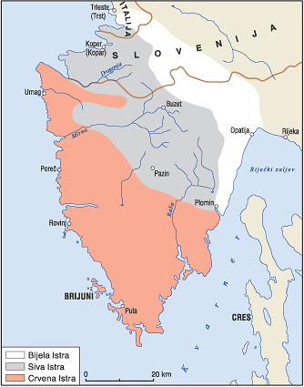

Figure 1. Geological map of Istria
Source: https://www.geotech.hr/geoloska-grada-istre/

White Istria – elevated, rocky areas composed of karstified limestone.

Grey Istria – central Istria, a depression filled with flysch.

Red Istria – western Istria, lying on limestone–dolomite bedrock, where terra rossa dominates.

The Labin area (Labinština) is a geographical and historical region in eastern Istria, bordered by the Raša River, Čepić field, the Plomin Bay, the southern slopes of Učka, and the Kvarner Gulf. Due to its limestone bedrock and susceptibility to chemical weathering, features such as fissures, sinkholes, dolines, and caves form easily. Mild slopes allow soil to accumulate, especially red soils. A smaller portion of Labinština lies within Grey Istria.

Research Question and Hypothesis
Red soil (terra rossa) ) ⁽¹⁾ is characteristic of subtropical and Mediterranean karst regions with significant rainfall. It forms through the dissolution of limestone and dolomite and represents the insoluble residue. It accumulates in sinkholes, dolines, and karst fields.
Red soil is clayey, loose in structure, and low in humus (1–3%). It typically contains more than 40% clay and is rich in iron and aluminum oxides, which give it its distinctive red color. It absorbs and retains water well, which helps plants survive hot Mediterranean summers. It is suitable for grapevines, figs, olives, and other fruit.
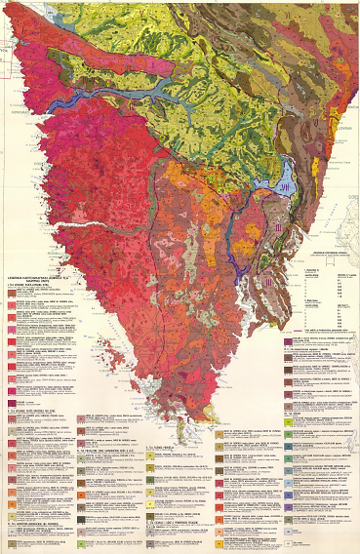

Figure 2. Pedological map of Istria County
Source:https://esdac.jrc.ec.europa.eu/images/Eudasm/HR/PDF/russ_x85.pdf
According to the pedological map ^{(8),}six types of red soil occur in the Labin region. We therefore asked:
- Where in the Labin area can red soil be found, and do these locations correspond to the pedological map?
- What type of land cover exists at these sites?
- What are the physical and chemical properties of the red soil at the selected locations?

Research Methods and Materials

The study involved 36 members of the GLOBE group.
Twenty-four students worked in six field teams, while 12 students conducted laboratory analyzes and processed results.
The research took place from September 2024 to October 2025.
Cooperation with local residents helped identify sampling locations.

The research is divided into two parts: fieldwork in which we recorded the coordinates of the measurement sites, determined the type of cover and took soil samples, which we determined the basic properties of in the field, and in the second part we analyzed the physicochemical properties of the soil in the school laboratory.

From accessories and materials, we had everything we needed according to individual protocols.

In our work, we used the following work methods:
We used Globe GPS protocols⁽³⁾ to determine geographic coordinates and Globe MUC protocols⁽⁴⁾ for land cover classification.
For soil analysis, we used the Globe protocols for soil ⁽⁵⁾ and the Field Work Guide ⁽⁶⁾, and to determine the properties that are not included in the fine protocols, we followed the instructions of the test kits.

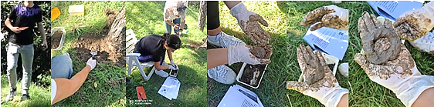
Figure 3. Field work

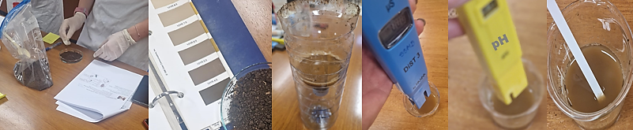
Figure 4. Work in a school laboratory

Results and data analysis
According to the pedological map of Istria County⁽⁸⁾, terra rossa appears in six cartographic units (10, 11, 12, 13, 17, 18) across the Labin area.
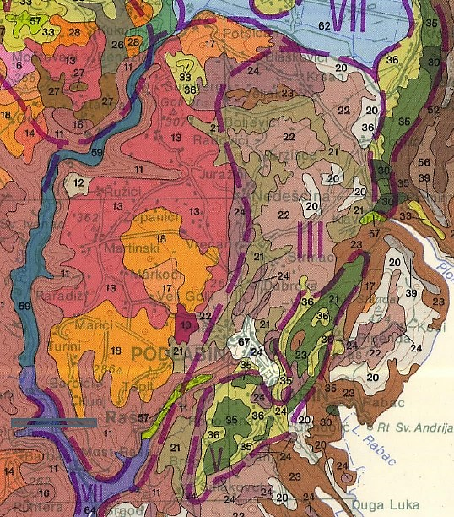
Figure 5. Excerpt from the pedological map of the County of Istria, Labinština.
Source: https://esdac.jrc.ec.europa.eu/images/Eudasm/HR/PDF/russ_x85.pdf

Table 1. lists sampling locations, soil types, and sample photographs. All samples were taken from uncultivated land to avoid the influence of agricultural practices.
Samples were taken from a depth of 20 cm.

Table 1. Terra rossa according to the pedological map and samples from individual locations.

NUMBER  NAME OF LOCATION | TYPE ACCORDING TO THE PEDOLOGY MAP OF ISTRIA |  | SAMPLES  COLLECTED IN THE FIELD
1.  VINEŽ | 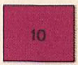 | RIGOLANO from red soil | 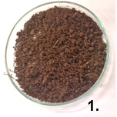
2.  RAŠA | 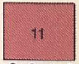 | RED typical shallow  BROWN ON LIMESTONE shallow stone | 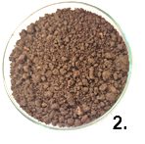
3.  RUŽIĆI | 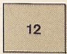 | RED typical shallow BROWN ON LIMESTONE shallow  EUTRICH BROWN sinkhole | 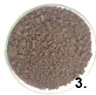
4. RADOVIĆI | 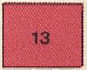 | RED SOIL typical shallow (partially bauxite) medium deep and deep  BROWN ON LIMESTONE shallow and medium deep  RIGOLANO from red soil and brown on limestone | 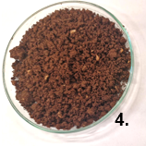
5.  VELI GOLJI | 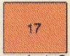 | RED clay leached (partially bauxite)  BROWN ON LIMESTONE medium deep  DISTRICT BROWN on red clay  LEESIFIED acrylic | 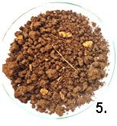
6.  MARIĆI | 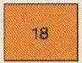 | RED clay leached, anthropogenic (partially bauxite)  DISTRICT BROWN on red clay  BROWN ON LIMESTONE medium deep  LEESIFIED acrylic, anthropogenic | 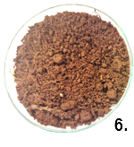

As stated in Table 1, we selected the locations on cartographic units according to the types of soil from the pedological map, so Figure 6 shows the location of the measuring points on the map, and Table 2 shows the geographical coordinates and MUC classification of the cover.

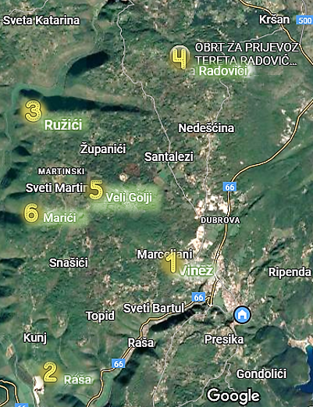

Figure 6. Measuring points
Source: https://www.google.com/maps

Table 2. Geographic coordinates and MUC classification of cover

GEOGRAPHICAL COORDINATES |  |  |  | MUC | Land Cover
Location | Latitude  N | Longitude  E | Elevation  (m) | MUC | Land Cover
1. VINEŽ | 45.097250° | 14.106910° | 210 | 433 | Shrub vegetation
2. RAŠA | 45.064822° | 14.064753° | 34 | 121 | Deciduous dry forest
3. RUŽIĆI | 45.139722° | 14.038611° | 172 | 56 | Bare karst – sinkhole
4. RADOVIĆI | 45.163980° | 14.091980° | 181 | 121 | Deciduous dry forest
5. VELI GOLJI | 45.110383° | 14.074633° | 298 | 121 | Deciduous dry forest
6. MARIĆI | 45.100449° | 14.042630° | 266 | 433 | Shrub vegetation

In the field, the basic properties of all samples were determined, as shown in Table 3.

Table 3. Basic properties
Property | Location
Property | 1.  VINEŽ | 2.  RAŠA | 3.  RUŽIĆI | 4.  RADOVIĆI | 5.  VELI  GOLJI | 6.  MARIĆI
Structure | Granular | Blocky | Blocky | Granular | Blocky | Granular
Color | 10R3/4 reddish brown | 10YR3/2 grey-brown | 10R4/2 light brown | 10R3/6 brownish red | 10R4/2 light brown | 10YR2/4 dark brown
Consistency | Loose | Loose | Firm | Firm | Loose | Loose
Stone content | Low | Low | Low | Low | High | Low
Root content | Low | Low | Low | Low | High | Low
Carbonates | 3–5% | 3–5% | 3–5% | 3–5% | 3–5% | <1%

In the school laboratory, we determined the physical and chemical properties of all samples and presented the results in Table 4.

Table 4. Physicochemical properties of samples
Property | Unit | Location
Property | Unit | 1. VINEŽ | 2.  RAŠA | 3. RUŽIĆI | 4.  RADOVIĆI | 5.  VELI  GOLJI | 6.  MARIĆI
Sand | % | 22.5 | 35.9 | 35.5 | 21.5 | 27.7 | 31.5
Silt | % | 32.0 | 33.2 | 12.2 | 32.5 | 35.6 | 32.5
Clay | % | 45.5 | 30.9 | 52.3 | 46.0 | 36.7 | 36.0
Soil type |  | Clay | Clay loam | Clay | Clay | Clay loam | Clay loam
Permeability | % | 55 | 70 | 68 | 49 | 59 | 65
pH | pH units | 5,7 | 6,7 | 7,4 | 5,5 | 5,5 | 5,7
Conductivity | μS | 345 | 80 | 180 | 360 | 980 | 432
N-P-K |  | low | medium | low | low | low | low
Humus |  | low | high | low | low | low | low
Potassium | mgL⁻¹ | 50 | 50 | 50 | 50 | 50 | 50
Chlorides | mgL⁻¹ | 0 | 0 | 0 | 0 | 0 | 0
Sulfates | mgL⁻¹ | <200 | <200 | <200 | <200 | <200 | <200
Nitrates/Nitrites | mgL⁻¹ | 5 | 10 | 5 | 10 | 1 | 1
Phosphates | mgL⁻¹ | 3.25 | 2.26 | 1.63 | 1.63 | 1.63 | 1.63
Copper | mgL⁻¹ | 1 | 1 | 1 | 1 | 1 | 1
Iron | mgL⁻¹ | 3 | 3 | 1,5 | 1.5 | 1.5 | 1.5
Lead | mgL⁻¹ | 0 | 0 | 0 | 0 | 0 | 0
Mercury | mgL⁻¹ | 0 | 0 | 0 | 0 | 0 | 0

Discussion & Conclusion
We sampled six locations corresponding to the pedological map units containing red soil. All samples were taken at 20 cm depth from uncultivated terrain.
Most sites were covered by deciduous forests (oak, hornbeam, ash) or macchia; only Ružići had bare karst terrain (sinkhole).
Key findings:
- Soil structure ranged from granular to blocky.
- Consistency was loose in four samples and firm in two (Ružići, Radovići).
- Soil color ranged from reddish brown to dark brown (Munsell 10R–10YR).
- Carbonate content was up to 5%, except one sample (Marići) with <1%, consistent with non-carbonate terra rossa.
- Clay content ranged from 30.9% (Raša) to 52.3% (Ružići).
- Three samples were classified as clay soils (Vinež, Ružići, Radovići) and three as clay loams (Raša, Veli Golji, Marići).
- Water permeability was higher in samples with more sand.
- pH values ranged from slightly acidic to neutral (5.5–7.4), typical for red soils.
- Humus and nutrient content was generally low.
- Harmful substances (chlorides, sulfates, heavy metals) were negligible.
Comparing our results with literature (e.g., Cambic soils presentation⁽⁹⁾), we conclude that red soli (terra rossa) occurs in 10–30% of the mapped units, and in one unit even around 40%.
Therefore, we confirm our hypothesis:
The Labin region is part of Red Istria and contains characteristic terra rossa soils.
These areas are already used for vineyards and olive groves, although many fields remain uncultivated.
Recent regional publications suggest increasing interest in using these soils sustainably and preventing conversion to tourist developments.

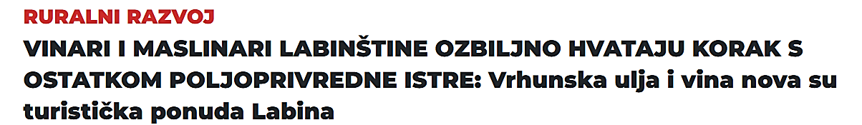
RURAL DEVELOPMENT
WINE AND OLIVE GROWERS OF THE LABIN AREA ARE SERIOUSLY CATCHING UP WITH THE REST OF AGRICULTURAL ISTRIA: Top-quality oils and wines are Labin's new tourist offer

Figure 8. Published by Glas Istra
Source: https://www.glasistre.hr/

Bibliography/Citations

- Crvenica (red soil) https://hr.wikipedia.org/wiki/Crvenica
- Geomorfologija (Bijela, Siva, Crvena Istra), (GEOMORPHOLOGY (WHITE, GREY, RED ISTRIA), (https://www.istrapedia.hr/hr/natuknice/851/geomorfologija-bijela-siva-crvena-istra
- GLOBE GPS PROTOCOL https://www.globe.gov/documents/356823/11572602/GPS+Protocols.pdf/6723169a-8b4c-449b-8755-e057be7693a3
- GLOBE MUC PROTOCOL, https://www.globe.gov/documents/355050/5a2ab7cc-2fdc-41dc-b7a3-59e3b110e25f,
- GLOBE SOIL PROTOCOL, https://www.globe.gov/web/soil
- KARAKTERIZACIJA (OPIS) TALA, Vodič za rad na terenu (CHARACTERIZATION (DESCRIPTION) OF SOILS, Guide for field work),
https://drive.google.com/file/d/1dLpGQuVhfPNdJsJc3IHBoOi_QFyhYvWh/view
- Labinšćina (Labinština), https://www.istrapedia.hr/hr/natuknice/3039/labinscina-labinstina
- PEDOLOŠKA KARTA ISTRE,( PEDOLOGY MAP OF ISTRIA), https://esdac.jrc.ec.europa.eu/images/Eudasm/HR/PDF/russ_x85.pdf
- Vukadinović V. KAMBIČNA TLA, ( CAMBIC SOILS), https://pedologija.com.hr/Literatura/Pedogeneza/Automorfna_III.pdf

Acknowledgements
We would like to thank our Globe teacher Olivera Tadić for her daily help and support.

Badge Descriptions

I am a Data Scientist
We collected soil samples from six locations in the Labin region, analyzed their physical and chemical properties in the school laboratory, and compared the results with the pedological map of Istria. We presented the results in tables and interpreted them to confirm our hypothesis about the presence of terra rossa.

I am an Earth System Scientist
Our research applied several GLOBE protocols (GPS, MUC, Soil) and showed the connection between the pedosphere, biosphere, and atmosphere. We studied how soil types are linked to vegetation cover, geological structure, and local climatic conditions in the Mediterranean environment.

I am a Collaborator
Our project involved 36 students working in teams: some collected data in the field while others performed laboratory analysis. We collaborated with local residents to identify locations, and we combined all results to reach our conclusions. This teamwork helped us complete the project successfully.

I make an Impact
Our study showed that parts of the Labin region belong to Red Istria and are suitable for viticulture, olive growing, and fruit production. We highlighted the importance of preserving this valuable soil and suggested its sustainable use instead of abandonment or urbanization. In this way, our research can inspire positive action in the local community.

