Air quality bioindicators
Leon Dakić 6th grade, Mislav Ostarčević 6th grade, Ivan Teufel 5th grade
Mentors: Ankica Veseljić, Andreja Gašparović
OŠ Banija, Karlovac

Summary
In our project, we assessed air quality in the city of Karlovac at two city locations by investigating the biodiversity and species of lichens on silver maple trees (Acer saccharinum). We asked the following research questions: Which location will have the highest biodiversity of lichens? Which species of lichens will we find at both locations? What is the air quality at the locations studied according to the species of lichens found? We divided the lichen species found according to the degree of eutrophication, which includes the deposition of dust and nitrogen compounds in the air and tree bark, into eutrophic, mesotrophic and oligotrophic. The eutrophic group represents lichens that are extremely tolerant to the presence of nitrogen compounds in the air and tree bark, the mesotrophic group represents moderately tolerant lichens, and the oligotrophic group represents lichens that are extremely sensitive to the presence of nitrogen compounds in the air and tree bark. The results showed the presence of lichens on all studied trees at both locations. At the Arboretum location, lichen biodiversity is lower compared to the School Park location. At the Arboretum location, we found the lichen Evernia prunastri, which belongs to the group of oligotrophic lichens, while this species was not found at the School Park location. Mesotrophic lichens Parmelia sulcata, Melanelixia sp. and Flavoparmelia caperata were found in both investigated locations. Two types of eutrophic lichens were found at the Arboretum location, while six types of lichens from this group were found at the School Park location. According to the found species, we have confirmed better air quality at the Arboretum location.

Uvod
While measuring tree circumference for the Carbon Cycle project in the school park, students noticed various lichen species on tree bark. This sparked their interest, and they began to search the literature, learning that lichens are a symbiosis of fungal hyphae and cyanobacteria or unicellular green algae. According to their external appearance, lichens can be divided into foliose, crustose, and fruticose forms. They are important as pioneers of vegetation because they are the first to colonize uninhabited areas and make them suitable for life for other organisms. They are often found on tree bark and rocks. Lichens can also be bioindicators of air quality, that is, air pollution.
The Air Quality Index is an indicator of air quality and is determined based on measurements of pollutant concentrations in the air. It is used to inform the public about air quality and health risks (Hrvatska enciklopedija, 2025). In Croatia, the Air Quality Index is determined every hour based on data received from measuring stations. According to the European Air Quality Index standard, concentrations of twelve pollutants are measured: sulfur dioxide, nitrogen dioxide / nitrogen oxides, particulate matter (PM10, PM2.5), ozone, benzene, lead, carbon monoxide, arsenic, cadmium, nickel and benzo(a)pyrene. In Croatian legislation, air pollution limit values ​​are defined in order to protect human health and the environment, and are prescribed by the Air Protection Act (NN 127/19, 57/22 136/24) and the Regulation on levels of pollutants in the air (NN 77/20) and are harmonized with the relevant EU directives and regulations. In the city of Karlovac, air quality is determined at one location by an automatic station of the Croatian Meteorological and Hydrological Service (DHMZ), which measures concentrations of nitrogen oxides and ground-level ozone (Figure 10).

By monitoring lichen biodiversity in an area, it is possible to monitor and assess air quality because different lichen species have different degrees of tolerance to pollution, that is, to the degree of eutrophication, which includes the deposition of dust and nitrogen compounds in the air and on tree bark. The presence of lichen species that do not tolerate eutrophication in an area confirms exceptionally clean air (Llop i sur., 2012).
With this study, we aimed to assess air quality by investigating lichens at two urban locations in the city of Karlovac. One location was the school park next to Banija Elementary School in the Banija city district, and the other was located near the city center in the Arboretum of the Forestry and Wood Technology School.
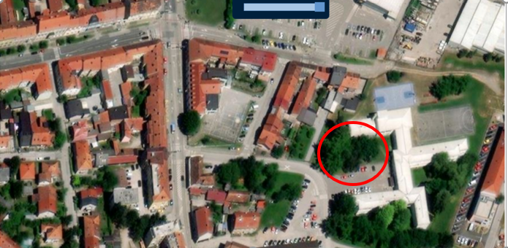
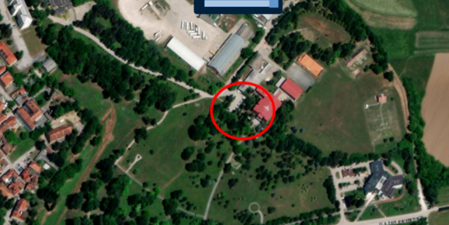

Figure 1. Location: Arboretum Figure 2. Location: School park

The Arboretum of the Forestry and Wood Technology School also houses an automatic measuring station of the DHMZ (Figure 3.)

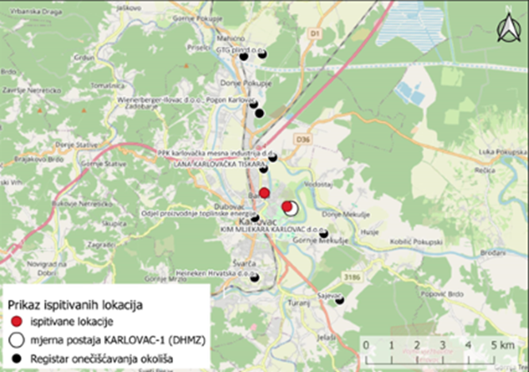
Figure 3. Representation of the surveyed locations (on the left in the picture School Park, on the right in the picture Arboretum), the location of the automatic measuring station of the DHMZ Karlovac-1 and the location of the polluters from the Environmental Pollution Register Viewer

Research questions and hypotheses
The following research questions were posed:
1. At which studied location will lichen biodiversity be higher?
2. Which lichen species will be found at both locations?
3. What is the air quality at the studied locations according to the identified lichen species?
Our assumptions were that lichen biodiversity would be higher in the Arboretum of the Forestry and Wood Technology School, that species composition would differ between the studied locations, and that the identified lichen species would indicate air quality at the studied locations
Methods:
For the study of lichens, we selected silver maple trees (Acer saccharinum) present at both studied locations. At each location, three silver maple trees were selected that were equally spaced and had trunk diameters measured according to the GLOBE protocol for biometrics, ranging from 180 cm to 280 cm (Figure 4. and Figure 5.).
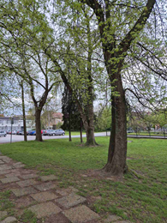
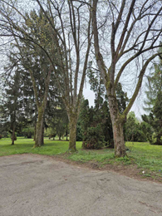

Figure 4. Location of trees in Arboretumu Figure 5. Location of trees in School park

A grid consisting of five squares measuring 10 × 10 cm was constructed and used to determine lichen coverage (Kuru, 2022). The grid was placed with its lower edge at a height of 135 cm on each tree, and lichen coverage was recorded on all four cardinal directions at both locations.
For each grid square and all four cardinal directions, lichen species were identified using lichen determination keys (CEN, 2014; Pier Luigi, 2024) and each species was assigned a value from 0 to 5 depending on how many grid squares the species was recorded in at both studied locations (Kuru, 2022).
Considering that the main expected source of pollution is traffic, which causes elevated levels of nitrogen compounds, the identified lichen species were classified according to the degree of eutrophication into eutrophic, mesotrophic, and oligotrophic groups (Llop i sur., 2012; Lichen walk, 2021). The eutrophic group represents species highly tolerant of nitrogen compounds in the air and tree bark, the mesotrophic group represents species with moderate tolerance, and the oligotrophic group represents species highly sensitive to nitrogen compounds.
Since bark pH can influence the lichen species present on trees, bark samples were collected from each tree and their pH values were determined. The bark was crushed, soaked in distilled water for 48 hours, filtered, and the pH value was measured using universal indicator paper (CEN, 2014).
Daily validated data on nitrogen oxide concentrations (NOx expressed as NO₂) measured at the DHMZ Karlovac-1 automatic station were obtained from the Air Quality Portal and compared with current air temperature and precipitation measured at the Banija Elementary School atmospheric GLOBE station.
In a Geographic Information System (QGIS 3.34.5), the studied locations, the location of the DHMZ Karlovac-1 measuring station, and pollution sources from the Environmental Pollution Register were displayed (ROO, 2025).

We analyzed a satellite image of the investigated locations, downloaded from the GLOBE Visualization System, and determined the MUC categories of cover according to the GLOBE protocol in the vicinity of the investigated locations Arboretum and School Park.
Results

At the location of the Arboretum, we determined seven species of lichen. Four lichen species were found on tree 1, three lichen species were found on tree 2, and six lichen species were found on tree 3 (Table 1.).

Table 1. Lichen species found and their spread per tree and cardinal direction at the Arboretum location

 | TREE 1 |  |  |  | TREE 2 |  |  |  | TREE 3
VRSTA/STRANA SVIJETA | S | J | I | Z | S | J | I | Z | S | J | I | Z
Evernia prunastri | 0 | 0 | 0 | 0 | 0 | 0 | 0 | 0 | 3 | 3 | 0 | 3
Flavoparmelia caperata | 0 | 0 | 0 | 0 | 0 | 0 | 0 | 0 | 0 | 0 | 1 | 0
Lepraria sp. | 2 | 2 | 1 | 1 | 4 | 3 | 5 | 5 | 3 | 5 | 2 | 3
Melanelixia sp. | 0 | 0 | 0 | 0 | 0 | 0 | 0 | 2 | 4 | 0 | 3 | 0
Parmelia sulcata | 0 | 2 | 5 | 0 | 0 | 5 | 5 | 4 | 5 | 5 | 5 | 1
Physcia tenella | 0 | 2 | 0 | 2 | 0 | 0 | 0 | 0 | 0 | 0 | 0 | 0
Physconia grisea | 0 | 0 | 1 | 2 | 0 | 0 | 0 | 0 | 1 | 0 | 0 | 0

Eleven lichen species were identified at the School park location. Four lichen species were found on tree 1, three lichen species were found on tree 2, and eleven lichen species were found on tree 3 (Table 2.).

Table 2. Lichen species found and their spread per tree and cardinal direction at the School park location

 | TREE 1 |  |  |  | TREE 2 |  |  |  | TREE 3
VRSTA/STRANA SVIJETA | S | J | I | Z | S | J | I | Z | S | J | I | Z
Candelaria concolor | 0 | 0 | 0 | 0 | 0 | 0 | 0 | 0 | 2 | 3 | 0 | 3
Flavoparmelia caperata | 0 | 0 | 0 | 0 | 0 | 0 | 0 | 0 | 0 | 0 | 2 | 0
Hyperphyscia adglutinata | 2 | 0 | 0 | 3 | 5 | 5 | 0 | 0 | 5 | 5 | 5 | 5
Lecanora sp. | 0 | 0 | 0 | 0 | 0 | 0 | 0 | 0 | 0 | 0 | 1 | 1
Lecidella elaeochroma | 0 | 0 | 0 | 0 | 0 | 0 | 0 | 0 | 0 | 0 | 1 | 1
Melanelixia sp. | 0 | 0 | 0 | 0 | 0 | 0 | 0 | 2 | 4 | 0 | 1 | 3
Parmelia sulcata | 0 | 0 | 0 | 0 | 0 | 0 | 0 | 0 | 5 | 5 | 4 | 4
Physcia tenella | 5 | 0 | 0 | 2 | 5 | 5 | 0 | 0 | 5 | 5 | 2 | 0
Physconia grisea | 0 | 0 | 0 | 2 | 0 | 0 | 0 | 0 | 1 | 0 | 0 | 0
Punctelia subrudecta | 0 | 0 | 0 | 0 | 0 | 0 | 0 | 0 | 0 | 2 | 2 | 2
Xanthoria parietina | 1 | 0 | 0 | 1 | 0 | 0 | 0 | 0 | 1 | 0 | 1 | 1

At the Arboretum location, the largest number of specific species is from the group of mesotrophic lichens (Table 3.), a total of three species, of which Parmelia sulcata was found on all three trees (Figure 7.). From the group of oligotrophic lichens, we determined one species, Evernia prunastri, on tree 3, where the frequency of occurrence is 3/5 per quadrant for three parts of the world (Figure 6.). We identified two species from the group of eutrophic lichens (Table 3.). The eutrophic species Physcia tenella (Figure 8.) was found only on tree 1 on the south and west sides, where the representation per quadrant was 2/5. Physconia grisea was found on trees 1 and 3 and the frequency of occurrence does not exceed the value of 2 per quadrant. Three species were found from the group of mesotrophic lichens (Table 3.).
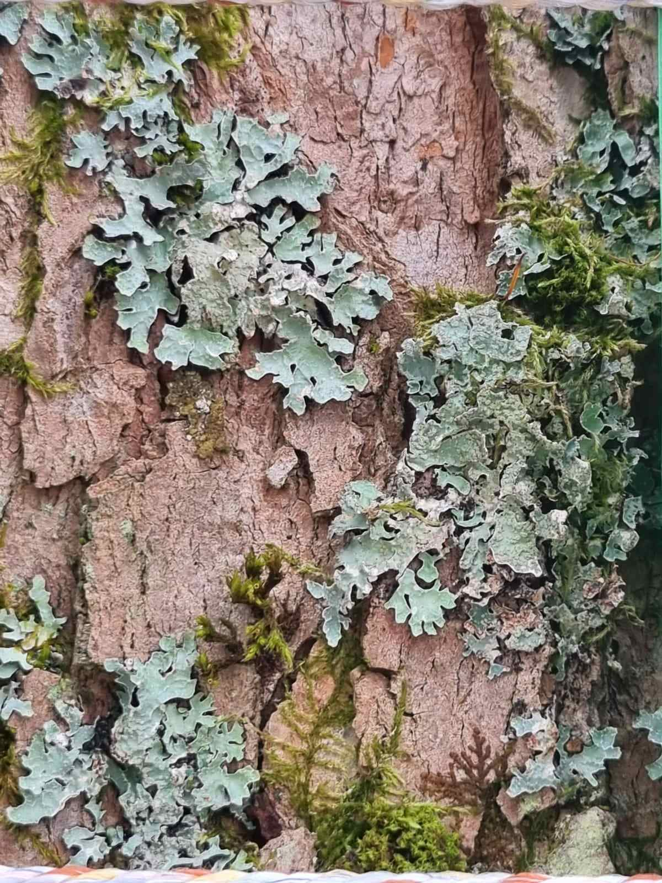

Figure 6. Evernia prunastri Figure 7. Parmelia sulcata Figure 8. Physcia tenella

Table 3. Distribution of found lichen species into indicator groups according to eutrophication they tolerate at the Arboretum location

OLIGOTROPHIC | MEZOTROPHIC | EUTROPHIC
Evernia prunastri | Flavoparmelia caperata | Physconia grisea
 | Melanelixia sp. | Physcia tenella
 | Parmelia sulcata

At the Školski park location, the largest number of identified species is from the eutrophic lichen group (Table 4.). Their abundance varies from tree to tree. The lichens Hyperphyscia adglutinata and Physcia tenella were found on all three trees. The frequency of occurrence of the lichen Physcia tenella is mainly medium to high. On each tree, it appears at least on one side in the value 5/5. The same applies to the lichen Hypherphyscia adglutinata, which appears on tree 1 in the abundance of 2/5 (north) and 3/5 (west), while the maximum abundance was recorded on the northern and southern sides of tree 2 and on all four sides of tree 3. No species were identified from the oligotrophic lichen group, and we identified three species from the mesotrophic lichen group (Table 4.).

Table 4. Distribution of found lichen species into indicator groups according to eutrophication they tolerate at the School park location

OLIGOTROPHIC | MEZOTROPHIC | EUTROPHIC
 | Flavoparmelia caperata | Candelariella sp.
 | Melanelixia sp. | Hyperphyscia adglutinata
 | Parmelia sulcata | Lecidella elaeochroma
 |  | Physconia grisea
 |  | Physcia tenella
 |  | Punctelia subrudecta

All trees at the School Park location had a bark pH value of 5.5, and all trees at the Arboretum location had a bark pH value of 6,5.

Figure 9. Comparison of the current air temperature measured at the atmospheric GLOBE station of the Banija Elementary School and daily validated data for the average concentration of nitrogen oxides NO_{x} expressed as NO₂ measured at the Karlovac-1 DHMZ station in the period from 1.1.2022 to 1.1.2024.
Daily concentrations of nitrogen oxides in the analyzed period range from 1.658 µg/m³ to 85.602 µg/m³ and are variable throughout the year, with the highest concentrations in autumn and winter. The current air temperature is inversely proportional to the concentration of nitrogen oxides in the analyzed period. The highest measured temperature is 35.0 °C, and the lowest is -2.0 °C (Figure 9.).

Figure 10. Comparison of the amount of precipitation measured at the atmospheric GLOBE station of the Banija Elementary School and daily validated data for the average concentration of nitrogen oxides NO_{x} expressed as NO₂ measured at the Karlovac-1 DHMZ station in the period from 1.1.2022 to 1.1.2024.
Nitrogen oxide concentrations in the analyzed period do not depend on the amount of precipitation. The highest measured amount of precipitation in the observed period was 410 mm (Figure 10.).

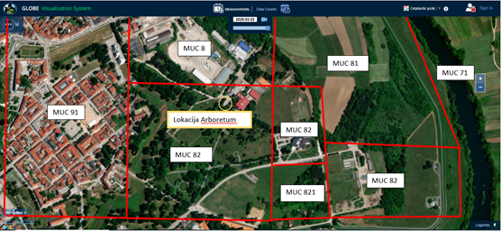

Figure 11. MUC land cover categories in the vicinity of the research site Arboretum

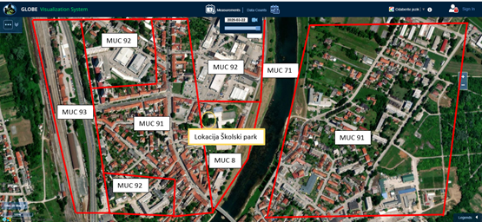

Figure 12. MUC land cover categories in the vicinity of the research site School park
By analyzing the locations of pollutants and MUC cover categories, we notice that the Arboretum location is located in a less populated area, there are no commercial and industrial areas or roads nearby (Figure 11.), and according to the pollutant register, there is one pollutant in its immediate vicinity (Figure 3.). The Školski Park location has a road with high traffic density, households and a commercial and industrial area in its immediate vicinity (Figure 12.), and there are two pollutants in its immediate vicinity (Figure 3.). The Arboretum location is in the immediate vicinity of the DHMZ Karlovac-1 station, and the Školski Park location is further away from the Karlovac-1 measuring station (Figure 3.).

Discussion and conclusions

By analyzing our results, we observe the presence of lichens on all trees at both locations. Lichen biodiversity is higher at the School Park location, which did not confirm our first hypothesis. We assume that a possible cause of lower lichen diversity at the Arboretum location is that all three trees examined are located next to the school parking lot. At the School Park location, two trees are located next to the school parking lot, while the third tree on which we found the largest number of lichen species is further away from the parking lot and is sheltered by other trees, and we believe that this is the cause of higher lichen biodiversity at the School Park location (Figure 4. and Figure 5.).

However, the lichen species found differed at both investigated locations, which confirmed our second hypothesis. At the Arboretum location, we found the lichen Evernia prunastri, which belongs to the group of oligotrophic lichens that are very sensitive to the presence of nitrogen compounds in the air and tree bark, while this species, and no other oligotrophic lichen, was found at the School park location. Mesotrophic lichens that are moderately sensitive to the presence of nitrogen compounds in the air and tree bark Parmelia sulcata, Melanelixia sp. and Flavoparmelia caperata were found at both investigated locations. At the Arboretum location, two species of eutrophic lichens that are tolerant to the presence of nitrogen compounds in the air and tree bark Physconia grisea, Physcia tenella were found, while at the School park location, six species of lichens from this group were found: Xanthoria parietina, Candelariella sp., Physcia tenella, Punctelia subrudecta, Lecidella elaeochroma, Hyperphyscia adglutinata. The abundance of eutrophic species at the Arboretum site is low. At the School Park site, the eutrophic species Physcia tenella occurs in high abundance on all trees, similar to Hypherphyscia adglutinata, while other eutrophic species occur in low to medium abundance and vary from tree to tree.
The results show that at the Arboretum location, lichen biodiversity is lower compared to the School Park location, however, an oligotrophic Evernia prunastri species was found, which is extremely sensitive to nitrogen compounds. According to the literature (Llop et al., 2012), the species found, i.e. indicator groups (eutrophic, mesotrophic, oligotrophic), are a better indicator of air quality than the number of species at the location, so we conclude that the air quality is better at the Arboretum location.

According to the Regulation on the Levels of Pollutants in the Air (NN 77/20), with regard to the protection of human health and quality of life, one-hour concentrations of nitrogen dioxide (NO₂) must not exceed the limit values ​​(LV) of 200 µg/m³ more than 18 times during a calendar year. Analyzing the graphic display of daily NO₂ concentrations and current air temperatures (Figure 9.), we note that the recommended limit values ​​have not been exceeded. The graphic display also shows that in the autumn and winter period, daily concentrations of nitrogen oxides are higher than in the spring and summer periods. We assume that this may be due to more burning of household fireplaces during the seasonal period of low current air temperatures, which also, along with traffic, contribute to a higher concentration of nitrogen compounds in the air.
Although we found in the literature (Sensees, 2024) that precipitation can help clean the atmosphere by washing away pollutants, comparing the amount of precipitation measured at the atmospheric GLOBE station at Banija Elementary School and the concentration of nitrogen oxides NO2, we do not see a clear connection (Figure 10.). According to the Regulation, the average annual concentration of NO₂ must not exceed the LV of 40 µg/m3 in a calendar year. According to the annual air quality report for 2022 and 2023, the annual value measured at the Karlovac-1 station is 9 µg/m³, and it was assessed that the limit value for the average annual value of NO₂ concentrations was not exceeded with regard to the protection of human health, i.e. the air was of category I, which is in line with our results of the analysis of air quality bioindicators at the Arboretum location.

According to the literature (Air Quality Portal, 2025), most NO₂ is emitted with exhaust gases from car engines, so the concentrations of this gas in the atmosphere are directly related to traffic density. We believe that the Karlovac-1 measuring station is too far from the School park location in the Banija district and that we cannot take this air quality data into account for this location, or we can assume that due to denser traffic, the values ​​of nitrogen oxides in the air would be higher at the School park location (Figure 3.). Also, in the immediate vicinity of the examined School park location in the Banija district, there are a large number of households and polluting factories that could contribute to air pollution. Since nitrogen compounds are deposited in the bark of trees in addition to the air, we assume that this could have affected the measured pH values ​​of the bark in the acidic area at both locations, which, according to the literature, corresponds to the types of lichens found. At the School park location, lower pH values ​​of the bark were measured compared to the Arboretum location, which may be related to the presence of more nitrogen compounds in the bark of the trees. Also, at the School park location, we found six eutrophic lichen species that are tolerant to the presence of nitrogen compounds in the air, and not a single lichen from the oligotrophic group that is sensitive to the presence of nitrogen compounds in the air. Also, at the Arboretum location, the frequency of occurrence of the two types of eutrophic lichens found was quite low, so we conclude that the air quality is poorer in the Banija city district at the School park location.

According to the literature, poor air quality can have numerous negative health consequences. It increases the risk of respiratory infections, heart attacks, strokes and lung cancer. The most vulnerable groups are the already sick, children, the elderly and the poor. Harmful effects can occur after both short-term (hours, days) and long-term (months, years) exposure to polluted air (Eko akcija, 2025). The Karlovac Arboretum covers 16 hectares and is located a ten-minute walk from the city center, and the citizens of the city of Karlovac often use it for recreation and relaxation because it is away from traffic and the hustle and bustle of the city. Our lichen research has proven that the air quality in the Arboretum area is better than the air quality in the Banija district, where the School park is located. We plan to present the results of our research in the local community to raise awareness of the importance of monitoring air quality and its impact on citizens' health.

The limitation of this study is that the number of trees and locations surveyed is too small to be able to speak with certainty about the air quality in the city of Karlovac. We plan to expand this research to a larger number of locations in the city of Karlovac. We also believe that it would be desirable to determine the air quality at more city locations in the city of Karlovac, because our research has shown that air quality depends on the characteristics of the location surveyed.
Literature

- CEN (2014): Ambient air - Biomonitoring with lichens - Assessing epiphytic lichen diversity https://standards.iteh.ai/catalog/standards/cen/60c434bc-1493-47ff-9b03-c8021c48f88e/en-16413-2014, datum pristupa: 27.03.2025.
- Eko akcija (2025): Kako zagađeni zrak utječe na zdravlje? Kvalitet zraka u gradovima Bosne i Hercegovine. https://zrak.ekoakcija.org/content/kako-zagadeni-zrak-utjece-na-zdravlje, datum pristupa: 27.03.2025.
- Lichen Walk (2021): Lichen Walk Project, A walk to discover lichens in Edinburgh . https://lichenwalk.wordpress.com/wp-content/uploads/2021/04/full_lichen_walk.pdf, datum pristupa: 27.03.2025.
- Llop Esteve, Pinho Pedro, Matos Paula, Pereira Maria João, Branquinho Cristina (2012): The use of lichen functional groups as indicators of air quality in a Mediterranean urban environment, Ecological Indicators, Volume 13, Issue 1, 2012, Pages 215-221
- Hrvatska enciklopedija, mrežno izdanje (2025): Indeks kvalitete zraka https://www.enciklopedija.hr/clanak/indeks-kvalitete-zraka, datum pristupa: 27.03.2025.
- Križanić Božurić Mirta (2018): Čudesni lišajevi https://savjetodavna.mps.hr/2018/12/21/cudesni-lisajevi/?print=print, datum pristupa: 07.04.2025.
- Kuru Saarajohanna (2022): Epiphytic macrolichens on park maples (Acer platanoides) in Uusimaa region ﻿. https://helda.helsinki.fi/items/2c00c6c6-e69c-4e94-9a39-41ec4c0157c1, datum pristupa: 07.03.2025.
- Pier Luigi, Conti Matteo, Martellos S (2024): ITALIC 8.0, the information system on italian lichens. https://italic.units.it/, datum pristupa: 07.03.2025.
- ROO (2025): Sustav registra onečišćivača okoliša. https://roo.azo.hr/, datum pristupa 07.03.2025.
- Sensees (2024): Praćenje kvalitete zraka. https://mysensees.com/hr/meteo-hr/, datum pristupa: 10.04.2025.
- Portal kvalitete zraka u RH (2025): Indeks kvalitete zraka u RH. https://iszz.azo.hr/iskzl/, datum pristupa: 07.03.2025.

