


Ministry of Education
Directorate General of Education in Musandam Governorate
Khawla Bint Al-Azwar Basic Education School

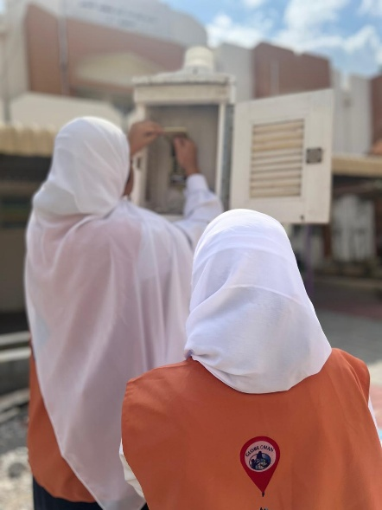

Research study titled:
Analysis of the impact of local climate changes on air temperature, soil temperature, and humidity in the Wilayat of Khasab during the year 2025.
Preparation by the two students: Fajr Al-Shahya and Miyar Al-Shahya
Supervised by: Fatima Al-Shahya

Table of Contents
Research summary 3
Basic terms 4
Research questions 4
Implementation Plan 6
Previous studies related to the research 7
Equipment and tools used • Hygrometer (humidity meter) • Digital thermometer 10
Data analysis: 10
Comparison of meteorological data between Khasab Station and GLOBE Station 11
Results: 13
Challenges 14
Discussion of the results: 16
Thanks and appreciation 17
References 17

Research summary
This research comes within the framework of the growing interest in studying local climate changes and the direct and indirect environmental impacts they cause on natural systems and human societies, as climate changes have become one of the most prominent environmental issues preoccupying the world at the present time, because of their clear effects on temperatures, humidity, soil, water, and various human activities. This research aims to study and analyze the impact of local climate changes on air temperature, soil temperature, and humidity levels in the Wilayat of Khasab during the year 2025 AD, as it is one of the coastal regions with distinct environmental and climatic characteristics in the Sultanate of Oman. And the mountainous. From this standpoint, the research seeks to understand the nature of local climate changes in the state, and to analyze how these changes are reflected in basic climate elements such as temperature, Air, soil temperature, and relative humidity.
The research is based on a scientific approach that combines field work and descriptive analysis, where field data is collected directly from the study site using simple and available measuring tools such as a digital thermometer and a hygrometer to measure humidity. This data is recorded periodically and regularly during different time periods from the year 2025 AD, allowing monitoring of daily and seasonal changes in the climate elements studied. The data is also documented in organized tables to ensure accuracy and ease of analysis.
In addition to the field data collected directly from the study site, this research also relies on official climate data issued by the meteorological station in the state of Khasab, in addition to data available from the Environment Agency in the Sultanate of Oman through the open data portal. This accreditation comes within the framework of strengthening the scientific basis of the study, and ensuring the comprehensiveness and accuracy of the analysis by making use of approved and reliable data sources.
Field data is an essential element in this research, as it reflects the actual climatic conditions at the study site during the monitoring period, and represents direct measurements of a number of important weather variables such as air temperature, soil temperature, relative humidity, and atmospheric pressure. These data are distinguished by their ability to clarify subtle local changes that may not appear clearly in general climate records, especially in areas affected by local geographical or environmental factors.
On the other hand, the official climate data issued by the meteorological station in the state of Khasab provide regular and approved time records, collected according to precise scientific standards and advanced measuring devices, which makes them an important reference for comparing field results and verifying the extent of their compatibility with the general climate trends of the region. These data also contribute to giving a more comprehensive picture of the prevailing climate characteristics, and help explain possible differences between field measurements and official measurements.
As for the data of the Environment Agency in the Sultanate of Oman, which is available through the open data portal, it is an important supporting source for the study, as it provides access to environmental information.
Basic terms
Climate change:
They are long-term changes that occur in various climate elements such as temperature, humidity, rainfall patterns, and winds, which may be caused by natural factors or human activities.
Air temperature:
It is the degree of warmth or coolness of the surrounding air in a specific place and time, and it is considered one of the most important elements of the climate that affects the other climatic and environmental elements.
Soil temperature:
It is the temperature of the surface layer of the soil, and it is affected by several climatic factors such as air temperature, solar radiation, and humidity. It plays an important role in environmental and plant processes.
Relative humidity:
It is the amount of water vapor present in the air compared to the maximum amount the air can hold at a certain temperature, and it directly affects the sensation of temperature and environmental conditions.
Field data:
These are the data collected directly from the study site using measurement tools, reflecting the actual environmental conditions in the studied area.
Meteorological station:
It is an entity specialized in monitoring and recording weather and climate elements regularly, providing official data used in climatic and environmental studies.
Research questions
This research is based on a set of research questions aimed at guiding the process of data collection and analysis, and among the most prominent of these questions are:
1. What is the impact of local climate changes on air temperature in the state of Khasab in 2025? What is the impact of local climate changes on air temperature in the Wilayat of Khasab in 2025?
2. What is the nature of the relationship between air temperature and soil temperature during the study period? What is the nature of the relationship between air temperature and soil temperature during the study period?
3. How do relative humidity levels change with the seasons in the state of Khasab? How do relative humidity levels change with the seasons in the state of Khasab?
4. Are there significant differences between the field data collected and the data issued by the meteorological stations? Are there significant differences between the field data collected and the data issued by meteorological stations? And what are the reasons for these differences, if they exist?
Research Hypothesis
This study is based on the following hypothesis:
There are significant differences in some meteorological variables (such as temperature, relative humidity, and atmospheric pressure) between the Khasab station and the GLOBE station during the study period, due to the differing locations of the two stations and the measurement methods used in each.
Research plan
The research relies on the descriptive-analytical method, where the studied climatic phenomena are described and analyzed based on data collected both field-wise and officially. The research plan begins with identifying the study site and selecting appropriate measurement points that represent the local environment in the Wilayat of Khasab, taking into account surrounding environmental factors such as proximity to the sea or mountainous areas.
A timeline is prepared for data collection throughout the year 2025, covering different time periods, allowing for the monitoring of daily and seasonal changes. Appropriate measuring tools, such as digital thermometers and hygrometers, are used to accurately measure temperature and humidity.
After collecting the data, it is organized into clear tables, then analyzed using simple statistical methods and graphs to illustrate the trends and relationships between the different climatic variables. The results are also compared with the official climatic data issued by the meteorological station and the environmental authority, in addition to utilizing GLOBE programs and data to support the analysis and comparison.
In the final stage, the final research results are extracted and interpreted in light of the research questions and proposed hypotheses, followed by the presentation of a set of recommendations that can contribute to enhancing environmental awareness, supporting local climate studies, and encouraging further research in this field.

Implementation Plan
Implementer | Implementation Mechanism | Objectives to Be Achieved | Time Period
Supervising teacher & team members | Reviewing scientific literature and climate reports, and examining previous studies | Collecting preliminary information on climate change in Khasab Wilayat | 1–15 January 2025
Supervising teacher & team members | Communicating with the Khasab meteorological station and requesting data from the Environment Authority via the Open Data Portal | Coordination and request for official climate data | 16–31 January 2025
Supervising teacher & team members | Conducting field visits to the study site and identifying suitable locations for measuring air temperature, soil temperature, and humidity | Determining the study area and measurement points | 1–15 February 2025
Supervising teacher & team members | Using a digital thermometer and hygrometer and recording readings regularly | Initiating field data collection | 16 February – 31 March 2025
Supervising teacher & team members | Taking measurements on a weekly basis and organizing data into tables and charts | Continuing data collection and analyzing seasonal variations | 1 April – 30 June 2025
Supervising teacher & team members | Analyzing the data and comparing it with meteorological station data, Environment Authority data, and GLOBE program datasets | Comparing field data with official datasets | 1 July – 30 September 2025
Supervising teacher & team members | Interpreting relationships between air temperature, soil temperature, and humidity | Analyzing preliminary results | 1–31 October 2025
Supervising teacher & team members | Organizing results and writing them in the form of a complete scientific research paper | Writing the research draft | 1–30 November 2025
Supervising teacher & team members | Holding meetings to discuss final results and formulate recommendations | Discussing results and writing recommendations | 1–15 December 2025
Supervising teacher & team members | Linguistic and scientific review of the research and preparing it for submission | Final review and final formatting of the research | 16–31 December 2025
Supervising teacher & team members | Preparing a presentation using presentation software | Preparing the research presentation | 1–10 January 2026
Supervising teacher & team members | Designing a research poster and training on its presentation | Preparing the research poster and presentation training | 11–20 January 2026

Previous studies related to the research
Many scientific studies have addressed climate change and its impact on various climate elements such as temperature, humidity, and precipitation, both at the regional and local levels. Among the most prominent studies related to the subject of this research are the following:
Al-Suqaf et al. (2024) conducted a study titled “Spatiotemporal trends and implications of climate extremes over Oman: A comprehensive ERA5 reanalysis assessment,” which aimed to analyze the spatiotemporal trends of climate extremes in the Sultanate of Oman using reanalyzed ERA5 data from 2012 to 2022.
The study results showed a significant increase in maximum and minimum temperatures in various regions of the Sultanate, in addition to clear changes in humidity and rainfall patterns. This study is an important reference for our current research, as it supports the idea of local climate changes that directly affect climate elements, including air temperature and humidity. This is what the current research aims to study on a local scale in the Wilayat of Khasab.
The climatic data issued by the National Center for Statistics and Information in the Sultanate of Oman, available thru the Open Government Data Portal, relied on recording multiple climatic indicators such as temperatures, relative humidity, and rainfall amounts, based on data from meteorological stations spread throughout the Sultanate.
These data are characterized by accuracy and temporal continuity, as daily average temperatures, maximum and minimum limits, as well as humidity measurements using specialized devices are recorded. These data are used as an official source for comparison with field data in this research, thereby enhancing the reliability of the analysis and results.
Hussein et al. (2025) in their study titled "The Impact of Temperature and Humidity Changes on Wheat Growth and Production in Kom Ombo" addressed the relationship between climate changes and agricultural activity in Upper Egypt. The study results showed that the increase in temperatures and changes in humidity levels directly affect plant growth and productivity.
Although the study's location differs from the Wilayat of Khasab, this study highlights the importance of understanding the relationship between different climatic elements and their impact on the environment, which aligns with the current research objectives in analyzing the relationship between air temperature, soil temperature, and humidity.
Ejike et al. (2025) presented a comparative study titled "Comparative Study of Machine Learning-Based Rainfall Prediction in Tropical and Temperate Climates," which focused on the use of machine learning techniques in rainfall prediction in different climates. The study emphasized the importance of having accurate and long-term climatic data to understand climatic patterns and future changes.
This study highlights the importance of analyzing temporal climate data, which supports the current research approach based on collecting periodic data and analyzing it to understand local climate changes.
Benefits of previous studies
• Supporting the theoretical framework of the research and highlighting the importance of studying climate changes locally.
• Confirming the existence of clear climate changes in the Sultanate of Oman in recent years.
• Clarifying the importance of linking field data with official data.
• Enhancing the reliability of the methodology used in the current research.
Introduction and Literature Review
Climate change is considered one of the most prominent environmental issues that has received widespread attention in recent decades, due to its direct impacts on various climate elements such as temperature, humidity, and precipitation, in addition to its effects on ecosystems and human activities. Many global and regional studies have shown increasing trends in temperatures and noticeable changes in humidity patterns, especially in coastal and semi-arid areas. In the Sultanate of Oman, recent studies have indicated significant climatic changes over the past years, manifested in the rise of maximum and minimum temperatures and changes in humidity levels. The study by Al-Suqaf et al. (2024) addressed the spatial and temporal trends of climate extremes in the Sultanate and confirmed the presence of significant climate changes in most regions. The data from the National Center for Statistics and Information also highlighted the importance of relying on meteorological station records in analyzing long-term climate changes.
On the practical side, other studies have shown that changes in temperature and humidity directly affect the natural environment and agricultural production, as mentioned in the study by Hussein et al. (2025), which addressed the impact of these changes on crop growth. The importance of these studies is highlighted in supporting the current research, which aims to field study local climate changes in the Wilayat of Khasab and link them with official data, thereby contributing to enhancing the scientific understanding of climate change at the local level.
Research methods
The research relied on collecting direct field data according to the protocols of the global GLOBE program, using precise measuring tools including: a digital thermometer (for calibration and backup measurements), a hygrometer for humidity, and soil depth measuring tools. Tasks were distributed to the team daily to ensure coverage of the school week (from Sunday to Thursday).
Table No. (1): Measurement Schedule for the GLOBE Team. The table above was updated daily on the official THE GLOBE PROGRAM website (with the timing set to UTC), and the process was documented with screenshots of the entries (such as entering the current temperature on 07-10-2025, and Multi-Day Soil Temperature). The data was also recorded locally in Excel spreadsheets for statistical analysis and comparison with the official data from the weather station in Khasab.
Research methods and communication with a meteorologist at the state's meteorological station.
Search location: Khawla bint Al-Azwar School at these coordinates:
• Elevation: 216 m
• Longitude: 56.15133 East
• Latitude: 26.10094 North
• Location ID 103912:
• Source of the location GPS:
• Protocols, and wind movement.
The Wilayat of Khasab is characterized by high relative humidity, especially during the summer, in addition to the variation in temperatures between the different seasons. This site was chosen due to its environmental and climatic significance, and its suitability for studying local climate changes and their impact on various climatic elements.
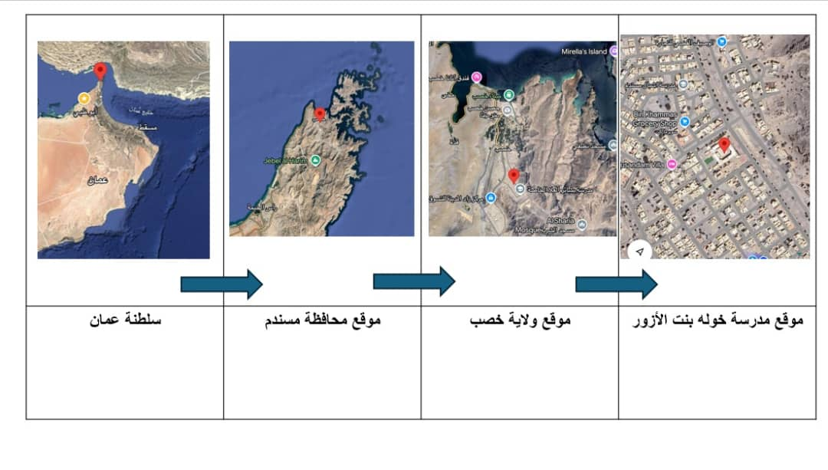
Data collection
Data was collected in this research using two main methods: field data collection and reliance on official data.
Field data collection included measuring air temperature, soil temperature, and relative humidity using a digital thermometer and a hygrometer. The readings were recorded periodically according to a specific schedule to ensure the accuracy of the results.
As for the official data, it was obtained from the meteorological station in the Wilayat of Khasab, in addition to the data available thru the open data portal of the Environment Authority and the National Center for Statistics and Information. After collecting the data, it was organized, analyzed, and compared with the aim of monitoring local climate changes and studying the relationship between different climate elements. The tasks were systematically distributed among the team members to ensure the continuity of daily measurements according to the GLOBE program protocols. The team measurement schedule (Table 1) for the Atmosphere Protocol and Soil Temperature Protocol has been prepared, including the distribution of days among the participating students.
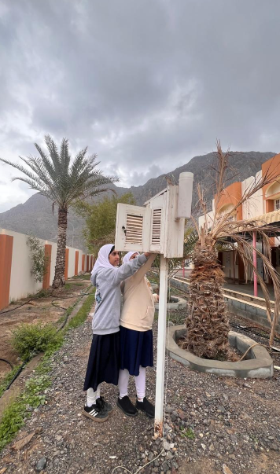
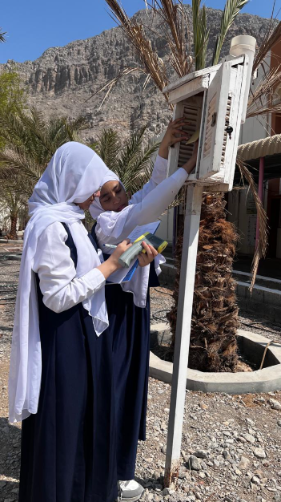

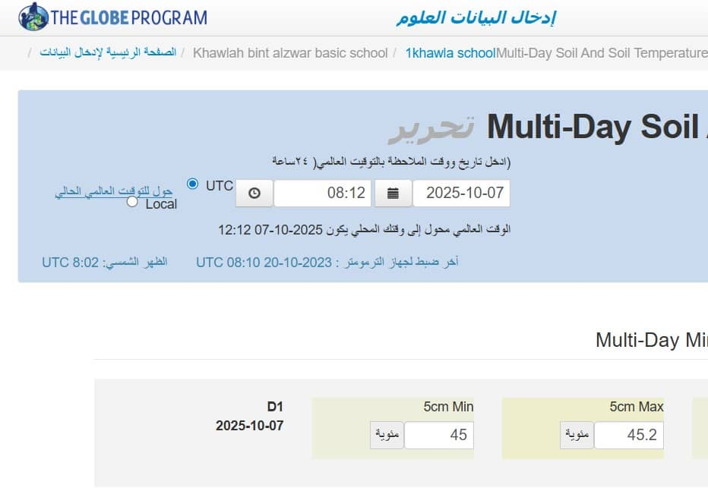

Equipment and tools used
• Hygrometer (humidity meter)
• Digital thermometer

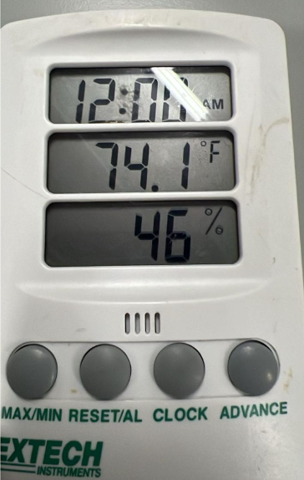
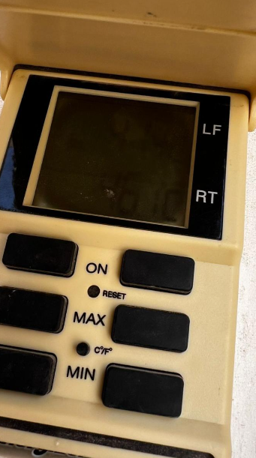

Data analysis:
Microsoft Excel was used to analyze the climatic data collected from the weather station during October 2025. By entering daily measurements and averages of various weather elements such as air and soil temperatures, relative humidity, and atmospheric pressure, tables and bar charts were created to illustrate trends and comparisons between the different elements. The program helped in accurately calculating the overall averages and extracting key values such as the average maximum and minimum temperatures, in addition to presenting the results visually to facilitate understanding of the fluctuations throughout the month. The data was organized into multiple worksheets, where daily measurements were separated from monthly averages, and functions such as AVERAGE, MAX, MIN, and PivotTables were used to summarize the data and create automatic charts. Conditional formatting was also used to highlight exceptional values, such as heat spikes or pressure drops, which contributed to quickly identifying prominent patterns.
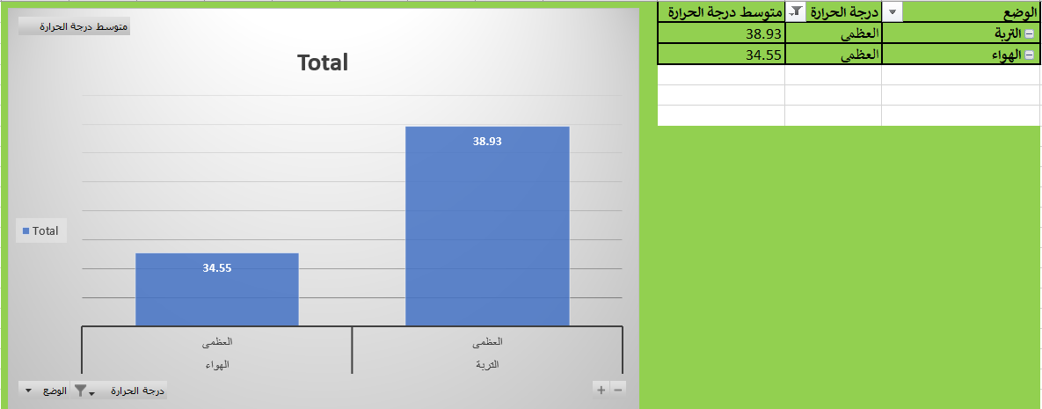
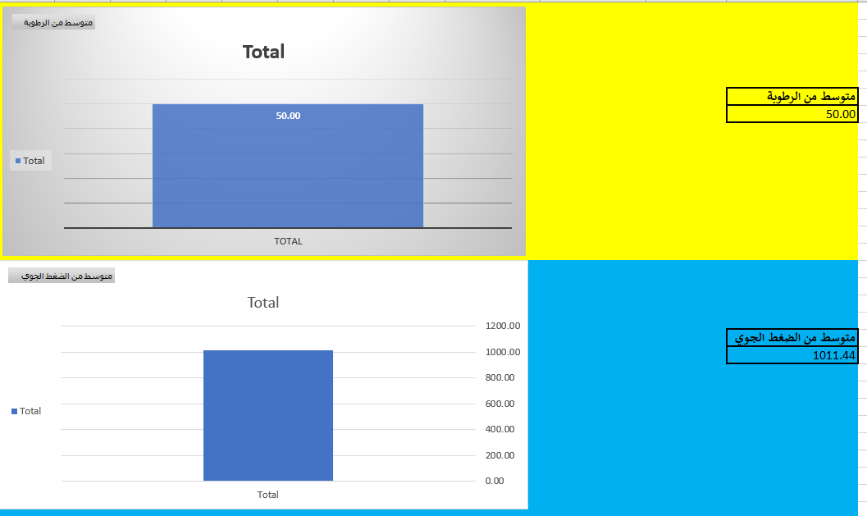
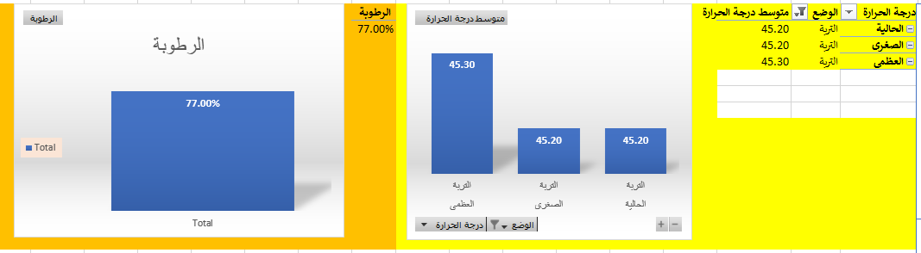
Comparison of meteorological data between Khasab Station and GLOBE Station
Based on the data in the two files, a comparison was made between the recorded weather values at the Khasab station and the GLOBE station for the common dates in October 2025, after converting the dates from serial format to standard historical format. This comparison aims to highlight the similarities and differences between the two stations in terms of the main weather elements.
The comparison included the following variables:
• Maximum and minimum air temperature
• The maximum and minimum soil temperature
• The current air temperature
• Relative humidity
• Atmospheric pressure
The values have been presented in a unified table so that the data from each station appear side by side, making it easier to analyze and directly compare the two stations.
Comparison and analysis results
1. Temperatures Temperatures
The results showed significant differences in maximum and minimum temperatures between the two stations on several days. For example, on the date 2025-10-02, the maximum temperature at the Khasab station reached 35.9°C, while the GLOBE station recorded 37.7°C. These differences may be attributed to the varying locations of the stations or the timing of the measurements (daily measurements versus instantaneous measurements).
2. Soil temperature Soil temperature
The GLOBE station recorded higher soil temperatures on some days compared to the Khasab station, which may reflect differences in soil nature or direct exposure to solar radiation.
3. Relative humidity Relative humidity
It was observed that the humidity data in the GLOBE file were recorded in decimal format (such as 0.77) and were converted to percentages (77%) to match the data format of the Khasab station. After standardization, a general convergence in humidity values was observed, with some daily fluctuations.
4. Atmospheric pressure Atmospheric pressure
Atmospheric pressure data showed a relative convergence between the two stations, with slight differences that could be due to variations in geographic elevation or the precision of the measuring instruments.
5. General Averages General Averages
The first file contained statistical averages on a separate sheet, such as the average maximum temperature of 34.64°C, which supports the overall trend of the daily recorded data during the study period.
The comparison shows that there is a general similarity in climatic trends between the Khasab station and the GLOBE station, with limited quantitative differences in some atmospheric elements, especially temperatures. These differences indicate the importance of standardizing measurement methods and observation times when comparing climatic data between different stations, to ensure the accuracy of analysis and scientific conclusions.
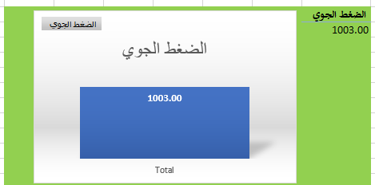
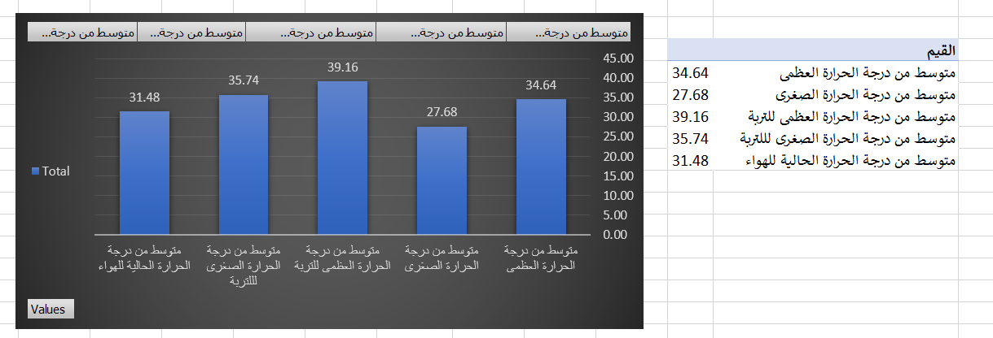
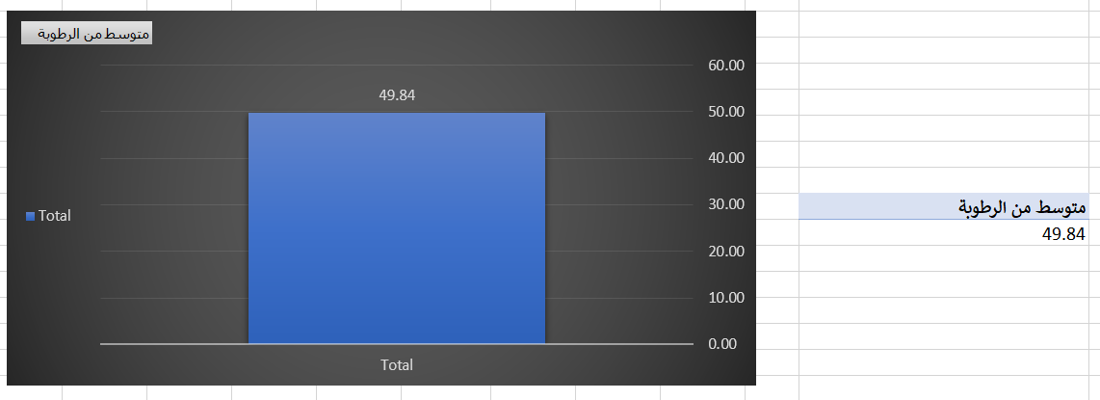
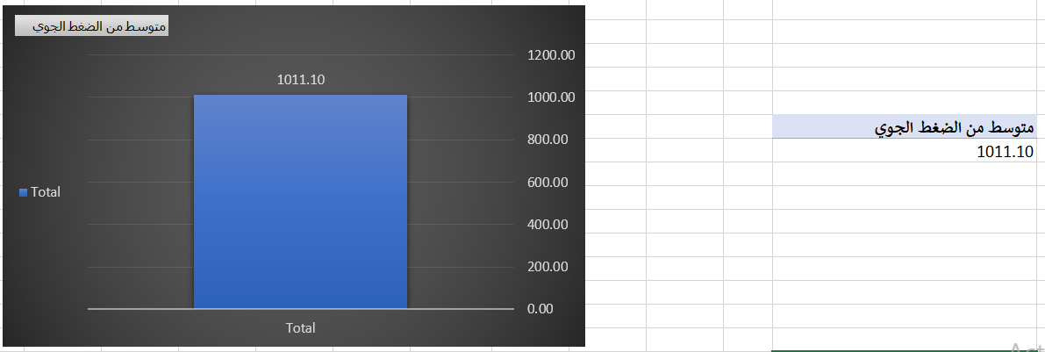
Results:
The results showed that the average maximum air temperature reached 34.64 degrees Celsius, while the average minimum was 27.68 degrees Celsius, and the average current temperature (daily approximation) was 31.48 degrees Celsius. As for the soil temperature, it recorded a higher average maximum of 39.16 degrees Celsius and an average minimum of 35.74 degrees Celsius, reflecting greater heating of the soil compared to the air during the day. Additionally, the average relative humidity was 49.84%, with individual values reaching around 50% or higher on some days (such as 77% in certain contexts, possibly related to instantaneous measurements or wetter days). Meanwhile, the average atmospheric pressure was 1011.10 hPa, which is a relatively stable value with some minor fluctuations, such as 1003.00 hPa in some recordings. The data covers sporadic days from October 1 to 31, 2025, with a greater focus on maximum values, and some gaps appearing in the complete daily recordings.
Those responsible for data collection and role distribution
• Students: Collecting field data and recording it in field logs
• The supervising teacher: supervision, guidance, and ensuring the accuracy of measurements
• School team: Coordination and follow-up to facilitate data collection
Basic and supporting information
Reasons for choosing the research topic
• The importance of climate change and its direct impact on the local environment and human life
• Increasing awareness of the environmental risks associated with rising temperatures and changing humidity
Related studies and research
• Dependence on previous studies on local climate change in the Sultanate of Oman (e.g., Al-Saqaf et al., 2024)
• Utilizing data from meteorological stations and the National Center for Statistics and Information
The importance of the research for the local community and the region
• Understanding seasonal environmental changes
• Raising environmental awareness among students and the local community
• Providing reliable scientific data for environmental and agricultural planning
Challenges
Collecting and analyzing climate data is a precise and complex task that requires adherence to several scientific standards to ensure the accuracy and reliability of the results. During this research, which studies the impact of local climate changes on air temperature, soil temperature, and humidity in the Wilayat of Khasab, we faced a set of significant challenges that can be classified into three main categories: challenges in field data collection, challenges in data analysis, and challenges related to comparing field data with official data or data from programs like GLOBE.
Potential challenges in data collection
The first and most important challenges were related to the changing weather conditions. Wilayat Khasab is located in a mountainous and coastal area, making the weather prone to sudden fluctuations. For example, the temperature may vary significantly during the daytime, and humidity can be affected by sea breezes or local wind changes. These fluctuations complicate the process of consistently collecting daily data, making it difficult to obtain uniform measurements throughout the study period.
Secondly, adhering to the data collection schedule was a significant practical challenge. Given that the research relied on data collection once or twice a week over several months, the team encountered days when the weather conditions were not suitable for measurement, or there were equipment malfunctions, resulting in the loss of some measurements. This requires rescheduling field trips and re-measuring some indicators, which takes additional time and effort.
Thirdly, we faced logistical difficulties related to equipment and tools. Although the hygrometer and digital thermometer were provided, some devices require periodic calibration to ensure measurement accuracy, and intensive use in exposed environments may lead to slight reading errors. Additionally, transporting the equipment to field sites and securing it safely posed a challenge, especially in mountainous areas or uneven terrain.
Fourthly, training students and ensuring their readiness to conduct measurements scientifically correctly represents another challenge. Collecting climatic data requires a precise understanding of measurement protocols and following specific steps when recording readings. Any error in measurement or timing could lead to distorted results, which requires continuous supervision and intensive practical training to ensure accuracy and reliability.
Challenges in data analysis
After collecting the field data, a set of challenges related to data analysis and comparison emerged.
The first of these challenges is the variation in readings between days and locations. For example, soil temperatures recorded a greater increase than air temperatures, and humidity varied between coastal and mountainous regions, making the analysis of general trends more complex. This variation requires the use of precise statistical methods to reduce errors and provide accurate averages.
Secondly, any field study faces issues with the accuracy of devices and the measurement of indicators. Despite the calibration of the instruments, the variation in values between different devices can sometimes lead to inconsistent data, which necessitates reviewing and verifying the readings before entering them into the analysis, and re-measuring when necessary.
Thirdly, interpreting the data in its local climatic context presents a significant challenge. Local factors must be taken into account, such as the impact of topography, proximity to the sea, wind direction, and soil type on measurement results. Ignoring these factors may lead to inaccurate conclusions about actual climate changes.
Fourthly, dealing with missing or incomplete data was an additional challenge. Some days, not all measurements were recorded due to weather conditions or equipment malfunctions, necessitating the use of statistical methods for estimation or data completion to ensure the continuity of the analysis.
Challenges in comparing data with other sources
Any field research faces an additional challenge when trying to compare local data with global data or data from programs like GLOBE.
First, the units of measurement or data collection protocols may differ between various sources, requiring data conversion and unit standardization before comparison.
Secondly, the geographical climate differences between the study site and other locations make comparisons indirect. For example, GLOBE data may represent distant areas or different terrains and environments, which requires careful interpretation of the results and avoids generalizing the conclusions.
Thirdly, the lack of complete daily records in some official or global data sources limits the accuracy of seasonal or daily analysis, making reliance on monthly averages more appropriate, but it reduces the detailed information on climatic variables.
Ways to overcome the challenges
To overcome these challenges, several strategies have been adopted:
1. Repeating measurements to ensure their accuracy and reduce random errors. Repeating measurements to ensure their accuracy and reduce random errors.
2. Comparing field data with official sources to ensure its accuracy, such as data from national meteorological stations and the National Center for Statistics and Information. Comparing field data with official sources to ensure its accuracy, such as data from national meteorological stations and the National Center for Statistics and Information.
3. Using statistical analysis to estimate averages and differences, and to reduce the impact of outliers or missing data. Using statistical analysis to estimate means and differences, and to reduce the impact of outliers or missing data.
4. Training the field team on measurement protocols and the importance of accurately recording daily observations. Training the field team on measurement protocols and the importance of accurately recording daily observations.
5. Standardizing measurement units and technical specifications when comparing data with other sources such as GLOBE. Standardizing units of measurement and technical specifications when comparing data with other sources like GLOBE.
6. Recording all surrounding environmental conditions during measurement, such as sunlight intensity, wind direction, and soil type, to ensure better interpretation of the results. Recording all surrounding environmental conditions during the measurement, such as sunlight intensity, wind direction, and soil type, to ensure better interpretation of the results.
Those responsible for data collection and role distribution
Collecting field data on climate changes is a precise process that requires coordinated cooperation among all research participants to ensure the accuracy and reliability of the results. Students form the core part of the team responsible for data collection, as they go to the study sites in the Wilayat of Khasab to observe and measure various climate elements, including air temperature, soil temperature, and humidity levels. Students are pre-trained on using devices and equipment to develop their skills in data collection and analysis.
Discussion of the results:
The fact that October 2025 experienced high temperatures, particularly in the average maximum air temperature (34.64 °C) and soil temperature (39.16 °C), suggests that the region experienced warmer conditions than normal in the northern coastal regions, including Alexandria or the Nile Delta. The average maximum temperature in October in Alexandria is normally between 27-28 °C (approximately 81-82 °F), while the minimum is between 19-21 °C, with a mean average of 23-24 °C for the entire month, based on past records (1991-2020). This implies that October 2025 experienced a positive anomaly of 4-7 °C in the maximum temperatures, which is a substantial variation that confirms the warming trend in the region. At the global level, October 2025 was one of the warmest months on record (third or one of the highest), with increasing temperatures in North Africa and other areas, consistent with the expected impacts of climate change that lead to the increase in late autumn heatwaves.
The noticeable difference between the temperatures of the air and the soil (up to 4-5 °C) is expected in the semi-arid or coastal regions such as the Nile Delta, where the soil is expected to absorb the solar radiation and increase the soil temperature more rapidly compared to the air, especially during the daylight hours. In the previous studies on the climate in Egypt, it is observed that the surface soil is usually 5-10 °C higher than the air.
Regarding relative humidity, the average of 49.84% is considered lower than the historical average for October in Alexandria (around 63-68%), indicating relatively drier periods during the month. This decrease may be due to the dominance of dry northern or eastern air masses, or the effect of strong winds that reduce surface humidity. However, the individual high values (such as 77%) may be associated with days of higher humidity near the coast or after light rainfall, making the feeling of heat more uncomfortable on those days due to the heat index, which rises with humidity. In coastal areas, moderate to low humidity makes the weather more comfortable compared to summer, but with high temperatures, the atmosphere remains relatively hot.
As for atmospheric pressure, the average of 1011.10 hPa falls within the normal range for October in northern Egypt (usually 1010-1015 hPa), reflecting a general atmospheric stability without major disturbances such as storms or severe depressions. Temporary drops (such as 1003 hPa) may indicate the passage of a transient low-pressure system or changes in air currents, but they have not led to significant changes in the weather. This stability aligns with the autumn weather pattern in the region, where the chances of rain decrease and sunny conditions prevail.
From an environmental and economic perspective, this warm month raises concerns about the impacts of climate change on Egypt, as records show an increase in annual and seasonal temperatures, with positive trends in thermal deviations over the decades. In North Africa, recent years (including 2025) have seen above-average temperatures, increasing pressure on water resources, agriculture, and energy. In the Nile Delta, which relies on intensive agriculture, high soil temperatures may lead to increased evaporation and reduced water use efficiency, especially with the forecast of decreased rainfall in the region in the long term. Additionally, warm nites (minimum 27.68 °C) reduce the nighttime cooling period necessary for many crops, which may affect productivity.
Conclusion and Recommendations:
The analysis of October 2025 data shows that the month was exceptional in terms of warmth, with significant positive temperature anomalies compared to historical averages, reflecting the continuation of climate change trends in Oman. The results confirm the importance of collecting complete daily data and comparing it with long-term time series to accurately measure deviations. It is recommended to conduct future studies that include additional factors such as wind speed, rainfall amount (which appears to be low this month), and heat index indicators. The monitoring station network in the delta should also be strengthened for better coverage, with a focus on studying the effects of soil temperature on agriculture and public health.
Thanks and appreciation
Words scatter like ink and love on the pages for everyone who contributed, helped us, and sparked our curiosity toward research and investigation in the environmental and climatic field in the Sultanate of Oman. We recognize that this research would not have been completed without the continuous support and assistance from many individuals and institutions, who provided us with their time, knowledge, and expertise to carry out this scientific work in the best possible manner. From this standpoint, we extend our deepest gratitude and appreciation to everyone who contributed to the success of this research, whether directly or indirectly. We extend our sincere thanks to the members of the GLOBE Program team for their valuable assistance and continuous encouragement, as well as their dedicated efforts in providing the necessary tools and protocols for collecting and analyzing climate data. Their technical and scientific support played a significant role in guiding us toward the correct methods for collecting field data and understanding the measurement protocols for various climate elements, including air temperature, soil temperature, and humidity levels. We also appreciate the significant efforts of the program supervisors in Musandam Governorate, who provided us with the necessary guidance and direction to complete the research as required.

References
- Al-Saqqaf, A. S., Zhang, J., Yao, F., Al-Maamari, A., Hizam, M. H., Hamed, M. M., & Shaheed, S. D. (2024). Spatiotemporal trends and significance of climate extremes in the Sultanate of Oman: A comprehensive assessment using ERA5 reanalysis. Theoretical and Applied Climatology, 155, 10051–10067.
https://doi.org/10.1007/s00704-024-05222-z
https://link.springer.com/article/10.1007/s00704-024-05222-z
- National Centre for Statistics and Information (NCSI). (2023). Weather and climate indicators data in the Sultanate of Oman. Sultanate of Oman.
https://data.gov.om/armmvmb/weather
https://www.data.gov.om/
- Hussein, M. M., Suleiman, S. S., & Ibrahim, M. (2025). Impact of temperature and humidity changes on wheat growth and productivity in Kom Ombo. Journal of African Research and Nile Basin Countries, 9(2), 124–138.
https://doi.org/10.21608/mbddn.2025.368748.1267
https://journals.ekb.eg/article_428552_0.html
- Ejik, O., Ndzi, D., & Shakir, M. Z. (2025). A comparative study of rainfall prediction using machine learning techniques in tropical and temperate climates. Climate, 13(8), Article 167.
https://doi.org/10.3390/cli13080167
https://www.mdpi.com/2225-1154/13/8/167

