Development of Waveguide Biosensor for Detection of Flaviviridae Utilizing Mosquito Habitat Data

Corbin Adkins, Justin Lan, Anna Ager, Michelle Eno, Benito Esposti, Andrew Kim, Nicole
Schmidt, and Felipe Solorzano

STEM Enhancement in Earth Science, NASA
STEM Enhancement in Earth Science, The Texas Space Grant Consortium
STEM Enhancement in Earth Science, The University of Texas at Austin

Abstract
Efficient diagnostics have the potential to subside epidemics and global mortality rates- particularly in the context of Flaviviridae, a family of deadly, vector-borne viruses spread by mosquitoes. Current biosensors being used to detect the presence of Flaviviridae require two components: a biological component such as a protein, and a technological component to create a measurable signal. Surface Plasmon Resonance (SPR) biosensors effectively diagnose Flaviviridae from the point of care using quick, portable methods; however, these tools cannot diagnose a specific disease due to the structural similarities within Flaviviridae. They are also more economical due to their materials not being single-use as opposed to fluorescence-based devices. Fluorescence-based devices are accurate, however, the requirements of this method reduce its portability and increase potential costs. We hypothesized that either SPR or fluorescence contrast methods are more optimal in determining the presence of Flaviviridae, depending on SEES data patterns from the GLOBE Observer app. Based on data observations, we predict that implementing fluorescence-based biosensors in densely populated urban areas will be more efficient, as this biosensing method is more accurate at determining a specific disease within a large population, and do not require the flexibility and portability of SPR-based biosensors.

Index

Comparing Current Biosensing Methods --------------------------------- 4-8
Comparison of current biosensing methods: electrochemical, thermometric, optical, and piezoelectric
Different Types of Viruses ---------------------------------------------------- 8-10
Explanations of the types of flavivirus: Yellow Fever, Zika, West Nile, and Dengue
Comparing Fluorescent and SPR Methods ---------------------------- --- 10-12
Description of the main two contrast methods studied and their respective pros and cons
SEES Data Incorporation ---------------------------------------------------- 12-17
Explanation of how SEES data was quantified and observed to help determine contrast method
Target Audience and Application ------------------------------------------- 17-19
Justification of who benefits from a waveguide based biosensor, and estimated cost
Understanding Waveguide Function --------------------------------------- 19-20
Basic explanation of how waveguides work and their general advantages/disadvantages
Our Waveguide Design -------------------------------------------------------- 20-21
Explanation of how our waveguide works and it’s specific advantages/disadvantages
Figures -------------------------------------------------------- -------- ----------- 21-22
Images of our waveguide through OnShape AutoCAD
Acknowledgments -------------------------------------------------------------- 22-24
References ------------------------------------------------------------------------ 25-37

Comparing Current Biosensing Methods
A biosensor is defined as a compact analytical device that works to measure biological reactions by quantifying signals indicative of the presence of an analyte, the substance of interest. They are primarily composed of a biological sensing element that provides selectivity as well as a transducer that converts physio-chemical behavior into detectable signals (Varnakavi et al., 2021). In practice, a biological material is placed in contact with the transducer, and the analyte interacts with the material to generate signals in a process known as bio-recognition. From there, the transducer performs signalisation, a process that converts the bio-recognition event into a measurable signal that is proportional to the amount of analyte-bioreceptor interactions (Săndulescu et al., 2015). The processed signals can then be quantified and analyzed.

Electrochemical Biosensors
Electrochemical biosensors are based on the idea of transducing biochemical events to electrical signals. As an analyte interacts on an active electrode surface, the reaction may cause electron transfer across the medium, producing a current (amperometric), or it can contribute to the potential, producing a voltage (potentiometric) (Grieshaber et al., 2008). The altered current flow caused by the movement of electrons can be measured, in which the magnitude of the current is proportional to the concentration of the analyte.
In general, electrochemical biosensors are simple devices to develop and operate, characterized by their low-cost production and easy-to-understand user interface. In addition to avoiding the complex set up process and cost that other methods carry with them, electrochemical biosensors also are advantageous for their versatility in terms of miniaturization, their excellent performance with small analyte volumes, and their ability to be used in turbid biofluids (Cho et al., 2020). Specifically, the fact that they are unaffected by interference from absorbing and fluorescing compounds is key. In contrast, such devices’ potential is severely limited by a number of factors that should be noted. Mainly, they do not have the type of surface architecture that would facilitate high sensitivity. This means they would have a limited temperature and pH range, and outside of this range, the behavior of the biosensor may be impacted greatly.
Electrochemical biosensors are renowned for their versatility and expandability. With that being said, there is another type of biosensor that further integrates itself with the natural processes of chemical/biological reactions: thermometric biosensors.

Thermometric Biosensors
Thermometric biosensors take advantage of a basic property of biological reactions: being endothermic or exothermic. The difference in the temperature between the substrate and product is measured by thermistors in the form of thermal signals generated during the catalytic reaction. Such signals are proportional to the concentration of the substrate. By measuring the heat absorbed or released during a reaction (∆T), information can be obtained on the efficiency and degree to which the creation of product from substrate took place (Varnakavi et al., 2021). Thermometric biosensors are best suited in the sensing of multiple reactions, since it tracks the sum of all enthalpies. In addition, changes in temperature are measured by thermistors, which are highly sensitive and give high levels of detail. However, their applicability within disease detection is limited. This is partially due to their failure to be useful in bioengineering applications.
Simple in nature, thermometric biosensors offer value in numerous tasks. However, at the core of a biosensor’s functionality is the conversion of signal to data that is able to be read and analyzed. This cannot be emphasized more in the inner workings of optical biosensors.

Optical Biosensors
Optical biosensors are devices that utilize optical measurements (absorbance, fluorescence, chemiluminescence) and employ fibre optics and optoelectronic transducers in the detection process (Bosch et al., 2007). Optical biosensors mainly use enzymes and antibodies as transducing elements and are renowned for their ability to provide label-free and real-time parallel detection. In optical biosensors, the transduction process has the potential to create a change in the absorption, transmission, reflection, refraction, light polarization, and more, in response to physical or chemical changes created by the biorecognition elements.
Optical biosensors offer great advantages in terms of practicality, speed, and scope of use. The selectivity of the biological sensing element offers the opportunity for highly specific devices that can perform real-time analysis in complex mixtures, without the need for extensive sample pretreatment or large sample volumes (Dey et al., 2011). Furthermore, optical biosensors are simple-to-operate tools that are immune to electrical or magnetic interference. As promising as this may sound, the main drawback for devices of this type are their cost. The difficulties involved in fabricating optical biosensors puts a major strain on its availability for use.
In addition to the techniques that have been stated thus far, a more affordable approach in biorecognition takes advantage of audible detection methods.

Piezoelectric Biosensors
Piezoelectric biosensors rely on acoustics to function. They operate based on the change in the physical properties of an acoustic wave in a response that can be correlated to the amount of analyte absorbed (Pohanka, 2018). Piezoelectric crystals form the basis of these biosensors. The crystals with positive and negative charges vibrate with characteristic frequencies. Adsorption of certain molecules on the crystal surface alters the resonance frequencies which can be measured by electronics.
The simplicity and low price of piezoelectric sensors are favorable for practical use. They have the advantage of being able to work in several modes from which direct, label free, interaction with analyte provides the maximal use of advantages offered by the piezoelectric platform (Pohanka, 2018). Due to this, antigens and antibodies serve as promising biomolecules in terms of compatibility with a piezoelectric biosensor. Specifically, they are suitable for sized analytes with high molecular weight due to the fact they cause higher decrease of oscillation frequency. On the contrary, piezoelectric immunosensors are not equipped with optimal sensitivity to be widely used for general health purposes.
Overall, differing biosensing methods offer promise in various sectors. Likewise, waveguide-based biosensors, which utilize changes in the refractive index of analytes, are an emerging technology that has promise in the future of pathogen detection.

Waveguide-based Biosensors
Waveguide-based biochemical sensors exploit detection of target molecules that bind specifically to a functionalized waveguide surface. When light is coupled into a waveguide, it will propagate along the waveguide with negligible loss. The electromagnetic field distribution of the light interacts with the biomolecules near the waveguide surface. A small adjustment in the refractive index near the waveguide surface when a target analyte is captured causes changes in the output’s optical signal, which acts as the sensing signal (Li et al., 2011).
Waveguide biosensors exhibit potential in terms of miniaturization and cost-efficient production. The evanescent wave technique provides enhanced sensitivity through greater number of reflections per unit length (Pathak, 2004). Moreover, this method provides that the light monitored is always guided with no coupling requirement in the sensor region. This makes having an integrated miniaturized device feasible, thus largely avoiding surface and bulk effects (Pathak, 2004). On the contrary, the main issue against this mode of sensing is surface contamination. In order to combat this, careful design of the biolayer attachment must be done to avoid nonspecific binding and the need for frequent recalibration of the instruments.
Collectively, multiple factors should be taken into account when prompted with choosing a biosensing method. Aspects such as specificity, ability to function without being influenced by physical parameters, and cost are all valid considerations. With that being said, the promise that waveguide-based biosensors show in terms of their ability to offer sensitive, non-invasive detection of biological analytes with near instantaneous responses is unprecedented (Zeininger et al., 2019). In response to this emerging approach, we wish to go into further detail on the functionality and practicality of a waveguide-based sensing method.

Different Types of Viruses

Yellow Fever
The Yellow Fever virus is spread by Aedes and Haemogogus mosquitoes (Gaythorpe et al., 2021). This virus is commonly identified with the detection of immunoglobulin M (IgM), immunoglobulin G (IgG), and neutralizing antibodies (Centers for Disease Control and Prevention [CDC], 2015b; Centers for Disease Control and Prevention [CDC], 2015a). The inability for the RNA to be detected once symptoms are apparent causes complications in the testing process (CDC, 2015a). This complexity risks false-negative test results from virus isolation or reverse transcription polymerase chain reaction (RT-PCR) tests (CDC, 2015a). RT-PCR tests can help diagnose viral diseases, among other diseases, with the study of a virus’s RNA (National Cancer Institute [NCI], n.d.). Also, the recognition of the IgM antibodies in humans can also occur years after vaccination as well as during an infection (Gibney et al., 2012). This could potentially cause difficulties with detecting Yellow Fever in vaccinated people.

Zika
Zika is typically spread by Aedes mosquitoes. Currently, the most common method for detecting ZIKV within biosensors is reverse transcriptase-polymerase chain reaction (RT-PCR). However, we decided against focusing on this method because it is limited to the acute stage of the virus. In terms of fluorescence, it is typically detected with the label known as SYTO 9, which works by detecting the presence of dsRNA generated after the copy of single stranded homopolymeric RNA. The specific protein that is focused on in this method is NS5, which is the primary protein concerning the viral replication cycle. This means that the fluorophore identifies the reproduction of the ZIKV within a sample. Finally, in terms of the SPR method, there is a focus on the NS1 protein in ZIKV because it can interface well with SPR-based systems and detection methods.

West Nile
West Nile virus is primarily spread by Culex species mosquitoes. Specifically, it should be emphasized that approximately 80% of WNV infections in humans are asymptomatic, leading many to be unaware that they have contracted the disease. This means that the commercial tests employed to detect WNV must establish high sensitivity and specificity as priorities. Mainly, the virus can be diagnosed by detecting WNV IgM antibodies and measuring their ability to inhibit the binding of monoclonal antibodies against the NS1 and E proteins. In addition, infection is also generally associated with the regulation of the Glial fibrillary acidic protein (GFAP) in the blood. Previously, sensitive detection techniques such as enzyme linked immunosorbent assay (ELISA) and reverse transcriptase polymerase chain reaction (RT-PCR) for RNA were employed most often. However, the long turnaround times and the need for a centralized laboratory accompanied by highly trained personnel proved to be detrimental to the effectiveness of these methods. Collectively, the current obstacles that face WNV detection and the fact that NS1 is essential for the genetic replication of WNV provides valuable insight into the properties needed from an applicable biosensor.

Dengue
Dengue is spread by Aedes mosquitoes. A vaccine is available for dengue, and is approved for admisnistartion around the globe. The main method of detecting dengue is through viral antigen capture (VAC). VAC works by recognizing the NS1 protein in a sample. Fluorescence and SPR waveguides would also aim to detect the NS1 protein. Due to WNV detection also testing for NS1, cross talk is possible for the SPR method of detection. Cross talk should not happen for fluorescence because the wavelength will be unique for each disease.
Alexa Fluor fluorophore labelling has been shown to be the most effective for

Comparing Fluorescent and SPR Methods
One major part of a biosensor is how the device is identifying what is being sought out (ie: a virus) as separate from what it is in (ie: a solution that is being checked for the presence of said virus). There is a large variety of ways in which this may be investigated, such as surface-enhanced Raman scattering (SERS) (Ozcelik et al., 2017), optical imaging (Fact Sheet, n.d.), and contrast dyes. However, we will be focusing on fluorescence imaging (Fluorescence Imaging, n.d.) and surface plasmon resonance (SPR) (What Is Surface, 2018). Having examined many of the currently available methods, we have concluded that those listed will be optimal for use in tandem with waveguide technology.

Fluorescence
Biological components, such as tissues and cells, are primarily made up of water, meaning that they are clear. This makes viewing the specific structures within them very difficult without some way of differentiating the structure or component being sought from the rest of the objects. Fluorescence provides a way of centralizing identification to specific structures by emitting light of a specific visible wavelength when it interacts with light of another wavelength (Fluorescence Imaging, n.d.). The way it is applied through certain structures is typically through proteins known as fluorophores, which exhibit the property described above. These fluorophores interact with and attach to the structure being sought out, making them identifiable. In fluorescent imaging, the sample is then viewed under a microscope with a black background as an excitation light shines at it to activate the fluorescence.
One major advantage of fluorescence is its potential for use in tandem with waveguides. Since fluorescence is emitting light, the waveguide has a clear wave to maintain. This also makes it easier to use for specific data collection. That being said, one challenge of fluorophores is the requirements to make them fluoresce. Many require light of a specific wavelength to strike them as that is what makes them release light of one specific wavelength (A. Stambaugh, personal communication, July 15, 2021). At times, this specific wavelength can present itself as an extra cost or as another component, making it a bit more difficult to use for affordable or portable applications. That being said, there is also an effective label-free option in the surface plasmon resonance technique.

Surface Plasmon Resonance
Surface plasmon resonance (SPR) is a verified label-free biosensing tool that specializes in sensing the interactions between a variety of biomolecules (What Is Surface, 2018). The way it works is that a polarized light source is fired at a metal film with glass on the side that the light fires from and a solution containing biomolecules on the other side (How Does, n.d.). On the biomolecule side, ligands form a line along the metal, and various molecules are able to bind. Depending on how many bind at any given time, the free electrons in the metal, called surface plasmons, act as resonators. Resonance can occur between the plasma oscillations of the free electrons in the metal and the bound electromagnetic field of the totally internally reflected photons (What Is Surface, 2018). Essentially, where the solution on the one side of the metal has no binding occurring, the surface plasmons at a certain angle of incidence resonate with the light and create a dark band in the middle of the area detecting reflected light. As biomolecules bind, the dark band will shift (SPRtech101, 2011). This allows the detection of how many ligands are binded and how many are not, indicating the amount of interaction from the biomolecules.
An advantage of this method is that unlike fluorescence, SPR doesn’t require light of a certain wavelength, which reduces potential costs for specialized laser tools that could be required with fluorescence. However, a disadvantage of SPR would be the specificity of its applicative properties. Since it entirely focuses on the amount of binding occurring between biomolecules and ligands, we would need to narrow down what kind of binding we would be looking at and how to separate the involved biomolecules in order to avoid binding from biomolecules we are not focusing on. Overall, however, it has more potential for portability and price, but could be less accurate or have data that is more difficult to process.

SEES Data Incorporation
SEES mosquito habitat mapper data from 2019 to 2021 was downloaded and sorted via Python and Excel to filter needed subsets. After these sets were obtained, they were cross-referenced with other data to observe trends and correlations.
To determine the contrast method used by the waveguide model, two tests were completed to interpret the dispersion of the mosquito habitats using the 2019-2021 SEES intern Mosquito Habitat Mapper Observations. This dataset contained 3974 individual data points. The first test used Python coding to mark all observations that had at least one confirmed larvae sighting, regardless of genus. The second test used Excel to mark observations of three specific genera known for transmitting diseases. All data was retrieved from the GLOBE Advanced Data Accessing Tool. Quantitative larvae data was not used for this project because the primary purpose of utilizing the SEES data was to observe how dispersed positive larvae observations were recorded across the United States.

Observing Mosquito Habitat Mapper Data Using Jupyter Notebook
SEES data processing was completed using Jupyter Notebook, an application that allows for data analysis. The 2019-2021 Mosquito Habitat Mapper dataset was downloaded from the GLOBE tool as a CSV file and imported into a Python 3 file on Jupyter. First, all observations that had either no mosquito larvae data or had zero recorded larvae sightings were removed. Then, using the Python Pandas 0.24.2 library, a data frame was created containing only the mapper id, larvae count, and observation coordinates (longitude and latitude) from the original dataset (Kim, 2021). After this filtration process, there were a total of 453 recorded observations that contained at least one larva. All data was exported as a new CSV file and stored in the personal device.

Map layer created using GoogleMyMaps containing all confirmed Mosquito Larvae Observations
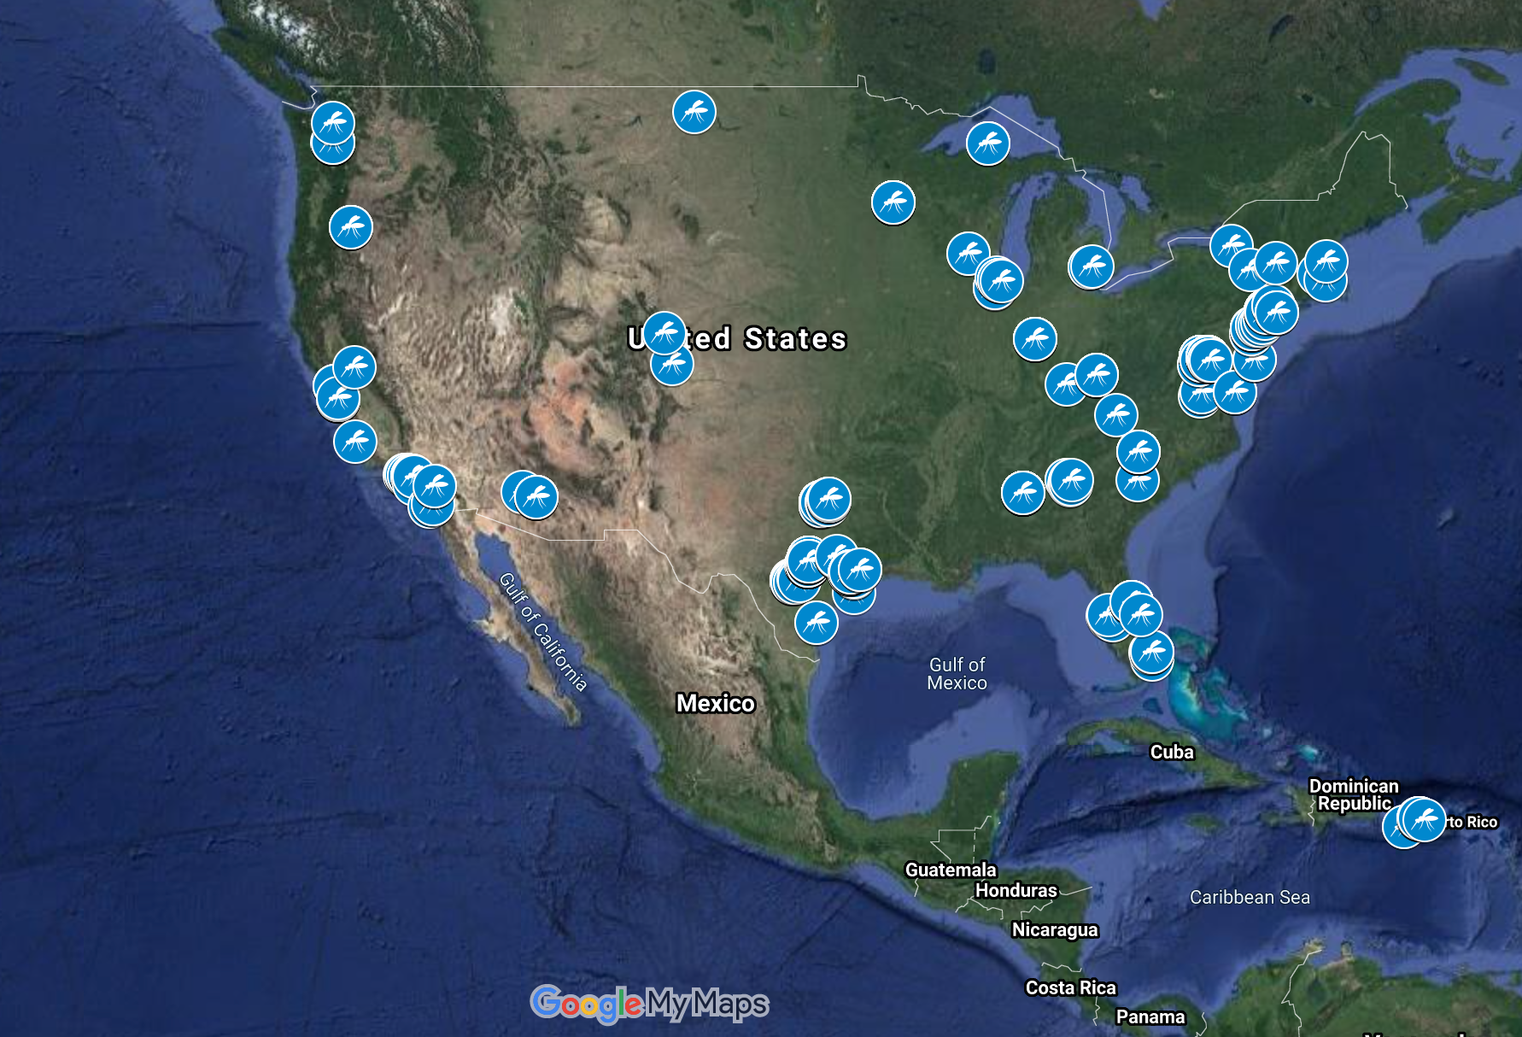
Map Data ©2021 INEGI Imagery ©2021 NASA, Terrametrics

Map showing all confirmed Mosquito Larvae Observations in comparison to an Esri Population Density Map
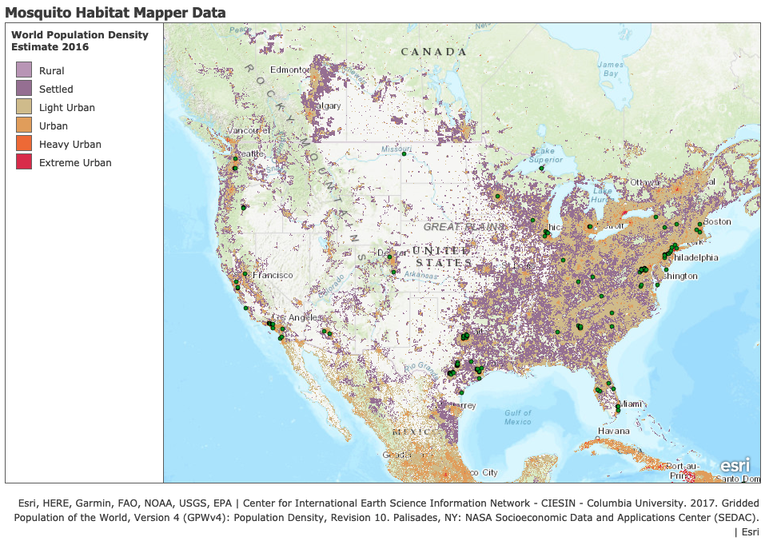
ArcGIS software ArcGIS Online (ESRI, 2021) was used for map generation, Population Density Map Source: Esri. World Population Density Estimate 2016. 2017 Redlands, CA: Environmental Systems Research Institute, Inc.

The CSV file containing the non-zero larvae counts was then uploaded onto an ArcGIS map. To analyze the relationship between the mosquito observations and their respective environments, a 2016 Esri population density map was downloaded using the ArgGIS Search for Layers function. This map classified different regions of the US into six respective regions: Rural, Settled, Light Urban, Urban, Heavy Urban, and Extreme Urban based on population per square kilometer. By comparing the two map layers, it was discovered that many of the mosquito larvae sightings were heavily concentrated in Light Urban or Urban regions next to a large body of water, primarily the Oceans and Great Lakes. This suggests that there exists a positive correlation between mosquito and human population density. Additionally, it is indicative that coastal regions are more suitable mosquito habitats than regions that do not surround water.
However, it is important to recognize the quantity and concentration of the mosquito habitat mapper data was dependent on the residence of the SEES interns, as well as the variation in setting up traps. Therefore, it is possible that some regions around the United States, including the land that had no data on the population density map, are underrepresented with respect to mosquito count. Additionally, due to the lack of a more recent population density map, there may be recent population or land cover changes that were not accounted for in this study.

Isolating Key 3 Genera Observations With Excel
This isolation method used the same base dataset as the Python method. By using the filter feature on Excel, the data was organized into three groups according to the key 3 genera: Culex, Aedes, Anopheles. Each subset was copied into new spreadsheet documents.
These documents were then converted to CSV files and uploaded to Google MyMaps as individual layers, allowing the points to be examined over satellite terrain and land cover imagery.

Top left: Culex dataset, Top right: Aedes dataset, Bottom: Anopheles dataset
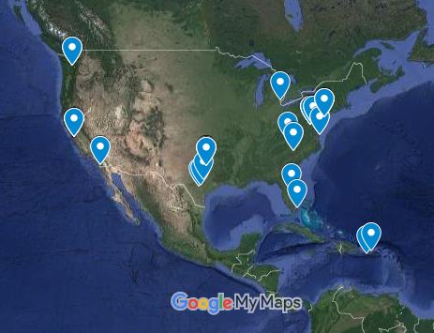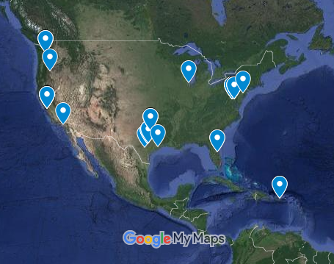
Map Data ©2021 INEGI Imagery ©2021 NASA, Terrametrics
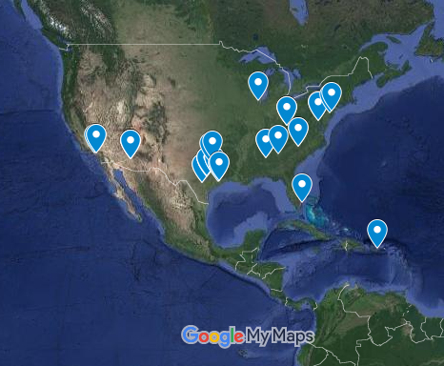
Map Data ©2021 INEGI Imagery ©2021 NASA, Terrametrics

Within the three maps, each point was manually examined to examine their respective surroundings. Most of these points are easily accessible by road or by short walk on open land, so portability for the device will not be an issue.
During this study, the Anopheles dataset was removed because the target diseases were limited to Zika, Dengue, Yellow Fever, and the West Nile Virus, none of which the Anopheles species transmits. The remaining layers were then cross referenced with population density data from 2015 to see the approximate population density in which most of the observations were taken. This research showed that the majority of the Culex and Aedes observations took place in suburban areas or suburban/rural mixed areas, usually with a population density of around 3-10 thousand people.
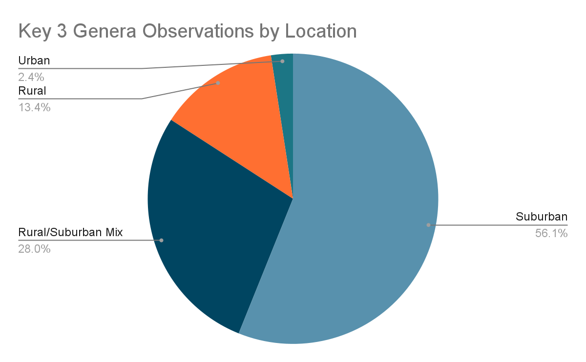
As in the case of the Python method, this dataset does not perfectly represent the country as a whole as it is entirely dependent on where the SEES interns lived at the time of their internship and where they stationed their traps. However, this also visualizes the general distribution of people throughout the United States; more people in suburban areas than the countryside or a fully urban area. Thus, these areas should be the priority for this method of virus detection regardless, as there are more people in these areas that could become infected; less populated areas may be underrepresented, but they are not the priority for this kind of method as there is less risk of infection or an epidemic.

Target Audience and Application
The CDC would be greatly benefited by the research that can be conducted with the assistance of the mosquito habitat data as well as the fluorescence waveguides and SPR waveguides. By using the mosquito habitat data, the CDC could identify areas that are more prone to disease outbreaks due to climate and other factors as well as areas that would cause disease to spread easily. The mosquito habitat data can also show the type of mosquito that inhabits an area. This information would be useful to the CDC because it would allow scientists to predict which diseases could spread. By using the mosquito habitat data, the CDC can decide which device will be most beneficial for tracking diseases within a specific situation and location. The fluorescence waveguide would be more helpful in a rural area because the cost of this method can be lowered with less usage. One fluorescent protein labeling kit from ThermoFisher can cost $500 rather than the more expensive costs of the SPR method (Fluorescent Protein, n.d.); this prices individual tests with this method at $1.64 (Fluorescent Protein Labeling. (n.d.)). The SPR method is better suited for urban areas because although it is an expensive device, the equipment does not have as many materials that need to be replenished.
The SPR method would be the most beneficial method for urban hospitals and clinics, especially in cases of large outbreaks. This is a faster method, which would be beneficial in an urban setting since the close proximity of people would cause disease to spread faster. This method also uses less single use materials, which would benefit urban areas that would likely have disease outbreaks that are more rapid and more widespread. The SPR device costs between $120,000 to $250,000 (Tang et al., 2010). Also, the OpenSPR device from Nicoya is low maintenance (Meet OpenSPR. (n.d.)), so, while it has a higher upfront cost, it does not require much in the way of maintenance costs over the lifetime of the device. Since the SPR device has a high upfront price, it would not be advantageous for low income communities.
The fluorescence waveguide and the data the device can collect would allow the general public to gain knowledge about mosquito borne diseases that are present in their areas. Awareness of local diseases would assist in giving citizens knowledge of which diseases they would need to take preventative measures against. The use of this device would drastically impact the spread of diseases and would allow for more accurate data regarding local conditions. The fluorescence waveguide is the best device for communities because although the materials can be more expensive when used generously, the method can cost less than the SPR waveguide when used for a small rural area. This is because fluorescence waveguides use materials such as dyes that are single use; the cost of these dyes can cause this method to be more expensive than the SPR waveguide when used often. A fluorescence protein labeling kit can cost approximately $500 (Fluorescent Protein, n.d.). The waveguide part of the device can cost about $325.

Understanding Waveguide Function
A waveguide is a device that allows electromagnetic waves to propagate through a cylindrical or rectangular tube used for the propagation of an electromagnetic signal from one end of the device to the other. Optical fibers, flexible transparent rods, and planar waveguides, flat films that guide light in one dimension, are the basic elements in optical chemical sensing. Simply, a waveguide works by creating an artificial phase change due to the waveguide’s internal structure. When a waveguide is paired with a contrast method, such as fluorescence or SPR, specific diseases can be tested for. Waveguides have many advantages, high sensitivity and specificity, remote measurements at long distances, electrical isolation, small size and flexibility, resistance to hazardous environments, suitable materials can be chosen in accordance with biocompatibility for plastic optodes, and modulation of light in multiple waves. All these properties together make the waveguide easier and better to use in situ, in low budget analysis, and allow for high portability. Although waveguides pose many advantages, there are also disadvantages to its optochemical sensing. Parasitic optical signals (e.g. unwanted background fluorescence, stray ambient light, contamination etc.) due to light scattering can lead to slow reduction in light & long term instability. Also, the phase change requires very specific extrusions on the internal structure of the waveguide, if these extrusions are even the tiniest bit off (anything >0.15mm) the phase change will be incorrect.

Our Waveguide Design
Our design utilizes basic waveguide principles, and a customizable design, to allow for a cheap, portable, and easy to use device. The waveguide, unlike many current waveguides, incorporates both the waveguide and sample sections so quick testing can be done in situ and without a lab. The waveguide is made up of four parts, the vial holder, vial change, connector, and waveguide body (see Fig.1). The light enters from the open rectangular end of the waveguide body and undergoes the phase change due the unique extrusions of the internal structure. These extrusions will need to be different for each individual disease tested. The light then goes through the connector and into the vial holder and vial change pieces. The light then shines through a glass vial containing a sample and contrast method. The light then goes out the small hole at the end of the waveguide. How the disease is detected depends on whether fluorescence or SPR is being used. With fluorescence the glass vial needs to be removed and if the disease is present the sample in the vial should fluoresce. If SPR is used, the light which comes out of the other end of the waveguide will need to be checked for a second phase change. If the light undergoes a second phase change after passing through the sample, the disease is present (see fig.2-5 for more visuals).
The customizability of our design is extremely important because it allows multiple samples to be tested very rapidly one after another; only the glass vial needs to be switched out if each sample is being tested for the same disease. If one sample is being tested for multiple diseases, only the waveguide body needs to be switched out for the different extrusions each disease requires. This simplicity not only opens up the opportunity for the design to be used by citizen scientists, it also allows the waveguide to be portable and disease detection can be done completely outside of a lab.

Figures
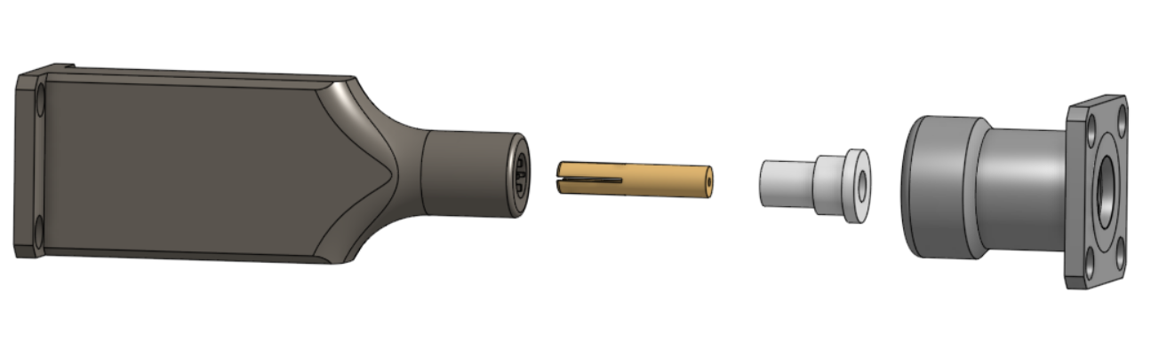
(Fig.1; From left to right: Waveguide Body, Vial Holder, Vial Change, Connector)
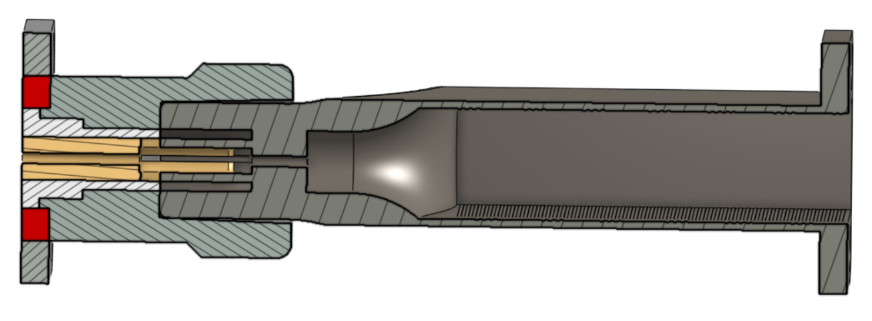
(Fig.2; Cross section view of the assembled waveguide)
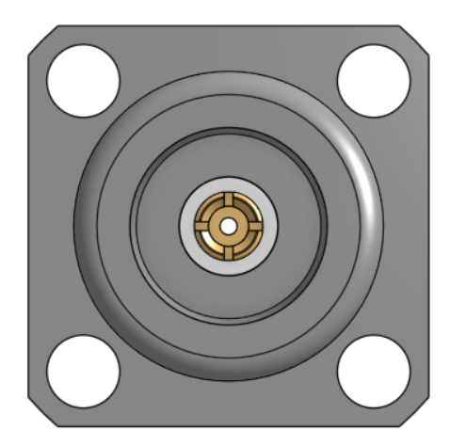
(Fig.3; Front view of assembled Vial Holder, Vial Change, and Connector)
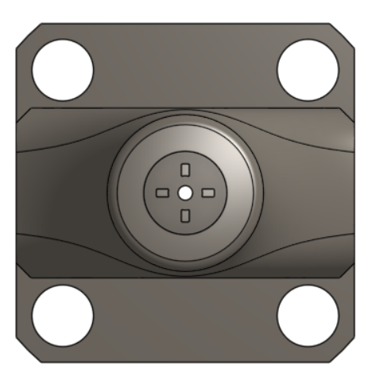
(Fig.4; Front view of Waveguide Body)
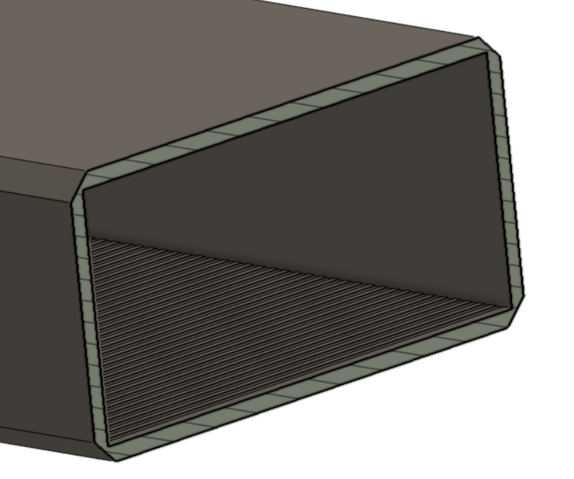
(Fig.5; Cross section view of Waveguide Body extrusions)

Acknowledgements
Thank you to the Mosquito Mappers mentors: Cassie Soeffing, Dr. Rusty Low, Peder Nelson, and Dr. Erika Podest, peer mentors: Pratham Babaria, Matteo Kimura, Kavita Kar, Rebecca Boger, Vishnu Rajasekhar, Faguni Gupta, and professors: Yuankai Tao, Alexandra Stambaugh, and Shantanu Pathak for their assistance in guiding us through our research.

This project included: Corbin Adkins, Anna Ager, Michelle Eno, Benito Esposti, Andrew Kim, Justin Lan, Nicole Schmidt, and Felipe Solorzano.
Corbin Adkins developed the idea for incorporating SEES data into the biophotonics project and helped to refine the idea for data analysis. He focused on the Excel method for isolating subsets of the data, and helped with analyzing data from both methods of isolation.
Anna Ager established the biophotonics group and the project by designing the biophotonics research project, providing the inspiration and outline for the project, scheduling meetings for the group throughout the course of the summer. She also researched the information for the function of waveguides, implication of the future of waveguides
Michelle Eno researched the target audience for our research and explained how this research could benefit society. She also researched the price of fluorescence protein labeling and the SPR method to better explain which method would be most beneficial within different situations. The Yellow Fever virus was another focus of her research.
Benito Esposti designed the CAD model for our waveguide. By analyzing the advantages, disadvantages, and various constraints of different methods he came to a decision on the final design. Through the use of Ansys Optical Analysis software and Onshape CAD he developed differing models, and improved the waveguides general function for customizability and cost effectiveness. Benito also helped research the current biosensing methods, and how they work in comparison to a waveguide.
Andrew Kim created two maps using GoogleMyMaps and ArcGIS. He imported GLOBE SEES Mosquito Habitat Mapper Dataset into Jupyter Notebook and filtered out observations that had no or zero larvae counts. Andrew exported the filtered data to a csv file and uploaded it to a GoogleMyMap. Then he developed an ArcGIS map which contained the mosquito mapper points and an Esri population density layer to compare the relationship between mosquitoes and human population. He also wrote the “Observing Mosquito Habitat Mapper Data Using Jupyter Notebook” section and the introduction for “SEES Date Incorporation.”

Justin Lan researched existing biosensing methods, mainly the different types of electrochemical, thermometric, optical, and piezoelectric techniques popular in bioinformatics, taking into account aspects such as cost, sensitivity, and ease of use. He wrote the section of the paper titled “Comparing Current Biosensing Methods” and primarily focused on West Nile virus in his research on the different types of flaviviruses, completing the WNV portion of the section titled “Different Types of Viruses”. By looking into the tendency of flaviviridae to cross-react and examining the advantages and disadvantages of the various methods, the need for the joint operation of waveguides and accompanying contrast methods was emphasized.
Nicole Schmidt researched different contrast methods, including fluorescence, surface plasmon resonance, and contrast dyes, gathering information concerning the process itself, advantages, disadvantages, and applications that had already been implemented in the context of biosensors and flaviviridae. She focused on Zika during her research, but also gathered information concerning the family in this context. Nicole also wrote the section in the paper concerning this information, titled “Comparing Fluorescent and SPR Methods”, and covered the relevant information concerning Zika in the last paragraph of the previous section, titled “Different Types of Viruses”. Finally, she created and formatted the formal bibliography (see below).
Felipe Solorzano was extraordinarily charismatic as well as spellbinding with his communication to others. He was able to glue the team together when they had their struggles with each other.

References
Advanced Data Access Tool. (2021, July 29). The GLOBE Program. Retrieved July 29, 2021, from https://datasearch.globe.gov/
Analyte Binding. (n.d.). Science Direct. Retrieved July 27, 2021, from https://www.sciencedirect.com/topics/engineering/analyte-binding
Ansys Student - Free Software Download. (n.d.). Ansys. Retrieved July 27, 2021, from https://www.ansys.com/academic/students/ansys-student
Arranz, A., & Ripoll, J. (2015). Advances in optical imaging for pharmacological studies. Frontiers in Pharmacology, 6. https://doi.org/10.3389/fphar.2015.00189
Ashrit, L. (n.d.). Waveguide – classification, modes, how it works, application, advantage. ElectricalFundaBlog.com. Retrieved July 27, 2021, from https://electricalfundablog.com/waveguide-classification-modes/
Ballinger, M.e., Rice, C.m., & Miller, B.r. (1988). Detection of yellow fever virus nucleic acid in infected mosquitoes by rna:rna in situ hybridization. Molecular and Cellular Probes, 2(4), 331-338. https://doi.org/10.1016/0890-8508(88)90016-3
Barth, I., Conteduca, D., Reardon, C. et al. Common-path interferometric label-free protein sensing with resonant dielectric nanostructures. Light Sci Appl 9, 96 (2020). https://doi.org/10.1038/s41377-020-0336-6
Bhalla, N., Jolly, P., Formisano, N., & Estrela, P. (2016). Introduction to biosensors. Essays in biochemistry, 60(1), 1–8. https://doi.org/10.1042/EBC20150001
Biosensor design. (n.d.). COMSOL. Retrieved July 27, 2021, from https://www.comsol.com/model/download/636951/applications.biosensor_design.pdf
Boisdé, G., & Harmer, A. (1996). Chemical and biochemical sensing with optical fibers and waveguides. Artech House.
Bosch, M., Sánchez, A., Rojas, F., & Ojeda, C. (2007). Recent Development in Optical Fiber Biosensors. Sensors, 7(6), 797–859. doi:10.3390/s7060797
Buckley, A., Gaidamovich, S., Turchinskaya, A., & Gould, E. A. (1992). Monoclonal antibodies identify the ns5 yellow fever virus non-structural protein in the nuclei of infected cells. Journal of General Virology, 73(5), 1125-1130. https://doi.org/10.1099/0022-1317-73-5-1125
Building a biosensor! [PowerPoint slides]. (2012). iGem Calgary. Retrieved July 27, 2021, from http://2012.igem.org/wiki/images/7/72/BuildingABiosensor.pdf
Çavdaroğlu, S., Hasan, M. M., Mohan, A., Xenophontos, E., Costa, A., Aborode, A. T., Tsagkaris, C., Outani, O., Ahmad, S., & Essar, M. Y. (2021). The spread of Yellow fever amidst the COVID-19 pandemic in Africa and the ongoing efforts to mitigate it. Journal of medical virology, 93(9), 5223–5225. https://doi.org/10.1002/jmv.27027
CDMF FAPESP. (2019, May 17). Early diagnosis of zika infection using a zno nanostructures-based rapid electrochemical biosensor [Video]. Youtube. https://www.youtube.com/watch?v=_mQ_IivEH0w
Centers for Disease Control and Prevention. (2015a, August 21). Clinical & Laboratory Evaluation. U.S. Department of Health and Human Services. https://www.cdc.gov/yellowfever/healthcareproviders/healthcareproviders-clinlabeval.html
Centers for Disease Control and Prevention. (2015b, August 21). Diagnostic Testing. U.S. Department of Health and Human Services. https://www.cdc.gov/yellowfever/healthcareproviders/healthcareproviders-diagnostic.html
Channon, R. B., Yang, Y., Feibelman, K. M., Geiss, B. J., Dandy, D. S., & Henry, C. S. (2018). Development of an Electrochemical Paper-Based Analytical Device for Trace Detection of Virus Particles. Analytical chemistry, 90(12), 7777–7783. https://doi.org/10.1021/acs.analchem.8b02042
Cornell, T. A. (2005). Fabrication of resonant optical waveguide biosensors using electron gun depositions [Doctoral dissertation, West Virginia University]. West Virginia University: The Research Repository. https://researchrepository.wvu.edu/etd/1623/
Dey, D., & Goswami, T. (2011). Optical Biosensors: A Revolution Towards Quantum Nanoscale Electronics Device Fabrication. BioMed Research International, 2011. https://doi.org/10.1155/2011/348218
Edmunds, J. (2019, July 8). Waveguides explained [Video]. Youtube. https://www.youtube.com/watch?v=r9-m17IPOco
ESRI. ArcGIS Online. 2021 Redlands, CA: Environmental Systems Research Institute, Inc.
Fact sheet: Optical imaging. (n.d.). Value Initiative. Retrieved July 27, 2021, from https://www.snmmi.org/AboutSNMMI/Content.aspx?ItemNumber=5692
Faria, H. A. M., & Zucolotto, V. (2019). Label-free electrochemical DNA biosensor for zika virus identification. Biosensors and Bioelectronics, 131, 149-155. https://doi.org/10.1016/j.bios.2019.02.018
Fluorescence imaging. (n.d.). Teledyne Photometrics. Retrieved July 27, 2021, from https://www.photometrics.com/learn/microscopy-basics/fluorescence-imaging
Fluorescent Protein Labeling. (n.d.). ThermoFisher Scientific. Retrieved July 29, 2021, from https://www.thermofisher.com/us/en/home/life-science/protein-biology/protein-labeling-crosslinking/fluorescent-protein-labeling.html?ef_id=CjwKCAjwi9-HBhACEiwAPzUhHB87bxtvJnIjoIuWw960k_3NT1F_rA62ISSrMdt_Xzp2cJXEe8dncxoCS3EQAvD_BwE:G:s&s_kwcid=AL!3652!3!386245227784!b!!g!!&cid=bid_pca_ppf_r01_co_cp1359_pjt0000_bid00000_0se_gaw_dy_pur_con&gclid=CjwKCAjwi9-HBhACEiwAPzUhHB87bxtvJnIjoIuWw960k_3NT1F_rA62ISSrMdt_Xzp2cJXEe8dncxoCS3EQAvD_BwE
Gauglitz, G. (2020). Critical assessment of relevant methods in the field of biosensors with direct optical detection based on fibers and waveguides using plasmonic, resonance, and interference effects. Analytical and Bioanalytical Chemistry, 412(14), 3317-3349. https://doi.org/10.1007/s00216-020-02581-0
Gaythorpe, K. A.M., Hamlet, A., Jean, K., Ramos, D. G., Cibrelus, L., Garske, T., & Ferguson, N. (n.d.). The global burden of yellow fever. In ELife. ELife. https://doi.org/10.7554/eLife.64670 (Reprinted from Epidemiology and Global Health, 2021, March 16,)
Geng, Z., Zhang, X., Fan, Z., Lv, X., Su, Y., & Chen, H. (2017). Recent Progress in Optical Biosensors Based on Smartphone Platforms. Sensors (Basel, Switzerland), 17(11), 2449. https://doi.org/10.3390/s17112449
Gibney, K. B., Edupugnati, S., Panella, A. J., Kosoy, O. I., Delorey, M. J., Lanciotti, R. S., Mulligan, M. J., Fischer, M., & Staples, J. E. (2012, December 5). Detection of Anti-Yellow Fever Virus Immunoglobulin M Antibodies at 3-4 Years Following Yellow Fever Vaccination. US National Library of Medicine. https://www.ncbi.nlm.nih.gov/pmc/articles/PMC3516084/
Global Learning and Observations to Benefit the Environment (GLOBE) Program, 2021, July 18, globe.gov
Grating-Coupled interferometry. (n.d.). Creoptix Sensors. Retrieved July 27, 2021, from https://www.creoptix.com/technologies/gci
Grieshaber, D., MacKenzie, R., Vörös, J., & Reimhult, E. (2008). Electrochemical Biosensors - Sensor Principles and Architectures. Sensors (Basel, Switzerland), 8(3), 1400–1458. https://doi.org/10.3390/s80314000
Gylfason, K. B. (n.d.). Biosensing with silicon photonics [pdf].
Habarugira, G., Suen, W. W., Hobson-Peters, J., Hall, R. A., & Bielefeldt-Ohmann, H. (2020). West Nile Virus: An Update on Pathobiology, Epidemiology, Diagnostics, Control and "One Health" Implications. Pathogens, 9(7), 589. doi:10.3390/pathogens9070589
Hamlet, A., Gaythorpe, K. A.M., Garske, T., & Ferguson, N. M. (2021). Seasonal and inter-annual drivers of yellow fever transmission in south america. PLOS Neglected Tropical Disease. https://doi.org/10.1371/journal.pntd.0008974
Harrison, S. C. (2016). Immunogenic cross-talk between dengue and zika viruses. Nature immunology, 17, 1010-1012. https://doi.org/10.1038/ni.3539
How Does Surface Plasmon Resonance Work? (n.d.). Biosensing Instrument. Retrieved July 27, 2021, from https://biosensingusa.com/technologies/surface-plasmon-resonance/surface-plasmon-resonance-work/
Howe, C. L., Webb, K. F., Abayzeed, S. A., Anderson, D. J., Denning, C., & Russell, N. A. (2019). Surface plasmon resonance imaging of excitable cells. Journal of physics D: Applied physics, 52(10), 104001. https://doi.org/10.1088/1361-6463/aaf849
Isothermal Amplification. (2021). New England Biolabs. Retrieved July 27, 2021, from https://www.neb.com/applications/dna-amplification-pcr-and-qpcr/isothermal-amplification
Jha, N. (Ed.). (n.d.). Biosensors: Features, Principle and Types (With Diagram). Biology Discussion. Retrieved July 27, 2021, from https://www.biologydiscussion.com/enzymes/biosensors/biosensors-features-principle-and-types-with-diagram/10240
Kim, Andrew (2021) Mosquito-Habitat-Mapper (Version 1.0.0) [Source Code]. doi.org/10.5281/zenodo.5168112
Kluyver, T., Ragan-Kelley, B., Fernando Perez, Granger, B., Bussonnier, M., Frederic, J., … Willing, C. (2016). Jupyter Notebooks – a publishing format for reproducible computational workflows. In F. Loizides & B. Schmidt (Eds.), Positioning and Power in Academic Publishing: Players, Agents and Agendas (pp. 87–90)
Koczula, K. M., & Gallotta, A. (2016). Lateral flow assays. Essays in biochemistry, 60(1), 111–120. https://doi.org/10.1042/EBC20150012
Kovacs, B., & Horvath, R. (2019). Modeling of Label-Free Optical Waveguide Biosensors with Surfaces Covered Partially by Vertically Homogeneous and Inhomogeneous Films. Journal of Sensors, 2019. https://doi.org/10.1155/2019/1762450
LEAP Australia. (2018, June 22). Rectangular Waveguide ANSYS HFSS [Video]. Youtube. https://www.youtube.com/watch?v=F6qOlGe1wrw
Li, K., Morton, K., Veres, T., & Cui, B. (2011). Nanoimprint lithography and its application in tissue engineering and biosensing. Comprehensive Biotechnology, 125-139. https://doi.org/10.1016/B978-0-08-088504-9.00497-9
Lo, Y.-C., Gui, R., Honda, H., & Torres, J. Z. (2016). Computer-Aided biosensor design. Computer-aided Technologies - Applications in Engineering and Medicine. https://doi.org/10.5772/65038
Londono-Renteria, B., & Colpitts, T. M. (2016). A Brief Review of West Nile Virus Biology. Methods in molecular biology (Clifton, N.J.), 1435, 1–13. https://doi.org/10.1007/978-1-4939-3670-0_1
Lustig, Y., Sofer, D., Bucris, E. D., & Mendelson, E. (n.d.). Infectious diseases. In J. W.A. Rossen (Ed.), Frontiers in microbiology. Frontiers Media. https://doi.org/10.3389/fmicb.2018.02421 (Reprinted from "Surveillance and diagnosis of west nile virus in the face of flavivirus cross-reactivity," 2018, October 11, Frontiers in Microbiology, 9)
Macdonald, A. (2017, November 28). Types of Biosensors and Evolving Applications: Glucose Monitoring to Personalized Health. Technology Networks. Retrieved July 28, 2021, from https://www.technologynetworks.com/tn/articles/evolving-biosensor-applications-glucose-monitoring-to-personalized-health-294590
Martinez, J. S., Grace, W. K., Grace, K. M., Hartman, N., & Swanson, B. I. (2005). Pathogen detection using single mode planar optical waveguides. Journal of Materials Chemistry, 15(43), 4639-4647. https://doi.org/10.1039/B502329G
McFadden, M., Mitchell-Dick, A., Vazquez, C., Roder, A., Labagnara, K., McMahon, J., … Horner, S. (2018). A Fluorescent Cell-Based System for Imaging Zika Virus Infection in Real-Time. Viruses, 10(2), 95. doi:10.3390/v10020095
Meet OpenSPR. (n.d.). Nicoya. Retrieved August 5, 2021, from https://nicoyalife.com/products/spr-instruments/openspr/?utm_medium=paid_search&utm_source=Google_Search&utm_campaign=awareness_branded_OpenSPR&utm_term=spr%20system&utm_campaign=Nicoya+Campaign&utm_source=adwords&utm_medium=ppc&hsa_acc=6194700013&hsa_cam=13912600243&hsa_grp=126544617724&hsa_ad=534515687462&hsa_src=g&hsa_tgt=kwd-1286623877655&hsa_kw=spr%20system&hsa_mt=p&hsa_net=adwords&hsa_ver=3&gclid=Cj0KCQjwxdSHBhCdARIsAG6zhlXTwIx3H4lbWa19PQADsxS8BGiHMI2MyvuWzZStTjO4-DHObPz-nlMaAgBHEALw_wcB
Milvich, J., Kohler, D., Freude, W., & Koos, C. (2018). Surface sensing with integrated optical waveguides: a design guideline. Optics Express, 26(16), 19885-19906. https://doi.org/10.1364/OE.26.019885
Mukundan, H., Anderson, A., Grace, W. K., Grace, K., Hartman, N., Martinez, J., & Swanson, B. (2009). Waveguide-Based Biosensors for Pathogen Detection. Sensors, 9(7), 5783–5809. doi:10.3390/s90705783
Musso, D., & Desprès, P. (2020). Serological Diagnosis of Flavivirus-Associated Human Infections. Diagnostics, 10(5), 302. doi:10.3390/diagnostics10050302
Myhrvold, C., Freije, C. A., & Gootenberg, J. S. (2021). Biotechnology. In Science journal (pp. 444-448). American Association for the Advancement of Science. https://doi.org/10.1126/science.aas8836 (Reprinted from "Field-deployable viral diagnostics using crispr-cas13," 2021, July 23, Science Journal, 373[6553])
Naresh, V., & Lee, N. (2021). A Review on Biosensors and Recent Development of Nanostructured Materials-Enabled Biosensors. Sensors, 21(4), 1109. doi:10.3390/s21041109
National Cancer Institute. (n.d.). Reverse Transcription-Polymerase Chain Reaction. U.S. Department of Health and Human Services. https://www.cancer.gov/publications/dictionaries/cancer-terms/def/reverse-transcription-polymerase-chain-reaction
Optical imaging. (2020, December). National Institute of Biomedical Imaging and Bioengineering. Retrieved July 27, 2021, from https://www.nibib.nih.gov/science-education/science-topics/optical-imaging
Orton, T. (2020, March 22). SFU researchers develop tech for cheaper coronavirus testing kits. Vancouver Is Awesome. https://www.vancouverisawesome.com/courier-archive/news/sfu-researchers-develop-tech-for-cheaper-coronavirus-testing-kits-3119520
Ozcelik, D., Cai, H., Leake, K., Hawkins, A. & Schmidt, H. (2017). Optofluidic bioanalysis: fundamentals and applications. Nanophotonics, 6(4), 647-661. https://doi.org/10.1515/nanoph-2016-0156
Parks, J., Schmidt, H. Flexible optofluidic waveguide platform with multi-dimensional reconfigurability. Sci Rep 6, 33008 (2016). https://doi.org/10.1038/srep33008
Pathak, S. (2004). Resonant optical waveguide biosensor characterization [Doctoral dissertation, West Virginia U]. West Virginia University: The Research Respository. https://researchrepository.wvu.edu/etd/2058/?utm_source=researchrepository.wvu.edu%2Fetd%2F2058&utm_medium=PDF&utm_campaign=PDFCoverPages
Pathak, S. (2021, July 16). [Personal interview by A. Ager, N. Schmidt, & M. Eno].
Piliarik, M., Vaisocherová, H., & Homola, J. (2009). Surface plasmon resonance biosensing. Methods in molecular biology (Clifton, N.J.), 503, 65–88. https://doi.org/10.1007/978-1-60327-567-5_5
Pohanka, M. (2017). The piezoelectric biosensors: Principles and applications, a review. International Journal of Electrochemical Science, 12, 496-506. https://doi.org/10.20964/2017.01.44
Pohanka M. (2018). Overview of Piezoelectric Biosensors, Immunosensors and DNA Sensors and Their Applications. Materials (Basel, Switzerland), 11(3), 448. https://doi.org/10.3390/ma11030448
Qui, L., Di, B., Wang, X., Liang, W. (2020, December 18). Development of an Antigen Capture Immunoassay Based on Monoclonal Antibodies Specific for Dengue. American Society for Microbiology. https://journals.asm.org/doi/full/10.1128/CVI.00212-08
Racaniello, V. (2016, May 11). Virus Watch: Building Zika Virus [Video]. Youtube. https://www.youtube.com/watch?v=cpdXFIGC7YI
Rathore, A., & St John, A. L. (2020). Cross-Reactive Immunity Among Flaviviruses. Frontiers in immunology, 11, 334. https://doi.org/10.3389/fimmu.2020.00334
Sáez-Álvarez, Y., Arias, A., Del Águila, C., & Agudo, R. (2019). Development of a fluorescence-based method for the rapid determination of zika virus polymerase activity and the screening of antiviral drugs. Scientific Reports, 9(1). https://doi.org/10.1038/s41598-019-41998-1
Selvin, P. R., Lougheed, T., Hoffman, M. T., Park, H., Balci, H., Blehm, B. H., & Toprak, E. (2021, July). Fluorescence imaging with one-nanometer accuracy (FIONA). Cold Spring Harbor Laboratory Press. https://doi.org/10.1101/500298v1
Shaikh, N. A., Ge, J., Zhao, Y.-X., Walker, P., & Drebot, M. (2007). Development of a novel, rapid, and sensitive immunochromatographic strip assay specific for west nile virus (WNV) igm and testing of its diagnostic accuracy in patients suspected of WNV infection. Clinical Chemistry, 53(11), 2031-2034. https://doi.org/10.1373/clinchem.2007.091140
Silva, P. A. G. C., Pereira, C. F., Dalebout, T. J., Spaan, W. J. M., & Bredenbeek, P. J. (2010). An RNA pseudoknot is required for production of yellow fever virus subgenomic RNA by the host nuclease xrn1. Journal of Virology, 84(21), 11395-11406. https://doi.org/10.1128/JVI.01047-10
SPRtech101. (2011, September 30). Surface plasmon resonance explained [Video]. Youtube. https://www.youtube.com/watch?v=sM-VI3alvAI
Srivastava, K. R., Awasthi, S., Mishra, P. K., & Srivastava, P. K. (2020). Biosensors/molecular tools for detection of waterborne pathogens. Waterborne Pathogens, 237-277. https://doi.org/10.1016/B978-0-12-818783-8.00013-X
Stambaugh, A., Parks, J. W., Stott, M. A., Meena, G. G., Hawkins, A. R., & Schmidt, H. (2018). Optofluidic detection of Zika nucleic acid and protein biomarkers using multimode interference multiplexing. Biomedical optics express, 9(8), 3725–3730. https://doi.org/10.1364/BOE.9.003725
Stambaugh, A. (2021, July 15). [Personal interview by A. Ager, N. Schmidt, B. Esposti, J. Lan, & A. Kim].
Syzdykova, Laura & Binke, Stephan & Keyer, Viktoriya & Shevtsov, Alexandr & Zaripov, Mikhail & Zhylkibayev, Assylbek & Ramanculov, Erlan & Shustov, Alexandr. (2020). Fluorescent tagging the NS1 protein in yellow fever virus: Replication-capable viruses which produce the secretory GFP-NS1 fusion protein. Virus Research. 294. 198291. 10.1016/j.virusres.2020.198291.
Syzdykova, L. R., Binke, S., Keyer, V. V., Shevtsov, A. B., Zaripov, M. M., Zhylkibayev, A. A., Ramanculov, E. M., & Shustov, A. V. (2021). Fluorescent tagging the ns1 protein in yellow fever virus: Replication-capable viruses which produce the secretory gfp-ns1 fusion protein. Virus Research, 294, 198291. https://doi.org/10.1016/j.virusres.2020.198291
Tang, Y., Zeng, X., & Liang, J. (2010). Surface Plasmon Resonance: An Introduction to a Surface Spectroscopy Technique. Journal of chemical education, 87(7), 742–746. https://doi.org/10.1021/ed100186y
Tao, Y. (2021, July 8). [Personal interview by the author].
Tothill, I.e., & Turner, A. (2003). BIOSENSORS. Encyclopedia of Food Sciences and Nutrition, 489-499. https://doi.org/10.1016/B0-12-227055-X/01374-2
Vigneshvar, S., Sudhakumari, C. C., Senthilkumaran, B., & Prakash, H. (2016). Recent advances in biosensor technology for potential applications – an overview. Frontiers in Bioengineering and Biotechnology, 4. https://doi.org/10.3389/fbioe.2016.00011
Virus testing kits to be developed using RNA imaging technology. (n.d.). Photonics Media. Retrieved July 27, 2021, from https://www.photonics.com/Articles/Virus_Testing_Kits_to_Be_Developed_Using_RNA/a65659
Wang, L., Veselinovic, M., Yang, L., Geiss, B. J., Dandy, D. S., & Chen, T. (2017). A sensitive DNA capacitive biosensor using interdigitated electrodes. Elsevier, 87, 646-653. https://doi.org/10.1016/j.bios.2016.09.006
Waveguide. (n.d.). Science Direct. Retrieved July 28, 2021, from https://www.sciencedirect.com/topics/earth-and-planetary-sciences/waveguide
What is Surface Plasmon Resonance (SPR)? (2018). Reichert Technologies. Retrieved July 27, 2021, from https://www.reichertspr.com/about/what-is-surface-plasmon-resonance-spr/
Wikipedia contributors. (2020, December 31). Surface plasmon resonance microscopy. In Wikipedia, The Free Encyclopedia. Retrieved 18:23, July 27, 2021, from https://en.wikipedia.org/w/index.php?title=Surface_plasmon_resonance_microscopy&oldid=997498308
Woda, M., & Mathew, A. (2015). Fluorescently labeled dengue viruses as probes to identify antigen-specific memory B cells by multiparametric flow cytometry. Journal of immunological methods, 416, 167–177. https://doi.org/10.1016/j.jim.2014.12.001
Wolfram Mathematica. (n.d.). Wolfram. Retrieved July 27, 2021, from https://www.wolfram.com/mathematica/
Zeininger, L., Weyandt, E., Savagatrup, S., Harvey, K. S., Zhang, Q., Zhao, Y., & Swager, T. M. (2019). Waveguide-based chemo- and biosensors: Complex emulsions for the detection of caffeine and proteins. Lab on a Chip, 19(8), 1327-1331. https://doi.org/10.1039/C9LC00070D
Zhao, L., & Alto, B. W. (2016). Development of rapid detection method for west nile virus surveillance in florida. U of Florida. https://www.fdacs.gov/content/download/73605/file/Zhao_and_Alto_FINAL_REPORT.pdf

