By Jobbe van Helsdingen, Willem Keij, Sven den Ouden, Sterre Schols, Nienke Sietses.

Leidsche Rijn College

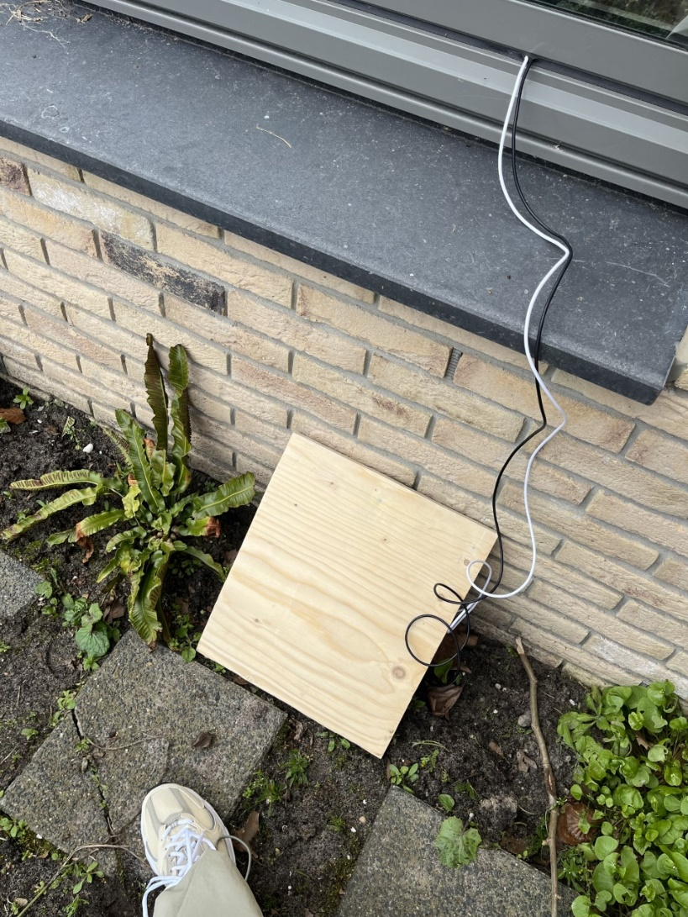

The particulate matter around different elementary schools.

## Abstract

Particulate matter are particles in the air that are smaller than 10 µm. In the Netherlands, the maximum particulate matter value of 10 µm is 40 µg/m3 and of 2 µm it is 25 µg/m3. The particulate matter particles can be very harmful to your health. We measured the values ​​at various primary schools in Utrecht.

## Research question

How much particulate matter is around different elementary schools, and what may be the cause of these amounts?

## Introduction & review of literature

Particulate matter refers to particles in the air, they vary in size but are all smaller than 10 µm. In the Netherlands, the maximum particulate matter value of particles around the size of 10 µm is 40 µg/m3 and the maximum value of particles around the size of 2 µm is 25 µg/m3. The particulate matter particles can be very harmful to your health, long-term exposure to high particle levels can cause reduced lung function and the development of chronic bronchitis[1]. Even short-term exposure can aggravate lung disease, lead to asthma attacks, and can increase susceptibility to respiratory infections[2].

We measured the particulate matter values for the different sizes ​​at various primary schools in Utrecht, and compared them to each other.

## Research methods

Carrying out our research

* Do preliminary research to decide where we measure the particulate matter.
* Mount the particulate matter sensors[3] to DIY measuring stations and place them at different elementary schools.
* Process our data using knowyourair.net.[4]
* Analyse our data using excel.

## Results

In the first graph(particulate matter per size) can be observed that the Torenplein school had particulate matter values far lower than the other schools and that the arcade has the highest values of particulate matter.

In the second graph(particulate matter at different times) can be observed that the amount of particulate matter is less later in the day, at the Arcade and Beatrix elementary schools it was the lowest in the afternoon and at the Torenplein school it was the lowest in the evening.

## Conclusion

Of all the measured places, the Arcade had the highest values, and the Torenplein the lowest.

Of all the times of day, the afternoon had the lowest overall measurements. It was the lowest value of the day at all schools except for the Torenplein school, which had their lowest measurements in the evening.

We expected that the area around the schools, such as a lot of nature, a lake or big roads, would effect the values of particulate matter.

We expected the Arcade to have the lowest amounts, because of the amount of nature in the immediate surroundings, but due to construction the measurements were higher than expected.

## Discussion

4 of the 10 sensors that were placed at elementary schools were faulty, which unfortunately meant that 2 schools had no data to analyse and include in the research.

Not all of the sensors were placed at comparable heights, some were placed on rooftops, while others were placed on the ground.

## Citations

Citation 1: [Particulate matter effects on health(national park service)](https://www.nps.gov/subjects/air/humanhealth-pm.htm#:~:text=Short%2Dterm%20exposures%20to%20particles,been%20linked%20to%20heart%20attacks.)

Citation 2: [SODAQ AIR (knowyourair.net)](https://knowyourair.net/)

Citation 3: [Regelgeving | RIVM](https://www.rivm.nl/fijn-stof/regelgeving)

1. Citation 1
2. Citation 1
3. Citation 3
4. Citation 2