Running Head: Case Study of Hurricane Harvey (2017)

1

**Case Study of Hurricane Harvey (2017)**

Manuel Leal Morin, Allison Duran, Angie Garza, Capri Crespo, Yashraj Patil

NASA SEES Earth System Explorers

Case Study of Hurricane Harvey (2017)

2

**Table of Contents**

Abstract

3

Purpose and Hypothesis

4

Materials and Methods

5

Data Summary

6

Analysis and Results

8

Conclusion and Discussion

10

Acknowledgements

13

References

15

Case Study of Hurricane Harvey (2017)

3

**Abstract**

This research describes hurricanes, more specifically, Hurricane Harvey, and the various

ways that clouds contributed to its formation, strength, and effects. Clouds affect the storm

power, organization, distribution, and how we can track it. This study serves to see what clouds

can tell us about Hurricane Harvey.

Hurricane Harvey was a devastating hurricane that passed through Texas in August of

2017. Cloud formation and coverage during the hurricane made the natural disaster much

stronger, leading it to become a category 4. Due to the several effects of climate change and El

Niño and La Niña, the hurricane posed even more threats to life and cities along the coast. By

using patterns in a time lapse cloud cover, we can analyze the relation between cloud cover and

hurricanes. This can help us better understand what cloud cover is showing us in regards to

general hurricane characteristics, allowing us to better combat these disasters. This research is

crucial to the information and understanding we can obtain from such a horrific natural disaster.

Case Study of Hurricane Harvey (2017)

4

**Purpose Hypothesis**

The purpose of this study was to identify the relationship that clouds can have with

hurricanes and what they can tell us about these hurricanes. The goal of the data analysis was to

see the multiple views and changes in time that could tell us how we can better understand and

identify a hurricane. The first prediction of this research was that clouds would be able to tell us

a clear correlation with hurricanes and their patterns. This piece of research was prompted

because most of the authors live near zones and areas threatened by hurricanes. Since most of the

researchers have been affected by hurricanes and have experienced the destruction they can do

first hand, this was an obvious choice and path that could also help others learn more to

understand this natural disaster more.

The background information of this topic is as follows. A hurricane's speed and path

depend on complex ocean and atmospheric interactions, including the presence or absence of

other weather patterns. This complexity of the flow makes it very difficult to predict the speed

and direction of a hurricane (National Weather Service). Deep clouds that are heavily laden with

water droplets and ice crystals trap outgoing infrared radiation, creating a localized greenhouse

effect that traps heat and warms the atmosphere in the area of the developing storm. (Florida

State University, 2020).

Case Study of Hurricane Harvey (2017)

5

**Materials and Methods**

To analyze each ground or satellite image as precisely as possible, each researcher went

through around eight weeks of training, learning how to classify and characterize land cover

data. The work was split up evenly, with each researcher going through the different aspects that

made this hurricane as devastating as it was. Each researcher looked over different satellite

images provided from NASA and Google over a time lapse. Then the different aspects of this

specific hurricane were analyzed. Climate change was analyzed, then the effects of El Niño and

La Niña, and then how clouds could relate to the hurricane and what it could tell us about

Hurricane Harvey. Also, using the satellite images, there was a correlation that could be made

with the GLOBE Observer “up” pictures that were taken from the ground and analyzed.

After researching the causes, the results were analyzed to see how all these factors

contributed to the hurricane to make it as horrific as it was. The formation, rainfall, and

interaction with land was what made Hurricane Harvey one of the most destructive hurricanes in

recent U.S history when it made landfall on the Texas coast in 2017.

Case Study of Hurricane Harvey (2017)

6

**Data Summary**

Climatologists agree that global warming contributed to Harvey’s impact. Studies found

the amount of rainfall was 38 percent higher because of global warming. There are three main

reasons for this (Hurricane Harvey Facts 2019). The Gulf region air temperatures were two to

three degrees hotter (in Fahrenheit) than in the past, which allowed the air to hold more moisture.

Second, rising sea levels made flooding more likely near Gulf Coast cities. The sea levels around

Houston were six inches higher than 20 years ago, partially due to warmer temperatures melting

the ice caps in Antarctica. Third, global warming stalled weather patterns in the region. That

allowed Harvey to hover over Houston instead of moving back out into the ocean. The

convergence of all three effects allowed Harvey to drop feet of rain instead of inches.

The hurricane reached category 3 status by 25 August while it approached the middle

Texas coast. It later intensified to a category 4 hurricane. Hurricane Harvey produced 52

tornadoes. About half of them were reported near the Houston metro area and other neighboring

states.However, extremely heavy rains continued on the north and northwest side of the tropical

cyclone. The cyclone began to disappear over northern Kentucky late the next day (Hurricane

Harvey Facts 2019).

El niño and la niña are both weather patterns and affect the range of temperatures all over

the world. The main difference between El Niño and La Niña is the sea-surface area temperature.

When it comes to El Niño, ocean temperatures decrease in the Gulf of Mexico (Information

about the El Nino and La Nina cycles). La Niña is the opposite of El Niño, causing the Gulf of

Mexico to increase in temperature and the chances of hurricanes to occur. In the previous slide

we discussed the differences between El Niño and La Niña, but the year 2017 was a La Niña

year. This had a big impact on hurricane season, causing ocean temperatures to increase. La Niña

Case Study of Hurricane Harvey (2017)

7

not only causes temperatures to rise, but also creates distinctive rain clouds. With this

information, we can use the cloud coverage data from La Niña and use it for future purposes.

Using cloud coverage from La Niña can tell us if there is a hurricane or storm coming, this can

give us time to prepare and spread awareness.

Case Study of Hurricane Harvey (2017)

8

**Analysis and Results**

The results showed many aspects to why the hurricane was so powerful. La Niña actually

helped the hurricane since it caused colder clouds because of the warm air that it brings to the

south to rise quicker. This rising air causes the clouds to eventually condense and become

extremely cold due to higher elevations, correlating well with the fact that hurricane clouds tend

to be colder. After the hurricane passes the sun shines and the clouds eventually dissipate due to

a sudden increase in temperature. Also, low wind shear causes more damage, since it allows the

clouds to stay together more and keep their structure and strength while the hurricane passes

(Figure 1). El Niño however brings in thicker, more condensed clouds due to the pre-existing

cold temperature (Figure 2, 4, 5, 8).. Texas is expected to get a hurricane this year or next year,

as we can see the clouds look similar to the ones we see from a satellite image right before

Hurricane Harvey. Thicker clouds from El Niño mixed with the warmer, newer air from La Niña

is the perfect recipe for disaster.

Cloud coverage played a crucial role in the initial formation and subsequent

intensification of Hurricane Harvey. The storm originated as a tropical disturbance in the

Caribbean Sea, where clusters of convective clouds began to organize. As the disturbance moved

over warm ocean waters with high moisture content, the cloud coverage expanded and deepened,

contributing to the development of a tropical depression, then a tropical storm, and eventually a

Category 4 hurricane.

One of the most devastating impacts of Hurricane Harvey was the extraordinary amount

of rainfall it brought to southeastern Texas. Cloud coverage played a direct role in this excessive

precipitation. The storm's expansive cloud system contained abundant moisture, and as the storm

moved slowly over the region, the clouds continuously released heavy rainfall for several days.

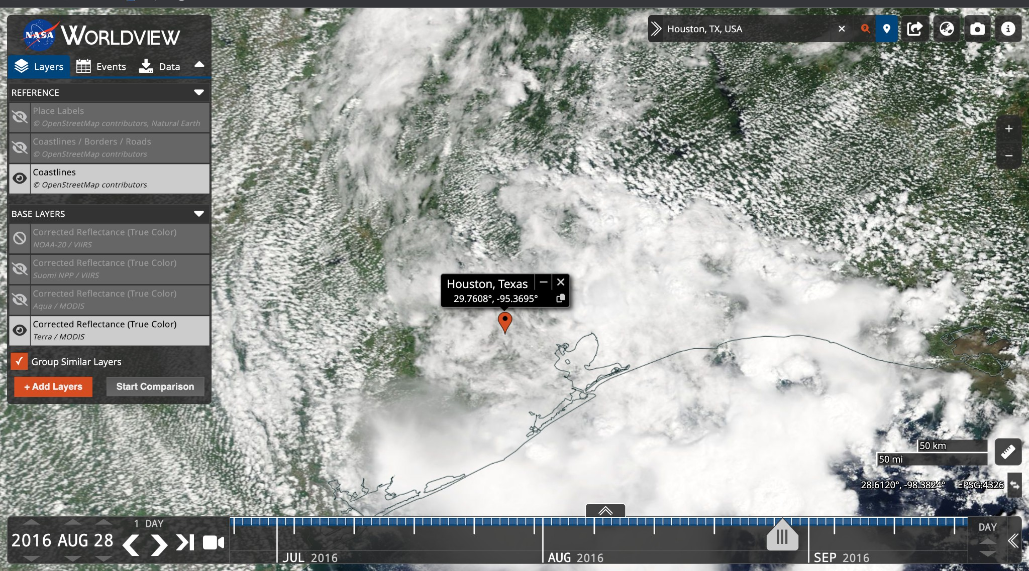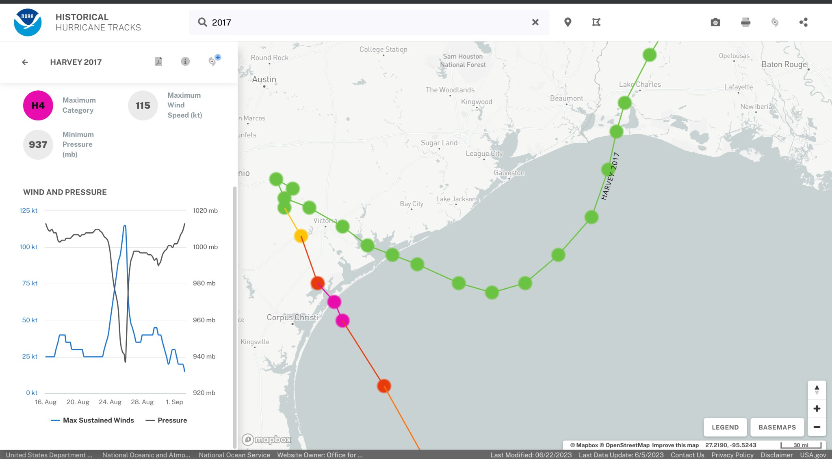

Case Study of Hurricane Harvey (2017)

9

The persistent cloud cover facilitated the continuous supply of moisture, leading to catastrophic

flooding in many areas.

As Hurricane Harvey made landfall and moved inland, cloud coverage played a role in

modifying the storm's behavior. The interaction between the storm's cloud systems and the

landmass affected the storm's structure and intensity. Land-based topography and surface

conditions can disrupt the airflow and alter the

distribution of clouds, potentially leading to

changes in rainfall patterns and storm dynamics.

**Figure 1**

**Figure 2**

Wind Speed Analysis.

Satellite Image 1 year before Harvey.

This analysis shows that the wind speed is slowest

Year of El Niño - Colder air.

after it makes impact, where it actually caused the

most damage.

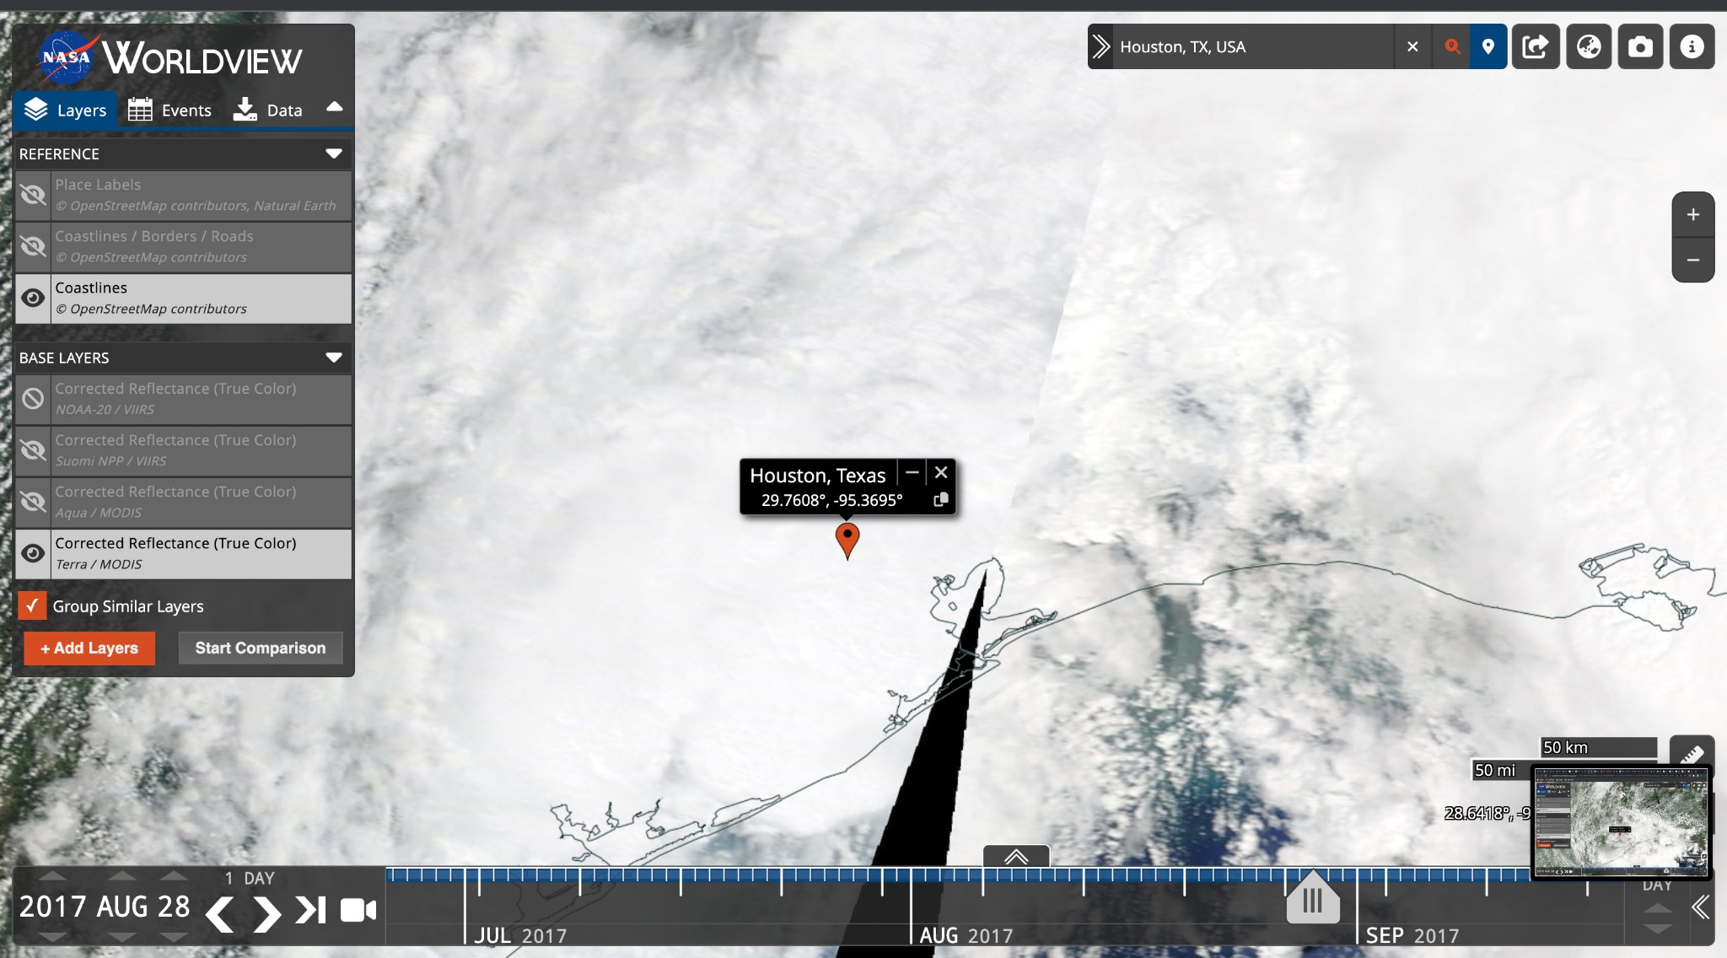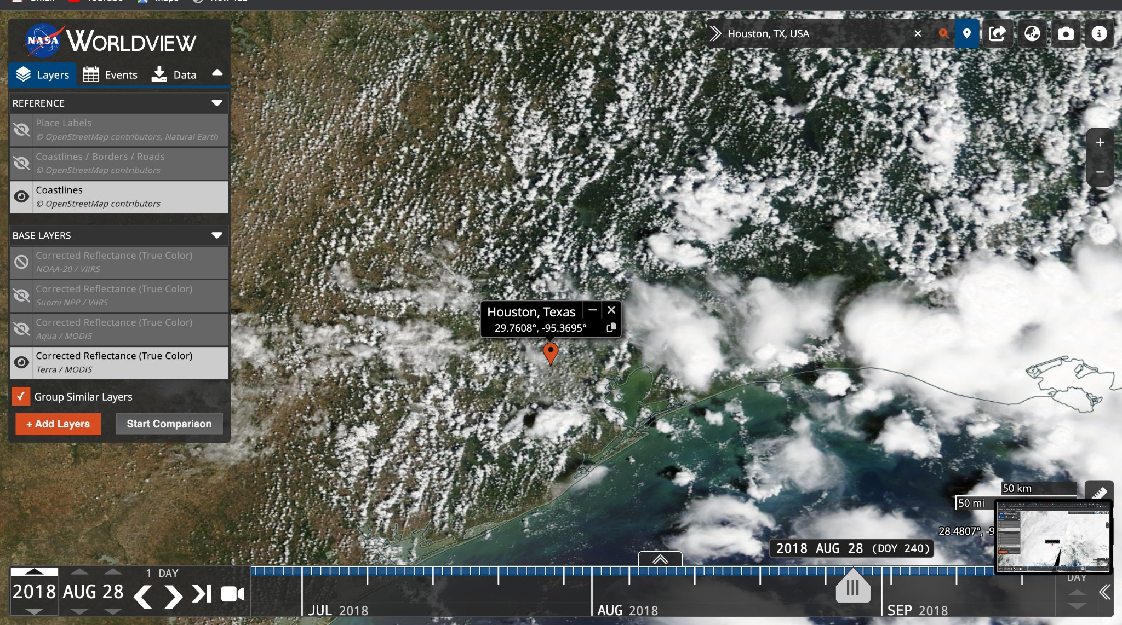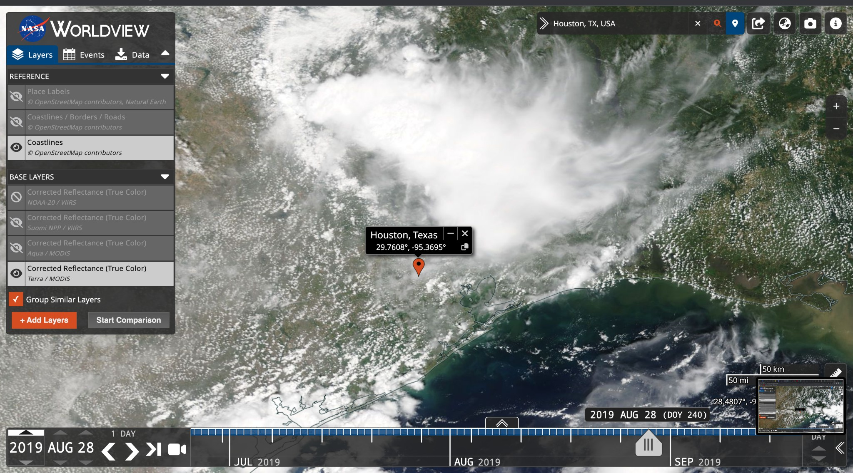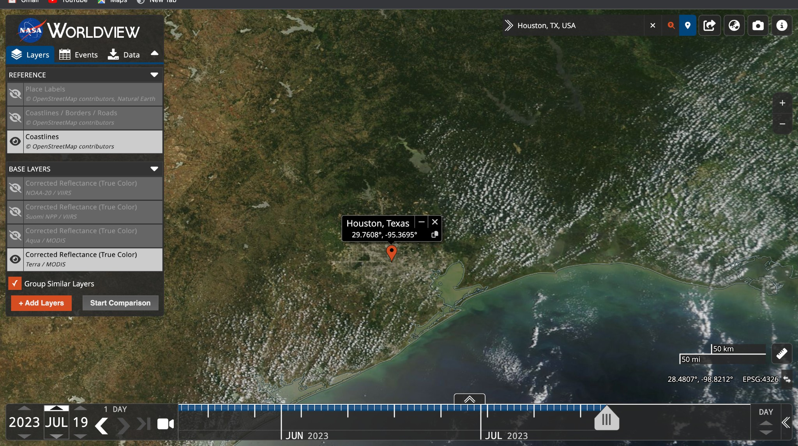

Case Study of Hurricane Harvey (2017)

10

**Figure 3**

**Figure 4**

Satellite Image during Harvey.

Satellite Image 1 year after Harvey.

Year of La Niña - Warmer air.

Year of El Niño - Colder air.

**Figure 5**

**Figure 6**

Satellite Image 2 years after Harvey

Satellite Image 6 years after Harvey -

Present day

Year of El Niño - Colder air.

Year of El Niño - Colder air.

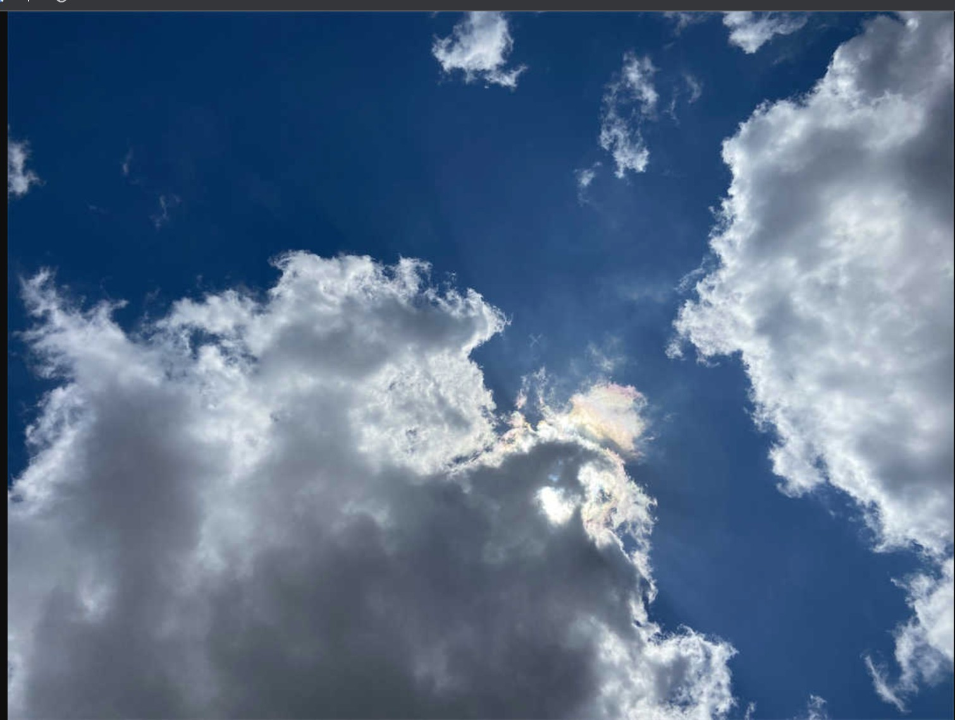

Case Study of Hurricane Harvey (2017)

11

**Figure 7**

**Figure 8**

Ground Image - 2020

Ground Image - 2023

Year of La Niña - Warmer air.

Year of El Niño - Colder air.

Case Study of Hurricane Harvey (2017)

12

**Conclusion and Discussion**

Based on all the different factors, such as climate change and El Niño and La Niña, it’s

safe to say that clouds had a bigger role than first anticipated. Overall, cloud coverage

observations, obtained through satellite imagery and ground-based instruments, offer valuable

insights into the dynamics and behavior of hurricanes. Integrating cloud data with other

meteorological variables enables forecasters to improve hurricane track predictions, intensity

forecasts, and warnings, ultimately helping to mitigate potential impacts on affected areas.

Although the time to research was limited, the information was still valuable. Possible

improvements to be made are just looking more into the topic and trying to find studies that

relate to the topic more.

Case Study of Hurricane Harvey (2017)

13

**Acknowledgements**

Thank you to the NASA SEES Internship in collaboration with UT Austin program and

mentors, Celena Miller and Margaret Baguio.

Thank you to the Earth System Explorers/Mosquito Mappers mentors, Dr. Rusanne Low,

Ms. Cassie Soeffing, Mr. Peder Nelson, Dr. Erika Podest, Andrew Clark, and peer mentor

Yashraj Patil.

The project included Dr Russane Low, Mr. Peder Nelson, Peer Mentor Yashraj Patil,

Manuel Leal Morin, Allison Duran, Angie Garza, and Capri Crespo.

*Dr. Rusanne Low and Mr. Peder Nelson* were the expert validators for this study. Their

work makes sure that an expert opinion increases the credibility of this study.

*Yashraj Patil* was the peer mentor and helped provide a deeper understanding and insight

into a topic that was already an interest. Yashraj Patil has done research in the past over natural

disasters, but was able to understand more about the American hurricanes and what caused

Hurricane Harvey to be as devastating as it was.

*Manuel Leal Morin, Allison Duran, Angie Garza, and Capri Crespo* were all trained

classifiers in this study. They analyzed several satellite and on ground images, different aspects

that can cause changes in the weather, and what clouds can tell us about hurricanes as a whole.

They learned about citizen science, how to validate data, and the different factors that contribute

to causing a category 4 hurricane.

*Manuel Leal Morin* helped write the Abstract, Purpose and Hypothesis, Materials and

Methods, Data Summary, Analysis and Results, Conclusion and Discussion. Manuel assisted in

seeing the results and correlation between the satellite and ground images, as well as the science

behind the causes and results. Manuel led the team and made sure everyone was on task and

Case Study of Hurricane Harvey (2017)

14

contributed. Manuel is also credited with editing and putting together the video presentation of

our project. *Allison Duran* went through the changes that climate change caused to the hurricane,

and helped with the Data Summary. *Angie Garza* did research on El Niño and La Niña to see

what role they played on Hurricane Harvey, and helped with the Data Summary. *Capri Crespo*

helped see the results and assisted in writing the Analysis and Results.

Case Study of Hurricane Harvey (2017)

15

**References**

Eric S. Blake, David A. Zelinsky. (2018, May 9th). *National Hurricane Center Tropical*

*Cyclone Report Hurricane Harvey.* <https://www.nhc.noaa.gov/data/tcr/AL092017_Harvey.pdf>

Kevin E. Trenberth, Lijing Cheng, Peter Jacobs, Yongxin Zhang, John Fasullo. (2018,

May 9th). *Hurricane Harvey Links to Ocean Heat Content and Climate Change.*

<https://agupubs.onlinelibrary.wiley.com/doi/full/10.1029/2018EF000825>

Kimberly Amadeo. (2019, January 20). *Hurricane Harvey Facts, Damage, and Costs.*

[https://www.lamar.edu/_files/documents/resilience-recovery/grant/recovery-and-resiliency/hurric](https://www.lamar.edu/_files/documents/resilience-recovery/grant/recovery-and-resiliency/hurric2.pdf)

[2.pdf](https://www.lamar.edu/_files/documents/resilience-recovery/grant/recovery-and-resiliency/hurric2.pdf)

NASA.

*How*

*Do*

*Hurricanes*

*Form.*

[https://gpm.nasa.gov/education/articles/how-do-hurricanes-form#:~:text=A%20cumulonimbus%](https://gpm.nasa.gov/education/articles/how-do-hurricanes-form#%3A~%3Atext%3DA%20cumulonimbus%20cloud.%2Cand%20moist%20and%20rises%2C%20too)

[20cloud.,and%20moist%20and%20rises%2C%20too](https://gpm.nasa.gov/education/articles/how-do-hurricanes-form#%3A~%3Atext%3DA%20cumulonimbus%20cloud.%2Cand%20moist%20and%20rises%2C%20too)

NASA. <https://worldview.earthdata.nasa.gov/>

NASA.

[https://climate.nasa.gov/earth-now/#/vitalsign?vitalsign=visible_earth&altid=0&animating=f](https://climate.nasa.gov/earth-now/%23/vitalsign?vitalsign=visible_earth&altid=0&animating=f)

NOAA Historical Hurricane Tracks [https://coast.noaa.gov/hurricanes/#map=4/32/-80](https://coast.noaa.gov/hurricanes/%23map%3D4/32/-80)

Chris A. Kimble. (2019, December 9). *Information about El Nino and La Nina cycles.*

[https://www.weather.gov/ama/elnino#:~:text=In%20general%2C%20El%20Ni%C3%B1o%20co](https://www.weather.gov/ama/elnino#%3A~%3Atext%3DIn%20general%2C%20El%20Ni%C3%B1o%20conditions%2Cthese%20trends%20are%20even%20greater)

[nditions,these%20trends%20are%20even%20greater](https://www.weather.gov/ama/elnino#%3A~%3Atext%3DIn%20general%2C%20El%20Ni%C3%B1o%20conditions%2Cthese%20trends%20are%20even%20greater)

Case Study of Hurricane Harvey (2017)

16

National Weather Service. (2021, May 10). *NWS Jackson, MS: El Nino and La Nina.*

[https://www.weather.gov/jan/el_nino_and_la_nina#:~:text=La%20Ni%C3%B1a%20increases%2](https://www.weather.gov/jan/el_nino_and_la_nina#%3A~%3Atext%3DLa%20Ni%C3%B1a%20increases%20the%20number%2Cinfluence%20where%20Atlantic%20hurricanes%20form)

[0the%20number,influence%20where%20Atlantic%20hurricanes%20form](https://www.weather.gov/jan/el_nino_and_la_nina#%3A~%3Atext%3DLa%20Ni%C3%B1a%20increases%20the%20number%2Cinfluence%20where%20Atlantic%20hurricanes%20form)

NASA.

(2019,

June

27).

*What*

*is*

*El*

*Niño?*

[https://spaceplace.nasa.gov/el-nino/en/#:~:text=In%20El%20Ni%C3%B1o%20years%2C%20lot](https://spaceplace.nasa.gov/el-nino/en/#%3A~%3Atext%3DIn%20El%20Ni%C3%B1o%20years%2C%20lots%2Cwarm%20part%20of%20the%20ocean)

[s,warm%20part%20of%20the%20ocean](https://spaceplace.nasa.gov/el-nino/en/#%3A~%3Atext%3DIn%20El%20Ni%C3%B1o%20years%2C%20lots%2Cwarm%20part%20of%20the%20ocean)