What Types Of Clouds Are Most Common In Winter In Parish, NY In The Morning?
Priscilla Britton, Kayla Muckey, Noah Spencer, et al.
Teacher: Jessica Halsey
APW Jr/Sr HS
Parish, NY, USA
March 6th, 2024

Abstract:
Our research question is What Types Of Clouds Are Most Common In Winter In Parish, NY In The Morning? We think that stratus clouds will be the most common because of what we remember from past winters. We used the GLOBE Cloud Protocol on the Observer App to collect our data. After all our data was collected, we did end up finding out that stratus clouds were the most common when the sky was overcast. We also found out the cirrus clouds are the most common when the sky is more clear.

Research Question and Hypothesis:
Our research question is: What Types Of Clouds Are Most Common In Winter In Parish, NY In The Morning? Our predication is that the sky will be mostly overcast with status clouds. It is important to study the clouds during the different seasons to see if there are any drastic changes to them, during different weathers, climates, and seasons. It is also important to study clouds during different seasons because clouds change through all seasons. They are more gray in the winter and lighter in the summer.

Introduction:
How Do Clouds Form?
Clouds form when water gets heated up by the sun and it rises. Then water vapor must be cooled and go on particles in the air such as dust or sea salts. When they cool further, the ice particles that make up cloud may transform into larger particles that fall to Earth as precipitation. (“ISCCP: Cloud Climatology”)

What are the main cloud types?
Clouds can be split into three levels. The height of low clouds is between the surface to 6,500ft. The two most common clouds on this level are stratus and cumulus, which form vertically. There are also hybrids of the two, stratocumulus and nimbostratus. The next level is mid-level (between 6500 to 13000 ft). The most common cloud types you’ll find are the altocumulus, which are made of severely patchy white or gray layers and look to be made of small fluffy ripples. The altostratus clouds that are gray and usually cover the entire sky. And the nimbostratus that are dark, thick, and block out sunlight. The last level are high level clouds. The main type are cirrus clouds Cirrus clouds are clouds that are shaped like feathers. The cirrus cloud is mostly formed or made up of ice crystals if you did not know. There is a cloud called the cirrostratus and it's a very thin cloud that covers the sky like a rug. The cirrostratus cloud is mostly seen in winter, and you can even see a halo that the sun makes. Cirrocumulus is a patchy type of cloud sometimes thin too. (“Types of Clouds | NOAA SciJinks – All About Weather” and “The Four Core Types of Clouds”)

How might the change of seasons affect clouds?
In hotter months the sun heats up Earth’s surface air and causes it to rise. This moisture-rich air begins to cool down and condense into clouds. We typically see cotton ball-like cumulus clouds in our sky in the summer. In summer we also get a lot more thunderstorms because it's hotter during the summer. In the cooler seasons, our ground temperatures are colder, so we get clouds in different ways. For the most part, our clouds are brought into the region as moisture and transported into the area with low-pressure systems. This results in the wispy cirrus clouds and the gray blankets of stratus that can completely block out our sun. In colder months they also look more gray and gloomy. (Smith 2023)

Research Methods:
First, lets talk about what the climate and area are like for our school. The climate of central NY state is generally humid continental. June to early September has summer-like conditions. For winter, temperatures are normally below freezing through January and February. (“Climate of New York (state) Facts for Kids”) Near APW its pretty rural as buildings are spaced out a lot. There's a lot of Amish farms and not too many houses right next to each other. We collect data outside the office doors on the pavement. Across from the elementary school there's a clear view of the sky.

Collecting Data: We collected data using the cloud protocols on the GLOBE Observer App.
First, we get 1 person from each cloud level (3 people).
Then we go outside the office doors with the iPad and cloud identification chart
Then after you must identify what type of clouds there are
Then what color the sky is and if it's snowy, muddy, or dry
Then you have to point the iPad in each direction, north, east, south, west, up, and down.
Lastly, we go back inside and submit it

Our goal was to collect data at least twice a week. Unfortunately, we could not always do this because of breaks and other days off. We collected data through the months of December, January, and February. We ended up with 20 days of observations.

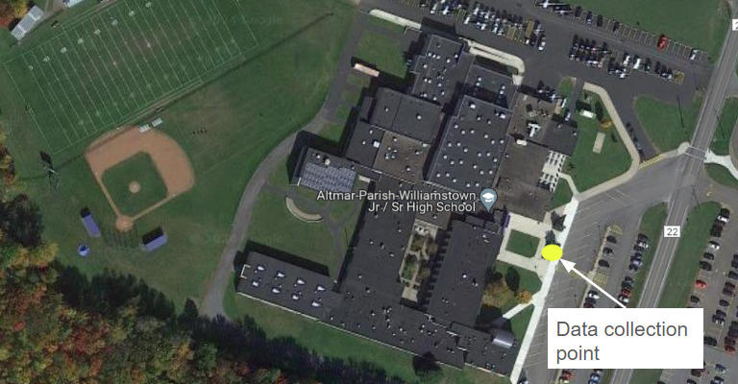
Figure 1: Shows a close up image of our school with the data collection point. Image from Google Maps

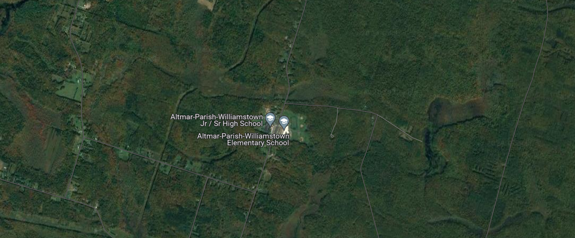
Figure 2: A zoomed out shot showing how rural the area is. Image from Google Maps

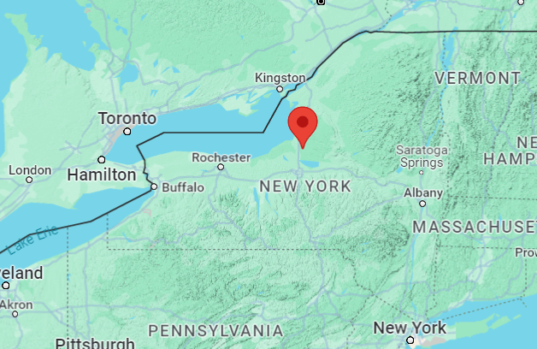
Figure 3: A map showing NY and the location of our school. Image form Google Maps

Results:
Once the data was collected, our teacher helped us download it from the GLOBE Data Visualizer. We then made two graphs, one showing the different cloud types we saw (figure 4) and the other showing cloud cover (figure 5).
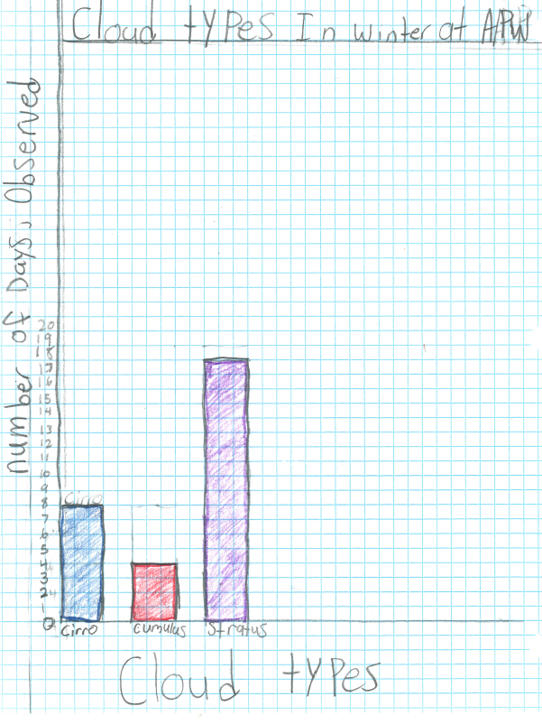
Figure 4: This figure shows how many times that we observed the three main clouds

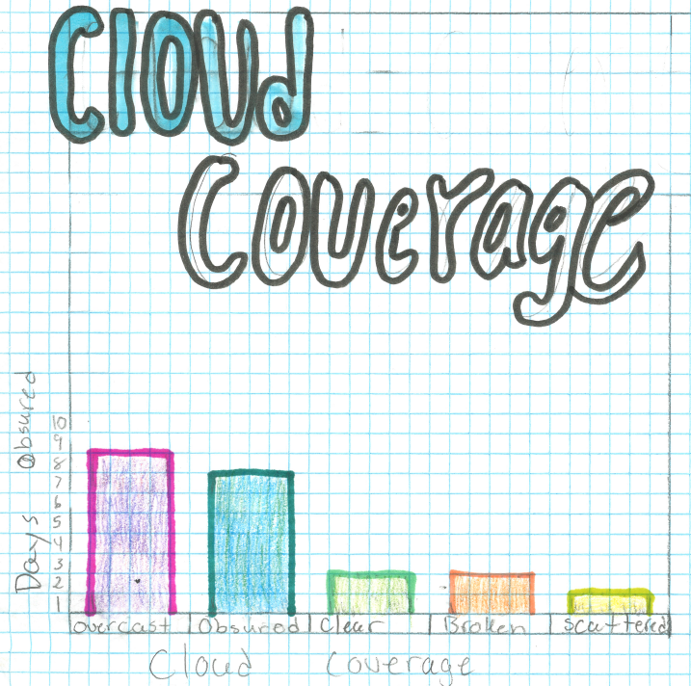
Figure 5: This figure shows what cloud coverage was like for our observations. Some students did get confused with overcast and obscured. We believe they are all overcast but did our graph based on the GLOBE reported data.

Discussion:
Our data shows that stratus clouds were the most seen cloud type. It also shows that the sky was mostly overcast. We did see cirrus clouds when it was clear skies. The data does help answer the research question because we were able to collect data that can answer it. We were able to observe the different types of clouds during our observations. Our hypothesis ended up being correct. This was no surprise based on past winters. Some students picked obscured instead of overcast so that data has errors.

Conclusion:
In conclusion, we had a fun time collecting our cloud data and being able to see it on the GLOBE website. We would like to do future research with collecting data for all the different seasons. We do plan on collecting cloud data for the spring. We also wonder how cloud types will be impacted by climate change. Just like clouds affect the climate, the climate affects clouds. Climate scientists believe that as Earth’s climate warms, there will be fewer clouds to cool it down. And so, we can’t rely on clouds to slow the climate change. (“How Do Clouds Affect Earth's Climate?” and “ISCCP: Cloud Climatology”) To understand clouds and their effect on the climate, we need more data. It would be neat to see how cloud types for Parish change over time.

Bibliography:
“Climate of New York (state) Facts for Kids.” Kids encyclopedia facts, 9 February 2024, https://kids.kiddle.co/Climate_of_New_York_(state). Accessed 6 March 2024.
“The Four Core Types of Clouds.” National Oceanic and Atmospheric Administration, 28 March 2023, https://www.noaa.gov/jetstream/clouds/four-core-types-of-clouds. Accessed 6 March 2024.
“How Do Clouds Affect Earth's Climate?” NASA Climate Kids, https://climatekids.nasa.gov/cloud-climate/. Accessed 6 March 2024.
“ISCCP: Cloud Climatology.” International Satellite Cloud Climatology Project, https://isccp.giss.nasa.gov/role.html. Accessed 6 March 2024.
“NASA GLOBE Cloud Protocol - Clouds Protocol.” GLOBE.gov, https://www.globe.gov/web/s-cool. Accessed 6 March 2024.
Smith, Cory. “Why Winter clouds look nothing like Summer clouds.” WLTX-TV, 27 November 2023, https://www.wltx.com/article/weather/why-winter-clouds-are-different-from-summer-clouds-weather/101-72db1803-9828-4dc6-99e5-9dbdb07b440a. Accessed 6 March 2024.
“Types of Clouds | NOAA SciJinks – All About Weather.” SciJinks, https://scijinks.gov/clouds/. Accessed 6 March 2024.
Badge Descriptions/Justifications:
•Be a Collaborator: Only two students are listed but 20 students helped collect data. We each became an expert with our cloud level. We would then work together to discuss what cloud types were in the sky.
•Be a Data Scientist: We collected our own data and then looked after it to come up with our conclusion.

