Title of Research Project
EFFECT OF URBANIZATION ON SURFACE, AIR AND SOIL TEMPERARURE CHANGES IN AKURE, NIGERIA

Grade Level: Secondary School (grades 9-12, ages 14 – 18 years)
Report Type: 2021 International Virtual Science Symposium Report

Student Names
- Folayan Favour
- Dunbaiju Promise
- Oluwaseyi Olamobisi

GLOBE Teachers Name
Mr. Olawunmi Fasakin
Mrs. Oluremi Adeniyi

School Name
St. Peter’s Unity Secondary School, Akure (SPUSSA), Ondo State

Country
Nigeria

Date
10th March 2021

Principal of School: Mrs. F. M. Arowosade
Country Coordinator: Mrs. Aminulai Modupe Salamotu

Table of Content

- Abstract ………………………………………………………………………….2
- Research Questions ……………………………………………………………3
- Introduction and Literature Review ……………………………………………3
- Research Methods and Materials ……………………………………………..4
- Results ……………...…………………………………………………………..10
- Discussion ………………………………………………………………………17
- Conclusion ………………………………………………………………………18
- Bibliography/Citations ………………………………………………………….18
- Acknowledgments ……………………………………………………...………19
- Badges Descriptions ………………………………………………………… 19

Abstract: (less than 300 words)
The Earth atmospheric system has been seriously affected by different urbanization processes that greatly impacted natural ecosystem. These have influenced the evapotranspiration and the energy cycle. Data were collected from three observational sites (School Football Field, School Farm and Cement Floor) within SPUSSA study area. The objectives of this project are to evaluate the effect of urbanization and examine the influence of surface temperature on air temperature and soil temperature. These data are weekly surface land, air and soil temperatures for period of five months from October 2020 to February 2021. No soil temperatures were obtained from the Cement Floor. Cloud cover conditions were recorded. Data were analyzed using mean graph and analysis of variance (ANOVA) test. The general attributes of the surface and sky conditions are dry ground, leaves on trees, low moisture content, overcast, somewhat hazy sky visibility and opaque cloud opacity. The mean weekly graphs indicate increase surface land temperature, air temperature and soil temperature with time across the three selected sites. This implies increase of surface land, air and soil temperatures with urbanization, that is, increase surface temperature with increase air temperature and increase surface temperature with soil temperature. The ANOVA reveals significant effect of urban island heat effect (urban land transformation) on surface land, air and soil temperatures across the School Field, School Farm and Cement Floor, at probability p<0.05 and 5% error level, with significant values of 0.000 (for the three climatic variables on the School Farm); significant values of 0.004, 0.000 and 0.000 (for the three climatic variables on the School Farm), and significant values of 0.000 and 0.000 (for the two climatic variables). It is recommended that other climatic factors should be included for further studies to give a holistic view to effects of urban land transform in the study area.

Keywords: Observation sites, evapotranspiration, Earth atmospheric system, cloud cover, ANOVA.

Research Questions:
- Does urbanization increases surface temperature?
- Does surface temperature have corresponding influence on air temperature increase?
- Does surface temperature have corresponding influence on soil temperature at a depth of 10 cm?

Introduction and Review of Literature: (250 – 500 words)
Urbanization processes bring about drastic changes over the nature of earth’s surface and atmosphere parameters of an environment. These processes initiate changes in thermal energy, moisture variations, radiation transformation and aerodynamic properties, thereby influencing the earth’s natural solar and hydrologic systems (Babatola, 2013).

The evapo-transpiration in the urbanization would be reduced due to the removal of vegetation and its replacement by impervious materials. Physical processes impacting the local climate attributes are influenced by location of the area, exposure of the area and surface conditions such as heat capacity, moisture component, vegetation cover, and roughness of the ground surface. The climate in an area where the local conditions of the earth’s surface are clearly different from those in surrounding areas (e.g. hills, forest, city, croplands, rivers and mountain environment) is referred to as Local climate (Oliveira, 2003).

The temperature variability of a location, nature and extent of cloud cover affect the characteristics of Earth’s physical geographic system (GLOBE, 2014).

St. Peter’s Unity Secondary School, Akure (SPUSSA) study area was used as a point of reference to corroborate the fact that the land surface transformation from natural to artificial surfaces in Akure Metropolitan city has dynamically affected evapo-transpiration system which consequently impacted surface temperature, air temperature and soil temperature.

Saaroni et al. (2000) explained that in cities or urban areas, larger evapo-transpiration processes take place leading to more consumption of energy when compared with rural settings. This makes the urban environment act as a heat sink.

Babatola (2013) described the indiscriminate removal of vegetation covers for industrial development, roads and bridges construction, and increase in building structures on the land surface due to human activities as Urbanization processes. These human activities will bring about reduction of evapo-transpiration.

The aim of the study is to investigate how the Urban Heat Island Effect (UHIE) changes the climatic properties over a specified period of time in Akure City, Nigeria using SPUSSA community as a case study. The objectives of this project are to evaluate the urbanization (land surface transformation) on surface temperature and examine the effect of surface temperature on air temperature and soil temperature at different atmospheric or observational sites.

The Sun is a major source of energy for Earth’s surfaces processes, changes and at Earth’s surfaces. Solar isolation drives atmospheric and ocean circulation. The temperature variability of a location affects the characteristics of Earth’s physical geographic system. Human activities can modify the physical environment.

At Earth surface, some of the solar energy evaporates water and some warms the surface. Heat from the surface flows into the ground and into the air if they are colder than the surface. The heat of the vaporization of water is released when and where the water condenses often as clouds form. At heart of the energy cycle is the surface temperature. All aspect of the energy budget contributes to or is affected by surface temperature.

Research Methods and Materials:
- Surface temperature was measured with a hand-held infra-red thermometer (IRT). This device was pointed at the ground to measure surface temperature readings.
- Cloud protocols were performed along with the Surface Temperature protocols.
- We used the GLOBE cloud chart to identify cloud type. We estimated the cloud cover.
- We used meter sticks to measure the depth of soil at 10 cm.
- We established three (3) atmospheric study sites within SPUSSA compound where soil temperature and air temperature were measured.
- The GPS coordinates of the atmospheric sites were recorded.
- Measurements were taken at open area of land exposed to sunlight.
Project Design
Three observational or atmospheric study sites that are large, open and homogenous, of dimension 30 m X 30 m were established in the school compound. Nine (9) individual observational spots were randomly selected within the 30 m X 30 m observation sites which are at least 5 meters apart (GLOBE, 2014).
At each of the observation spot surface temperature data were collected to be compared with air and soil temperature measurements. In addition, the GPS values at the centers of each observation site were recorded. The atmospheric or selected site is considered to have its own micro-climate.

Geographical Location and Climate of Akure City
Akure city lies on latitude 7° 4’ and 7°25’ north of the equator and longitude 5° 5' and 5°30' east of the Greenwich meridian. The city comprises of two local government areas which are Akure South and Akure North in Ondo State, South Western part of Nigeria (Figure 1). It is about 700 km (430 miles) southwest of Abuja and 311 km (193 miles) north of Lagos State. Residential districts are of varying density, some area such as Arakale, Ayedun Quarters, Ijoka, and Oja-Oba consist of over 200 inhabitants per hectare (81/acre), while areas such as Ijapo Estate, Alagbaka Estate, Avenue and Idofin have between 60 and 100 inhabitants per hectare (24 and 40/acre). The city is situated in the tropic rainforest zone in Nigeria (Adeoye, 2016). Akure is situated 250 meters above sea level and Ado-Ekiti and Idanre hills. It is surrounded with large granite formations of volcanic origins. It is in the humid tropical region of Nigeria, with annual rainfall of over 1500 millimeters. During the months of November, December, January and February the cooler dry continental air from the north-east prevails while the rainy season ranges from about March to October.

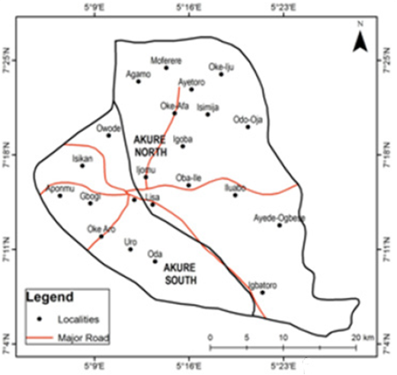
Figure 1: Map of Akure Metropolitan City showing the Two Local Government Areas and Major Districts (After Aremu et al., 2017)

Study Area (SPUSSA)
St. Peter’s Unity Secondary School, Akure (SPUSSA) is situated in the central region of Akure city. Figure 2 is a Google map showing the location of SPUSSA in the Akure city.
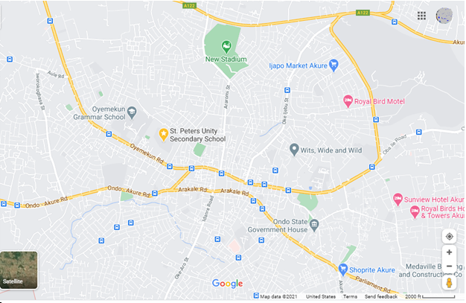
Figure 2: Google Map showing the location of SPUSSA (study area) in Akure City.

Figure 3 display a Google map indicating the locations of the three observational or atmospheric sites within SPUSSA compound, the study area. These sites are the School farm, School Football field and Cement floor.
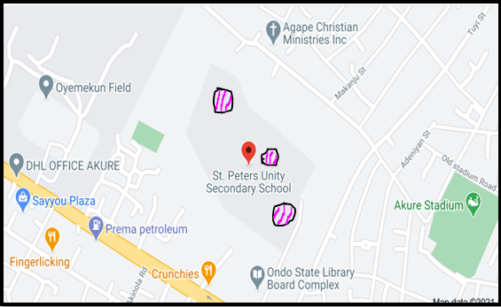
SCHOOL FARM
CEMENT FLOOR
SCHOOLFIELD
Figure 3: Location of the Three Atmospheric or Observational Sites within SPUSSA premises – the Study Area

Data Collection: The data for this study were collected from three atmospheric or selected sites within SPUSSA community. Data were obtained for a period of four months from November 2020 to February 2021. The observation sites are School Football Field, School Farmland and Cemented Floor (Figures 4, 5 and 6). Nine observation spots were chosen within the atmospheric sites. Although these sites do not cover the whole of Akure Metropolis, the areas are still correctly relevant in terms of urban surface which is the basis of this study. Therefore, interpretation will be confined to those areas. These sites are also part of the micro-climate areas that play significant role at the macro-climate effect over the city. The data for this study were collected through primary sources, that is, biweekly.
Figures 7 – 11 show the GLOBE students taking readings or data at the three observation sites within the study area.

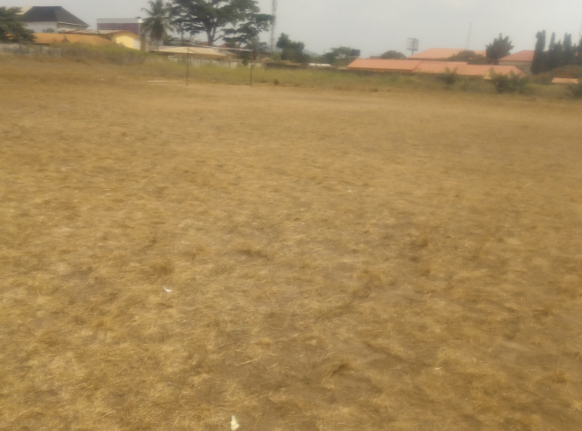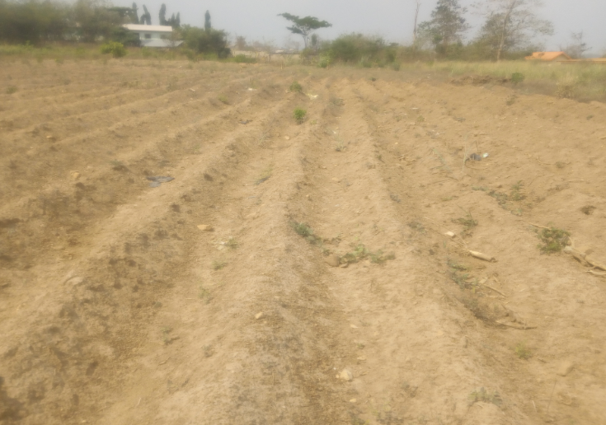
Figure 5: 30 m X 30 m School Farm Observation or Atmospheric Site
Figure 4: 30 m X 30 m School Football Field Observation or Atmospheric Site

Figure 6: 30 m X 30 m Cemented Parking Floor Observation or Atmospheric Site

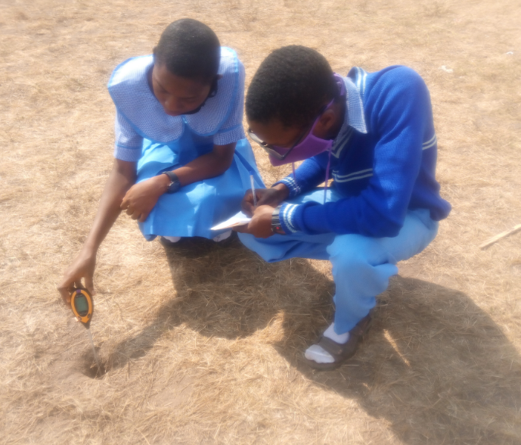
Figure 8: GLOBE Team observing Soil Temperature at one of the Observation spots on the School Field with the 4-in-1 Soil meter.
Figure 7: GLOBE Students taking Air Temperature data at one of the Observation spots on the Cemented Floor Site with the Digital Hygro-thermometer.

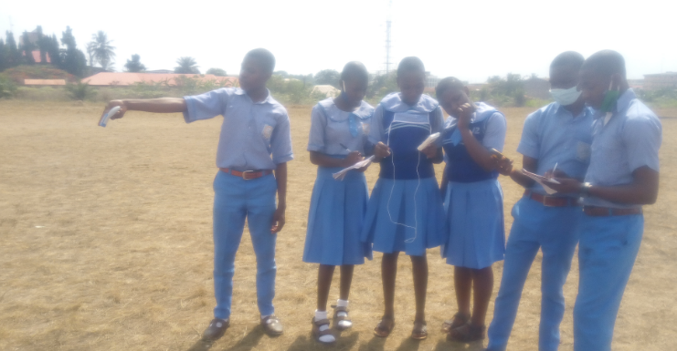
Figure 9: The GLOBE Team recording Surface Temperature, Air Temperature and the Coordinate values at School Field Observation Site with Infrared Thermometer, Digital Hygro-thermometer and etrex 10 GPS device.

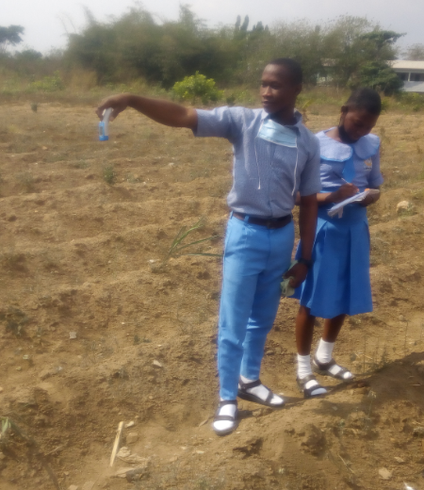
Figure 11: GLOBE Team observing Surface Temperature at one of the Observation spots on the School Farm with the Infrared thermometer device.
Figure 10: GLOBE Team recording Soil Temperature data at one of the Observation spots on the School Farm with the 4-in-1 Soil meter at a depth of 10 cm.

Data Analyses: The data from this study were analyzed using descriptive one way Analysis of Variance ANOVA statistics. ANOVA was used to analyze increase in urbanization effect, that is, increase in urban land surface transformation, on surface temperature as well as relationship between surface temperature and air temperature and relationship between surface temperature and soil temperature. Mean graphs were also used.

Results: (Including GLOBE Data!)
The GPS Coordinates for the three observational sites are:
School Field coordinates N07⁰ 15’ 31.2”, E005⁰ 11’ 03.4” with elevation 352 m and accuracy ±2 m.
School Farm coordinates N07⁰ 15’ 4.2”, E005⁰ 10’ 53.8” with elevation 354 m and accuracy ±2 m.
Cemented Floor coordinates N07⁰ 15’ 34.7”, E005⁰ 11’ 03.8” with elevation 352 m and accuracy ±2 m.
Samples of weekly data measurements and cloud cover conditions obtained from the School Field, School Farm and Cemented Floor are presented in Tables 1, 2 and 3.

Table 1: Data and Observations obtained from the School Field after Two Weeks.
Observation Spots | Surface Temperature  (°C) | Air temperature  (°C) | Soil Temperature  (°C) | Cloud Cover conditions-  Sky and Surface
1 | 46.1 | 37.3 | 33.0 | Dry ground, Leaves on trees.  Moisture content: Low.  Cloud Cover: Overcast.  Sky colour: Pale Blue.  Sky visibility: Somewhat hazy.  Cloud Opacity: Opaque.
2 | 47.6 | 39.4 | 39.0
3 | 47.6 | 41.2 | 39.0
4 | 49.7 | 40.8 | 40.0
5 | 49.1 | 40.9 | 39.0
6 | 51.6 | 41.2 | 38.0
7 | 50.6 | 41.1 | 39.0
8 | 51.6 | 40.3 | 40.0
9 | 51.8 | 40.7 | 40.0

Table 2: Data and Observations obtained from the School Farm after Two Weeks.
Observation  Spots | Surface Temperature  (°C) | Air temperature  (°C) | Soil Temperature  (°C) | Cloud Cover conditions-  Sky and Surface
1 | 52.6 | 40.7 | 40.0 | Dry ground, Leaves on trees.  Moisture content: Low.  Cloud Cover: Overcast.  Sky colour: Pale Blue.  Sky visibility: Somewhat hazy.  Cloud Opacity: Opaque
2 | 50.6 | 41.5 | 38.0
3 | 49.5 | 40.8 | 40.0
4 | 47.7 | 40.1 | 38.0
5 | 53.4 | 40.8 | 37.0
6 | 51.8 | 41.4 | 39.0
7 | 48.3 | 41.3 | 39.0
8 | 49.8 | 41.1 | 38.0
9 | 49.9 | 41.1 | 37.0

Table 3: Data and Observations obtained during the Cemented Floor after Eight weeks.
Observation spots | Surface Temperature  (°C) | Air  Temperature  (°C) | Cloud Cover conditions-  Sky and Surface
1 | 47.5 | 32.5 | Dry ground, Leaves on trees.  Moisture content: Low.  Cloud Cover: Overcast.  Sky colour: Milky.  Sky Visibility: Somewhat hazy.  Cloud Opacity: Opaque.
2 | 47.4 | 38.1
3 | 48.2 | 37.9
4 | 48.9 | 38.1
5 | 47.6 | 38.4
6 | 48.6 | 38.6
7 | 48.2 | 38.8
8 | 43.7 | 38.2
9 | 51.6 | 39.5

The average values of the three climatic factors (Surface temperature, Air temperature and Soil temperature at a depth of 10 cm) obtained during the period of the study from the three observation sites are shown in Tables 4, 5 and 6.
Table 4: Average values of Surface temperature, Air temperature and Soil temperature at a depth of 10 cm obtained from the School Field during the period of the Research.
Average School Field Data Measurements
Weeks | Surface Temperature  (⁰C) | Air Temperature  (⁰C) | Soil Temperature  (⁰C)
2 | 49.5 | 41.5 | 39.9
4 | 48.5 | 40.2 | 38.2
6 | 48.3 | 36.4 | 38.1
8 | 50.1 | 36.9 | 40.2
10 | 50.4 | 38.4 | 36.7
12 | 45.6 | 35.6 | 34.3
14 | 45.3 | 35.7 | 36.9
16 | 50.4 | 35.3 | 36.6
18 | 52.4 | 36.7 | 40.2
20 | 51.2 | 36.7 | 39.3

Table 5: Average values of Surface temperature, Air temperature and Soil temperature at a depth of 10 cm obtained from the School Farm during the period of the Research.
Average School Farm Data Measurements
Weeks | Surface Temperature  (⁰C) | Air  Temperature  (⁰C) | Soil  Temperature  (⁰C)
2 | 50.4 | 41.0 | 38.4
4 | 49.1 | 38.4 | 34.7
6 | 49.7 | 38.8 | 36.9
8 | 51.0 | 41.2 | 40.7
10 | 51.7 | 40.3 | 39.6
12 | 48.8 | 37.6 | 37.4
14 | 51.3 | 38.4 | 38.7
16 | 53.0 | 40.2 | 40.3
18 | 54.1 | 40.7 | 42.7
20 | 53.5 | 40.3 | 42.9

Table 6: Average values of Surface temperature and Air temperature obtained from the Cement Floor during the period of the Research.
Average Cemented Floor Data Measurements
Weeks | Surface Temperature  (⁰C) | Air Temperature (⁰C)
2 | 40.1 | 34.7
4 | 47.8 | 38.4
6 | 46.9 | 35.8
8 | 48.0 | 37.8
10 | 48.0 | 37.9
12 | 43.1 | 35.4
14 | 44.9 | 37.3
16 | 44.3 | 37.6
18 | 47.4 | 39.8
20 | 47.4 | 39.5

Figures 12 and 13 show the average or mean graphs of the Surface, Air and Soil Temperatures against time over the School Field and School Farm Observational Sites within the Study Area; while Figure 14 displays the average or mean graph of the Surface and Air temperatures against time over the Cemented Floor Observational Site within the Study Area.
Figure 12: The Average Surface, Air and Soil Temperatures against Time over the School Field Observational Site within the Study Area.

Weeks
Figure 13: The Average Surface, Air and Soil Temperatures against Time over the School Farm Observational Site within the Study Area.

Weeks
Figure 14: The Average Surface and Air Temperatures against Time over the Cement Floor Observational Site within the Study Area.

Table 7: ANOVA Result for the School Field
 |  | Sum of Squares | df | Mean Square | F | Sig.
Surface Temperature | Between Groups | 447.420 | 9 | 49.713 | 12.499 | .000
 | Within Groups | 318.202 | 80 | 3.978
 | Total | 765.622 | 89
Air Temperature | Between Groups | 320.287 | 9 | 35.587 | 16.040 | .000
 | Within Groups | 177.489 | 80 | 2.219
 | Total | 497.776 | 89
Soil Temperature | Between Groups | 335.993 | 9 | 37.333 | 13.986 | .000
 | Within Groups | 213.547 | 80 | 2.669
 | Total | 549.540 | 89

Table 8: ANOVA Result for School Farm
 |  | Sum of Squares | df | Mean Square | F | Sig.
Surface Temperature | Between Groups | 244.704 | 9 | 27.189 | 2.969 | .004
 | Within Groups | 732.742 | 80 | 9.159
 | Total | 977.446 | 89
Air Temperature | Between Groups | 171.451 | 9 | 19.050 | 25.930 | .000
 | Within Groups | 58.773 | 80 | .735
 | Total | 230.225 | 89
Soil Temperature | Between Groups | 541.122 | 9 | 60.125 | 40.533 | .000
 | Within Groups | 118.667 | 80 | 1.483
 | Total | 659.789 | 89

Table 9: ANOVA Result for Cemented Floor
 |  | Sum of Squares | df | Mean Square | F | Sig.
Surface Temperature | Between Groups | 563.496 | 9 | 62.611 | 31.646 | .000
 | Within Groups | 158.280 | 80 | 1.979
 | Total | 721.776 | 89
Air Temperature | Between Groups | 253.031 | 9 | 28.115 | 27.101 | .000
 | Within Groups | 82.991 | 80 | 1.037
 | Total | 336.022 | 89

Figure 15 presents the Print screen of GLOBE Visualization page of St. Peter’s Unity secondary School, Akure, Ondo State, Nigeria.

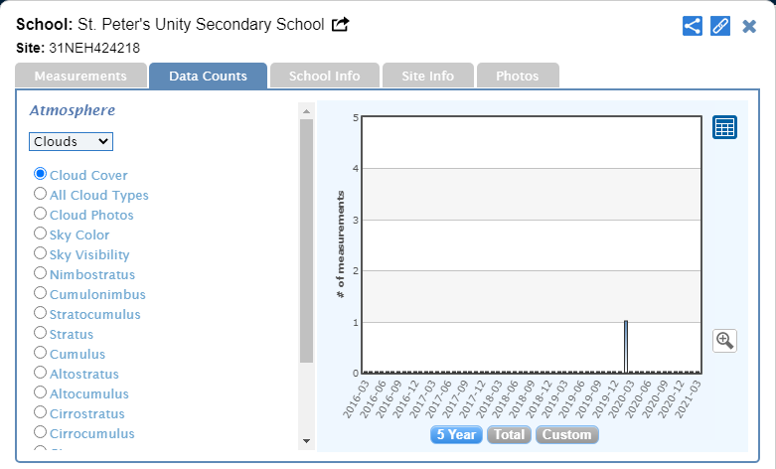
Figure 15: Print screen of GLOBE Visualization page of St. Peter’s Unity secondary School, Akure, Ondo State, Nigeria.

Discussion:

- Does urbanization increases surface temperature?
- Does surface temperature have corresponding influence on air temperature increase?
- Does surface temperature have corresponding influence on soil temperature at a depth of 10 cm?
From Figure 12, increases in surface temperature and air temperature with increase in soil temperature are observed after week 14.
From Figure 13, after twelve weeks, the surface temperature, air temperature and soil temperature experienced increase in their values.
From Figure 14, after twelve weeks, the surface temperature and air temperature experienced increases in their values.
ANOVA statistical technique was used to test the significance of surface temperature across the sites in area of investigation as well as the significance of the corresponding influence of the surface temperature on air temperature and soil temperature.
Table 7 shows the ANOVA result from the School Field site. The value of the F-statistics for surface temperature, air temperature and soil temperature at a depth of 10 cm, at probability p< 0.05 and 5% error level are 12.499, 16.040 and 13.986 respectively. All the three variables have significant values of 0.000. This indicates that surface temperature, air temperature and soil temperature at a depth of 10 cm over the School Field is significant across the study area. This implies that the significance of one is a corresponding significance of the other over the area of investigation.
Table 8 presents the ANOVA result from the School Farm observation site. The F-statistics values for surface temperature, air temperature and soil temperature at a depth of 10 cm, at probability p< 0.05 and 5% error level are 2.969, 25.930 and 40.533 respectively. The significant values of the surface temperature, air temperature and soil temperature at a depth of 10 cm are 0.004, 0.000 and 0.000 respectively. This indicates that surface temperature, air temperature and soil temperature at a depth of 10 cm over the School Farm site is significant across the study area.
Table 9 displays the ANOVA result from the Cemented Floor atmospheric site. In this case, the soil temperature at a depth of 10 cm was not carried out. Hence, two variables are possible. The F-statistics values for surface temperature and air temperature, at probability p<0.05 and 5% error level are 31.646 and 27.101 respectively. The significant values of the surface temperature and air temperature are 0.000 and 0.000 respectively. It reveals that the surface temperature and air temperature over the cemented floor is significant across the study area.
Conclusion:
The study has revealed that the rate of urbanization is high in the Akure city and this consequently impacted the study area over the period of investigation; and that there is significant influence of urbanization on surface temperature. In addition, surface temperature has a close relationship with air temperature and soil temperature such that there is greater influence of surface temperature on air temperature and soil temperature.

It is recommended the future study on effect of urbanization rate in the area of study should include more climatic factors for a more broad based understanding.

Bibliography/Citations:
- Adeoye, D. O. (2016). Challenges of Urban Housing Quality: Insights and Experiences of Akure, Nigeria. rocedia - Social and Behavioral Sciences, 216, 6, 260–268.
- Aremu, O., Bello, E., Aremu, B., Aganbi, B. & Machoko, J. (2017). Monitoring and Analysis of Urban Heat Island using Remote Sensing Data- A Case Study of Akure, Ondo State, Nigeria. International Journal of Environmental Science and Natural Reseources, 4, 1 – 20.
- Babatola, E. B. (2013). Urban Influence on Relative-Humidity and its corresponding Effects on Rainfall, A Case study of Ibadan, Nigeria. Mediterranean Journal of Social Sciences, 4, 343 -351.
- GLOBE (2014). Surface Temperature Protocol. Atmosphere, 1 – 17.
- Oliveria et al. (2003). Annual and Diumal wind pattern in the city of Sao paolo. Water, air and soil pollution: Focus 3, 3 – 15.
- Saaroni et al. (2000). Spatial distribution and micro scale characteristics of urban heat island in Tel-aviv, Israel. Land scape and urban planning, 48, 1 – 18.

GLOBE Materials used: GLOBE Cloud Cover Chart.
Acknowledgments

Our gratitude and appreciation go to Mrs. F. M. Arowosade, Principal of St. Peter’s Unity Secondary School, Akure (SPUSSA), Ondo State, Nigeria for her technical support, moral advice and assistance during the study.
Phone Number: +234-8168404253

We are grateful to Mrs. Aminulai Modupe Salamotu, the Nigeria Country Coordinator, for her constructive advice and assistance to the implementation of GLOBE programs in schools in Ondo State, Nigeria. We salute your courage. She is GLOBE Certified.

Phone Number: +234-8035984500
Email: stepb13@yahoo.com

Badge Descriptions/Justifications:
I AM A COLLABORATOR:
We have five (5) teams working together as a group in same school. There was interaction between students from different classes
- The first team was responsible for the digging of a hole and ensuring that the hole dug was ten (10) cm in nine (9) observation spots on various sites (School Field and Farm). Their names include: Semire Victor (SS 2), Dunbajiu Promise (SS 2) and Oloda Dominion (JSS 3).
- The second team was responsible for surface temperature recording. Their names include: Olamobisi Oluwaseyi (SS 2), Obiogba Nneka (SS 1), Orungbemi Princewill (SS 2) and Folayan Favour (SS 2).
- The third team was responsible for the measurement of the air temperature. Their names include: Odunjo Adeola (SS 2) and Semudara Favour (SS 2).
- The fourth team was responsible for the measurement of the soil temperature. Their names are Toyin Afe Favour (SS 2), Ojo Gbemisola (SS 2).
- The fifth team was responsible for observing cloud cover conditions. Their names are Akinsunmade Tope (SS 3), Eke Paul (SS 3), Akomolafe Kemisola (SS 3).
Students from various classes are able to improve the research by dividing ourselves into groups’ e.g. SS3 for cloud conditions.

I AM A STEM PROFESSIONAL:
- Dr. Francis Akinluyi from the Federal University of Technology, Akure, Ondo state, Nigeria is a Senior Lecturer in the field of Remote Sensing led us in obtaining and recording the coordinates of the study sites with the aid of GPS device.
- Mr. Fasakin, O. from St. Peter’s Unity Secondary School, Akure, Nigeria who is a physicist led us through the course of taking the observations and helping in taking improved precision in the course of taking the measurement.
They lectured the students on steps taken during the course of our research. Thus, working with them makes us part of the STEM professionals

I AM A DATA SCIENTIST:
We were able to observe during the course of our research that the level of surface temperature, air temperature and soil temperature was more, compared to the past, due to increased rate of urbanization. Therefore, as the years are increasing, human activities will lead to increase in urbanization and thus reduce evapotranspiration of the city.

