FROM SKY TO GROUND- NASA GLOBE PROTOCOLS AND SCIENTIFIC MODELING IN ENVIRONMENTAL EDUCATION
Emilly Talita da Silva Xavier
Escola Estadual Professora Calpúrnia Caldas de Amorim - EECCAM
Rua Manoel Gonçalves de Melo, 42; Caicó-RN
emillyinfojimin@gmail.com

Fernanda Sofia Soares Santos
Escola Estadual Professora Calpúrnia Caldas de Amorim - EECCAM
Rua Manoel Gonçalves de Melo, 42; Caicó-RN
fernandasofia193@gmail.com

Janniely Lívia dos Santos Medeiros
Escola Estadual Professora Calpúrnia Caldas de Amorim - EECCAM
Rua Manoel Gonçalves de Melo, 42; Caicó-RN
jannielyinfo@gmail.com

Salma Sophia Felix dos Santos
Escola Estadual Professora Calpúrnia Caldas de Amorim - EECCAM
Rua Manoel Gonçalves de Melo, 42; Caicó-RN
salmasophiasantos@gmail.com

Thaynara Mayane Fernandes de Souza
Escola Estadual Professora Calpúrnia Caldas de Amorim - EECCAM
Rua Manoel Gonçalves de Melo, 42; Caicó-RN
Thaynaramayane@gmail.com
Alaine Maria dos Santos Silva
Escola Estadual Professora Calpúrnia Caldas de Amorim - EECCAM
Rua Manoel Gonçalves de Melo, 42; Caicó-RN
alainemss@gmail.com

ABSTRACT
This study investigated the pedagogical potential of applying the scientific protocols of the GLOBE/NASA Program, combined with the construction of three-dimensional models, as a strategy to promote youth protagonism, educational inclusion, and the development of critical environmental awareness among high school students. The project was carried out at Escola Estadual Professora Calpúrnia Caldas de Amorim, located in Caicó-RN, in the Seridó Potiguar territory — a semi-arid region characterized by water scarcity and significant climatic challenges. The methodology involved the application of GLOBE protocols related to Earth's spheres: Atmosphere (cloud observation), Pedosphere (soil analysis), Biosphere (tree measurement), and Hydrosphere (water quality assessment). The data collected were integrated into scientific three-dimensional models representing the Earth system, highlighting the interdependence among environmental spheres. These models will be presented at the National Fair of the GLOBE Brazil Program as a visual and pedagogical synthesis of the results obtained. The findings demonstrated that the combination of empirical observation, digital technology, and tangible modeling fosters meaningful learning, stimulates critical thinking, and enhances the inclusion of students targeted by special education. The experience revealed that citizen science, mediated by art and technology, is an effective strategy to foster environmental engagement and strengthen the understanding of the Sustainable Development Goals (SDGs), especially SDG 4, 13, and 15. It is recommended that interdisciplinary practices of this nature be continued and expanded, consolidating the GLOBE protocols as an educational tool in challenging socio-environmental contexts.
KEYWORDS. Citizen science. Environmental education. Scientific modeling. GLOBE/NASA. Sustainability.
- Research Questions/Research Problem

The present study investigates the pedagogical potential of applying scientific protocols from the GLOBE/NASA Program, articulated with the construction of three-dimensional models, as a strategy to promote youth protagonism, educational inclusion, and the development of critical environmental awareness among high school students. In this perspective, an understanding is sought of how the integration of science and art can make the learning of environmental topics more meaningful, visual, and accessible to diverse student profiles.
Within this framework, the following guiding question is formulated: how can the application of scientific protocols from the GLOBE/NASA Program, combined with the construction of three-dimensional models, enhance inquiry-based learning, youth protagonism, and environmental awareness among high school students—including those who are part of the target group of special education—in a semi-arid region such as the Seridó Potiguar?
The central problem of this study arises from the need to integrate science, art, and inclusion in the teaching of environmental themes, fostering an investigative, participatory, and contextualized approach. Recent literature in environmental education and citizen science indicates that active and experiential methodologies, when associated with tangible modeling and the use of digital technologies, stimulate young people’s interest in science and sustainability, especially when grounded in local realities (Silva & Pereira, 2023; NASA GLOBE, 2024; Oliveira et al., 2022).
The Seridó Potiguar region, characterized by a semi-arid climate and socio-environmental vulnerabilities, constitutes a favorable setting for the development of educational practices that encourage systematic observation, critical thinking, and student protagonism. In this context, the application of GLOBE protocols—Clouds, Soil, Trees, and Water—combined with the construction of three-dimensional models representing the Earth’s spheres, represents a concrete opportunity to articulate scientific knowledge and traditional understandings, promoting an integrated comprehension of the planet as a dynamic and interdependent system.

- Introduction

The growing environmental degradation places on education the challenge of developing innovative pedagogical practices capable of connecting scientific knowledge to students’ local realities and of promoting critical, sustainable, and socially committed education. In light of the impacts of climate change, science education must go beyond the mere transmission of content and encourage the active construction of knowledge, engaging young people in concrete actions of environmental observation and monitoring (Carvalho, 2021; Louv, 2019).
In the Seridó Potiguar region, located in the semi-arid Northeast of Brazil, the effects of water scarcity and high temperatures are particularly evident, influencing social, economic, and ecological dynamics. This context calls for an educational approach that fosters understanding local environmental phenomena and encourages youth protagonism in the search for sustainable solutions (Santos & Lima, 2022). Critical environmental education thus assumes a transformative role, integrating scientific and popular knowledge while strengthening the connection among school, territory, and community (Guimarães, 2020).
The GLOBE/NASA Program (Global Learning and Observations to Benefit the Environment) represents one such innovative strategy by articulating citizen science, systematic data collection, and global collaboration. Created in 1995, the program aims to engage students and teachers in standardized environmental measurements and observations, making the results available in a global database (NASA GLOBE, 2024). This methodology promotes student engagement in scientific practice and encourages understanding of Earth as an interconnected system composed of the atmosphere, biosphere, hydrosphere, and pedosphere.
The integration of GLOBE protocols with scientific modeling through three-dimensional models expands pedagogical possibilities by enabling environmental phenomena to be represented in a visual, concrete, and inclusive manner. The use of tactile and visual resources supports the participation of students who are part of the target group of special education, ensuring accessibility and equity in the learning process (Mantoan, 2015; Santos, 2021). Furthermore, the construction of models fosters interdisciplinary synthesis among science, art, and technology, bringing natural science content closer to students’ realities and encouraging the development of critical thinking (Azevedo & Oliveira, 2020).
Within this perspective, the present study analyzes how the application of GLOBE/NASA protocols, articulated with the construction of three-dimensional models, can contribute to youth protagonism, inclusive education, and socio-environmental engagement in a semi-arid context. Aligned with the Sustainable Development Goals (SDGs) of the 2030 Agenda, the project emphasizes SDG 4 (Quality Education), SDG 13 (Climate Action), and SDG 15 (Life on Land), reaffirming the role of schools in educating critical and environmentally responsible citizens (United Nations, 2015).

3. Theoretical Reference

The theoretical foundation of this research is structured around interdependent axes that articulate citizen science and the appropriation of the scientific method, modeling and the use of three-dimensional models as instruments for meaningful learning, critical environmental education contextualized to the semi-arid region, and inclusive education practices and accessibility in science teaching. These axes converge to support a pedagogical approach that combines scientific observation, concrete experimentation, and educational inclusion, constituting a formative model that values student protagonism, critical thinking, and social engagement in the face of contemporary environmental challenges.

3.1 Citizen science and inquiry-based learning
Citizen science is understood as a pedagogical strategy that brings the population closer to scientific processes, fostering the development of cognitive, ethical, and social competencies linked to investigation and responsible decision-making (Bonney et al., 2014; Bonney et al., 2016). By involving students in the collection, recording, and interpretation of environmental data, such initiatives promote scientific literacy, critical thinking, and the formation of active ecological awareness.
In the school context, network-based projects such as the GLOBE Program, affiliated with NASA, strengthen the dialogue between local knowledge and global databases, enabling students to compare their observations with records from different regions of the world (NASA, 2023). This interaction broadens the sense of belonging to a global scientific community and consolidates the social dimension of science, transforming learning into a collaborative practice with social, environmental, and educational impact.

3.2 Modeling and three-dimensional models: concrete representations for learning science
Modeling in science education is recognized as an essential cognitive and communicative process for meaning making and for the development of scientific argumentation skills (Newman et al., 2012; Valeeva et al., 2023). Through the production of physical, three-dimensional models, students externalize mental models, test hypotheses, and construct shared explanations of complex natural phenomena.
When associated with scientific observation protocols—such as those of the GLOBE Program—three-dimensional models function as epistemological mediators between theoretical abstraction and empirical experience, fostering meaningful learning (Ausubel, 2003). Beyond their didactic value, such models assume an aesthetic and communicative role, enabling the socialization of scientific knowledge with the community and configuring a tangible and accessible space for citizen science.
Accordingly, modeling is consolidated as an active methodology that integrates art, science, and inclusion, transforming learning into an exercise of authorship, expression, and shared environmental responsibility.

3.3 Critical environmental education and contextualization in the semi-arid region
Critical environmental education, as proposed by Jacobi (2005), advocates a form of education that goes beyond the mere transmission of ecological information, articulating science, culture, and citizenship from the perspective of social transformation. This approach emphasizes the political and emancipatory character of education, conceiving the environment as a system of interdependent social and ecological relations.
In the Brazilian semi-arid context, characterized by climatic and hydrological vulnerabilities, the promotion of educational practices that stimulate observation, analysis, and environmental monitoring as instruments of emancipation and collective care is imperative (Brasil, 2018; United Nations, 2015). Within this setting, the integration of GLOBE protocols and the GLOBE Observer application enhances the formation of critical and co-responsible subjects capable of understanding and acting upon local environmental issues—particularly those related to the sustainable management of water, soil, and vegetation.
Such a critical and contextualized perspective reinforces the relevance of pedagogical practices that promote territorial literacy and dialogue between scientific and popular knowledge, strengthening ethical commitment to sustainability.

3.4 School inclusion and accessibility: the potential of tactile and interactive practices
School inclusion in science education presupposes the recognition and valuing of differences as formative potential, ensuring that all students actively participate in the construction of knowledge (Mantoan, 2015). In this regard, practices grounded in tactile, visual, and interactive resources—such as the construction of three-dimensional models—expand opportunities for meaningful learning among students who are part of the target group of special education, fostering perception, experimentation, and a sense of belonging.
From a Freirean perspective, inclusive education is grounded in dialogue, experience, and learner autonomy—principles that also underpin emancipatory science education (Freire, 1996). By articulating citizen science protocols with modeling and accessibility practices, a collaborative and equitable learning environment is established, in which knowledge is collectively constructed and student protagonism is strengthened
Thus, this theoretical framework supports the proposal of the present research: to bring the scientific method closer to students’ everyday experiences, to promote full inclusion in investigative practices, and to consolidate a critical, participatory, and sustainable education aligned with contemporary educational and societal demands.

- Metodology

The research was conducted at Escola Estadual Professora Calpúrnia Caldas de Amorim, in Caicó, Rio Grande do Norte, adopting a methodology that combined empirical observation, the use of digital technology, and scientific modeling through three-dimensional models. The study involved high school students, including those who are part of the target group of special education, fostering an investigative and inclusive approach.
Scientific protocols from the GLOBE/NASA Program were applied to guide the collection and recording of environmental data, as follows:
- Atmosphere (Clouds) – Observation and classification of clouds by type and coverage, using the GLOBE Observer – Clouds application.
- Pedosphere (Soil) – Analysis of soil texture, color, moisture, and infiltration in the school surroundings.
- Biosphere (Trees) – Measurement of tree height and diameter to assess local biodiversity.
- Hydrosphere (Water) – Collection and measurement of parameters such as pH, turbidity, nitrite, and temperature, with records entered into the GLOBE application.

Figure 1 presents the initial interface of the GLOBE Observer application and the official GLOBE Program webpage, which served as central tools for recording and monitoring the observations.

Figure 1 – Representation of the GLOBE Observer application home page and the GLOBE Program page.
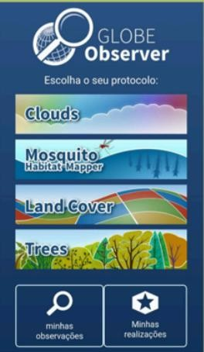
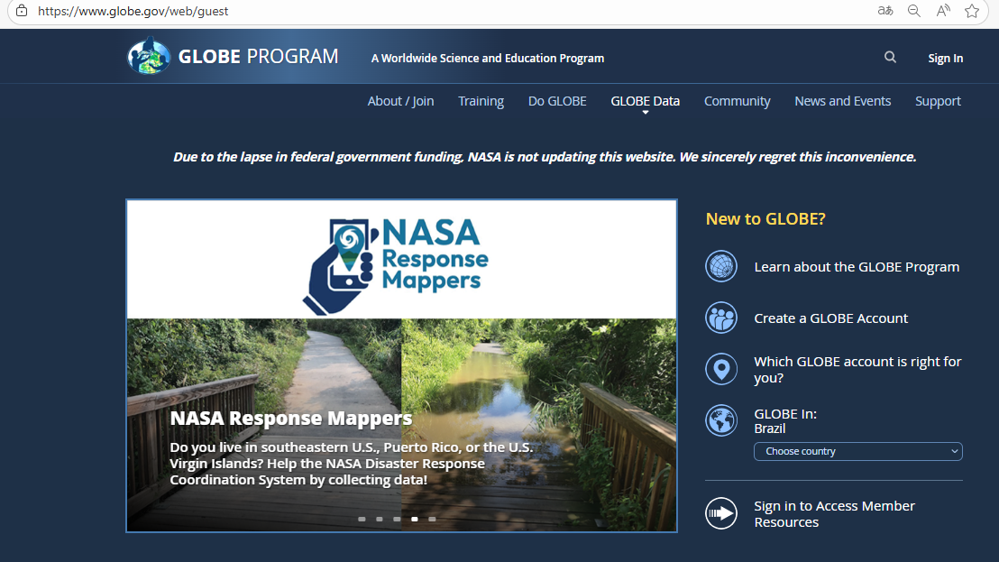
Source: Survey data (2025).

The collections were conducted in accordance with the official protocols of the GLOBE/NASA Program, ensuring methodological standardization, reliability, and international comparability of the data. All the information obtained was recorded and validated on the program's portal, favoring sharing with the global environmental monitoring network. The integration of this data into the educational environment stimulated the construction of scientific models representing the four spheres of the Earth system — atmosphere, pedosphere, biosphere, and hydrosphere — allowing students to transform empirical observations into concrete and interactive representations. This stage consolidated the investigative character of learning, strengthening youth protagonism and scientific literacy in the school context.

- Analysis of data/results
The application of scientific protocols from the GLOBE/NASA Program enabled students to experience the process of field-based scientific investigation, integrating observation, data collection, and representation through three-dimensional models. The activities addressed the four spheres of the Earth system, as well as an integrated representation of the planet as a dynamic system, fostering a contextualized understanding of environmental phenomena in the semi-arid region of Seridó Potiguar.

5.1 Atmosphere – Cloud Observation
Observations were conducted using the GLOBE Observer – Clouds application, which allowed the recording of cloud type, coverage, and altitude. The collected data indicated a predominance of cumulus and cirrus clouds during periods of lower humidity and higher solar incidence, particularly in the morning. Stratocumulus and nimbostratus clouds were identified during phases of thermal and moisture transition, indicating convective formations.

Table 1- Frequency of observed cloud types (n = 12 days)

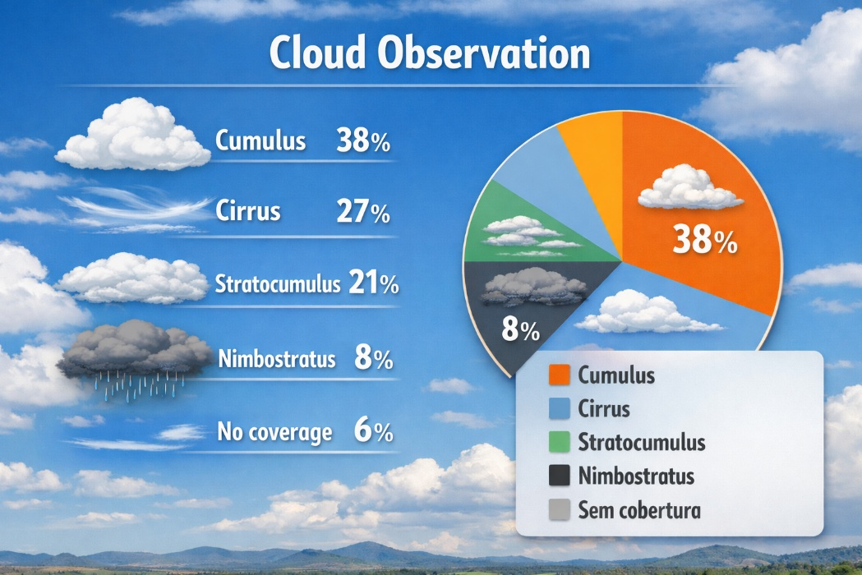
Fonte: dados do App Globe Observer dos pesquisadores (2025).

The activity expanded the meteorological perception of the students, promoting the understanding of the relationships between cloud formation, temperature and humidity. Special education students participated through oral descriptions and tactile models, ensuring accessibility and inclusion.

  - Pedosphere – Soil Analysis
Soil collections were divided between two areas: around the school and on the banks of the Barra Nova River, an area with higher humidity and vegetation cover. This strategy made it possible to compare textures, colorations and infiltration rates between different environments. The samples showed sandy to sandy loam texture, slightly acidic pH and low water retention in the most exposed areas. On the banks of the river, darker soil and higher moisture content were observed, evidencing the influence of vegetation and proximity to water.

Table 2. Frequency of observed cloud types (n = 12 days)
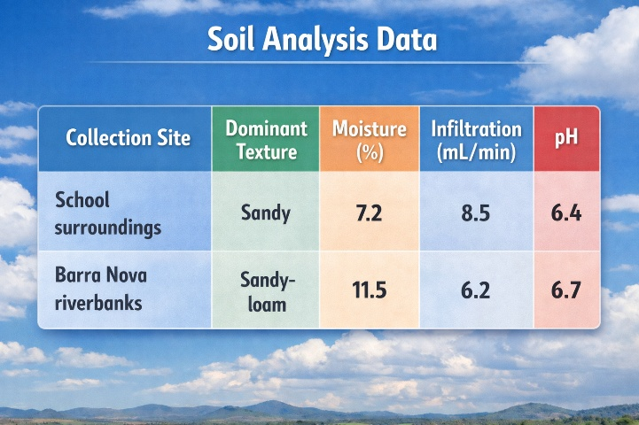
Source: survey data, 2025.

The representation of these data in three-dimensional soil profile models made it possible to visualize layers with different colorations, grain sizes, and moisture levels. Students who are part of the target group of special education participated in assembling the reliefs and gluing natural materials, reinforcing the inclusive character of the activity.

5.3 Biosphere – Tree Measurement
Within the biosphere protocol, students carried out measurements of height and diameter at breast height (DBH) of ten trees in the school surroundings, using a measuring tape and the GLOBE application. The observed species included juazeiro (Ziziphus joazeiro), algaroba (Prosopis juliflora), and umbuzeiro (Spondias tuberosa), all of which are adapted to the semi-arid climate.
The results indicated an average height of 4.8 m and a mean DBH of 0.23 m, values consistent with medium-sized species typical of the Caatinga biome.

5.4 Hydrosphere – Water Collection and Analysis
Water sampling was conducted at three sites: the school reservoir, a shallow well, and a stormwater channel. The physicochemical parameters measured—pH, turbidity, nitrite, and temperature—were analyzed in accordance with the official protocols of the GLOBE Program.
The results revealed slightly acidic pH values (6.2–6.8) and moderate turbidity in samples containing sediments, particularly in the stormwater channel.

Table 3 Average results of water samples in the City of Caicó-RN

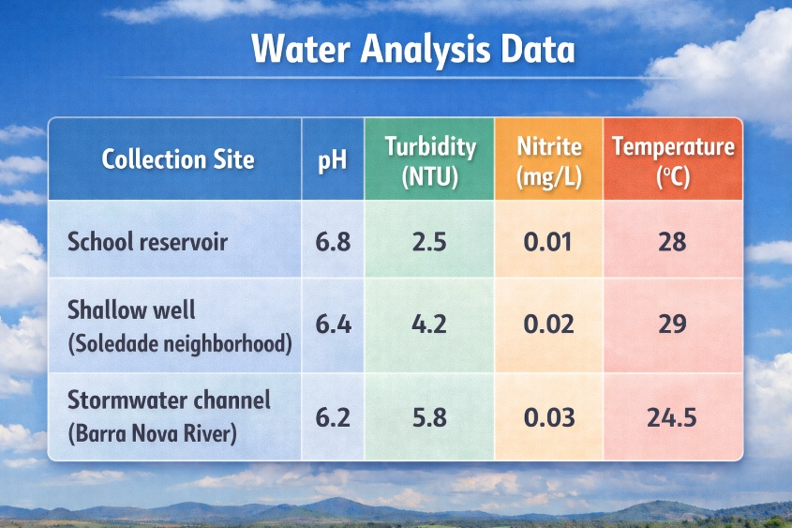

Source: survey data, 2025..

These results were recorded and sent to the official GLOBE portal, allowing the comparison of local data with those of other Brazilian schools. The visualization of the collection points on the world map reinforced the notion of belonging to a global citizen science network.

5.5. Integration of the Four Spheres in Three-Dimensional Models

The collected data were integrated into collective three-dimensional models, which represented in a visual and concrete way the interactions between atmosphere, pedosphere, biosphere and hydrosphere in the territory of the Seridó potiguar. The final model evidenced the direct relationship between vegetation cover and soil infiltration, demonstrating how the presence of vegetation contributes to water retention and moisture maintenance. He also highlighted the influence of humidity conditions and cloud formation on the region's water availability, evidencing the interdependence between the elements of the Earth system. In addition, the activity made it possible to understand the importance of sustainable management of natural resources and to identify the presence and effects of human actions on the environment, stimulating reflection on possible strategies to mitigate environmental impacts. The Figure 2 shows images of the models, both of soil, clouds, and trees.

Figure 2 – Demonstration of the models by the different Globe protocols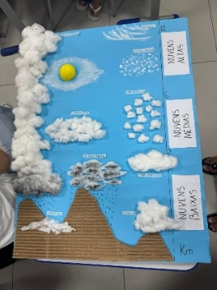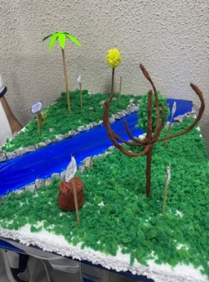
Source: survey data, 2025

The students used recyclable materials and raised textures to represent the interactions among soil, water, vegetation, and atmosphere, highlighting the role of vegetation cover in soil retention, thermal regulation, and the maintenance of local environmental balance. The resulting three-dimensional models were exhibited at the school and at the 10th DIREC Fair in Caicó, Rio Grande do Norte, and will be part of the National GLOBE Brazil Program Fair, functioning as instruments of visual synthesis, scientific communication, and educational inclusion. Throughout the process, students demonstrated increased engagement, curiosity, and a sense of belonging, as they recognized their territory scientifically represented through environmental modeling.
6. Discussion
The results obtained from the application of the scientific protocols of the GLOBE NASA Program, articulated with scientific modeling through three-dimensional models, reveal the potential of this pedagogical practice for science education in the semi-arid context of the Seridó Potiguar region. The adopted methodology promoted inquiry-based and collaborative learning, allowing students—including those from special education—to understand in a concrete manner the interrelationships among the elements of the Earth system.
Within the atmosphere protocol, cloud observation and classification using the GLOBE Observer – Clouds application fostered the development of students’ meteorological perception, enabling the identification of relationships among cloud cover, temperature, and air humidity. According to Santos and Lima (2022), understanding local atmospheric dynamics is essential for the construction of ecological citizenship, especially in socio-environmentally vulnerable regions such as the semi-arid zone. The activities contributed to linking everyday climatic phenomena with scientific study, strengthening a critical and contextualized view of the environment.
In the pedosphere protocol, the comparative analysis of soils collected in the school surroundings and along the banks of the Barra Nova River enabled discussion of the impacts of land use and occupation on infiltration and moisture retention. The differences observed between the two environments reinforced the importance of vegetation for water resource conservation and local ecological balance. This stage also enhanced collaborative work, allowing students to correlate science and territory, in line with Carvalho (2021), who advocates a critical and emancipatory environmental education in which students recognize themselves as agents of socio-environmental transformation.
Within the biosphere protocol, measurements of tree height and diameter in the school surroundings led to an understanding of the relationship among vegetation, climate, and soil. The recognition of typical Caatinga species, such as juazeiro and umbuzeiro, stimulated dialogue on the importance of local biodiversity and sustainable practices in caring for the biome. The integration of empirical observation and three-dimensional representation fostered student protagonism by transforming field data into concrete scientific representations.
The hydrosphere protocol enabled the analysis of water quality at different sites in Caicó, Rio Grande do Norte, promoting reflections on the relationship among pH, turbidity, and water pollution. Data collection and recording on the GLOBE Program portal brought students closer to authentic scientific investigation practices, allowing comparisons with results from other schools. This process reinforces the citizen science perspective highlighted by Bonney et al. (2016), which views collaborative data production as a means of social engagement and strengthening scientific literacy.
The integration of the four Earth spheres through three-dimensional models consolidated learning by transforming empirical observation into visual and tactile representations of environmental phenomena. This strategy contributed to the effective inclusion of students from special education, who were able to interact with diverse textures, reliefs, and forms. As argued by Mantoan (2015), inclusive practices require methodologies that consider different forms of expression and knowledge acquisition, ensuring equity. The use of models also enabled interdisciplinarity among Science, Geography, Arts, and Technology, corroborating Azevedo and Oliveira (2020), for whom inquiry-based teaching should involve multiple languages and stimulate creativity in problem solving.
Students used recyclable materials and raised textures to represent environmental interactions, emphasizing the role of vegetation in soil retention and local thermal balance. The models were presented at a school event, at the 10th DIREC Fair in Caicó, Rio Grande do Norte, and will be presented at the National GLOBE Brazil Program Fair, functioning as instruments of visual synthesis, scientific communication, and the valorization of student authorship. The public exhibition of the works represented not only the culmination of investigative activities but also a moment of recognition of identity, creativity, and youth protagonism. This participatory dimension reaffirms Freire’s (1996) view that emancipatory education is realized when learners recognize themselves as authors of their own knowledge and as agents of collective transformation.
Finally, it is emphasized that the proposal aligns with the Sustainable Development Goals (SDGs), particularly SDG 4 (Quality Education), SDG 13 (Climate Action), and SDG 15 (Life on Land) (United Nations, 2015). By integrating environmental observation, technology, inclusion, and public communication of knowledge, the project reaffirms the role of the school as a strategic space for educating critical, conscious, and sustainability-committed citizens.
Thus, it is confirmed that pedagogical practices based on active methodologies, citizen science, and accessibility are capable of transforming science education into a concrete, interdisciplinary, and socially meaningful experience, strengthening scientific culture and the bond among school, territory, and community.
7. Conclusion
Observations conducted using the GLOBE Observer application enabled an integrated understanding of the elements that compose the local environment, particularly regarding the interrelationships among soil, vegetation cover, and water resources. The comparison between areas near the school and the banks of the Barra Nova River revealed significant differences in soil composition and moisture, reflecting distinct land uses and the impacts of human activities on local ecosystems. These results reinforce the relevance of contextualized environmental investigations that bring science closer to students’ daily lives and strengthen critical environmental education practices (Brasil, 2018).
As highlighted by Jacobi (2005), the incorporation of investigative practices in the school environment, associated with direct observation and the use of digital technologies, stimulates student protagonism and fosters ecological awareness grounded in socio-environmental responsibility. From this perspective, experiences such as the one developed in this study contribute not only to the development of scientific and investigative competencies but also to the formation of ethical and sustainable values oriented toward care for the territory and environmental citizenship.
Accordingly, the use of GLOBE Observer was consolidated as an effective pedagogical tool for science education, promoting active student engagement in authentic, interdisciplinary scientific investigation practices connected to local realities. The results and three-dimensional models produced were presented at the 10th DIREC Fair in Caicó, Rio Grande do Norte, and will be presented at the National GLOBE Brazil Program Fair, highlighting the potential of public schools as spaces for knowledge production and scientific dissemination. The experience reaffirms the potential of integrating education and citizen science as a transformative strategy for meaningful learning and for advancing the Sustainable Development Goals—especially SDG 4 (Quality Education) and SDG 13 (Climate Action)—in alignment with the United Nations 2030 Agenda (United Nations, 2015).

References

AZEVEDO, C. R.; OLIVEIRA, L. A. A modelagem científica como estratégia para o ensino de ciências: uma abordagem investigativa e interdisciplinar. Revista de Ensino de Ciências e Matemática, v. 11, n. 4, p. 51–69, 2020. DOI: https://doi.org/10.26843/rencima.v11i4.3021.
BONNEY, R. et al. Next steps for citizen science. Science, v. 343, n. 6178, p. 1436–1437, 2014. DOI: https://doi.org/10.1126/science.1251554.

BONNEY, R.; PHILLIPS, T. B.; BALLARD, H. L.; ENCK, J. W. Can citizen science enhance public understanding of science? Public Understanding of Science, v. 25, n. 1, p. 2–16, 2016. DOI: https://doi.org/10.1177/0963662515607406.

BRASIL. Base Nacional Comum Curricular: Educação é a base. Ministério da Educação, 2018. Disponível em: http://basenacionalcomum.mec.gov.br. Acesso em: ___ ___ ___.

CARVALHO, I. C. M. Educação ambiental: a formação do sujeito ecológico. 9. ed. São Paulo: Cortez, 2021.

FREIRE, P. Pedagogia da autonomia: saberes necessários à prática educativa. São Paulo: Paz e Terra, 1996.

GUIMARÃES, M. Educação ambiental crítica: diálogos com Paulo Freire. Campinas: Papirus, 2020.

JACOBI, P. Educação ambiental, cidadania e sustentabilidade. Cadernos de Pesquisa, v. 35, n. 118, p. 189–205, 2005. DOI: https://doi.org/10.1590/S0100-15742005000100010.

LOUV, R. A última criança na natureza: resgatando nossas crianças do transtorno do déficit de natureza. São Paulo: Aquariana, 2019.

MANTOAN, M. T. E. Inclusão escolar: o que é? por quê? como fazer? São Paulo: Moderna, 2015.

NASA. The GLOBE Program: Global Learning and Observations to Benefit the Environment. NASA Earth Science Division, 2023. Disponível em: https://www.globe.gov. Acesso em: ___ ___ ___.

NASA GLOBE. GLOBE Observer App: protocols and learning resources. NASA, 2024. Disponível em: https://observer.globe.gov. Acesso em: ___ ___ ___.

NEWMAN, D. L.; CATAVERO, C. M.; WRIGHT, L. K. Physical models can provide superior learning opportunities in biology. CBE—Life Sciences Education, v. 11, n. 4, p. 389–401, 2012. DOI: https://doi.org/10.1187/cbe.12-04-0036.

OLIVEIRA, M. A.; SANTOS, P. R.; SOUZA, V. T. Educação científica e sustentabilidade no semiárido: perspectivas para o ensino de ciências em contextos locais. Revista Brasileira de Educação Ambiental, v. 17, n. 2, p. 233–250, 2022. DOI: https://doi.org/10.34024/revbea.2022.v17.14312.

SANTOS, A. C. P.; LIMA, J. R. S. Educação ambiental e protagonismo juvenil no semiárido: caminhos para a sustentabilidade. Revista Educação e Contemporaneidade, v. 31, n. 63, p. 1–16, 2022. DOI: https://doi.org/10.21879/faeeba2358-0194.

SANTOS, R. S. Educação inclusiva e ensino de ciências: desafios e possibilidades para o público-alvo da educação especial. Revista Educação, v. 46, n. 1, p. 25–38, 2021. DOI: https://doi.org/10.22456/1982-7199.116704.

SILVA, T. J.; PEREIRA, F. M. Ciência cidadã e engajamento ambiental: práticas colaborativas no ensino médio. Revista de Ensino de Ciências e Tecnologia, v. 16, n. 3, p. 1–17, 2023. DOI: https://doi.org/10.3895/rencima.v16n3.11234.

UNITED NATIONS. Transforming our world: the 2030 Agenda for Sustainable Development. New York: United Nations, 2015. Disponível em: https://sdgs.un.org/2030agenda. Acesso em: ___ ___ ___.

VALEEVA, R.; SAKHIEVA, R.; SHTYLEVA, I. Exploring the impact of modeling in science education: a systematic review. Journal of Science Education and Technology, v. 32, n. 2, p. 123–138, 2023. DOI: https://doi.org/10.1007/s10956-022-09984-7.

