Assessing the Effects of Surface Temperature and
Tree Coverage in Select Suburban Parks

Student Researchers:
Yasmina Abbas, Marwa Aidibi, and Zainab Zaidan

School:
Crestwood High School, Dearborn Heights, MI 48127

High School Teacher:
Diana Johns

March 11, 2022

Table of Contents

Abstract ………….…..………………………………………………………………………………… 3

Research Question ………………………………………………………………….………………….. 3

Null Hypotheses ………………………………………………………..……………………………… 4

Introduction and Review of Literature ……………………………………………………….………... 5

Research Methods ………………………………………………………………………………….. 8 - 9

Results ………………………………………………………………………………………..….. 10 - 14

Discussion ……………………………………………………………………………………..… 14 - 16

Conclusion ………………..……………………………………………………………………… 16 - 17

Submitting GLOBE Data Verification ……………………………………………………………..… 18

Citations ………………………………………………………………………………………………. 18

Acknowledgments …………………………………………………………………………….……… 19

Badges ………………………………………………………………………………………..………. 19

Abstract:
Parks are a significant and positive addition to any urban area for their recreational use and as places where families can gather in groups to enjoy the outdoors. This research focused on examining the relationship between tree height, tree circumference, and their relationship to surface temperature. An iPhone with the GLOBE Observer Trees App was used to measure tree height and a DBH (diameter breast height) measuring tape allowed tree circumference to be determined. A digital infrared thermometer and a GLOBE AREN TerraROVER were both used to determine surface temperatures at two suburban parks in Dearborn Heights, Michigan. Ten trees per park were measured and the highest and lowest surface temperatures were determined. Temperature data was collected in both July and October. The TerraROVER 2 was used at both parks to determine GPS, surface temperature, and air temperature. The TerraROVER is much like the Mars Rovers in that it is remotely controlled and simultaneously measures both GPS locations and surface temperature. All of our data suggests a clear relationship between tree height/circumference and surface temperatures. There were significantly lower surface temperatures in areas under largely shaded trees as compared to areas where there was no shade or tree coverage. To increase the quality of use in parks during the summer, it is essential to decrease surface temperatures to create ambient air temperatures that people want to be outside in. Each of the two parks that were assessed need to have more native trees planted as soon as possible. Many of the more desirable native tree species that should be planted grow slowly so to create a cooler environment for recreating users, it is essential to plant these trees sooner rather than later.
Key Words: surface temperature, TerraROVER 2, suburban parks, tree height, tree circumference

Research Question:
To what extent does tree coverage play a role in affecting the surface temperatures of two (2) local suburban parks.
To what extent might this affect the park experience of guests in Dearborn Heights, Michigan?
Null Hypotheses:
- Tree coverage does not affect surface temperatures or play a role in the quality of a park.
- There is no significant difference in surface temperature data collected at Site 1 (Central Park) and Site 2 (Van Houten Park).
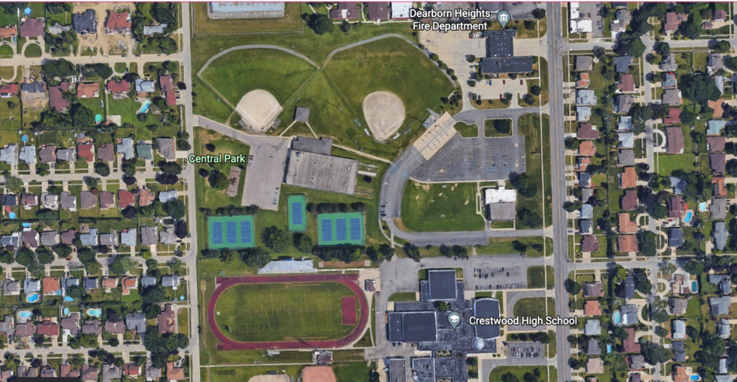

Figure 1a: Site Visualization. The location on the satellite image shows Site 1 (Central Park). This site is located by a school, tennis courts, and baseball fields. The majority of the trees that data was collected on are located by the tennis courts where there is a playground and picnic area.
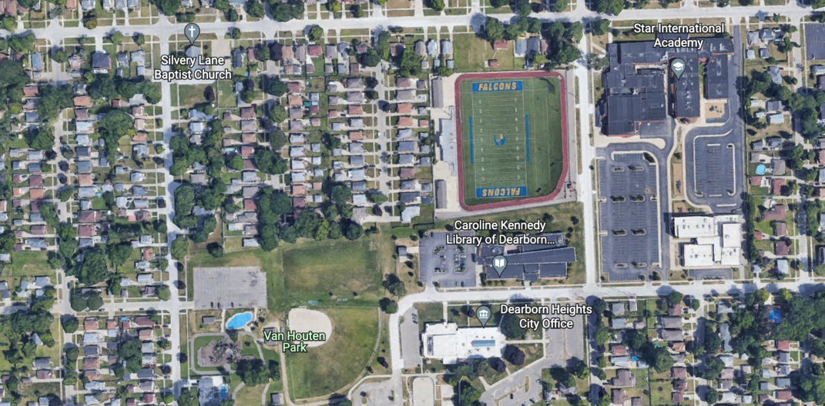

Figure 1b: Site Visualization. The location on the satellite image shows Site 2 (Van Houten Park). The park is located near a public library, a football field, and a school. The majority of the trees that data was collected on were near a popular playground and splash pad.

Introduction and Review of Literature:
Throughout the past few decades, many public parks have grown less popular in the summer. Most families prefer to be inside where there are constant temperatures with air conditioning and no insects to bite them. Although parks in our area are still used for baseball and soccer tournaments, fewer families are picnicking. It's clear the parks we’ve grown up around have become less visited for family and group celebrations. As temperatures rise with climate change, the role of trees has become increasingly important in preserving the usage of the parks we’ve known and loved for so long. Despite trees being known for their most important role, acting as carbon sinks, they also hold another important feature related to cooling, decreasing surface temperatures with their large canopies of beautiful leaves. Especially during the warmer summer months, trees grow huge blanket-like covers with their leaves that help cool the areas in direct sunlight and make a park visit more enjoyable for those hoping to spend a day with family and friends outdoors. In recent years, park trees have been cut down, ignored, or, most importantly, planted in areas that do not maximize their potential to decrease surface temperatures. In our research, we analyzed how much the shade trees provide changed the temperature of the ground, and how this could positively affect the usage of parks. In recent years, trees have been planted and evaluated in terms of aesthetics, valuing neat rows of trees, all of which are the same species. Although some may consider this visually pleasing, it does not follow the pattern typically found in natural ecosystems. Native trees planted in response to local soil types and moisture are better ways to mimic nature and this would help the trees to thrive and at the same time provide much needed habitat for local organisms. Planting a variety of different native tree species also helps if there is an outbreak of disease or an invasive species that decimates a particular type of tree. Tree diversity also takes into account that each species has a different form that can provide valuable shade in specific areas of the park. Oftentimes, larger trees at parks that are actually providing shade are not well maintained and are left to die and decay. The loss of these large trees reduces a major benefit of trees as “providing aesthetic beauty for residents” (Pandit, Polyakov, and Sadler). Poor yearly maintenance also makes trees more susceptible to storm breakage and this further reduces the opportunity to reduce surface temperatures. In an article by Herbert Schroeder, “Public Preference For Tree Density In Municipal Parks”, Schroeder writes that “To prevent serious losses in future landscape value, park managers need to evaluate the condition of trees in their parks and to replace those trees expected to die over the next few years. To prevent significant loss of the park's tree cover, tree replacement should begin several years before the older trees actually die” (Schroeder and Green). The planning of how space is utilized in parks should not only focus on the present but also the future and how we will need to rely on the shade provided by trees in subsequent years. According to “Large Trees Are Keystone Structures in Urban Parks,” researchers argue “if large trees are keystone structures in urban parks, it is imperative that this is recognized in policy to ensure their ongoing existence.” (Stagoll, Lindenmayer, Knight, Fischer, and Manning). Overall, the main focus should be on trees, especially native trees, and how they can be utilized to reduce urban temperatures.
Key Words: urban parks, global heating effect, climate change, surface temperature, native trees
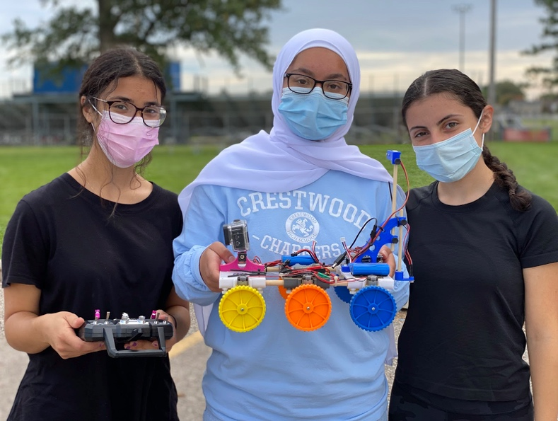
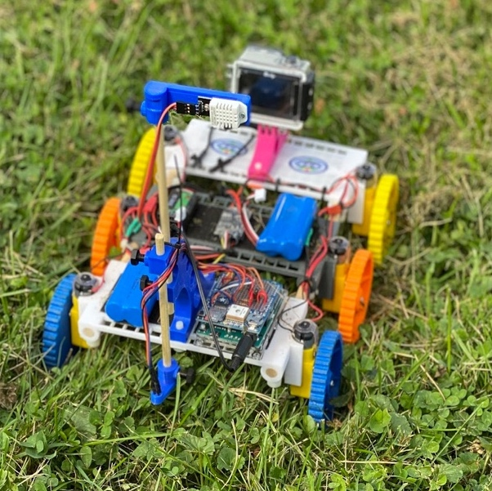

Figure 2: TerraROVER. The picture on the left shows the TerraROVER that was provided to student researchers through the GLOBE NASA AREN Project. On the right, student researchers, Marwa Aidibi, Zainab Zaidan, and Yasmina Abbas showcase the ROVER and its remote control.

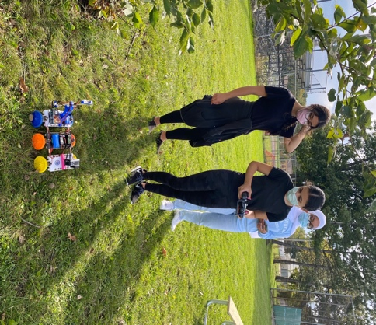
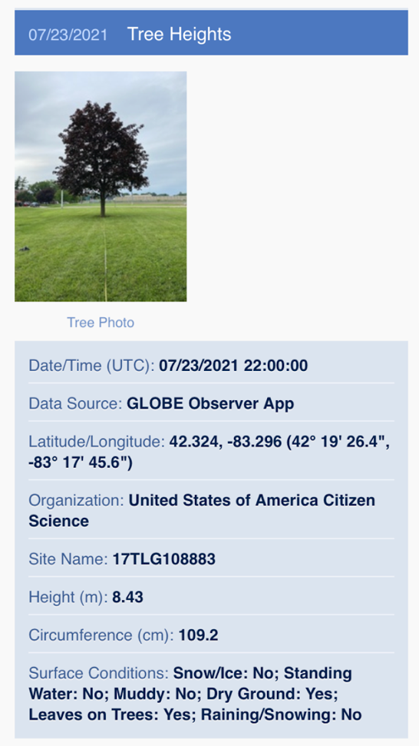

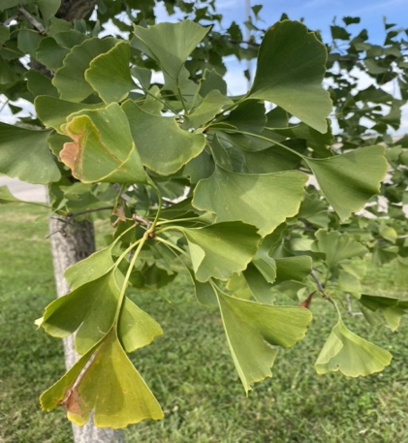

Figure 3: Visiting Sites. The picture on the left is the GLOBE Observer App: Trees. This software allows for the calculation of tree heights by following GLOBE Tree Observer protocols. It also automatically takes into account date, time, absolute location, and allows student researchers to include any extra information such as circumference, surface conditions, and a tree photo. The picture on the top right is of student researchers collecting data using the TerraROVER 2. The picture on the bottom right is of a Ginkgo Biloba (Maidenhair) tree at Site 1 (Central Park), which is, unfortunately, a tree that is nonnative to Michigan, which highlights the need for native trees to be planted.

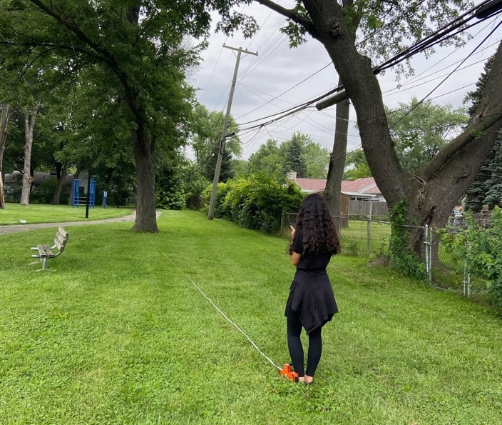

Figure 4: Tree Heights. Here, student researcher, Marwa Aidibi, stands 50 feet away from the tree (as per GLOBE protocol) to calculate the tree height using the GLOBE Observer App.
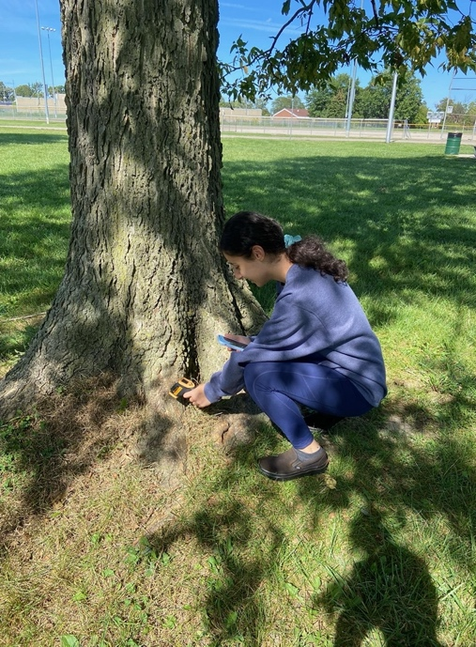
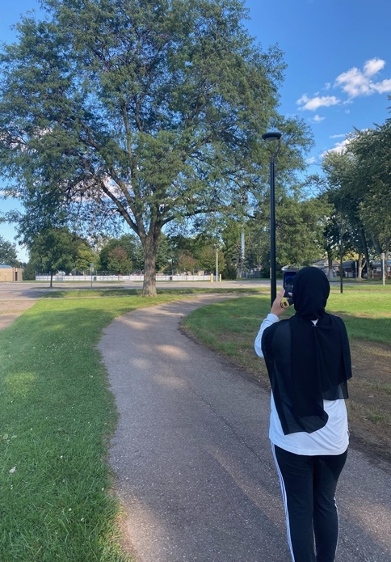
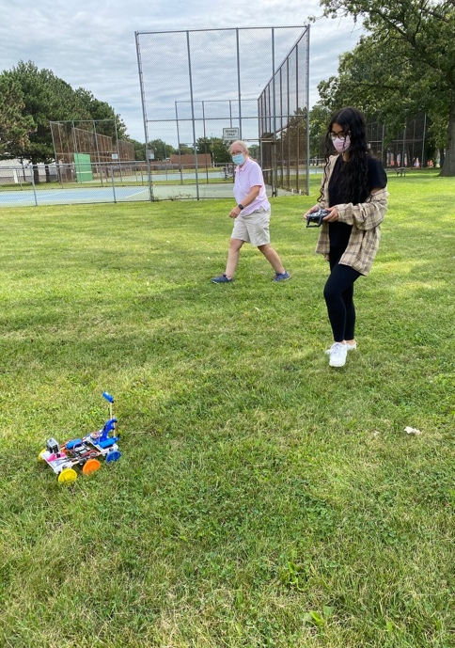
Figure 5: Collecting Data. The picture on the far left shows a student researcher, Zainab Zaidan, collecting tree data using GLOBE protocols. In the middle, student researcher, Marwa Aidibi, is using the TerraROVER 2 to collect surface temperatures at Site 1 (Central Park). On the right, student researcher, Yasmina Abbas, calculates the infrared temperature of a tree at Site 2 (Van Houten Park).

Research Methods:

Throughout Summer 2021, a variety of atmospheric and biometry data was collected at three (3) different locations in Dearborn Heights, MI. The 3 parks we chose were Central Park, Van Houten Park, and Richard A. Young Center, all of which are common areas for visitors to ride bikes, picnic, and spend time with families and friends. Unfortunately, due to technological issues, the data from Site 3 (Richard A. Young Center) was corrupted. Due to this, it was necessary to exclude Site 3 and focus on Site 1 and Site 2. The two (2) largest parks in North Dearborn Heights, MI (Van Houten Park 7,404.47 m² and Central Park 6,504.96 m²) were selected for this research due to their proximity to the homes of many families who reside in our school district. The area of each site was determined using the Google Earth web-based application. Both parks have a playground and 2 have tennis courts/baseball fields, however, these recreational areas are not placed in a way that utilizes pre-existing tree coverage. Using tape measures, GLOBE observer application, and an infrared thermometer, we calculated the approximate tree height and surface temperature of 10 trees at each park over multiple days across the months of July-September. By October 2021 we gained access to a TerraROVER 2 which collected exact GPS location and surface temperature in a more efficient way. The TerraROVER (Terra Remotely Operated Vehicle for Education and Research) is designed for work with grassy, rocky, cemented, terrain. Developed by NASA and part of AREN (AEROKATS & ROVER Education Network), the ROVER allows for the collection of data in a precise and accurate way.
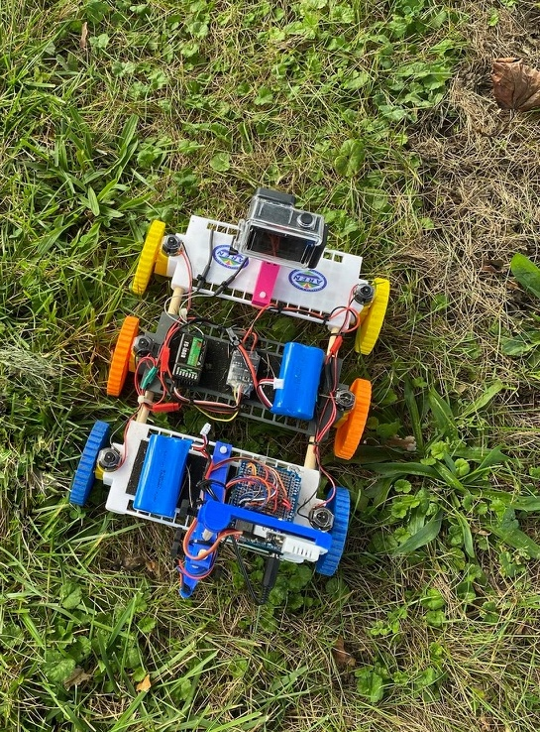
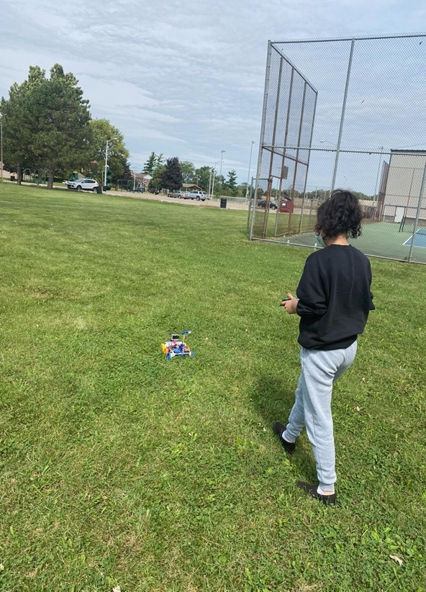
Once the data from the TerraROVER 2 was collected, it was transferred into the software CODAP (Common Online Data Analysis Platform), which gave access to graphical interpretations, maps, etc, of the data we had collected over 3 hours. Multiple graphs were made in order to compare the correlation between surface temperature and air temp/location/time/etc.

Figure 6: The photo on the left is of student researcher, Yasmina Abbas, using the TerraROVER 2 at Site 1 (Central Park) The picture on the right shows an up-close picture of TerraROVER 2 that was used to collect data throughout the park locations.

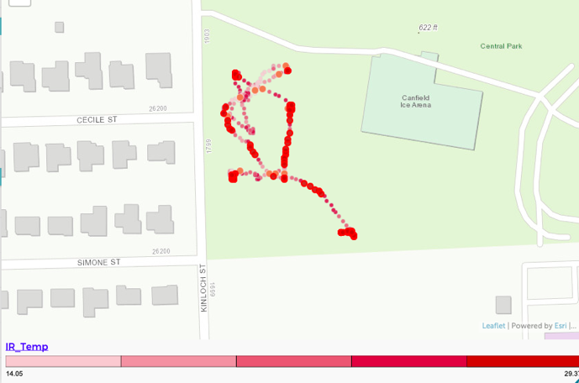
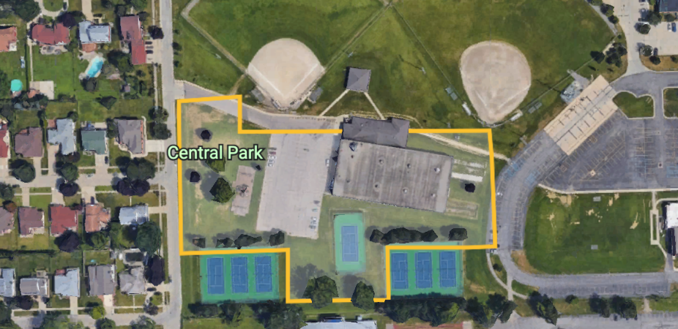
Figure 7a: Satellite Area. These two photos show the location of Site 1 (Central Park) and more specifically where the trees were located and where the data was collected using TerraROVER 2 and CODAP.

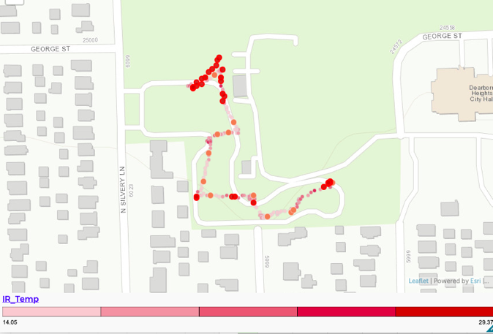
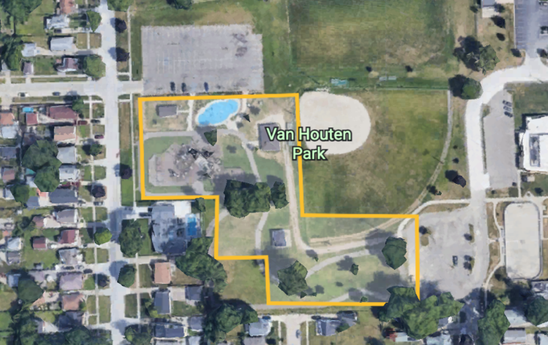
Figure 7b: Satellite Area. These two photos show the location of Site 2 (Van Houten Park) along with the exact area where data was collected and compared.

Results:
Throughout the summer, data was collected numerous times to ensure validity and to reduce errors. The usage of the TerraROVER 2 coupled with our manual infrared thermometer allowed for the isolation of the most significant data to create numerous graphs that granted that ability to analyze and interpret the data. When gathering surface temperatures from a large area, the Terra Rover 2 was superior in its ability to quickly gather large amounts of data.

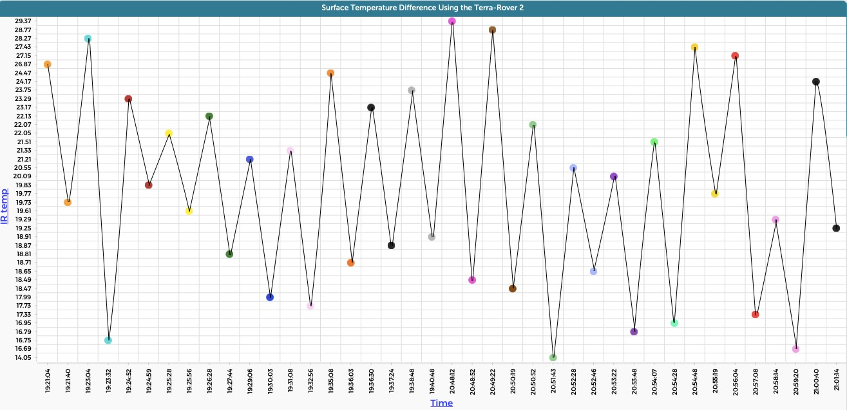

Figure 8: Using the software CODAP, the drastic difference in surface temperatures between the unshaded region of the trees and the shaded region could be completely visualized. On the vertical axis is the infrared thermometer data that was collected using the TerraROVER, and on the horizontal axis is the time of collection. Each coordinating pair of color-coded dots represents a tree that data was collected on, with the higher dot being the unshaded region, and the lower dot being the shaded region (eg: the first pair of orange dots represents one tree, in order of unshaded temperature first, then shaded temperature. The pattern continues for each coordinating pair of same-color dots). This graph allows for a graphical representation of the major difference between the surface temperatures, with each dip indicating the difference between the unshaded and shaded regions.
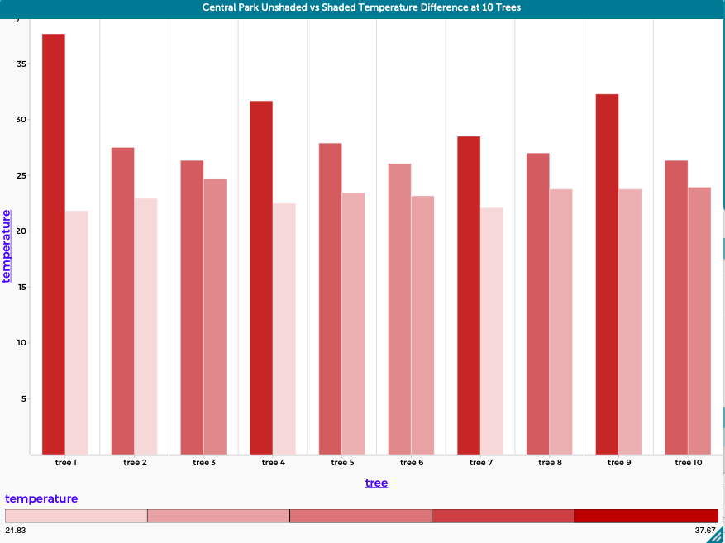

Figure 9a: In this image, the graph of the “Central Park Unshaded vs Shaded Temperature Difference at 10 Trees” indicates the surface temperature difference (in Celsius) of each tree that data was taken on at Site 1 (Central Park). This data was collected manually using the surfacing temperature gun, and the bar graph compares the unshaded area of each tree (the higher peak) to the shaded area of each tree (the lower peak).

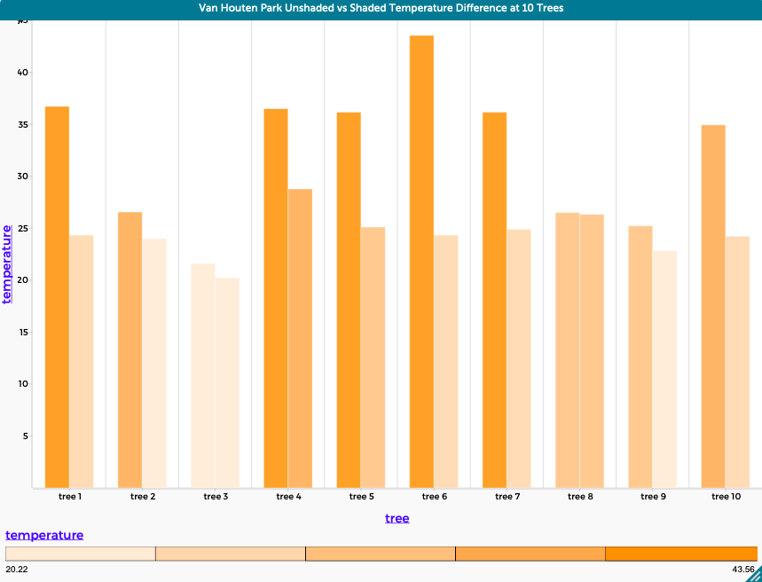

Figure 9b: In this image, the graph of the “Van Houten Park Unshaded vs Shaded Temperature Difference at 10 Trees” indicates the surface temperature difference (in Celsius) of each tree that data was taken on at Site 2 (Van Houten Park). This data was also collected manually using the surfacing temperature gun, and the bar graph compares the unshaded area of each tree (the higher peak) to the shaded area of each tree (the lower peak). Together, Figures 9a and 9b relate the manually calculated surface temperature difference to the surface temperatures collected by the Terra-Rover in Figure 8, using various types of graphs (bar and scatter plot) to compare the data.
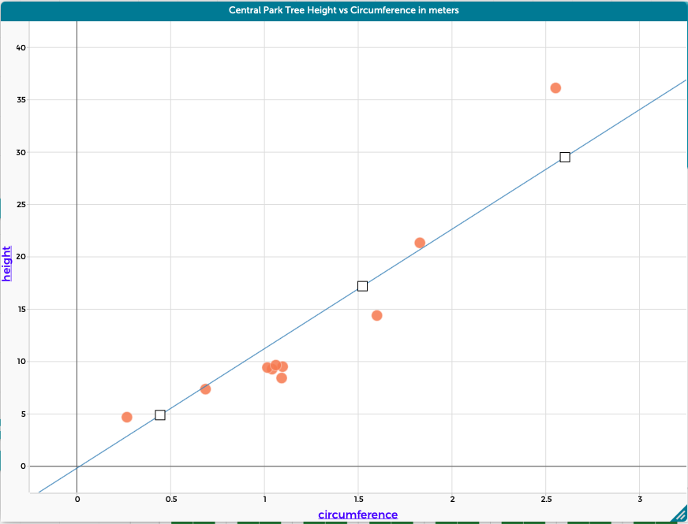

Figure 10a: The scatter plot above depicts a positive correlation between the height (in meters) of the trees at Central Park and their circumference (in meters), as tree circumference increases, so does the height. Taking into account the fact that trees with a larger circumference usually indicates an older tree, this data allows us to state that older trees are generally taller and larger.
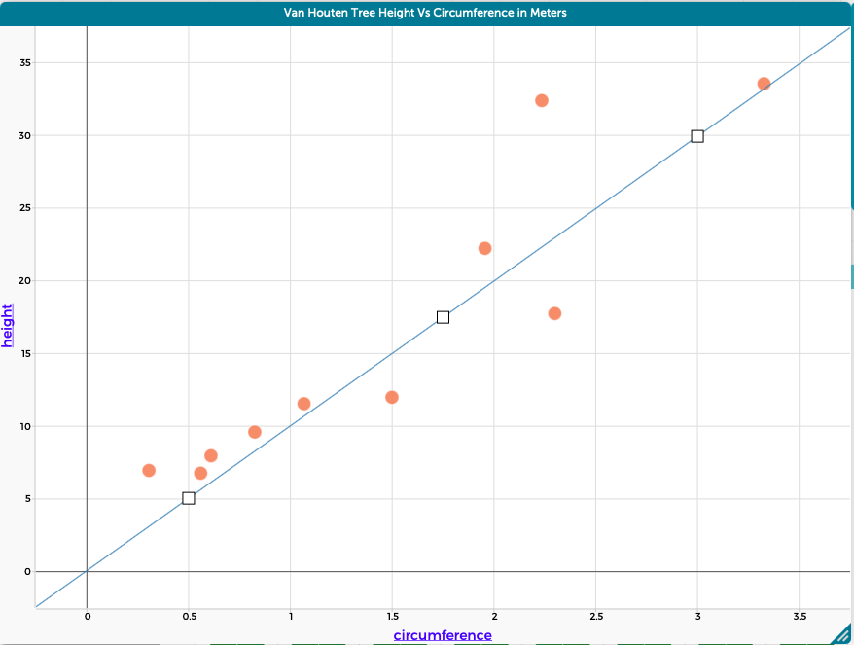

Figure 10b: The scatter plot above of the Van Houten Park tree height and circumference (in meters) also indicates a positive correlation between the two calculated values. Using the data from both sites, it is reasonable to conclude that wider trees are oftentimes larger and taller.

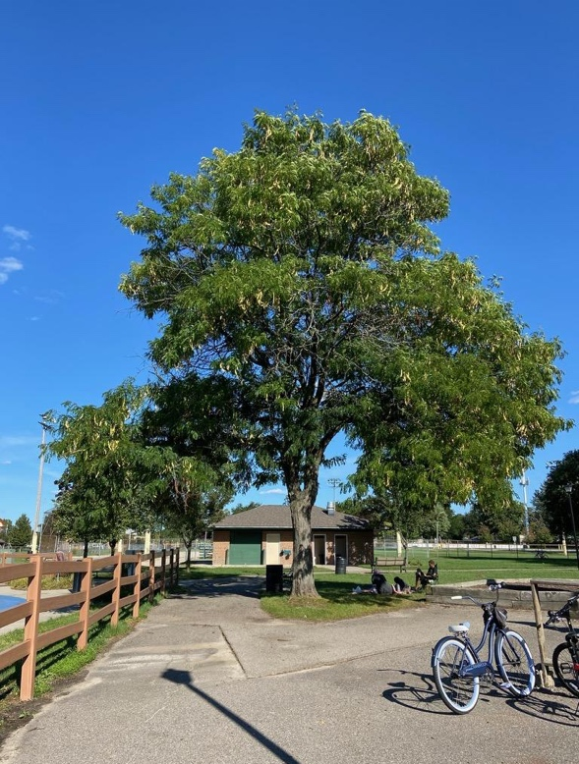

Figure 11a: Large Tree. As shown above, tree 1 at Van Houten Park is a tree that has both a large circumference and a large height.

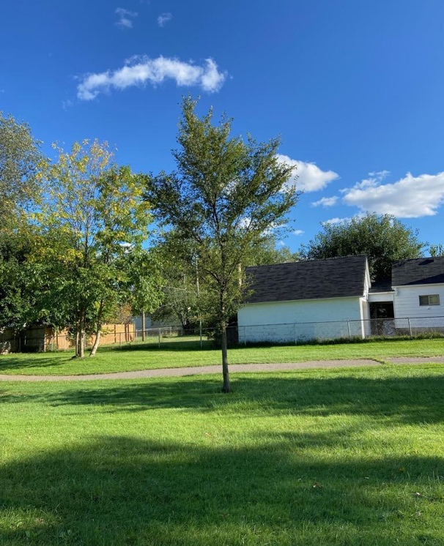
Figure 11b: Small Tree. As shown above, tree 3 at Van Houten Park is a tree with both a small circumference and a small height.

Discussion:
Through the findings made during the period that data was collected, the urgency of the issue at hand has become increasingly apparent. Unlike many other issues, climate change is not one that should or can be ignored. As depicted in Figures 8, 9a, and 9b, the trees’ natural ability to shade and decrease the temperature of the regions near each tree is extremely significant, with the difference as the drastic dips in temperature between the unshaded and shaded regions highlights the need for tree coverage. Furthermore, the graphs of Figures 10a and 10b depict a major aspect related to tree coverage, the canopy of the trees. In general, through the data of tree circumference and height that was calculated, there was a clear correlation between the two variables: as circumference increased, the height also showed a noticeable increase. Furthermore, trees with larger circumferences and heights are mainly older trees, with larger canopies. Comparing the tree canopies of younger trees, such as that of Figure 11a, to those of older trees, such as that of Figure 11b, indicates that smaller, younger trees, have less of a surface temperature difference than taller, older trees. In Figure 11a, trees with larger canopies, are oftentimes those favored by park-goers. For example, in Figure 9a, the large tree shown is being utilized for its shade potential, as park guests gather around the tree to lounge and avoid the hot sun. On the contrary, Figure 11b shows a small, tiny tree that park guests do not favor. In Figure 9b, the tree labeled “tree 3” on the x-axis is the same tree shown in Figure 11b. As indicated in the graph of Figure 9b, tree 3 has little variation in the surface temperature difference between the unshaded and shaded area, due to the small canopy that tree 3 has, which offers very little, sparse shade.

In terms of solutions to the issue of rising surface temperatures due to climate change, the connection between tree heights and circumferences is crucial. It is much more beneficial to plant and care for trees that will reach greater sizes, than those that have smaller growth potential. Although larger trees could be planted, it is not cost-effective and could lead to stress in a mature tree. It is vastly more beneficial to focus on the conservation and care of existing trees and to create a program where trees are constantly be replaced as older trees when they are in decline.

Although the research conducted was done in an attempt to control the most variables possible, it is nearly impossible to conduct field research with no sources of error. Due to this, an acknowledgment of possible sources of error is necessary. One major source of error is transportation issues. In an ideal situation, data collected would’ve preferably been instantaneous, with two student researchers at two different parks, with two rovers, at the same time. However, due to our limited transportation opportunities, it was difficult to gather information at preferred times. Furthermore, the issue of limited resources comes into play, as ideally, we would've liked to have multiple rovers being used at the same time. Unfortunately, the cost of that would have surpassed our budget, and instead, one rover was used which caused surface temperatures to be acquired at different times of the day. In an ideal scenario, an unlimited budget and time would’ve been highly preferred. In the future, acquiring multiple surface rovers, and an increased amount of student researchers, would increase and improve the validity of the experiment.
Originally, the null hypotheses created prior to data collection indicated that (1) tree coverage neither affects surface temperatures nor plays a role in the quality of a park and (2) that there is not a significant difference between the data collected at Site 1 (Central Park) and Site 2 (Van Houten Park). The data collected indicates that the first (1) null hypothesis stated is rejected and that there is a connection between tree coverage, surface temperature, and the quality of a park. Contrastingly, the second (2) null hypothesis proved to be accepted, as there was not a major difference in the data collected at Sites 1 and 2. Throughout this research, the evidence that tree canopies heavily influence a park-goer’s experience illuminates the need for increased care for tree maintenance and preservation. The trend of increased temperatures in the unshaded regions compared to the decreased temperatures in the shaded region was highly prevalent and significant in its effect on the quality of a park visit; shaded regions are preferred, while unshaded regions are neglected.

Conclusion:
The data collected during Summer 2021 showed that the relative heights and circumferences of each tree had a positive correlation with the radius of tree coverage, as taller and wider trees often covered much larger areas than smaller, thinner ones. Using an infrared (IR) thermometer a notable difference in temperature was noted between areas in direct sunlight, such as the tennis courts and baseball fields, versus the areas that had more shade coverage, such as the picnic tables under trees (as noticed at Van Houten Park).

Later, the TerraROVER 2, created by NASA, was granted to our student research team by AREN, which heavily assisted in the efficiency of our research. The TerraROVER comes equipped with infrared sensors, GPS, etc, to allow for data of air temperature, surface temperature, longitude and latitude, and time to be recorded. Today, ROVERs are being used in more ways than ever before to allow for research to be done not only on solid ground but even bodies of water. The ROVERs are being constantly improved and even adapted in ways to allow for new types of data to be recorded, such as particulate matter.

It is suggested that park personnel consider placing picnic tables in cooler more shaded portions of the park to attract more local citizens to visit. If picnic tables were placed under trees, more shade would be provided, enhancing the visitor experience. As Sadler, a student at the University of Western Australia School of Agriculture and Resource Economics, stated, “These benefits could vary from providing aesthetic beauty for residents,” or especially a more enjoyable experience for park-goers. Planting more native trees is also incredibly beneficial for the environment. Audubon, an organization aimed to protect birds, states, “In addition to the reduced noise and carbon pollution from lawn mower exhaust, many native plants, especially long-living trees like oaks and maples, are effective at storing the greenhouse gas carbon dioxide.” In order for us to combat climate change properly, we must plant more native species versus nonnative plants, as we saw at Central Park. Along the curb of Central Park, we saw newly planted trees, and among further examination of the leaves, we found out that the tree was the Ginkgo biloba, or Maidenhair, which is a tree native to China. Most non-native trees do not provide the same ecosystem services as native trees. Native trees have coevolved with other local organisms like insects and mammals so there are a myriad number of strong interrelationships between them. In the future, we encourage parks to plant trees in areas where park-goers frequently like to stay. For example, if a family would like to have a picnic at their local park, they tend to find a shady part of the park, so they are not in direct sunlight. With many trees at local parks being cut down, there are fewer spots for people to enjoy their experience at the park, although trees are very crucial to parks.

Submitting GLOBE Data Verification:
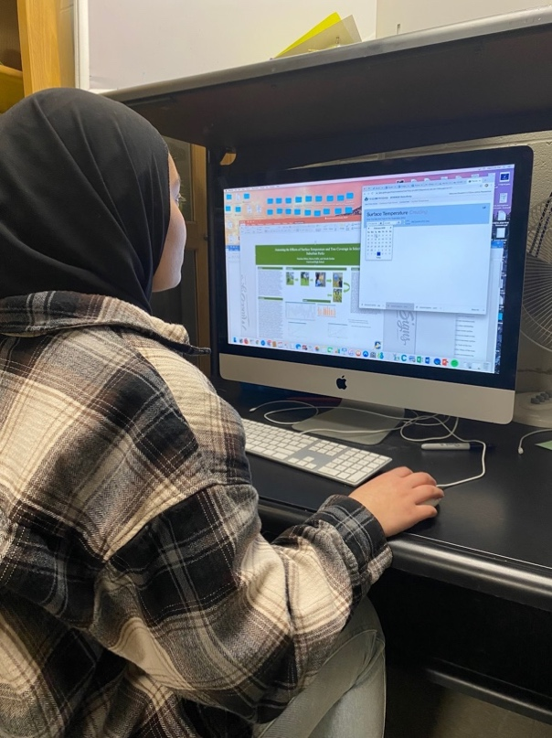

Student researcher, Zainab Zaidan, sits at the computer to submit our data for GLOBE verification.

Citations:
Almas, Andrew David. “Native Trees, Urban Forest Management Planning, and Residents: Knowledge, Attitudes, and Actions.” Department of Geography and Planning University of Toronto, 2017.
Pandit, Ram, et al. “The Importance of Tree Cover and Neighbourhood Parks in Determining Urban Property Values.” Australian Agriculture and Resource Economics Society, 7 Feb. 2012.
Schroeder, Herbert W, and Thomas L Green. “Public Preference For Tree Density In Municipal Parks.” Journal of Arboriculture, 11 Sept. 1985.
Stagoll, K, et al. “Large Trees Are Keystone Structures in Urban Parks.” Conservation Letters, 2012
“Why Native Plants Matter.” Audubon, 18 May 2017, https://www.audubon.org/content/why-native-plants-matter

Acknowledgments:
Thank you to the NASA Mission Earth Project coordinated by Dr. Kevin Czajkowski of the University of Toledo. Much of the equipment we utilized in our research was made available through this project. Thanks also to Mr. David Bydlowski and Mr. Andy Henry of the NASA AREN project for providing access to the TerraROVER 2 for collecting data. They were both always available to answer questions that helped guide our research. Thanks also to Mrs. Johns, for supplying for providing background information and helping us to focus our investigation.

Badges:
I Am A Data Scientist: Over the summer and fall, we collected data on surface temperatures and transferred our data onto the software system Common Online Data Analysis (CODAP). Using this data, we were able to compare the correlations between trees and their surface temperatures. Using CODAP and the GLOBE database we were able to create multiple graphs and draw conclusions about the urban heat island effect.

I Am A STEM Professional: We were assisted by STEM professional, Andy Henry, through an online meeting, who collaborated with us to increase of mastery of CODAP and to transfer our data from the TerraROVER 2 to our computer for analysis. Through his assistance, we were able to manage CODAP efficiently meanwhile analyzing our results.

I Make an Impact: Understanding the importance of tree placement is something that enhances the visitor’s experience when recreating at our local parks on hot days. The data we collected will be shared with our local parks and recreation department so that they are aware of “hot” spots that could use extra tree plantings. After speaking with some of the park visitors, we learned more people would our local parks if there were more trees to provide shade for their activities like picnics.

