Use of the Globe Observer in the georeferencing of fire outbreaks in São João do Sabugí/RN
Petrúlio Correia
Professor, Secretária Estadual de Educação e Cultura (SEEC- RN) Avenida Honório Maciel, 354 Centro. 59310-000 petruliocorreiarn@gmail.com

Inajá Silva de Lucena
Professor, Secretária Estadual de Educação e Cultura (SEEC- RN) Avenida Honório Maciel, 354 Centro. 59310-000 inaja.silva@gmail.com

Ana Lauane da Silva Lima Estudante, Escola Estadual Senador José Bernardo Avenida Honório Maciel, 354 Centro. 59310-000
Lauaneana7@gmail.com

Mirella Thuany de Araújo Medeiros Estudante, Escola Estadual Senador José Bernardo Avenida Honório Maciel, 354 Centro. 59310-000
mirellathuany@gmail.com

Ranyara Galdino dos Santos Estudante, Escola Estadual Senador José Bernardo Avenida Honório Maciel, 354 Centro. 59310-000
ranyaragaldino@gmail.com

Mona Lisa de Medeiros Silva Estudante, Escola Estadual Senador José Bernardo Avenida Honório Maciel, 354 Centro. 59310-000
monalisademedeirosmedeiros@gmail.com

ABSTRACT
In Brazil, burning is a cultural and economic practice historically incorporated into the country's productive and social dynamics. However, this practice, often legitimized by its tradition and apparent functionality, generates widely negative environmental, social, and economic impacts. The lack of adequate information among the population, coupled with insufficient oversight, application of penalties, and conflicts of interest between the public and private sectors, intensifies the occurrence of criminal burning and contributes to a scenario of environmental degradation, material damage, risks to public health, and irreversible ecological losses. In the municipality of São João do Sabugí/RN, this problem is also recurrent, manifesting itself in both rural and urban areas and directly affecting the quality of life of the local population. Given this context, this study aims to identify the factors that motivate the practice of burning in the municipality and analyze its socio-environmental impacts. To this end, quantitative and qualitative data collection instruments were used, including a questionnaire applied via Google Forms to the local population, in addition to information provided by official sources, such as the National Institute for Space Research (INPE) and the Globe Observer application. The latter contributed relevant data, obtained through temperature, cloud cover, precipitation, and relative humidity protocols, fundamental for understanding the environmental conditions related to heat sources. The analysis of the results allows for the identification of the main agents involved and a deeper understanding of the direct and indirect effects of this practice. By promoting an integrated approach between citizen science, technology, and environmental education, this study seeks to support prevention, monitoring, and awareness actions, strengthening public and institutional strategies aimed at combating wildfires and protecting the environment in the municipality of São João do Sabugí/RN.

KEYWORDS: wildfires; environment; protocols; Globe Observer; public health.

1. Research Questions / Research Problem
- What are the main socioeconomic and cultural factors that motivate the rural and urban population of São João do Sabugí, Rio Grande do Norte, to use burning as a land management practice?
- In what ways can temperature, cloud cover, precipitation, and relative humidity protocols contribute to either favoring or intensifying the occurrence of fires in the municipality?
- What impacts do fires have on air quality, public health, and the natural resources of the region?
- How does the local community perceive the consequences of fires, and which sustainable alternatives could be implemented to mitigate these effects?
Fires constitute a recurring phenomenon in several regions of Brazil, particularly in the Seridó Potiguar, where this practice remains frequent. Such activity is mainly associated with the clearing of agricultural areas and the disposal of solid waste in both rural and urban settings. In the municipality of São João do Sabugí (RN), the use of fire as a management tool continues to be a common practice, raising concerns regarding environmental, social, and public health impacts. The central problem lies in the need to understand fires resulting from anthropogenic action or omission, since they predominantly originate from human activities. According to data from the National Institute for Space Research (INPE), Brazil ranks third among South American countries with the highest number of fire hotspots. This reality also extends to the Seridó region, where the phenomenon is recurrent. From an environmental perspective, the typical climatic conditions of the semi-arid region—characterized by high temperatures, low relative humidity, and prolonged dry periods—significantly favor the spread of fire (Almeida et al., 2021).
The relevance of this study is grounded in the need to understand the interaction among the factors that influence the occurrence of fires within the specific context of São João do Sabugí (RN). It is observed that most of these events are caused by human actions, whether accidental or intentional. However, the climatic and environmental conditions characteristic of the region may intensify both the occurrence and propagation of fire (Barlow et al., 2020). Furthermore, from a social perspective, atmospheric pollution resulting from fire-related smoke directly affects public health, contributing to the worsening of respiratory diseases, especially among children and older adults. The community relevance of this research is significant, as its findings may provide support for the formulation of public policies aimed at prevention and environmental education, with an emphasis on replacing harmful practices with sustainable alternatives. In addition, the study has the potential to strengthen awareness-raising actions that value local knowledge and encourage practices compatible with the region’s socio-environmental conditions. Thus, the intention is to contribute to the promotion of environmental awareness and education as essential instruments for addressing and reducing fires and other associated illegal practices.

2. Introduction

According to the Federal Constitution of Brazil (1988, art. 225), everyone has the right to an ecologically balanced environment, considered a common good of the people and essential to a healthy quality of life, imposing upon the government and society the duty to defend and preserve it for present and future generations. Fires constitute a global environmental challenge and, at the same time, a practice deeply rooted in local contexts. In many regions of Brazil, such as the Seridó region, fire is used as a tool for agricultural management, land clearing, and the disposal of solid waste. However, both urban and rural fires have become a growing concern worldwide. Fires cause soil degradation, biodiversity loss, the emission of polluting gases, and risks to public health. In São João do Sabugí, Rio Grande do Norte, such practices are associated with the dry climate and anthropogenic activities, including the burning of household waste and the disposal of cigarette butts.
The absence of a specific municipal law for fire control and of systematized data hampers prevention and public management. Nevertheless, this does not prevent enforcement and punishment, since federal and state legislation establishes infractions and defines responsibilities related to the practice. Within this context, the GLOBE Observer application emerges as a citizen science tool, enabling the population to record and georeference fire hotspots, generating useful information in the form of data collected in the semi-arid region and promoting environmental education through citizen science applied to research and monitoring.

3. Theoretical Framework

Since fire was discovered and controlled by humanity, it has played a central role in the development of life on Earth and has become part of the culture of many societies. Fire constitutes one of the main agents of environmental transformation, whether used intentionally and in a controlled manner for soil renewal or when it spreads uncontrollably over large areas, with the potential to destroy or damage local vegetation. Whether intentional or not, fires cause significant environmental damage. One of the main consequences is the emission of aerosols and greenhouse gases into the atmosphere, such as carbon dioxide (CO₂), methane (CH₄), nitrous oxide (N₂O), as well as particulate matter—solid or liquid particles suspended in the air, including dust, soot, and smoke.
Fires are natural or anthropogenic events that can cause severe damage to affected areas, resulting in substantial economic, social, and environmental losses. Both urban and rural fires are a growing concern in many parts of the world, including Northeast Brazil. Although often associated with agricultural practices, the risks of this activity extend to public health, the environment, and even the local economy. In this context, understanding the consequences of such actions and adopting measures to prevent and mitigate their impacts is essential. Studies also indicate that environmental conditions in semi-arid regions—characterized by prolonged droughts and high temperatures—favor the spread of fire (Almeida et al., 2021). In addition, cultural practices transmitted across generations reinforce the use of fire as a traditional management tool (Mistry & Berardi, 2016).
Reflection on fires and their consequences, whether caused by human action or not, reveals that ecosystems are among the most negatively affected components. When fires originate from human activities, whether intentional or accidental, climatic and environmental conditions become decisive, as they create a favorable setting for uncontrolled fire spread, intensifying the resulting impacts. Although humanity has learned to control fire, there is an urgent need to educate its use in a conscious and responsible manner. Fire has been destroying fauna and vegetation, contributing to climate change, affecting human health, and threatening the survival of biodiversity as a whole. While fire has historically been a major ally in human progress, it has also become a significant problem for vegetation, wildlife, and the global climate.
Fires may also occur naturally in dry, arid, and semi-arid areas with vegetation. Under conditions of wind and low humidity, natural sparks may ignite fires that can, in some cases, reach large proportions. Anthropogenic fires are also common, particularly in rural areas, for pasture clearing or soil preparation for subsequent crops. When fires are caused by human actions, the risks are considerable, as changes in wind direction can spread sparks to other areas, initiating new fires that may become uncontrollable. Moreover, smoke degrades air quality not only in the affected areas but also in distant regions, as it is transported by air currents.
A significant proportion of fires originates accidentally from everyday practices carried out by the population. One of the most common examples is the incineration of solid waste, in which materials are improperly discarded and accumulated, leading to the burning of dry vegetation in vacant lots and urban areas with the intention of cleaning and reducing waste volume (Da Silveira, 2020).

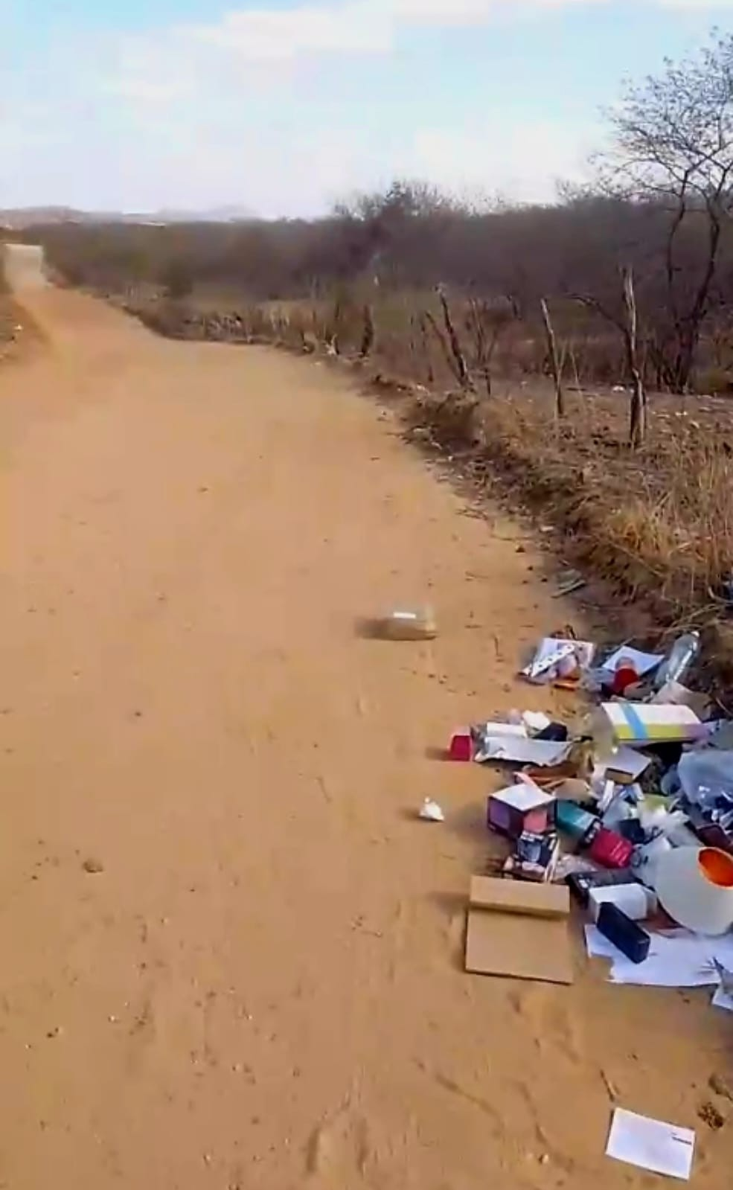
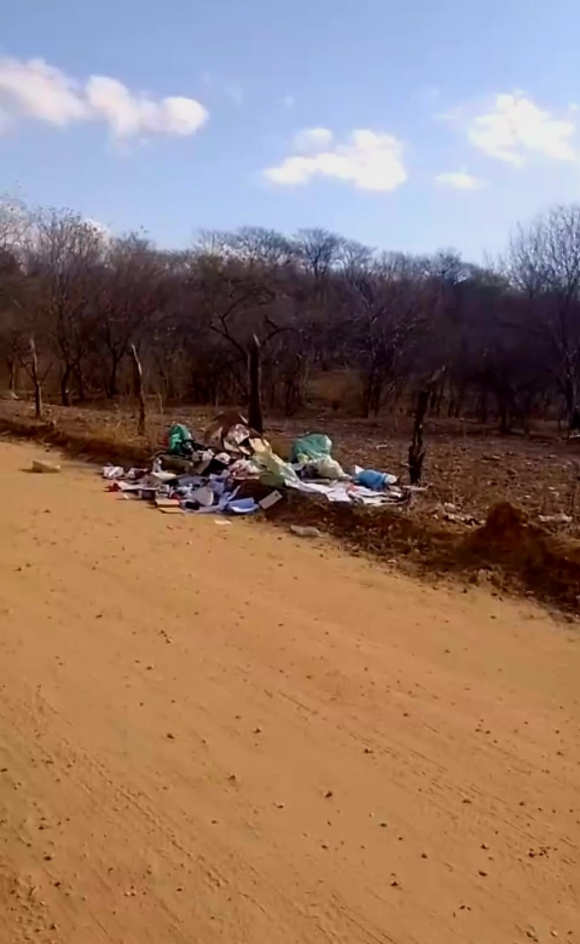
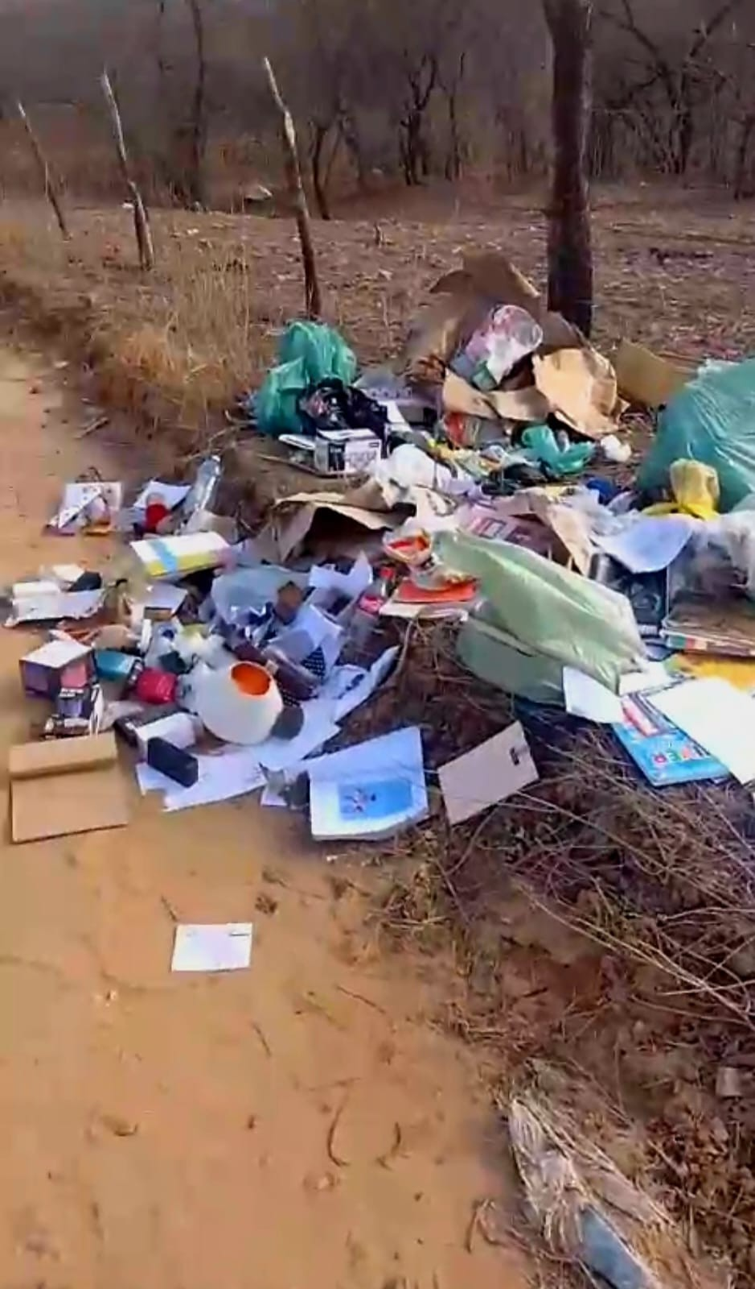
Figure 1, 2 e 3 - São João do Sabugí Garbage discarded in various parts of the rural area of São João do Sabugí

Source: Authors (2025)

There are also many other examples that are also caused unintentionally, such as cigarette remains that are thrown away while still lit, such as the abandonment of reflective objects such as glass, cans and others, which have the potential to cause combustion due to the effect of the sun's rays (SOUSA et al., 2015).
Figure 4 e 5 - Fire outbreaks in São João do Sabugí
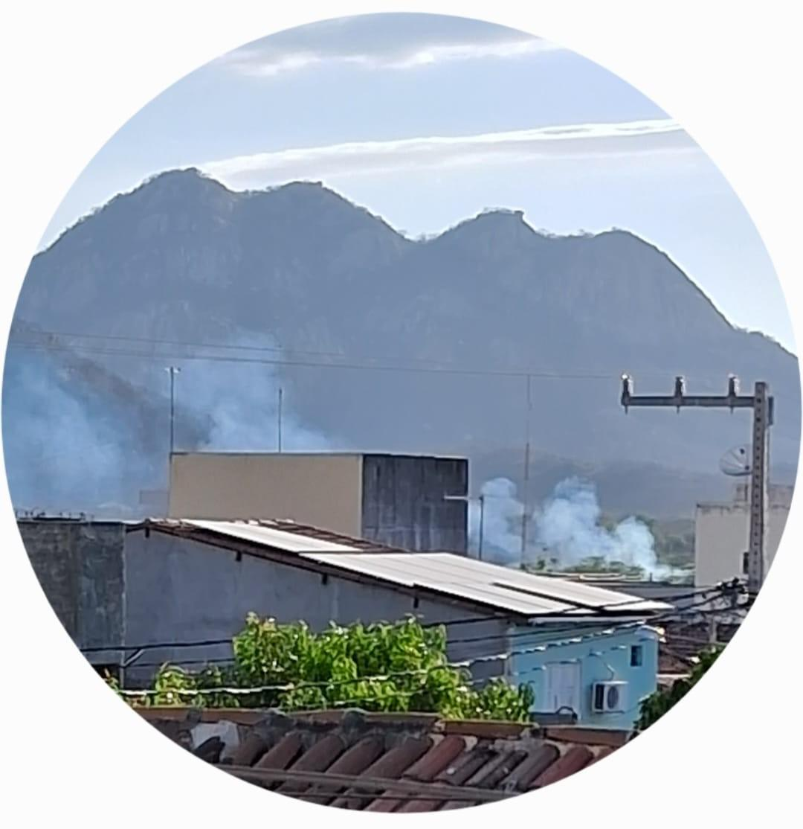
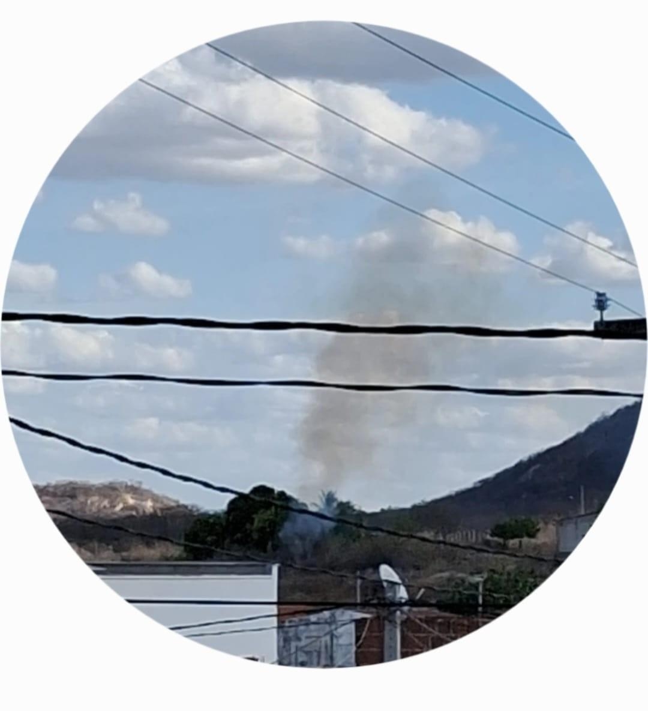
Source: Authors (2025)

It is known that fire behavior is directly linked to the environment in which it develops. In this sense, the characteristics of wildfires are affected by complex interactions among external factors such as precipitation, temperature, and relative air humidity. The lower the precipitation, the lower the relative humidity, which leaves vegetation dry and more prone to combustion (Dias, 2008). Conversely, higher precipitation increases relative humidity, making vegetation wetter and, consequently, less susceptible to combustion. Thus, the absence of rainfall may be identified as a key factor for fires in the Seridó Potiguar region, not because the air becomes rarer, but because it becomes drier and hotter, causing vegetation to dry out and become highly flammable, serving as the main combustible material for flames, especially during the dry season and periods of high regional temperatures.
The most effective solution to fires would be the interruption of this practice by the population; however, such an outcome is unlikely, since the use of fire is historical and has accompanied human societies since their origins. Limited public knowledge, insufficient monitoring and enforcement, the lack of penalties, and conflicts of interest create a scenario marked by destruction, loss of life, and significant environmental damage at both national and global levels. Given that a large proportion of fires originates from human actions, solutions must necessarily involve public awareness and changes in social behavior. Simple measures—such as avoiding the disposal of cigarette butts in areas with dry vegetation—already represent meaningful progress and contribute to environmental cleanliness. Likewise, burning waste, whether in residential settings or open areas, should be avoided, as sparks can be carried by the wind and ignite distant areas, generating new fire outbreaks. For the clearing of large areas, mechanical weeding is recommended rather than the use of fire as a cleaning agent. Through awareness-raising initiatives, the strengthening of legislation, and the encouragement of more sustainable agricultural and urban practices, it becomes possible to reduce these risks and protect the future of the planet. The participation of all sectors—government, society, and the private sector—is essential to ensure more responsible and sustainable development.

4. Materials and Methods
The present study employed the GLOBE Observer application, developed by NASA, and the meteorological information application of the Center for Weather Forecasting and Climate Studies (CPTEC/INPE) as the main tools for the georeferencing of fire hotspots in the municipality of São João do Sabugí, Rio Grande do Norte, and for defining the research category. The selected category was the atmosphere sphere, and records were produced through participatory data collection, encompassing daily information with emphasis on air temperature, cloud cover, precipitation, and relative humidity protocols.
The research was conducted through records entered into the application, including geographic coordinates, date, time, and observed vegetation characteristics. This investigation adopted a mixed-methods approach (quantitative and qualitative), in which participants administered questionnaires to the local population and conducted semi-structured interviews via Google Forms in the classroom (Computer Laboratory). In addition, photographic records and interviews were carried out with residents from both urban and rural areas at strategic locations, as well as with community leaders and municipal health agents. This methodological design provided a comprehensive perspective on the causes and consequences of fires in the municipality. Data from the strategic points were collected at two distinct locations within the city of São João do Sabugí, Rio Grande do Norte, with each selected point corresponding to a specific neighborhood and its respective map.
  - Point 1 (P1): Belo Horizonte Neighborhood
Figure 6 - São João do Sabugí RN
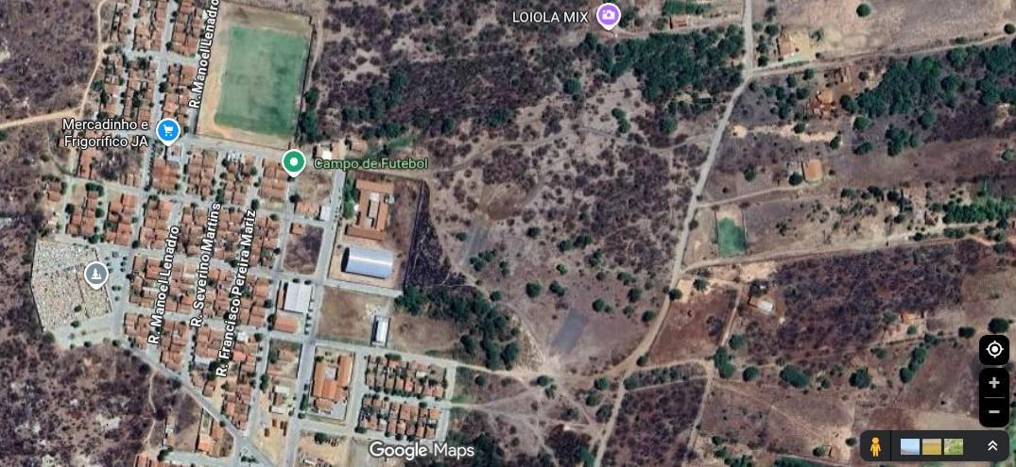

Soource: Google Maps

  - Point 2 (P2): Downtown
Figure 7 -São João do Sabugí RN
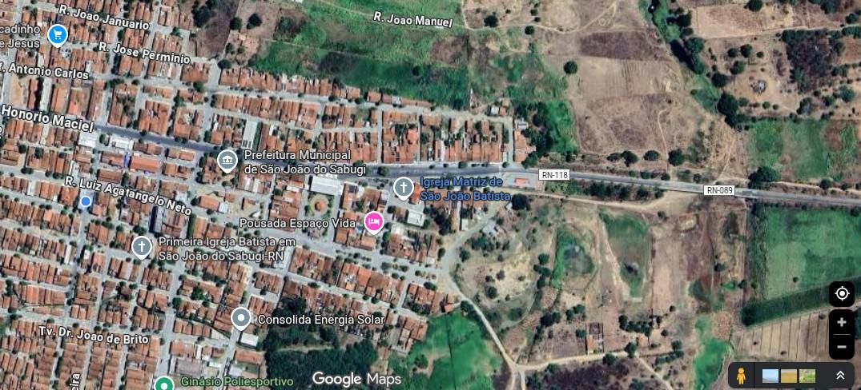

Source: Google Map

The points chosen were of paramount importance for data collection through the questionnaire, as fire outbreaks occur close to these areas. The residents who live in these places are the most affected by the smoke generated by the fires in this perimeter.

5. Analysis of data/results
Data collection was carried out between August and October 2025, during the dry season. For the identification of the collection points, with the help of the GLOBE Observer and CPTEC/INPE applications, two distinct points (P1 and P2) distributed throughout the city were selected, which were duly georeferenced. After this stage, photographic records and observations of the places with the occurrence of fire outbreaks were carried out. The procedures adopted for data collection followed the methodologies described in the GLOBE Observer protocols, which help in monitoring the conditions of the atmospheric sphere and observing changes over time.

Figure 8 - Globe Observer Monitoring and Observing Protocols in the Globe Observer App
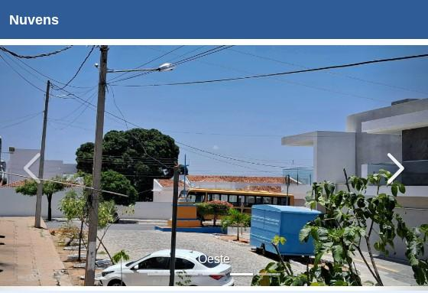

Source: Globe Observer

Figure 9 - Monitoring and observation of numerical weather forecast
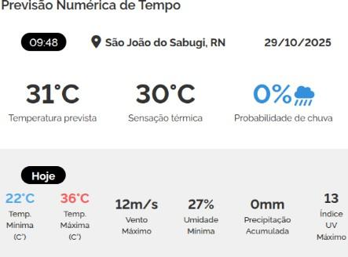

source: Centro de Previsão de Tempos e Estudos Climáticos (CPTEC/INPE)
Data collection was also conducted through semi-structured individual interviews, direct observation and documentary research. The interviews, used as an instrument to obtain primary data, involved 90 participants, including members of the Senador José Bernardo State School and residents of the rural and urban areas of the municipality of São João do Sabugí (RN). Each interview lasted an average of approximately 15 minutes, being recorded on Google Forms and in printed format. Subsequently, the answers were fully transcribed for qualitative analysis of the data. The data obtained in the collection of information regarding the atmospheric sphere, with emphasis on the protocols of air temperature, cloud cover, precipitation and relative humidity, were essential for the conclusion of this study. From the comparison of these parameters, it was possible to understand more precisely the climatic variations observed in the research area, which contribute to the occurrence of fires at certain times of the year in the municipality of São João do Sabugí (RN).

Discussion

The analysis of this research was based on the answers to the questionnaire applied to students and residents, available in a form (Table 1), as well as on the monitoring of the protocols of the atmospheric sphere of the GLOBE Observer and on the meteorological information collected by the Center for Weather Forecasting and Climate Studies (CPTEC/INPE). The objective was to understand how the protocols studied can contribute to the georeferencing of fires in the municipality of São João do Sabugí (RN).

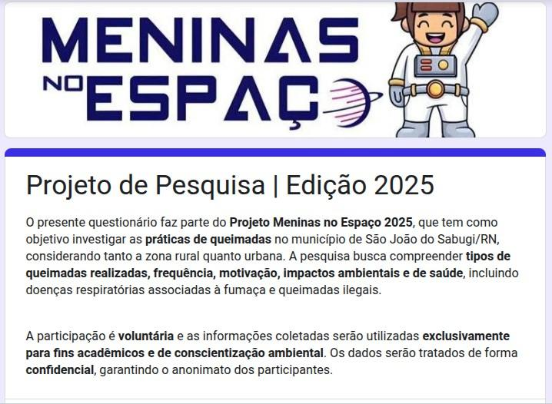
Table 1: Questionnaire of questions applied to students and residents.

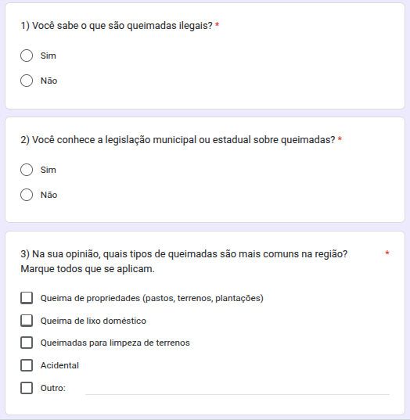
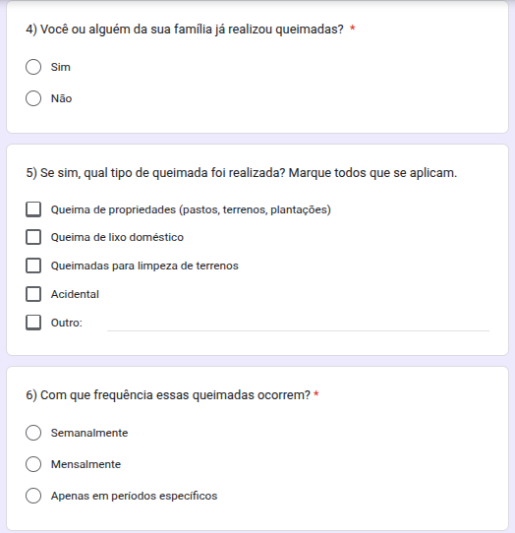

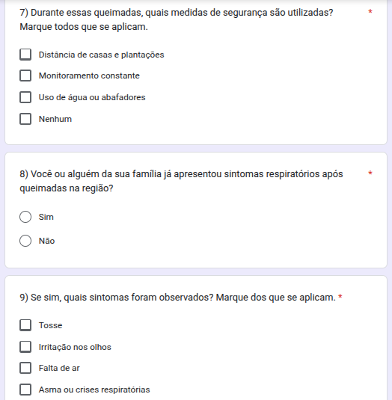
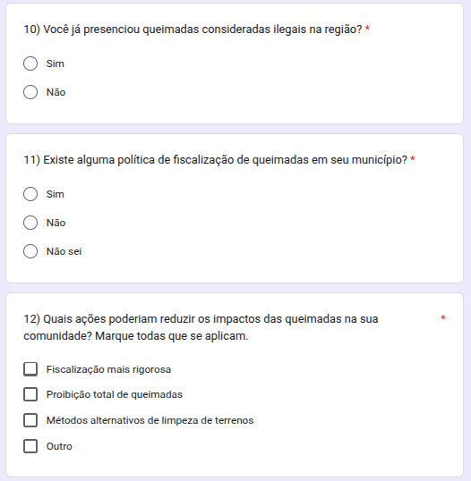
Of the 90 participants who responded to the survey during the period in which it was available, 56.7% were female and 42.2% were male, as illustrated in Figure 1.Therefore, there is a predominance of female participation, evidencing greater interest of women in research. Therefore, there is a predominance of female participation, evidencing greater interest of women in research.
Figure 1. Breakdown of participants who responded to the survey by sex
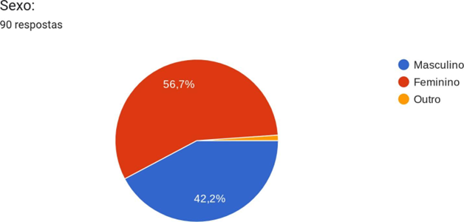

Participants were asked about their place of residence. As shown in Figure 2, 84.4% of the interviewees live in the urban area, while 15.6% live in the rural area.

Figure 2: Participants' place of residence
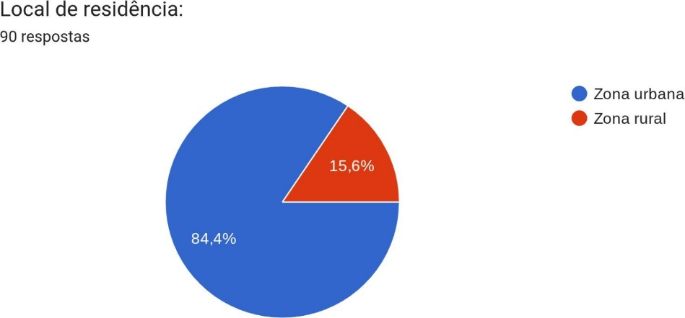

A The first question of the questionnaire, presented to the students, aimed to identify previous knowledge about the concept of illegal burning. As illustrated in Figure 3, 95.6% of the participants demonstrated that they understood the meaning of the term, while only 4.4% stated that they did not know.

Figure 3: Manifestation of the research participants when questioned about the meaning of illegal burning.
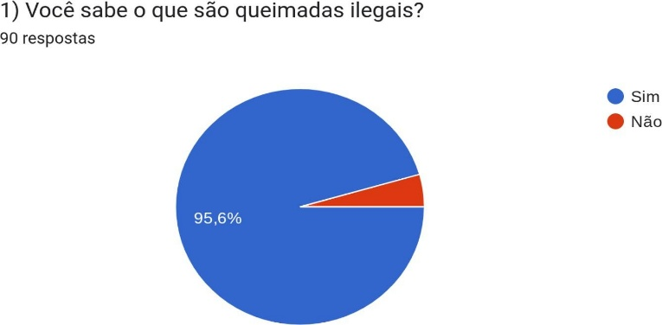

Regarding knowledge about municipal or state legislation regarding fires, Figure 4 shows that 80% of the participants are unaware of any norm related to the theme, while only 20% have some knowledge about it. The results presented in Figure 4 demonstrate that a minority of the interviewees who participated in the survey have already heard about the topic. A negative and worrying point. This result shows the lack of information and awareness of the population, in addition to the need to strengthen the laws in the municipality to minimize the occurrence of the problem.
Figure 4: Participants' statement on municipal and state legislation regarding fires.
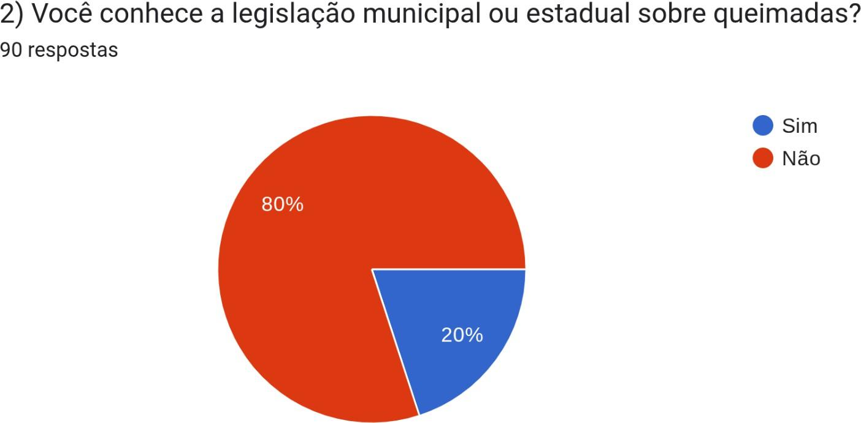

Figure 5 presents the opinion on the most common types of fires in the municipality.
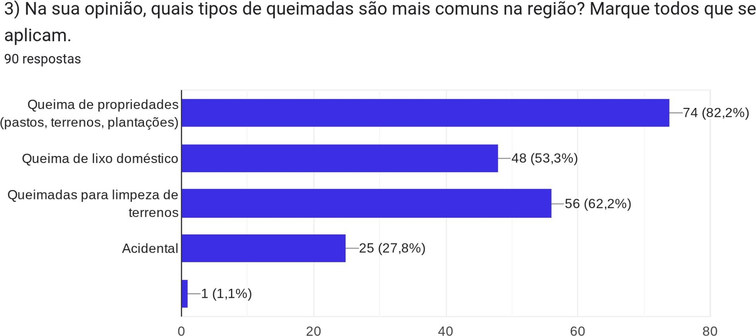

A Figure 5 shows that 82.2% of the interviewees mentioned burning on private properties, 62.2% reported the practice of burning to clear land and 53.3% indicated the burning of domestic garbage. These results demonstrate that a large part of the occurrences of fires in the municipality originate from anthropic actions.

Figure 6 shows the survey regarding the burning by family members of the participants in the municipality of São João do Sabugí (RN).

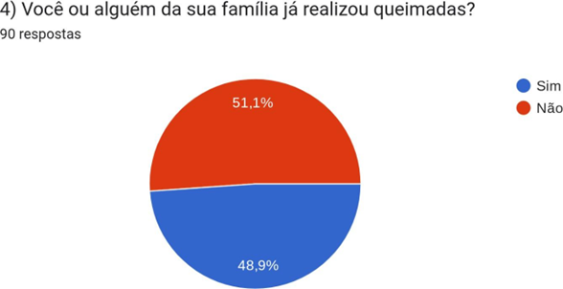

Figure 6 shows that 48.9% of the participants stated that their family members carry out burning practices that cause problems in the municipality, while 51.1% stated that they do not. Figure 7 shows the types of fires carried out, according to the affirmative answers to the previous question.
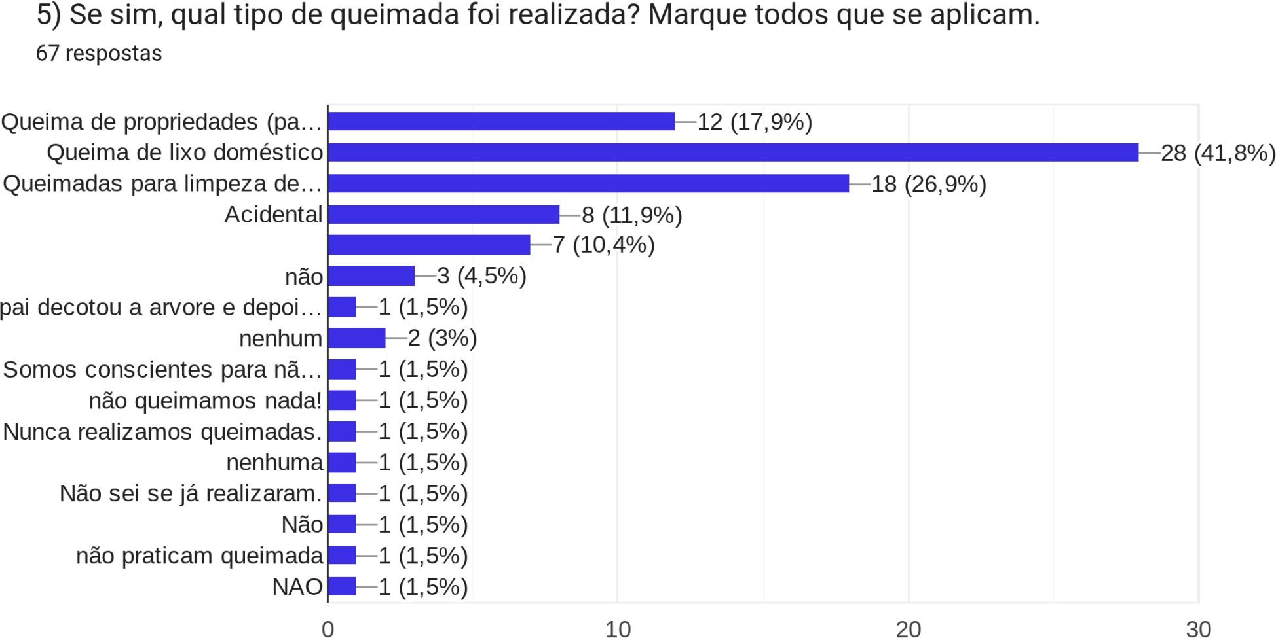

Based on the answers presented in Figure 7, it is observed that the burning of domestic garbage and burning to clean land are the main practices that contribute to the degradation of air quality in the municipality. Almost half of the respondents (41.8%) stated that burning garbage is a common practice. Given this scenario, it is essential that educators and public managers promote environmental awareness actions with students and the community, aiming to combat these practices.

Figure 8 indicates the possible periods of occurrence of fires, based on the frequency of these events in the municipality of São João do Sabugí (RN).

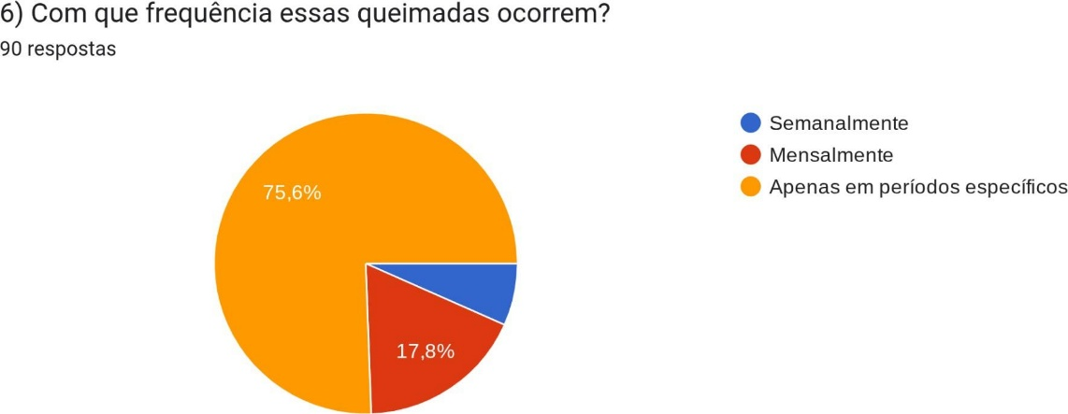

D And according to the interviewees, 75.6% stated that the fires occur only in specific periods of the year, 17.8% answered that they happen monthly and 6.7% declared that they occur weekly. In addition, 75.6% of the participants indicated that these practices are more frequent in the second half of the year, especially during the dry season, which favors the occurrence of fires.

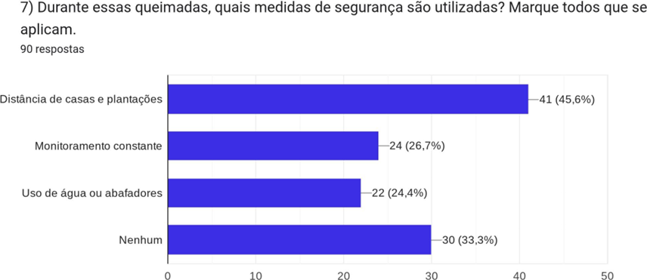
Figure 9 shows the safety measures that are used during fires.

Of those interviewed, 45.6% stated that their homes and plantations are located close to the burned areas, while 33.3% reported that no safety measures are adopted during the practice. These data reveal a worrying picture, since the proximity to the burning areas increases the risks of accidents, damage to health and environmental damage, evidencing the need for more effective prevention and awareness policies in the municipality

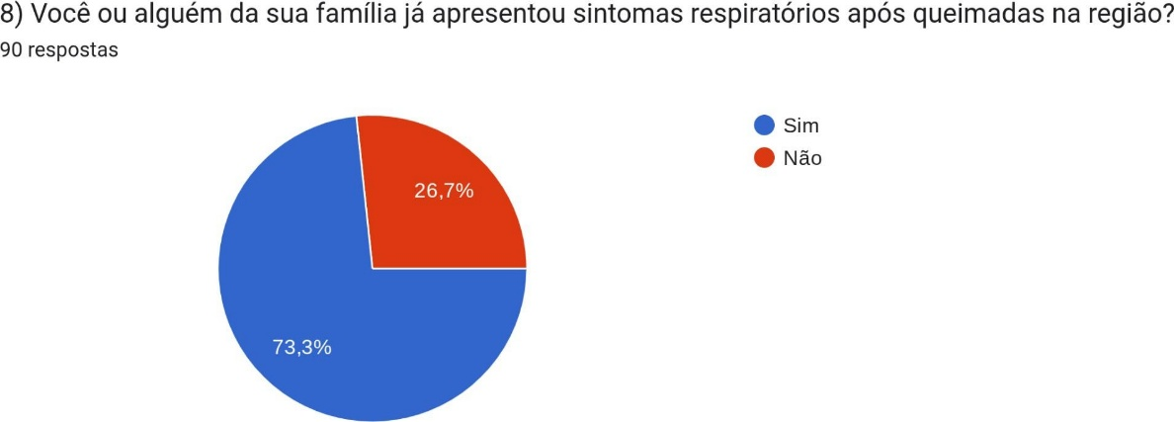
A Figure 10 shows the respiratory symptoms presented by the population as a result of the fires in the municipality.

In response to the question, 73.3% of the participants stated that they had already presented respiratory symptoms resulting from the fires in the municipality, while 26.7% declared that they had never been affected. These data are worrisome, as they show that burning practices harm a significant portion of the population, reinforcing the need for public awareness and prevention policies to minimize such health impacts.
Figure 11 shows all the symptoms observed in the population during the occurrence of fires in the region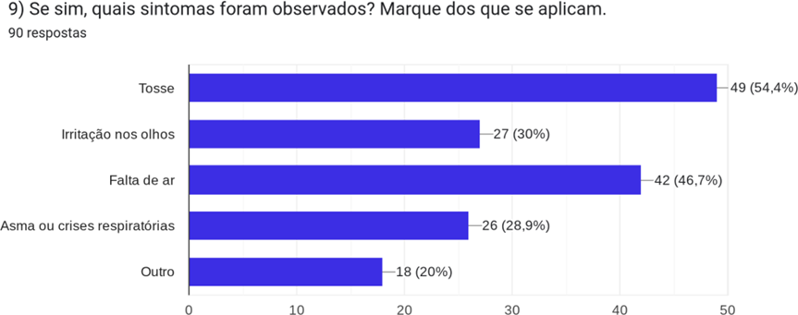
Among the interviewees, 54.4% reported coughing as a symptom resulting from the fires, 46.7% had shortness of breath due to air pollution in the region, 30% reported eye irritation and 28.9% problems related to asthma or respiratory crises. These data are worrying and highlight the need to implement stricter municipal laws to curb such practices in the municipality. The interviewees were asked about the occurrence of fires considered illegal in the region. Among the 90 participants, 86.7% stated that they had already witnessed such fires, while only 13.3% answered that they had not, as shown in figure 12.
It is evident that a significant portion of the population is aware of illegal burning practices in the municipality. However, there is a lack of laws that encourage these people to report and register occurrences, which could contribute to reducing the problem. Figure 13 presents the question about the existence of fire inspection policies in the municipality of São João do Sabugí (RN). According to the data, 62.2% and 33.3% of the interviewees stated that they had no knowledge about such policies, which represents an extremely worrying situation. Only 4.4% answered affirmatively, indicating awareness of the existence of inspection in the municipality.
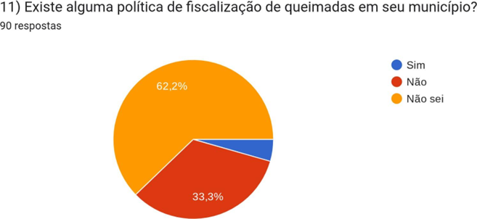

Figure 14 presents the results regarding the participants' responses on the actions that could be implemented to reduce the impacts of fires on communities.
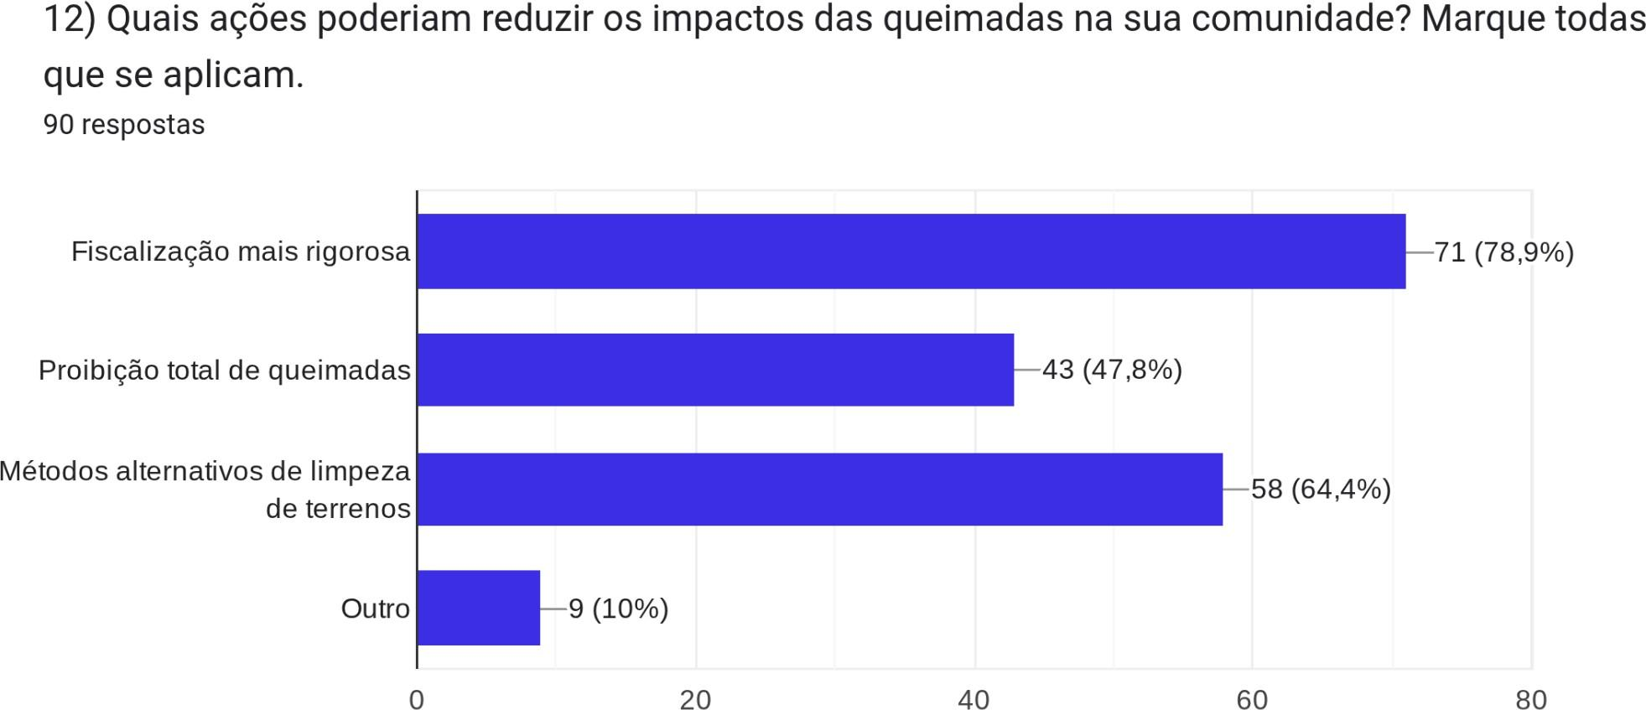

According to Figure 14, 78.9% of the respondents indicated the need for stricter enforcement as a measure to curb fires in the municipality. In addition, 64.4% suggested the adoption of alternative methods for land clearing, given that burning areas is commonly used to reduce labor costs. Finally, 47.8% supported the total prohibition of fires, provided that this measure is accompanied by effective enforcement and the implementation of a bill regulating the practice in both rural and urban areas of the municipality.

- Conclusion
During the development of this study, a significant convergence was identified between the results obtained from the analysis of data collected through the Google Forms questionnaire and the meteorological protocols examined. The atmospheric conditions observed during the research period—such as prolonged drought, low relative air humidity, high temperatures, strong winds, and the absence of rainfall—proved to be determining factors for the ignition and spread of fire.
However, it was found that the lack of effective public policies for fire prevention and control contributes to the increase in the number of fires in the municipality of São João do Sabugí, Rio Grande do Norte. In this context, the results allow the conclusion that the main causes of fires and fire outbreaks in the region are directly associated with anthropogenic activities, such as land clearing for agriculture or pasture, the use of fire as a rapid and low-cost method for soil cleaning, the burning of household and construction waste, the removal of vegetation for irregular constructions, and energy poverty, which leads to the use of firewood as a domestic fuel source.
Overall, the research demonstrated a comprehensive understanding of fire practices in the municipality of São João do Sabugí (RN), highlighting their main determining factors and environmental impacts. Meteorological conditions exert a direct influence on both the ignition and propagation of fire, with drought, low relative humidity, high temperatures, wind presence, and rainfall scarcity constituting key determinants in this process.
Based on the findings, anthropogenic fires were observed to occur predominantly during the dry season in the region. The numerous fire hotspots recorded during this period produce several climatic effects resulting from the emission of aerosol particles released during burning events. In light of this, it becomes essential to understand the impacts of these practices on public health, particularly among residents of more vulnerable areas of São João do Sabugí (RN), who are the most affected by fire outbreaks. The information obtained should be organized, disseminated, and discussed not only among local authorities but also within multidisciplinary teams, in order to promote continuous monitoring and to support effective actions addressing environmental and public health problems in the municipality.
It is expected that the results of this study will contribute to the formulation of preventive public policies, the strengthening of environmental education programs, and the adoption of sustainable household practices capable of reducing illegal fires and, consequently, promoting environmental preservation and improving the quality of life of the local population.

References

Almeida, C. T., Coutinho, A. C., Esquerdo, J. C. D. M., & Adami, M. (2021). Spatiotemporal patterns of fire occurrence in Brazilian biomes. International Journal of Wildland Fire, 30(7), 543–556. https://doi.org/10.1071/WF20154

Barlow, J., Berenguer, E., Carmenta, R., & França, F. (2020). Clarifying Amazonian catastrophe. Science, 369(6500), 36–38. https://doi.org/10.1126/science.abc7483

Mistry, J., & Berardi, A. (2016). Bridging indigenous and scientific knowledge. Journal of Environmental Management, 182, 70–78. https://doi.org/10.1016/j.jenvman.2016.07.038

Silva, J. M. N., Carreiras, J. M. B., Rosa, I., & Pereira, J. M. C. (2019). Wildfires in a socio-ecological context of land use change in the tropics: Dynamics, drivers and impacts. Forest Ecology and Management, 448, 149–157. https://doi.org/10.1016/j.foreco.2019.06.023
ARAÚJO, E.A. RIBEIRO, G.A. Impactos do fogo sobre a entomofauna do solo em ecossistemas florestais. Natureza & Desenvolvimento, v. 1, n 1, p. 75-85, Fev-2005.

CERVO, A. L.; BERVIAN, P. A.; SILVA, R. Metodologia científica. 6. ed. São Paulo: Pearson Prentice Hall, 2007

