

Carbon Under One Roof:
A Household Carbon Budget

Miss. Arisa Thongtang (Grade 11) and Mr. Arin Thongtang (Grade 12)

GLOBE Teacher: Miss. Chomchanok Sutthapas

Shrewsbury International School, Riverside Bangkok
Thailand

16 January 2026

Abstract

Human-induced disruptions to the global carbon cycle remain the primary driver of accelerating climate change. While carbon emissions are often discussed at national or industrial scales, the capacity of small-scale residential ecosystems to store carbon – particularly below ground – remains underexplored. This three-year study completes a household-scale carbon budget by integrating aboveground vegetation carbon storage, net primary productivity (NPP), belowground soil carbon storage, and personal greenhouse gas emissions within a residential study site.

Aboveground carbon storage was quantified using the GLOBE Non-standard Site Carbon Cycle Protocol through measurements of tree circumference at breast height, shrub canopy dimensions, and herbaceous biomass. Net Primary Productivity (NPP) was determined by tracking changes in vegetation carbon storage over time. Belowground carbon storage was assessed using Pedosphere Protocols, incorporating soil characterization, bulk density measurements, and soil organic carbon analysis via the Walkley-Black method across multiple soil depths. Household carbon footprint data were calculated following the ISO 14064-1:2006 standard, categorizing emissions into direct, energy-indirect, and other indirect sources.

Results indicate that large trees dominate aboveground carbon storage, while soil organic carbon contributes approximately 20-48% of total ecosystem carbon storage when measured comprehensively to depth. Despite measurable increases in vegetation biomass and an increase in NPP of 240 gC/m² over the study period, household greenhouse gas emissions consistently exceeded the ecosystem’s total carbon storage capacity. These findings demonstrate that while residential ecosystems play a meaningful role in carbon sequestration, nature-based storage alone is insufficient to offset household emissions, underscoring the necessity of integrating behavioral emission reductions with ecosystem-based climate solutions.

Research Questions:
- What is the total carbon storage capacity of vegetation within the residential study site when assessed across large trees, shrubs/saplings, and herbaceous plants?
- How does vegetation biomass relate to carbon storage capacity and Net Primary Productivity (NPP) over time?
- How much carbon is stored below ground in soil, and how does soil carbon storage vary with depth and soil characteristics?
- What proportion of total ecosystem carbon storage is contributed by belowground soil carbon compared to aboveground vegetation?
- How does the household’s total carbon footprint compare to the combined carbon storage capacity of vegetation and soil within the study site?
- To what extent can a residential ecosystem realistically offset household greenhouse gas emissions?

Hypotheses:
- Large, mature trees store the greatest proportion of aboveground carbon, followed by shrubs and saplings, while herbaceous vegetation stores the least aboveground carbon but contributes to ecosystem productivity.
- Vegetation biomass, carbon storage capacity, and Net Primary Productivity (NPP) are positively correlated, with increases in biomass corresponding to increases in stored carbon over time.
- Soil organic carbon constitutes a substantial fraction of total ecosystem carbon storage, generally increasing with depth and contributing significantly to ecosystem carbon stocks when measured comprehensively.
- The household’s total greenhouse gas emissions exceed the combined carbon storage capacity of vegetation and soil within the study site, indicating that residential ecosystems alone are insufficient to achieve household-level carbon neutrality.

Introduction and Review of Literature:

Carbon is embedded in every living system on Earth. It forms the structural backbone of organic matter and governs the exchange of energy between the atmosphere, biosphere, and pedosphere. Among its many forms, carbon dioxide (CO₂) plays a particularly critical role: it is essential for photosynthesis, yet excessive atmospheric concentrations disrupt Earth’s radiative balance and accelerate climate change. Understanding how carbon moves through natural and human systems is therefore central to evaluating climate mitigation strategies.

Since the onset of industrialization, human activities – primarily the combustion of fossil fuels and land-use change – have introduced carbon into the atmosphere at rates far exceeding the capacity of natural sinks to remove it. Greenhouse gases such as carbon dioxide (CO₂), methane (CH₄), and nitrous oxide (N₂O) trap outgoing infrared radiation, intensifying the greenhouse effect and leading to rising global temperatures, extreme weather events, and ecosystem disruption. Atmospheric carbon dioxide concentrations reached 426.91 parts per million in 2024, the highest level observed in at least 800,000 years, underscoring the urgency of identifying both emission reductions and effective carbon storage mechanisms.
Figure1 Global Monthly Means since 1980

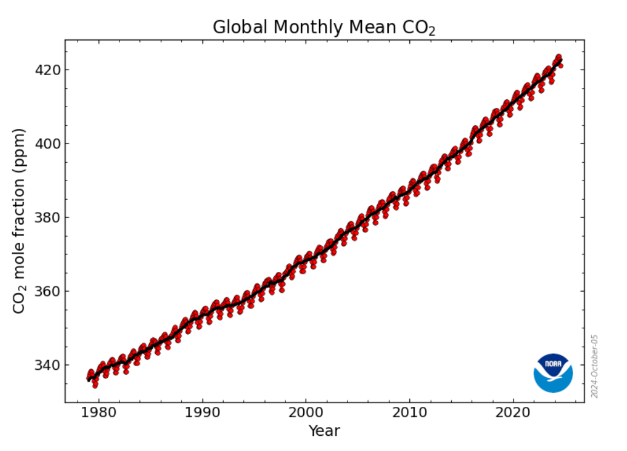
Source NOAA
Natural carbon sinks; namely forests, grasslands, wetlands, and oceans play a vital role in moderating atmospheric carbon levels. Together, terrestrial and oceanic sinks absorb approximately 55% of anthropogenic carbon emissions each year, However, recent studies indicate that the efficiency of these sinks may be weakening due to rise, and reliance on natural sinks alone may no longer be sufficient to stabilize atmospheric carbon concentrations (Myles R. Allen et al., 2022). As a result, evaluating carbon dynamics across multiple scales has become increasingly important.

Figure2 Global carbon cycle diagram
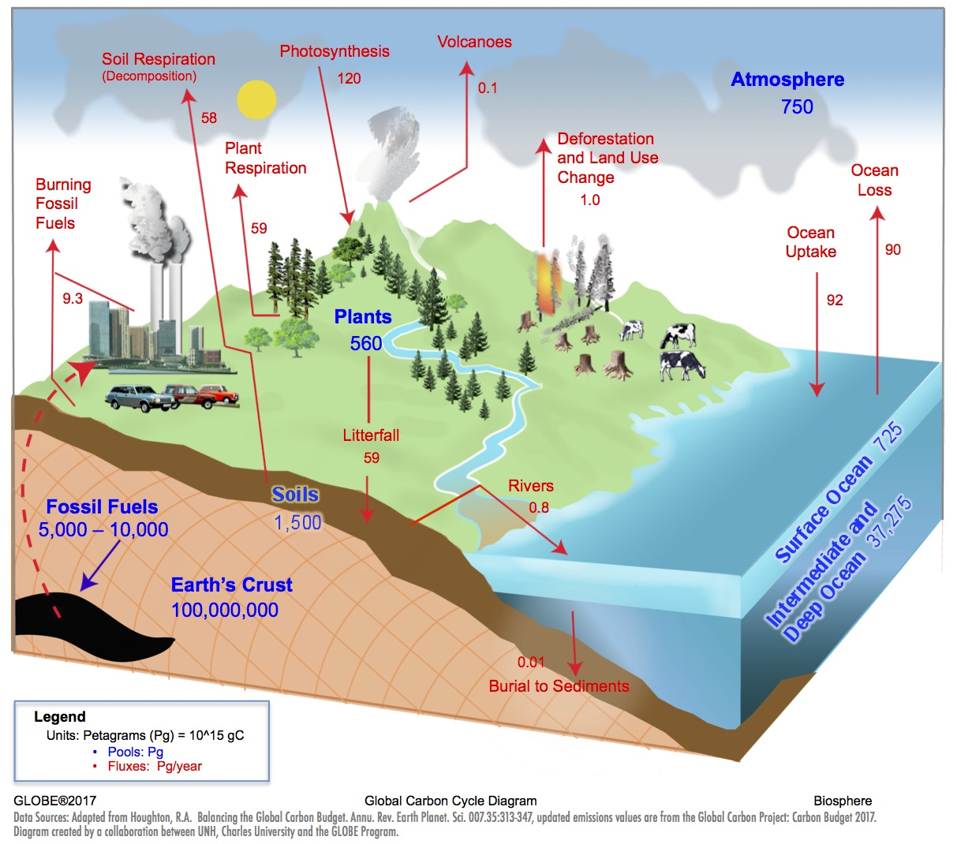
Source Globe.gov

While carbon sequestration is often examined at global or regional scales, significantly less attention is given to carbon dynamics at the household or residential scale. Yet, residential areas represent a meaningful interface between human activity and natural systems. Vegetation in hoe gardens, yards and urban green spaces contributes to carbon storage, while household energy use, transportation, and consumption generate greenhouse gas emissions. Evaluating carbon storage and emissions together within a single residential system provides a more complete understanding of how human behavior interacts with local ecosystems.

Previous studies have consistently demonstrated that vegetation carbon storage is strongly influenced by biomass, species composition, and structural characteristics. Research conducted in school environments across Southeast Asia and South Asia has shown that large, mature trees store substantially more carbon than shrubs or herbaceous vegetation due to their higher biomass. Fast-growing and broad-canopied species, such as rain trees and resin trees, exhibit particularly high sequestration potential, especially in soils with favorable moisture and organic matter content (Nicha Thachuen et al., 2022; Prayada Saratnont and Thanyarat Sapasin, 2023). These findings reinforce the importance of vegetation structure in determining aboveground carbon storage.

However, focusing exclusively on aboveground biomass provides an incomplete picture of ecosystem carbon storage. Soil organic carbon (SOC) represents the largest terrestrial carbon pool, often exceeding the carbon stored in vegetation. Soil carbon storage depends on factors such as bulk density, organic matter content, soil texture, and depth. Studies have shown that while surface soils contain higher concentrations of organic matter, deeper soil layers can store substantial quantities of carbon due to greater mass and long-term stability (Jobbágy and Jackson, 2000). Despite its significance, belowground carbon is frequently excluded from small-scale carbon assessments due to methodological complexity.

Net Primary Productivity (NPP) offers a dynamic perspective on carbon storage by quantifying the rate at which vegetation accumulates carbon over time. Unlike static measurements of biomass, NPP reflects the balance between photosynthetic carbon uptake and respiratory losses. Tracking changes in vegetation carbon storage across sequestration potential under real environmental conditions.

In parallel with ecosystem-based carbon storage, household carbon footprints remain a major contributor to global greenhouse gas emissions. Residential energy consumption, transportation, water use, and air travel collectively generate substantial quantities of carbon dioxide equivalent (CO₂e). Standardized frameworks such as ISO 14064-1:2006 enable the systematic quantification of these emissions, allowing direct comparison between human-generated emissions and ecosystem-based carbon storage.

Despite growing interest in nature-based solutions, few studies integrate aboveground vegetation carbon, belowground soil carbon, Net Primary Productivity, and household greenhouse gas emissions within a single, continuous study framework. As a result, the realistic capacity of residential ecosystems to offset household emissions remains poorly constrained. This study addresses that gap by completing a three-year, household-scale carbon budget that integrates biological, pedological and anthropogenic carbon components.

By combining multi-year vegetation measurements, depth-resolved soil carbon analysis, and standardized carbon footprint accounting, this research aims to evaluate whether carbon storage within a residential ecosystem can meaningfully counterbalance household greenhouse gas emissions. In doing so, the study highlights both the potential and the limitations of ecosystem-based carbon sequestration at the household scale, offering insights relevant to climate mitigation strategies that extend beyond individual behavior to integrated human-environment systems.

Research Methods and Materials

This study represents the final phase of a three-year investigation. Year1 established aboveground vegetation carbon storage. Year2 integrated Net Primary Productivity and preliminary soil carbon estimates. Year3 completes the carbon budget through depth-resolved belowground carbon analysis. Methodological frameworks remained consistent to allow direct comparison across years.

Our land cover sample site is situated at 13.72411 Latitude, 100.503101 Longitude, with an elevation of 6 meters above sea level, covering 9,702 square meters. Classified as a Non-Standard Site, it exceeds 50% human interference, including residential and dwelling areas. The study was conducted within a residential backyard located in Bangkok, Thailand, representing a mixed-use household ecosystem where vegetation and daily human activities coexist. The site includes a combination of large trees, shrubs and saplings together with herbaceous plants. The study area remained consistent across all three years, allowing direct temporal comparison of carbon storage and productivity.

Equipment includes photographs, a smartphone with a GPS application, a compass, the Modified UNESCO Classification Guide (MUC Field Guide), a measuring tape, brown bags, grass clippers, pen and paper, a clinometer and a densiometer. Tool requirements for soil protocols: Soil color book, trowel, compass, meter stick, 15 quart-size sealable bags, 5 sampling PVC tubes, wood block, hammer, shovel and marker, auger, 2mm mesh sieve, graduated cylinder, rubber gloves, soil organic matter tool kits.

Protocols include the Land Cover Sample Site Protocol, along with the Biometry Carbon Cycle Protocols covering Tree Mapping, Tree Circumference, Shrubs/Sapling, and Herbaceous Vegetation. For belowground carbon storage, Soil Characterization Protocol, Star-Pattern Soil Moisture Protocol, Depth Profile Soil Moisture Protocol and Soil Bulk Density Protocol. Then, we find soil organic carbon (SOC), using the Walkley-Black method.

Aboveground vegetation carbon was quantified using the GLOBE Non-Standard Site Carbon Cycle Protocol. Vegetation within the study site was categorized into three structural groups: Large trees, shrubs and saplings and herbaceous vegetation.

For large trees, circumference at breast height (CBH) was measured annually using a measuring tape at 1.3 meters above ground level. These measurements were converted to diameter at breast height (DBH) and used in species-appropriate allometric equations to estimate aboveground biomass. Shrubs and saplings were measured using the average height of the shortest and the tallest side, while herbaceous vegetation biomass was estimated through ground cover assessment and biomass conversion factors.

Aboveground biomass values were converted to carbon storage using a standard carbon fraction of 0.5. Carbon storage was expressed in grams of carbon (gC) and normalized per unit area (gC/m²) to enable comparison across years.

Figure3 Steps for carbon cycle measurement
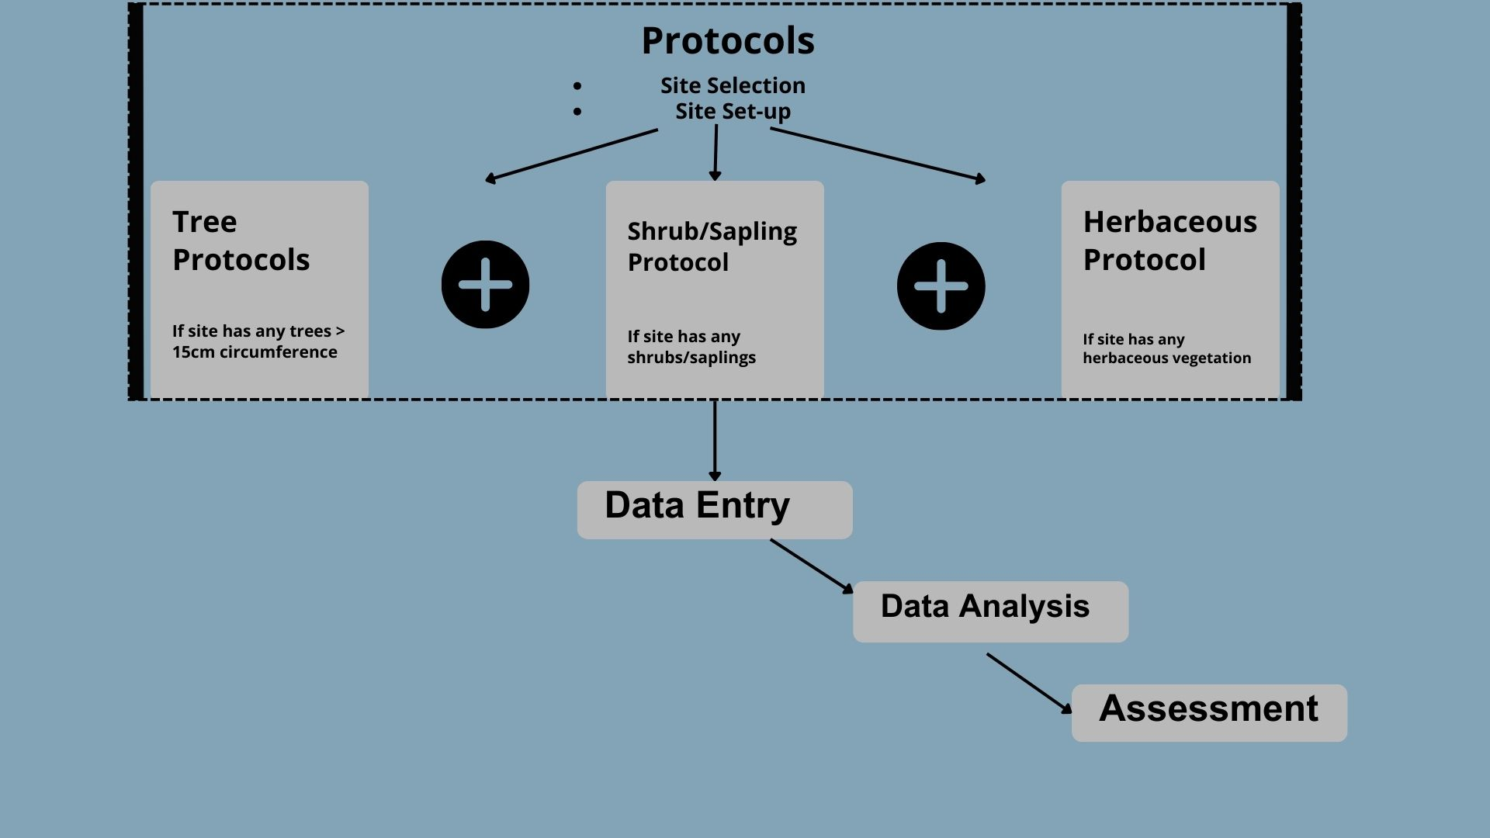
Source GLOBE Program, 2022

Figure4 Calculation of carbon stored in trees
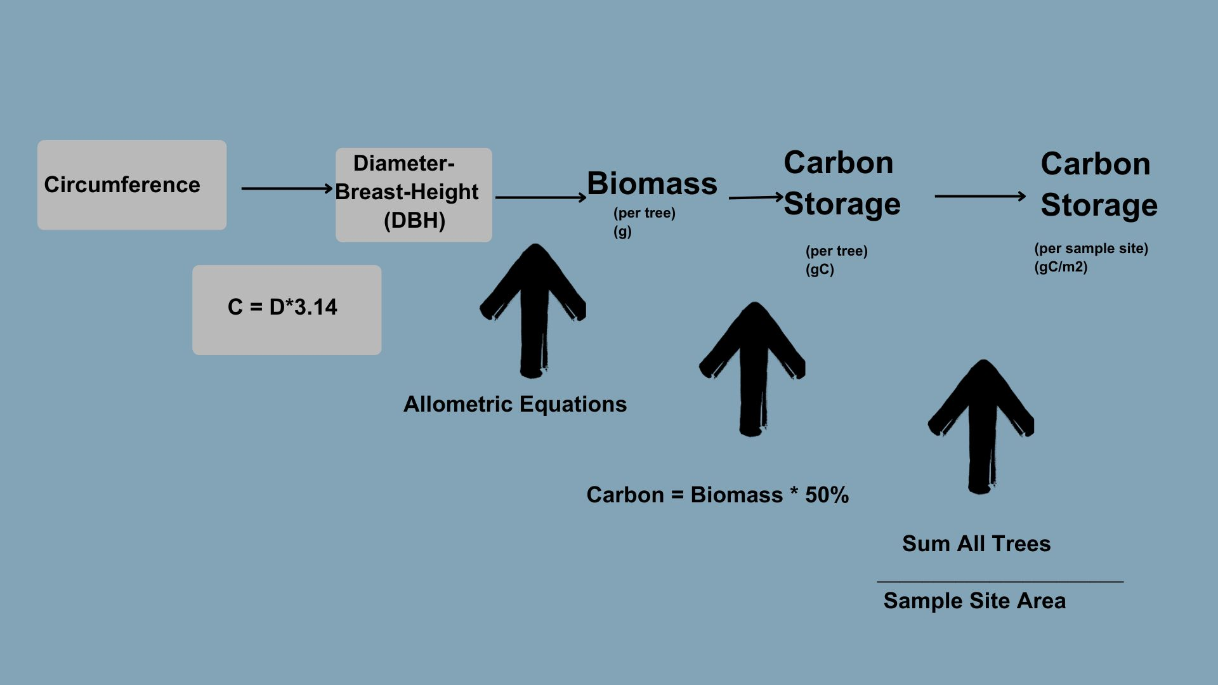
Source: Globe Non-Standard Site Carbon Cycle Protocols

Net Primary Productivity (NPP) was calculated by measuring the annual change in aboveground vegetation carbon storage. Carbon storage values from consecutive years were compared to determine net carbon accumulation within the ecosystem. This approach allowed NPP to reflect actual ecosystem growth under prevailing environmental conditions rather than theoretical productivity estimates. Positive NPP values indicated net carbon sequestration, while negative values would indicate biomass loss.

Belowground carbon storage was assessed using the GLOBE Pedosphere Protocols, incorporating soil physical characterization and chemical analysis. Soil samples were collected at multiple depths to capture vertical variation in soil organic carbon storage. Sampling depths included surface and sub-surface layers, allowing for assessment of carbon distribution with depth.

Bulk density was determined by measuring the dry mass of a known soil volume. Soil organic carbon content was analyzed using the Walkley-Black wet oxidation method, which quantifies oxidizable organic carbon. Soil carbon storage for each depth layer was calculated using measured carbon concentration, bulk density, and sampling depth as shown in the following equation:

The equation of soil carbon density estimate is
DSCDi = p x PSOCi * Bf
Where DSCDi is the soil carbon density of the ith soil genera (kg.m -2); p is the average bulk density of soil (kg.m-3); PSOCi is the percentage of organic matters of the ith soil genera (%); Bf is the Bemmelen factor (0.58).

Note that the Bemmelen factor derives from the fact that organic matter in soil contains around 58% carbon on average, or the factor 1.724 (e.g. 1/0.58) is commonly used to convert soil organic carbon (SOC) to soil organic matter (SOM).

Bulk Density (g/mL or g/cm^3) = Mass of dry soil (g) – Mass of rocks (g)
Container volume (mL) – Volume of rocks (mL or cm^3)

Soil Carbon Stock (gC/m2) = SOC (%) * Bulk Density (g/cm3) * Depth (cm)*10

Total belowground carbon storage was obtained by summing carbon stocks across all sampled depths.

Figure5 Our Star Pattern Soil Moisture
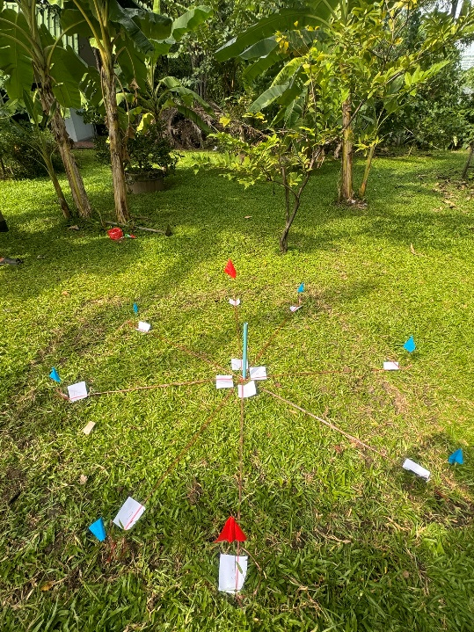 | 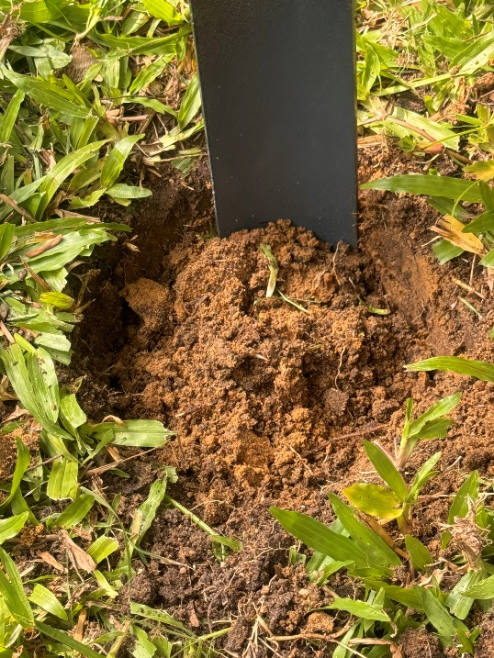

Figure6 Soil Measurements
 | 

Figure7 A Colorimetric Reference Chart
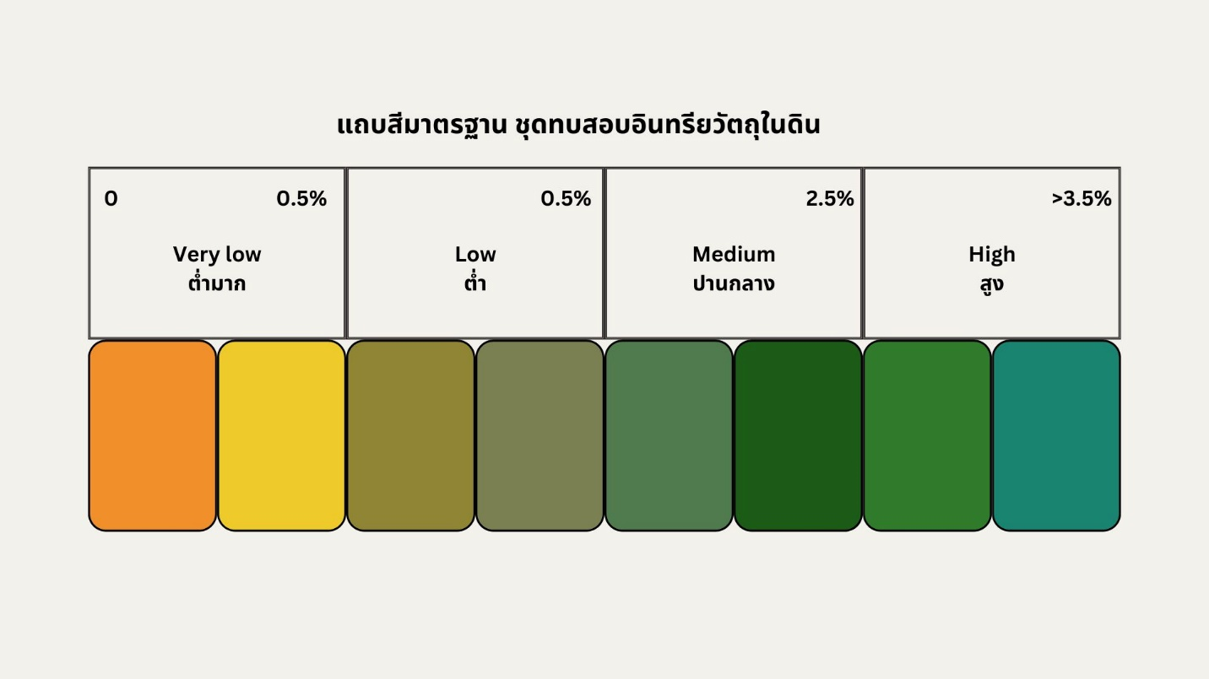

Figure8 Experiment with the Walkley-Black Method
 | 
 | 

Household greenhouse gas emissions were calculated following the ISO 14064-1:2006 standard, ensuring consistency and comparability with internationally recognized carbon accounting practices. Emissions were categorized into: direct emission (Scope 1) involving on-site fuel use, energy-indirect emission (Scope 2) accounting for purchased electricity and other indirect emissions (Scope 3) taken into account of transportation, water use and air travel.

Activity data were collected through utility records, travel logs and household surveys. Emission factors were applied to calculate carbon dioxide equivalent (CO₂e) emissions for each category. Total household emissions were then compared against combined aboveground and belowground carbon storage within the study site.

Figure9 Classifying activities based on the scope of greenhouse gas emissions
and removals Types 1, 2, and 3.
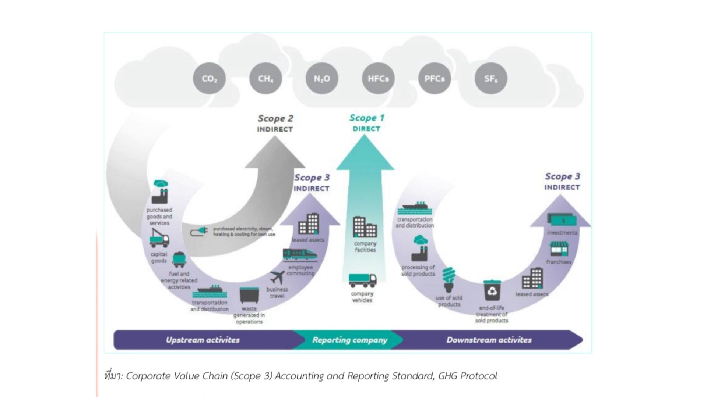
Source Corporate Value Chain (Scope3) Accounting and Reporting Standard, GHG Protocol

Figure10 Calculating the quantity of greenhouse gas (GHG) emissions
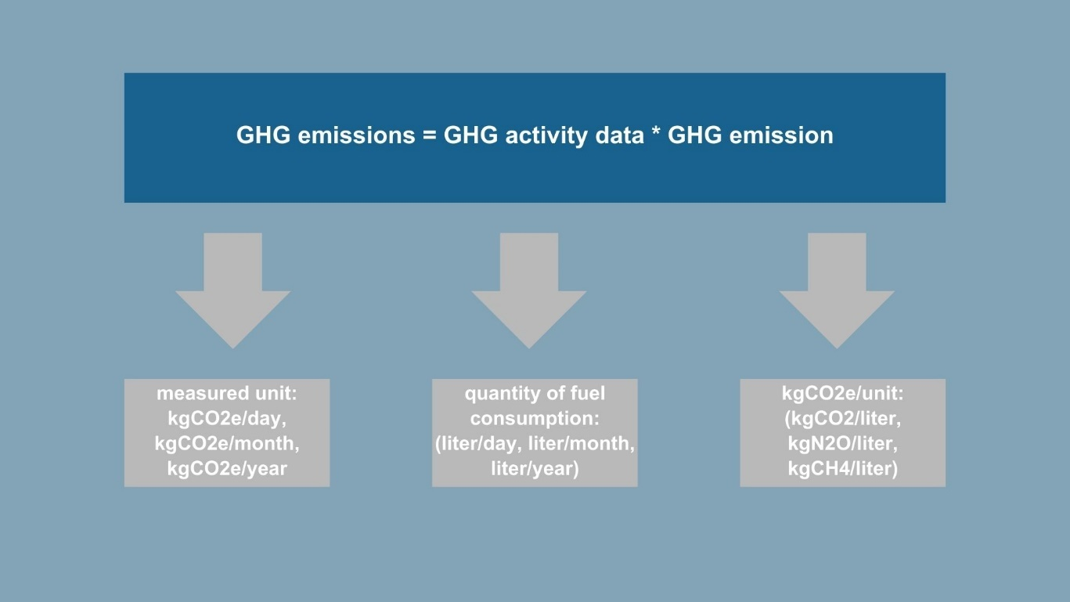
Source ISO 14064-1:2006 Greenhouse gases – Part1: Specification with guidance at the organization level for quantification and reporting of greenhouse gas emissions and removals

Table1 Emission factors (EF) for greenhouse gas emissions, Types 1, 2, and 3.
Activity | Measured United | Scope of Work | GHG Emission | Reference Source
 |  |  | (KgCO2e/unit)
Energy: Mobile Combustion |  | Scope 1
Benzene | Liter |  | 2.2376 | IPCC Vol.2 table 3.2.1, 3.2.2, DEDE
Electricity Usage |  | Scope 2
Thailand Grid Mix Electricity | kilowatt -hour  (kWh) |  | 0.5813 | Thailand Grid Mix Electricity LCI Database 2552 (2009)
Water Usage |  | Scope 3
Thailand Metropolitan Water Authority | cubic meter  (m3) |  | 0.7948 | Thailand Greenhouse Gas Management Organization
Air travel |  | Scope 3
Domestic: Economy class | Passenger/ km |  | 0.158 | Defra, 2010
International short-haul flight: Economy class | Passenger/ km |  | 0.0933 | Defra, 2010
International long-haul flight: Economy class | Passenger/ km |  | 0.0834 | Defra, 2010
International short-haul flight: Business class | Passenger/ km |  | 0.25 | Defra, 2010
International long-haul flight: Business class | Passenger/ km |  | 0.18 | Defra, 2010
Source Citing data from the Emission Factor gathered from meteorological information for assessing the carbon footprint of the greenhouse gas management organization (private sector), updated as of April 30, 2013.

Table2 The method for calculating GHG emissions
Activities that are sources of GHG emissions | Method for calculating GHG emissions (kgCO2e)
Travel and transportation by vehicle type | Amount of fuel used in transportation (measured in fuel types) * GHGs emission factors by fuel type (KgCO2e/unit)
Usage of electricity imported from external sources  (Energy Indirect Emission) | Electricity consumption (kWh) * GHGs emission factor (KgCO2e/kWh)
Usage of water  (Other Indirect Emissions) | Water consumption (m3) * GHGs emission factor (KgCO2e/m3)
Air transportation  (Other Indirect Emissions) | Number of passengers (passenger) * distance (km)* GHGs emission factor (KgCO2e/passenger-km)
Source ISO 14064-1:2006 Greenhouse gases – Part1: Specification with guidance at the organization level for quantification and reporting of greenhouse gas emissions and removals

Figure11 Example of collecting data at the primary level - electricity and water bill
 | 
Results

Results indicate that large trees accounted for the majority of aboveground carbon storage across all three years. Despite representing a smaller proportion of total vegetation count, mature trees stored substantially more carbon than shrubs, saplings and herbaceous plants due to their greater biomass and structural complexity. Shrubs and saplings contributed moderately to total storage, while herbaceous vegetation stored the least aboveground carbon.

Table3 Summary of the carbon storage within the trees

 | Unit | Nov-25 | Oct-24 | Jan-24
Plot aboveground biomass | g/plot | 39,864,628 | 35,138,588 | 31,402,875
Plot aboveground carbon storage | gC/plot | 19,932,314 | 17,569,294 | 15,701,437
Biomass | g/m2 | 4,109 | 3,622 | 3,237
Aboveground carbon storage | gC/m2 | 2,055 | 1,811 | 1,618

Table4 Summary of the carbon storage in the shrub/sapling in our site
 | Unit | Nov-25 | Oct-24 | Jan-24
Deciduous Biomass | g/m2 | 5.8 | 1.7 | 1.4
Evergreen Biomass | g/m2 | 36.7 | 45.7 | 27.7
Total Biomass | g/m2 | 42.5 | 47.4 | 29.1
Carbon Storage - Shrub/sapling | gC/m2 | 21.2 | 23.6 | 14.5

Table5 Summary of the carbon storage in grass in our site
 | Unit | Nov-25 | Oct-24 | Jan-24
Biomass: Grass in brown bag | g/m2 | 97 | 136 | 13
Brown bag | g | 8 | 8 | 3
Net Biomass - Herbaceous | g/m2 | 28 | 31 | 10
Carbon Storage - Herbaceous | gC/m2 | 14 | 15.5 | 5
Incremental increases in tree biomass over time resulted in measurable growth in total aboveground carbon storage, supporting the hypothesis that vegetation structure strongly influences carbon sequestration capacity.
Figure12 The relationship between the circumference size of trees at breast height and aboveground biomass
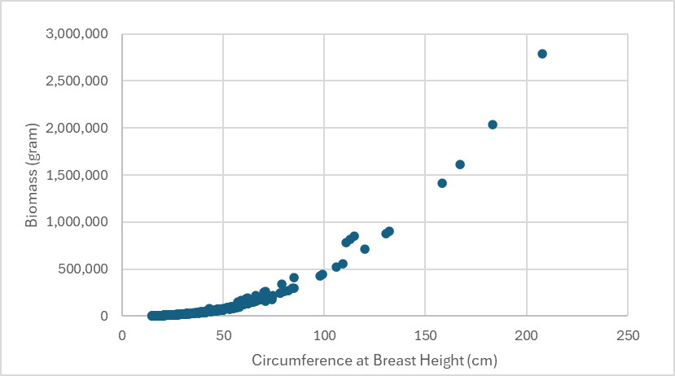

Figure13 The proportion of aboveground biomass in various parts of large trees
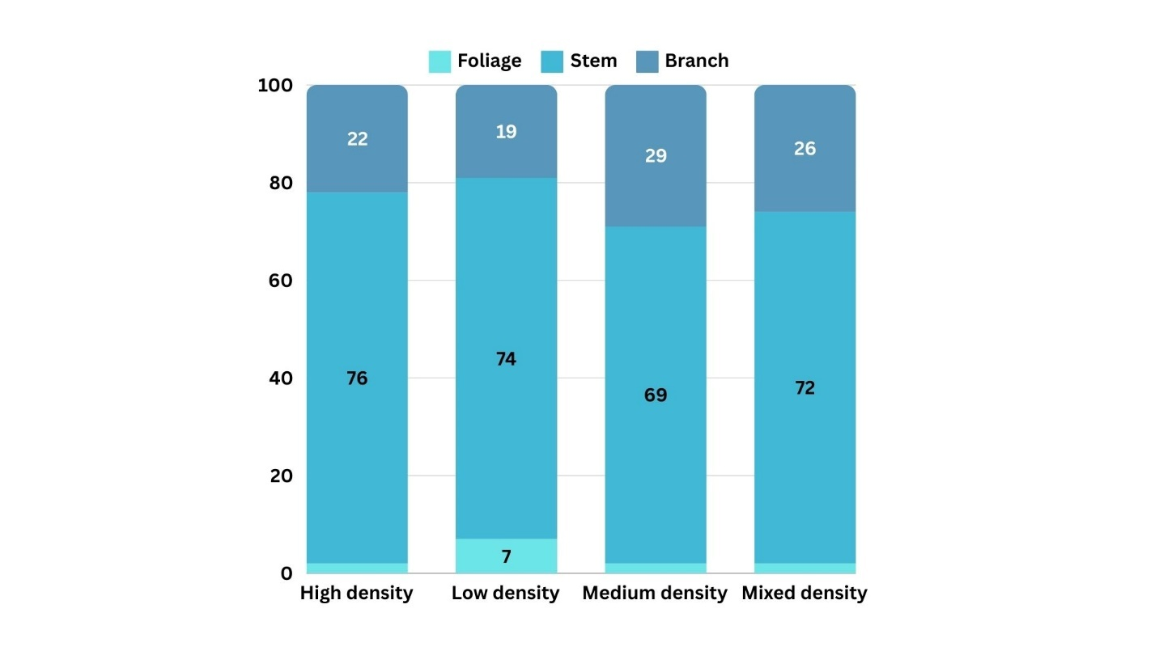

Figure14 The proportion of large trees in the area categorized by wood density
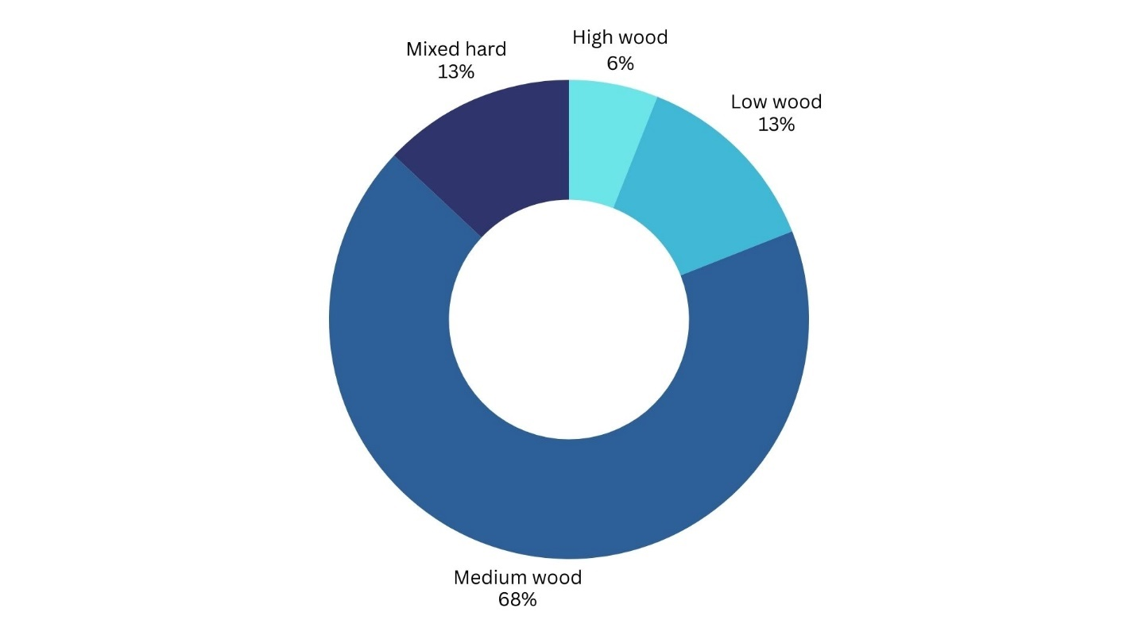

Figure15 Data analysis from the GLOBE Visualization System – Carbon Cycle
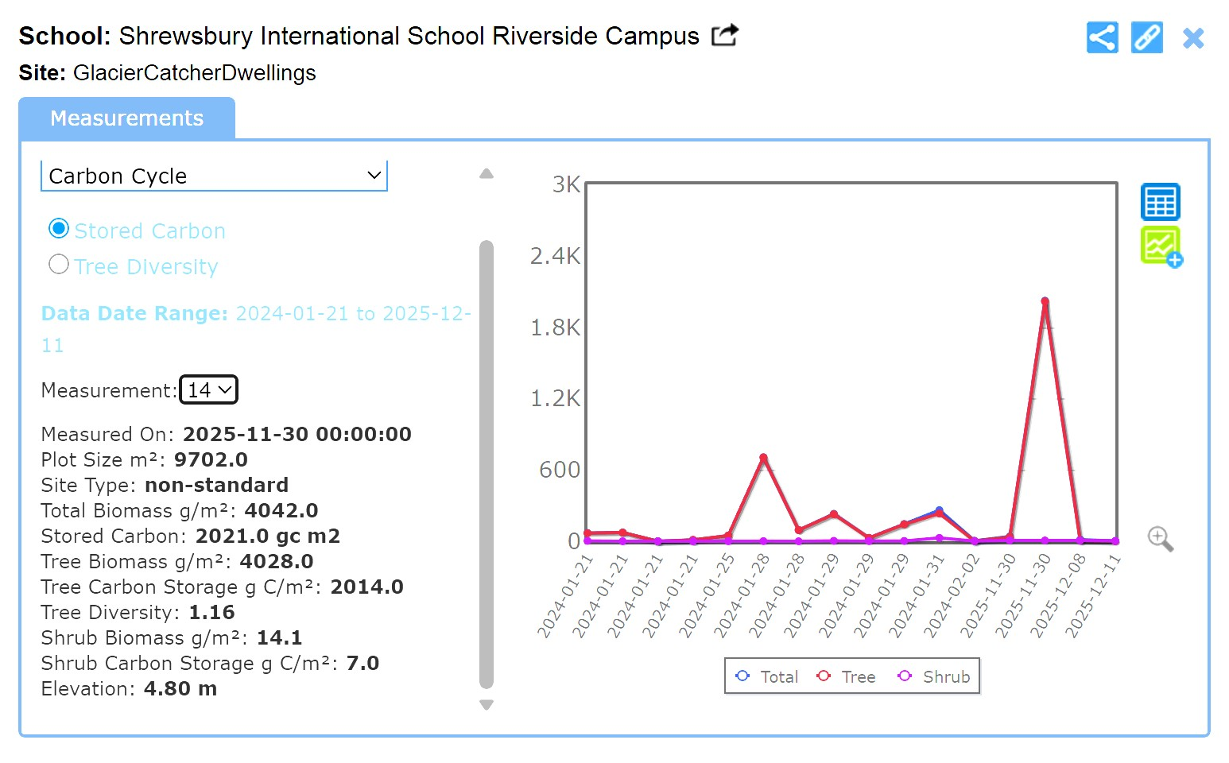

Figure16 Distribution of carbon storage across vegetation types within the residential study site
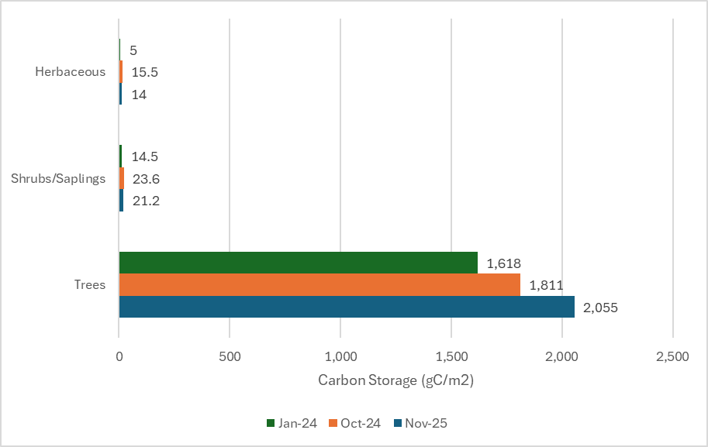 | 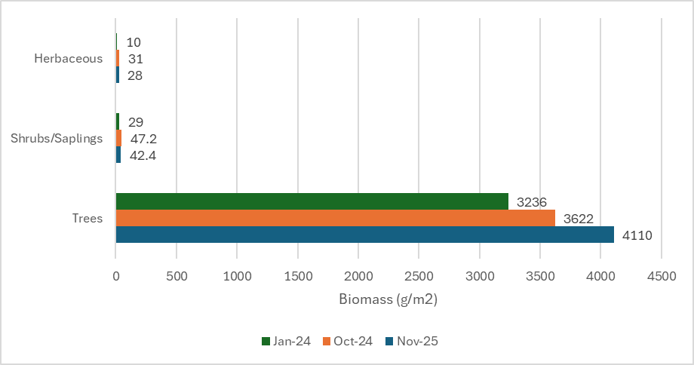

The ecosystem exhibits a positive Net Primary Productivity throughout the study period. Between Years 2 and 3, NPP increased by 240 gC/m², mainly contributing from continued vegetation growth and carbon accumulation in matured trees. This positive NPP reflects favorable growing conditions and the presence of mature vegetation capable of sustained carbon uptake. The results demonstrate a clear relationship between increasing biomass and carbon storage over time.

Table6 Carbon Change Over Time
NPP | Yr 3 – Yr 2 | Yr 2- Yr 1
 | gC/m2 | gC/m2
Tree | 244 | 193
Shrubs & Saplings | -2.4 | 9
Herbaceous | -1.5 | 11
Total - aboveground | 240.1 | 212.6

Although overall NPP showed an upward trend driven by increasing biomass in large trees, this pattern was not consistent across all vegetation types. Big trees exhibited positive NPP, reflecting continued growth and carbon accumulation, whereas shrubs and herbaceous vegetation showed negative NPP. This decline is likely attributable to regular pruning and biomass removal, which reduced net carbon gain in these smaller vegetation classes despite favorable growing conditions.

Soil organic carbon constituted a substantial portion of total ecosystem carbon storage. SOM concentration decreases with depth and cumulative soil carbon stock increases when depth and mass are included. Soil contributes roughly 20-48% of total ecosystem carbon.

For belowground carbon storage, soil organic matter was classified as very low (0–0.59%), low (0.6–1.59%) and medium (1.6-2.5%) across the soil profile. Bulk density values within physically realistic ranges measured in this study (1.10–1.64 g cm⁻³) were used to estimate soil carbon stocks. Based on these values, total soil carbon storage was estimated to range between 4,903 and 18,428 kg, contributing approximately 20–48% of total ecosystem carbon storage within the study site, compared to an estimated 19,932 kg of aboveground vegetation carbon.

Figure17 Data analysis from the GLOBE Visualization System – Pedosphere
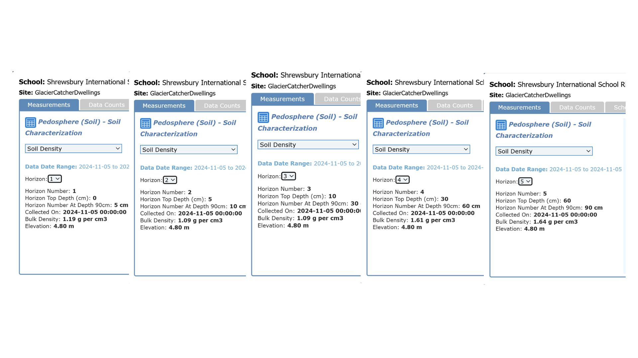

Table7 Soil Moisture – Depth Profile Year-3 depth-resolved soil figure
 | A | B | C | (A-B)/(B-C) |  | Pipe
Depth | Mass of wet soil and container | Mass of dry soil and container | Mass of empty container | Soil Water Content | Mass of rocks | Container volume | Volume of rocks | Bulk Density
 | (g) | (g) | (g) | (g/g) | (g) | (mL) | (mL or cm^3) | (g/mL or g/cm^3)
0-5cm | 322.7 | 292 | 19.7 | 0.113 | 61.0 | 217.84 | 24.3 | 1.19
10 cm | 341.7 | 276.3 | 19.7 | 0.255 | 76.7 | 217.84 | 38.7 | 1.10
30 cm | 362 | 288.7 | 19.7 | 0.273 | 103.7 | 217.84 | 50.7 | 1.10
60 cm | 359 | 339.7 | 19.7 | 0.060 | 56.7 | 217.84 | 36.7 | 1.61
90 cm | 367.3 | 348 | 19.7 | 0.059 | 73.3 | 217.84 | 42.8 | 1.64

Table8 Estimation of Soil Carbon Storage as a function of depth
Depth | p = the average bulk density of soil | PSOCi = % of organic matters of the ith soil genera |  | Bf = the Bemmelen factor | Plantable areas | Soil Depth | Total Carbon Storage | Total Carbon Storage
 | (g/mL or g/cm^3) | min | max |  | (cm) | (cm) | Min (kg) | Max (kg)
0-5cm | 1.19 | 0.0159 | 0.0250 | 0.58 | 17,373,000 | 5 | 1,433.43 | 2,389.06
10 cm | 1.10 | 0.0159 | 0.0250 | 0.58 | 17,373,000 | 5 | 1,417.60 | 2,362.67
30 cm | 1.10 | 0.006 | 0.0159 | 0.58 | 17,373,000 | 20 | 2,051.64 | 6,154.93
60 cm | 1.61 | 0 | 0.0059 | 0.58 | 17,373,000 | 30 | - | 3,971.08
90 cm | 1.64 | 0 | 0.0059 | 0.58 | 17,373,000 | 30 | - | 3,550.61
Estimated Belowground Carbon Storage |  |  |  |  |  |  | 4,902.68 | 18,428.36

These findings highlight the importance of including soil carbon in ecosystem carbon assessments and support the hypothesis that belowground carbon storage is comparable in magnitude to aboveground vegetation carbon when measured comprehensively.

Despite measurable carbon storage in both vegetation and soil, the household’s annual greenhouse gas emissions substantially exceeded the ecosystem’s total carbon storage capacity. Even when accounting for multi-year carbon accumulation, the residential ecosystem was unable to offset household emissions. This imbalance remained consistent across all three years of the study.

On the aspect of carbon footprints, we delivered the details from calculations using the ISO14064-1 standard guidelines as follows:

Table9 Greenhouse gas emissions (CO2) – travel and transportation by vehicle type in the category of cars
Activities that are sources of GHG emissions - Travel and transportation by vehicles in the category of cars
GHG Emissions Quantity (CO2) - Travel and Transportation by Vehicle Type (kgCO2) | =Quantity of gasoline used (liter/year) * Emission factor for GHG emissions from diesel use (combustion) (kgCO2/liter)
Using Gasohol 95 (Fossil Fuel: Benzene 95%, Ethanol 5) | 0.95
EF - Travel and Transportation by Vehicle | 2.2376 | kgCO2/liter
Total Gasohol 95 used - 2025 | 3004.88 | liter
GHG Emissions Quantity (CO2) - Travel and Transportation by Vehicle Type | 6,387.54 | kgCO2/year
category of car
Table10 Greenhouse gas emissions (CO2) – electricity use (Energy Indirect Emission)s
Activities that are sources of GHG emissions - Imported electricity use (Energy Indirect Emission)
GHG Emissions Quantity (CO2) - Electricity | = Quantity of electricity consumption (kWh) * GHG Emission Factor (KgCO2e/kWh)
EF - Electricity consumption from external sources (Energy Indirect Emission) | 0.5813 | kgCO2e/kWh
Total Electricity Use - 2025 | 32,961 | kWh/year
GHG Emissions Quantity (CO2) - Electricity - 2025 | 19,160.23 | kgCO2e/year

Table11 Greenhouse gas emissions (CO2) – water (Other Indirect Emissions)
Activities that are sources of GHG emissions - Water use (Other Indirect Emissions)
GHG Emissions Quantity (CO2) - Water | = Quantity of water consumption (cubic meter) * GHG Emission Factor (KgCO2e/kWh)
EF - Water consumption | 0.7948 | kgCO2e/m3
Total Water Usage - 2025 | 910 | m3
GHG Emissions Quantity (CO2) - Water - 2025 | 723.27 | kgCO2e/year

Table12 Greenhouse gas emissions (CO2) – air travel (Other Indirect Emissions)
Activities that are sources of GHG emissions - Air travel (Other Indirect Emissions)
GHG Emissions Quantity (CO2) - Air travel | = no. of passengers (passenger) * distance (km)* GHG Emission Factor (KgCO2e/passenger-km)
EF - Domestic: Economy class | 0.158
EF - International short-haul flight: Economy class | 0.0933
EF - International long-haul flight: Economy class | 0.0834
EF - International short-haul flight: Business class | 0.25
EF - International long-haul flight: Business class | 0.18
Air travel 2025 - Details.
Air travel activity of researcher #1: | Distance traveled (km) | Classified as
Bangkok - Singapore (Economy Class) | 1,420 | Short-haul
Singapore - Bangkok (Economy Class) | 1,420 | Short-haul
Bangkok - Doha (Business Class) | 5,308 | Long-haul
Doha - Sao Paulo (Business Class) | 11,853 | Long-haul
Sao Paulo, Brazil - Belem, Brazil (Economy Class) | 2,475 | Short-haul
Belem - Sao Paulo, Brazil (Economy Class) | 2,475 | Short-haul
Sao Paulo, Brazil - Doha (Business Class) | 11,853 | Long-haul
Doha - Bangkok (Business Class) | 5,308 | Long-haul
Bangkok - Hokkaido (Business Class) | 5,073 | Long-haul
Hokkaido - Bangkok (Business Class) | 5,073 | Long-haul
Air travel activity of researcher #2: | Distance traveled (km) | Classified as
Bangkok - Singapore (Economy Class) | 1,420 | Short-haul
Singapore - Bangkok (Economy Class) | 1,420 | Short-haul
Bangkok - Doha (Business Class) | 5,308 | Long-haul
Doha - Sao Paulo (Business Class) | 11,853 | Long-haul
Sao Paulo, Brazil - Belem, Brazil (Economy Class) | 2,475 | Short-haul
Belem - Sao Paulo, Brazil (Economy Class) | 2,475 | Short-haul
Sao Paulo, Brazil - Doha (Business Class) | 11,853 | Long-haul
Doha - Bangkok (Business Class) | 5,308 | Long-haul
Bangkok - Hokkaido (Business Class) | 5,073 | Long-haul
Hokkaido - Bangkok (Business Class) | 5,073 | Long-haul
Total traveled distance | 104,514
GHG Emissions Quantity (CO2) - Air travel -2025 | 17,970 | kgCO2e/year

Table13 Carbon Footprint Breakdown
Activities | 2024 | 2024 | 2023
CO2 - Transportation by car | 6,387.54 | 6,470 | 7,321
CO2 - Electricity (Energy Indirect Emission) | 19,160.23 | 21,026 | 20,112
CO2 - Water (Other Indirect Emission) | 723.27 | 764 | 924
CO2 - Air travel (Other Indirect Emission) | 17,970 | 13,298 | 2,601
Total Carbon Dioxide Emission (kgCO2/yr) | 44,241 | 41,557 | 30,959

Figure18 Carbon dioxide (CO2) emissions proportion by activity type
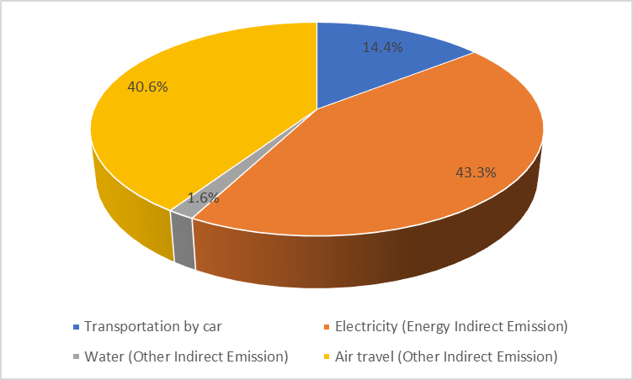
Figure19 Integrated Household Carbon Budget Across Three Years (unit: kgCO2e/year)

Discussion

This study completes a three-year household-scale carbon budget by integrating aboveground vegetation carbon, Net Primary Productivity (NPP), belowground soil carbon storage and household greenhouse gas emissions. By examining these components together within a single residential ecosystem, the research provides a comprehensive assessment of how human activity and natural carbon storage interact at the household level.
The dominance of large trees in aboveground carbon storage observed in this study is consistent with findings from regional and global vegetation carbon assessments. Mature trees possess greater biomass, deeper root systems, and longer lifespans, allowing them to accumulate and retain carbon more effectively than shrubs and saplings or herbaceous plants. Although shrubs and saplings together with herbaceous vegetation contribute relatively little to total aboveground carbon storage, their role in ecosystem productivity remains important, particularly in maintaining soil structure, organic matter inputs and microclimatic stability.

The positive Net Primary Productivity recorded throughout the study period indicates that the residential ecosystem remained a net carbon sink. An increase in NPP of 240.1 gC/m² between Year2 and Year3 reflects continued biomass accumulation and suggests that even unmanaged residential vegetation can contribute to ongoing carbon sequestration. However, NPP alone does not equate to carbon neutrality, as the rate of carbon uptake remains small relative to household emissions.

One of the most significant findings of this study is the substantial contribution of belowground soil carbon to total ecosystem storage. When measured across multiple depths, soil organic carbon accounted for approximately 20-48% of total ecosystem carbon storage. This highlights the critical role of soils as long-term carbon reservoirs and demonstrates that assessments focusing solely on aboveground vegetation substantially underestimate ecosystem carbon storage capacity. The cumulative contribution of deeper soil layers further emphasizes the importance of considering soil mass and bulk density, rather than surface organic matter concentration alone.

Despite the inclusion of both aboveground and belowground carbon storage, the residential ecosystem was unable to offset household greenhouse gas emissions. This persistent imbalance underscores a key limitation of nature-based solutions at the household scale. While vegetation and soil provide meaningful ecosystem services, their sequestration capacity is constrained by land area, growth rates, and ecological limits. These findings suggest that relying solely on local carbon storage to counterbalance household emissions is unrealistic, even in well-vegetated residential settings.

The comparison between ecosystem carbon storage and household emissions reinforces the importance of integrating emission reductions with carbon sequestration efforts. Energy consumption, transportation and air travel contributed disproportionately to the household’s carbon footprint, overwhelming the relatively slow and limited rate of biological carbon accumulation. This imbalance illustrates the asymmetry between rapid carbon release through human activity and the gradual process of carbon sequestration in natural systems.

Several limitations should be acknowledged. Soil carbon measurements were constrained by sampling depth and spatial heterogeneity, which may introduce uncertainty in total belowground carbon estimates. Additionally, the study site represents a single residential ecosystem and results may vary under different climatic, soil or land-use conditions. However, the multi-year design and consistent methodology strengthen the reliability of observed trends and allow meaningful comparison across time.

Conclusions

This research demonstrates that residential ecosystems can store significant amounts of carbon in both vegetation and soil, with belowground carbon representing a substantial and often overlooked component of total ecosystem storage. Large trees play a dominant role in aboveground carbon sequestration, while soils act as long-term carbon reservoirs that stabilize and retain organic carbon over time.

However, the findings also reveal a clear limitation. Even when carbon storage is measured comprehensively, household greenhouse gas emissions far exceed the sequestration capacity of a residential ecosystem. This imbalance highlights the necessity of prioritizing emission reductions alongside ecosystem-based carbon storage. Nature-based solutions, while valuable, cannot substitute for reductions in fossil fuel use, energy consumption and high-carbon behaviors.

By completing a three-year household-scale carbon budget, this study bridges the gap between global carbon cycle concepts and everyday human activity. It emphasizes that climate action must be approached as an integrated system, where behavioral change, policy intervention, and ecosystem protection work together. Understanding carbon at the scale of one household provides a tangible framework for translating global climate challenges into locally meaningful action. Ultimately, this research underscores that living sustainably requires more than planting trees. It requires rethinking how carbon flows through both natural ecosystems and human lifestyles.

Bibliography/Citations:
Batjes, N. H. (2014). Total carbon and nitrogen in the soils of the world. European Journal of Soil Science, 65, 10–21.

Chhabra, A., Palria, S., & Dadhwal, V. K. (2003). Soil organic carbon pool in Indian forests. Forest Ecology and Management, 173(1-3), 187–199. https://doi.org/[DOI if available]

Chonradee Chuayruang, Siwaporn Plodkanthong, and Katathong Tanwetchakul (2023). The Study of Relationship Between Type of Intercropping and Soil Characterization of Rubber Plants Affecting Latex Quantity (Science and Environmental Research of the Science and Technology Promotion Institute/Wichienmatu School), Trang, Thailand.

Christina Davies Waldron (USA) (2006). 2006 IPCC Guidelines for National Greenhouse Gas Inventories, Volume 2 Chapter 3 Mobile Combustion

Colbert A and Younger S (2024, Jan 12). Five Factors to Explain the Record Heat 2023. Retrieved from NASA. https://earthobservatory.org/images/152313/five-factors-to-explain-the-record-heat-in-2023

Deng, S., Wang, G., Liu, S., Wei, X., Zhang, Z., & Yu, Z. (2010). A GIS-based approach for quantifying and mapping carbon sink and stock values of forest ecosystem: A case study. Ecological Economics, 69(7), 1408–1416. https://doi.org/[DOI if available

Dunning, Hayley (2018, Jul 20) How Plants Use Carbon Affects Their Response to Climate Change”, Imperial College London

Field, C. B., et al. (1998). Primary production of the biosphere: integrating terrestrial and oceanic components. Science, 281(5374), 237–240.

ISO 14064-1:2006, Greenhouse gases – Part 1: Specification with guidance at the
organization level for quantification and reporting of greenhouse gas emissions and
removals

Jobbágy, E. G., & Jackson, R. B. (2000).
The vertical distribution of soil organic carbon and its relation to climate and vegetation.
Ecological Applications, 10(2), 423–436.

Kenward, Alyson (2011, July 20) Climate Change May Make Carbon Sinks Less Effective, Studies Say. Retrieved from Climate Central: https://climatecentral.org/news/forests-and-oceans-help-store-carbon-but-are-vulnerable-to-climate-change

Kornwit Namuang, Tongta Reunrunwong, and Ittaya Yingnok (2023). The Study of Relationship Between Soil Organic Matter and Soil Characterization (Science and Environmental Research of the Science and Technology Promotion Institute/Phimai Wittayalai School), Phimai, Thailand.

Myles R. Allen, et al. (2022). Net Zero: Science, Origins, and Implications. Annual Review of Environment and Resources, Vol47: 849-887

Nicha Thachuen and colleagues (2022) Carbon Sequestration in Trees at Darawittayalai School Area (Science and Environmental Research of the Science and Technology Promotion Institute/School Darawittayalai), Chiang Mai.

Nowak, D. J., & Crane, D. E. (2002). Carbon storage and sequestration by urban trees in the USA. Environmental Pollution, 116(3), 381–389.

Prayada Saratnont and Thanyarat Sapasin (2023) A Study of Biodiversity of Outstanding Tree Species at Chulabhorn Royal Academy Science School, Trang, in Relation to Carbon Sequestration Quantities (Science and Environmental Research of the Science and Technology Promotion Institute/Chulabhorn Royal Academy Science School), Trang.

Ramkumar Shakti. (2019, Dec 1) Greenhouse Gas Emissions https://studentenergy.org

Sangay Choden and Yeshey, et al. (2024) A Comprehensive Investigation on Carbon Storage in the Vegetation of Our Schoolyard and Determining the Carbon Footprint of the School through the Measurement of Carbon Using GLOBE’s Carbon Cycle Protocols (Pelrithang Higher Secondary School), Sarpang, Bhutan

The GLOBE Program. (2022). Biometry Protocol Tree Circumference Field Guide. The GLOBE Program.

The GLOBE Program. (2022). Biosphere Carbon Cycle Introduction. The GLOBE Program.

The GLOBE Program. (2022). MUC Field Guide A Key to Land Cover Classification. The GLOBE Program.

The GLOBE Program. (2022). Non-Standard Site Carbon Cycle Protocols. The GLOBE Program.

Badge Descriptions/Justifications:

 | I AM A DATA SCIENTIST  This study applies a multidisciplinary data-driven approach by integrating datasets from the GLOBE Carbon Cycle, Biometry, and Pedosphere Protocols alongside household greenhouse gas emissions calculated using ISO 14064-1:2006 standards. Data were normalized across spatial and temporal scales to enable direct comparison between aboveground carbon, belowground soil carbon, Net Primary Productivity, and carbon footprint values. This analysis allowed meaningful inference on carbon dynamics and supported data-informed recommendations for reducing emissions.
 | I AM AN EARTH SYSTEM SCIENTIST  This research investigates carbon flows and storage across interconnected Earth systems by examining carbon sequestration in plant biomass (biosphere), soil organic carbon accumulation (pedosphere), and anthropogenic emissions from household activities. By linking carbon stocks and fluxes across these systems, the study demonstrates how natural processes operate on longer timescales that are mismatched with rapid human-driven carbon release, highlighting the complexity of the Earth system carbon cycle.
 | I MAKE AN IMPACT  By identifying a clear discrepancy between household greenhouse gas emissions and the carbon storage capacity of vegetation and soil, this research directly informed lifestyle and behavioral changes aimed at reducing emissions. The quantified carbon gap guided actions such as emission reduction efforts and verified carbon offset purchases, enabling the transition toward net-zero status. This study demonstrates how scientific evidence can drive measurable, real-world climate action at the household level.
 | I AM A PROBLEM SOLVER  This research addresses the real-world challenge of household-level carbon imbalance by quantitatively evaluating whether ecosystem carbon storage can offset personal greenhouse gas emissions. By completing a three-year carbon budget integrating vegetation, soil, and emissions data, this study identifies the limits of nature-based carbon sequestration at the residential scale and informs evidence-based decisions on where emission reductions are most urgently required.

