Investigating Mosquito Habitat Preferences
For Tree Canopy Or Building Shade
In Urban Environments

Simoni Khare, Alexandra Dziaba, Priyanka Sadagopan, John Simkin,
Sarah Park, Moho Goswami, Arnav Deol, and Megha Sharma

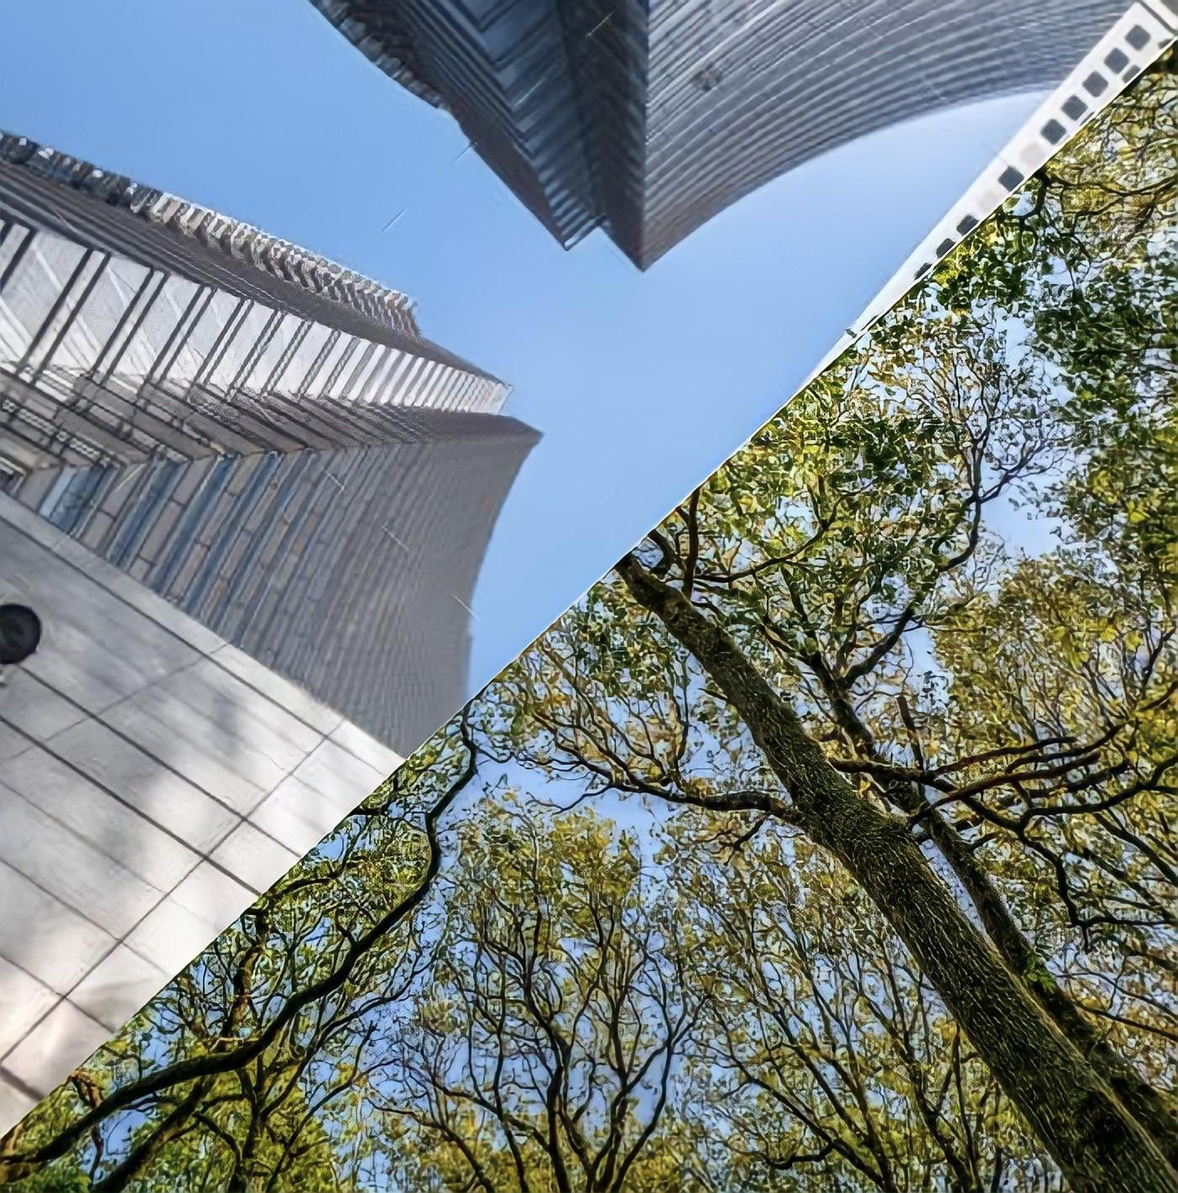

ABSTRACT

The world’s population continues to grow, with much of the growth occurring in urban areas. This increase in urban population growth is problematic as urban settings are ideal for the spread of mosquito-borne/vector diseases. Thus, it is vital to understand the habits underlying mosquito breeding to prevent or minimize the spread of disease. In this study, we examine whether mosquitoes, when ovipositing, prefer habitats in building shade or tree canopy shade. By setting our traps here, we also explore if mosquitoes prefer the hotter or cooler end of the heat spectrum in cities. The study consisted of setting up 4 or 6 mosquito larvae traps, made out of two-liter soda bottles cut in half with black surfaces and grass clippings as bait, in various cities: Austin, Texas; Frisco, Texas; McLean, Virginia; Colorado Springs, Colorado; Edison, New Jersey; Alameda, California. Half of the traps were in building shade and the other half were in canopy shade. After three days, the traps were observed for data collection, and if present, larvae were counted and logged via the GLOBE Observer app. We then utilized ArcGIS and spreadsheets to visualize our data. The results suggest that there is a greater number of mosquitoes breeding in habitats under canopy shade rather than building shade. To further expand our knowledge regarding habitats preferred by mosquitoes, we could observe a greater number of locations to determine if other factors, rather than shade location, impact mosquito ovipositing. A supplementary study could investigate if mosquitoes prefer tree canopies for oviposition because they consume foliage or sap.

Keywords: Urban heat islands, heat spectrum, oviposition, tree canopy, building shade

RESEARCH QUESTION

- Do mosquitoes have an oviposition preference for tree canopy or building shade in urban environments?
- Does this preference vary by state?
- Do disease-carrying mosquitoes breed in urban environments?

Given that the percentage of the world’s population located in urban areas is expected to continue to increase, it is vital to analyze the impact of urban environments on mosquito breeding habitats. Because mosquito or vector-borne diseases can thrive in urban environments, a key issue to be evaluated is the preferences of mosquitoes' oviposition concerning shadowed regions of different land covers in urbanized areas. City parks and buildings characterize urban areas, and mosquitoes will seek the shade created by them to oviposit in. Thus, our main guiding research question was whether mosquitoes in urban areas prefer to lay eggs in the shade of a tree canopy or building.

Multiple factors play into oviposition preference, however - not just shade type. Since climate and latitude take on significant roles in mosquito abundance, our group knew that to ensure shade was the spotlighted factor in our experiment we had to create a model that investigated mosquito breeding habits in several locations with varying climates. This posed the question: does climate or latitude affect mosquitoes’ preference for tree canopy or building shade?

INTRODUCTION AND REVIEW OF LITERATURE

Vector-borne diseases pose a significant threat to society, especially with the increasing impact of both climate change and urbanization on the globe. Though The National Malaria Eradication Program has virtually eliminated malaria in the United States (“Elimination of Malaria in the United States (1947 — 1951),” cdc.gov), other vector-borne diseases, such as West Nile Virus and Dengue, are susceptible to transmission in the continental United States (“Mosquitoes in the United States,” cdc.gov). Climate change and urbanization provide a common element impacting mosquito breeding: i.e., heat. The relationship between heat and mosquito-transmitted diseases is complicated. On one hand, increasing temperatures catalyze larval development, producing small adult mosquitoes at a high pace, but these smaller vectors are often characterized by lower fertility and blood meal size (Franklinos, Lydia H, et al. 303-304). However, the effect of heat on vector-borne disease varies vastly between species. In some genera, higher temperatures suggest short incubation and high infection and transmission rates, but in the Aedes genus, low temperatures procure those results. Since there are multiple factors and species that play into vector-borne infection rates, more research needs to be conducted. It is because of these discrepancies in the relationship between heat and mosquito infection that every new study is important to expand our understanding of how climate change is likely to impact vector-borne disease.

Our group’s project investigates a more specific aspect of how heat and urbanization affect mosquito habitats, particularly in urban heat islands. Urban heat islands (or UHIs) are a phenomenon where cities have a warmer climate than their surrounding rural or suburban areas, caused by (but not limited to) infrastructure that traps heat by day and releases it at night, lack of vegetation, and waste heat (Luvall et al. 311). Taking the knowledge about heat and mosquitoes into account, our group decided UHIs are worth exploring. Moreover, the United Nations have predicted that by 2050, 68% of the global population will be living in urban areas, making this area of research all the more relevant (“68% of the world population projected to live in urban areas by 2050, says UN,” un.org). To better understand urban heat islands, envision a heat spectrum that represents the temperature range in a city: areas with more vegetation and less infrastructure such as city parks will have cooler temperatures as compared to areas congested with buildings, people, and pavement. We chose to investigate if mosquitoes prefer to oviposit under the shade of a tree canopy or a building in urban environments because these two locations are on different locations on the heat spectrum, while still providing the shade in which mosquitoes prefer to lay eggs. 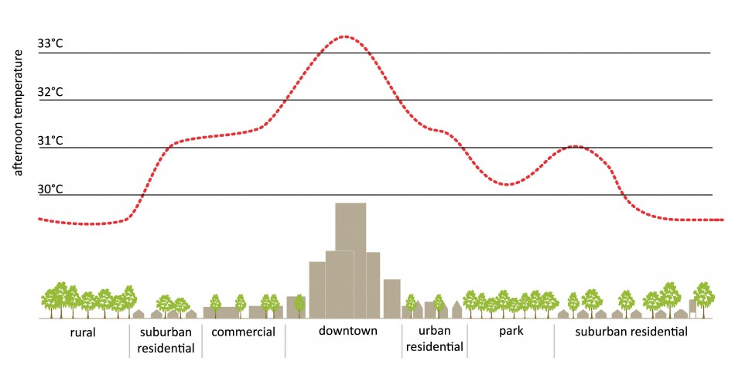
Picture credit: “Urban Heat Island.” Urban Green-Blue Grids for Resilient Cities, EPA, UHI Basics, 2008, www.urbangreenbluegrids.com/uploads/HeatIsland-naar-EPA-eng-950x476.jpg.

RESEARCH METHODS

Planning The Project
Our group had study sites in Austin, Texas; Frisco, Texas; McLean, Virginia; Colorado Springs, Colorado; Edison, New Jersey; Alameda, California; and Troy, Michigan. Austin, Texas was hot and sunny with frequent but very short rainstorms. Frisco, Texas was hot and very humid with completely sunny weather. McLean, Virginia was hot and humid. Colorado Springs, Colorado was unnaturally hot and dry with a bit of rain in the evening. Edison, New Jersey was warm and cloudy with slight rain at night. Alameda, California was hot and sunny and only slightly cloudy. Data was collected around three days after setting up the traps.

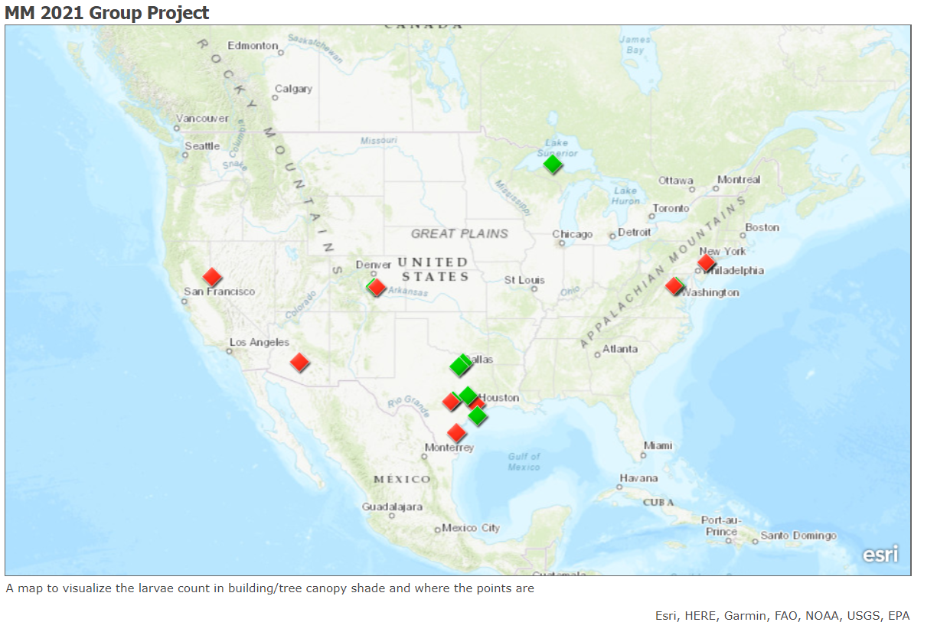
Carrying Out The Plan
To set up the experiment, our group each set up 4-6 mosquito larvae traps in urban areas in our respective cities, which included: Austin, Texas; Frisco, Texas; McLean, Virginia; Colorado Springs, Colorado; Edison, New Jersey; Alameda, California. Half of these traps were under a leafy canopy cover (trees/bushes/etc), and the other half remained under the shadow of a building. Other than shade, all the traps were structured the same - made from a 2-liter soda bottle cut in half and colored black (via spray paint or wrapping something black on the outside of the trap). All the traps also contained grass clippings for bait, to ensure the setup of the traps remained constant throughout the experiment. Then, we let these traps sit for three days undisturbed before checking for hatched larvae in the traps and noting down the number of larvae observed before eliminating the traps to avoid the breeding of adult mosquitoes. Additionally, we accessed data from other SEES interns from the GLOBE Observer Mosquito Habitat Database to create sitemaps using ArcGIS so we could analyze where mosquitoes bred under building shade and canopy cover.

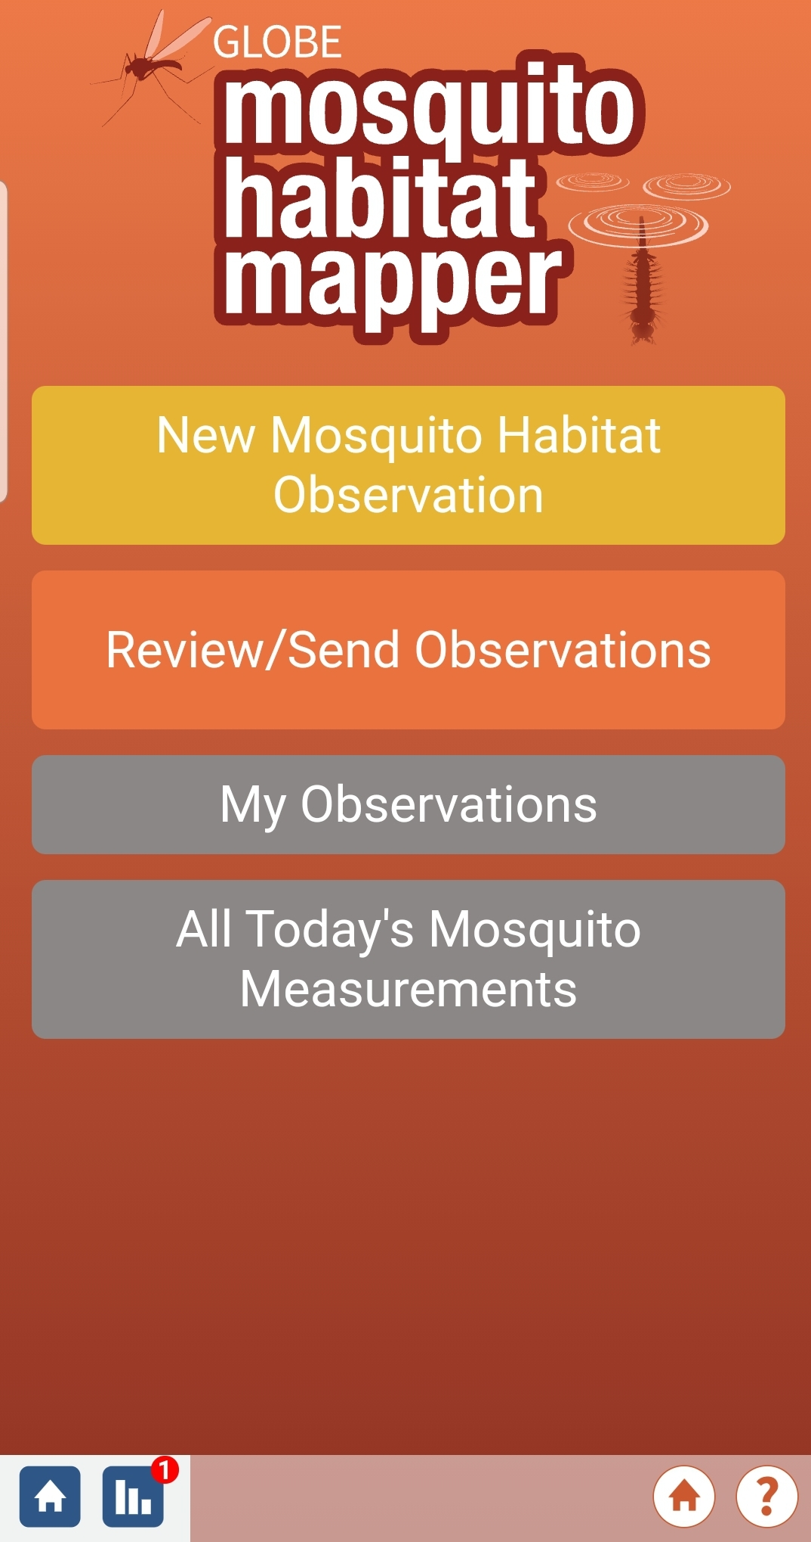

RESULTS

State | Tree Canopy | Building Shade
Arizona | n/a | 18
California | 0 | 0
Colorado | 0 | 0
Michigan | 36 | n/a
Nevada | n/a | 0
New Jersey | 0 | 0
Texas | 95 | 24
Virginia | 16 | 0

Figure 1
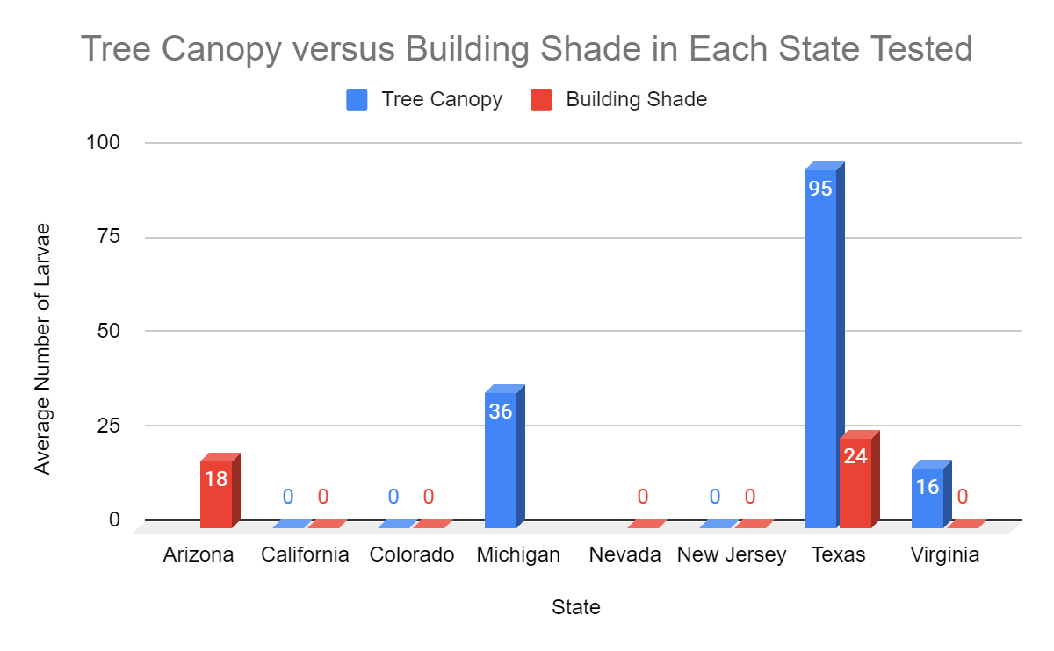
Figure 2

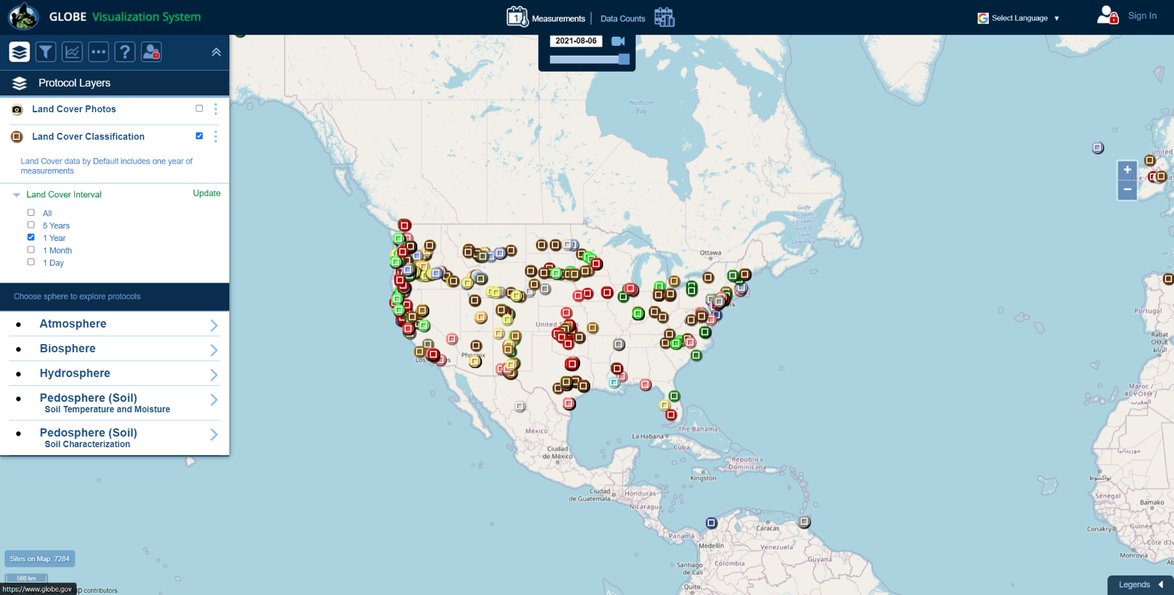

DISCUSSION

Looking at figure 2, it appears that mosquitoes prefer tree canopy shade overbuilding shade. This is not the result that was expected; we had theorized mosquitoes would oviposit in building shade more because mosquitoes bearing vector-borne diseases have recently increased in urban environments. This experiment is of importance to society as well as the scientific community. The results can alert those living in urban areas about the mosquito danger zones and what areas or actions to avoid to protect oneself, thus allowing scientists to better understand mosquitoes in urban areas and create new ways to mitigate the spread of vector-borne diseases. However, there are a wide variety of characteristics individual to a specific city. This alone can cause a discrepancy in the data collected as some cities are better suited for mosquitoes, regardless of shade type.

The overall results found during this experiment are inconclusive. Our sample size was small as well; we set 4-6 traps in only 5 states in which ⅗ had no comparable data due to zero larvae in both shade locations. Moreover, the short duration of time allowed for the mosquitoes to breed (3 days) was an insufficient incubation period for the majority of the trap locations.

An apparent drawback in our experiment was the human element; because all of our traps were set in an urban environment, they were exposed to the potential threat of humans disposing of or tipping over the traps. Four out of the thirty-four traps our team set up had either no water or were missing altogether, and though this was disheartening, we learned from one of our mentors, Dr. Low, that “zeroes are data too,” meaning that what initially appeared as a failed trap contributes to our research as much as the other traps. Additionally, one way we could interpret this error is that humans may destroy traps by tipping over containers full of still water in urban areas, so common civilian interference can be classified as a factor reducing mosquito habitats.
This study was built off the studies performed by Luvell on Urban Heat Islands and Kavita Kar on the effect of the socioeconomic factors on vector-borne diseases. The socioeconomic factors affect the number of skyscrapers and greenery causing a change in the heat spectrum of a city. With the expansion of UHIs, it is important to see how different variables affect mosquito oviposition. As cities continue to grow the number of man-made structures will too. Since mosquitoes prefer warmer climates yet tend to oviposit under shade due to perceived safety, it aides mosquito studies to identify the preferences of mosquitoes when it comes to types of shade (tree canopy versus building shade). Shade is only one (1) socioeconomic factor in UHIs that can affect mosquito oviposition. In the future scientists must study other factors, such as population density and building material, to better understand mosquitoes to limit and even stop the spread of vector-borne diseases.

CONCLUSION
In all, the experiment was unable to accurately answer the main research question due to the lack of comparable data and the limitations placed on the experiment. These limitations, primarily those of time and sample size, unfortunately, restricted our research team’s ability to holistically answer our research question. While one of our mentors, Rusty, said “zeros are data,” zeros across most of the locations imply that the type of shade is negligible yet the data from Texas and Virginia shows otherwise. This paper’s findings, while inconclusive, still provide data and a sound process for future researchers to investigate the same topic. In the future, this experiment would be more accurate if performed in numerous locations over a greater time frame. For example, we could set mosquito traps in an area of interest grid at both shaded locations, sustained and collected for a month in each season. Another improvement to the experiment would be to compare similar cities as all cities do not have the same effect on mosquito populations. This experiment is relevant today due to the fact that the percentage of people in urban areas is expected to increase causing vector-borne diseases that thrive in urban heat islands to affect a greater number of the population.
Working with project mentors during this experiment helped in reaching out to other interns interested in similar ideas and helped focus our attention on a specific experiment. Our team reached out to Dr. Allison Parker, Dr. Russanne Low, Peder Nelson, and Kavita Kar. Dr. Parker provided guidance regarding the setup of the experiment. She advised us to use the same type of bait and contact local public health departments or mosquito research teams to obtain permission to set up traps. She also suggested placing traps behind statues or similar heavy, unmovable objects to keep them out of the line of sight of pedestrians and placing the NASA logo on them to maintain a more official appearance. Dr. Low suggested uses for the data and tools available to have a more fully developed project. Peder Nelson provided insight into specific factors in urban areas to investigate and helped our group decide on comparing types of shade. Additionally, he provided tips on how to incorporate coding into our project. Kavita Kar provided her 2020 research paper, “The effect of poverty on mosquito-borne illness across the United States”, to help us understand how socioeconomic factors intersect with mosquito populations and vector-borne disease. Our four project mentors greatly assisted us in narrowing down the focus of our research, designing and implementing a scientific experiment, and the overall implementation of our research idea.
GLOBE IVSS Badges

Be a Data Scientist
Data utilized in this research derived from our team members’ experiments with mosquito traps in shaded regions as well as mosquito habitat mapper data from other SEES interns collected through the GLOBE Observer app. Many of the team experiments yielded zero larvae, possibly owing to the limited duration of the experiment at three days, external factors such as humans or animals interfering with traps, mosquito prevalence in an area, and mosquito habitat preferences. Additionally, data taken from the GLOBE database did not include results for both tree canopy and building shade for each location - Arizona, Nevada, and Michigan. Only traps in Texas contained mosquito larvae under both building shade and tree canopy shade. In total, more larvae were found under tree canopy shade than under building shade. This may suggest that mosquitoes prefer natural ecosystems that contain more greenery for egg-laying.

Make an Impact
Our members all reside in or near metropolitan areas, thus the environmental and health threats associated with the urban heat island effect impact our local communities. Knowing that mosquitoes prefer tree canopy shade over building shade affects the health of these cities’ residents, as well as the billions of people that will move into urbanized areas as time progresses.

ACKNOWLEDGMENTS

Thank you to Rusty, Peder, and Cassie, our amazing mentors who answered all our questions and provided the sources of our information- we appreciate you! We would like to give a special thanks to Peder as well for helping us come up with our area of study.

Simoni Khare designed and set up the experiment, wrote the Introduction and Literary Review and a portion of the Research Questions, peer-edited many other sections, designed the layout and visual theme of the research paper, and participated in setting up mosquito traps for the project’s data collection process. Simoni is credited for being team lead, recruiting the group members, and planning and scheduling group meetings. Through this project, Simoni gained leadership skills and a love for earth science and is now considering a career in NASA.

Alexandra Dziaba helped write the discussion and conclusion as well as created the figures in the results. Alexandra also participated in the mosquito trap set up, the creation of the results, and concluding slides. Alex created the results, discussion, and conclusion sections on the poster and helped edit the poster. Alexandra also participated in the filming of the video. Alexandra learned how to utilize software like the Globe observer app and ArcGIS. During this project, Alexandra gained communication skills and connections with experts in the Earth and Space field.

Priyanka Sadagopan wrote the majority of the Abstract and part of the Procedures section, participated in mosquito trap set up for the data collection process, formatting the majority of the slide deck, and editing the summary video. Priyanka learned about new software, such as ArcGIS and Collect Earth Online, and how they correlate with data collection and analysis and is now sure that engineering is a good field for her.

John Simkin wrote and edited The Research Question, along with editing of the Abstract and Introduction. In addition, John researched the vector-borne diseases that could be carried by mosquitoes captured in Virginia.

Sarah Park set up mosquito traps for the project’s data collection process and wrote the Planning the Project section of the research paper and poster. She also assisted with the filming of the presentation video. Through working on this project, Sarah learned about new software, like ArcGIS, and how software can be used as tools to learn more about our surrounding environment. She was also able to strengthen her communication and collaboration skills through working on this project. Sarah is now confident in her STEM abilities and how she can use them to execute a science experiment and write a research paper sharing her findings.

Moho Goswami set up mosquito traps to obtain data for the experiment. She also wrote the GLOBE IVSS Badges section, edited the Conclusion, helped edit slides for the video, and came up with the project title. Moho learned how programs such as GLOBE Observer, ArcGIS, and Collect Earth Online can be used to study land cover and mosquito habitats. She also solidified her interest in pursuing a career in earth science.

Arnav Deol set up traps to collect data throughout the experiment in accordance with the research question. Additionally, he edited the paper and poster and assisted with the filming of the video. Through the research process, Arnav learned how to leverage new software in order to explore research questions, and built the skills necessary to succeed in our new, interconnected world.

Megha Sharma contributed to the paper and set up traps to record mosquito data. She edited the research paper and filmed portions of the video. Megha learned how to effectively use Python to create data maps and learned the process of writing a research paper. Now she can use these skills to continue her passions in research and contribute to further scientific findings.

BIBLIOGRAPHY/CITATIONS
- “CDC - Malaria - about Malaria - History - Elimination of Malaria in the United States (1947-1951).” Centers for Disease Control and Prevention, Centers for Disease Control and Prevention, 23 July 2018, www.cdc.gov/malaria/about/history/elimination_us.html.
- Franklinos, Lydia H, et al. “The Effect of Global Change on Mosquito-Borne Disease.” The Lancet Infectious Diseases, vol. 19, no. 9, 2019, doi:10.1016/s1473-3099(19)30161-6.
- Khare, Simoni, et al. “MM 2021 Group Project.” Igestrategies.maps.arcgis.com, igestrategies.maps.arcgis.com/.
- Low, R., Boger, B., Nelson, P. and Kimura, M. (2021). GLOBE Observer Mosquito Habitat Mapper Citizen Science Data 2017-2020, v1.0. https://observer.globe.gov/get-data/mosquito-habitat-data
- Luvall, J.C., Quattrochi, D.A., Rickman, D.L., Estes Jr., M.G., 2015. Urban Heat Islands. In: Gerald R. North (editor-inchief), John Pyle and Fuqing Zhang (editors). Encyclopedia of Atmospheric Sciences, 2nd edition, Vol 1, pp. 310–318. ISBN: 9780123822253.
- “Mosquitoes in the United States.” Centers for Disease Control and Prevention, Centers for Disease Control and Prevention, 5 Mar. 2020, www.cdc.gov/mosquitoes/about/mosquitoes-in-the-us.html.
- “68% Of the World Population Projected to Live in Urban Areas by 2050, Says UN | UN DESA Department of Economic and Social Affairs.” United Nations, United Nations, 16 May 2018, www.un.org/development/desa/en/news/population/2018-revision-of-world-urbanization-prospects.html.

