Can Atmospheric Measurements Explain the Damage from Hurricane Katrina and Hurricane Zeta?
Mason Easley, Nathaniel Mooney, Ava Poage, Michael Smith, Kaedon Anderson
Mrs. Melissa Wedel
Christian Collegiate Academy
United States
March 20, 2021

Abstract

Humidity, wind speed, and water temperature are some of the main components in severe weather events. Hurricanes are a major concern of tropical and subtropical coastal communities. Low-pressure systems over warm water can create strong hurricanes. The Atlantic hurricane season occurs from June first to November thirtieth each year. A hurricane begins with a tropical depression which is a tropical cyclone with winds of 38 mph or less. The next stage is a tropical storm which has a wind speed of 39-73 mph which can intensify into a hurricane with wind speeds of 74 mph or more. Hurricanes can become major hurricanes once their wind speed increases to 111 mph or higher. Looking at the damage to the Mississippi Gulf Coast from Hurricane Katrina and 2020's Hurricane Zeta, our team wanted to see if atmospheric measurements could help to predict the damage seen in these storms and other storms. Once a hurricane forms, the Saffir-Simpson Wind Scale helps to predict damage and rate the storm by wind speed into a category (NOAA, n.d.). While damage can be estimated or anticipated, atmospheric measurements alone cannot fully predict the damage in major storms like Katrina and Zeta. Since Hurricane Katrina, better tools have made narrowing the cone of impact better. These tools include better satellites with more frequent photos and supercomputers to better predict and model storm intensity, behavior, and track (Prociv, 2015).

Research Question and Hypothesis:

Research Question: Can atmospheric measurements predict and explain damage from Hurricane Katrina and Hurricane Zeta?

Hypothesis: That atmospheric measurements will be able to explain and help people predict the type of damage seen in both Hurricane Katrina and Hurricane Zeta.

Introduction and Review of Literature

 | Date(s) | mbar pressure | Wind Speed | Air Temperature | Water Temperature | Death/Damage
Hurricane Katrina  Category 2 | August 23-31, 2005 | 920 mbar | 174 mph | 82 F | 85 F | · 1833 fatalities  · 1245 – 1833 crimes  · 705 missing and presumed dead  · Cost $161 billion
Hurricane Zeta  Category 3 | October 24 to November 2, 2020 | 970 mbar | 110 mph | 73F | 77.5 F | · 8 fatalities  · 77 injuries  · Cost $3.5 billion

Hurricane Katrina hit Louisiana and Mississippi on August 29, 2005. With wind speeds of 120 mph, it was a category 3 hurricane that resulted in a high death toll and catastrophic property damage. The storm surge from Katrina was a big problem and significant flooding was caused not only by the storm surge but also by a breach in the levee system for New Orleans (Gibbens, 2019). The driving factors behind the damage from Katrina are storm surges, wind, tornadoes, and rainfall. This hurricane caused an estimated 1833 deaths and a cost of 161 billion dollars.
Hurricane Zeta left a lot of damage in Mississippi on October 28, 2020. The damage from the 110 mph winds looked a lot like tornado damage. Some people further north of the coast said that the storm caused more damage than Hurricane Katrina further north (Jeansonne, 2020). While weather reports do not confirm tornados, the hurricane-force winds were strong enough and created a path that was much like a tornado path (Jeansonne, 2020). The damage seen can be explained by the wind speed using the Saffir-Simpson Hurricane Wind Scale which uses wind speed to give the storm a category of 1 to 5. According to weather reports and the Saffir-Simpson Hurricane Wind Scale, Hurricane Zeta was a category 2 storm at landfall but there is some dispute that it had 112 mph winds making it a category 3 storm. A category 3 storm would cause devastating damage according to the scale (NOAA, n.d.).

Research Methods

Research methods included qualitative data from GLOBE atmosphere measurements at INFINITY Science Center in Pearlington, MS. The data was collected from 4/10/18 to 1/4/21. We used this data because it had a good date range for our team to look at to compare low barometric pressure reading and to be able to see if severe storms like thunderstorms, tornadoes, or hurricanes may have happened on any dates with low barometric pressure readings. Our team also looked at other weather data on the dates for Hurricane Katrina and Hurricane Zeta along with noting the Saffir-Simpson Hurricane Wind Scale (NOAA, n.d.). We also reviewed the literature to be able to answer the research question.
Our Biology teacher, Mrs. Melissa Wedel, taught us the GLOBE atmosphere protocol. We learned how to collect barometric pressure, air temperature, humidity, rainfall, rainwater pH, ground conditions, and to identify clouds that were at each level (low, mid, and high). Collecting data at our school helped us understand how to collect atmosphere data and what it meant for weather conditions. We were also able to see what our measurements were on stormy days versus clear days.

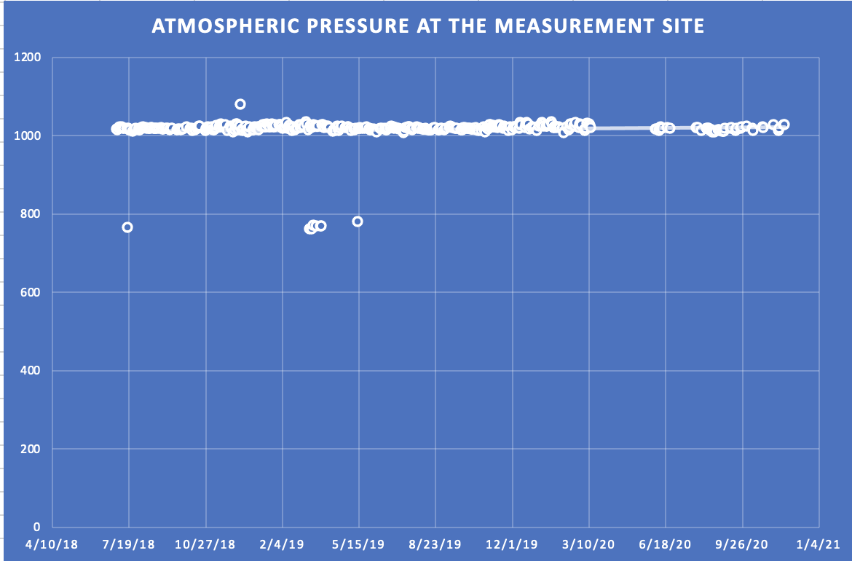

Chart of the barometric pressure readings at INFINITY Science Center created in excel using GLOBE atmosphere data recorded from 4/10/18 to 1/4/21.

The following dates on the trendline showed outliers (barometric pressure readings outside the usual range) in the barometric pressure:

● 7/17/18 - 765 mbar
● 3/11/19 - 762 mbar
● 3/14/19 - 763 mbar
● 3/20/19 - 769 mbar
● 3/25/19 - 769 mbar
● 3/26/19 - 769 mbar
● 5/13/19 - 780 mbar

Of those variables, only two were accompanied by rainfall. On 7/17/18 13 mm of rainfall is recorded and on 5/13/19, 76 mm of rainfall is recorded. The rainfall on 5/13/19 shows significant rainfall. The other dates with low barometric pressures may have been errors made during the atmosphere data collection. The Governor of Mississippi, Phil Bryant declared a state of emergency following heavy storms along the Gulf Coast of Mississippi with heavy rain and flooding on May 11th and 12th of 2019 (Floodlist, 2019). This matches the data recorded at INFINITY Science Center on May 13, 2019, showing that the barometric pressure had indicated an intense storm which was also shown by the amount of rainfall recorded at INFINITY Science Center.

Discussion, Results, and Conclusions

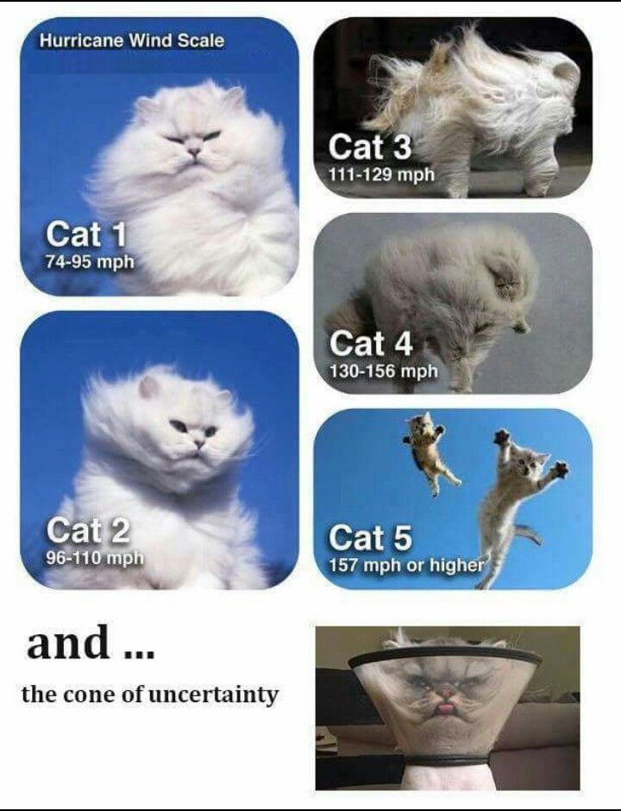

Photo Credit: Live Storm Chasers 2020, n.d. Categories of Hurricanes with Wind Speed.

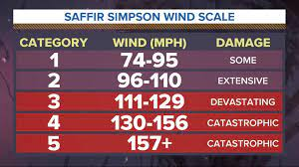
Photo Credit: Holt, 2020. Saffir-Simpson Hurricane Wind Scale with Expected Damage.

The Saffir-Simpson Hurricane Wind Scale can explain the different levels of damage and destruction based on wind speeds (Holt, 2020).

Humidity, wind speed, and water temperature are some of the main components in severe weather events. Hurricanes are a major concern of tropical and subtropical coastal communities. Low-pressure systems over warm water can create strong hurricanes (NOAA, n.d.).
The Atlantic hurricane season occurs from June first to November thirtieth each year. A hurricane begins with a tropical depression which is a tropical cyclone with winds of 38 mph or less. The next stage is a tropical storm which has a wind speed of 39-73 mph which can intensify into a hurricane with wind speeds of 74 mph or more. Hurricanes can become major hurricanes once their wind speed increases to 111 mph or higher. Looking at the damage to the Mississippi Gulf Coast from Hurricane Katrina and 2020's Hurricane Zeta, our team wanted to see if atmospheric measurements could help to predict the damage seen in these storms and other storms. Once a hurricane forms, the Saffir-Simpson Wind Scale helps to predict damage and rate the storm by wind speed into a category (NOAA, n.d.). While damage can be estimated or anticipated, atmospheric measurements alone cannot fully predict the damage in major storms like Katrina and Zeta. Since Hurricane Katrina, better tools have made narrowing the cone of impact better. These tools include better satellites with more frequent photos and supercomputers to better predict and model storm intensity, behavior, and track (Prociv, 2015).
In conclusion, better forecasts using better tools have helped to predict the damage that will come from hurricanes but being able to fully predict the outcome in dollars and loss of life is not an exact science.

References

ABC 13. (2020, August 29). Weather: Hurricane Katrina by the numbers. https://abc13.com/weather/hurricane-katrina-by-the-numbers/944320/
Jeansonne, E. (2020, November 2). Hurricane Zeta’s winds caused tornado-like damage: where the strongest winds occurred and why. WLOX. https://www.wlox.com/2020/11/02/hurricane-zetas-winds-caused-tornado-like-damage-where-strongest-winds-occurred-why/
Floodlist. (2019, May 13). USA – Flooding prompts Mississippi and Louisiana to declare a state of emergency. http://floodlist.com/america/usa/mississippi-louisiana-may-2019
Gibbens, S. (2019, January 16). Hurricane Katrina explained. National Geographic. https://www.nationalgeographic.com/environment/article/hurricane-katrina
Holt, A. (2020, May 20). Hurricane: Tropics Topics: The Saffir-Simpson Wind Scale. 3 News. https://www.kiiitv.com/article/weather/hurricane/tropics-topics-the-saffir-simpson-wind-scale/503-7ac121bf-ef3e-43ad-8492-aaf7c2912511
NOAA. (n.d.). Saffir-Simpson Hurricane Wind Scale. National Hurricane Center and Central Pacific Hurricane Center. https://www.nhc.noaa.gov/aboutsshws.php
Weather Spark. (n.d.). Average weather in West Gulfport Mississippi, United States. com https://weatherspark.com/y/12438/Average-Weather-in-West-Gulfport-Mississippi-United-States-Year-Round
Prociv, K. (2015, August 24). 10 years after Hurricane Katrina forecasts could save more lives. The Washington Post. https://www.washingtonpost.com/lifestyle/kidspost/10-years-after-katrina-better-forecasts-could-save-more-lives/2015/08/24/aaa07d9e-44f9-11e5-8e7d-9c033e6745d8_story.html

