Exploring Various Environmental Aspects and Determining Their Impact on Mosquito Populations for Eco-friendly Solutions

Avery Abramson, Sanjana Anand, Paige Bowman, Isabela Erfort, Aksh Iyer, Vishruth Konakanchi, Virginia Ogburn, and Haran Tekle

Global Learning and Observations to Benefit the Environment (GLOBE) Observer, National Aeronautics and Space Administration (NASA), NASA Johnson Space Center, NASA STEM Enhancement in Earth Science (NASA SEES), Texas Space Grant Consortium, The University of Texas at Austin
NASA Earth System Explorers, Mosquito Mappers
August 6th, 2021

Table of Contents
- Abstract ………………………………………………………………………………...p. 2
- Introduction and Review of Literature ……………………………………………....p. 3-4
- Research Questions…………………………………………………………………...p. 4-7
- What is the Impact of Water Properties on Mosquito Populations?
- What is the Impact of Type of Bait on Mosquito Populations?
- What is the Impact of Temperature on Mosquito Populations?
- What is the Impact of Air Quality on Mosquito Populations?
- Hypothesis …………………………………………………………………………...p. 7-8
- Variables ……………………………………………………………………………..p. 8-9
- Equipment and Materials …………………………………………………………...p. 9-10
- Research Methods ……...………………………………………………………….p. 10-11
- Observed Data and Results …….………………………………………………….p. 11-14
- Analysis of Data and Discussion ……………………..…………………………p. 14-17
- The Effects of Water Properties on Mosquitoes
- The Effects of Type of Bait on Mosquitoes
- The Effects of Temperature on Mosquitoes
- The Effects of Air Quality on Mosquitoes
- Sources of Error
- Conclusions ……………………………………………………………………….p. 17-19
- Acknowledgements …………………………………………………………………...p. 20
- Bibliography ……………………………………………………………………....p. 21-24
- Abstract
The purpose of this research project was to explore various environmental aspects and determine their impact on mosquito populations to find eco-friendly solutions for reducing the transmission of mosquito-borne diseases. Utilizing the NASA SEES GLOBE Observer 2021 data, four research questions were conceptualized: What is the impact of water properties on mosquito populations? What is the impact of type of bait on mosquito populations? What is the impact of temperature on mosquito populations? What is the impact of air quality of mosquito populations? These questions were investigated by analyzing data such as water turbidity and water container dimensions, nutritional density of mosquito habitats, temperature on mosquito developmental and growth cycles, and air pollutants on mosquito habitats. Trends observed in each research question through the NASA SEES Mosquito Mapper trap data were organized with Anaconda and MatLab, which were used to collect and categorize information. The results of this research can help regulate mosquito populations and prevent mosquito-borne diseases. Based upon the data collected, it was established that lower turbidity and smaller containers of water would deter mosquitoes, compared to higher turbidity and larger containers of water. Additionally, it was found that bait and water types of creek water, sugar, and tree bark dissuade mosquitoes from laying their eggs. Higher temperatures were also determined to increase mosquito egg mortality rates as well as accelerate the typical embryonation and larval growth periods. Finally, heavily polluted areas were found to correlate with an increase in mosquito populations, as it expanded their range of travel. While there was limited time to determine results, this data is anticipated to be used in future studies to discover eco-friendly methods for regulating mosquito populations and the spread of related disease.
Keywords: Mosquito, water properties, type of bait, temperature, air quality
- Introduction and Review of Literature
Removing standing water is essential to stopping the spread of mosquito vector-borne diseases. Water contaminated with organic matter such as leaves, animal waste, and grass allows for mosquito populations to grow extensively, as this matter provides excellent larval food sources. Sanitizing water with chlorine or other disinfectants is key in preventing the survival of mosquito larvae. Many governments have sanitation departments or wastewater treatment plants dedicated to this purpose. Eliminating all potential breeding sites is the most important strategy for solving this problem. Still bodies of water attract adult mosquitoes to lay their eggs. Ditches filled with water are also favorable for mosquitoes to lay their eggs. Mosquito larvae thrive in water conditions that are less than 0.6 meters deep. Removing these bodies of standing water or adding a feature, such as a fountain or waterfall, can effectively inhibit mosquito growth. Additionally, organisms such as bacteria, crustaceans, fish, and nematodes also help control mosquito populations and can be introduced into habitats.
Bacillus thuringiensis israelensis (Bti), an organic larvicide, is found as a bacterium in soil. It is able to stunt mosquito larvae development and therefore plays a considerable role in reducing mosquito populations. Due to its organic nature, Bti has been deemed as one of the least harmful larvicides that can be inflicted onto ecosystems; however, it is still able to administer notable harm on them when used to combat mosquito populations. It is also applied in areas that already attract mosquitoes, such as agricultural landscapes. It was favored to provide possible developments of attractive, eco-friendly mosquito larvicides through the data collected in this study not only to reduce mosquito populations, but do so in a way that would not interfere with other affairs such as farming, improving convenience. In order to do so, it is imperative to understand how a variety of baits impact mosquito populations.
Mosquitoes require specific temperatures to properly grow and develop. The dynamics of the various stages of a mosquito are greatly affected by the temperature. Mosquitoes are cold-blooded animals, meaning that their body temperature varies with the environment. The best temperature for a mosquito habitat is 27 degrees Celsius. At 16 degrees Celsius, they become lethargic, and at any temperature below 10 degrees, their functioning capabilities come to a stop. Mosquitoes thrive in warm and humid conditions; however, too much humidity can be fatal for them. An environment with heat and rainfall is ideal for mosquitoes, and many studies have found that malaria transmission was primarily influenced by environmental temperatures. The mosquito species Aedes Aegypti's most important predictor of distribution was temperature. It affects the hatching time for mosquito eggs and its viability. Colder temperatures trigger diapause in mosquito eggs. Temperatures affect mosquito development, reproduction, and the survival of mosquito larvae.
As temperatures rise, biting rates and the development of both viruses and mosquitoes increase. Pollutants in the air can affect mosquito populations in direct and indirect manners when they diffuse through elements such as air, soil, and water. Solid air pollutants, like dust and smoke, expand their range of travel. A mosquito in areas where there are high levels of air pollutants present will be able to spread any disease it is infected with at a higher rate than a mosquito that is in an environment with purified air. Mosquitoes in air polluted areas could endanger people because they would be able to expand their range of travel whilst carrying disease from previous locations. This is why scientists are working to decrease air pollution in areas that have a high rate of disease transmission.

- Research Questions
What Is the Impact of Water Properties on Mosquito Populations?
Two of the biggest factors in determining mosquito breeding sites are water turbidity and water container size. Turbidity is defined as the amount of murkiness in water. Water properties can be affected in multiple ways with higher or lower turbidites. The first impact of turbidity on water is the variations in temperature that it causes. The dust particles in the water absorb more radiation and heat from the sun, which causes an increase in water temperature.
In addition, higher turbidity causes increased darkness in the water due to a higher concentration of dust particles. The effects of water turbidity correlate with water container size and together impact where mosquitoes lay their eggs. In bigger containers of water, there are cooler water layers under the surface level. However, there can be variations in the temperature of the water when both container size and turbidity are taken into account. For example, a smaller container of water with high turbidity would not have any cooler layers because of its size; to elaborate, higher turbidity makes the water even warmer. On the other hand, a bigger container of water with high tubridy will not be as warm from the increased turbidity because there are cooler layers of water throughout the container.
With all of this in mind, mosquitoes will prefer a certain combination of water properties due to their instinctive behavior. In one of the experiments conducted, mosquitoes preferred laying their eggs in big containers of murky canal water. The main reason for this is because in bigger containers, there is less fluctuation in temperature, and mosquitoes prefer this because cooler temperatures give mosquito larvae more time to develop and grow. Additionally, mosquitoes prefer darker environments, which are caused by higher turbidity. They prefer these cooler areas and darker environments because if water gets too hot, effects could be fatal.
Overall, water properties have a large impact on the attractiveness of breeding sites. Although there was limited time to conduct research, correlations between attractiveness for mosquito breeding sites and water properties were found.
What Is the Impact of Type of Bait on Mosquito Populations?
Nutritional density is the ratio of nutrients to energy. An adequate amount of this in mosquito habitats is imperative for mosquito larvae to develop. A lack of nutritional density can result in failure of larval development, smaller adult sizes, and a compromised reproductive system for mosquitoes. It is essential to understand how nutritional density affects mosquito populations so a clearer understanding of how to mitigate against it can be refined. It also provides context for determining how different baits affect mosquito populations.
Other factors to consider when discussing nutritional density include carbohydrates and proteins. Depending on other circumstances, mosquitoes may prefer baits that contain more carbohydrates versus proteins or proteins versus carbohydrates, even if the nutritional density of different baits with such differing contents are equal. It should also be noted how certain mosquito larva diets can impair or improve their development. This can be taken advantage of when formulating a potential eco-friendly larvae bait; if it fails to stunt mosquito growth, it can at least hinder it and possibly debilitate their reproductive systems.
What Is the Impact of Temperature on Mosquito Populations?
During this study, it was deemed important to find the effects of external temperatures on mosquitoes. As the global climate continues to warm, this research will be vital in finding out how mosquitoes will react as temperatures rise. Mosquitoes are ectothermic, so temperature is known to have an effect on them as they gain heat from external sources.
Mosquitoes normally live in warmer climates and enter a state of diapause during cold conditions. During diapause, the mosquitoes’ metabolism slows, and glycerol is generated to replace some of the water in their systems. Because glycerol lowers the temperature at which fluids freeze, this new glycerol reduces ice forming within their cells, so damage cannot occur. This allows survival at much lower temperatures. It would take several days of sub-zero temperatures to kill most of them. Meanwhile, temperatures around 27 degrees Celsius are ideal for mosquitoes to reproduce and survive; most mosquito activity happens around this temperature.
What Is the Impact of Air Quality on Mosquito Populations?
The role of air pollution parameters on mosquito vector density has not been well addressed in the scientific literature. However, some studies have indicated that the presence of air pollutants interferes with the life cycle of mosquitoes, especially the Aedes Aegypti mosquito. It was established that air pollutants influence the lifespan, life cycle, travel range, and the rate of proliferation of mosquitoes. Specific air pollutants, Particulate Matter per 2.5 million (PM25) and Ozone (O₃), were the focus of this research.
- Hypotheses
It was hypothesized that mosquitoes prefer bigger containers of water with higher turbidity. Mosquitoes prefer higher variation of water temperatures, and bigger containers of water contain cool layers. This results in the preferred variation of water temperature between the surface level and lower levels of water. Additionally, turbidity increases the temperature of water, but bigger water containers keep the temperature comfortably varied for mosquitoes to lay their eggs. Together, higher turbidity and larger water container sizes create temperature conditions that are appreciable for mosquitoes to lay their eggs.
It is predicted that bait type will heavily impact mosquito reproduction. Nutritional density plays a large role in the development and life cycle of mosquitoes, and bait types with a high nutritional density will be best suited for healthy mosquitoes. Additionally, bait types within the traps that are abundant in nutritional density are expected to contain more mosquito larvae than bait types with less nutritional density. Of bait types that contain more nutritional density, it is predicted that those with higher carbohydrate content will better ensure the survival of mosquito larvae than bait types that contain higher protein content. Overall, this would result in denser mosquito larvae populations within mosquito habitats containing high nutritional density with an emphasis in carbohydrates.
It is predicted that varying temperatures will greatly affect mosquitoes’ reproduction and growth cycles. However, it is most likely that other environmental factors such as humidity, water properties, nutrients, vegetation, et cetera, will also play a significant role. In hotter temperatures, it is predicted that mosquitoes will become more active and lay more eggs than in cooler environments.
It is possible that air pollutant levels have a direct relation with mosquito populations, since they have denser populations in urban areas. However, other factors, such as water quality and host preferences, also come into play. Nonetheless, it is likely that air pollutant levels negatively influence mosquito population and growth since mosquitoes have shorter lifespans in polluted areas. The general effects of toxic pollutants on most living beings also reinforce the hypothesis that air pollutant levels inhibit the spread of mosquito activity.
- Variables
General independent variables included bait types, location, shade exposure, trap containers, water quality, et cetera. Bait types investigated in this study included alfalfa, algae, beef, cat food, dog food, fish bait, fish food, fruit pieces, grass, leaves, honey, lavender, pine needles, sugar, tree bark, and white clover. Some traps remained baitless as well, though it is assumed they garnered naturally-occuring baits overtime in order for mosquito larvae to thrive. Water types investigated in this study included clean water, creek water, grass water, and rice water. Traps were exposed to shade on three levels; full shade, periodic shade, and no shade. All trap containers were artificial and ranged from buckets, rain barrels, et cetera. Investigations took place all across the United States of America. They were also conducted in select areas of the Republic of India and the Republic of Korea. As such, this investigation was an international effort.
The amount of mosquito larvae was dependent on turbidity and water container size; mosquito larvae presence was also dependent on bait type. In this study, mosquito size and embryonation rate were dependent on the external temperature. Air pollution parameters, namely PM25 and Ozone, were used in this investigation as air quality indicators.
- Equipment and Materials
- Anaconda application
- Cellphones
- Computers
- Five 4-liter black buckets
- Five 19-liter dark blue buckets
- Five 9-liter black buckets
- Google Colaboratory
- GLOBE Observer application
- MatLab application
- One 2-liter artificial bottle
- One 89-liter brown rain barrel
- Python
- Stones
- Ten 31-centimeter wooden paint stirrers
- Universal Clip-type LED Cellphone Microscope
- Various baits
- Various water types
- Wooden sticks
- Research Methods
To explore water properties, different containers of water with water from different areas were set up. To assess the relationship between mosquito larva count with water properties and type of bait, data compiled from the GLOBE Observer application under the Mosquito Habitat Mapper tool by interns from multiple locations was analyzed. The interns set up multiple mosquito larvae traps using various bait and water types, while keeping the container, collection methods, and location of the traps constant. Mosquito larvae in the traps were counted and assessed, taking note of bait types and water properties that coincided with mosquito larva counts. The nutritional density of each bait and water type were not researched on their own; instead, their nutritional density was assumed based on the amount of mosquito larva present in each of the traps.
Throughout this study, it was important to use external sources along with conducting localized research. Because of the difficulties collecting data on temperature in such a short time frame, a majority of the data collected was online by reading other scientific articles and journals. Using the GLOBE Observer application, the NASA SEES 2021 interns were able to document other environmental factors that may have been interacting with the temperature to create excellent mosquito habitats.
In this project, the association between air pollution parameters on mosquito larva count observed using the GLOBE Observer application by interns at different locations was investigated. Larva count data was collected using different types of mosquito traps set up by the interns at different locations. PM25 values changed between the samples, as well as the Ozone levels, making the graphs inconclusive. However, further research allowed us to predict the future trends.
- Observed Data and Results
Python and Google Colaboratory were used to analyze the trend seen in the relationship between the PM25 value of air and the number of larvae found in the bait traps. The relationship between Ozone levels of air and the number of larvae found in the traps were also graphed. Microsoft Excel .csv dataset files were uploaded to a Google Colaboratory notebook and used the MatPlotLib, Locale, CSV, and NumPy libraries to draw the graphs depicting the trends in the relationship between the PM25 value of air and number of larvae observed, as well as the Ozone levels of air and number of larvae observed.
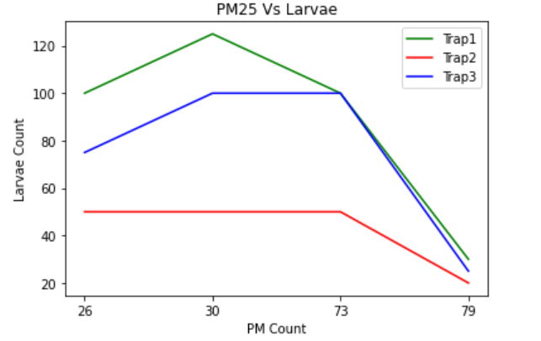
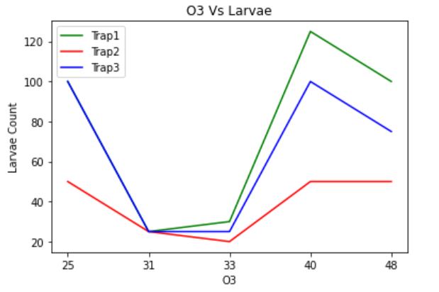
It can be observed that the change in the larvae count observed with the change in PM25 or Ozone levels is erratic. However, it should be noted that this is because of the remaining variables not remaining constant, rather than a lack of relationship between the independent and dependent variables taken. Further research is needed to help draw a proper conclusion on this matter.

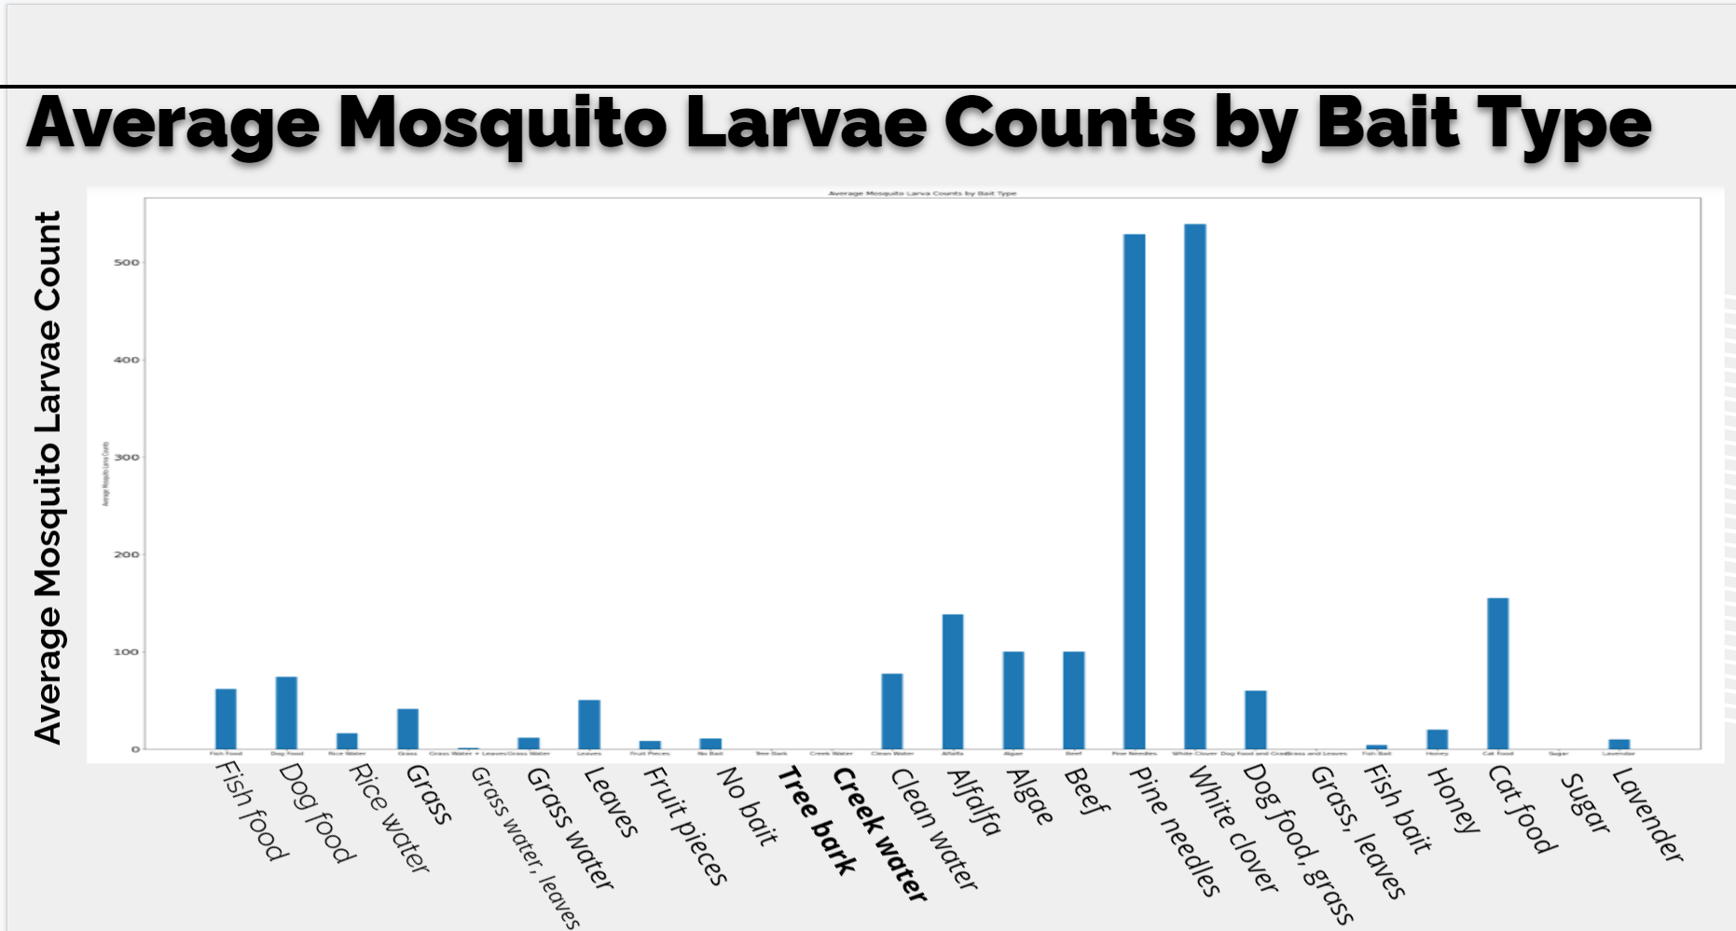
The results from the Mosquito Mapper Globe Observer 2021 data demonstrate that pine needles and white clover yielded the highest populations, reaching over 500 larva. Bait types such as tree bark, creek water, and sugar yielded the lowest result, attracting no mosquitoes.
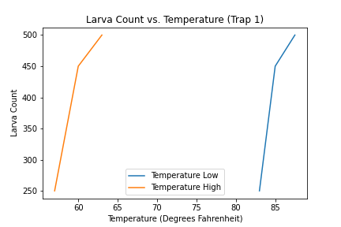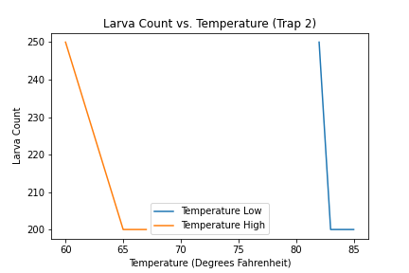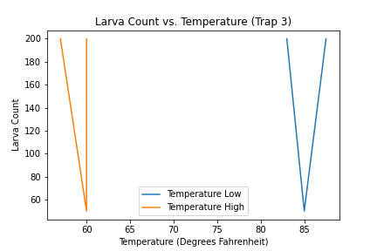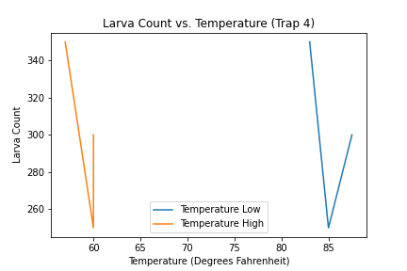
Research predicted that higher temperatures would attract a greater mosquito population. The data from our graphs vary, so it is inconclusive on whether temperature impacts the populations based on the Mosquito Mapper data.
- Analysis of Data and Discussion
The Effects of Water Properties on Mosquitoes
During the study of water property effects on mosquito populations, minimal data was collected. However, in one experiment where multiple types of water with different water properties were set out, correlations between attractiveness for mosquitoes and specific water properties were found. Through the experiment, it was found that mosquitoes prefer bigger water containers with higher turbidity.
The correlation found for this experiment was also supported in a research paper written by Krijn Paaijmans in 2008. In his paper, Dr. Paaijmans shows that mosquitoes prefer bodies of water with higher turbidites.
The Effects of Type of Bait on Mosquitoes
When laying their eggs, it appears mosquitoes consider the nutritional density of baits. Higher nutritional density in mosquito habitats result in larger mosquito larvae populations. According to data collected over the course of eight weeks, white clover attracted the most mosquitoes, while creek water, sugar, and tree bark attracted the least. When compared, it was determined that pine needles and white clover received a rating of excellent at attracting mosquitoes; alfalfa, algae, beef, and cat food received a rating of good at attracting mosquitoes; clean water, dog food, fish food, grass, and leaves received a rating of average at attracting mosquitoes; fish bait, fruit pieces, grass water, honey, lavender, no bait, and rice water received a rating of fair at attracting mosquitoes; and creek water, sugar, and tree bark received a rating of poor at attracting mosquitoes.
White clover has an equal amount of carbohydrates and protein, so it appears that mosquito larvae do not prefer an abundance of one macronutrient over the other. On the contrary, mosquito larvae may prefer baits with an equal content of both. White clover is very rich in both carbohydrates and proteins, though when compared to other baits, they do not compare; for example, beef contains much more protein, but much less carbohydrates in the context of ratio measurements. For baits that contained more nutritional density along with an equal amount of carbohydrates and proteins, it is unable to assess why these baits were not as successful as white clover with this data.
Adult mosquitoes are commonly nourished by substances containing sugar, so it is notable that mosquito habitats containing sugar did not contain any mosquitoes, let alone attract them. This could be due to external factors. Creek water and tree bark contain and host other organisms, so this could have potentially deterred mosquitoes from laying their eggs in mosquito habitats that contained these baits despite their nutritional contents. If this is the case, then mosquitoes prefer to lay their eggs in an environment secluded from other organisms, regardless of bait attractiveness.
The Effects of Temperature on Mosquitoes
Through this research, it has been shown that in higher temperatures, mosquito embryonation, larval growth, and pupal growth are faster; however, mosquitoes generally live for shorter spans and develop smaller bodies. In cooler climates, the mosquitos’ embryonation and larval growth is slower, yet they live longer and grow larger bodies. This is important because in female mosquitoes, size is directly related to fecundity. A study conducted by Hans Briegel in 2003 on the Aedes Aegypti mosquito said, “Blood consumption by large females was more than twice that of small females, but fecundity increased about 4-fold.” The study also concluded that “In large females, the gonotrophic cycle was completed in a significantly shorter period than in smaller ones that ingested blood of equal volumes.” Because temperatures affect the size that mosquitoes grow, temperature, in turn, affects the amount of eggs a mosquito lays.
Increased temperatures have also been associated with an increase in egg mortality due to greater desiccation in hotter areas. This will lead to more mosquito adults, and in turn, more disease transmission. As the global change in our climate continues, there will be larger habitable environments for mosquitoes and their larvae to survive in. As a result, there will be more mosquitoes to transmit diseases.
The Effects of Air Quality on Mosquitoes
Findings from investigating the effects of air quality on mosquito populations can be used to track a dengue outbreak, forecasting models utilising air pollution. In order to prevent dengue infection, which is transmitted by both Aedes Aegypti and Aedes Albopictus, a safe Ozone-producing air purifier could be utilized concurrently with other mosquito disease control methods.
Sources of Error
During research of water properties, it could be wrong to assume that trends observed in the experiment are true for all mosquito breeding sites. For example, the trend in higher turbidity being more attractive could be wrong because the exact amount of turbidity was not measured when making the assumptions.
It could be flawed to assume the nutritional density of baits in each mosquito habitat depending on the density of mosquito larvae present without accounting for external factors, such as shade and weather. Moreover, the amount of baits placed in each trap was not noted, nor was it a control. It could have also been more valuable to research the nutritional density of each bait type before conducting the study. This would allow for direct comparison regarding the correlation of nutritional density to mosquito larvae population, rather than assuming the nutritional density of each bait. Additionally, it could allow for comparison on external factors.
Due to the fact that this study was conducted during a two month period in the summer, there was no way to analyze the effects of cool temperatures on mosquitoes.
Ozone air-purifiers are not deemed to be safe for the human population. Further studies may reveal important instruments for environmental monitoring and the control of mosquito-borne diseases.
- Conclusions
Even though research on water properties' effect on mosquito populations is not complete, correlations were still found. Overall, it was found that turbidity and water container size affect the attractiveness of breeding sites for mosquitoes to lay their eggs. Specifically, higher turbidity and larger water containers attract more mosquitoes. With this in mind, it is possible to make these conditions less frequent and, in turn, decrease the amount of mosquitoes in a certain area.
Due to a limited time frame, this study is not complete. Correlations on mosquito larva presence and nutritional densities of baits could be assumed, but causations cannot be. As such, it is assumed that mosquitoes prefer to lay their eggs in isolated mosquito habitats with baits that are not only abundant in nutritional density, but contain an equal amount of protein and carbohydrates. On the contrary, it could also be assumed that mosquito larvae are able to thrive better in this environment (hence their abundance), and it could have no relation to how mosquitoes determine where to lay their eggs. Even so, it could potentially be assumed that both or neither are factors. However, further research would be needed to verify this. Nonetheless, it is hoped that by using this data in the future, we can modify highly effective baits to be used in mosquito habitats without leaving an impact on ecosystems to stunt mosquito growth. This will then help to stop the spread of mosquito-borne diseases.
It can be concluded through this research that temperatures influence mosquito embryonation cycles and the length of their larval and pupal stages, as well as their survival and maximum longevity. This will be important as the rising of global temperature continues at record rates, because there will be a rise in the number of mosquitoes. Additionally, the area that mosquitoes can survive in will expand. However, with an effective larvicide, these worsening effects of climate change can be reversed to help save many lives; over 830,000 people died of mosquito-borne illnesses in 2018 alone, and it is hoped that this study can prevent this death toll from increasing more.
The following conclusion has been made on the relationship between air quality and mosquito proliferation. Results from this study and further research into the matter indicated that PM25 and Ozone appear to have a negative correlation, showing that lower PM25 and Ozone values coincided with a higher number of larvae.

- Acknowledgments

Thank you to the NASA Earth System Explorers, Mosquito Mappers, and NASA SEES mentors (Margaret Baguio, Dr. Russanne Low, Celena Miller, Peder Nelson, and Cassie Soeffing) and peer mentors (Matteo Kimura and Aseel Rawashdeh).
This project included:
- Avery Abramson (Contributed, designed, researched, and wrote)
- Sanjana Anand (Contributed, designed, researched, and wrote)
- Paige Bowman (Coded, contributed, designed, researched, and wrote)
- Isabela Erfort (Contributed, designed, researched, and wrote)
- Aksh Iyer (Contributed, designed, researched, and wrote)
- Vishruth Konakanchi (Coded, contributed, designed, researched, and wrote)
- Virginia Ogburn (Contributed, designed, researched, and wrote)
- Haran Tekle (Contributed, designed, researched, and wrote)

- Bibliography
Air Quality Historical Data Platform. aqicn.org/data-platform/register. Accessed 30 July 2021.
Briegel, Hans. “Metabolic Relationship between Female Body Size, Reserves, and Fecundity of Aedes Aegypti.” Journal of Insect Physiology, Pergamon, 1 Oct. 2003, www.sciencedirect.com/science/article/abs/pii/002219109090118Y?via=ihub.
Drewnowski, Adam, et al. “A Proposed Nutrient Density Score That Includes Food Groups and Nutrients to Better Align with Dietary Guidance.” Nutrition Reviews, Oxford University Press, 1 June 2019, www.ncbi.nlm.nih.gov/pmc/articles/PMC6489166/.
“How Does the Change in Weather Affect Mosquitoes?” Mosquito Squad, www.mosquitoesquad.com/blog/2019/october/how-does-the-change-in-weather-affect-mosquitoes/.
Khairul, Ahmad, et al. “CORRELATIONAL ANALYSIS OF AIR POLLUTION INDEX LEVELS ON DENGUE SURVEILLANCE DATA: A RETROSPECTIVE STUDY IN MELAKA, MALAYSIA.” ResearchGate, Dec. 2020, www.researchgate.net/publication/346655125_CORRELATIONAL_ANALYSIS_OF_AIR_POLLUTION_INDEX_LEVELS_ON_DENGUE_SURVEILLANCE_DATA_A_RETROSPECTIVE_STUDY_IN_MELAKA_MALAYSIA.
Kiarie-Makara, Martha W, et al. Effects of Temperature on the Growth and Development of Culex Pipiens Complex Mosquitoes (Diptera: Culicidae), vol. 10, no. 6, ser. 11, Nov. 2015, pp. 1–10. 11, doi:10.9790/3008-10620110.
Mahroof, Rizana M., et al. “Efficacy of Ozone Against the Life Stages of Oryzaephilus Mercator (Coleoptera: Silvanidae).” PubMed.Gov, 9 Feb. 2018, pubmed.ncbi.nlm.nih.gov/29177449.
Reiskind, Michael H., et al. “Nutrient-Dependent Reduced Growth and Survival of Larval Culex Restuans (Diptera: Culicidae): Laboratory and Field Experiments in Michigan.” OUP Academic, Oxford University Press, 1 July 2004, academic.oup.com/jme/article/41/4/650/883791.
Paaijmans, Krijn. Weather, Water and Malaria MOSQUITO LARVAE: The Impact of Meteorological Factors on Water Temperature and Larvae of the Afro-Tropical Malaria Vector Anopheles GAMBIAE GILES. 2008.
Poulin, Brigitte, et al. “Mosquito Traps: An Innovative, Environmentally Friendly Technique to
Control Mosquitoes.” International Journal of Environmental Research and Public
Health, MDPI, 18 Mar. 2017, www.ncbi.nlm.nih.gov/pmc/articles/PMC5369149/.
Stormwater Structures and mosquitoes. United States Environmental Protection Agency, Aug. 2005, www.cherokeega.com/Stormwater-Management/_resources/documents/2017Stormwater_mosquitoes.pdf.
Shapiro, Lillian L. M., et al. “Quantifying the Effects of Temperature on Mosquito and Parasite Traits That Determine the Transmission Potential of Human Malaria.” PLOS Biology, Public Library of Science, 16 Oct. 2017, journals.plos.org/plosbiology/article?id=10.1371%2Fjournal.pbio.2003489.
“The Life Cycle of a Mosquito.” Mosquito Squad, www.mosquitoesquad.com/blog/2019/october/the-life-cycle-of-a-mosquito/.
Thiruvachelam, Loshini, et al. “Correlation Analysis of Air Pollutant Index Levels and Dengue Cases across Five Different Zones in Selangor, Malaysia.” Geospatial Health, 6 May 2018, geospatialhealth.net/index.php/gh/article/view/613/664.
United States Environmental Protective Agency. “Bti for Mosquito Control.” EPA,
Environmental Protection Agency, 22 July 2020,
www.epa.gov/mosquitocontrol/bti-mosquito-control.
van Schoor, Tess, et al. “Impacts of Dietary Nutritional Composition on Larval Development and
Adult Body Composition in the Yellow Fever Mosquito.” Insects, MDPI, 15 Aug. 2020,
www.ncbi.nlm.nih.gov/pmc/articles/PMC7469193/.
V., Heuzé, et al. “White Clover (Trifolium Repens).” Feedipedia, 2019,
www.feedipedia.org/node/245.
Zapper. “What Temperature Kills Mosquitoes: Does A Cold Winter Mean A Bug-Free Summer?” Bug Zapperz, 18 Apr. 2021, bugzapperz.com/what-temperature-kills-mosquitoes-does-a-cold-winter-mean-a-bug-free-summer/.

