Smart weather station: use of Arduino Uno and artificial intelligence (AI) to optimize irrigation in family farming in the semi-arid region of Rio Grande do Norte

Anny Louise Torres Gurgel Magno
Escola Estadual em Tempo Integral Professora Maria Zenilda Gama Torres Rua Luzia Mendes de Freitas, 237, CEP: 59700-000, Apodi/RN annylouisetorresgurgelmagno@gmail.com

Eloísa Emanuelly Soares Nobre
Escola Estadual em Tempo Integral Professora Maria Zenilda Gama Torres Rua Luzia Mendes de Freitas, 237, CEP: 59700-000, Apodi/RN soaresnobree@gmail.com

Estefany Yasmim de Paiva Silveira
Escola Estadual em Tempo Integral Professora Maria Zenilda Gama Torres Rua Luzia Mendes de Freitas, 237, CEP: 59700-000, Apodi/RN y.estefany2304@gmail.com

Layanne Nobre da Costa
Escola Estadual em Tempo Integral Professora Maria Zenilda Gama Torres Rua Luzia Mendes de Freitas, 237, CEP: 59700-000, Apodi/RN layannecnobre7@gmail.com

ABSTRACT
This project proposes the creation of a weather station using an Arduino Uno and various sensors. The initiative arises in response to the water shortages that are compromising family farming in the semi-arid region of Rio Grande do Norte. The system was designed to collect data on soil moisture, light, and rainfall. The methodology included theoretical research, prototype assembly, and interviews with local farmers to validate the project's practical application. Tests conducted with the Arduino Uno revealed that the system and sensor functioned well. In addition to the positive impact on agriculture, the project sparked a greater interest in science, technology, and sustainability among our students, contributing to the development of a more solid environmental awareness.

KEYWORDS: Weather station; Arduino; Water shortage.

1. Research Questions / Research Problem
- How can the implementation of a low-cost automated irrigation system using Arduino contribute to water sustainability in family farming in the Brazilian semi-arid region?
- What impacts does accessible agricultural automation have on productivity and on the reduction of losses caused by water scarcity in small rural properties?
- In what ways can technological democratization reduce structural inequalities between small and large rural producers in Brazil?
- How can the dimensions of the atmosphere, biosphere, hydrosphere, and pedosphere be integrated into the design of sustainable technologies for family farming?
Technological advances in agriculture have increased productivity and sustainability; however, access to these innovations remains uneven. While large farms rely on automated irrigation and remote monitoring, small farmers face financial and technical constraints that limit efficient water use and increase vulnerability in semi-arid regions such as Apodi, Rio Grande do Norte (Silva & Costa, 2020; Sousa & Rocha, 2016). Low-cost technologies, including Arduino-based systems, emerge as accessible alternatives for irrigation control and environmental monitoring, fostering digital inclusion and technological democratization in rural areas (Silva & Costa, 2020; Pereira & Nascimento, 2021; Brazil, 2019). Research indicates that the sustainability of family farming in semi-arid regions depends on innovative practices that integrate environmental aspects in a balanced manner (Alves & Lima, 2020). The development of an automated irrigation system with temperature, humidity, and light sensors can optimize water use, reduce losses, and increase productivity, generating social and environmental benefits. For small producers, such solutions strengthen autonomy, promote technological equity, and support adaptation to semi-arid climate challenges (Alves & Lima, 2020).
Within the context of family farming, accessible and sustainable technologies directly influence food security and local development by enabling more efficient water management and encouraging resilient agricultural practices (Sousa & Rocha, 2016). The project therefore contributes to balancing productivity, environmental preservation, and social inclusion in rural areas.

2. Introduction
Technological progress has been marked by unequal access to technological resources. While large rural producers employ advanced tools for crop inspection, field monitoring, and climate observation, small farmers often lack such systems, remaining exposed to difficulties in managing water use, drought, and other challenges. The absence of accessible technologies compromises productivity, increases the risk of losses, and deepens structural inequality in the agricultural sector. This reality is reflected in the four major environmental spheres that regulate life on the planet—atmosphere, biosphere, hydrosphere, and pedosphere—which are interconnected in all rural productive processes.
Data from Agência FAPESP indicate that approximately 88% of Brazilian agricultural producers are small or medium-scale farmers. The lack of technological tools in rural areas intensifies the impacts of climatic events such as extreme rainfall and prolonged droughts, reducing producers’ capacity to respond to adverse scenarios. Although several states have sought to minimize agricultural losses through automated irrigation systems, many initiatives disregard the national economic context, limiting access for producers with lower purchasing power.
According to Silvia Massruhá, President of the Brazilian Agricultural Research Corporation (Embrapa), the next step for Brazilian agriculture to remain competitive involves democratizing access to technology, given that many options exist but few are accessible in rural contexts (Agência FAPESP, 2023). This scenario highlights the urgency of developing low-cost, accessible, functional, and reliable technological solutions for small and medium-scale farmers.
The atmospheric protocol refers to air conditions, temperature, and climate variability, which directly influence water balance and evaporation. The biosphere encompasses all living organisms—plants, microorganisms, and humans—that depend on environmental balance for survival. The hydrosphere includes water in all its forms, a central element for agriculture and essential for life maintenance. The pedosphere, composed of soils, represents the space where these interactions materialize, as water, organic matter, and nutrient cycles occur within it. Any technological advancement aimed at agriculture must therefore consider these four dimensions in an integrated manner to ensure proper functioning of cultivation systems.
Water scarcity in the Brazilian semi-arid region, particularly in Apodi/RN, directly affects family farming, which represents the main source of livelihood for many local families. In response, the development of sustainable and accessible solutions to promote efficient water use becomes necessary. Irrigation automation emerges as a viable alternative. This project proposes the construction and application of an automated irrigation system based on Arduino Uno, capable of measuring temperature, soil moisture, and light intensity. The system also distinguishes between day and night and identifies cloudy or sunny conditions. The proposal aims to offer an affordable and efficient simplified weather station, enabling small and medium producers to make timely decisions regarding irrigation. Additionally, the system provides intelligent and automated support, allowing rapid responses to potential issues and preventing significant crop losses.

3. Theoretical Framework
Technological advancement in agriculture has proven essential for improving productive efficiency and promoting rational use of natural resources. In family farming, particularly in Brazil’s semi-arid regions, access to sustainable technologies remains fundamental for ensuring productivity and environmental preservation. Family farming in the northeastern semi-arid region plays a significant role in food security and local economies but faces limitations imposed by water scarcity and adverse climatic conditions (Alves & Lima, 2020). In this context, low-cost technologies such as Arduino-based systems represent viable alternatives for agricultural automation. These systems allow monitoring of variables such as temperature, humidity, and light, supporting decision-making processes and promoting efficient water use and cost reduction (Silva & Costa, 2020). Water scarcity, intensified by irregular rainfall patterns, requires innovative solutions to ensure agricultural sustainability. Irrigation automation adapted to the reality of small producers contributes to intelligent water resource management and strengthens family farming in semi-arid regions (Brazil, 2019).

4. Materials and Methods
The prototype development followed a practical and interactive approach, structured into four main stages: exploratory research, aimed at understanding the technology and the challenges faced by small producers; technical planning, involving definition of assembly principles and Arduino optimization; prototype development, consisting of system assembly; and functional validation, focused on performance and effectiveness analysis. Each stage was essential for validating the system, requiring continuous understanding of the chosen technology and its relationship with the environmental protocols of atmosphere, biosphere, hydrosphere, and pedosphere, which collectively determine the ecological balance necessary for sustainable agriculture.
Initially, research was conducted using reliable sources and bibliographic reviews to gather theoretical foundations related to environmental sensor operation (soil moisture, rainfall, and light), basic principles of Arduino Uno automation, and the implementation of technologies in agriculture. Consideration was given to system interaction with the four natural spheres: atmosphere, through temperature and light data collection; hydrosphere, via water control and rational use; pedosphere, through soil moisture measurement; and biosphere, by promoting favorable conditions for healthy plant growth. Based on this information, system objectives, required sensors, and criteria for automated irrigation activation were defined.
With the components established, assembly of the integrated automated prototype was initiated. The items used included:
- Arduino Uno, como controlador principal do sistema;
Figura 01
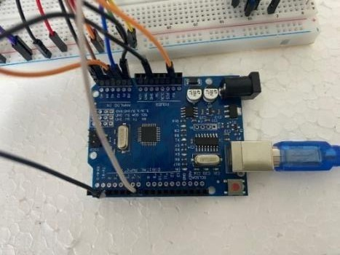
Fonte: Autoria própria

- Protoboard, para facilitar a montagem dos componentes;

Figure 02
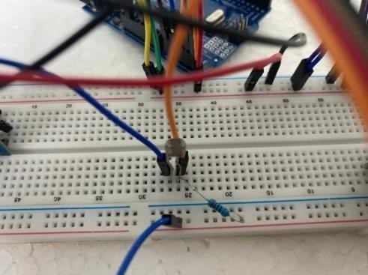
Source: Author

Figure 04
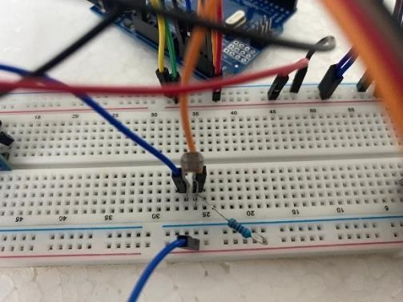
Source: Author

Figure 05
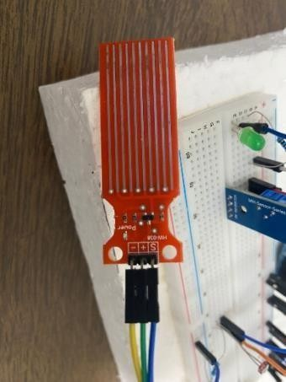
Source: Author
- Relay module, for water pump control;
Figure 06
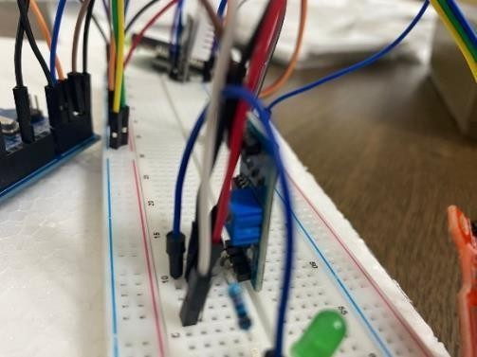
Source: Author

- Display LCD 16x2, for temporary display of data (in the future a website will be embedded in the project that will make data available in real time, remotely, without the need to be close to the prototype);
Figure 07
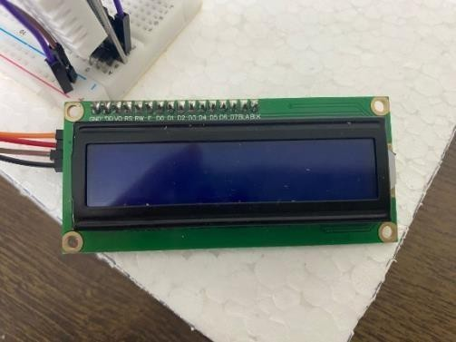
Source: Author

- Water pump, hose and reservoir, simulating the irrigation system.
Figure 08
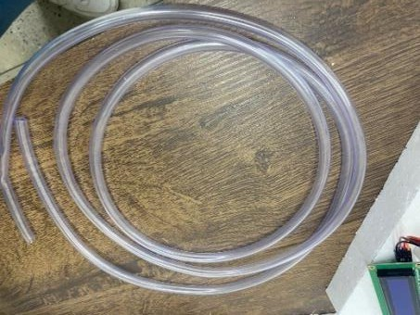
Source: Author

Programming was done in C/C++ language for Arduino, with possible future expansions for data analysis using the Python language. With the system assembled and consolidated, several functionality tests were carried out on different types of soil and in different and simulated conditions, such as: dry soil with sunny weather, moist soil with the presence of rain and changes in the luminosity of the environment in certain periods. Data collection was monitored and displayed instantly on the LCD, and in the future it will be integrated into a system with graphical analysis and information storage. Based on the tests, adjustments to the sensors were necessary, and calibration was essential for the correct functioning of the system.
At the end, future improvements were discussed and evaluated. As already mentioned, the future website with remote and real-time availability of data, as well as possible information analysis, become essential to facilitate smallholder farmers' access to modern technologies, offering a stable and accurate source of data on their crops.

Analysis of data/results
The prototype built presented satisfactory performance and adequate automated responses to the simulated environmental conditions. During the tests, the integrated sensors captured information accurately, measuring soil moisture, luminosity and the presence of rain efficiently and without errors. The system reacted autonomously, triggering irrigation when a real water deficit combined with the absence of rain was identified, confirming the efficiency of the automated process. In addition to basic functionality, the system demonstrated good stability even in adverse conditions and with rapid variations in light and humidity, reinforcing the reliability of the prototype and the calibration of the sensors. The responses were recorded on the LCD display, and the irrigation behavior remained consistent with the data received in real time, avoiding unnecessary activations and contributing to water and energy savings.
The analysis of the data organized in simple graphs, with the possibility of future integration into digital platforms, allowed us to identify important trends, such as the relationship between irrigation frequency, luminosity and soil moisture recovery after each cycle. This visualization reinforces the system's potential as an auxiliary tool in decision-making in the field, even on smaller-scale projects. During development, the interaction of the system with the four natural spheres was also considered: the atmosphere, by collecting temperature and luminosity data; the hydrosphere, through the control and rational use of water; the pedosphere, by monitoring soil moisture; and the biosphere, by promoting ideal conditions for healthy plant growth. This integration ensures that the operation of the prototype is aligned with the balance between the natural elements that sustain agriculture.

Discusion
The developed system proved to be functional and applicable in controlled environments, with the potential to adapt to various conditions. Its ability to monitor the environment, process information and make decisions in an automated way represents a step towards sustainable and precision agriculture, accessible to small producers. The savings in resources, the ease of operation and the possibility of future improvements, such as remote monitoring via the web, reinforce the relevance and feasibility of the project as a low-cost technological solution with a high positive impact.

Conclusion
The project showed that the use of accessible technologies, such as Arduino, can offer viable and effective solutions to the challenges faced by small rural producers and families in the semi-arid region. The developed weather station stood out as a support tool

sustainable agriculture, contributing directly to the conscious use of water and enabling greater autonomy in the management of water resources.
In addition to the technical impact, the initiative reinforces the transformative role of public education. The active participation of the students of E.E.T.I. Zenilda Gama shows that, even with limited resources, it is possible to generate innovation from local realities, uniting scientific knowledge and social commitment in favor of regional development.

References
Agência FAPESP. (2023, 30 de agosto). Existem muitas tecnologias para o campo, mas falta democratizar o acesso, apontam especialistas. Agência FAPESP. https://agencia.fapesp.br/existem-muitas-tecnologias-para-o-campo-mas-falta-democratizar-o-ace sso-apontam-especialistas/44714

Alves, J. M. B., & Lima, J. R. F. (2020). Agricultura Familiar e Sustentabilidade no Semiárido Nordestino. Revista Cadernos de Agroecologia, 15(1).
Brasil. Ministério da Ciência, Tecnologia e Inovação. (2019). Cadernos temáticos: Tecnologias para o semiárido. Brasília, DF: Autor.
Pereira, M. L., & Nascimento, F. F. (2021). Aplicações educacionais do Arduino: Iniciação científica e protagonismo juvenil na escola pública. Revista Brasileira de Tecnologias Sociais, 7(2).

Silva, A. C., & Costa, F. A. (2020). Uso de Tecnologia na Agricultura Familiar: Aplicações com Arduino. Revista Brasileira de Ensino de Ciência e Tecnologia, 13(3).
Sousa, S. M., & Rocha, D. S. (2016). A escassez hídrica no semiárido nordestino: desafios e perspectivas para a agricultura. Revista GeoNordeste, 27(2).

