GLOBE Activities and Investigative Learning in Secondary School

Escola Estadual Professora Maria das Graças Silva Germano.

Ana Beatriz Pereira da Silva
Filiação: Escola da Rede Pública (Ensino Fundamental)
Endereço da Instituição: Brasil

Isabely Ramalho Almeida
Filiação: Escola da Rede Pública (Ensino Fundamental)
Endereço da Instituição: Brasil

Fernanda Gabrielly Vieira Lopes
Filiação: Escola da Rede Pública (Ensino Fundamental)
Endereço da Instituição: Brasil

Maria Vanessa Araújo da Cruz
Filiação: Escola da Rede Pública (Ensino Fundamental)
Endereço da Instituição: Brasil
Professor João Feliciano de Souza Júnior
orientador

ABSTRACT
Inquiry-based praticas in basic education support scientific literacy, student engagement, and the development of observation, data recording, and argumentation skills. This study analyzed the implementation of five GLOBE Program activities linked to the Atmosphere, Biosphere, Hydrosphere, Pedosphere, and Earth System protocols. The actions were conducted from October 27 to November 6, 2025, involving 90 students from 5th to 9th grades. A descriptive qualitative approach was adopted, combining participant observation, classroom reports, and learning evidence produced by students (classification systems, investigation records, soil descriptions, narratives, and diagrams). The results indicated strong engagement, increased participation of students usually less involved in regular classes, and consistent learning outcomes related to climate and latitude, leaf classification, pH interpretation, soil permeability and saturation, and interactions among Earth’s spheres. Time constraints, limited infrastructure, and teacher workload were identified as main barriers, addressed through schedule adjustments and early classroom preparation. The findings support the use of structured GLOBE activities as a feasible pathway to strengthen inquiry-based learning in schools.
KEYWORDS. Scientific literacy. Inquiry-based learning. Citizen science. GLOBE Program. Middle school.
- Research Questions / Research Problem
The adoption of inquiry-based methodologies in middle school has been identified as a relevant strategy for scientific literacy, particularly when learning is connected to concrete environmental situations. In schools with limited infrastructure and restricted instructional time, experimental practices and field-based activities tend to occur sporadically, which can constrain the consolidation of scientific skills such as observing, hypothesizing, recording data, comparing results, and supporting explanations.
Within the GLOBE Program, protocol-based activities (Atmosphere, Biosphere, Hydrosphere, Pedosphere, and Earth as a System) present strong pedagogical potential because scientific concepts are integrated with investigation procedures and the use of data. Even so, effectiveness under real school conditions depends on factors such as time organization, age-appropriate didactic adaptations, teacher mediation, student participation, and feasibility of implementation across grade levels.
In this context, the following research questions guided the study:
- To what extent does the implementation of five GLOBE Program activities promote engagement and participation among students from 5th to 9th grade?
- What evidence of inquiry-based learning can be identified in student products and sharing moments after the activities?
- What operational and pedagogical barriers emerge during implementation, and which mitigation strategies prove feasible in everyday school routines?
Relevance to the school community is associated with improved quality of science classes, encouragement of student leadership, and expansion of environmentally focused actions. Scientific relevance is associated with the systematic description of a multi-grade implementation, including outcomes and constraints, supporting replication and refinement of inquiry-based practices.

Figure 1 - Application of the activity.
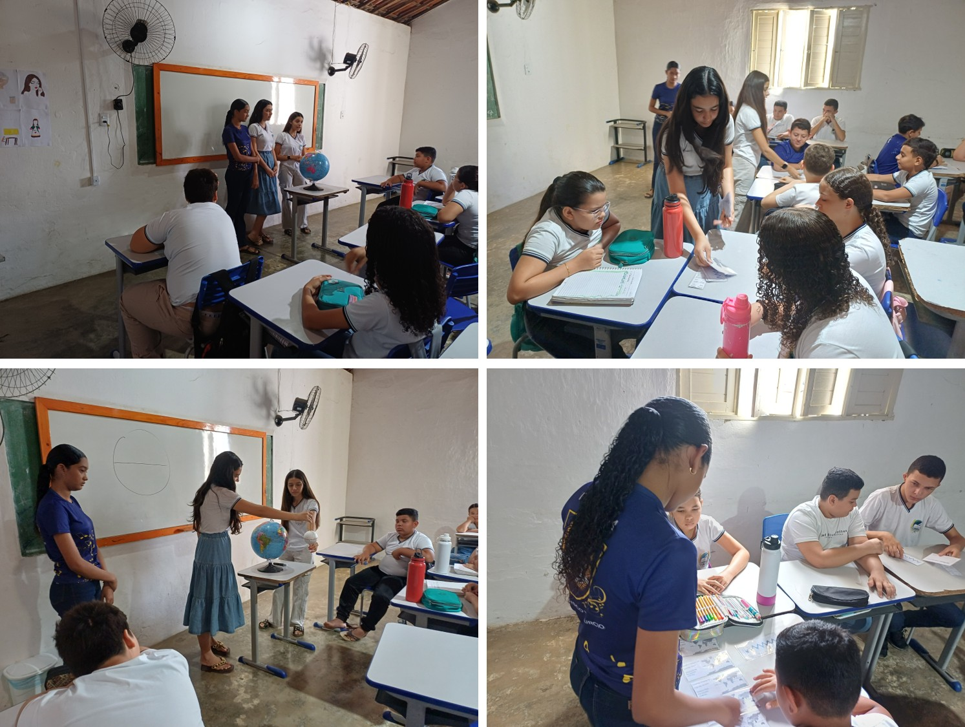
Source: School Coordinator (2025).

- Introduction
Science learning in middle school has benefited from approaches that value investigation, experimentation, and collective knowledge-building. In contexts with material limitations, activities with low cost, high adaptability, and emphasis on scientific skills are particularly appropriate. In this regard, the GLOBE Program offers a set of activities aligned with environmental themes and protocols that organize data collection and interpretation.
In this study, the implementation of five previously selected activities was analyzed across different grades in order to describe the process, identify learning evidence, and map challenges and organizational strategies. In addition to classroom impact, the presentation of the activities at a school science fair was considered as a dimension of science communication and conceptual consolidation.

- Theoretical Framework
Scientific literacy has been understood as the ability to mobilize knowledge, procedures, and attitudes to interpret phenomena, analyze evidence, and make informed decisions in daily life (Bybee, 2014). In this field, inquiry-based practices and active learning have been associated with improved engagement and conceptual understanding when compared to exclusively lecture-based approaches (Prince, 2004).
Citizen science has been described as a pathway for social participation in data production and environmental monitoring, with potential to strengthen connections among school, territory, and scientific culture (Bonney et al., 2009). In school settings, protocol-based activities support procedural standardization, improving the consistency of records and the comparability of results.
Experiential learning has also been emphasized, particularly when observation, action, reflection, and conceptual reorganization are integrated (Kolb, 1984). In heterogeneous classrooms, group organization and collaborative mediation expand opportunities for participation, including students with diverse learning and interaction profiles.

- Materials and Methods
A descriptive qualitative study design was adopted, focusing on the implementation of a sequence of five GLOBE Program activities in middle school classes.
Participants and context. A total of 90 students participated, distributed by grade: 5th grade (12), 6th grade (28), 7th grade (13), 8th grade (15), and 9th grade (22). The actions occurred between October 27 and November 6, 2025, in morning and afternoon shifts.
Implemented activities and protocols.
- Climate and Latitude: Exploring GLOBE Data (Atmosphere) – 6th grade.
- Leaf Classification (Biosphere) – 5th grade.
- Water Detectives: pH and Substances (Hydrosphere: water quality) – 9th grade.
- Just Passing Through: Water Infiltration in Soils (Pedosphere: soil characteristics) – 8th grade.
Earth System Components Working Together (Earth as a System) – 7th grade.
Evidence collection procedures. Process documentation was carried out (participant observation, classroom notes, and syntheses from sharing sessions), and learning evidence produced by students was collected: (a) associations between graphs/cards and latitudes; (b) group-created classification systems; (c) sensory investigation records and pH scale readings; (d) soil sample descriptions and percolation times; and (e) narratives and diagrams describing the path of a water droplet across Earth’s spheres.
Analysis strategy. A descriptive content analysis was conducted, organizing evidence into categories: engagement/participation; inquiry skills (observing, comparing, recording, explaining); conceptual understanding; and operational challenges.

- Data Analysis / Results
The five activities were implemented as planned, with logistical adjustments to fit the school schedule. Active student participation was observed, with the following results by activity:
Activity 1 (Atmosphere). Coherent relationships between latitude and annual temperature variation were constructed, with recognition that limited local thermal amplitude is associated with geographic position. Mathematical mediation by the student team was noted, given students’ difficulties with integers.
Activity 2 (Biosphere). Student-generated classification criteria were developed, unsuitable criteria were revised, and comparisons across groups were performed. Active participation was observed in initial discussions about everyday classifications, with positive involvement of a neurodivergent student during group dynamics.
Activity 3 (Hydrosphere). High engagement was observed during sensory investigation and pH measurement using indicator paper, with increased participation among students typically shy or less engaged in regular lessons. Procedures for comparing initial hypotheses with measurement results were mobilized.
Activity 4 (Pedosphere). A practical understanding of permeability and water retention differences was demonstrated, linked to soil texture and the presence of rocks/fine particles. Reflection on soil saturation and variation in filtered water color was observed, supported by arguments grounded in recorded observations.
Activity 5 (Earth as a System). Correct identification of elements in satellite images and maps (water, clouds, vegetation, soil) and proper association with Earth’s spheres were observed, including recognition of interactions, especially in the water cycle. Narratives and diagrams consolidated integrated learning, strengthened by collective sharing and presentation at the school science fair.

Activity 1: Climate and Latitude – Atmosphere Protocol (Summary)
This activity focused on analyzing the relationship between latitude and annual temperature variation through the interpretation of long-term climate data. Students constructed coherent and well-structured connections between geographic position and patterns of solar radiation incidence, recognizing that the limited annual thermal amplitude observed in their local region is directly associated with its latitudinal location. By comparing graphs and temperature records from different regions of the planet, students identified trends, contrasts, and consistencies in climate behavior. Mathematical mediation provided by the student team proved essential, particularly in addressing difficulties with integer numbers and negative temperature values, enabling accurate data interpretation and reinforcing students’ confidence in using quantitative information to support scientific reasoning.

Activity 2: Leaf Classification – Biosphere Protocol (Summary)
The activity was conducted with a 5th-grade class (12 students) on October 31. Students worked in small groups to create their own leaf classification systems using diverse samples collected beforehand. Following a guided discussion on the meaning and importance of classification, groups defined criteria, tested their adequacy, and compared systems across groups with support from the student team. Results indicated high engagement, effective collaborative reasoning, and inclusive participation, including positive involvement of a neurodivergent student. The activity concluded with reflective writing on everyday uses and benefits of classification, evidencing collective knowledge construction.
Figure 2 - Application of the activity.

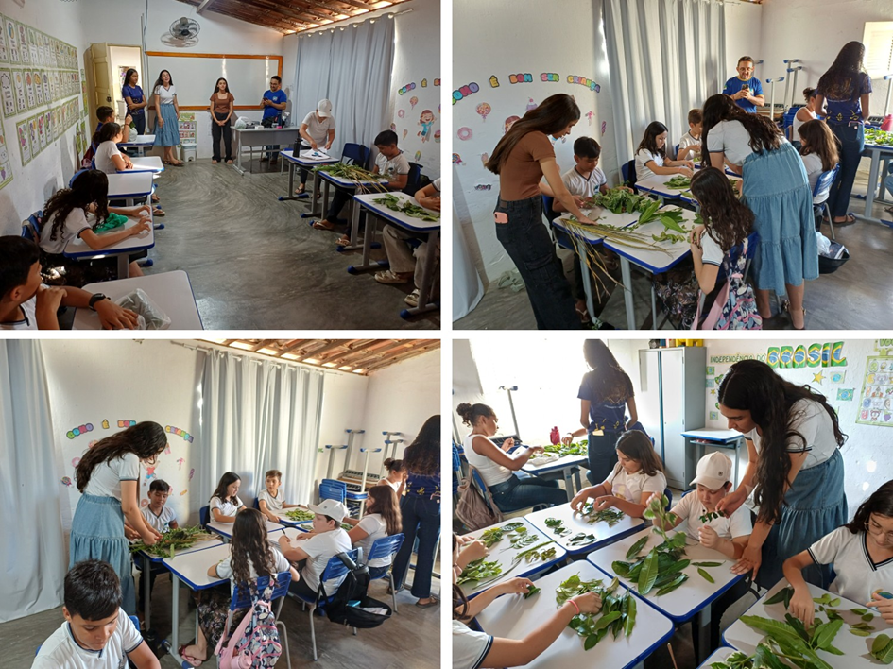

Activity 3: Water Detectives – Hydrosphere Protocol (Water Quality) (Summary)
Implemented on October 31 with a 9th-grade class (22 students), the activity investigated water pH using indicator paper and common substances (pure water, baking soda, lemon vinegar, and food coloring). After an introduction to water monitoring and pH relevance, students worked in pairs to conduct sensory observations, formulate hypotheses, and perform pH measurements, comparing results to a reference scale. High engagement was observed in both sensory investigation and measurement phases, with increased participation among typically shy or disengaged students, supporting inquiry skills and collective discussion.
Figure 3 - Application of the activity.

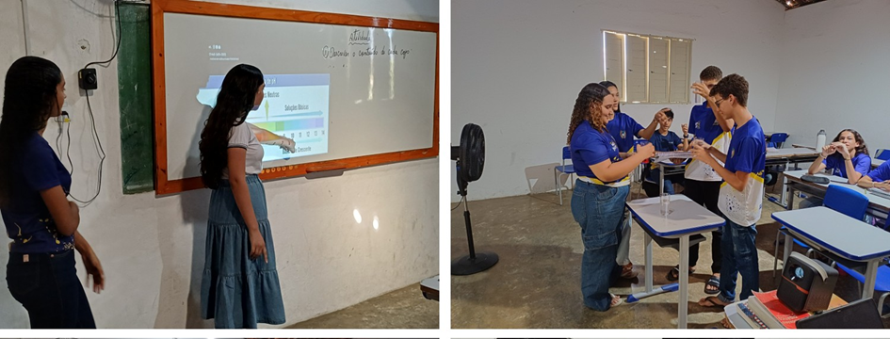

Activity 4: Just Passing Through – Pedosphere Protocol (Soil Characteristics) (Summary)
Conducted on October 27 with an 8th-grade class (15 students), this activity examined water infiltration using PET-bottle setups and soil samples collected on campus. Groups described soil properties (color, texture, moisture, inclusions) and measured percolation time after adding a fixed water volume. Results showed variability in infiltration linked to soil structure, prompting discussion on permeability, retention, and saturation. The activity fostered observational rigor, recording practices, teamwork, and critical reasoning about soil properties through hands-on investigation.
Figure 4 - Application of the activity.
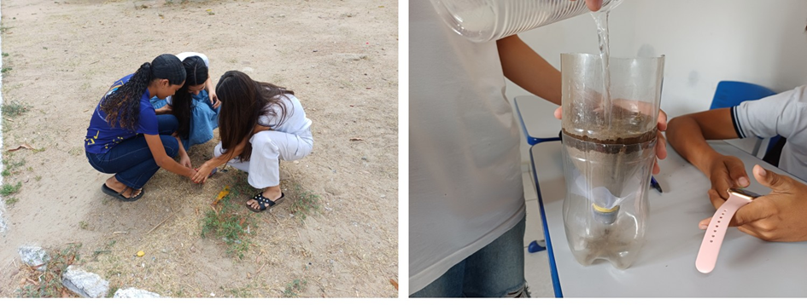

Activity 5: Earth System Components Working Together – Earth as a System Protocol (Summary)
Held on November 6 with a 7th-grade class (13 students), the activity explored interactions among atmosphere, hydrosphere, biosphere, and pedosphere using satellite images and maps (solar energy, temperature, clouds, precipitation, soil moisture, vegetation). Students identified elements, linked them to Earth’s spheres, discussed cross-sphere interactions (notably the water cycle), and produced narratives and diagrams tracing a water droplet’s pathway. Engagement and conceptual integration were strong, reinforced by collective sharing and subsequent presentation at the school science fair.
Figure 5 - Application of the activity.
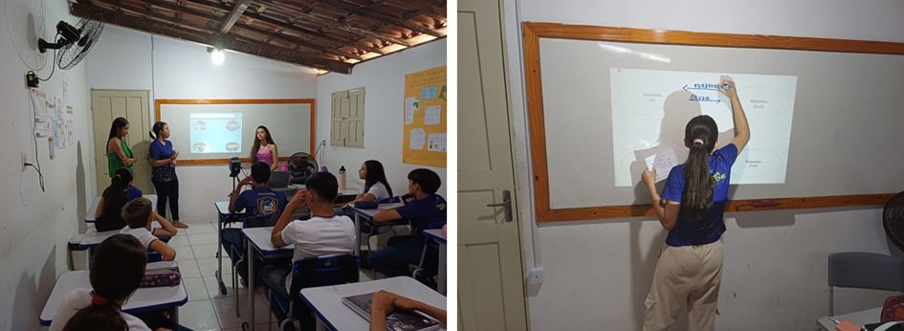

- Discussion
The results indicated that the activity sequence promoted engagement and participation and stimulated inquiry skills, consistent with active and experiential learning principles (Prince, 2004; Kolb, 1984). The diversity of protocols supported the integration of environmental content, expanding contextualization and systems thinking.
Student leadership within the team contributed to mediation, group organization, and the maintenance of discussions, aligning with citizen science and collaborative learning approaches (Bonney et al., 2009). Although no standardized quantitative achievement measure was applied, classroom evidence and student sharing moments presented conceptual coherence and progression of reasoning, especially when hypotheses were compared with observed outcomes.
Regarding barriers, time management and limited infrastructure were significant, particularly due to the absence of a science laboratory and the workload concentrated on a single science teacher. The adopted operational solution relied on schedule reorganization, grouping shorter activities, and early preparation of spaces, which proved functional during the period analyzed.

- Conclusion
The implementation of five GLOBE Program activities in grades 5 through 9 was feasible and pedagogically relevant, with evidence of strong engagement and inquiry-skill development. Concepts related to climate and latitude, biological classification, water quality through pH, soil properties, and interactions among Earth’s spheres were addressed through active participation and science communication in a school science fair context.
Recommendations include consolidating an annual inquiry-based practice plan integrating GLOBE protocols into the curriculum, systematizing formative assessment instruments (rubrics for recording, argumentation, and teamwork), and gradually expanding school-based environmental monitoring. For future studies, longitudinal data collection, comparisons across classes, and inclusion of quantitative learning indicators are suggested to strengthen educational impact analysis.

Overall Outcome:
Across activities, inquiry-based approaches promoted engagement, inclusivity, collaborative learning, and conceptual understanding of environmental systems, demonstrating the pedagogical value of protocol-driven, low-cost investigations in middle school contexts.
References
Bonney, R., Cooper, C. B., Dickinson, J., Kelling, S., Phillips, T., Rosenberg, K. V., & Shirk, J. (2009). Citizen science: A developing tool for expanding science knowledge and scientific literacy. BioScience, 59(11), 977–984.
Bybee, R. W. (2014). The BSCS 5E instructional model: Creating teachable moments. Colorado Springs, CO: BSCS.
Kolb, D. A. (1984). Experiential learning: Experience as the source of learning and development. Englewood Cliffs, NJ: Prentice Hall.
Prince, M. (2004). Does active learning work? A review of the research. Journal of Engineering Education, 93(3), 223–231.

