Investigating the presence of fuel-related chemicals in soil.

GLOBE students:
Stephen Edwards
Jamie Sacco
Kyle Borg Abela
Alexei Mifsud
Nathan Montesin
Jake Vella
Jake Camilleri

GLOBE Teachers: Mr. Joseph Savona & Mrs. Vanessa Edwards

St. Michael School, St. Venera
Malta

27th February 2025
Abstract

The research aims to investigate the presence of chemicals derived from fuel in the soil. Following a study carried out in 2024 on air quality at St Michael School, during which Nitrogen Dioxide (NO₂), Volatile Organic Compounds (VOCs), Carbon Dioxide (CO₂), and particulate matter (PM1, PM2.5, PM4, PM10) were measured, this study builds upon and complements the previous findings. The study was conducted to sensitise both the school community and the wider social community, including the St Venera Local Council, about the quality of air breathed by a population of approximately 400 individuals for an average of 35 hours per week over 36 weeks per year, as well as the presence of related chemicals within the school grounds. This research was carried out with the support of MCAST and its staff, who assisted in conducting experiments in their advanced laboratories. The results indicated the presence of chemicals and elements associated with the burning of fossil fuels. These findings provide further evidence that supports the results obtained in the previous air quality study. Moreover, the study proposes actions aimed at reducing the presence of these chemicals at both local and national levels, particularly in areas surrounding the school.

Keywords: Air quality, Benzene, Emissions, Clouds, Temperature, Traffic, Atmosphere, Carbon Dioxide, Polyaromatic hydrocarbons (PAH’s), Naphthalene, Phenantrene, Chrysene, Benzo pyrene, Lead (Pb), PM1, PM2.5, PM4, PM10, VOC, Airborne Particular matter (PM).

Research Questions

- What is the effect of traffic-related air pollution on the school environment?
- Is there a relationship between the results of the previous air quality study and the presence of fuel-derived chemicals detected in the soil?
- Are the detected chemical concentrations within established safety and regulatory limits?
- Do environmental factors such as temperature, humidity, and rainfall influence the concentration and distribution of these chemicals?
- Can these chemicals enter and be transferred through the food chain?

Urbanisation and a high dependency on private cars are contributing to increased levels of traffic-related pollutants. Drawing on knowledge gained by students through collaborative meetings with partner schools, as well as findings from previous research on air quality and on Polycyclic Aromatic Hydrocarbons (PAHs) and Lead (Pb), it was concluded that nitrogen dioxide (NO₂) and particulate matter (PM) levels around the school are high and that traffic-related chemicals are present in the soil.

Hypothesis
The school is located in a busy, highly urbanised area. Previous studies have indicated high concentrations of nitrogen dioxide (NO₂), total volatile organic compounds (TVOCs), and particulate matter (PMs). Based on the school’s geographical location and surrounding traffic density, the soil within the school grounds is contaminated with Lead (Pb) and Polycyclic Aromatic Hydrocarbons (PAHs).

Introduction
The aim of this study was to investigate the presence of Polycyclic Aromatic Hydrocarbons (PAHs) in soil samples. Soil samples were collected from three sites: two within the school grounds and one from an external site along the main road adjacent to the school.
Background on Polycyclic Aromatic Hydrocarbons (PAHs)
Polycyclic Aromatic Hydrocarbons (PAHs) are a group of hundreds of chemicals formed during the incomplete combustion of organic materials such as coal, oil, gas, wood, garbage and food. PAHs can be produced through human activities, including car exhaust and industrial processes, as well as through natural sources such as wildfires. These chemicals are widely distributed in the environment and can be found in air, water, soil and food. In the environment, PAHs may exist in a gaseous form or attached to fine particulate matter.
Although PAHs are commonly present in the environment, the main routes of human exposure are through tobacco smoke and diet. Cigarette smokers receive the majority of their PAH exposure from smoking, as PAHs are present in cigarettes, cigars, vape products and other smokable materials. Dietary exposure occurs mainly through the consumption of grilled, roasted, smoked or barbecued foods. PAHs are formed when food becomes charred or when fats drip onto open flames during cooking.
PAHs can also be released into the atmosphere through industrial emissions, vehicle exhaust, burning of waste and off-gassing from asphalt roads. A commonly detected PAH is naphthalene, which was formerly used in mothballs and is a major component of creosote, a preservative used for railroad ties and telephone poles. Indoors, sources of PAHs include cooking fumes, cigarette smoke, burning candles, and some air fresheners. Certain PAHs can also be absorbed through the skin following contact with contaminated soil or water.
Health Effects of PAHs
Long-term exposure to PAHs may result in adverse health effects, including liver and kidney damage, cataracts, and jaundice. Repeated skin contact with PAHs such as naphthalene may cause skin irritation and inflammation. Inhalation or ingestion of large amounts of naphthalene can lead to the breakdown of red blood cells. Occupational exposure to PAHs has been associated with increased incidences of lung, skin, bladder, and gastrointestinal cancers.
Background on Lead (Pb)
Lead was historically added to petrol as an anti-knocking agent; however, the use of leaded petrol has been banned in most countries. Despite this, traces of lead can still be found in soils, particularly in urban areas and near busy roads, due to historical deposition and its persistence in the environment. Lead is a naturally occurring bluish-grey metal found in small quantities in the Earth’s crust and is present in all environmental compartments.
When released into the air, lead particles can travel long distances before settling onto soil, where they strongly bind to soil particles. Lead exposure in adults can cause high blood pressure, neurological effects, kidney damage, and reproductive health issues. Symptoms of lead poisoning may include headaches, abdominal pain, constipation, muscle and joint pain, fatigue, sleep disturbances, irritability, and reduced libido. In many cases, adults with lead poisoning may not show obvious symptoms.
Laboratory Analysis
Following sample collection, soil samples were analysed at the MCAST Science Laboratories. A quantitative analysis was conducted to determine the concentration of PAHs, while a qualitative analysis was carried out to detect the presence of lead in the soil samples.
Study Site
The school is located in an urban environment, near two industrial areas and a main traffic artery that experiences heavy traffic for most of the day.
The students identified four study sites around the school (Figure 1). Soil samples were collected from three locations:
- A roadside area within the school grounds (Red)
- A ground area within the school grounds, located away from the street (Purple)
- A street-level site outside the school, closest to the main road and most exposed to vehicle exhaust emissions (Blue)
Weather parameters, including cloud cover and sky conditions, air temperature, wind, rainfall, and humidity, were measured from the school roof following GLOBE Protocols (Yellow).
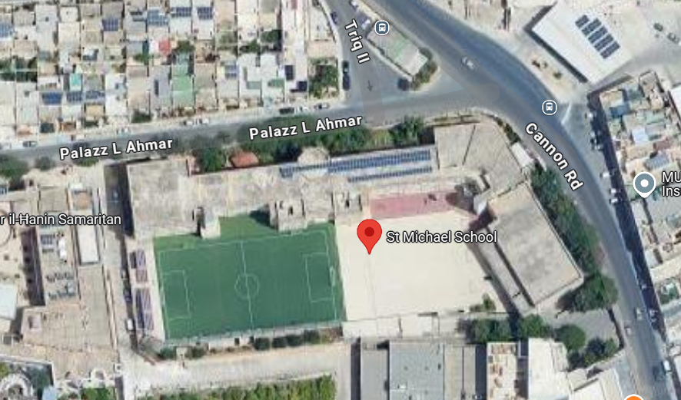

Weather Observations
Soil Sample
Street level
Soil Sample
Road side (School)
Soil Sample
Ground area

Figure 1 (School and observation sites)
Apparatus used:
- Data loggers to measure air temperature, humidity and air pressure.
- Rain Gauge
- GLOBE Observer App to record cloud type and cover
- Air quality monitor
- Plastic Bottle
- Thermometer
- Shovel
- Grape Hoe
- Ultrasonic Cleaner
- Fluorescence Spectroscopy Instrument with measuring cylinders, beakers and Pipettes.
- Centrifuge
- Data sheets
- Clipboard and pen

Methodology
On the 23rd of January 2025, students identified three soil sampling sites. Using a hoe and shovel, they collected soil samples from each site. Soil temperature, surface temperature, rainfall, air temperature, humidity, and air pressure were recorded. Cloud cover was observed using the GLOBE Observer App, and general weather and surface conditions were described according to GLOBE Protocols (GLOBE, 2014) (Figures 2 and 3).
The soil samples were placed in plastic containers and stored in a freezer until laboratory analysis. Soil analysis was conducted in two stages at the MCAST Science Laboratories.
PAH Analysis (Quantitative)
A quantitative analysis was carried out to determine the concentration of Polycyclic Aromatic Hydrocarbons (PAHs) present in the soil samples. Initially, the soil samples were purified to extract the target compounds. A mass of 2.5 g of soil was mixed with 10 ml of a hexane: acetone solvent mixture. The samples underwent ultrasonication for 10 minutes at 45°C, followed by evaporation under nitrogen, filtration, and centrifugation. The purified extracts were then analysed using fluorescence spectroscopy.
Lead Analysis (Qualitative)
A qualitative analysis was conducted to detect the presence of lead (Pb) in the soil samples. The soil underwent acid digestion to liberate lead ions. This procedure was carried out under the supervision of laboratory staff due to the use of a hazardous solution consisting of nitric acid and hydrochloric acid (commonly referred to as a piranha solution). The digestion process was conducted at 50°C for 15 minutes. Flame test principles were then applied to identify the presence of lead in each sample.
Readings of humidity, rain, air pressure, and cloud observations were taken around noon during the midday break. (Figure 5).

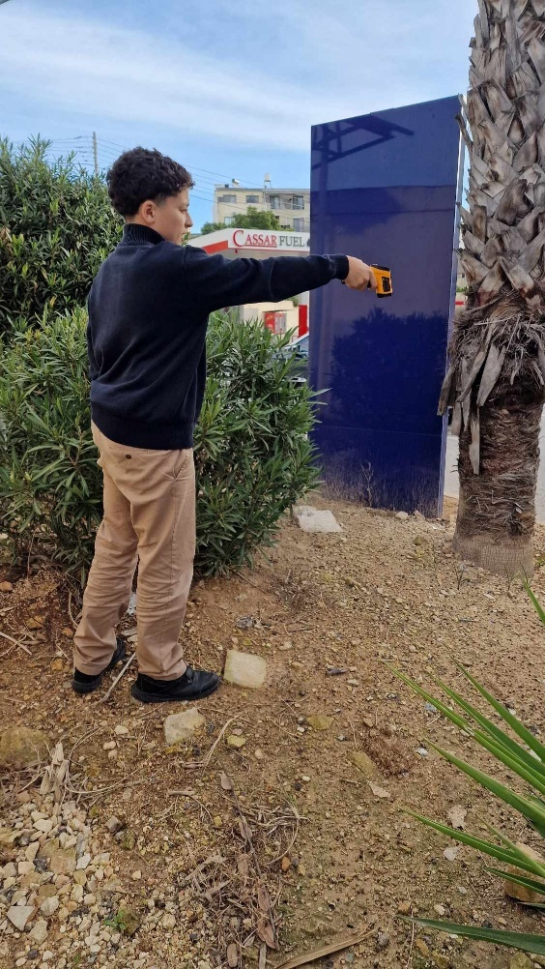
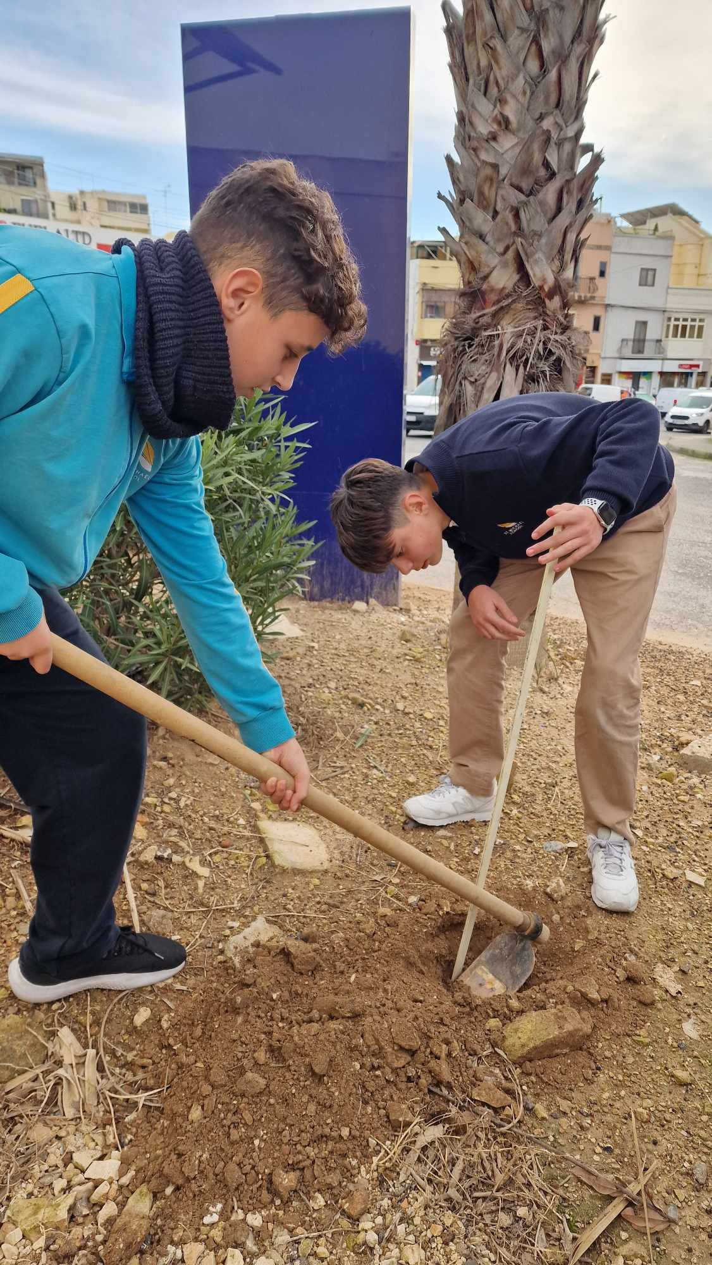

Figure 2: Soil Samples taken and taking readings using GLOBE protocls

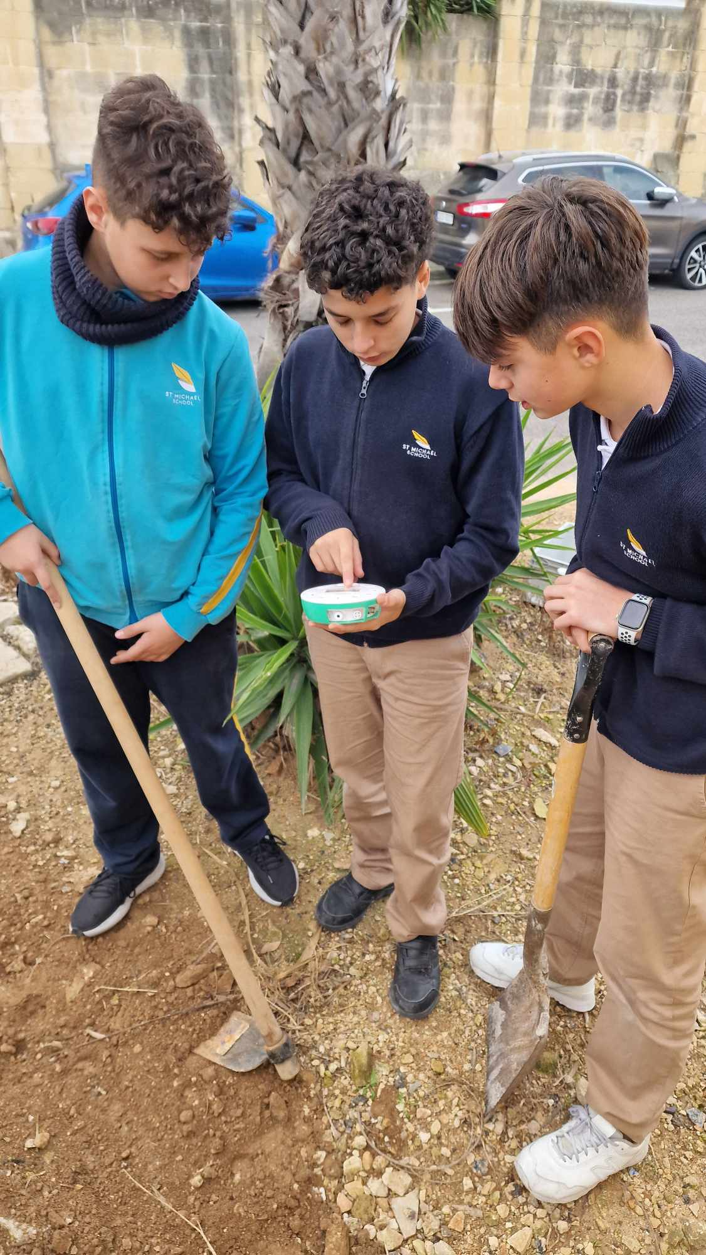
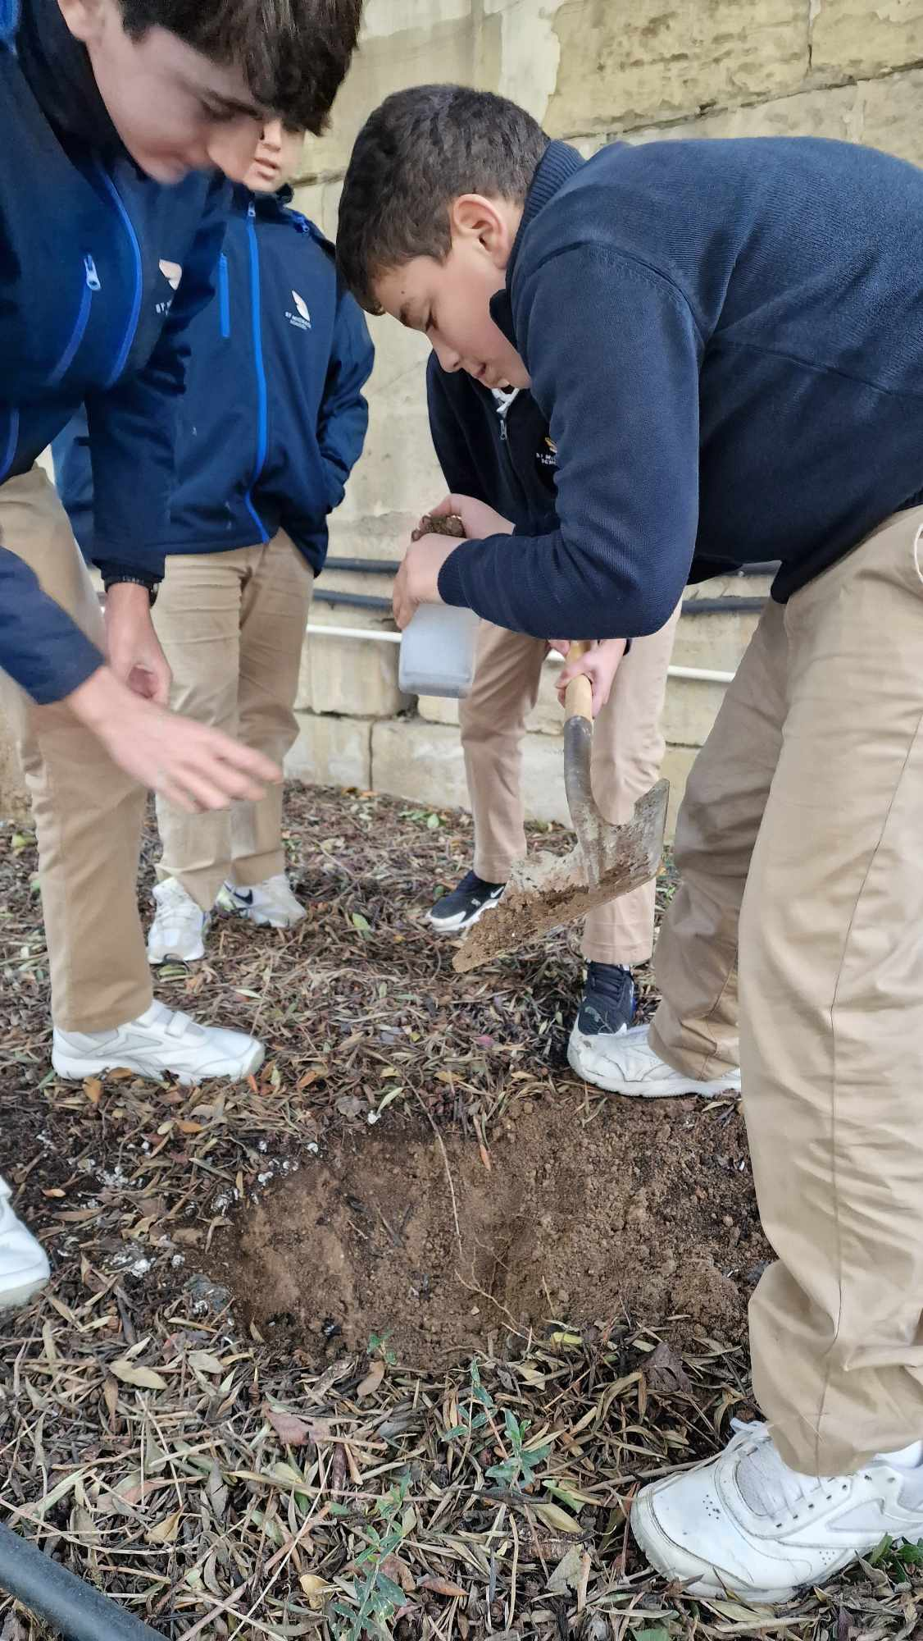

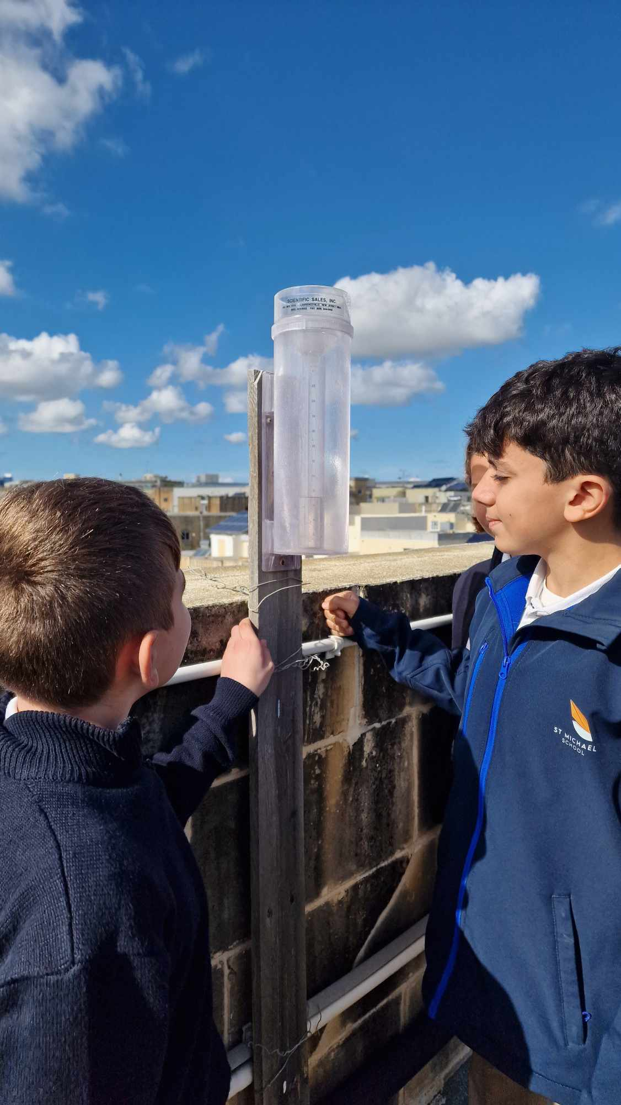

Figure 4: Students doing weather observations
Figure 5: Air quality monitor
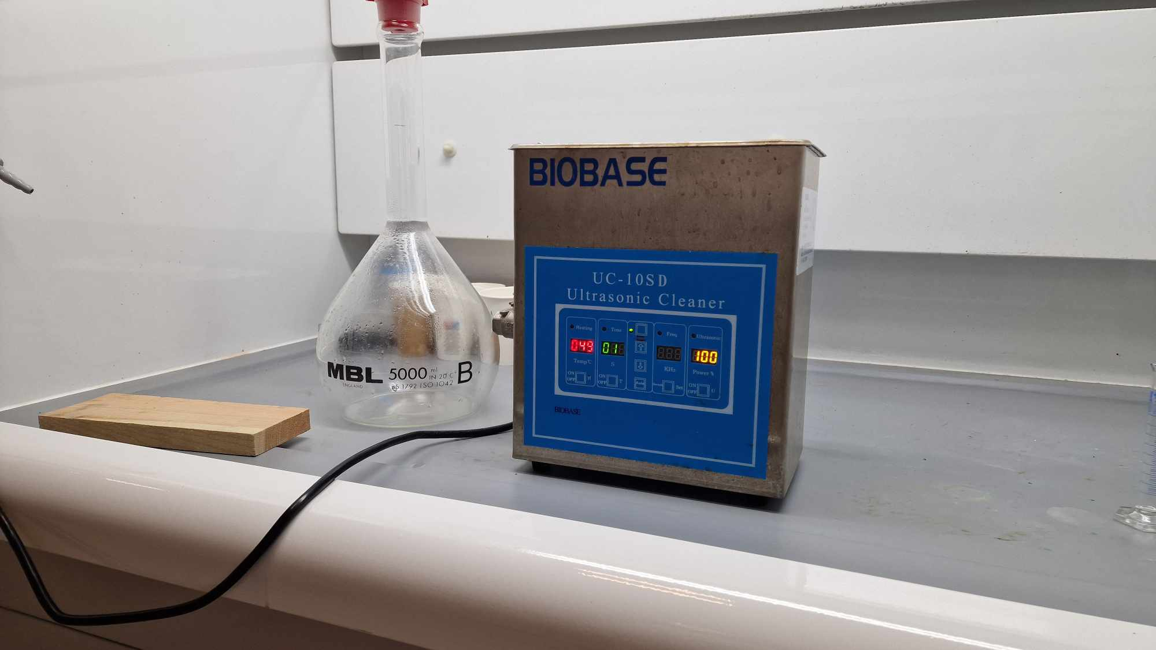
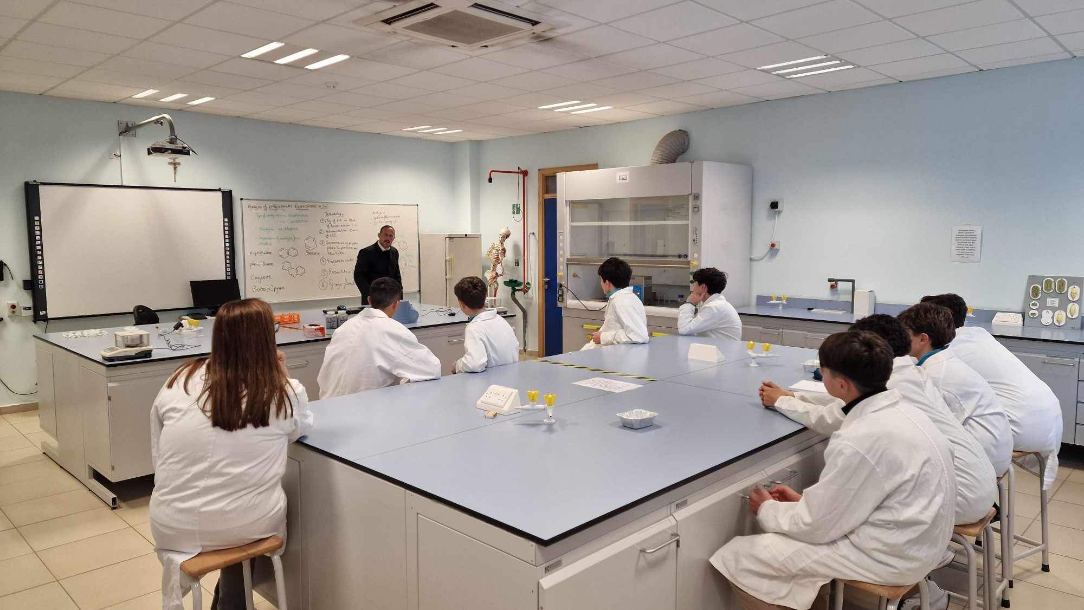
Figure 6: Ultrasonic Cleaner
Figure 5: Students at the Laboratory of MCAST
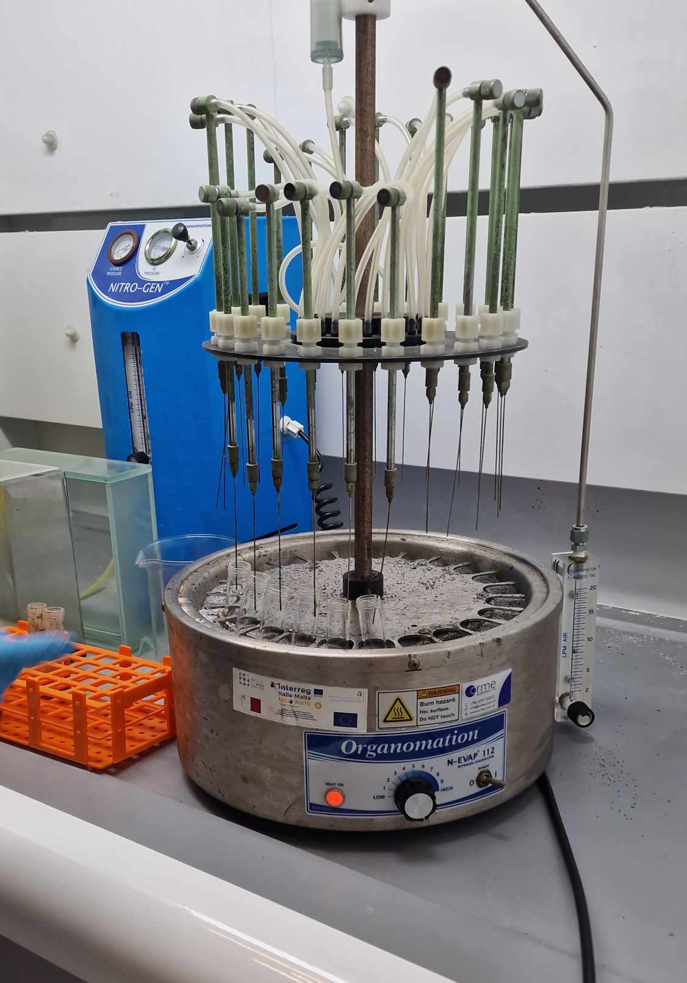

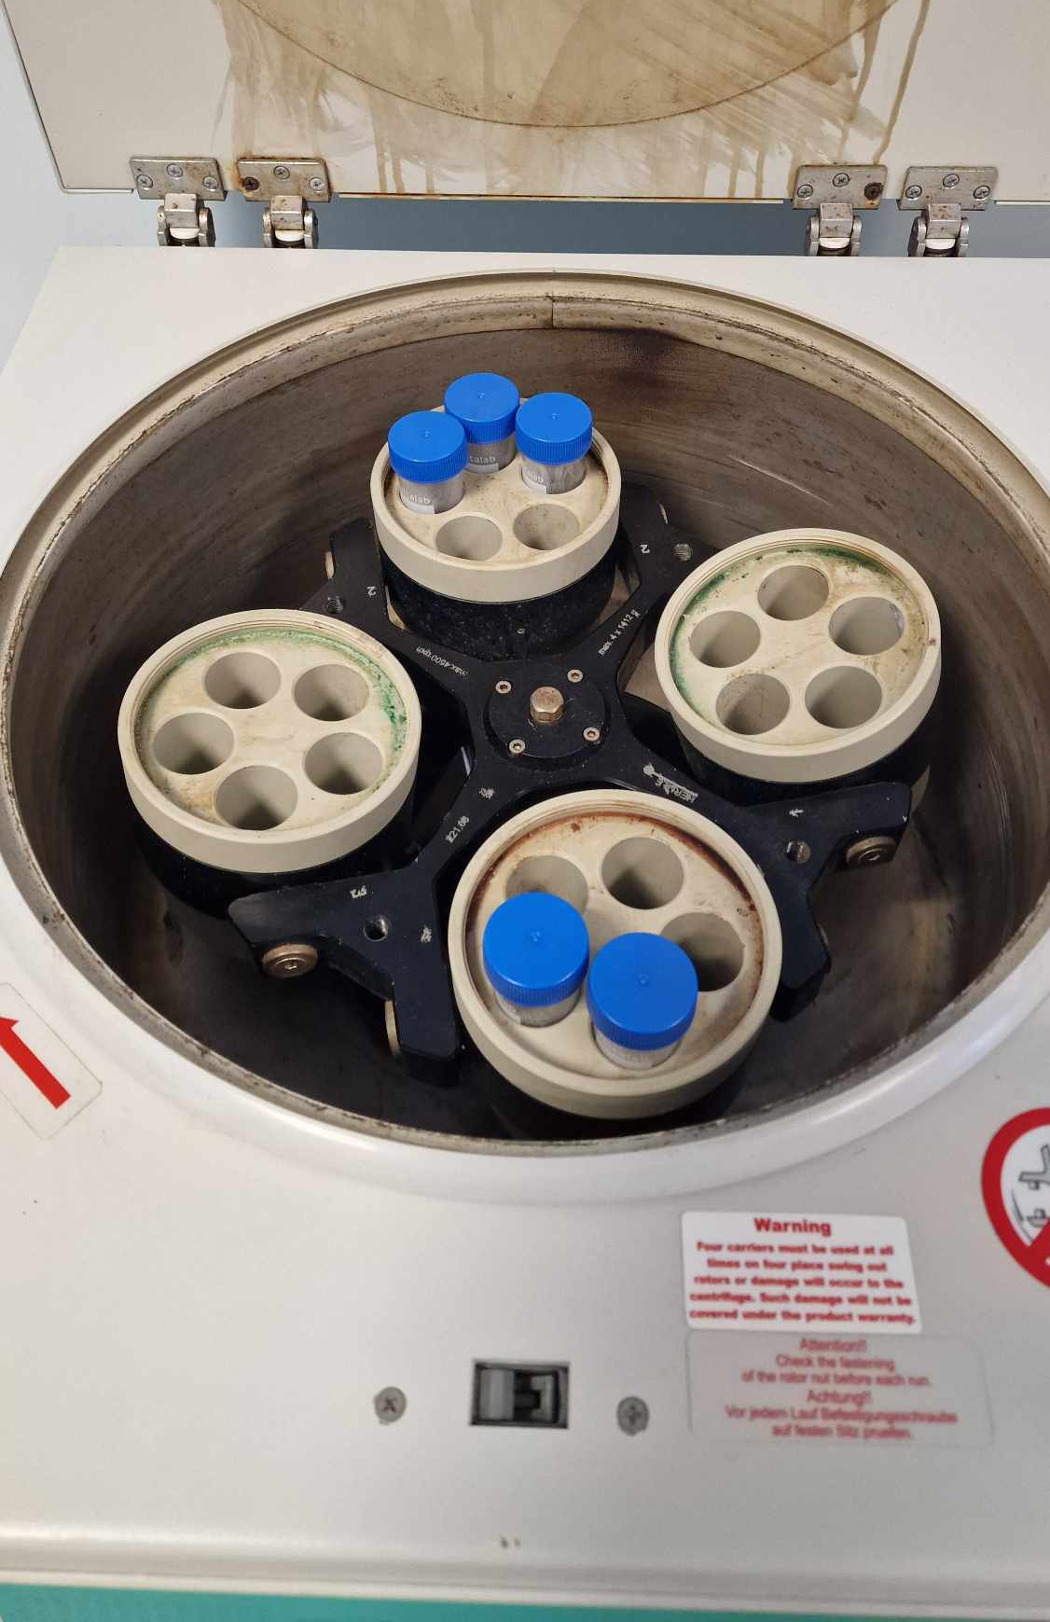
Figure 8: Centrifuge
Figure 7: Nitrogen Injector
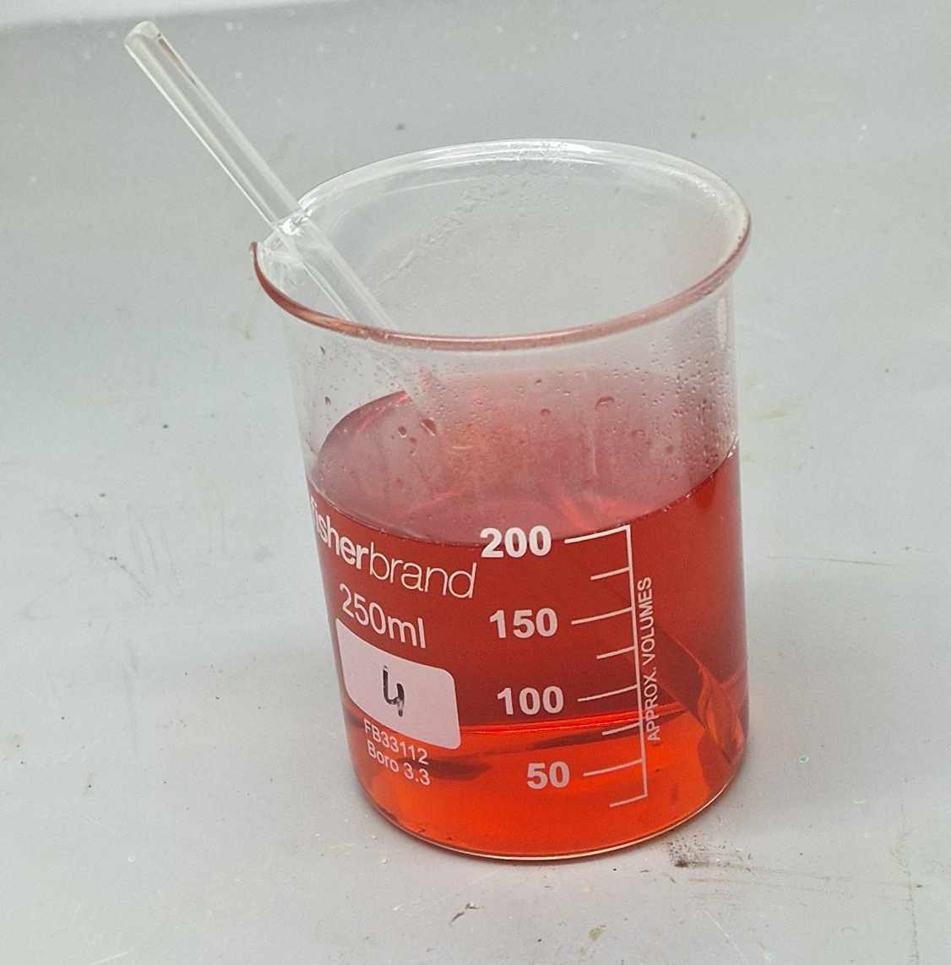
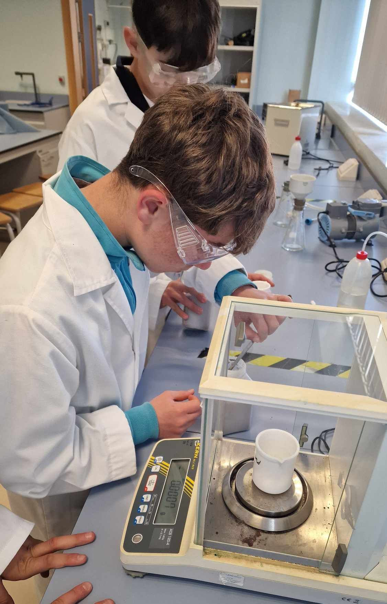
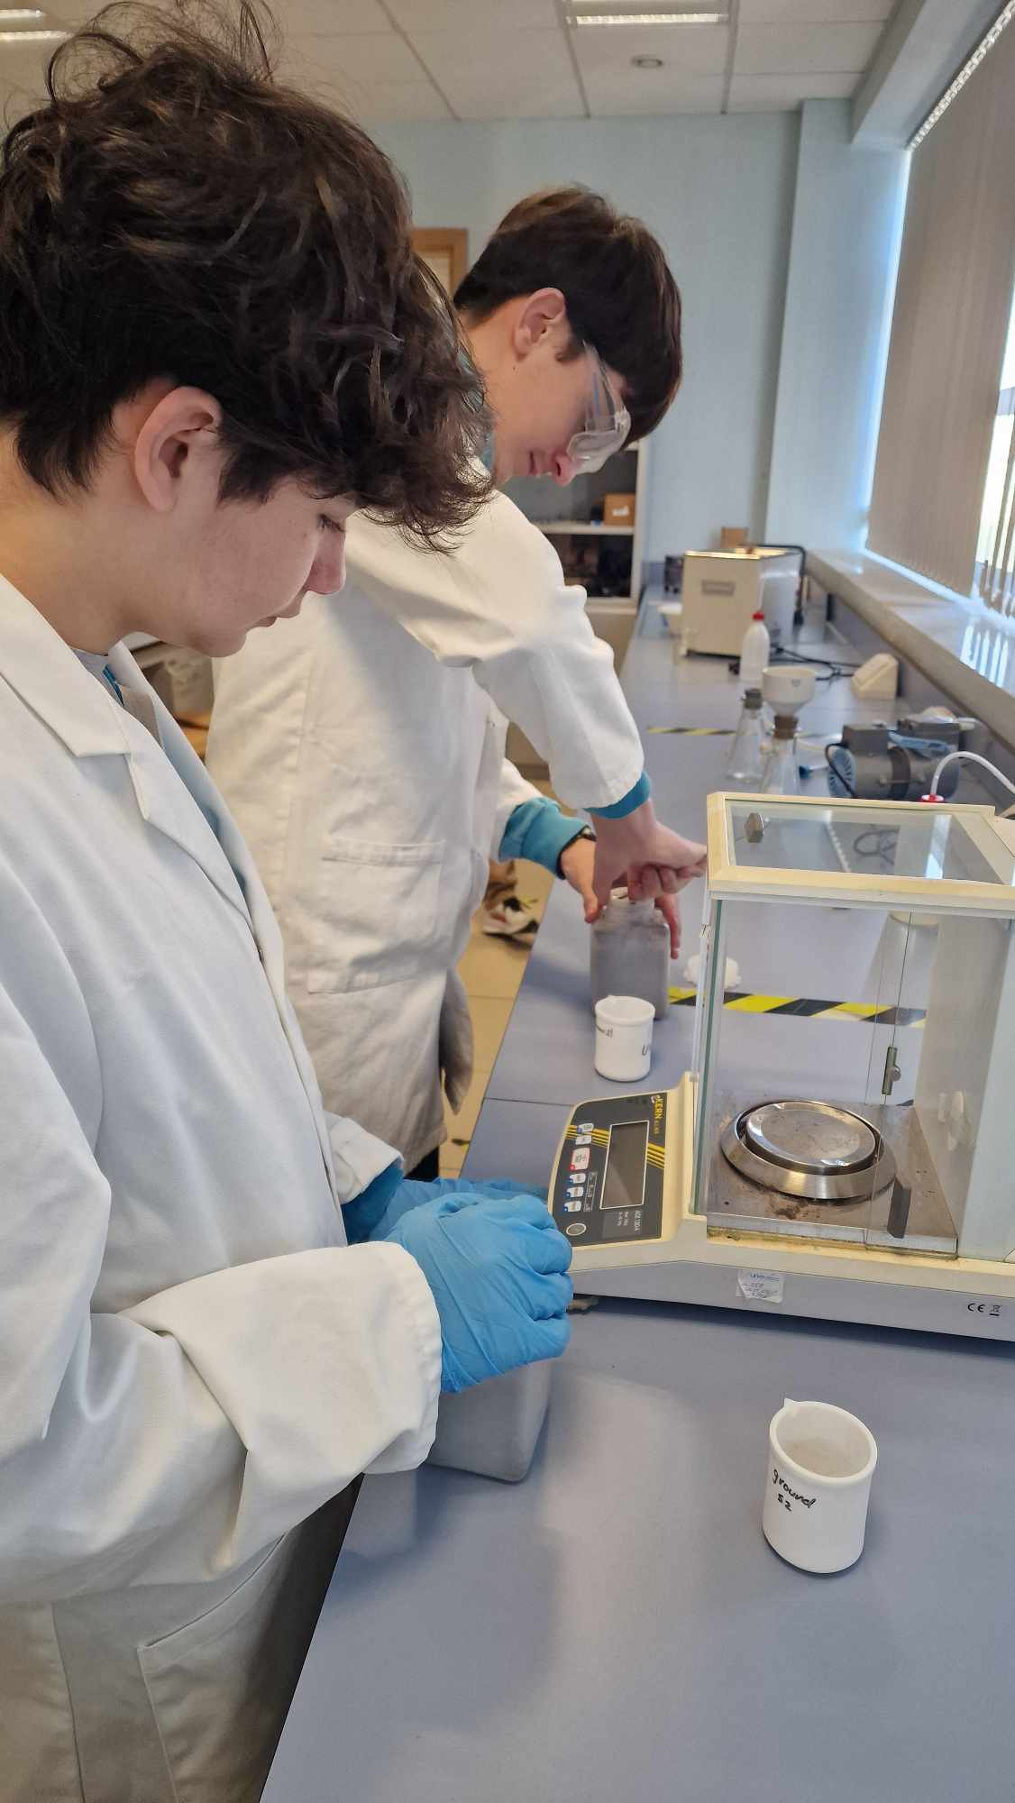
Figure 10: Students wieghing soil samples
Figure 9: ‘Piranha solution’ – soil digestion

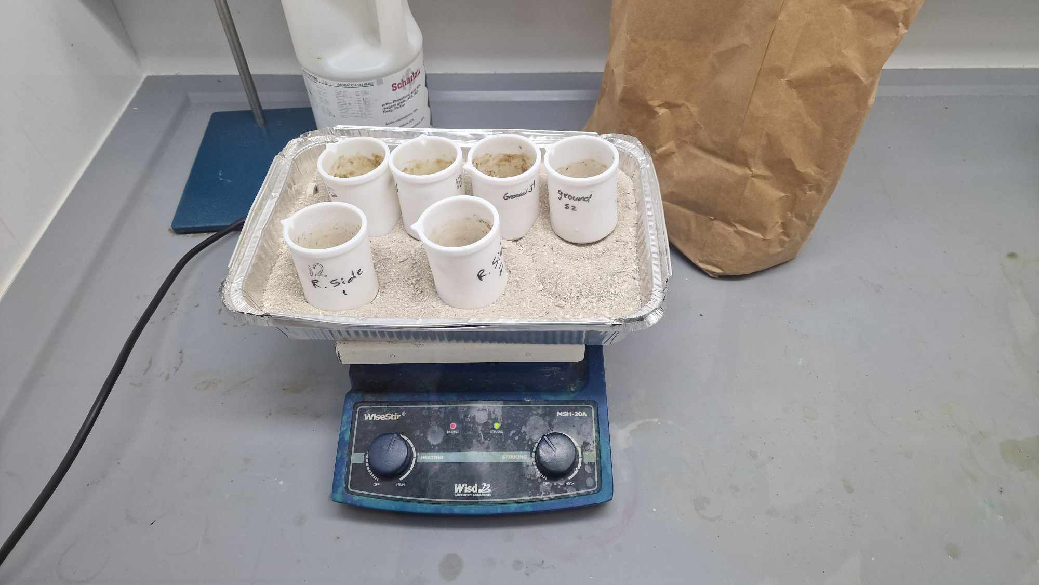

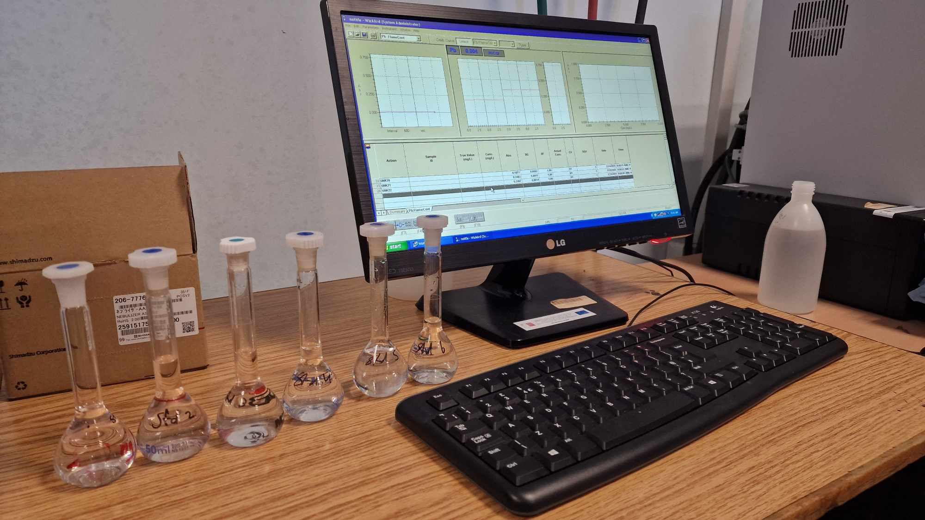
Figure 11: Solutions ready for Flame test of Lead ions
Figure 11: Samples cooling down during soil digestion
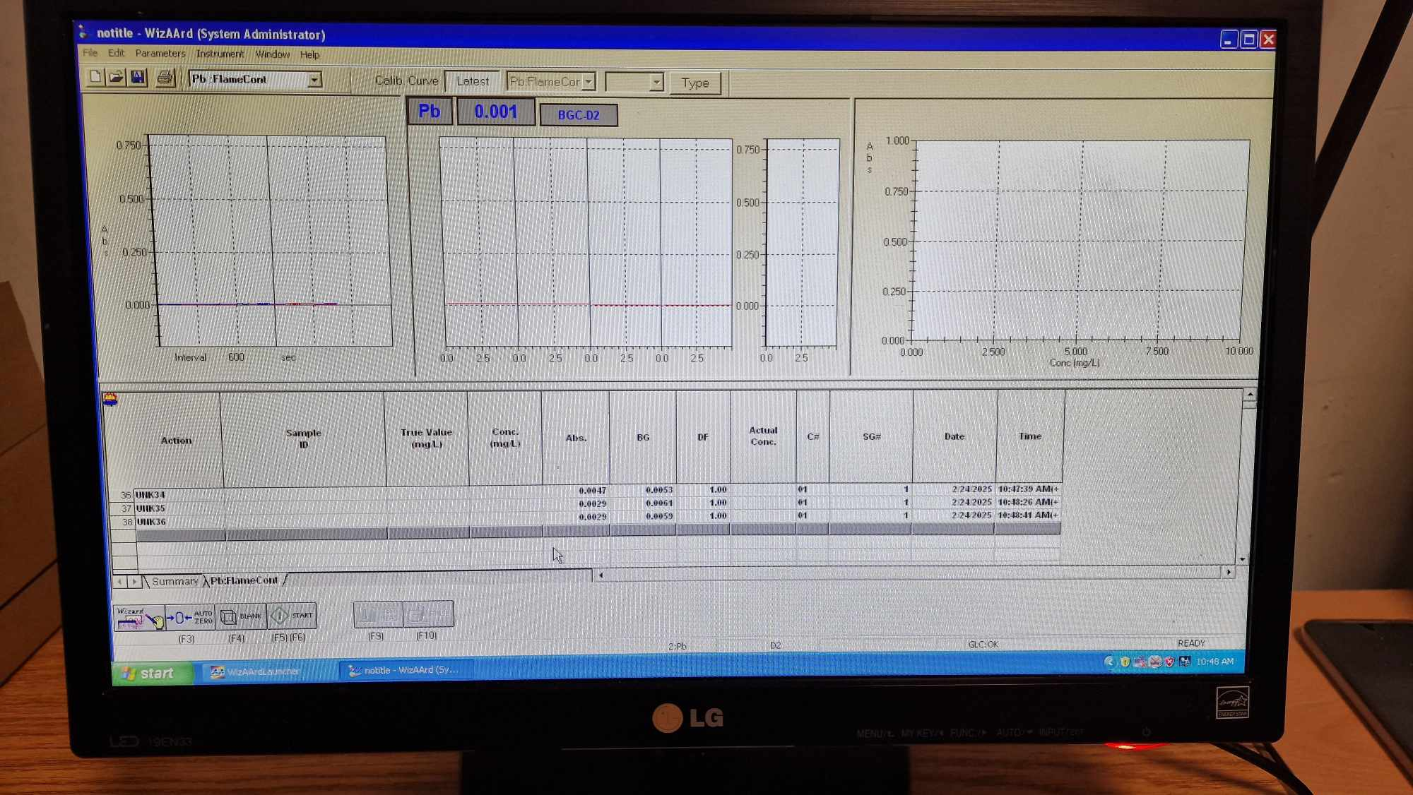
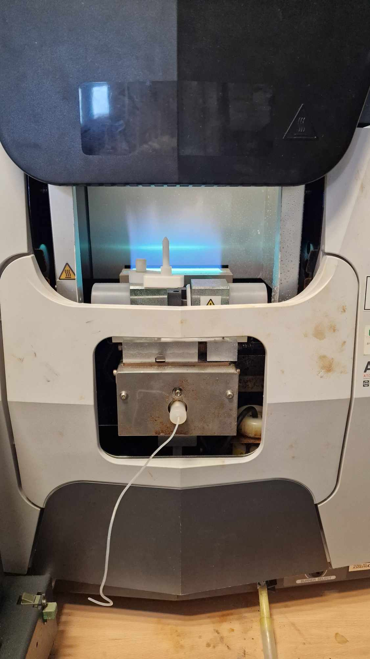
Data Analysis
Figure 13: Flame test of Lead ions
Figure 12: Flame test of Lead ions
All data collected (Air Temperature, Barometric Pressure, Humidity, Rainfall, Wind, Visibility) was recorded on a template and uploaded on GLOBE database through the Data Entry tool on the GLOBE Observer App. The Soil Samples were taken at MCAST laboratories to be analyzed with special methods and apparatus as mentioned before. All readings from samples were also recorded on a template.
Results
The screenshots below show data uploaded on GLOBE website during date of sample collection. (Figures 6, 7, 8, 9, 10, 11). Students collected readings of air temperature, barometric pressure, humidity, rainfall and cloud cover and type together with surface conditions following GLOBE Protocols guide on day of soil sample collection. Also, the results from analysis were recorded. All readings and results are shown in Table 1, 2, 3, 4.

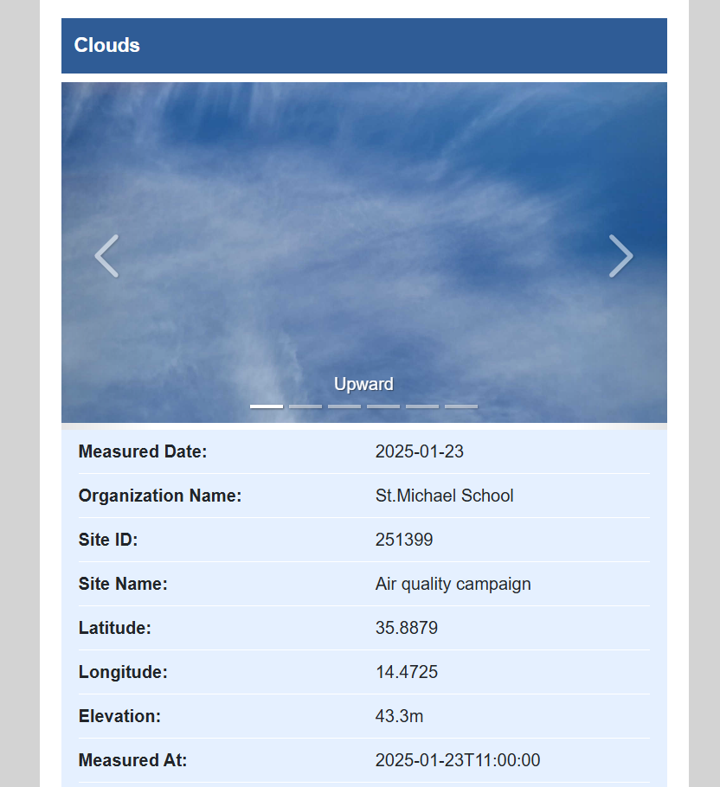

Figures 6: Rainfall plot of VIZ GLOBE

Figures 7: Cloud observations on My Observations - GLOBE

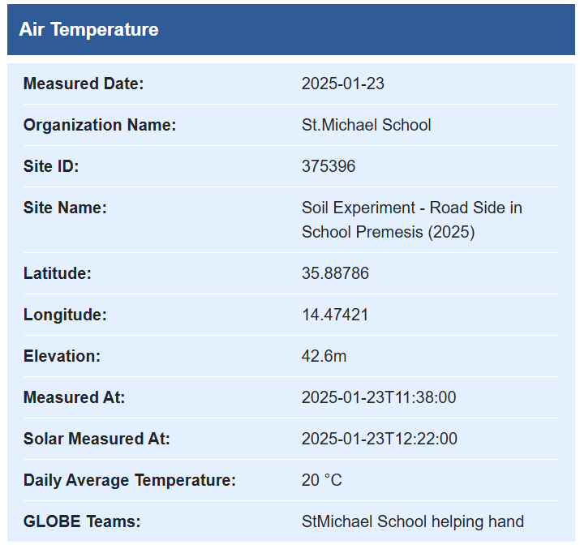
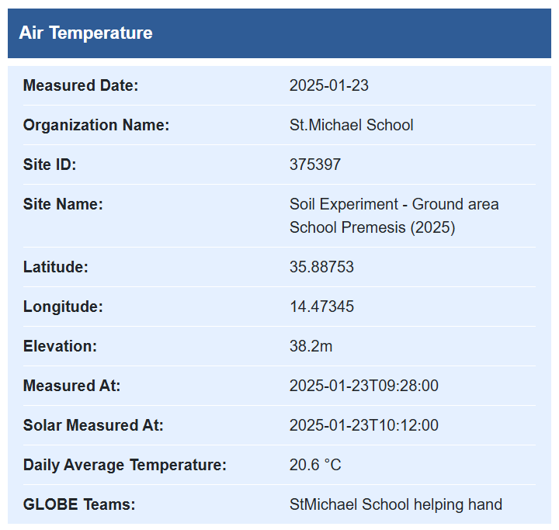

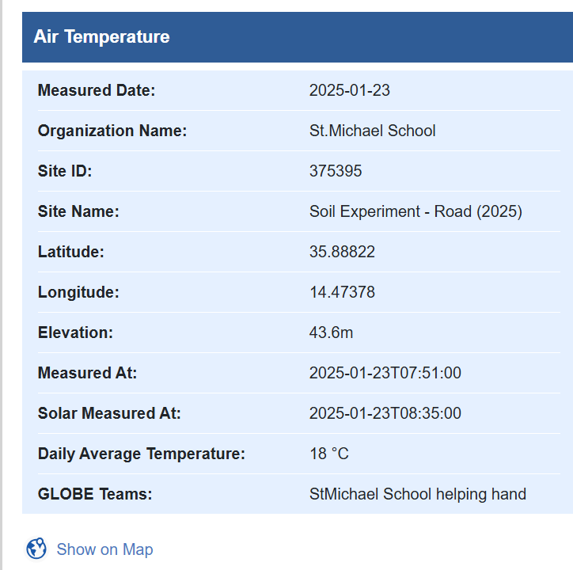
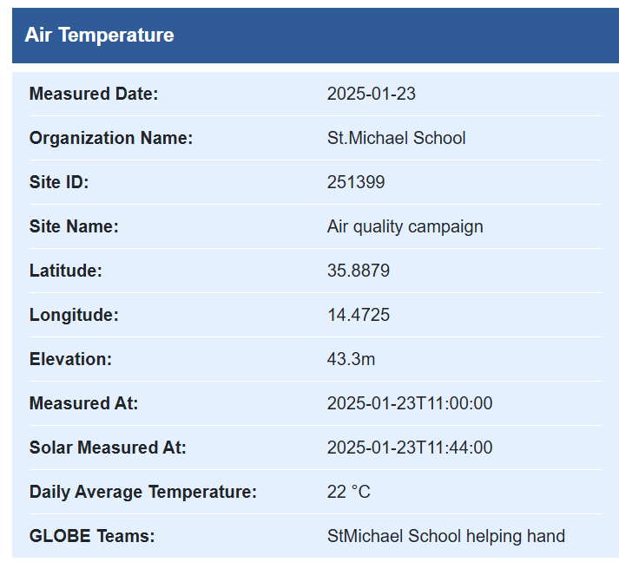

Figures 9: Temperature plot of VIZ GLOBE

Figures 7: Temperature observations on My Observations - GLOBE

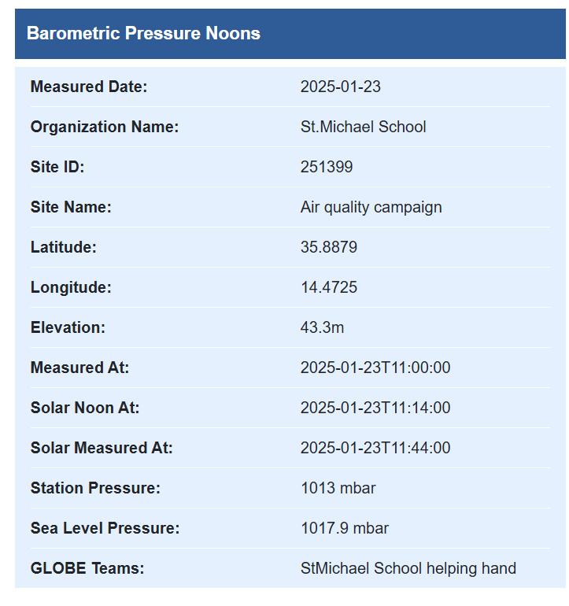

Figures 7: Barometer observations on My Observations - GLOBE

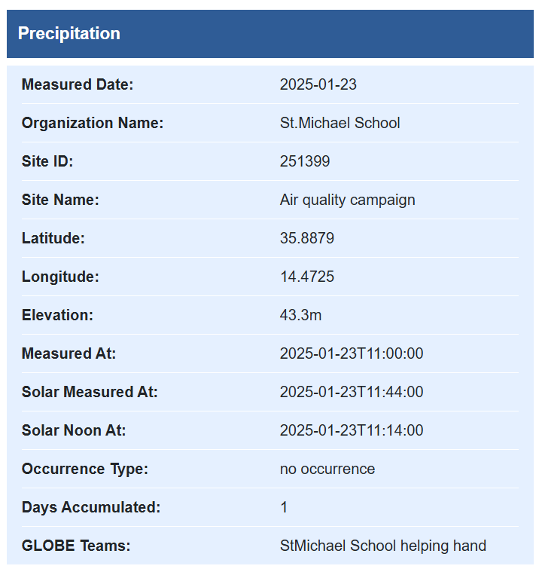

Figures 7: Precipitation observations on My Observations - GLOBE

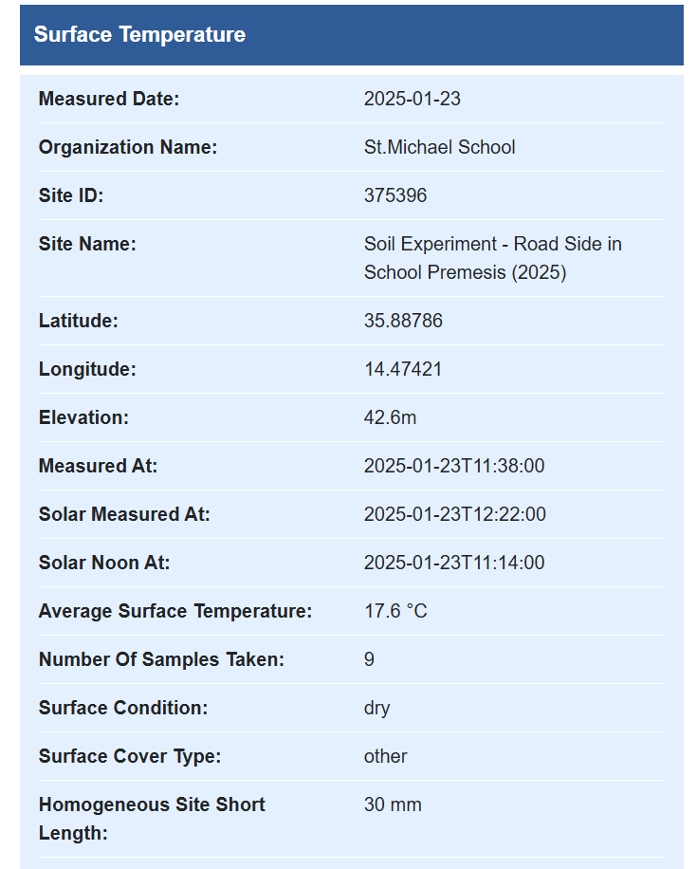
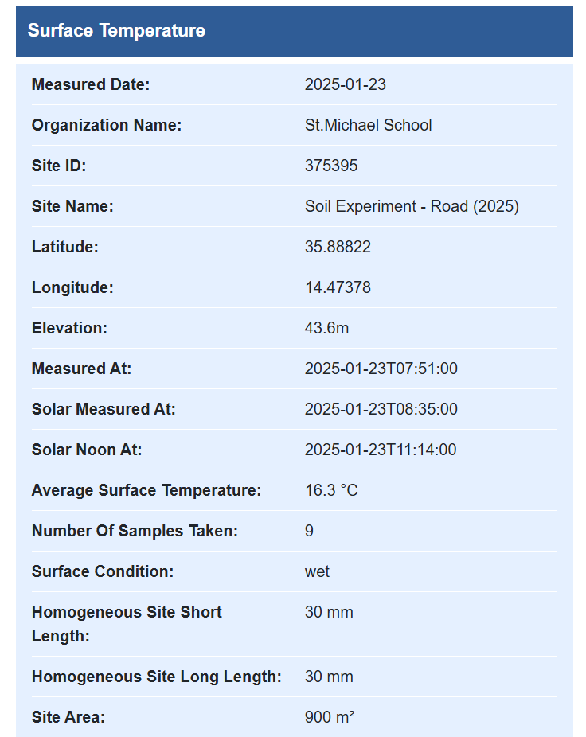
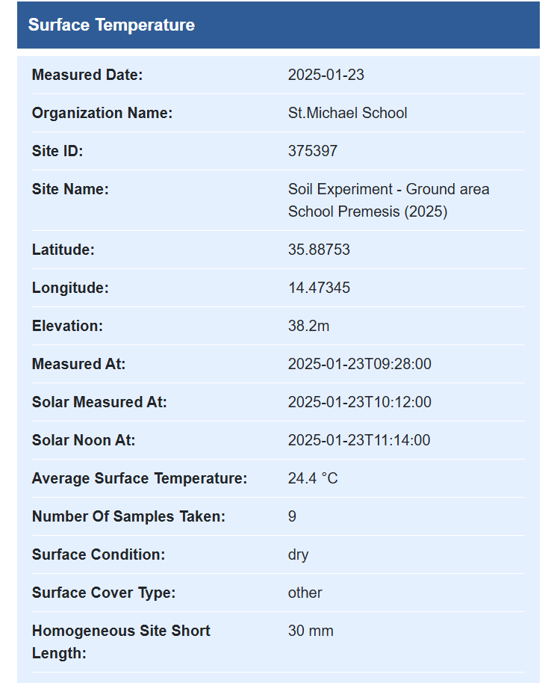
Figures 7: Surface Teperature observations on My Observations - GLOBE
Table 1: Data Sheet – Atmospheric conditions and Cloud Type
Date | Time | Rainfall |  | Wind |  |  | Visibility
Date | Time | Yes | No | Strong | Light | Calm | Good | Fair | Poor
23-Jan | 12.30
Date | Time |  | Cloud type |  |  | Air Temperature  (°C) | Humidity  (%)
Date | Time |  | High | Mid | Low | Air Temperature  (°C) | Humidity  (%)
23-Jan | 11.44 |  |  |  |  | 22 | 76

Table 2: Data Sheet – Soil Temperature parameters
Date | Time | Air Temperature | Surface Temperature | Soil  Temperature (Depth) | Sample
11-Nov | 12.30 | 18 | 16.3 | 17 | Road (outside school)
12-Nov | 12.05 | 20.6 | 24.4 | 17 | Ground (garden)
13-Nov | 10.30 | 20 | 17.6 | 15 | Road Side (in school)

Table 3: Results – Lead amount per sample (Quantitative Analysis)
Samples  (2 samples each) | mg/g (per 1g sample)
Road (outside school) | 0.1
Road (outside school) | 0.080
Ground (garden) | 0.040
Ground (garden) | 0.035
Road Side (in school) | 0.060
Road Side (in school) | 0.067

Table 4: Results – Presence of Polyaromatic Hydrocarbons (Qualitative Analysis)

Samples  (2 samples each) | Presence | Type
Road (outside school) | Very High | 2 or more
Road (outside school) | Very High | 2 or more
Ground (garden) | Low | 1 or more
Ground (garden) | Low | 1 or more
Roadside (in school) | High | 1 or more
Roadside (in school) | High | 1 or more

Discussion
The results obtained were consistent with expectations. The highest concentrations of PAHs were detected in the soil samples collected from the roadside outside the school, followed by the roadside area within the school grounds. The lowest concentrations were recorded in the garden area located furthest from the road. These findings confirm that PAHs are primarily emitted from vehicle traffic.

PAHs are organic compounds that can be volatile, particularly under warmer and drier conditions. In humid environments, however, PAHs are more likely to adhere to soil particles due to increased soil moisture. Higher humidity can reduce PAH evaporation, resulting in prolonged retention of these compounds within the soil.

The qualitative analysis for lead showed a similar spatial distribution. The highest presence of lead was detected in the soil sample taken from the roadside, followed by the sample from the roadside area within the school premises, and the lowest levels were observed in the ground area furthest from the road. Soil moisture also influences lead behaviour: humid conditions may increase soil compaction, reducing lead mobility, while very dry conditions can promote dust formation, increasing the potential for lead resuspension and transport.

Although humidity does not directly cause PAHs or lead to behave in a specific manner, it influences environmental factors such as soil moisture, temperature, microbial activity and water movement, all of which affect the concentration and mobility of these contaminants.

These findings are supported by an air quality study conducted five years ago, during which three nitrogen dioxide diffusion tubes were installed around the school. That study similarly indicated that pollutant concentrations decrease with increasing distance from the main road, confirming that traffic-derived pollutants have a greater impact on areas closer to traffic sources.

Conclusion
The EU soil strategy for 2030 sets out a framework and concrete measures to protect and restore soils, and
The EU Soil Strategy for 2030 establishes a framework to protect and restore soils and promote their sustainable use, with the goal of achieving healthy soils by 2050 and implementing concrete actions by 2030.

Lead is naturally present in all soils, typically at concentrations ranging from 15 to 40 parts per million (ppm) or milligrams per kilogram (mg/kg). However, pollution can significantly increase soil lead levels, sometimes reaching several thousand ppm.

Based on the findings of this study, higher levels of lead were detected in soil samples collected from the roadside and areas adjacent to the road, while the sample collected further away from the road was within expected natural background levels. The results highlight the impact of traffic-related activities on soil contamination within urban school environments.

Recommendations:

Source Control: For the reduction of these chemicals in the soil and improvment would be the use of less cars, and more eco friendly transport such as electric cars, bicycles and hydrogen cars.
Using Plants to Remove Contaminants: Certain plants, known as hyperaccumulators, can absorb and accumulate lead and PAHs from the soil. Plants like sunflowers, mustard, and Indian mustard are commonly used for phytoremediation of lead. For PAHs, plants like poplar trees have been shown to degrade or accumulate these compounds.
Enhancing Plant Growth: The effectiveness of phytoremediation can be enhanced by optimizing soil conditions, such as adding nutrients or using biostimulants to boost plant growth and increase the uptake of contaminants.
Microbial Degradation of PAHs: Specific microorganisms can break down PAHs into less harmful compounds. By introducing or enhancing populations of bacteria, fungi, or other microorganisms, the degradation of PAHs can be accelerated. This process works well in warm, moist environments where microbial activity is high. Adding specific strains of microorganisms that are particularly efficient at breaking down PAHs. This can be a targeted and effective way to clean up contaminated soil.
Increasing Oxygen Availability: PAHs can be degraded more effectively in aerobic conditions. Aerating soil to increase oxygen availability can support microbial degradation of PAHs, speeding up the cleanup process.
Adding Phospate: Adding phosphates to contaminated soil can help immobilize lead. Phosphates react with lead to form insoluble compounds, reducing the lead’s mobility and bioavailability to plants and animals. This is especially useful in reducing the risk of lead uptake by plants.
Organic Matter to Bind Contaminants: Adding organic matter, such as compost, can help bind lead and PAHs to soil particles, reducing their mobility and bioavailability. Organic matter also supports microbial activity, which can aid in the breakdown of PAHs.

References

GLOBE teacher guide https://www.globe.gov/ (Accessed October 2024)
GLOBE Observer https://observer.globe.gov/ (Accessed March 2024)
https://www.sciencedaily.com/releases/2020/06/200626114750.htm
https://www.epa.gov/no2-pollution/basic-information-about-no2

Badges Description

I am a Data Scientist
Students analysed their own data (from their measurements). They were able to analyse line graphs to interpret the data. They also became aware of the limitations of the data and could only draw conclusions from the samples studied. From the data analysis, the students answered their research questions and made suggestions for future research. Also they compared results with past findings.

I am a STEM storyteller
This research was shared on an ArgisStory, and study was disseminated on school website, Facebook and newsletter. Also students participated in a webinar to share their findings.

I make an Impact
Nitrogen Dioxide and other gases are causing a detrimental effect on our environment. The research helped students, and the community recognize the effect of emissions. In addition to taking measurements at school, students also disseminated their knowledge among family and friends and with other schools in project. Finally, students made recommendations for future research in other periods of time and in the same period to better understand the effect of Nitrogen Dioxide and air quality.

