Wind Farm in Ruy Barbosa/RN: a proposal to analyze the socio-environmental and technological impacts using the GLOBE Protocols

Dra. Maria Romênia da Silva
Filiação: Escola Estadual Rui Barbosa (Tempo Integral)
Endereço da Instituição: Rua Umbelino de Moura, nº 65, Ruy Barbosa/RN.
e-mail: romeniadsilva@gmail.com

Audilene Ambrósio Cordeiro
Filiação: Escola Estadual Rui Barbosa (Tempo Integral)
Endereço da Instituição: Rua Umbelino de Moura, nº 65, Ruy Barbosa/RN.
e-mail: ambrosioaudilene@gmail.com

Maria Clara Cordeiro de Souza
Filiação: Escola Estadual Rui Barbosa (Tempo Integral)
Endereço da Instituição: Rua Umbelino de Moura, nº 65, Ruy Barbosa/RN.
e-mail: mariaclaracordeiro06@gmail.com

Ian Jefferson Machado de Sousa
Filiação: Escola Estadual Rui Barbosa (Tempo Integral)
Endereço da Instituição: Rua Umbelino de Moura, nº 65, Ruy Barbosa/RN.
e-mail: ianjefferson092007@gmail.com

Pedro Nicolas de Souza Farias
Filiação: Escola Estadual Rui Barbosa (Tempo Integral)
Endereço da Instituição: Rua Umbelino de Moura, nº 65, Ruy Barbosa/RN.
e-mail: pn710832@gmail.com

Iandyson Muniz da Silva
Filiação: Escola Estadual Rui Barbosa (Tempo Integral)
Endereço da Instituição: Rua Umbelino de Moura, nº 65, Ruy Barbosa/RN.
e-mail: iandysonm@gmail.com

ABSTRACT
This research aims to analyze, from the perspective of the GLOBE Protocols, the main environmental, social, and technological problems caused by the implementation of the Wind Farm in the city of Ruy Barbosa/RN. In this context, the article presents a didactic proposal composed of three pedagogical activities, developed based on the results obtained from the theoretical data collection, derived from interviews with city residents about the installation of the Wind Farm. Therefore, we will use the GLOBE Observer application to collect experimental data and perform an analysis of the socio-environmental and technological impacts. In this article, we present the results and analyses of the interviews that our team conducted with some city residents, aiming to validate our research hypothesis. Based on the data collected, we verified that the implementation of the Rio do Vento Wind Farm Complex, which passes through the city of Ruy Barbosa/RN, has caused some impacts that have been perceived by the municipality's population over the years. The main impacts detected were a decrease in fauna and flora, noise production, alteration of the natural landscape, cracks in houses, and interference with TV and cell phone signals. Therefore, the topic addressed in our article is important for the ecosystem of the Ruy Barbosa community and is justified based on the aforementioned arguments.

KEYWORDS. Wind Farm, GLOBE Protocols, Ruy Barbosa/RN, environmental problems.

- Introduction

With regard to the preservation of the environment, Wind Energy contributes to the reduction of air pollutants and the need to build large reservoirs, compared to thermal and hydroelectric plants. On the other hand, as negative impacts, there are the sound factor (rotor noise, depending on the specification of the equipment), the visual issue (grouping of towers) and possible electromagnetic interference that could disturb the communication and data transmission systems. As well as the structural problems caused in the residences of the city of Ruy Barbosa/RN during the construction of the Wind Farm.
The general objective of our Research Project is: To analyze, from the perspective of the GLOBE Protocols, the main environmental, social and technological problems caused by the implementation of the Wind Farm in the city of Ruy Barbosa/RN.
To achieve our overall goal, we have set ourselves some specific goals:
- Apply the GLOBE Protocols seeking to identify the main environmental, social and technological problems caused by the implementation of the Wind Farm in the city of Ruy Barbosa/RN;
- Use the GLOBE Observer Cloud Protocol to identify the most common types of clouds in the city of Ruy Barbosa, Potengi region of RN where part of the Rio do Vento Wind Complex is located;
- Compare the data obtained by the Biometrics (Trees) and Land Cover Protocols in the GLOBE Sphere of the Biosphere with the satellite images aiming to verify the changes in the local vegetation from the implementation of the Wind Farm in the city of Ruy Barbosa/RN;
- Adopt the GLOBE Protocol for Soil Temperature (Pedosphere) to collect data in residences near the Ruy Barbosa Wind Farm;
- Verify based on the data obtained with the GLOBE Mosquito Protocol (Hydrosphere) if there is a relationship between the increase in mosquito proliferation in the city of Ruy Barbosa and the deforestation caused by the installation of the Wind Farm.
We are using the GLOBE Sphere "Earth as a system" in the development of the research. Knowing that the Earth works as a large system formed by four spheres that act in an integrated way: Atmosphere (the air we breathe), Hydrosphere (all the water on the planet), Biosphere (living beings) and Pedosphere (the soil that sustains life). Because they are interconnected, changes in one sphere have a direct impact on the others (NASA - The GLOBE Program, 2025). Therefore, understanding the Earth as a system helps to understand how human actions and natural phenomena influence the balance of the planet. Therefore, we are using the following GLOBE protocols for our data collection and analysis: Clouds (Atmosphere), Mosquitoes (Hydrosphere), Biometrics - Trees (Biosphere), Land Cover (Biosphere) and Soil Temperature (Pedosphere).
Therefore, the article presents a didactic proposal composed of three pedagogical activities, elaborated based on the results obtained in the theoretical data collection, from the realization of some interviews with residents of the city of Ruy Barbosa/RN about the installation of the Wind Farm. Therefore, we will use the GLOBE Observer application (NASA, 2025) aiming to collect experimental data to analyze the socio-environmental and technological impacts based on the GLOBE Protocols.

- Theoretical Reference
The Rio do Vento Wind Complex is a set of wind farms located in Rio Grande do Norte and operated by Casa dos Ventos. The Rio do Vento complex has a total of 240 wind turbines and 1038 Mega Watts of installed capacity, spread over 14,000 hectares in four municipalities in the state of Rio Grande do Sul: Caiçara do Rio do Vento, Ruy Barbosa, Riachuelo and Bento Fernandes. It has the capacity to power about 2 million Brazilian homes, however, the energy from the first part of the complex has already been previously sold to large Brazilian companies, such as Anglo American (mining), Grupo Moura (automotive components), TIVIT (IT services) and Vulcabrás Azaleia (footwear).
Figure 1, 2, 3 and 4: Rio do Vento Wind Farm – Ventos de Santa Alice (Ruy Barbosa/RN)
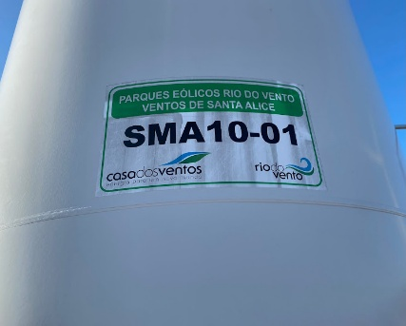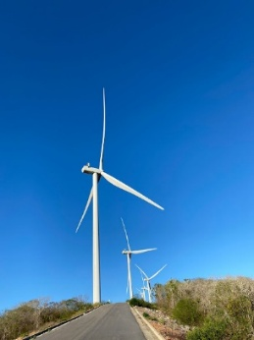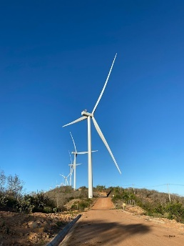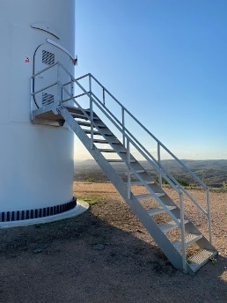
Source: Images recorded by EETI Rui Barbosa students.

Renewable energies have become an important resource for sustainable development, which have, over time, gained more strength and space in their growth and application, in general, the scenario of progress of renewable energy sources is promising, since the potential is high (Costa et al, 2019). According to Costa et al (2019), in Brazil, in 2017, the Northeast region was the one with the highest representation in the generation of energy from wind sources with 84% (33.99 TWh), followed by the South region with 14.4% (5.84 TWh) and the North region with 1.4% (0.55 TWh). The five states with the highest generation in this period were: Rio Grande do Norte (13.24 TWh), Bahia (7.79 TWh), Rio Grande do Sul (5.58 TWh), Ceará (5.10 TWh) and Piauí (4.59 TWh) (Abeeólica, 2025).
However, as a result of the installations of wind farms, it has become increasingly evident that the environmental, social and technological impacts caused by this type of enterprise are ignored by the agents during the implementation period that extends during the period of operation of the farms. The main socio-environmental impacts associated with both the construction and operation of wind farms are classified as: interference in flora and fauna due to changes in vegetation cover; direct interference with winged fauna by collision with wind turbine blades; traffic disturbance during the transport of wind turbine components; increase in demand for services and infrastructure; noise production; change in the landscape and increase in economic dynamics (Costa et al, 2019). It is worth noting that the relevance of these interferences varies with the regional and local characteristics of the municipalities where the wind farms are implemented.

- Materiais e Métodos
To carry out the analysis of the environmental, social and technological impacts from the GLOBE Protocols at the Rio do Vento Wind Complex in the city of Ruy Barbosa/RN, we made use of the following materials and methods:

First: Conducting the interviews
The research is being carried out in the city of Ruy Barbosa, a Brazilian municipality in the state of Rio Grande do Norte. According to an estimate by the IBGE (Brazilian Institute of Geography and Statistics) in the year 2024, its population was 3,266 inhabitants with a territorial area of 125,809 km.

Figure 5: Location of Ruy Barbosa in Rio Grande do Norte.
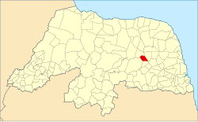
Fonte: Derivad de - File:RioGrandedoNorte MesoMicroMunicip.svg

Figura 6 e 7: Município de Ruy Barbosa no Rio Grande do Norte.
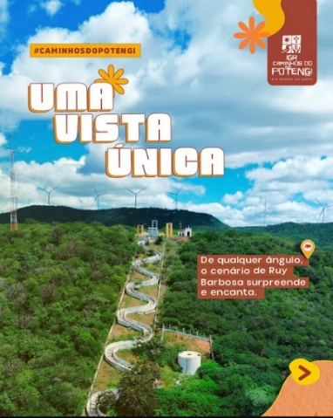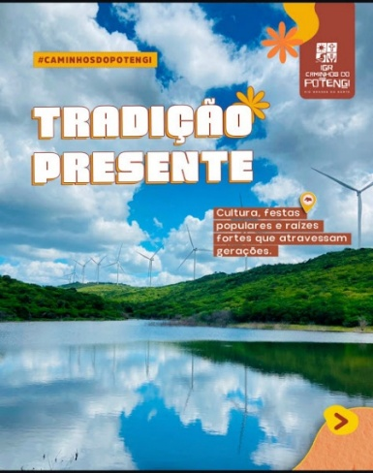
Fonte: Instagram Caminhos do Potengi.

Our team used, in the research project, structured interviews as an instrument for the construction of qualitative data (Duarte, 2002; Silva, Oliveira, Slage, 2021), since it follows a pre-defined script with the same questions for all candidates, ensuring a standardized and objective assessment. We planned to conduct the interviews to collect theoretical data that would corroborate our research hypothesis. Therefore, we organized eight questions that addressed the GLOBE protocols that we chose to use in our research project at this first moment of the investigation.

Activity 1: Our daily soil
The students will investigate the variations in the soils around the EETI Rui Barbosa and in the rural communities of the municipality where the Wind Farm was implemented to analyze which soil properties, such as moisture, temperature, color and texture, present considerable variation in a single landscape. They will also identify factors such as slope, shade, plants, and compaction, which affect the appearance of soils and their ability to retain moisture. Thus, students will understand that variations in the landscape can affect soil properties.
Objective of the Activity: To analyze how soil moisture, color, texture, and temperature properties can vary considerably in a single landscape.
GLOBE Protocols Involved: GLOBE Sphere: Pedosphere – the soil that sustains life and Protocol – Soil temperature; GLOBE Sphere: Biosphere - Living Beings and Protocol - Characterization/Land Cover
Materials and Resources needed: Small shovel; Box to store soil samples; Soil thermometer; GLOBE Observer App; Observation notebooks.

Activity 2: In the Clouds – Observation & Identification
OStudents will observe and draw the clouds in the city of Ruy Barbosa/RN, describing their shape and using their own words. Initially, qualitative descriptions will be made and, later, a more scientific vocabulary will be used to deepen the analysis carried out. A relationship will be established between the students' descriptions and the standard classification of the ten types of clouds identified by GLOBE. Each student will have a personal cloud notebook to use along with the GLOBE Cloud Chart. The observations will be carried out over several days. At the end of this period, students will make weather predictions and verify them, using their observations in partnership with the data collected in the GLOBE Observer app.
Objective of the Activity: Observe clouds, describe them with everyday vocabulary and compare this description with the official names of clouds, stimulating the interest of students in making observations about the types of clouds frequent in their city.
GLOBE Protocols InvolvedGLOBE Sphere: Atmosphere - the air we breathe and Protocols - Classification of Clouds and Contrails.
Materials and Resources needed: GLOBE Cloud Chart; Photocopies of the clouds described in this activity; GLOBE Science Notebook; GLOBE Observer App; Table: Different types of clouds; Cell phone / Camera or camcorder to take pictures of the clouds (optional);

Activity 3: Densiometer - construction and use
From the realization of the activity, it is expected that the students knew how to build a densiometer with low-cost materials, as well as explain its use articulated with the protocols Biometrics (Trees), Classification of Land Cover and Height of Trees. The most commonly used instruments for measuring canopy coverage are spherical, convex and concave densiometers, which are basically mirrors with about 96 points reflecting canopy coverage. The number of points on a tree's canopy is equivalent to the percentage of canopy cover. The GLOBE Program developed an adaptation of this densiometer to calculate the percentage of points that are crossed by the canopy along a transect or evaluation line (González, 2023). Through this activity, a densiometer will be built in the Science Laboratory of the Rui Barbosa Full-Time State School with low-cost materials easily found.
Objective of the Activity: Build a densiometer using low-cost materials and collect data based on the Biometrics (Trees), Land Cover Classification and Tree Height protocols.
GLOBE Protocols Involved: GLOBE Sphere: Biosphere - living beings and Protocols - Biometrics (Trees), Land Cover Classification and Tree Height.
Materials and Resources Needed: Toilet paper roll, paper towel, or aluminum foil; Dental floss; Transparent adhesive tape; Scissors; 1/4" washer or screw (if you don't have any of these items, you can use the ring of a keychain); Mobile with the GLOBE Observer App.

Analysis of data/results
In this article we present the results and analyses of the interviews that our team conducted with some residents of the city of Ruy Barbosa/RN, aiming to validate our research hypothesis. In the following tables, we describe the questions articulated with the spheres and protocols of GLOBE, as well as the answers of the interviewees.

Chart 1: Answers to question 1 – Earth as a system.  Identification | 1. In your opinion, what are the main environmental impacts caused by the implementation of the wind farm in the city of Ruy Barbosa?
Interviewee 1 - 63 years old, lives in the rural area, farmer and chicken breeder. | The biggest impact was during construction. A lot of dust, a lot of trucks and noise. The peace we had ended a little. Today it is quieter, but the natural environment has lost part of its calm.
Interviewee 2 - 49 years old, lives in urban areas, cattle breeder and subsistence farmer. | The biggest impact was on the landscape and fauna. Before the mountains were only green, now it's towers everywhere. The animals have disappeared a little, but the wind is still strong.
Interviewee 3 - 35 years old, rural worker and bricklayer in his spare time. | The most visible impact was the deforestation of small areas and the noise of the works. But after it was ready, the access improved, because they opened a good road.
Interviewee 4 - 37 years old, nursing technician and lives in the urban area. | The main impacts are minimal, such as dust during the work, but nothing serious for the local environment.
Interviewed 5 - 47 years old, former councilman and lives in the rural area. | In my opinion, the deforestation of the native forest, soil corrosion and erosion and the noise in the wind turbines
Interviewee 6 - 50 years old, Civil Servant and lives in the urban area. | In the construction of the roads, there was a lot of deforestation. And the use of dynamite has changed the route of the animals and there is also noise pollution for those who live nearby.
Interviewee 7 - 19 years old, Nursing Technician and lives in the rural area. | I think it changed the landscape and brought a little noise with the turbines.
Interviewee 8 - 54 years old, History teacher and lives in the urban area. | From my point of view, just visual, before we had a natural landscape and now we have a modified landscape in some aspects, better in terms of tourist attraction, visitation to the park, this has brought benefit to the municipality.
Source: Produced by the LUAR Potengi Team.

Table 2: Answers to question 2 – Spheres of the Pedosphere and Biosphere.  Identification | 2. Have you noticed any impact on the soil or on homes near the region where the wind farm was implemented?
Interviewee 1 - 63 years old, lives in the rural area, farmer and chicken breeder. | The soil became drier and harder in some places, because of the heavy machinery. Some nearby houses, according to her, had cracks in the walls.
Interviewee 2 - 49 years old, lives in urban areas, cattle breeder and subsistence farmer. | In some areas, the soil has become more hardened and rainwater runs off instead of seeping in. The floor is different, it looks pressed.
Interviewee 3 - 35 years old, rural worker and bricklayer in his spare time. | Yes, there was earth that became hard, and some houses near the towers were cracked. The movement of the trucks moved the ground.
Interviewee 4 - 37 years old, nursing technician and lives in the urban area. | I didn't notice anything on the ground or houses; Everything went on as normal nearby.
Interviewed 5 - 47 years old, former councilman and lives in the rural area. | There was an impact on the residences due to the detonation of rocks due to the explosives that the company that implemented the wind farm used, damaging some houses (such as my residence).
Interviewee 6 - 50 years old, Civil Servant and lives in the urban area. | Yes, there was a lot of change in the soil. And there is also the issue of people who live nearby, whose houses had many cracks.
Interviewee 7 - 19 years old, Nursing Technician and lives in the rural area. | Yes, the ground became harder and some houses felt small vibrations.
Interviewee 8 - 54 years old, History teacher and lives in the urban area. | In our urban region there was no such impact on the soil because the area used was an area of mountain mountains of difficult access, it was not used for planting or any management in these areas. In my opinion, there was no impact on the residences because they are approximately 600 to 700 meters from the park.
Source: Produced by the LUAR Potengi Team.

Panel 3: answers to question 3 – Mosquito protocol.
Identification | 3. Regarding animals and insects, have you noticed an increase or reduction in any species?
Interviewee 1 - 63 years old, lives in the rural area, farmer and chicken breeder. | There are fewer birds in the region. Before there were turtledoves, blue... Now they're gone for a while. Insects, on the other hand, increased, especially at night.
Interviewee 2 - 49 years old, lives in urban areas, cattle breeder and subsistence farmer. | There was a reduction in birds and an increase in bats and crickets. The birds moved away, but now there are all kinds of insects.
Interviewee 3 - 35 years old, rural worker and bricklayer in his spare time. | Wild animals have decreased. I hardly see any fox or saruê anymore. But the number of bees increased near the plantations.
Interviewee 4 - 37 years old, nursing technician and lives in the urban area. | Animals, especially birds, there was a reduction I think, I don't see those birds that were passing by, I could hear and see them.
Interviewed 5 - 47 years old, former councilman and lives in the rural area. | I did. Increase in animals such as snakes, peba, mocó, an increase in these species.
Interviewee 6 - 50 years old, Civil Servant and lives in the urban area. | There was a reduction due to deforestation and explosions.
Interviewee 7 - 19 years old, Nursing Technician and lives in the rural area. | I noticed fewer birds and insects around the towers.
Interviewee 8 - 54 years old, History teacher and lives in the urban area. | Yes, we have noticed a large increase in snakes throughout the municipality in the areas where the park is located. The place is infested with snakes, especially the Cascavel, which already existed in our region, but not in this quantity that we are seeing. The park's management was asked about this issue, the increase in snakes and snakes and they justified that the parks now have an environmental preservation area and Ibama and the preservation agencies started to release these animals in the preservation areas. Animals captured in other regions of the state.
Source: Produced by the LUAR Potengi Team.

Panel 4: Answers to question 4 - Tree protocol.
Identification | 4. In your opinion, did the amount of trees in the city's vegetation decrease after the installation of the wind farm?
Interviewee 1 - 63 years old, lives in the rural area, farmer and chicken breeder. | Yes, to make the roads and put the towers, they cut down some trees. It wasn't so much, but it changed the landscape.
Interviewee 2 - 49 years old, lives in urban areas, cattle breeder and subsistence farmer. | A little, yes. They cut down weeds to open a road and put a truck. Then the green even returned, but not like before.
Interviewee 3 - 35 years old, rural worker and bricklayer in his spare time. | Yes, they cut weeds to put the towers. Then they planted it again in some places, but it was different.
Interviewee 4 - 37 years old, nursing technician and lives in the urban area. | No, I only decreased in the part where the parks were built; There was no deforestation because of this here.
Interviewed 5 - 47 years old, former councilman and lives in the rural area. | It did decrease, due to the amount of deforestation that occurred in the vegetation of the mountain areas that were deforested to place the wind farm, reducing the amount of precipitation in our municipality.
Interviewee 6 - 50 years old, Civil Servant and lives in the urban area. | In my opinion, there was no reduction in vegetation.
Interviewee 7 - 19 years old, Nursing Technician and lives in the rural area. | Yes, they cut down some trees to make room for the roads and towers.
Interviewee 8 - 54 years old, History teacher and lives in the urban area. | The vegetation in the urban area remains the same as always, there has been no change. The rest of the municipality saw an increase in vegetation as there was a decrease in agriculture and the areas were restored.
Source: Produced by the LUAR Potengi Team.

Panel 5: Answers to question 5 – Sphere of the Atmosphere.
Identification | 5- Do you feel any change in the temperature and climate of the city after the installation of the Wind Farm?
Interviewee 1 - 63 years old, lives in the rural area, farmer and chicken breeder. | Look, the heat is the same, but it seems that the wind has been a little changed. It's a different breeze, you know?
Interviewee 2 - 49 years old, lives in urban areas, cattle breeder and subsistence farmer. | The weather remains warm, but it seems that the wind changes direction because of the propellers.
Interviewee 3 - 35 years old, rural worker and bricklayer in his spare time. | I didn't feel a big change. It just seems that the wind changes course. Sometimes the noise of the propellers even gives the impression of rain.
Interviewee 4 - 37 years old, nursing technician and lives in the urban area. | In my opinion, the climate and temperature remains the same as always.
Interviewed 5 - 47 years old, former councilman and lives in the rural area. | Yes, I feel a change in the climate. Due to deforestation, there was a significant increase in the temperature of our city.
Interviewee 6 - 50 years old, Civil Servant and lives in the urban area. | I didn't feel much change in the weather.
Interviewee 7 - 19 years old, Nursing Technician and lives in the rural area. | Yes, it seems that the wind has become more constant and the weather a little drier.
Interviewee 8 - 54 years old, History teacher and lives in the urban area. | In recent times we have noticed that there has been an increase in the wind, it has become windier and the nights are colder.
Source: Produced by the LUAR Potengi Team.

Panel 6: Answers to question 6 – Earth as a system.
Identification | 6- After the Wind Farm was implemented, did you notice any type of interference in communication in relation to telephone and internet signals (in the urban and rural areas)?
Interviewee 1 - 63 years old, lives in the rural area, farmer and chicken breeder. | Yes, here the phone signal has worsened. The internet goes down from time to time, especially when it's windy.
Interviewee 2 - 49 years old, lives in urban areas, cattle breeder and subsistence farmer. | Sometimes the phone fails, especially in rural areas. In the city it is normal, but here in the countryside the signal disappears.
Interviewee 3 - 35 years old, rural worker and bricklayer in his spare time. | In the rural area it got a little worse. The internet is oscillating and the phone goes down when the wind is strong.
Interviewee 4 - 37 years old, nursing technician and lives in the urban area. | Telephone and internet signals so normal, without any interference in the city, in the rural area there was really a problem because of the wind farm.
Interviewed 5 - 47 years old, former councilman and lives in the rural area. | There was interference, yes, the cell phone signal disappeared. And the signal from the TVs in the old antennas was also bad.
Interviewee 6 - 50 years old, Civil Servant and lives in the urban area. | For me it hasn't changed.
Interviewee 7 - 19 years old, Nursing Technician and lives in the rural area. | Yes, in some parts of the countryside the telephone signal has become weaker.
Interviewee 8 - 54 years old, History teacher and lives in the urban area. | In my point of view, in the urban area, there was an improvement because we use megabytes and now we use gigabytes, the speed has improved.
Source: Produced by the LUAR Potengi Team.

Panel 7: Answers to question 7- Earth as a system.
Identification | 7. Regarding the effects caused by noise and visual pollution, do wind turbines at the Wind Farm cause any kind of nuisance to you? Which ones?
Interviewee 1 - 63 years old, lives in the rural area, farmer and chicken breeder. | Yes, the noise of the propellers is annoying at night, and those flashing lights... We almost don't see the sky like before.
Interviewee 2 - 49 years old, lives in urban areas, cattle breeder and subsistence farmer. | Ah, by day not so much, but at night that buzz irritates. And the flashing lights, we think it's lightning from afar.
Interviewee 3 - 35 years old, rural worker and bricklayer in his spare time. | In the rural area it got a little worse. The internet is oscillating and the phone goes down when the wind is strong.
Interviewee 4 - 37 years old, nursing technician and lives in the urban area. | Noise is almost impossible to hear, but at dawn I hear it even though I am a little far away, and I think the wind turbines are beautiful.
Interviewed 5 - 47 years old, former councilman and lives in the rural area. | It does cause a lot of noise and noise. And it even interferes with people's sleep, especially in rural areas.
Interviewee 6 - 50 years old, Civil Servant and lives in the urban area. | It doesn't bother me either.
Interviewee 7 - 19 years old, Nursing Technician and lives in the rural area. | Yes, the noise of the propellers bothers a little at night and so are the flashing lights.
Interviewee 8 - 54 years old, History teacher and lives in the urban area. | The sound impacts are few because the wind turbines are a little far from my residence and the noise is not that harmful and the visual impact in my point of view is even attractive, people from other regions visit our municipality it is a form of tourist attraction.
Source: Produced by the LUAR Potengi Team.

Panel 8: Answers to question 8 – Earth as a system.
Identification | 8. In your opinion, what is the biggest advantage (benefit) for the city of Ruy Barbosa with the arrival of the Wind Farm?
Interviewee 1 - 63 years old, lives in the rural area, farmer and chicken breeder. | The benefit was the generation of temporary jobs and the increase in movement in local commerce. But after it ended, everything was the same again.
Interviewee 2 - 49 years old, lives in urban areas, cattle breeder and subsistence farmer. | It brought employment at the time of construction and helped bring clean energy. But for small farmers, not much has changed.
Interviewee 3 - 35 years old, rural worker and bricklayer in his spare time. | I think it's clean energy. It is better than thermoelectric or dam. And he helped the people with jobs at the time of construction.
Interviewee 4 - 37 years old, nursing technician and lives in the urban area. | The biggest advantage is a few temporary jobs and a little money for the city's coffers, but that's it.
Interviewed 5 - 47 years old, former councilman and lives in the rural area. | The advantage is the arrival of the ICMS resource that enters the city hall. That being well applied by the manager who makes a good administration is of great importance for the municipality.
Interviewee 6 - 50 years old, Civil Servant and lives in the urban area. | In my opinion, it is the collection of taxes for the municipality.
Interviewee 7 - 19 years old, Nursing Technician and lives in the rural area. | The clean energy and some jobs that the park has brought to the people.
Interviewee 8 - 54 years old, History teacher and lives in the urban area. | The financial part was very important in the properties where the park was established, the owners started to have an extra income and the municipality started to collect more with its ICMS, this helps a lot the municipalities where the parks are implemented, these benefits are very visible to those who arrive in the municipality.
Source: Produced by the LUAR Potengi Team.

Interview with Councilman Professor Ismael, representative of the Legislative Branch, about the implementation of the Wind Farm and the socio-environmental issues involved. Table 1 shows the answers.
Panel 1: Interview with Councilman Professor Ismael,
Identification | 1. Councilman Professor Ismael, how many years ago did you build the part of the Rio do Vento Wind Complex that passes through the city of Ruy Barbosa? | 2. Councilman Professor Ismael, do you remember how the implementation of the wind farm in Ruy Barbosa happened? How did the public administration deal with the release of land for the construction of wind farms? | 3. As a resident of the city of Ruy Barbosa, did you notice any change in the fauna and flora of the city in view of the installation of the wind farm? | 4. How do you, as a representative of the Legislative Branch, see today, tomorrow and the future of the city of Ruy Barbosa in relation to the maintenance of the Wind Farm and the socio-environmental issues involved?
Name: Ismael André dos Santos Silva  Age: 37 years old  Profession: Portuguese Language Teacher  Public Office: Councilor of the Municipality of Ruy Barbosa/RN  Residence: Urban area | The park began to be built in 2020 and to operate in 2021. | The implementation took place through a study of the area where there was better energy generation yield. From the studies, areas where we have wind turbines were compensated in real amounts to the owners. The public part, there was popular listening, but in a somewhat superficial way, since there was no investment in advertising talking about the real gains and the true environmental impacts. | The flora was devastated both where the wind turbines were deployed, and in a large area nearby. The fauna was even more damaged than the flora. Mainly, wild animals. | Unfortunately, 5 years after the beginning of the construction and installation process, the population has taken over conformism and demands nothing from the companies responsible for a policy of reestablishing the environment, in order to mitigate the damage. The ideal would be a broad social discussion and that a reforestation plan be drawn up in the region, at least to reduce the impacts.  So, we have to look at the recent past, study the present and plan for the future. To this end, it remains to politicize the people of the real impacts caused by the logistics of the wind farm in the municipality.
Source: Produced by the LUAR Potengi Team.

The results presented in the Tables and Table are directly related to our research question and provide a solid basis for discussions articulated with the GLOBE protocols we are using in our investigation.

Discussion
We analyzed the answers collected in the interviews, concluded that the results corroborate the project's hypothesis and answer our research question. Based on the data collected, we found that the implementation of the Rio do Vento Wind Complex that passes through the city of Ruy Barbosa/RN caused environmental, social and technological impacts that are being perceived by the population of the municipality over the years. We also noticed how the impacts are perceived differently by residents of the urban and rural areas. According to the answers described in Tables (1 to 8), the main socio-environmental and technological impacts detected were: reduction of fauna and flora, noise production, decharacterization of the natural landscape, cracks in houses and interference in TV and cell phone signals.
The interview with Councilman Professor Ismael, described in Table 2, corresponds to most of the answers described in the Tables, in view of the reality of the municipality, Professor Ismael emphasizes that: The ideal would be a social and broad discussion and that a reforestation plan be prepared in the region, at least to reduce the impacts. So, we have to look at the recent past, study the present and plan for the future. To this end, it remains to politicize the people of the real impacts caused by the logistics of the wind farm in the municipality.
Based on the analysis of the theoretical data, our team planned some pedagogical activities (described in topic 4 – Materials and methods) to experimentally validate the research hypothesis of our project. Our research is ongoing, we are currently collecting data (mainly with the GLOBE Observer application) through the realization of pedagogical activities, so we will soon disclose the results of this phase of the project.

Figues 12, 13, 14 e 15: Coleta de solo na zona rural – Pedosfera e Biosfera.
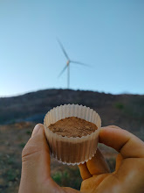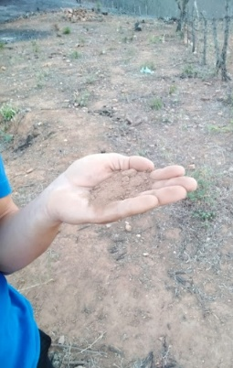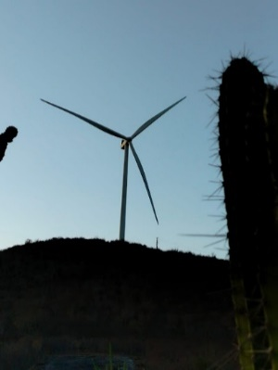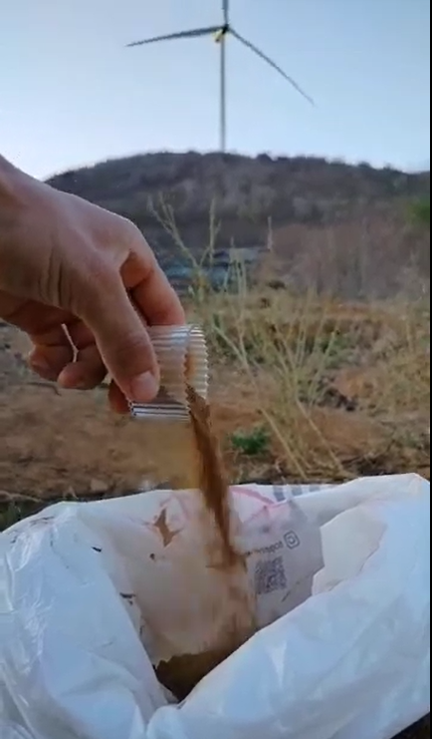
Source: Produced by the LUAR Potengi Team

Figures 16, 17, 18 and 19: Using the GLOBE Observer – Cloud Protocol application.
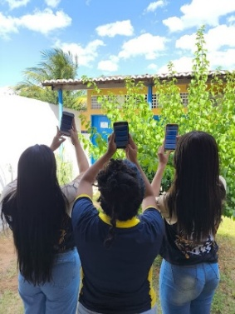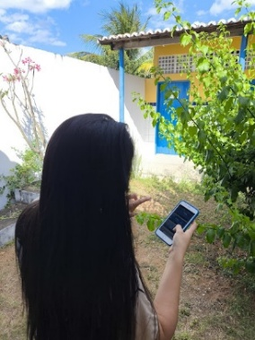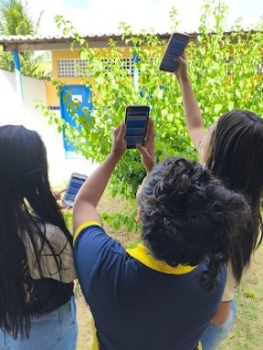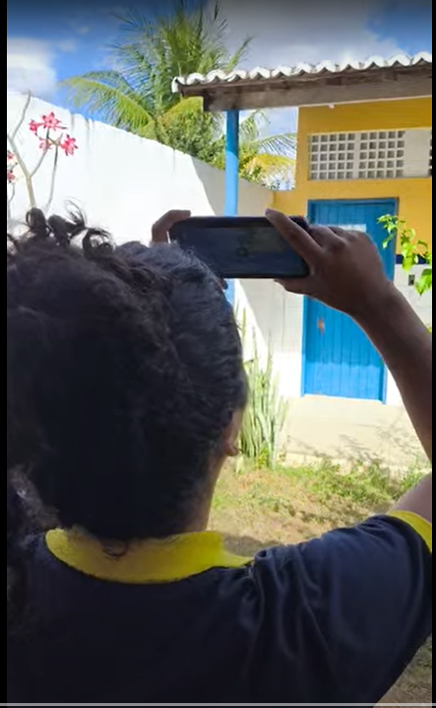
Source: Produced by the LUAR Potengi Team

Figures 20, 21, 22 and 23: Using the GLOBE Observer – Mosquito Protocol app
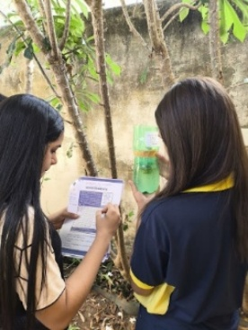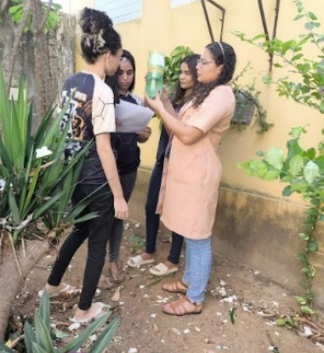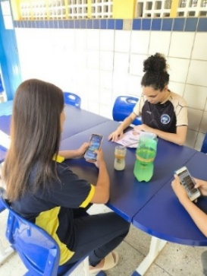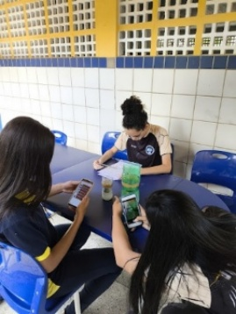
Source: Produced by the LUAR Potengi Team

Figures 24, 25, 26 and 27: Using the GLOBE Observer – Tree Protocol application.
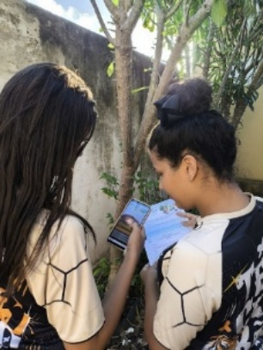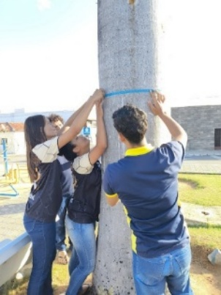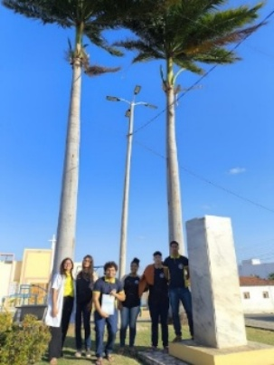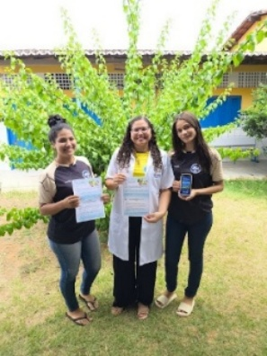
Source: Produced by the LUAR Potengi Team

Conclusion
Therefore, based on the analysis of the results, we realized that wind farms cause environmental impacts such as the alteration of fauna and flora, with the risk of collision and loss of habitat for birds, and the interference in the use of the land and landscape, due to the need for deforestation, earthworks and installation of large towers. There is also the production of noise and visual pollution, effects on microclimate and hydrology, as well as electromagnetic interference in communication systems. Although wind energy is renewable and does not emit greenhouse gases in operation, it is crucial that the installation is preceded by detailed environmental studies to minimize these negative effects.
Therefore, the theme addressed in our article is important for the ecosystem of the Ruybarbosense community and is justified based on the aforementioned arguments, since they dialogue with our general objective that seeks to analyze, from the perspective of the GLOBE Protocols, the main environmental, social and technological problems caused by the implementation of the Wind Farm in the city of Ruy Barbosa/RN. Finally, articulating Scientific Initiation and Environmental Education as proposed by the GLOBE program, our team aims to develop a project that encourages environmental and scientific research with an emphasis on climate change in the region of the city of Ruy Barbosa, reflecting on the need to generate technologies from a renewable energy source thinking about a sustainable future.

References

ASSOCIAÇÃO BRASILEIRA DE ENERGIA EÓLICA (ABEEÓLICA). Boletim Anual de Geração Eólica 2017. Disponível em: http:// abeeolica.org.br/dados-abeeolica/. Acesso 11 de out. 2025.
COSTA et al. Impactos Socioeconômicos, Ambientais e Tecnológicos Causados pela Instalação dos Parques Eólicos no Ceará. Revista Brasileira de Meteorologia, v. 34, n. 3, 399 411, 2019 rbmet.org.br Artigo DOI: http://dx.doi.org/10.1590/0102-7786343049
DUARTE, Rosália. Pesquisa qualitativa: reflexões sobre trabalho de campo. Cadernos de Pesquisa, São Paulo, n. 115, p. 139-154, mar. 2002.
GLOBE Program. GLOBE Teacher’s Guide – Pedosphere (Soil). Washington, D.C.: NASA, 2023. Disponível em: https://www.globe.gov/. Acesso em: 10 out. 2025.
GLOBE Program. GLOBE Teacher’s Guide – Biosphere. Washington, D.C.: NASA, 2023. Disponível em: https://www.globe.gov/. Acesso em: 10 out. 2025.
GLOBE Program. GLOBE Teacher’s Guide – Atmosphere. Washington, D.C.: NASA, 2023. Disponível em: https://www.globe.gov/. Acesso em: 10 out. 2025.
GLOBE, 2014. GLOBE Program Teacher's Guide. Investigation Instruments: Densiometer. Retrieved from https://bit.ly/3Bx9xaX
GONZÁLEZ, Josefina. A Field View of Soil - Digging Around. 2014. Disponível em: https://www.globe.gov/do-globe/resources/learning-activities/-/learning_activity_details/12852723?pIds=3099391%2C372023&pbId=0&cur=1&sb=title&sd=asc. Acesso em: 17 out. 2025.
GONZÁLEZ, Josefina. Development and use of the densiometer. 2023. Disponível em: https://www.globe.gov/do-globe/resources/learning-activities/-/learning_activity_details/133221177?p_p_id=gov_globe_learning_activities_search_LearningActivitiesSearchPortlet&p_p_lifecycle=0&p_p_state=normal&p_p_mode=view&_gov_globe_learning_activities_search_LearningActivitiesSearchPortlet_sIds=3099387&_gov_globe_learning_activities_search_LearningActivitiesSearchPortlet_sd=asc&_gov_globe_learning_activities_search_LearningActivitiesSearchPortlet_sb=title&_gov_globe_learning_activities_search_LearningActivitiesSearchPortlet_resetCur=false&_gov_globe_learning_activities_search_LearningActivitiesSearchPortlet_cur=3. Acesso em: 17 out. 2025.
NASA. The GLOBE Program. 2025. Disponível em: https://www.globe.gov/. Acesso em: 25 out. 2025.
NASA. GLOBE Observer App. 2025. Disponível em: https://observer.globe.gov. Acesso em: 25 out. 2025.
NASA. GLOBE Protocols: Mosquito Habitat Mapper. 2025. Disponível em: https://www.globe.gov/do-globe-observations. Acesso em: 25 out. 2025.
OVEROYE, David. Cloud Observation, Description and Identification. 2023. Disponível em: https://www.globe.gov/do-globe/resources/learning-activities/-/learning_activity_details/12852723?pIds=3099391%2C372023&pbId=0&cur=1&sb=title&sd=asc. Acesso em: 17 out. 2025.
SILVA, Lorrane Stéfane; OLIVEIRA, Guilherme Saramago, SALGE, Eliana Helena Corrêa Neves. Entrevista na pesquisa em educação de abordagem qualitativa: algumas considerações teóricas e práticas. Revista Prisma, Rio de Janeiro, v. 2, n. 1, p. 110-122, 2021. Disponível em: https://revistaprisma.emnuvens.com.br/prisma/article/view/46. Acesso em: 05 out. 2025.

Research Project developed by the students of the 3rd grade of the Rui Barbosa State Full-Time School.
Our team used the activity "A Field View of Soil - Digging Around" (González – GLOBE, 2014) as a reference for the planning and organization of our proposal.
Our team used the "Cloud Observation, Description and Identification" activity (David Overoye – GLOBE, 2023) as a reference for the planning and organization of our proposal.
Our team used the activity "Development and use of the densiometer" (Josefina González – GLOBE, 2023) as a reference for the planning and organization of our proposal.
During the interview, councilman Professor Ismael authorized the disclosure of his identification.
The students who were part of the project, together with the advisor teacher, took the GLOBE Observer Citizen Scientist course, offered by the Brazilian Space Agency, available on the AEB Virtual School (https://drive.google.com/drive/folders/1t778sfefrKvC0hxVFe7wWbcraI4oWPiR?usp=sharing) platform.

