Analysing local plant life

*The correlation between maintenance and plant species in*

*Leidsche Rijn*

Isidora Sandoval Farías, Noeke Huls, Michail Roosjen.

Leidsche Rijn College, Utrecht, Utrecht, Netherlands.

Abstract:

Cities, like Leidsche Rijn, are quickly developing. Urbanisation is something taking place all over the world. Greenfields all over the world are getting covered up by cement. As a result, there is a noticeable decrease in wildlife in these areas. The decline in wildlife sizes and variety of species can have devastating effects on people when put on a larger scale. With this research, we wanted to research this correlation. During this research, we investigated three plots of land of 90 x 90 m. Maximapark, Veldhuizerpark and the Voedselbos. Maximapark is where the most maintenance takes place and by the Voedselbos the least. Once at the locations, we marked the area and started walking diagonals. As we encountered any new species, we would take a photo and write down where and what we had found. When looking back at the collected data we can see a link between the amount and type of maintenance that is done and the biodiversity of an ecosystem. The region with the most maintenance ended up being the place with the least number of species, and the place with the least maintenance has the greatest number of species. When looking at the types of plants that grow in such an area, we not only kept in mind how many species but also their importance in an ecosystem. The amount of plant species depends greatly on the maintenance done in the area. At frequently maintained locations we have seen fewer plant species than in locations with less frequent maintenance. If we were to do follow-up research, we would like to create a plan to idealize the way to maintain our environment in growing cities.

Index:

**Analysing local plant life 1**

Abstract: 2

Index: 3

Introduction: 4

The problem: 4

Background information: 5

Materials and methods: 9

Data and results: 11

Conclusion: 13

Discussion: 13

Acknowledgments: 14

References: 14

Introduction:

When browsing for ideas to research we found a common interest in researching local plant life and ecosystems. Therefore, the land cover classification protocol from the biosphere section would be most fitting. One of the interesting parts of this protocol is that we were able to learn more about the nature around us. Land cover research is very relevant. It is a way of keeping track of vegetation and wildlife. Collected data can later be used to predict the future of the flora which habituate an area. Over the past years Leidsche Rijn, the area we studied, has become heavily populated. As they try to maintain as much nature as possible, they are very much disturbing many ecosystems. As we keep on building roads, houses, and public facilities on top of land we are destroying ecosystems. In most cities, you will be able to find large public parks. In these parks, the growth of certain plants is controlled, and the natural processes are disturbed. This process of urbanisation is not only happening here in Leidsche Rijn but all over the world. With this research, we were looking to find a connection between the amount of maintenance and the biodiversity of an ecosystem. With this research, we want to be able to predict what will be of Leidsche Rijn and other cities all over the world if we keep on moving in this direction

The problem:

What is the connection between the maintenance and the number of plant species in an area?

* How does maintenance affect plant population sizes?
* Does the attention towards an ecosystem impact local plant life?
* How do different species of plants influence local insects?
* How does the local ecosystem determine the type of maintenance?

It is important to know how to maintain a certain ecosystem to preserve nature in urbanizing areas. The decrease of green areas is a problem happening all over the world, this issue results in a decrease in flora and fauna. With this study, we want to look at the local level of this issue, how flora and fauna are affected and how preserving nature can be improved.

On a large-scale decrement in the number of species of flora and fauna results in disturbance in ecosystems which consequently results in the extinction of species. Some of these species are of great importance to human life. An overwhelming amount of maintenance would mean a decrease in biodiversity not only among plants but also among animals. A decline in both of these would mean a decrease in insects who are essential for the pollination of plants. Without pollination, we can expect a huge decrease in yearly crop production. Which in return can result as a huge problem for human beings.

We want to look into local green areas, how the ecosystem functions, and what factors come to play, mainly we want to see how maintenance affects local nature. When the amount of maintenance in an area is increased, the number of plant species and their populations will decrease. Though in complete ignorance of a local ecosystem, one species could take over the whole area and decrease the chance for other species to prosper.

Background information:

* Leidsche Rijn

The measurements were taken in and around Leidsche Rijn.

Leidsche Rijn is a part of the city of Utrecht in the Netherlands. Leidsche Rijn is named after a part of the Rhine River; the Leidsche Rijn, which flows through the district. It is located west from the centre of Utrecht. Utrecht is a state located in the centre of the Netherlands.

The Netherlands is a country is western Europe, bordering Germany and Belgium, adjacent to the North Sea. The climate is a temperate oceanic climate with relatively mild summers and winters. rain occurs all year round. (De Boer, C. M., De Jong, C., Jutte, F., Padmos, J. H. A., & Peenstra, T. G. (2021). deGeo basisboek: Vol. tiende editie, eerste druk, vierde oplage (De Geo LRN⋅line ed.). ThiemeMeulenhoff bv.)

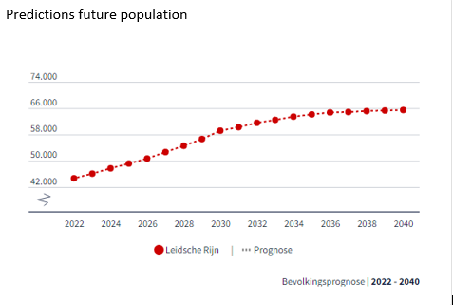

Figure 1

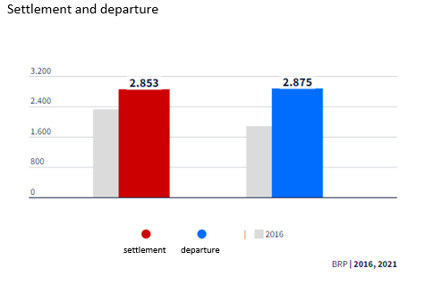

Figure 2

Figure 3

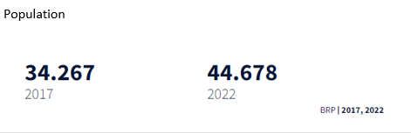

Figure 4

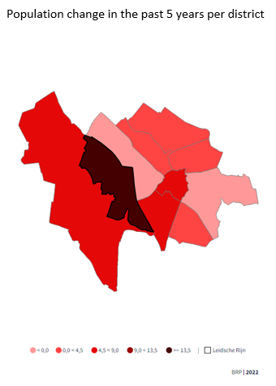

Figure 5

(BRP. (n.d.). Utrechtincijfers. Utrecht. Retrieved April 13, 2022, from <https://utrecht.incijfers.nl/dashboard/dashboard2020/bevolking--wijk->)

Leidsche Rijn is a fast-developing part of Utrecht. Looking at graphs (figures 1, 2, 3, 4, and 5) we can see that in the last 5 years the population has grown by 30.4%, which is, in comparison with Utrecht; 5,4%, a large percentage. Furthermore, the population is predicted to grow exponentially over the next 10 years.

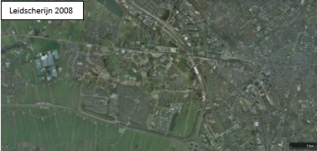

Figure 6

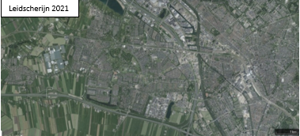

Figure 7

(*Satelliet*. (n.d.). [Satelite image]. Topotijdreis. <https://www.topotijdreis.nl/>)

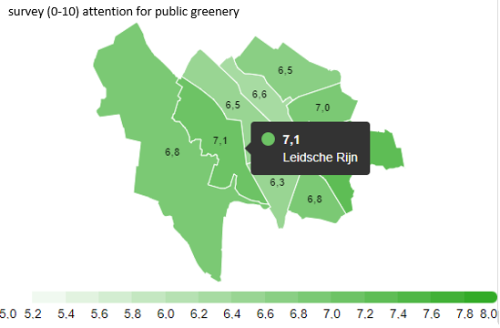

Figure 8

The rapid development in Leidsche Rijn can also be seen from above, two aerial satellite images from Leidsche Rijn, one made in 2008 and the other in 2021. The district has undergone a period of rapid urbanisation to compensate for the large population of the past years. A lot of new build houses can be seen in the 2021 satellite image, alongside new build services like schools or shopping centres.

The next three places are located in Leidsche Rijn and are the locations where the measurements were taken.

* Maximapark

The Máxima Park is located in the middle of Leidsche Rijn. Today, the park is home to cultural highlights. Works by local artists and a beautiful theatre with plenty of room for local artists in their programming. And of course, you will find references to the name of the park with a King's Tree and Máxima's Bench. (Cultuur & Historie | Maximapark. (2020, November 7). Maximapark. Retrieved April 13, 2022, from <https://maximapark.nl/over-het-park/cultuur-historie/>)

There is a lot of nature to enjoy in Maximapark. You could divide the park into two areas: the Buitenhof and the Binnenhof. The Buitenhof is bushy and a bit rougher than the Binnenhof, which is more of a stylized park area. There are many special places to visit, all accessible via Het Lint; a wide path that surrounds the park.

**Read more about the beautiful Lily Pond with its iconic bridge, the small pull ferry at Alendorp, the Viking Rhine, the Vlinderhof, the Japanese Garden, the Pergola, the Taxodium Islands, and the Ribbon.** (Natuur & Landschap | Maximapark. (n.d.). Maximapark. Retrieved April 13, 2022, from<https://maximapark.nl/over-het-park/natuur-landschap/>)

The Maximapark is maintained by the municipality. Alongside the help of many volunteers. In the area where we measured in the Maxima Park, the maintenance consists of cutting grasses, knotting,**and maintaining**riverbanks.

* Voedselbos

This plot of land is located in a place that was previously only grasslands. Around 2011 there was a long road placed. This road is only usable for bikes and walkers.

The project of which this area is a part of, started in 2015. The main goal of this place was to make a source of a lot of fruits and some vegetables and to store CO2. This place contributes to decreasing the CO2 levels. Achieving a high number of different species is also a main goal of this project/domain. Most of the plants were planted in 2018 and since then it has only grown more and more. (Degenaar, J. (n.d.). Lekkerlandgoed Haarzuilens, Natuur Monumenten. Retrieved April 14, 2022, from <http://www.lekkerlandgoed.nl/?msclkid=acf37abebc0b11ec95502967cdd9df09>)

It is designed to be the best achievable for a lot of different species and to be a relaxing and adventurous walking place.

The area is focused on complementing natural processes, instead of suppressing them. The surface area is about 5 hectares. It contains grassland, ditches, small hills, and puddles. This forms a great environment for a lot of different species.

* Veldhuizerpark

This park was planned to be a barrier of nature against the adjacent highway, the A12. It mainly cancels noise pollution, but also creates a view of nature instead of an ‘ugly’ highway for the neighbourhood. It consists of an artificially created hill, 10 meters tall, made from dirt. The whole surface area is equal to 16,7 hectares. And is filled with greenery like various trees, bushes, and grasses. There is a lake on the inside of the noise barrier, creating a border between nature and the residential area.

The Veldhuizerpark is maintained by the municipality. The maintenance consists of mowing grass, pruning bushes, and knotting trees.

Materials and methods:

* 1x Tape measure 30m
* 4x Wooden pole 10cm
* 1x Magnetic compass
* 1x GPS device w. coordinate system
* 1x Hammer
* 1x Logbook
* 1x Mobile phone w. camera
* 1x Drone w. camera

The materials were mainly available at our school, except for the logbook and the mobile phones used during the experiments.

With this research, we have used the protocols included in the Land Cover Classification protocol. These include the following protocols: Biometry protocol, Biosphere Investigation Instruments – Compass, Biosphere Investigation Instruments – MUC, Do You Know Your MUC, Biosphere Investigation Instruments - Tape Measure, Tree Height, Sample Site Selection and Set-Up. (GLOBE. (n.d.). Land Cover Classification - GLOBE.gov. Retrieved April 13, 2022, from <https://www.globe.gov/do-globe/globe-teachers-guide/Biosphere/land-cover-classification>)

Firstly, we have selected three areas within a 15 km radius based on their quality and quantity of maintenance, intended as public nature spots. These are:

* Maximapark

With a large amount of maintenance and less attention to the ecosystem.

Weekly maintenance includes standard jobs like mowing, trimming, and knotting.

* Veldhuizerpark

With a low amount of maintenance and less attention towards the ecosystem.

Quarterly maintenance including standard jobs like mowing, trimming and knotting.

* Voedselbos

With a low amount of maintenance and full attention towards the ecosystem. There isn’t a specific period wherein the maintenance is done. It mostly depends on the weather and what the plants need at that point. For example, if it was an extremely dry week then the plant will be watered, but if watering isn’t needed it will not be done.

           At the locations we have measured a 90 x 90 m area, according to the MUC protocol, using the tape measure, see satellite images (figures 10, 11, 12); Maximapark, Veldhuizerpark, and Voedselbos accordingly, and fixated it with wooden poles at every corner using a hammer, the position of the corners were calibrated using the GPS device. The diagonals of the square lay on the N-S and E-W axis. Starting at the east and south corners we walked along the axis and recorded the types and amount of vegetation. When encountering a tree, we used the Tree Height protocol to measure the dimensions of the tree.

We measured each area two times: The first round was before winter and the second after the winter. Measuring multiple times results in a more accurate representation of the data collected.

|  |  |  |
| --- | --- | --- |
| Area \ Rounds | First round | Second round |
| Maximapark | November 1 | March 16 |
| Veldhuizerpark | October 22 | March 17 |
| Voedselbos | October 18 | March 22 |

Figure 9

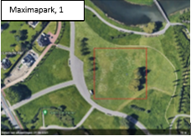

Figure 10

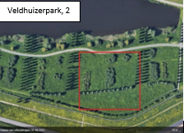

Figure 11

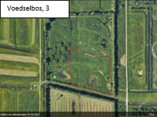

Figure 12

Data and results:

Figure 13

The second measurement shows a slight decrease in different species spotted in comparison to the first measurements taken. In the case of the Voedselbos and Maximapark, this can be explained by the fact that there weren’t a lot of mushrooms during the second encounters. This is because the mushroom season, which takes place in September, October, and November, had already passed. Another factor which made a difference was that during the first measurement, most of the spring plants that are regularly found in grasslands had already appeared. The huge difference in the number of species encountered in Veldhuizerpark the second time around can be explained by the fact that a week before the 2nd measurements were taken everything had been mowed. If this were not the case, I am certain that we would have found more species in Veldhuizerpark than in Maximapark.

This table shows the number of species counted in the first and second rounds of measurements.

If we look to all the data combined, we find that we have found nine different species from the Asteraceae family. From which 5 species were found in the Maximapark, 6 species in Voedselbos and 4 species in Veldhuizerpark.

Asteraceae is one of the species who are good for insects. Some others are the Ranunculaceae family, Salicaceae family, Brassicaceae family, Onagraceae family, Geraniaceae family, Umbelliferceae family and the Boraginaceae family.

Number of different species from plant which are good for insects:

|  |  |  |  |
| --- | --- | --- | --- |
|  | Maxima Park | Voedselbos | Veldhuizen park |
| Salicaceae | - | 2 species | 2 species |
| Ranunculaceae | 1 specimen | 1 specimen | - |
| Brassicaceae | - | 1 specimen | 1 specimen |
| Onagraceae | - | 1 specimen | - |
| Geraniaceae | 1 specimen | - | 1 specimen |
| Umbelliferceae | 1 specimen | 2 species | 2 species |
| Boraginaceae | - | - | 1 specimen |
| Asteraceae | 5 species | 6 species | 4 species |

Figure 14

Conclusion:

The amount of plant species depends greatly on the maintenance done in the area. At frequently maintained locations we have seen way fewer plant species than in locations with less frequent maintenance. We have also seen an increment in plant species at locations where there is more attention to the local ecosystem, environment, flora, and fauna.

If we look at the Voedselbos, where many species are left alive and thus the ecosystem is in a better condition. In contrast to the Maximapark, where fewer plant species are conserved, the ecosystem gives less space for insects or other fauna to inhabit the area, because of a decrease in food and living space for the animals. Animals like to live in bewildered nature, to be able to hide easily. Consequently, such an imbalance on a global scale will impact human lives, because of a decrement in insects and other species that are part of the food chain and other natural cycles of which we, humans, are part of.

More focussed conservation of an ecosystem would be necessary to maintain a stable environment for flora and fauna at a local scale and therefore does not have a large impact on a global scale.

Discussion:

Reflecting on our research I am sure that there are many things we could have done differently. For example, we wanted to visit the areas at least three times, but due to complications with conflicting plans, this was decreased to two times, which makes our results less accurate. Another thing that takes part in this is that we wanted to visit the areas in 3 different seasons, which we couldn’t accomplice in the time we had for this project.

The next step in our research would be to look at the applications of good maintenance in society. How to integrate a maintenance system for specific green spots around the globe, with more regard to the ecosystem and where preservation is adjusted to the needs of local flora and fauna. What also will be important in this part is how to maintain the contribution of the society around the ecosystems.

The outcome of the research is as we expected. We believed that if the maintenance was based on natural circumstances and focused on the well-being of an ecosystem that it would be better for the biodiversity than if the maintenance was based on what people want.

Acknowledgments:

We want to thank Isabelle Noble for helping with doing inventories of the green spaces in the first round. We want to thank Maaike Smeets and Rogier ter Bogt for helping with making a start of the project and helping us when needed.

We also want to thank Jan Degenaar and Maarten Schrama for giving access to their private land so that we could do our inventories at the Voedselbos.

And lastly, we want to thank Hettie Luijten for helping with the identification of some of the species.

References:

(BRP. (n.d.). Utrechtincijfers. Utrecht. Retrieved April 13, 2022, from <https://utrecht.incijfers.nl/dashboard/dashboard2020/bevolking--wijk->)

(*Satelliet*. (n.d.). [Satelite image]. Topotijdreis. <https://www.topotijdreis.nl/>)

(Cultuur & Historie | Maximapark. (2020, November 7). Maximapark. Retrieved April 13, 2022, from <https://maximapark.nl/over-het-park/cultuur-historie/>)

(Natuur & Landschap | Maximapark. (n.d.). Maximapark. Retrieved April 13, 2022, from <https://maximapark.nl/over-het-park/natuur-landschap/>)

(GLOBE. (n.d.). Land Cover Classification - GLOBE.gov. Retrieved April 13, 2022, from <https://www.globe.gov/do-globe/globe-teachers-guide/Biosphere/land-cover-classification>)

(De Boer, C. M., De Jong, C., Jutte, F., Padmos, J. H. A., & Peenstra, T. G. (2021). deGeo basisboek: Vol. tiende editie, eerste druk, vierde oplage (De Geo LRN⋅line ed.). ThiemeMeulenhoff bv.)

(Degenaar, J. (n.d.). Lekkerlandgoed Haarzuilens, Natuur Monumenten. Retrieved April 14, 2022, from <http://www.lekkerlandgoed.nl/?msclkid=acf37abebc0b11ec95502967cdd9df09>)