2022 International Virtual Science Symposium

Minas Gerais School Science Club: Juliana Karina Villela, Andrea Silva, Camille Santos, Luís Eduardo Cordeiro de Freitas.

School: Minas Gerais Public School.

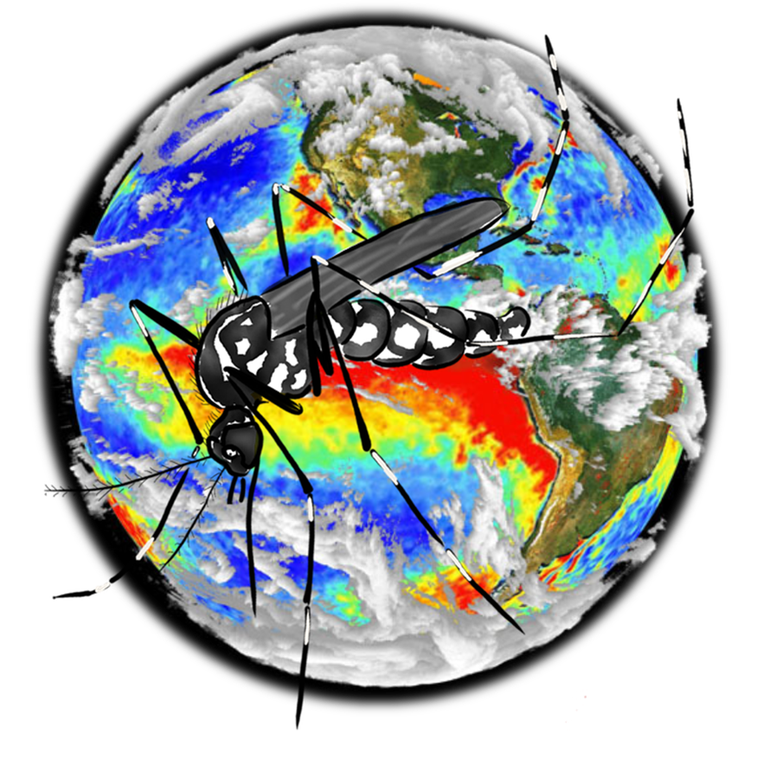
1. TITLE: It got hot, it rained, and puddled the ground! The ENSO weather phenomena influence in mosquitos’ positivity in Rio’s summer.

Figure 1. Mosquito and ENSO phenomena Source: https://wiki.bildungsserver.de/klimawandel/upload/Nino_1997-98.jpg
Rio de Janeiro /RJ – Brazil
Teacher: Inês Mauad
E-mail: inmauad@gmail.com
30 November 2021

2. ABSTRACT

This study investigated the increase in the proliferation of mosquito populations in Rio de Janeiro's summers comparing seasons of ENSO climatic phenomena. The years of the study are related to the occurrence of strong and moderate weather phenomena in the country: 2015 and 2016, strong cycles of the El Niño that is associated with intense rains and high temperatures and a record of diseases transmitted by the Aedes aegypti mosquito. The research also studied the periods of 2017 and 2018, which had moderate cycles of the El Niña climate phenomenon, despite they had caused devastating global and regional effects on the environment and on the populations of several Brazilian areas it didn’t interfere the mosquito proliferation.
Some weather phenomena, such as El Niño and La Niña, occurring repeatedly, can cause extreme events and together with human interference on the planet - deforestation, fires, misuse of land, decreased biodiversity, uncontrolled urbanization, among others, change the global climate.
Normally, these ENSO weather phenomena change temperatures and amounts of rainfall in different regions of the country. There is an increase in temperature and rainfall and can have significant impacts on the country population, as can be seen in Rio de Janeiro city, especially in urban areas. Its effects can lead to exposure to extreme conditions, such as natural disasters, droughts, and floods, as well as an increase in the spread of mosquito-borne diseases.
The combination of extreme global weather events, urban heat islands, population growth and poor sanitation conditions form the perfect combo for the proliferation of the most dangerous animal on the planet – the mosquito. In the case of Rio de Janeiro, in southeastern Brazil, Aedes aegypti, which transmits arboviruses – dengue, Zika, Urban Yellow Fever, and Chikungunya. El Niño has an impact on arbovirus cases because it causes an increase in the temperature of the environment and thus can accelerate the life cycle of Aedes aegypti, boosting the number of individuals and bites. The effects of El Niño phenomenon caused increased temperature and precipitation in the city of Rio de Janeiro – where floods and still water flooding were observed phenomena that evidence Aedes aegypti mosquito reproduction.
La Niña moderate phenomenon influences the climate because it promotes abnormal change in atmosphere pressure in the Pacific Ocean, causing its cooling. These masses of air also make the atmosphere drier. That is, with less humidity it is difficult to form large clouds that cause rains, but the temperature rises.
Data for the study were obtained by collecting mosquito larvae in homemade traps and weather gauges stored in GLOBE platform, official Brazilian data, and international website data. The results showed that cases of arboviruses, diseases transmitted by Aedes aegypti, increase considerably in years of ENSO climatic phenomena, as observed in 2015/2016, periods of very strong El Niño cycles, but in the moderate La Niña cycle, observed in 2017/2018, there was a decrease in rainfall, higher temperatures causing drier environmental conditions with low humidity. Despite the high temperatures, the reproduction of Aedes needs rain (water), therefore, La Niña cycle periods are not conducive to the increase of Aedes aegypti mosquito’ proliferation.

Keywords: Aedes aegypti, ENSO climatic phenomena, El Niño, La Niña, precipitation, temperature, breeding sites, arboviruses, life cycle.

3. RESEARCH QUESTION AND HYPOTHESIS
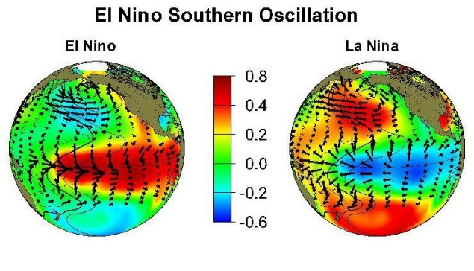
QUESTION
Are the variation in rainfall and temperature distribution, such as those that occur in ENSO phenomena (abnormal warming of surface waters in the Pacific Ocean) factors that influence the reproduction and proliferation of mosquito breeding sites in Rio de Janeiro's summers?

Figure 2. www.globe.gov/web/el-ni

HYPOTHESIS
ENSO climate phenomena, which cause variation in temperature and precipitation, affect the proliferation of disease-transmitting mosquitoes, such as Aedes aegypti, in the city of Rio de Janeiro, with impacts on the health of the population, as was seen in the summer from 2015-2016, period of the strongest cycles of the El Niño climate phenomenon. However, in moderate La Niña season observed in 2017 – 2018, there were no impact in the mosquito breeding sites distribution.

4. INTRODUCTION (Research History)
The recent increase in ecological and environmental changes due to the occurrence of extreme weather events caused by repeated ENSO weather phenomena, global warming, the urbanization of agricultural activities and human interference in the environment, have been observed to contribute to the appearance of several mosquito species in areas cities and increase gender where previously it was not possible. (Brazilian Journal of Health Research (2008)
In this study, it is demonstrated for a better understanding, how the climatic factors, such as the increase in air temperature and rainfall – interfere in Aedes aegypti mosquito reproduction during periods of ENSO climatic phenomena. The results of this study were compiled through data collected by larvae in traps in the school perimeter stored in GLOBE platform, and official data from the City of Rio de Janeiro. After the data research period, there was a comparative analysis of the data collected with the climatic factors, especially in the summers of Rio de Janeiro (2015/2016; 2017/2018), when there is an increase in diseases transmitted by mosquitoes of the Aedes genus, such as - Dengue, Yellow Fever, Chikungunya and Zika.
Figure 3. Human impact https://www.teacherspayteachers.com/.

The modification of the environment by human actions, disordered urban growth, the globalization process of international exchange and occurrence of extreme weather events caused by repeated ENSO weather phenomena are some factors that have been facilitating the emergence and spread of human infectious diseases transmitted by vectors. (http://www.rsp.fsp.usp.br/)
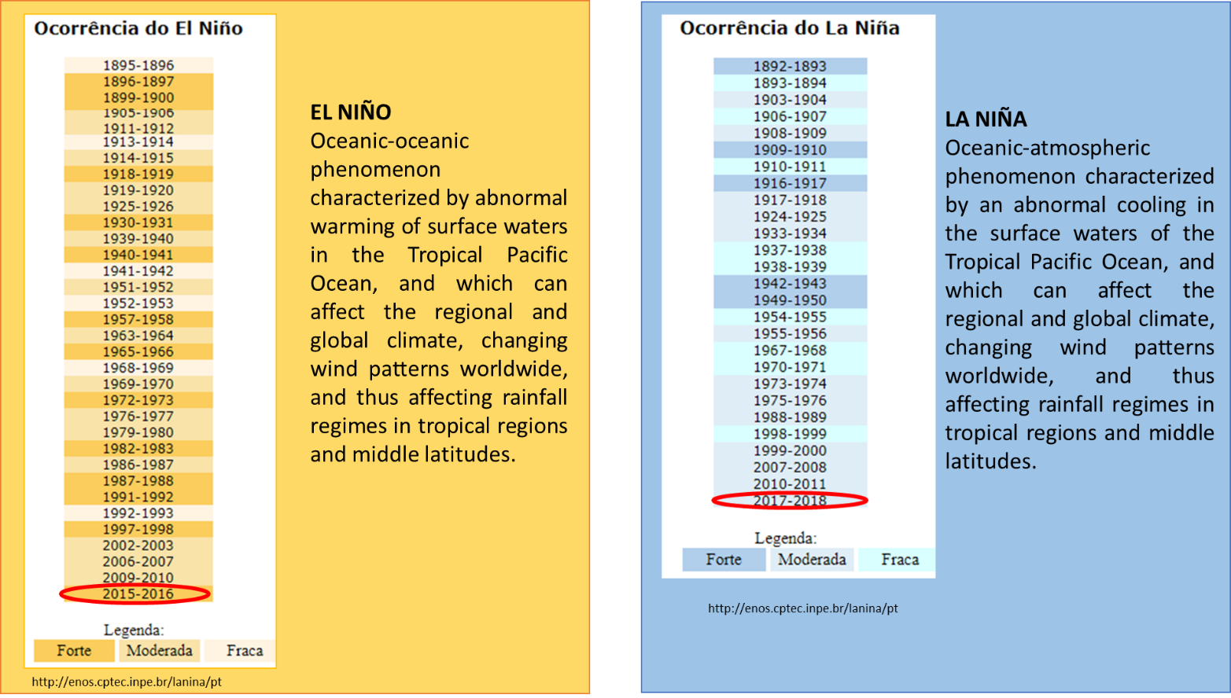
El Niño and La Niña are part of the same atmospheric-oceanic phenomenon that occurs in the Pacific Ocean (and in the adjacent atmosphere), called El Niño Southern Oscillation (ENSO). ENSO refers to situations in which the Pacific Ocean is warmer (El Niño) or colder (La Niña) than the historical normal. The change in the temperature of the Pacific Ocean has global effects on temperature and precipitation. (http://enos.cptec.inpe.br/) The effects of heavy rains associated with periods of high temperatures can lead to exposure of populations in affected areas to extreme conditions, such as natural disasters such as droughts, landslides, and floods, as well as an increase in the spread of diseases transmitted by mosquitoes. The combination of extreme weather phenomena, urban heat islands, an increase in population and poor sanitation conditions form the perfect combo for the proliferation of the biggest transmitter of diseases in the world – the mosquito.
Figure 4. El Niño and La Niña - atmospheric-oceanic phenomenon occurrence (ENSO)

There are several arboviruses worldwide, but in Brazil, Dengue, Zika and Chikungunya stand out mainly because they are transmitted by the same vector, the Aedes aegypti mosquito (CDC, 2016). Transmitted by mosquito vector widely distributed in the national territory and associated with man, the Brazilian population is exposed to infection by these three arboviruses. In the absence of an effective vaccine and specific treatment, it is important to maintain and integrate continuous entomological and epidemiological surveillance, in order to direct methods of control and prevention against these arboviruses in the country. Those are real challenges for Public Health and the all the society in the country. (http://www.scielo.br/pdf/rsp/v50/pt)
Most of Brazil has warmed more than the world average in the last century, according to data from the Brazilian Panel on Climate Change. The country has had a temperature increase of approximately 1.4ºC since 1960. The number of warm nights has increased throughout the country. In some places, minimum temperatures have also risen. Minimum temperature is an important parameter for the mosquito, because Aedes needs heat and water – and a series of cold nights could be the difference between a new generation of insects being born or not.
The population and public health of cities, communities and neighborhoods need to unite in actions to combat mosquitoes. Among the greatest efforts are the monitoring of mosquito populations in urban areas and their control with the destruction of their habitats, with the population acting effectively in prevention actions, especially in Rio's summers, when there is an increase in temperature and precipitation.
In this research, it was observed that during extreme weather events, such as continually ENSO, there is an increase in populations of disease-transmitting mosquitoes and thus a greater probability of outbreaks of Dengue, Yellow Fever, Chikungunya and Zika. The periods of this research are related to two episodes of this weather phenomena in the country: 2015 and 2016, strong cycles of the El Niño weather phenomenon and is associated with intense rains and high temperatures in Rio de Janeiro, and the years 2017 and 2018 which had moderate cycles of the La Niña climate phenomenon, however, they caused changing in the weather, devastating global and regional effects to the environment and Brazilian populations, but in the research, no higher incidence of mosquitoes was observed in La Niña periods.
The method applied for the research was school data stored in the GLOBE platform and GLOBE Mosquito Habitat Mapper (MHM) app using homemade mosquito traps, which helped to identify the larvae found and make it possible to reduce the breeding sites related with mosquito-borne diseases and Brazilian Official data.
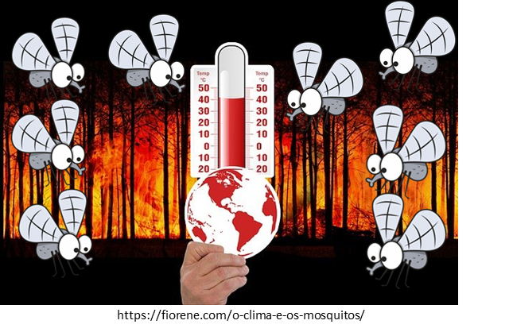
Figure 5. Mosquito and climate events studied in the research.

5. MATERIALS AND METHODS
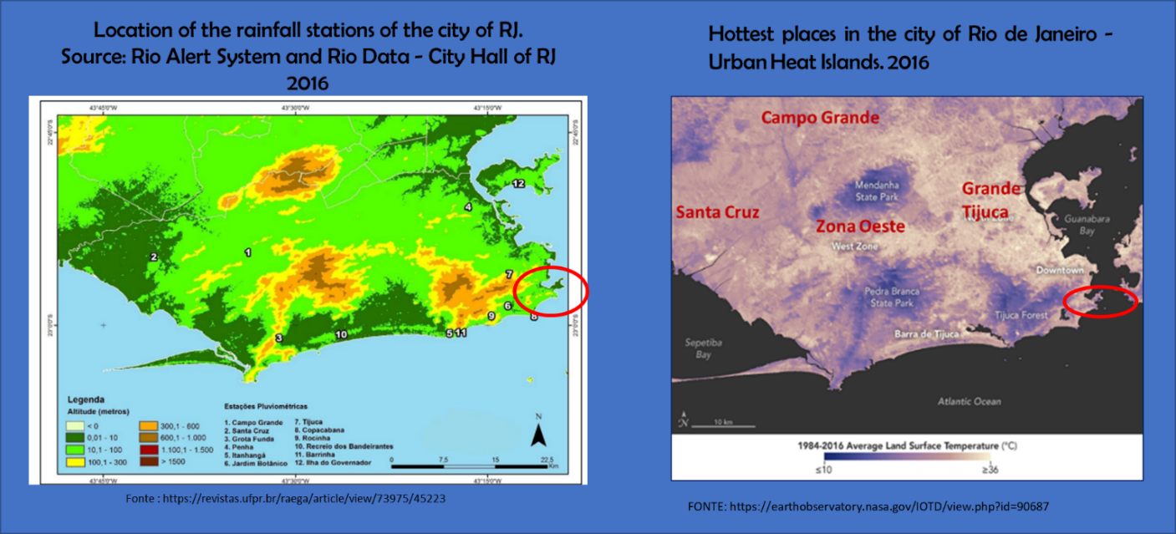
Figure 6. Rio de Janeiro city, RJ/ Brazil – Precipitation gauge distribution, and urban heats areas.

The city, and also the entire state of Rio de Janeiro, are completely inserted in the Atlantic Forest. The climate of the Atlantic Forest is predominantly humid tropical, influenced by the humid air masses coming from the Atlantic Ocean. Its average temperatures and air humidity are high throughout the year and the rains are regular and well distributed. The relief of the state of Rio de Janeiro is formed by plateaus (or Serra Fluminense), by the lowlands (Baixada Fluminense), as well as by the coastal massifs. (Figure 6) The latter are rock formations along the coast. Thus, the climate of Rio de Janeiro varies according to the region of the state and its proximity to the sea. In the Serra Fluminense, for example, the tropical climate of altitude predominates, with mild temperatures. On the other hand, in the Baixada Fluminense the predominant climate is the semi-humid tropical, with an average annual temperature of 24 ° C. In general, rainfall is abundant in the state. (https://escolaeducacao.com.br/geografia-do-estado-do-rio-de-janeiro/)
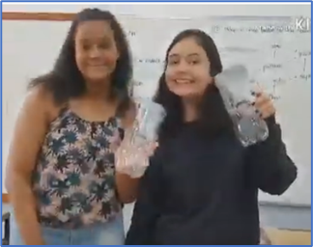
The use of traps to detect the presence of Aedes aegypti is a technique of the time of Oswaldo Cruz (Cruz, 1909), the greatest sanitary man from Rio, who lived in the early nineteenth century. During these campaigns in Brazil, larval research has already been used to sample this mosquito's posture.

Figure 7. Captive traps (transparent 1,5 L PET bottle traps filled with fish food)

Study Area
The study area was located in the two different locations (addresses), within two districts, in Rio de Janeiro County, RJ/ Brazil. (Figure 8). The research was school data stored in the GLOBE platform and GLOBE Mosquito Habitat Mapper (MHM) app using homemade mosquito traps and weather gauges and Brazilian official data collected from December 2015, 2016 – Strong El Niño cycle to April 2018 – Moderate La Niña cycle.

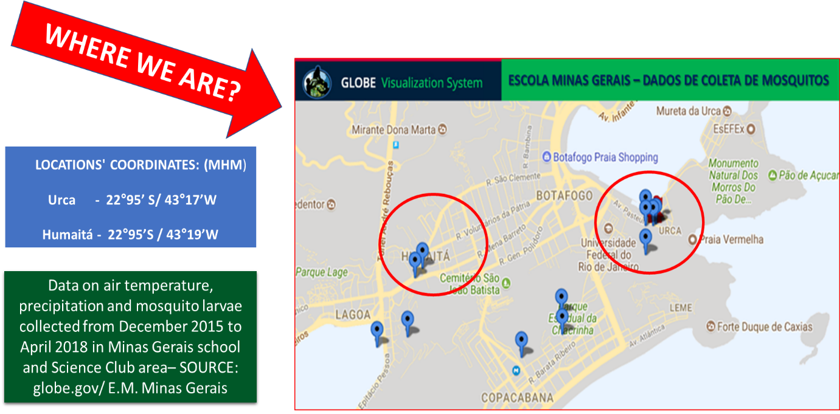
Figure 8. Urca and Humaíta Rio de Janeiro city, RJ/ Brazil – Research area

Materials
- Traps (transparent 1,5 L PET bottle traps filled with fish food) for mosquito larvae.
- Monthly data from Mosquito Habitat Mapper app.
- GLOBE platform and official data from the City of Rio de Janeiro.
- Monthly data on rainfall (mm) and temperature (°C) collected in the Alerta Rio system and school gauges. (http://alertario.rio.rj.gov.br/acumulados-mensaiscao.com.br/geografia-do-estado-do-rio) -of January/)
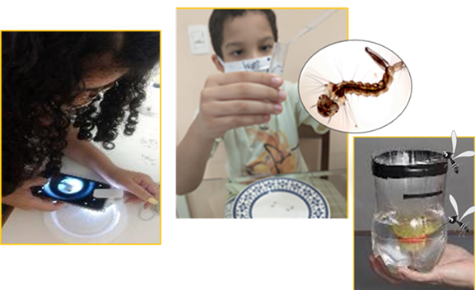
- GLOBE Collection Kit for field capture and data tabs elaborated by students according to GLOBE data platform and Official data.

Figure 9. Science club students analyzing mosquito data

Research Methods
- The data collection research used data that was collected from the experiment carried out in two different places in the Minas Gerais School and meeting place of the Science Club, in the city of Rio de Janeiro, where traps were installed to capture the Aedes aegypti mosquito, whose female is the main transmitter of the diseases: Dengue, Chikungunya and Zika – and precipitation and temperature data were collected from 2015 to 2018.
- These traps were monitored once a month. The net of traps was installed to cover the entire length of the school and science club area.
- The temperature and precipitation data were collected in every 5 days, but the research used monthly data.
- Mosquito Habitat application, GLOBE website and Official data were used for data visualization and tabs, as well as monthly rainfall (mm) and temperature (°C) data collected in the Alerta Rio system and in devices located at the school.
- After data collection research, an analysis and interpretation of the results were carried out through comparative graphs, spreadsheets, research on sites such as FIOCRUZ, NASA and disease incidence reports at the Municipal Health Department.
- The research was conducted in the data collected from December 2015 – Strong El Niño cycle to April 2018 – Moderate La Niña cycle, from our previous projects and stored on the GLOBE data platform.
- Remembering that zero is always important, as it determines the appearance / return of the mosquito to the studied areas.

Data Summary and Analysis

An important part of this research was the way of storing, treating, and visualizing the data, since a study like this generates a large amount of data, requiring specific tools; for this, was used the GLOBE Mosquito Habitat app, mosquito larvae hydrology protocols and GLOBE website as tools to data visualization and tabs production.
The research compared data from larvae traps (transparent 1,5 L PET bottle traps filled with fish food) at Minas Gerais School and Science club location from December 2015 to April 2018– periods of Strong El Niño cycle (2015/2016) and Moderate La Niña cycle (2017/2018), collected in our previous projects and stored on the GLOBE data platform.
The El Niño-Southern Oscillation (ENSO) is a recurring climate pattern involving changes in the temperature of waters in the central and eastern tropical Pacific Ocean. On periods ranging from about three to seven years, the surface waters across a large swath of the tropical Pacific Ocean warm or cool by anywhere from 1°C to 3°C, compared to normal. This oscillating warming and cooling pattern, referred to as the ENSO cycle, directly affects rainfall distribution in the tropics and can have a strong influence on weather across the United States and other parts of the world. El Niño and La Niña are the extreme phases of the ENSO cycle; between these two phases is a third phase called ENSO-neutral.
El Niño is the warm phase of the El Niño-Southern Oscillation. Its opposite phase is La Niña. El Niño is defined by warmer than average sea surface temperatures in the central-eastern equatorial Pacific Ocean and related atmospheric changes. Key characteristics of El Niño, presented in the two images below (figure 10), include: events occur irregularly but typically happen 2-4 times per decade and the events vary in strength and typically reach their peak intensity late in the calendar year. Most events last about one year.
La Niña refers to the periodic cooling of ocean surface temperatures in the central and east-central equatorial Pacific. La Niña represents the cool phase of the El Nino/Southern Oscillation (ENSO) cycle. La Nina weakened last spring into early summer but began to show signs of strengthening again late this summer as negative temperature anomalies returned to the equatorial Pacific Ocean.
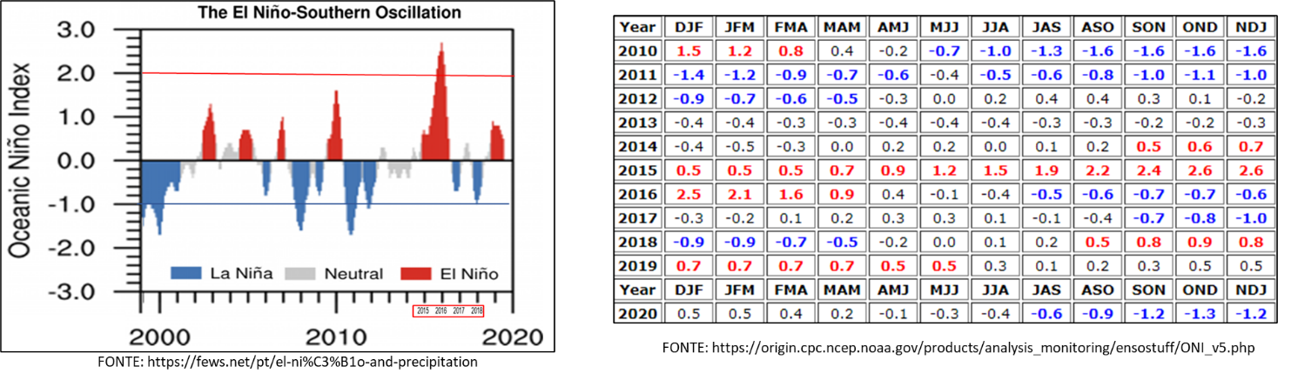
For historical purposes, periods of below and above normal Sea Surface Temperature (SST) are colored in blue and red when the threshold is met for a minimum of 5 consecutive overlapping seasons. The ONI is one measure of the El Niño-Southern Oscillation, and other indices can confirm whether features consistent with a coupled ocean-atmosphere phenomenon accompanied these periods.
Figure 10- Periods of alternation of ENSO climatic phenomena

The Aedes aegypti mosquito was originates from Egypt, Africa, and has been spreading through the tropical and subtropical regions of the planet since the 16th century, period of the Great Navigations. It is accepted that the vector was introduced in the New World, in the colonial period, through ships that trafficked slaves. In Brazil, the first reports of dengue date back to the end of the 19th century, in Curitiba (PR), in the south of the country.
At the beginning of the 20th century, the mosquito was already a problem, but not because of dengue - at the time, the main concern was the transmission of yellow fever, and the summer of 1908 left the population of Rio on alert for the risk of yellow fever. When carrying out the first detailed survey of mosquito infestation in Rio de Janeiro, researchers associated the greater presence of Aedes aegypti to the increase in population density in certain areas of the city and also showed the similarity between the map of the insect population concentration with the occurrence of yellow fever cases. Their observations also showed that the drop in ambient temperature to below 20oC interferes with the development and reproduction of the mosquito, which are drastically reduced, leading to a reduction in cases. Scientists have also observed that mosquitoes depend on water for their reproduction, but that the Aedes genus is resistant to the desiccation of the mosquito's egg, which can stay up to a year without contact with water. (IOC/Fiocruz).
Today, the mosquito is found in all Brazilian states.
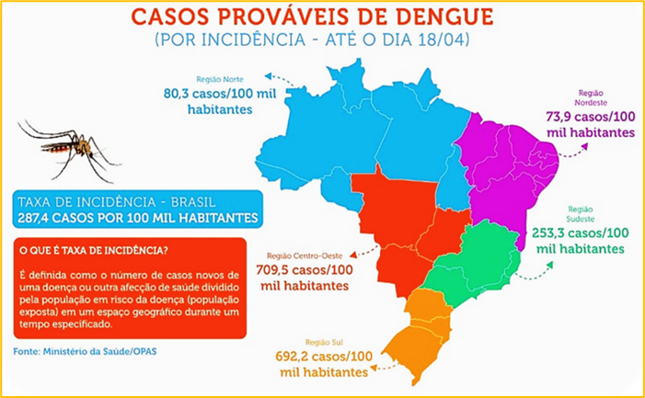
Figure 11 - Mapping of the foci of Aedes aegypti in Brazil and the southeast region - RJ in 2018

Minas Gerais school - Data Summary and Analysis (Source: globe.gov/ E. M. Minas Gerais)

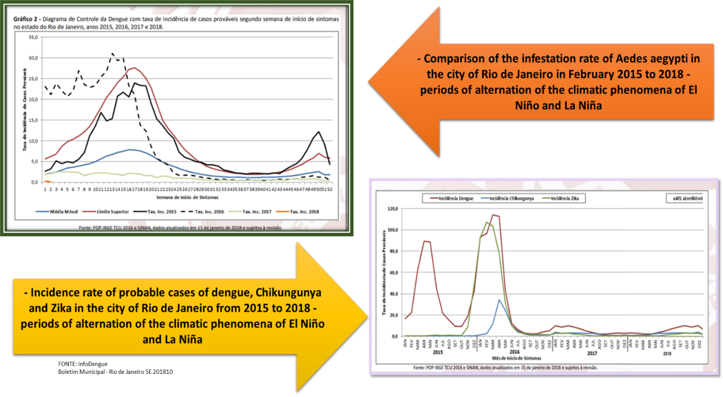
This project focuses on the identification of climatic factors, such as variation in air temperature and rainfall - which can cause the Aedes aegypti mosquito to reproduce faster, and the result of this reproduction was measured through data collected by larvae in traps and weather gauges at school and science club grounds. After the data research, there was a comparative analysis of the data collected on mosquito larvae, air temperature and precipitation with the periods of ENSO climatic phenomena (El Niño and La Niña) in the Rio de Janeiro summers, when there is an increase in transmitted diseases by mosquitoes of the Aedes genus, such as – Dengue, Yellow Fever, Chikungunya and Zika.
Figure 12 - Infestation rate of Aedes aegypti and mosquito transmitted diseases in the city of Rio de Janeiro in the study periods.

6. RESULTS
Minas Gerais school data analysis from air temperature, precipitation and mosquito larvae count ratio versus time from December 2015 to April 2018 to observe ENSO effects in mosquito proliferation of breeding sites.
It was observed, in the collected data and spreadsheet analyzed, that in periods where there is an increase in rainfall and air temperature (data collection in periods of strong El Niño) there is an increase in mosquito proliferation in the collection areas. (Figure 13; 14; 16 and 17)
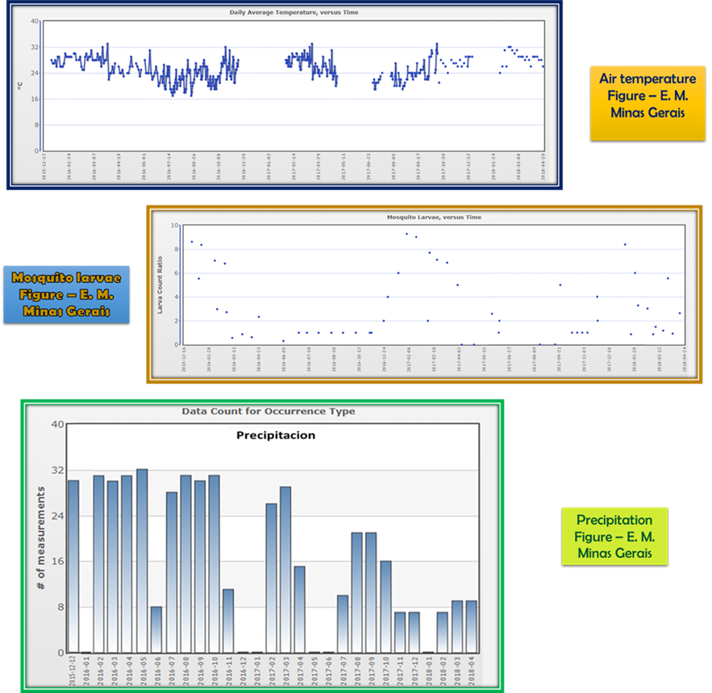
Figure 13 – Minas Gerais data collect from 2015 to April 2018 (source: globe.gov.)

It was observed, in the research, a higher positivity of mosquitoes in the school and science club area (number of larvae) in the artificial capture breeding sites – traps (transparent 1,5 L PET bottle traps filled with fish food), in 2016 (El Niño season) to the detriment of the same period 2018 (La Niña season). (Figures 16 and 17).
The data table (Figures 13; 14; 16 and 17) shows an increase in the incidence of mosquitoes in the collection of samples from capture traps, mainly from December 2015 to April 2016, in that period a greater amount of rain and highest temperature were observed in Rio.
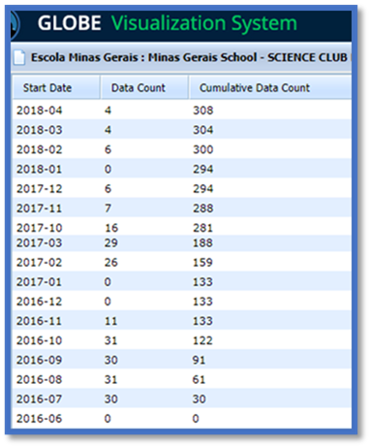
The samples from 2017/2018, despite the large number of days with high temperature, did not present an increased number of mosquito larvae (Figures 16 and 17).
Remembering that zero is always important, as it determines the appearance / return of the Aedes aegypti mosquito to the studied areas around the school.
Data on mosquito larvae collected during the period from December 2015 to April 2018– comparison to Strong El Niño cycle season and moderate La Niña cycle.

Figure 14 – Minas Gerais mosquito larvae collected from 2015 to April 2018 (source: globe.gov.)

7. HYPOTHESIS ANALYSIS

Our results have made us support our hypothesis
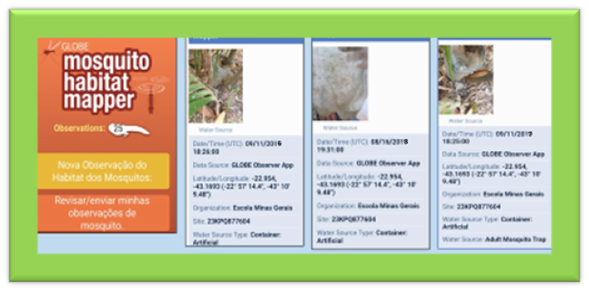
Figure 15- Minas Gerais school data (source: globe.gov).
After data research, was performed the analysis and interpretation of the results found through comparative graphics, tabs, spreadsheets, research on sites FIOCRUZ and GLOBE and reports of incidence of diseases in the Municipal Health Department.
Our results made support our hypothesis, the data collected show that the ENSO climatic phenomena influence the distribution of rain and heat. Although there was an increase in mosquito breeding sites in the summers of Rio de Janeiro (2015/2016) during El Niño season, in La Niña (2017/2018) event, there was no increase in mosquito proliferation.

8. DISCUSSION
The Aedes aegypti mosquito is sensitive to these two factors. When there is rain, the supply of breeding sites increases and when the temperature increases, the speed of development of mosquitoes that transmit diseases increases.
The diseases - Dengue, Chikungunya and Zika - transmitted by the mosquito Aedes aegypti can be deadly. The mosquito begins to reproduce during the warmer months when the rains are most abundant. Reproduction takes place precisely in puddles of still water. The mosquito lays eggs and after a few weeks the larvae hatch. Summer is the time with the highest incidence of diseases and summers characterized by climate phenomena (El Niño) are further aggravated!
The results of our research prove that the climatic phenomena bring with it the most constant and accentuated temperature and rainfall increase, interfering in the spread of Aedes aegypti, in the city of Rio de Janeiro, thus negatively affecting the health of the population of Rio de Janeiro.
The comparative analysis when we cross-checked the data collected from mosquito proliferation with climatic factors, especially in Rio de Janeiro summers, it is noted that in periods of higher temperature associated with increased rainfall, there is an increase in the development of mosquitoes such as Aedes aegypti – the transmitter of diseases, – Dengue, Chikungunya and Zika (El Niño season). (Figures 11;13;14; 16 and 17)
La Niña moderate phenomenon (2017/2018) influences the climate because it promotes abnormal change in atmosphere pressure in the Pacific Ocean, causing its cooling. These masses also make the atmosphere drier. That is, with less humidity in the air, it is difficult to form large clouds that cause rains causing temperature increase, however, only the two factors together cause the proliferation of reproduction of Aedes aegypti mosquito. (Figures: 11; 12; 13; 14;16 and 17).

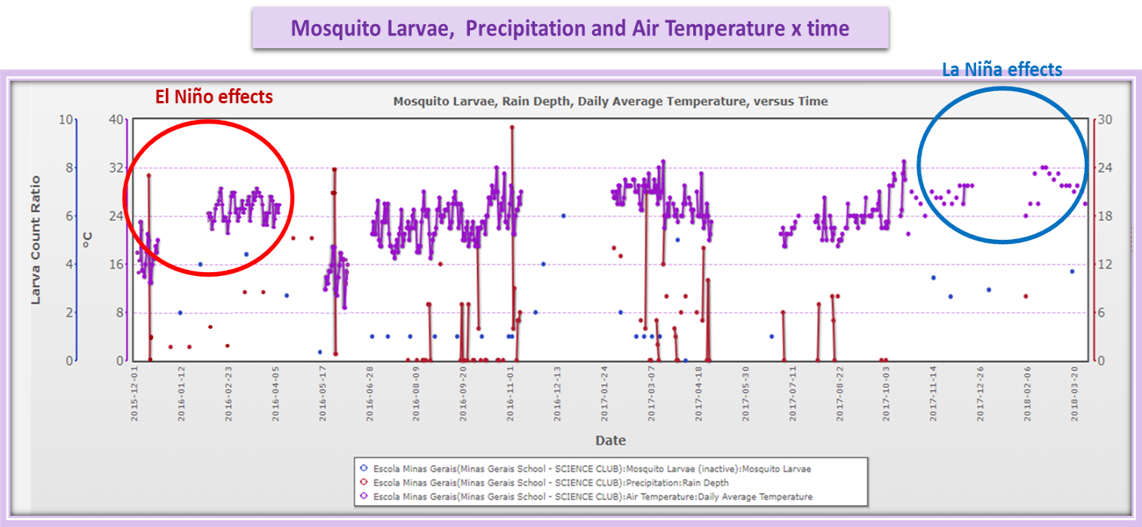
Figure 16- Minas Gerais school data analysis crossing air temperature, precipitation and mosquito larvae count ratio versus time projecting ENSO effect from December 2015 to April 2018.

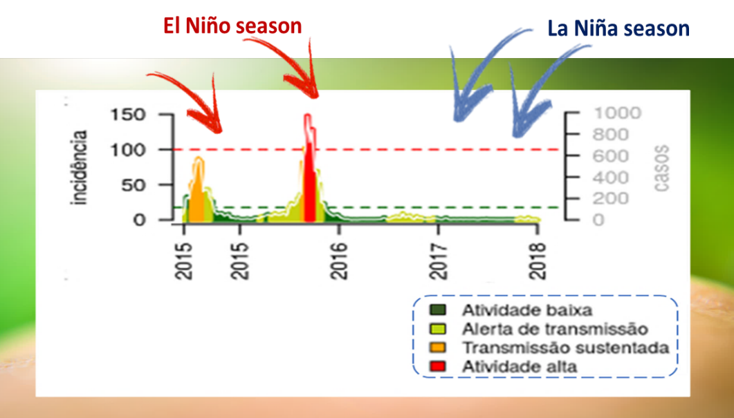

Figure 17-Data Table - higher notification of dengue cases are the years of El Niño phenomenon.
FONTE: Secretaria Municipal de Saúde do Rio de Janeiro
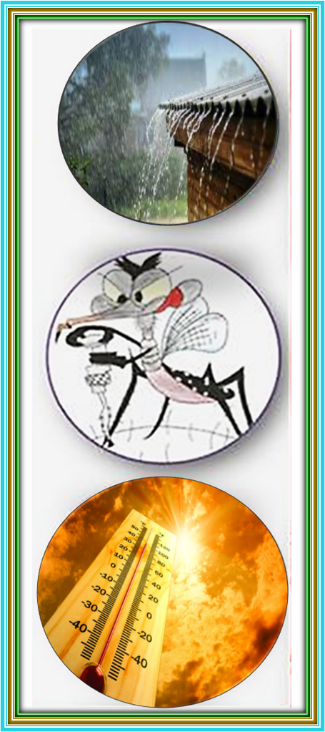
9. CONCLUSION
- Climatic phenomena such as El Niño and La Niña (ENSO) alter temperatures and amounts of rainfall in different regions of the country, in the case of the Southeast region of Brazil, there is an increase in temperature and rainfall and end up making the perfect climate for mosquito proliferation. The rains and temperature allow both larvae and adults to develop their functions more quickly, without restrictions on the quantity and quality of food and reproductive resources.
- The graph of figure 17 shows that cases of dengue, a disease transmitted by Aedes aegypti, increase considerably in years of climatic phenomena, and the spreadsheet from figure 16 shows that the mosquito larvae increase in the years 2015 and 2016, season of cycles of the El Niño climatic phenomenon quite accentuated and it was not relevant in La Niña moderate season of 2017/2018.
Figure 18- Rain and heat affect the proliferation of mosquitoes
- We can conclude that climate factors, such as increased temperature and precipitation, affect the spread of mosquitoes that transmit diseases, such as Aedes aegypti, in the city of Rio de Janeiro, with impacts on the health of the population.

Why do we need mosquito data?

We think it would be important to point out to the researchers of the Aedes aegypti mosquito and the diseases transmitted by it – dengue, chikungunya and zika – and to the Public Health Offices, as well as other students and the general population. Globally, there is a major effort to use satellite data to predict the onset, decline, and spread of vector-borne diseases. Reliable soil-based data are useful for the development of realistic computational models based on satellite data.
In most parts of the world, soil verification data are simply not available - so GLOBE observations are extremely important in tracking and controlling disease. These satellites cannot distinguish between the places in your community - we need the "eyes in the sky", but also the "boots on the ground"! Say NASA scientists. And the use of traps simulating containers artificial free, like tires and tanks of water, are the favorites of the mosquitoes and therefore can be safety use to know he data in regions and places that they are not available to collect directly from the free mosquito breeding sites.
Figure 19- eyes in the sky", but also the "boots on the ground"!
FONTE: https://www.revistabula.com/

10. SOLUTIONS
The results of our research prove that climate events (ENSO) bring with it, in Rio de Janeiro, variation in the weather and the most constant and marked temperature increase and rainfall (El Niño), interfering in the spread of Aedes aegypti, in the urban areas, thus negatively affecting the health of the population of Rio de Janeiro.
The best way to prevent diseases is to combat the vector mosquito. The population and public health need to unite in actions to combat Aedes aegypti and its diseases – Dengue, Chikungunya and Zika.
Among the greatest efforts are:
The identification and destruction of mosquito habitats, awareness, and action of the population effectively in actions to prevent and combat the Aedes aegypti mosquito.
Dissemination of information essential to combat the Aedes aegypti mosquito and diseases to the population of Rio de Janeiro for summers of climatic phenomena such as El Niño and La Niña (ENSO).
Training of multiplier citizen scientists in preventive actions against vector breeding sites - Aedes aegypti mosquito - beyond school walls.
Figure 20- Mosquito breeding site mitigation FONTE: Secretaria Municipal de Saúde do Rio de Janeiro
11. ACKNOWLEDGEMENTS

We thank Minas Gerais, Principals Deinze Marzal and Tania Campos, FIOCRUZ (Elimina dengue Project), Go Mosquito Community, GLOBE Mission Mosquito, Dr. Russanne Low and from Institute for Global Environmental Strategies, AEB Brazilian Space Agency, Aline Veloso and Erick Luiz Silva.

12. REFERENCES AND BIBLIOGRAPHY

1. BRAZILIAN JOURNAL OF HEALTH RESEARCH (2008), Vol. 10. Access: 20/02/2020.

2. CAMARA, Tamara Nunes Lima. Revista de Saúde Pública. Universidade de São Paulo. São Paulo, SP, Brasil. <http://www.scielo.br/pdf/rsp/v50/pt_0034-8910-rsp-S1518-87872016050006791.pdf> Access: 24/11/2021.

3. FEWS NET - https://fews.net/pt/el-ni%C3%B1o-and-precipitation. Access: 24/10/2021.
4. FIOCRUZ, Instituto Oswaldo Cruz, Aedes X Pernilongo comum,
<http://www.ioc.fiocruz.br/dengue/textos/aedexculex.html>. Access: 10/11/2021.
- Graphs of Research Institutions (FIOCRUZ).
- Portal ENSP - Projeto ZDC/ Escola Nacional Sergio Arouca – Fiocruz
- Info-dengue - https://info.dengue.mat.br/alerta/rio/dengue

5. BUREAU OF EPIDEMIOLOGY, DEPARTMENT OF DISEASE CONTROL, the Ministry of Health, Brazil. CADERNOS DE SAÚDE PÚBLICA vol.5 n.2 Rio de Janeiro Apr./June 1989.

6. GLOBE. GOV. Graphs made by students according to GLOBE data.
<https://vis.globe.gov/GLOBE/> Access: 24/10/2021.
- GLOBE Science Protocols – Atmosphere » air temperature, precipitation.
- Hydrosphere » Mosquito Larvae.

7. GLOBE Mosquito Habitat Mapper App to Locate Mosquito Larvae.
<https://mosquito.strategies.org/index.php/pt/pagina-inicial/app-brasil/>

8. GO MOSQUITO Community – <https://mosquito.strategies.org/index.php/en/>. Access: 20/10/2021.

9. MEMÓRIAS DO Inst. Oswaldo Cruz vol.108 no.8 Rio de Janeiro Dec. 2013 Epub Nov 28, 2013. < https://doi.org/10.1590/0074-0276130128> Access:24/10/2021.

10. MUNICIPAL Health Department, <http://www.rio.rj.gov.br/web/sms/dengue>
Acess:11/15/2017.

11. SOUZA-SANTOS R. Fatores associados à ocorrência de formas imaturas de Aedes aegypti na Ilha do Governador, Rio de Janeiro, Brasil. Rev. Soc. Bras. Med. Trop 1999;32:373-82.

12. WHO - World Health Organization 2012. Access: 22/10/2021.

13. THETE KD, Shinde LV. Biol Forum-An Int J. 2013, page. 124.

13. OPTIONAL BADGES FOR SCIENTIST SKILLS
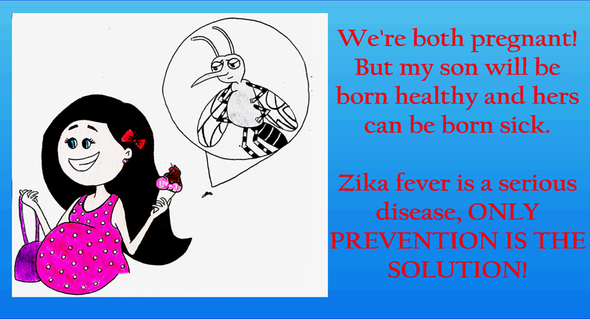
Figure 21 – Student drawing

Collaboration
All the students worked together to provide a good work. During the development of the project, each of the student could stand out in their best performance. Therefore, they were able to show their specials skills.
- Juliana Villela, and Andreia Silva: data collect research, project summary, video elaboration, theoretical part, and research on the subject.
- Camille Santos and Luis Eduardo Freitas: collection and production of exploitable data.
- Luiz Eduardo Freitas and Juliana Vilela: art and preparation of the video.
- Juliana Vilela, Andreia Silva, Camille Santos: drafting of the project.
- All group: Video Presentation.

Community impact
Use of local data from the GLOBE Mosquito Habitat Mapper app and Globe site data collect from Urca district comparing to official data makes it possible to characterize the number of the breeding sites and their mitigation. The use of GLOBE data from others site in Brazil and data from Municipal Health Department makes possible to show and compare that the Urca is a district that has Aedes aegypti mosquito and their density is higher in artificial captive traps and the importance of data zero to contain mosquito development in the district. The possibility of dissemination of information is essential to combat and the Aedes aegypti mosquito and prevent its diseases to the population of Rio de Janeiro mainly in summers of climatic phenomena such as El Niño (ENSO).

Exploring STEM Careers
The project used data stored which was collected by the students using GLOBE Mosquito Habitat Mapper and data research in GLOBE platform and official Brazilian data. MHM app shows high performance that allows the visualization of geographic information as well as performing data collection in the field and uses the GPS functionality of the mobile terminals to provide localization intelligence in mapping projects. The data collected and recorded as well as all field documentation of possible habitat, genus identification and mosquito species, destruction of breeding sites - help students and scientists to investigate more effectively and more promptly the proliferation of vectors in support of our battle to combat mosquitoes of diseases such as dengue fever, yellow fever, chikungunya and the Zika virus.
The weather data - air temperature and precipitation- were collected in gauges made by the students to be used in study area.

