GLOBE Hydrosphere Data Analysis & Hirase River Biological Survey

Sota Inagaki, Rindo Tsuda, Shota Terashima, Kanako Hagiwara, Yuri Tamura, Takumi Karasawa, Haruto Narikiyo

Ikuta High School
Kanagawa, Japan

Teacher: Ms. Reiko Nezu
January 26, 2026

ABSTRACT

We belong to the Science Club at Ikuta High School in Kanagawa Prefecture, Japan. Since 2016, we have been participating in GLOBE activities, conducting water quality surveys of a small river called Hirase River, which is located very close to our school, using the GLOBE Hydrology Protocol once a week. In this report, we analyzed the global trends of water-related data (i.e., water temperature, pH, nitrates, conductivity, and dissolved oxygen) collected from all around the world through GLOBE using a Python program. We also collected some environmental variables (i.e., urban areas around each GLOBE observation site and river width) and evaluated the relationships among the data of water qualities and the environmental variables. We found that the average water temperature has been rising year by year as global trend, indicating the effects of global warming. Last year, our cluster analysis revealed that the overall GLOBE observation sites were divided into three categories: (a) narrow rivers in a rich natural setting, (b) wide rivers in urban areas, and (c) narrow rivers in urban areas. We examined the factors affecting water qualities in these three types of rivers and clarified the characteristics of the Hirase River, which we are observing, in comparison to these three types of rivers. This year, we have further conducted separate analyses for rivers in natural settings and those in urban areas to deepen our investigation.
As a new initiative this year, we conducted a biodiversity survey around the Hirase River—where we perform our water quality monitoring—by calling for participation from local residents and junior high school students. Since this investigation has only just begun, we have not yet collected a sufficient amount of data; however, an interim report is included in this paper.

- Introduction
Our school, Ikuta High School, is located in the urban area of Kawasaki City in Kanagawa Prefecture, Japan. There is also a rich natural park called Ikuta Ryokuchi nearby. Close to Ikuta High School, there is a small river called Hirase River, which is about 3 meters wide (Figure 1). We have been conducting water quality surveys (i.e., water temperature, pH, COD, phosphoric acid, ammonium, and nitrates) using pack tests once a week since 2016 (Figure 2).
Since 2018, we have been conducting laboratory experiments under various conditions to determine how much nitrogen and phosphorus (i.e., referring to as nitrates) can be absorbed by the aquatic plant, Canadian waterweed (Elodea canadensis), in order to get insights for improving water quality in the Hirase river. Additionally, starting in 2024, we will also conduct experiments to verify whether divalent iron ions can promote photosynthesis, aiming at mitigating global warming by promoting photosynthesis in rivers. By using Euglena (genus of freshwater fish in the aquatic plant family Euglenaidae), we have already confirmed that iron fulvate containing divalent iron ions (i.e., ferric Fulvic acid) promotes photosynthesis. As the next issue, we are verifying whether the same trend is confirmed by typical water plants such as Canadian waterweed.
In this report, we aimed to detect global trends in water quality by using hydrosphere data extracted from the GLOBE Advanced Data Access Tool. Building on last year's findings, we performed a cluster analysis to categorize world rivers into three types and conducted deeper comparative analyses to clarify the characteristics of the Hirase River. Furthermore, we utilized this information for our future research on water purification and global warming mitigation. In addition to water quality, we launched a new biodiversity survey in collaboration with the local community this year. For the data analysis, we used a Python program and VS Code, creating various graphs to visualize the complex relationships between these factors.
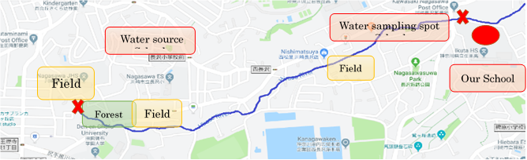
500ｍ
N

Figure 1. Location of Hirase River and our school
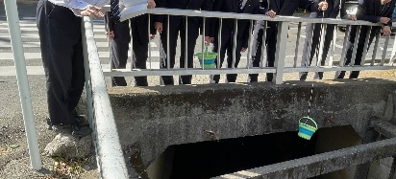

Figure 2. Observation activities

- Research Question and Hypothesis
- What kinds of global trends can be identified from the hydrosphere data extracted by GLOBE?
- What are the characteristics of the rivers at the GLOBE observation site?
- What differences can be seen in the transition of river water quality data between urban areas and nature-rich areas?
- We hypothesized that rivers can be classified into three groups based on their surrounding environment (urban or natural) and river width, and that the primary factors affecting water quality will differ for each group. Furthermore, we expect that the water quality of these rivers significantly influences the local biodiversity.

- Materials and Methods
- Data analysis
GLOBE hydrosphere data was downloaded through the Advanced Data Access Tool on the GLOBE site. The downloaded data includes water temperature, pH, nitrates, and dissolved oxygen. The data downloaded from the GLOBE site was supplemented with information on urban regions and river width measurements obtained from the map.
The downloaded data included the latitude and longitude of the measurement sites. We printed out each observation site by showing Google Maps based on the location data (Figure 3). A circle with a radius of 2 km was drawn on the printed map, and the proportion of urban areas within that circle was expressed as a number from 0 to 10 (10 = 100%). The approximate width of the river was represented in three stages: 1 for within 5 m, 2 for 5 to 50 m, and 3 for over 50 m. These values were added to the downloaded data. Ultimately, the necessary data was extracted and saved as a CSV file. (Figure 4)
The number of data points is as follows: there are a total of 1,152 GLOBE data entries. The tool used for Python was Vscode (Figure 4).
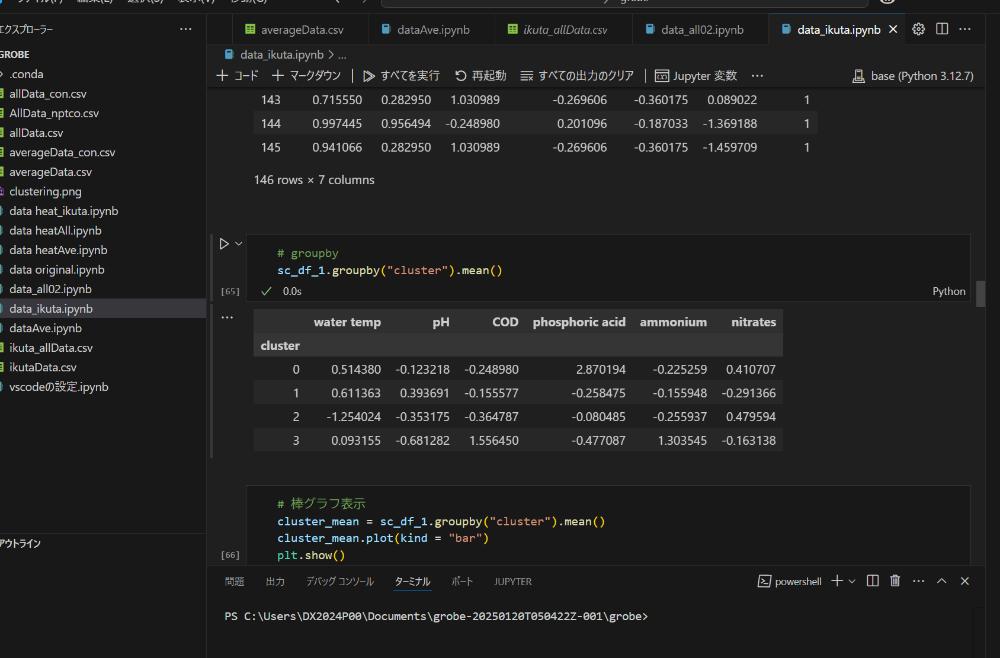
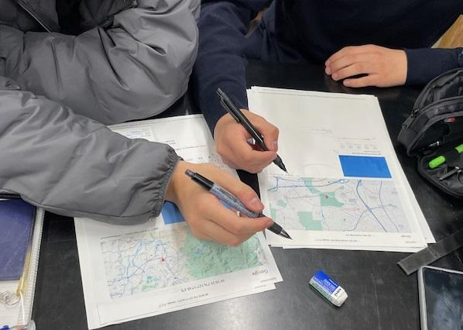

Figure 4. Python Screen
Figure 3. Assessing the degree of urbanization in the surrounding area of the observation points of GLOBE sites and the river widths

Building on our previous work, we introduced a new analytical step this year: separate evaluations of rivers in natural vs. urban environments. In this study, "Natural areas" were defined as regions where the urban land-use ratio is 30% or less, while "Urban areas" were defined as regions where the ratio is 70% or more.

B) Hirase River Biodiversity Survey
In collaboration with a local community group, "The Hirase River Basin Association," and a nearby junior high school, we conducted a biodiversity survey to identify species living around the Hirase River. Participants were asked to report their observations via a Google Form, providing the following four details: (1) latitude and longitude of the location, (2) time of the observation, (3) type of organism (e.g., fish, birds), and (4) physical characteristics such as color and body length. This survey was launched on January 10, 2026. (Figure 5 and 6)
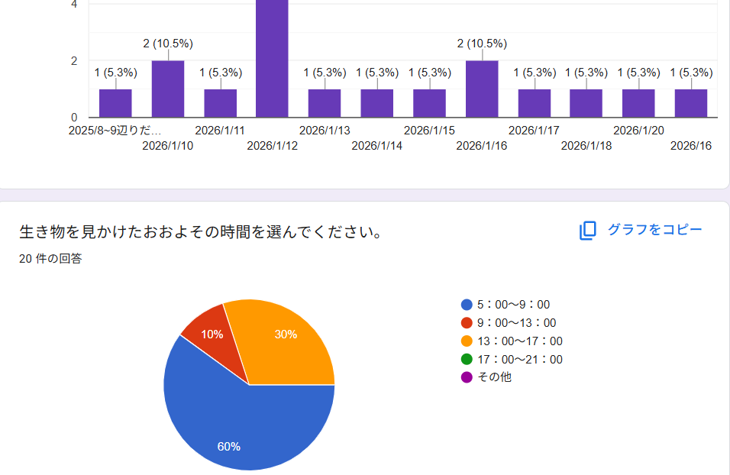


Figure 5. QR code used for the survey

Figure 6. Screenshot of the survey response screen

- Results and Discussion
- Data analysis
From the global water temperature data, we identified that the average water temperature has been rising year by year, indicating the effects of global warming. Surprisingly, while the average water temperature in urban areas has actually decreased, a slight increase in water temperature can be observed in natural settings (Figure 7). Since the urban ratio and river width data are based on last year’s observation points, many of the older points from before 2014 have missing data and were not included in the graphs. Regarding the average nitrogen concentration, although all graphs show a yearly increase, it is clear that the rate of increase is significantly higher in natural areas. This unexpected result suggests that global warming might be altering the nutrient cycles of natural ecosystems more significantly than previously thought (Figure 8).
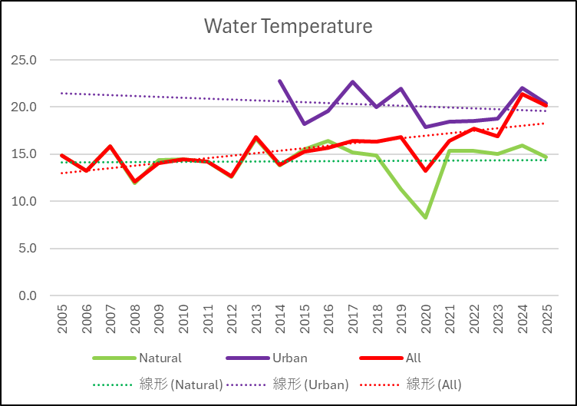
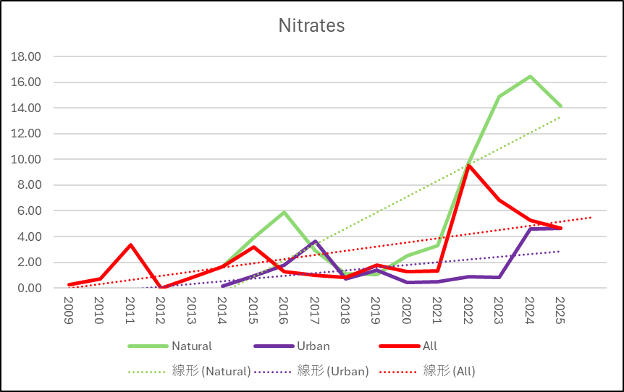

Figure 7. Yearly Changes in Global Water Temperature
Figure 8. Yearly Changes in Global Nitrogen Concentration

We conducted a multiple regression analysis by categorizing the regions into two groups: those with abundant natural environments and those with a high proportion of urban areas. In the regions rich in nature, it was found that most areas had low nitrogen concentrations, indicating a high percentage of rivers with good water quality (Figure 9. Clusters 0 and 2 in the figure).
These groups appear to be divided by their dissolved oxygen (DO) levels: Cluster 0 consists of rivers with lower DO levels, while Cluster 2 consists of those with higher levels. Although Cluster 1 is small in number, it showed significantly high nitrogen concentrations, suggesting these rivers may have potential water quality issues.

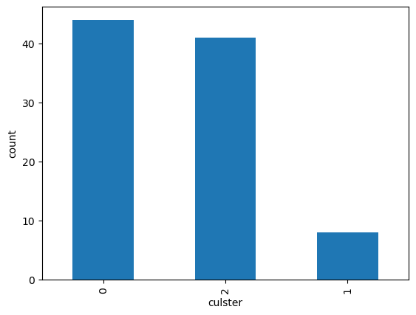
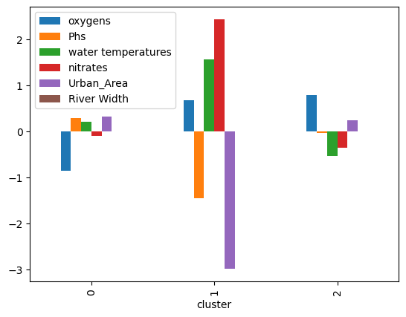

Figure 10. Sample Size per Cluster
Figure 9. Cluster Analysis of Nature-Rich Rivers

Regarding urban rivers, the majority are characterized by moderate levels of both dissolved oxygen (DO) and nitrogen concentration, with no extreme fluctuations (Figure 11. Cluster 1 in the figure). In contrast, Cluster 0 represents relatively clean rivers with high DO and low nitrogen concentrations, while Cluster 2 consists of rivers showing the opposite trend, indicating potential water quality issues. It is a highly interesting finding that these extreme water quality trends—both the very clean and the problematic—are predominantly observed in narrower rivers.
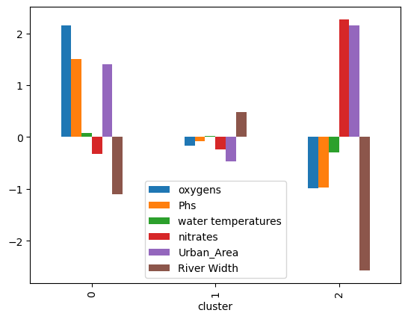
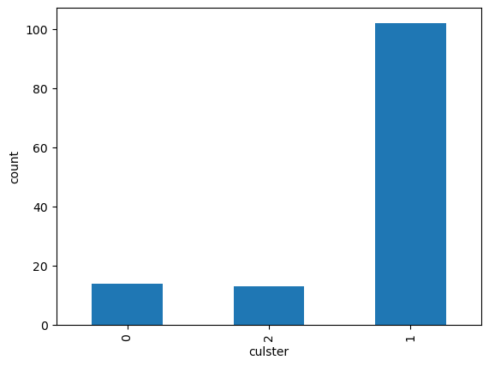

Figure 12. Sample Size per Cluster
Figure 11. Cluster Analysis of Rivers in Urban Areas

A possible reason for these extreme trends in narrower rivers is their lower water volume, which makes them more sensitive to their surroundings. In these rivers, pollutants are not easily diluted, leading to rapid degradation of water quality when runoff occurs (Cluster 2). Conversely, in the absence of pollution, the water quality remains high as it directly reflects the purity of its source, such as springs or forest runoff (Cluster 0).
While the conditions of all global observation sites are not fully known, our study focus, the Hirase River, is characterized by a very narrow width and is classified under Cluster 2 due to its relatively poor water quality.
The area surrounding the Hirase River consists of residential zones and agricultural fields. Because the river is narrow and has a low water volume, it lacks the capacity to sufficiently dilute pollutants. As a result, runoff containing domestic wastewater and fertilizers from the nearby fields likely leads to the high nitrogen concentrations observed in our analysis.

B) Hirase River Biodiversity Survey
Current data from the Hirase River biodiversity survey is insufficient for a full analysis or conclusion. However, our preliminary findings are visualized in a biodiversity map on the supplementary poster. Graphs have been prepared to illustrate the variety and count of species from the survey. We plan to update these results as new data becomes available.

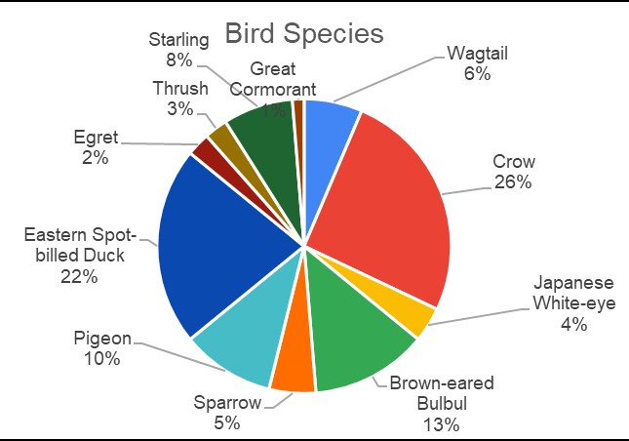
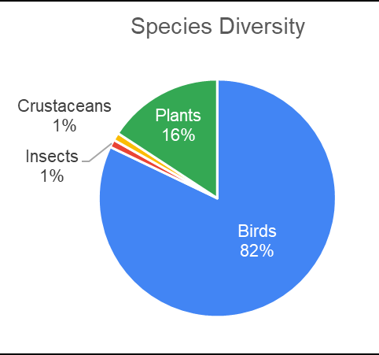

Figure 14. Reported Birds Species
Figure 13. Reported Species

- Conclusion and Future Issues
Our analysis indicates that rivers in nature-rich environments are more sensitive to the impacts of climate change. This shows that continuous water quality monitoring in these regions is crucial for monitoring climate change.
A significant finding is that extreme water quality trends—both exceptionally clean and highly polluted—predominantly occur in narrower rivers. This suggests that rivers with smaller water volumes are more susceptible to the direct influence of their immediate surroundings. Our specific observations of the Hirase River support this, suggesting that its narrow channel and proximity to residential and agricultural areas may contribute to its classification in the high-nitrogen group (Cluster 2).
Bibliography/Citations:
Nakayama, K., 2019: Data Scientist Ikuseikouza (Data Scientist Training Course). Tokyo, Mainabi
Kato, K., 2019: Kikaigakusyu Zukan (Encyclopedia of Machine Learning).Tokyo, Shoeisha
Author Name. (2023). Permafrost degradation and nitrogen cycling in Arctic rivers. Biogeosciences (or relevant journal name). https://doi.org/

