Relationships Between Surface and Near Surface Temperatures Based on Multiple Ground-Level Parameters During Michigan Winters

Student Researchers:
Hassan Fawaz, Kristian Manivilovski, and Jordon Horton

School:
Crestwood High School, Dearborn Heights, MI 48127

High School Science Teacher:
Mrs. Diana Johns

Date: March 1st, 2018

Table of Contents

- Abstract: Page 2
- Initial Research Question: Page 2
- Hypothesis: Page 3
- Investigation Plan: Page 4
- Research Methods: Page 5
- Globe Data and Data Entry: Page 8
- Data Analysis: Page 9
- Conclusion: Page 15
- Research Significance: Page 16
- Verifications: Page 16
- Measurement and Research Limitations: Page 16
- Works Cited: 17

Abstract:
Surface temperature is a critical component of what scientists use to observe global changes in climate to study global warming and climatic patterns of our world. Climate change and whether global warming is an issue that has been an issue in a worldwide conversation. Our research aims to determine if such changes are identifiable on the local level and given our degree of knowledge how detectable a known relationship is. We questioned the significance of the difference between the past two winters. Gathering near surface data, we wondered if we could notice the changes in humidity based on temperature. Through in-depth analysis of our data, we came to see much colder temperatures mid-winter this year yet colder temperatures at the beginning and end of last year’s winter. Although this year’s data didn’t extend further into the winter, it is evident that this year called for an early spring. With comparing the humidity to the air temperature, we had less luck. We identified an apparent trend between the two but weren’t able to elaborate on the relationship. Since surface temperature data only began at our school recently, further analysis of future winters should be conducted to notice shifts in climate and other relationships affecting the surface temperature.

Initial Research Questions:
How does climate change affect this winter in comparison to the previous winter?
Climate change is such a long process that most people wouldn’t recognize it without looking back. It’s like how growing up you don’t see the changes until you look at an older photo. Never can anyone just say there was less snow or it wasn’t as cold because there are still snow storms and bitter mornings. To look at climate change requires identifying patterns and trends throughout data of both years to see an overall change in the pattern versus a change in just temperature or snowfall. By taking surface temperature data for two consecutive years we can compare the extent of each winter to identify any changes.

How strong of a relationship can be detected between surface temperature and relative humidity?
Relative humidity is known to be related to the temperature. Given similar pressures warmer air temperatures will result in higher percent humidity and vice versa. To resemble this, we will take measurements relative humidity using a kite and portable data logger. Then we’ll compare it to the average temperature of the sites, hoping to find a relationship.

These questions guided the development our investigation into how surface temperature could be affected in the long run and how it has impacts on other environmental relationships. The Chimney Swift, a bird native to the Dearborn Heights, Michigan area, depends on certain surface temperature conditions for its nesting and feed, thus making our research relevant to the area.

Hypothesis:
Given the recent inconsistencies in the continental climate we wonder if locally any changes could be detected to imply climate change at work. If we were able to see differences between the winters, a shift may be due to a general variation in winters that are within a more prolonged change in climate. Before beginning data collection, we hypothesized this winter would have more variation in temperature and warmer days sooner than last year’s winter. This conclusion will be decided through analyzing the curves of the graphs and differences in averages we produce this year in relation to that of last year.
Working towards a better understanding of surface temperature, we chose this year to see how surface temperature plays a role in other environmental relationships given from last year when we studied the effects other parameters have on the surface temperature. Knowing the relationship existing between the relative humidity and surface temperature, research goes to seeing the extent our local surface temperature can have on the relative humidity. We predict to be able to clearly see the relationship that exists by testing the data points for a correlation value.

Investigation Plan:
A group of three researchers was first assembled to gather surface temperature, air temperature, relative humidity, pressure and pressure altitude data. After picking a suitable site using GLOBE protocols, we reviewed our previous year’s work and decided to build upon it. Last year we attached a Kestrel Drop Data Logger to the kites to obtain air temperature. To expand our parameters by logging more factors and flying the kites higher, we tried to compare winters by using the PocketLab Voyager device to collect new data.
The AEROKATS and ROVER Education Network (AREN) protocols were used to fly the four different kites that the PocketLab was attached to. The Delta Elevation 9 ft. was used when wind speeds were under 16 mph, Delta Elevation 7 ft. was used when wind speeds were over 16 mph but under 21 mph, a Class Hata was used when wind speeds were too high for either kite, and an Ultra Foil 9 for when no kite could be used due to damages, high wind speeds, etc. Damages were sustained to the Classic Hata, so whenever wind speeds were over 21 mph, which only occurred once, we could not obtain air temperature. We were also unable to fly the kite when there was any form of heavy precipitation. Furthermore, following these protocols we were able to fly an AEROKATS aero pod with a Vtech Kidizoom which we used to record our research site and take snips of it. We are hoping to extend our capabilities using the aero pod to use images straight from it rather than using Google Maps.
Snow depth measurements were taken using a meter stick. Air temperature, relative humidity, pressure, and pressure altitude data were taken with the PocketLab Voyager. Once data was collected, it was entered onto a Google spreadsheet to make it easier to analyze at future dates. Surface temperature and sky conditions were uploaded to the GLOBE database for sharing and visualization.
Research Methods:
The site selected was an out of use football/soccer field behind Crestwood High School which had been used before for surface temperature research. The research site is located approximately 30 meters away from Crestwood High School’s back wall of the science wing by the staff parking lot (Exact location: 42º19’16.07” N 83º17’40.50” W). Nine different areas were selected, all which were not shaded by the school walls at any time. This location can be accessed during weekdays and on weekends, but the kite was held in the school so it could not be accessed during the weekend which led to gaps in our data sheet whenever school was not held. The protocols utilized included snow depth, clouds, contrails and surface condition. Surface temperature was obtained using the AutoPro ST25 - Automotive Handheld infrared thermometer, and snow depth was measured with a meter stick.
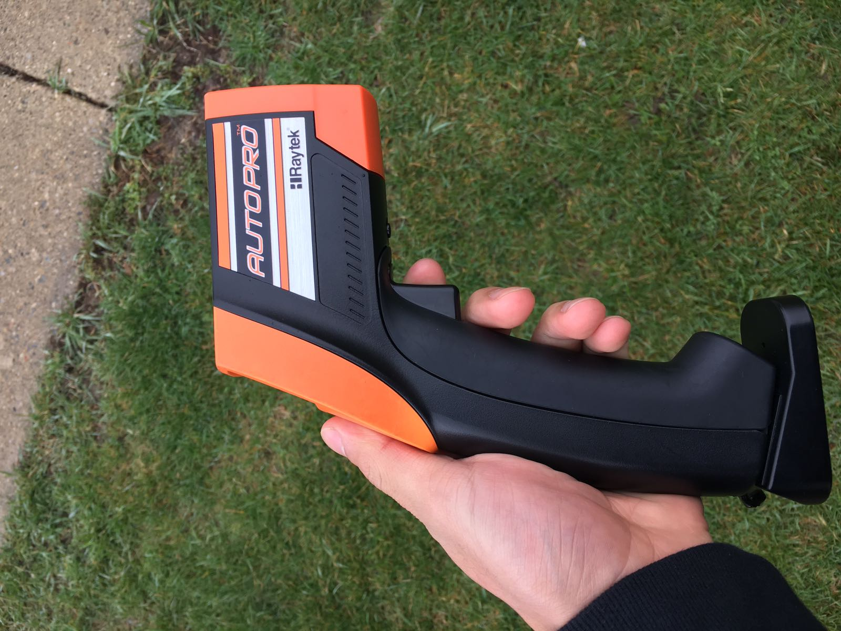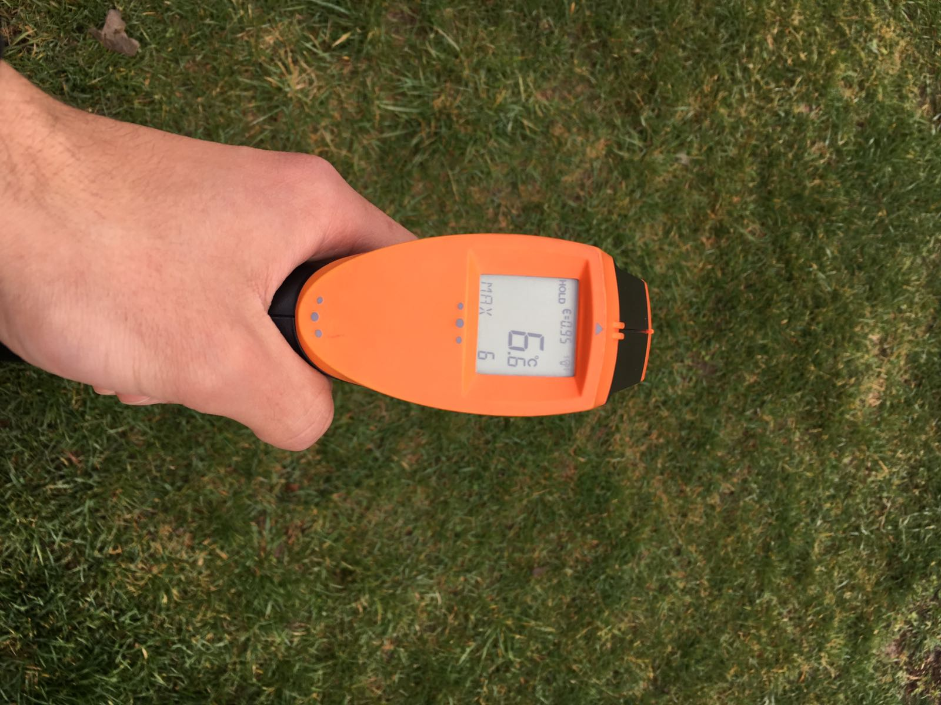
Figures 4 and 5: AutoPro ST25 - Automotive Handheld infrared thermometer on left. Screen display of surface temperature on right
There was variation within each area from day to day since they weren’t marked, but the protocols did ask for a random selection. Data was taken between 13:30 and 14:30 eastern (18:30 and 19:30 UTC) most of the time to reduce variability. The site itself is very large, so going over all of the areas took a while. Sometimes weather conditions would change instantly leaving variation between the first and last area tested, but those occasions were very rare.

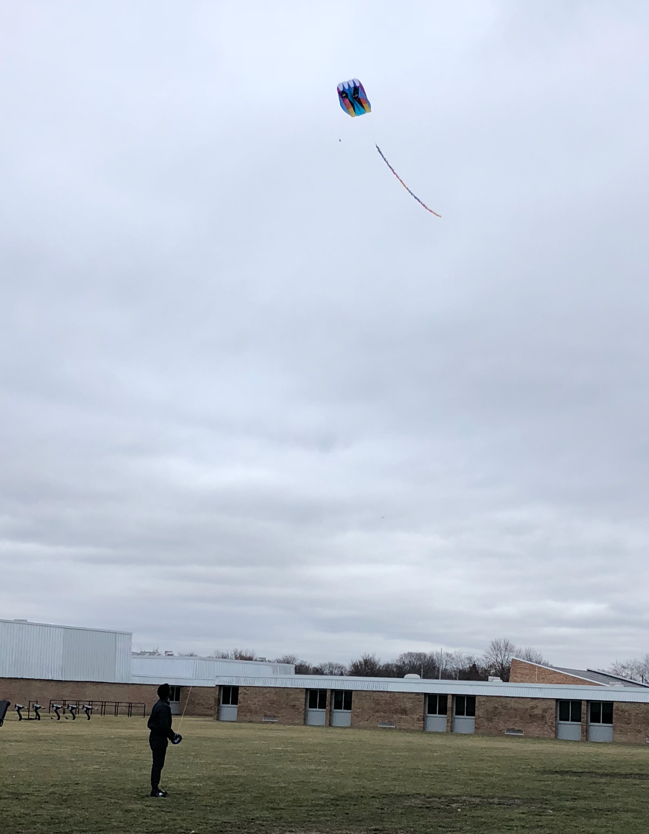

Figures 6 and 7: Ultra Foil 9 in action with PocketLab Voyager Data Logger Attached (left) and Delta Elevation 9ft (right)

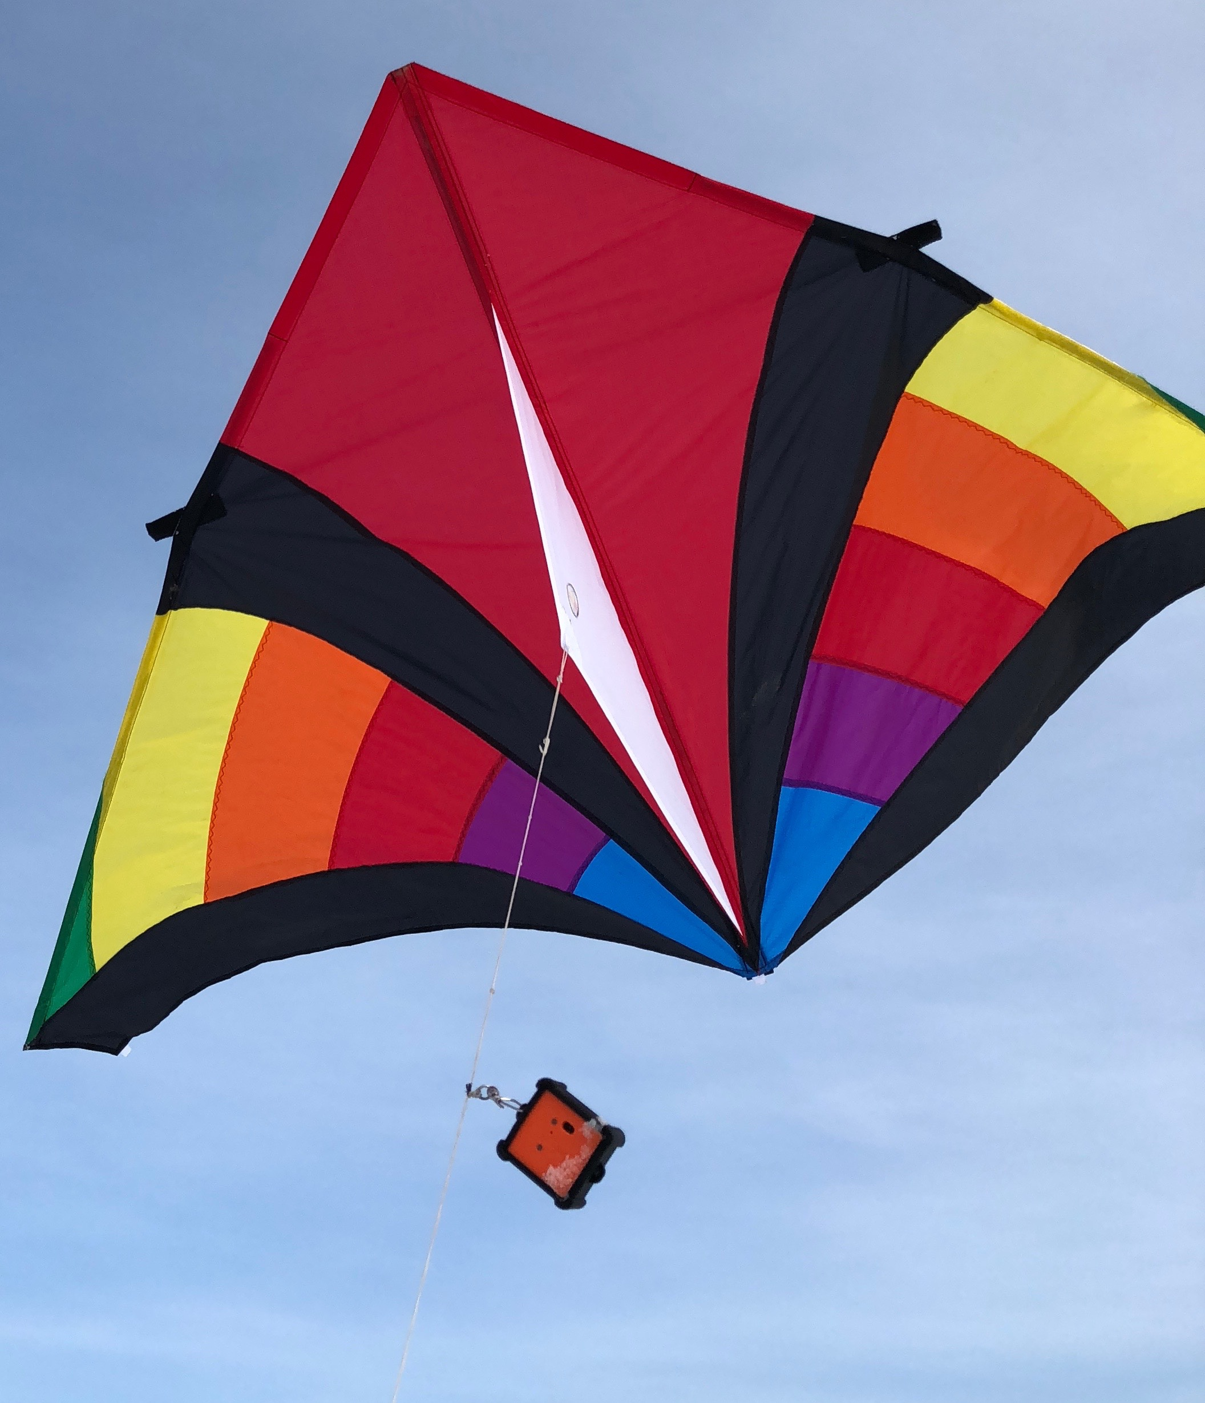

Figure 8: Delta Elevation 7ft with PocketLab Voyager Attached (left) and Classic Hata (Right)

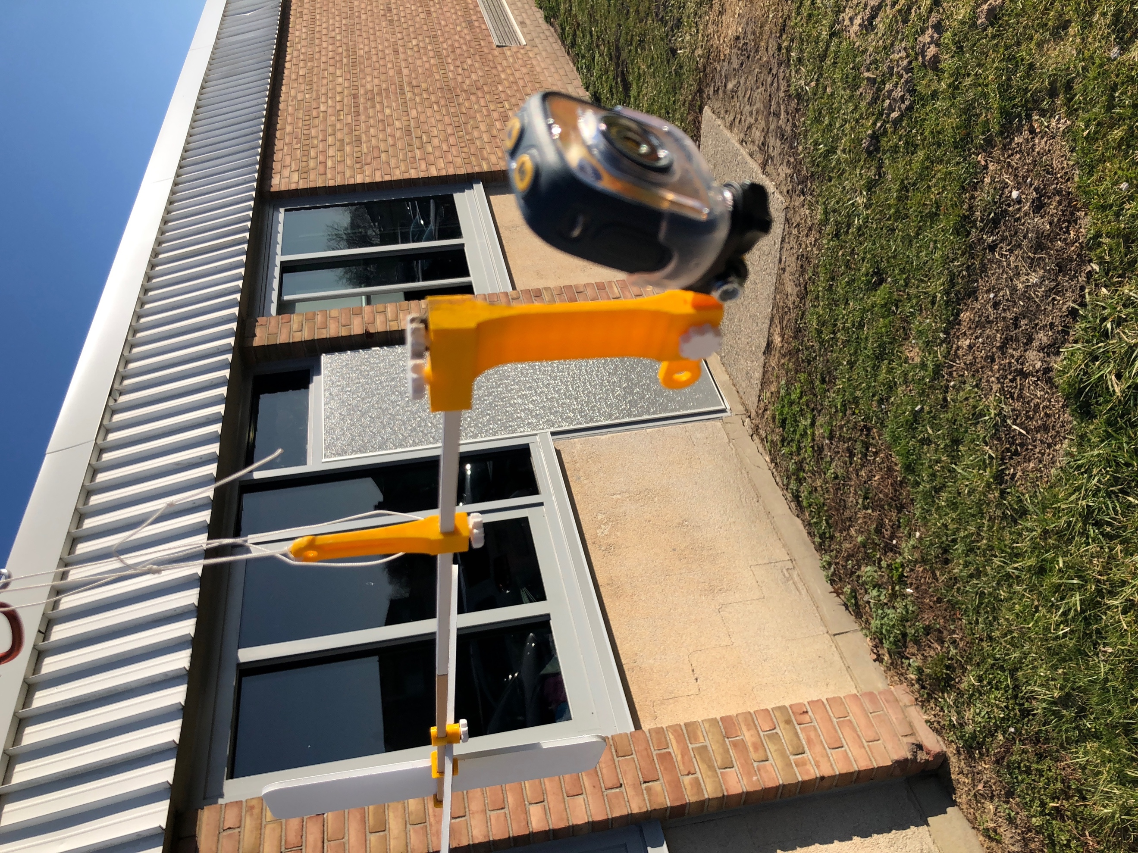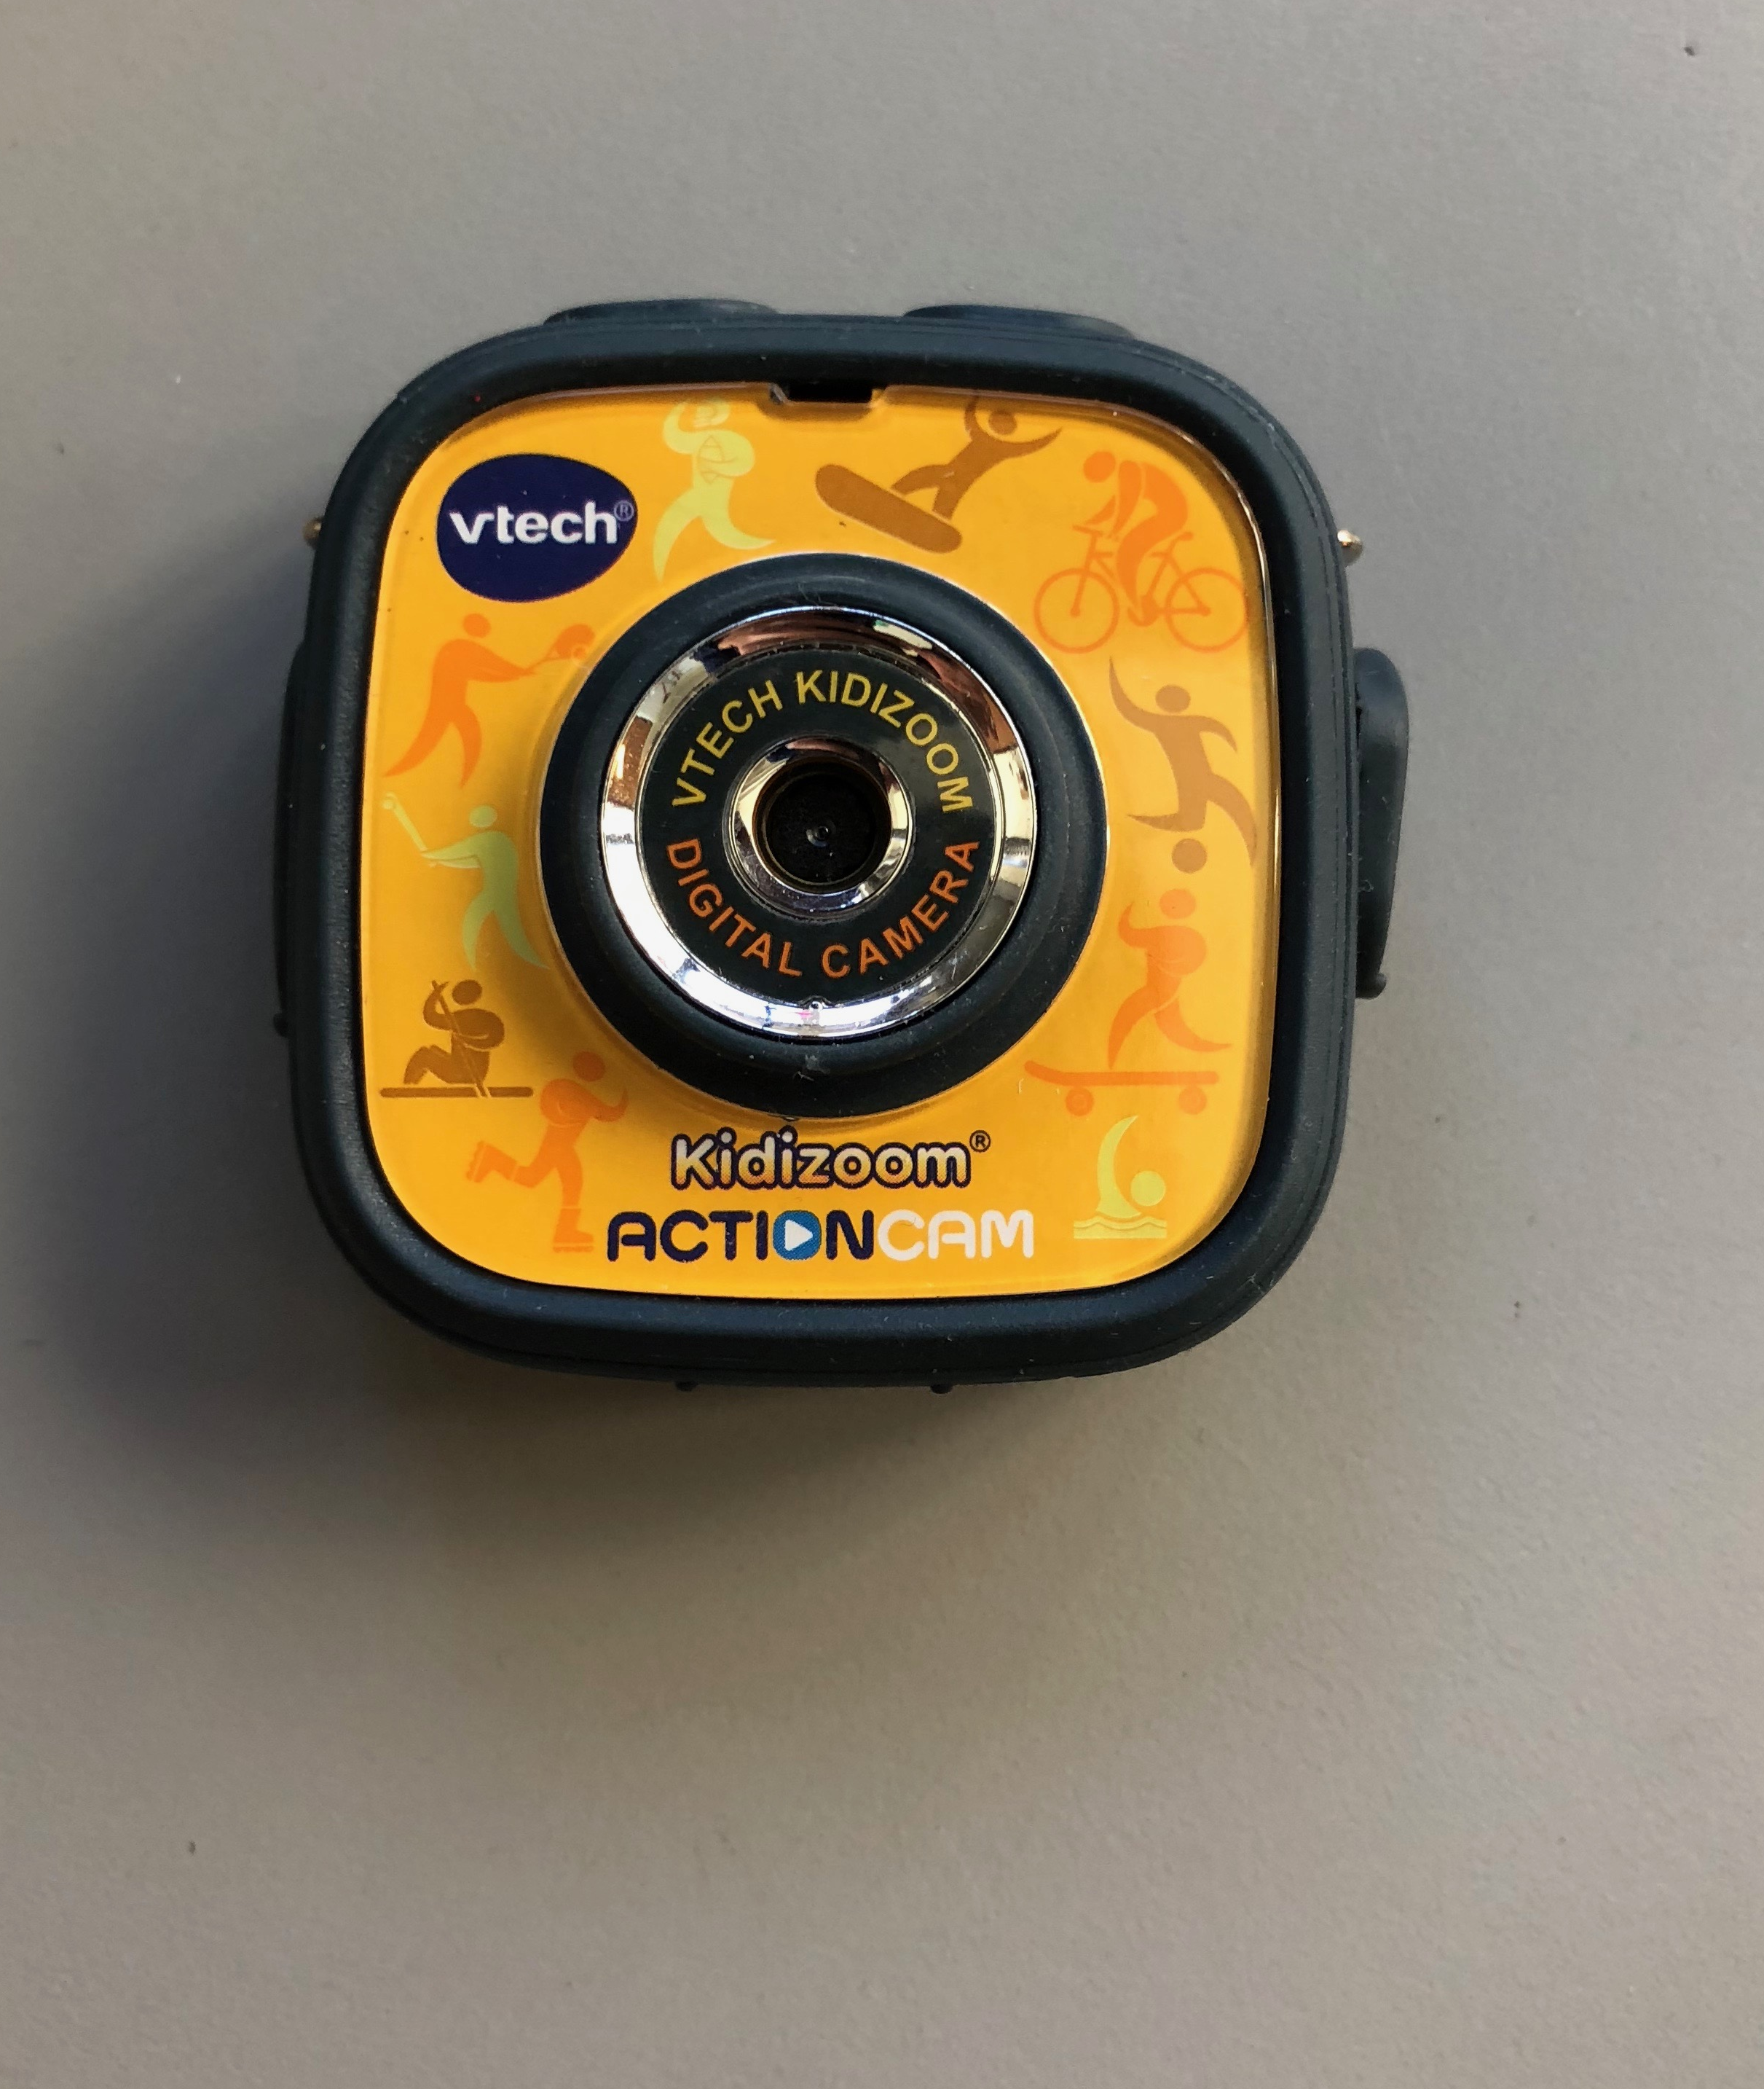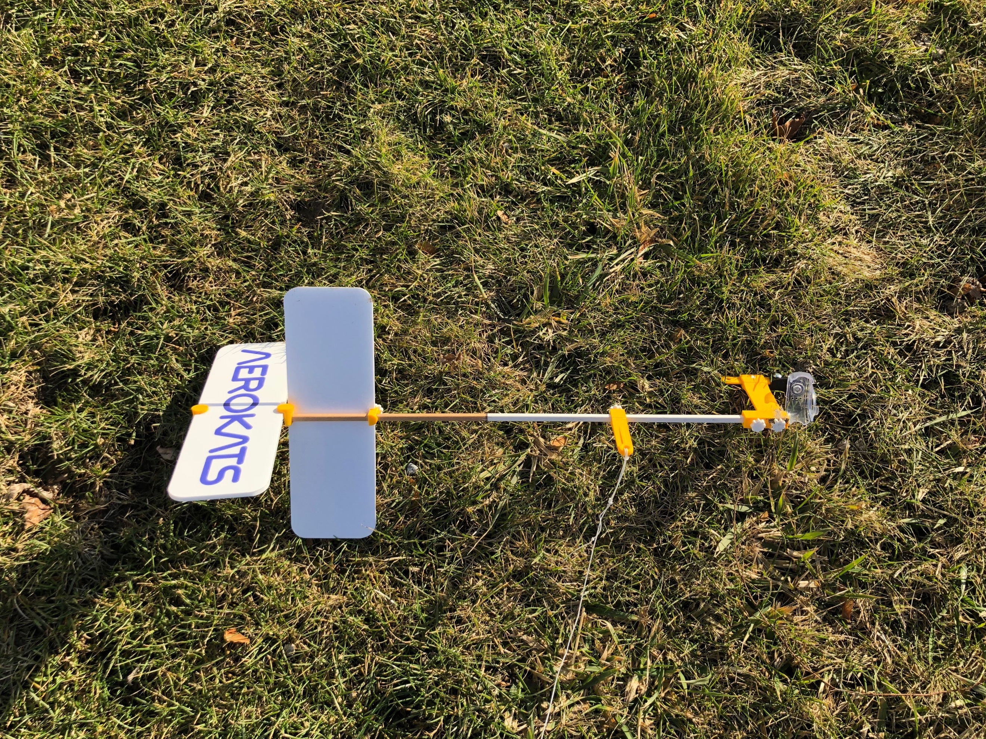

Figures 9-11: Aero pod (left and right) and Vtech Kidizoom

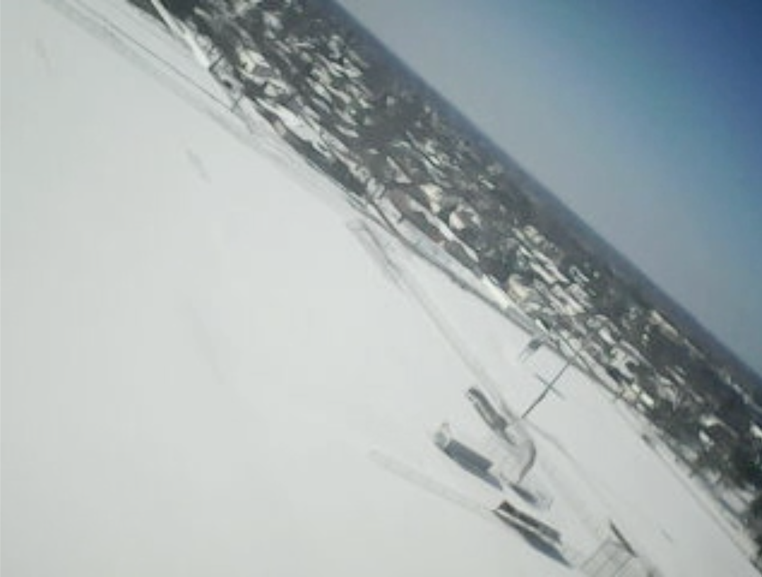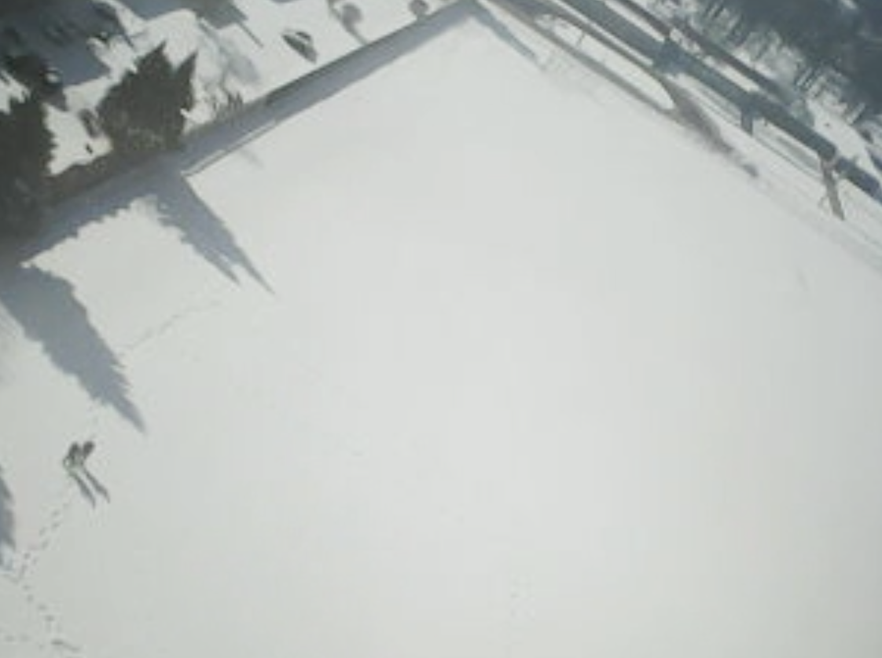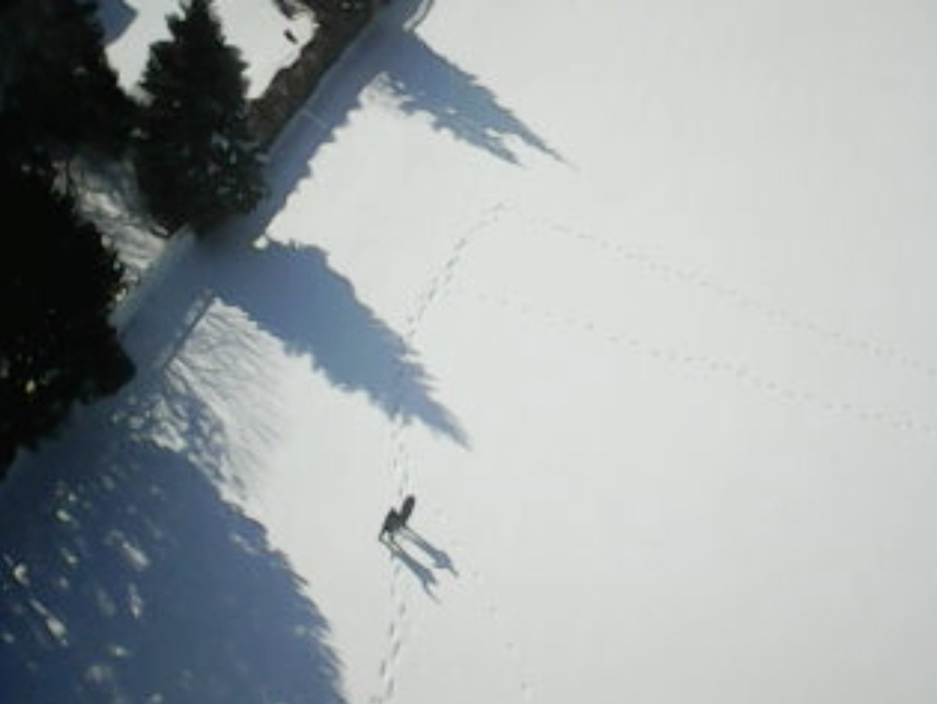

Figures 12-15: Pictures taken by Vtech Kidizoom

Over a month-long period from January 8, 2018 to February 16, 2018 we collected data on the necessary parameters. Data analysis was gradual but wasn’t complete until after data collection. The graphs and data charts of surface temperature versus snow depth from both years were juxtaposed to see discrepancies in patterns and calculate differences in averages. The surface temperature and relative humidity were plotted on a scatterplot and tests were run to identify a relationship.

GLOBE Data and Data Entry:
After measurements were taken, they were recorded on a surface temperature data sheet provided by the GLOBE website (globe.gov) (figures 1, 2, and 3) then entered into the GLOBE website through a computer. The data was later recorded a third time on the Google Spreadsheet to ease access and comparison, and to calculate the average of each day. Although our protocol is common, the equipment used and parameters focused on are unique to our school. We wish to get other schools involved with using such equipment given our research is successful. Unfortunately, data obtained from PocketLab Voyager was extremely questionable given that its readings of air temperature were very high compared to the actual temperature. For example, on January 18th, 2018 the average surface temperature was -10.71°C while the air temperature measured was around 25°C, contradicting any other source of air temperature measurement. As a result, working to troubleshoot the issues involved would be a big step in increasing the methods we use.
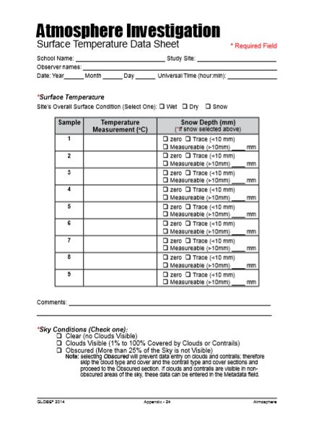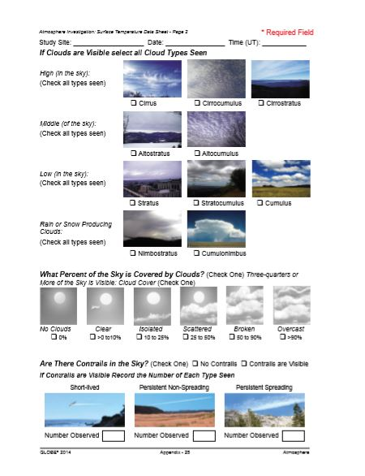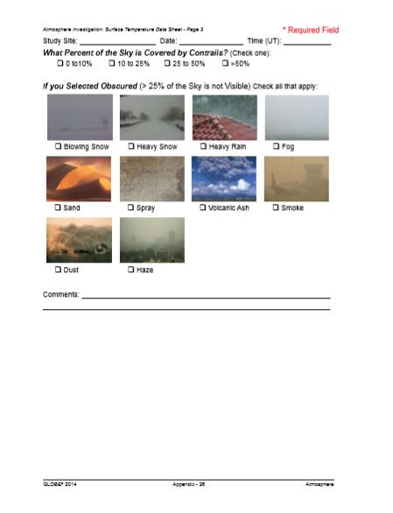
Figures 16-18: Atmospheric Investigation Data Sheet provided by GLOBE protocols

Data Analysis:
The daily surface temperatures taken on the 9 selected areas were entered on the spreadsheet below and the average was calculated.
Surface Temperature
Table 1: Recorded temperatures of each site and the daily average of all sites for the previous year throughout the span of data collection dates this year.

Date | Area 1 | Area 2 | Area 3 | Area 4 | Area 5 | Are a 6 | Area 7 | Area 8 | Area 9 | Average
1/18/18 | -10.8 | -10.6 | -10.2 | -10.6 | -11.4 | -11 | -11.4 | -10.2 | -10.2 | -10.71
1/19/18 | -7 | -6.8 | -7.2 | -8.6 | -8.2 | -9.4 | -8.4 | -7.4 | -6.8 | -7.76
1/22/18 | 6.2 | 5 | 5 | 5 | 5.2 | 5.2 | 5.2 | 6.6 | 4.4 | 5.31
1/25/18 | -3.2 | -0.8 | -4.2 | -4.4 | -5.2 | -4.4 | -5 | -6 | -5.4 | -5.4
1/31/18 | -4.4 | -4.6 | -5.2 | -6 | -6.6 | -6.8 | -7.2 | -6.8 | -7.4 | -6.11
2/1/18 | -6 | -10.2 | -10.6 | -10.2 | -11.6 | -12.8 | -12.8 | -8.8 | -13 | -10.67
2/2/18 | -20.6 | -20.6 | -21.6 | -21.4 | -23.8 | -24.4 | -23.8 | -27.6 | -28.4 | -23.58
2/5/18 | -14.2 | -14 | -13.8 | -14.2 | -13.6 | -12.3 | -12.6 | -12.6 | -13.6 | -13.43
2/6/18 | -18.8 | -15.2 | -14.4 | -15.2 | -14 | -14.4 | -14.6 | -14.4 | -15.8 | -15.2
2/7/18 | -9.2 | -10.6 | -4 | -10.8 | -13.2 | -13 | -13.4 | -13.6 | -13.4 | -11.24
2/8/18 | -15.2 | -17.8 | -18.4 | -21 | -20.2 | -19.2 | -20.2 | -18.2 | -17.8 | -18.67
2/13/18 | -3.2 | -1 | -3.5 | -3.4 | -2.8 | -5 | -0.6 | -4.5 | -4.4 | -3.16
2/15/18 | -3.8 | -4 | -4.2 | -4.6 | 0.2 | -5.2 | -5.4 | -5.4 | -5 | -4.16

Table 2: Recorded temperatures of each site and the daily average of all sites throughout data collection.
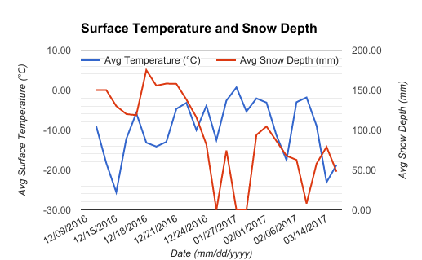
Figure 19: This graph represents the variation in the average surface temperature values and average snow depth for last year. Null data points were plotted. Data collected covers a much larger time period.

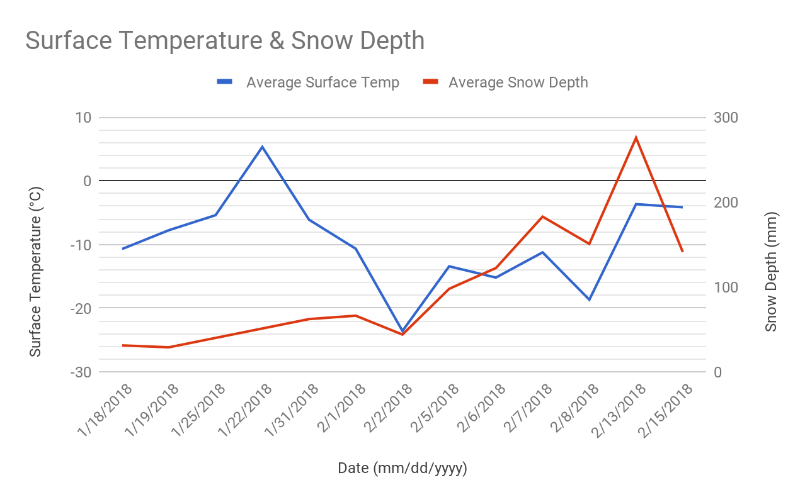

Figure 20: This graph expresses the variation of average surface temperature (from Table 1) and snow depth (From Table 2) throughout the data collection period for this year. Null data points are plotted.
Comparing Figure 9 with Figure 10, looking at the dates in common, we notice differences. Last year’s data (overall) presents the surface temperature as relatively constant for a long period of time. In beginning of January to the end of February, the surface temperature remained between 0°C and -10°C for the most part. However, this winter, the beginning of the year shows lower temperatures between -20°C and -30°C before gradually increasing as February arrived. Of common days of data collection, this year had an average of -10.6°C in the January-February period, while last year had an average of -4.37°C. Last year’s data extends into March, where temperatures remain fairly low and snowfall continues. On the other hand, this year the snowpack has melted towards the end of February and temperatures are relative warmer. While the previous winter experienced its colder days at the start and end of winter, this year we experienced heavy snowfall and the lowest temperatures in the middle of winter and see an early spring. If further data were allotted of this winter’s surface temperature and snowfall, a further analysis of the similarities and differences could be done; unfortunately, data usually available through our WeatherBug station proved inaccessible during time of research. If research could continue for years to come, it’d be interesting to see how winters turn out compared to the previous ones.
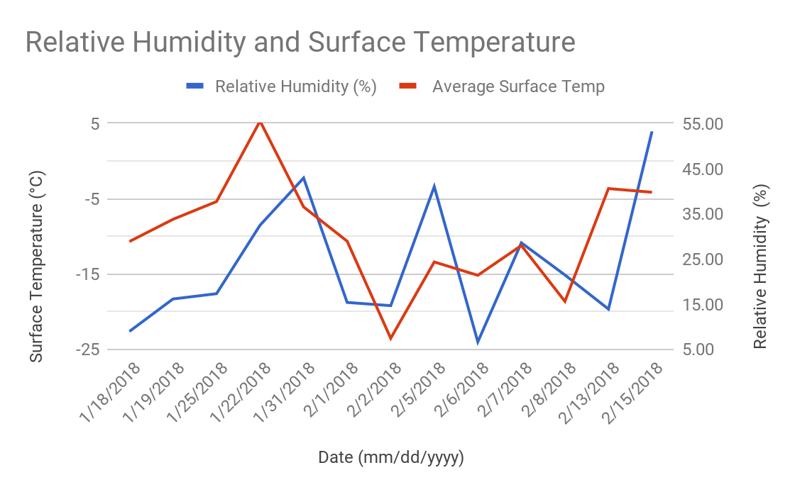
Figure 21: Displays the changes in humidity and surface temperature on days of data collection.
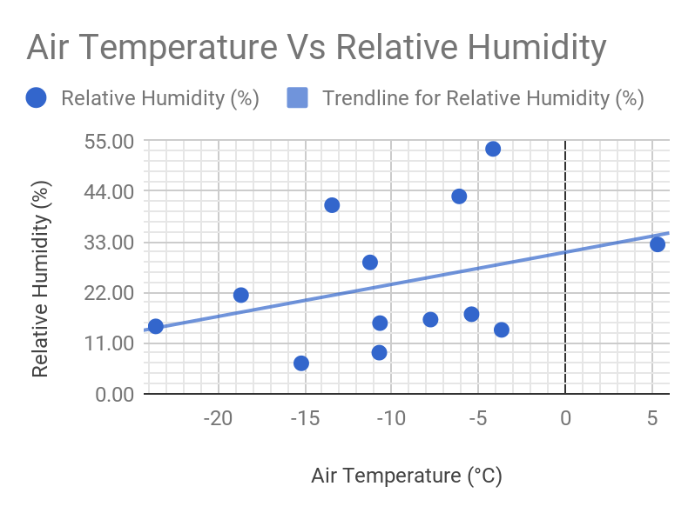
Figure 22: Expresses figure 11 data through scatter plot. Linear regression statistics were ran using TI-84 calculator.

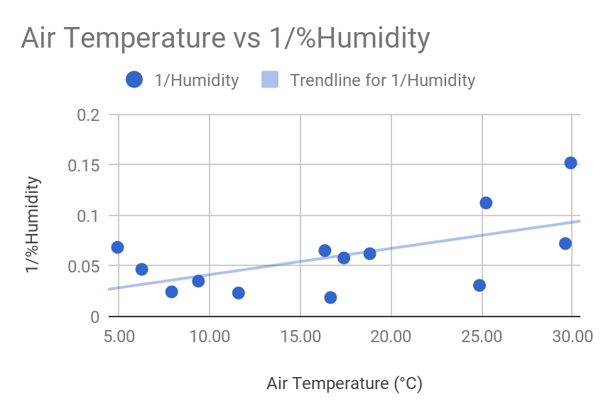
Figure 23: Re expresses data seen in figure 12 to increase the correlation value. Linear regression statistics were ran using TI-84 calculator.

Looking at the graph there is a visible relationship between the two in general. Overall, relative humidity has a degree of dependence on the temperature along with the pressure around it. The graph shows a shift in the relative humidity similar to the surface temperature, but there is a time lag in this shift. An attempt to apply a linear model to identify a correlation coefficient value proved inefficient to conclude there was a relationship. The data calculated a low r-value of .3564, which indicates a weak relationship in the linear fashion. With an attempt to re express the data, we reached only reached a r-value of .5858. With more advanced data analysis methods, we are sure a stronger relationship exists. We weren’t able to directly prove the relationship given our data, but we are able to suggest it even with data on such a localized level.
Conclusion:

With two consecutive years of data collection, comparisons and further investigations were made. Continuing collecting surface and near surface temperature along with snow depth, there were differences between this year’s data and that of last year. To expand on our research, we took relative humidity data to see if our local collection could be used to find the relationship known to exist with temperature and pressure. Although we took data on a smaller time frame than last year, enough days were allotted to allow analysis. Although the credibility of the PocketLab device came into question, we did not let that compromise our research endeavor. With two sets of data, we came accept part of our hypothesis that global warming can be identified in causing an early spring; however, we can’t completely say this was a warmer winter overall. The coldest months last winter were spread out at the beginning and end of winter, while this year the data puts the colder waves in the middle of the season. This interpretation was clearer than when attempting to understand the relationship relative humidity has with temperature. Knowing the relationship exists turned bias towards our methods, but analyzing the data through the graph allowed us to see a relationship existing. An attempt to identify the strength of said relationship failed through linear regression testing, and not enough knowledge is at our disposal to rely on other methods. Given more time and data this could easily be expanded on, but as of now we understand the changes through global warming and the complexities of environmental relationships.

Research Significance:
There is a breeding population of the Chimney Swift in Crestwood High School’s local area. By studying surface temperature, the feeding patterns of the chimney swift can be better understood. Since they are rare and feed on insects in the soil at a specific time in the summer, these birds are very difficult to study. By observing them and keeping track of surface temperature we might have a better understanding of their feeding patterns thus determine if climate change has an effect on them or not.
Deniers of climate change believe it is pointless to continue to make surface temperature measurements our primary metric of global warming. They claim that barbecues, air conditioner exhaust, trash incinerators, chimneys, pavement, metal automobiles and such are in the satellites’ way and prevent them from measuring the actual surface temperature, allowing NASA to make false conclusions. By taking our own measurements and sharing them with globe.gov, they are compared to the data determined by NASA to help validate their findings, enabling them to reach conclusions about surface temperature concerning climate change or any other topic.
We were trying new devices to log data and the PocketLab Voyager was one of them. The developers of the Voyager asked us for feedback on the device since we always use their equipment. Throughout our research we noticed that the Voyager’s Data was actually extremely unreliable especially since the device cannot be calibrated. PocketLab is sending us a new device which we will be studying in the future.

Verifications:
Dr. Kevin Czajkowski, from the University of Toledo, assisted in understanding the extent of our data and what is possible as far as extension of research. Via email, the factors affecting surface temperature were verified, and more potential factors arose, such the difference in temperatures as a result of land cover (asphalt, grass, concrete, etc.).

Measurement and Research Limitations:
Unless Crestwood High School was in accessible or weather would not allow, measurements were taken whenever possible. When wind speeds exceeded 21 mph or during precipitation, air temperature could not be obtained.
Beginning our data collection, the data we obtained using the PocketLab voyager and the kite could have been slightly inaccurate. Due to human error of not being able to fly the kite at the same elevation every single time the data could be skewed, causing variation in our data. We also had issues with the PocketLab data collection which may have resulted in false interpretation. On a day where the surface temperature was recorded to be -10.71°C the air temperature was said to be 25°C, which seems highly unlikely. It was easy to call out the inaccuracy of air temperature, but it is not so when it comes to other obtainable information such as relative humidity. We concluded that the PocketLab Voyager is not a reliable device, so its logged data was not sent to the GLOBE database. Moreover, the device we used was troublesome at times so we contacted PocketLab who told us they would send us a new one for us which we will compare to the one we have to better understand the problems with it.

Works Cited
Edmondson, J. L., I. Stott, Z. G. Davies, K. J. Gaston, and J. R. Leake. "Soil surface temperatures reveal moderation of the urban heat island effect by trees and shrubs." Nature News. Nature Publishing Group, 19 Sept. 2016. Web. 06 Feb. 2018.
Source: “Crestwood High School.” 42º19’16.07” N and 83º17’40.50” W. Google Earth. 1999. April 03, 2017.
"Surface Temperature Protocol." The Globe Program. N.p., n.d. Web. 15 Oct. 2017.

