Aquatic macroinvertebrates and their importance as water quality bioindicators in the Chimehuín River, Patagonia, Argentina.

Abstract:
In April 2015, the Calbuco volcano erupted depositing ashes in a wide region, being Junín de los Andes one of the most affected. Previously, in 2011, Puyehue volcano erupted with a bigger size and area of ash dispersion, but the winds favoured us and only came a few days in small quantities.
The Andes has numerous volcanoes that have generated great impacts on ecosystems and human activities: land and air transportation (at great distances), communications, infrastructure, agricultural activities, health, water sources.
In summer 2015 an investigation of benthic macroinvertebrates in the Chimehuín River had been carried out, which served as a basis to study the effect generated by the perturbation of the fallen ashes. In summers 2016 and 2017 a sampling of water quality and macroinvertebrate populations was carried out in seven sites of the river Chimehuín to compare its state with the 2015 and to observe anthropic impacts and of the volcanic ashes.
The results indicate verifiable alterations at five sampling sites that can be attributed to ashes but also coincide with areas that have historical anthropic impact (urban areas, campgrounds) and in areas where there were soil movements that increased disturbance. This impact was detected in macroinvertebrate populations most sensitive to changes in water quality.
It is necessary to continue the study in different years to corroborate the hypotheses and to know the recovery of macroinvertebrate populations.

Key words: volcanic ashes – Calbuco volcano – benthic macroinvertebrates – water quality – Patagonic rivers.

Aquatic macroinvertebrates and their importance as water quality bioindicators in the Chimehuín River, Patagonia, Argentina.

Pepe, Marianela; Martínez, Lucio and Wehinger, Juan
Huechulafquen Science Club
Junín de los Andes, Argentina

Teacher: Prieto, Ana Beatriz
February 2018

Table of Contents:
Abstract: 1
Aquatic macroinvertebrates and their importance as water quality bioindicators in the Chimehuín River, Patagonia, Argentina. 2
Research Questions and Hypothesis: 3
Materials and Method: 5
Data Summary: 6
Analysis and Results: 9
Analysis of macroinvertebrates by sampling site: 10
Conclusions: 10
Discussion: 11
Acknowledgements: 12
References/Bibliography: 12

Research Questions and Hypothesis:
Volcanic eruptions disperse ash at different spatial scales and wind causes re-suspension of the deposit. These impacts on ecosystems and human activities: land and air transportation (over long distances), communications, infrastructure, agricultural activities, health, water sources. (NASA Goddard, 2016; Craig et al., 2016; Wilson et al., 2013). It is necessary to remove the ashes to resume daily activities, but most of them are dispersed in rural areas that only the rains will introduce them into the soil.
On April 22 and 23, 2015, the Calbuco Volcano erupted, dispersing ashes in the city of Junín de los Andes and in the north of Patagonia. (Romero et al., 2016) Fig. 1.
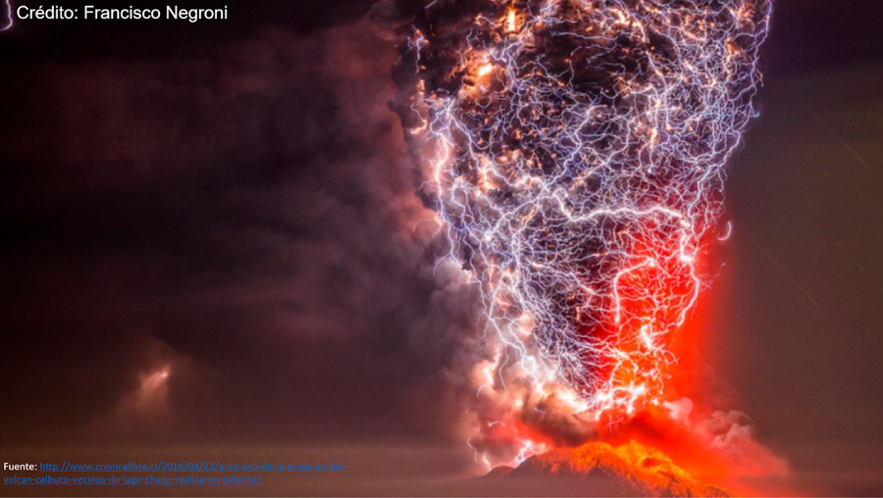
Fig. 1. Calbuco volcano eruption

In 2015 while investigating the populations of benthic macroinvertebrates of the river Chimehuín (Pepe and Grizack, 2016) the eruption of the volcano Calbuco took place, which forced to finish the work by the health risk of the ash exposure. The ash fall was abundant affecting the shores, sedimentation and turbidity of the Chimehuín River. Fig. 2
The Chimehuín river basin is one of the most important of the Lanín National Park, contributing 23% of the riverside environments of this park (Funes et al., 2006). The Chimehuín River is born in Lake Huechulafquen and travels 53 km. until its mouth in the river Collón Cura. It also receives the waters of Curruhé and Quilquihue rivers. It has a regime regulated by Lake Huechulafquen, in times of flood, is increasingly affecting the population due to urban growth on its shores (Bruno Cubero, 2001). New lots have been carried out, and the Chimehuín River springs and shores are being urbanized, which can lead to changes in riverbanks and water quality. The river supplies water to the city and rural areas.

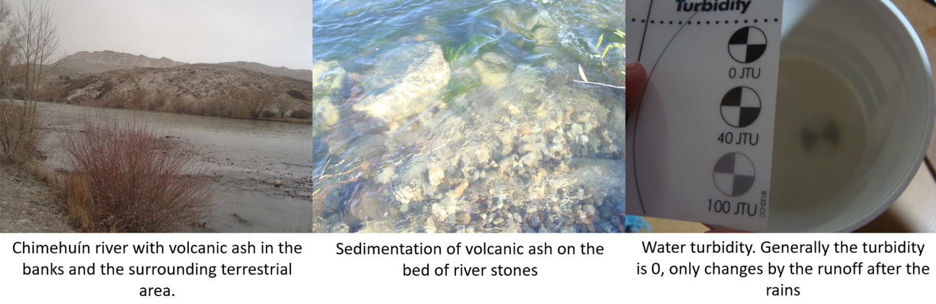
Fig. 2 Chimehuín river after the eruption

The flow increases by rains in winter and by snow break in spring. The lowest flow happens in summer and early fall, when anglers, bathers, campers and others most commonly use it. The quality of the water and of the banks is good, but in the urban zones with more alteration of banks (Aigo et al., 2015) changes in macroinvertebrate populations are detected.

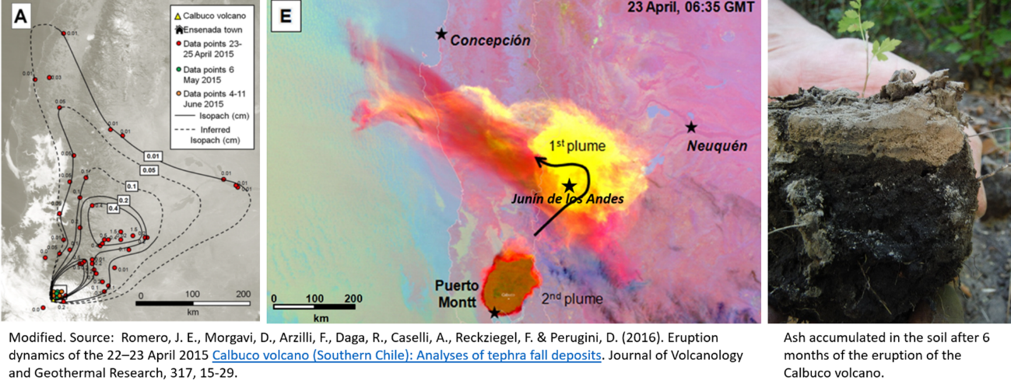
Fig. 3. Dispersion and accumulation of ash from the Calbuco volcano.

The Calbuco volcano has a long history of eruptions in 1792, 1845, 1893, 1894-95, 1906-07, 1917, 1927, 1929, 1932, 1945, 1961 and 1972. In April of 2015 erupted again dispersing great amount of ashes in the north of Patagonia (Romero et al., 2016), the city of Junín de los Andes was the most affected. The predominant wind is from the West, but on the day of the eruption, there was a change in direction. (Reckziegel et al., 2016)
In 2011, the Puyehue volcano eruption was of greater magnitude and ash dispersion, but the city of Junín de los Andes was little affected due to the predominance of the West winds. On this occasion, it affected the cities of Bariloche, Villa La Angostura, Jacobacci and several others. (Craig et al., 2016, Wilson et al., 2013, Mulena et al., 2012) Other important eruptions in the Patagonian region in recent times were Chaitén volcano in 2008 and Hudson volcano in 1991.
Numerous impacts have been documented in terrestrial and aquatic ecosystems, with varying degrees of involvement associated with the thickness of the ash, precipitation and humidity of the place. These variables also influence the recovery of ecosystems. Documented impacts in the region are:
- Diseases in domestic and wild herbivores (Flueck, 2016),
- Losses in agricultural production (Craig, et al., 2016)
- Changes in populations of:
  - Phytoplankton (Modenutti, et al., 2013) and zooplankton in rivers and lakes (Balseiro et al., 2014)
  - Trichoptera (Brand and Miserendino, 2014) and other macroinvertebrates (Lallement et al., 2014; Miserendino et al., 2012) in rivers of the Andes
  - Native terrestrial arthropods (Elizalde, 2014) y exotics (Masciocchi et al., 2012).
Recovery of ecosystems has also been documented after the disturbance in the cases cited, in some cases, it was not possible because there were no studies before the eruption. The thickness of ash deposited in the Chimehuín River was smaller than in the mentioned mountain rivers. During the summers of 2015 and 2016 we studied the populations of benthic macroinvertebrates (Pepe and Grizack, 2015; Pepe, 2016) Therefore it is possible to compare the effect of the fall of volcanic ash after 8 months and later to almost 2 years of eruption (in summer 2017).
Considering the above, the following research questions are posed:
- How does the ash fall affect water quality and macroinvertebrate populations?
- How will the anthropogenic impact of land use (with ash) affect the river, water quality, and macroinvertebrate populations?
- Are there any long-term impacts of ash fall?
Our hypotheses are:
H₁: The fall of volcanic ash affects the diversity of macrobenthic populations.
H₂: The anthropic impact around the river contributes sediments to the water causing a greater impact on macroinvertebrate populations
H₃: In the long term, populations of macroinvertebrates recover from the impact caused by the fall of volcanic ash.

Materials and Method:
Measurements were made in public places along the Chimehuín River coast (Fig. 4) following the GLOBE program Hydrosphere Protocols.
For the physical-chemical analyses of water, the LaMotte brand kits were used to determine: a) pH, turbidity and temperature (kit used in World Water Monitoring Challenge); b) Alkalinity Test Kit Code: 4491-DR-01; c) Dissolved Oxygen Test Kit. Code: 5860-01 and d) Nitrates Test Kit. Code: 3615-01.
For the identification of the macroinvertebrates, a dichotomous key was used and for its analysis, the protocol of macroinvertebrates of fresh water of the Program GLOBE was followed.
At each sampling site, the physical-chemical analysis of the water was carried out, the benthic macroinvertebrates were quantified and identified and the land use was recorded around the river. The safety measures recommended by the GLOBE Protocols and kits guides were followed.
Several samples were taken at each site to ensure their validity. Physical-chemical and biological (benthic macroinvertebrates) analyses of sites sampled prior to the eruption of the Calbuco volcano (summer 2015) and after the eruption (summers 2016 and 2017) were compared. Sampling was performed between 2 and 6 pm.

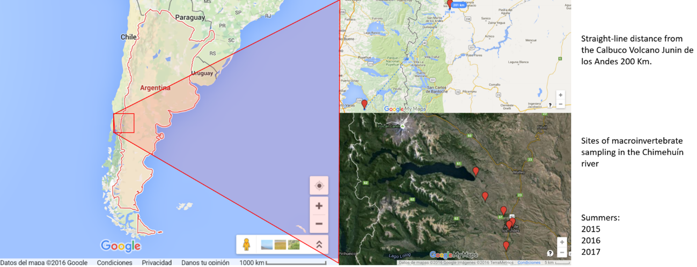
Fig. 4. Location of the Calbuco Volcano and sampling sites in the Chimehuín River.

The percentage of EPT richness (measured as the number of Ephemeroptera, Plecoptera and Trichoptera) was calculated on the total of species that are in the sites. The percentage of dominant taxon was also calculated on the total of the macroinvertebrates found in each site.

Data Summary:
Table 1. Results of physico-chemical analysis and benthic macroinvertebrates (Continue on the next page)
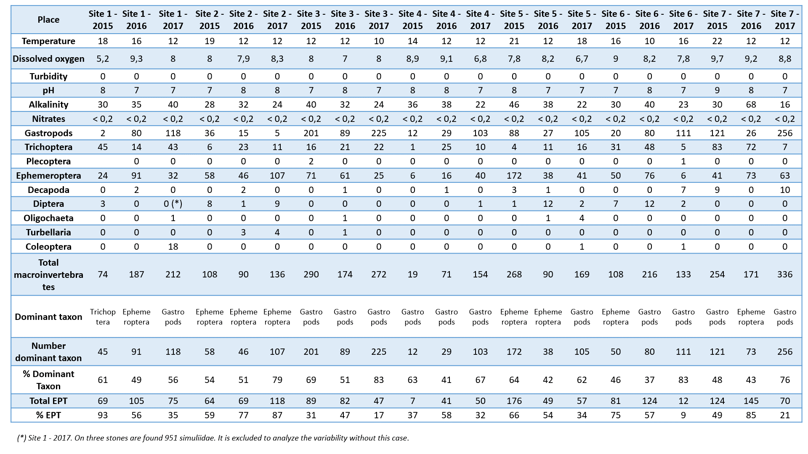
Table 1. Results of physico-chemical analysis and benthic macroinvertebrates (continuation)

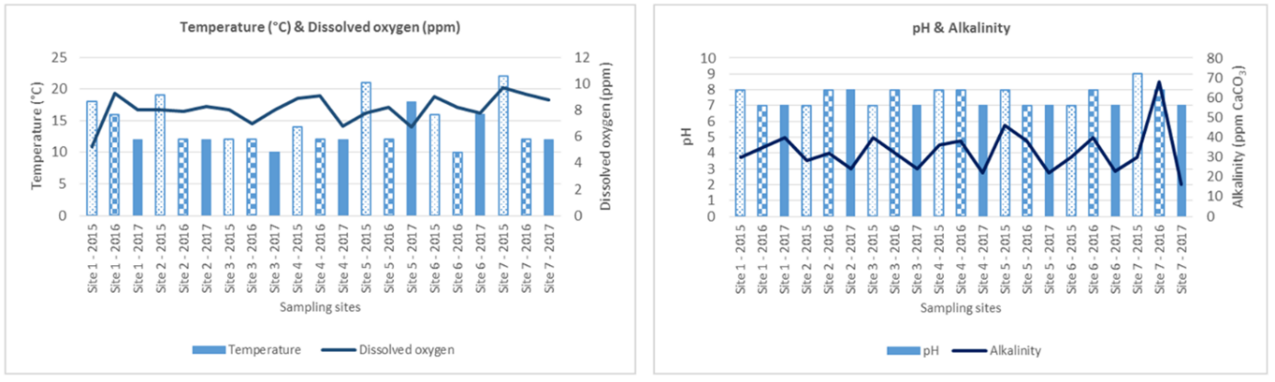
Fig. 5. Physical-chemical analysis results.

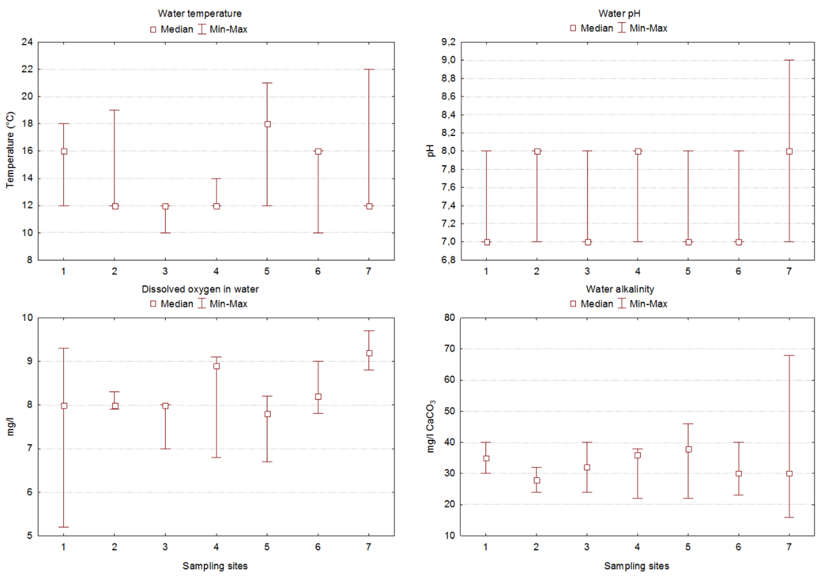
Fig. 6. Results of physical-chemical analysis, averages, maximum and minimum by site.

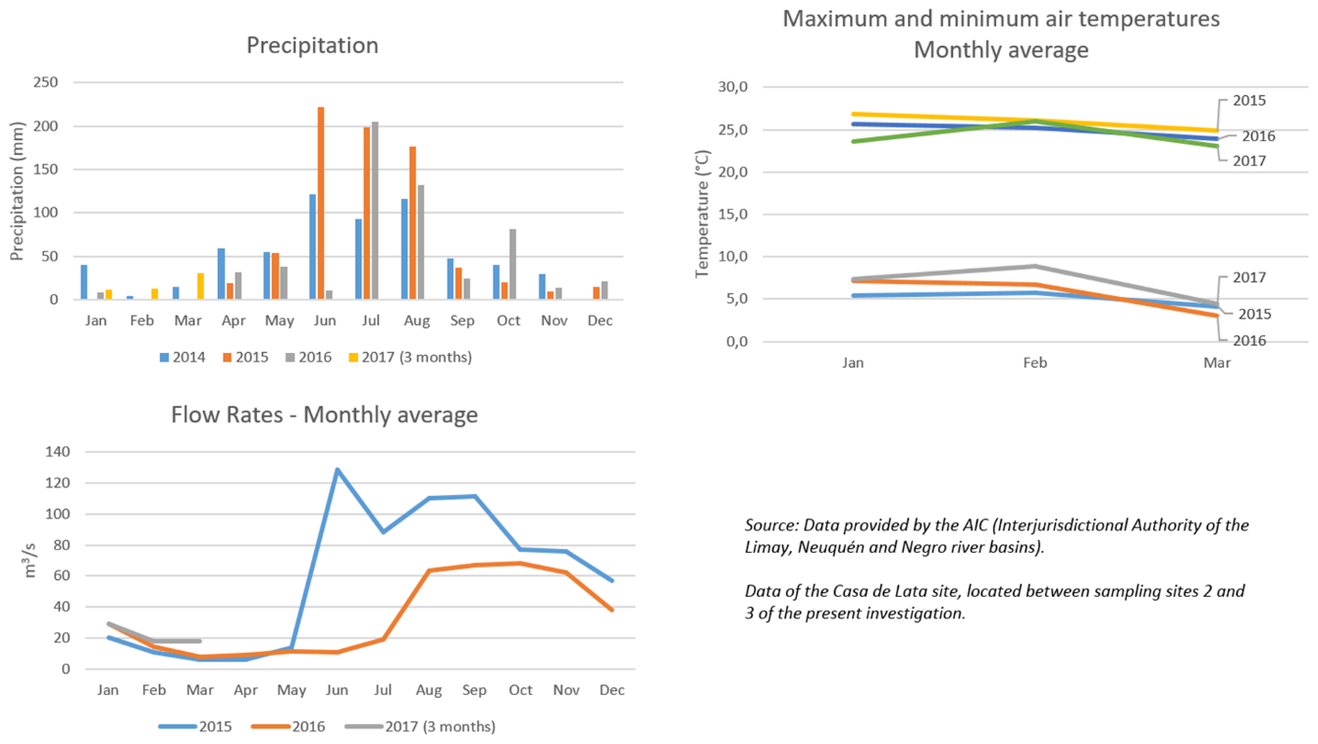
Fig. 7. Precipitations, Chimehuín river flows and air temperatures in the 2015, 2016 and 2017 surveys.

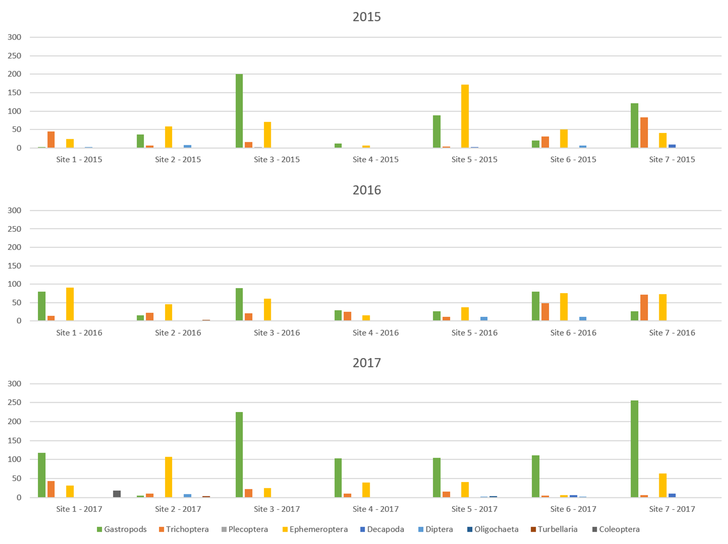
Fig. 8. Results of macroinvertebrate number and diversity by sampling site.

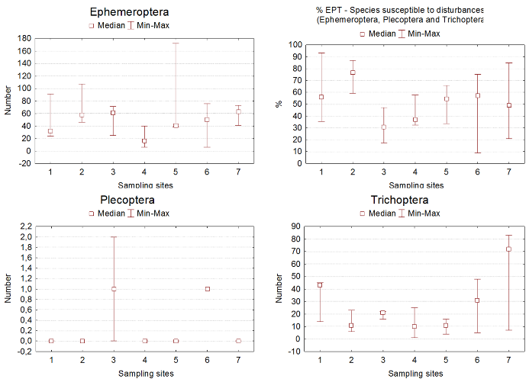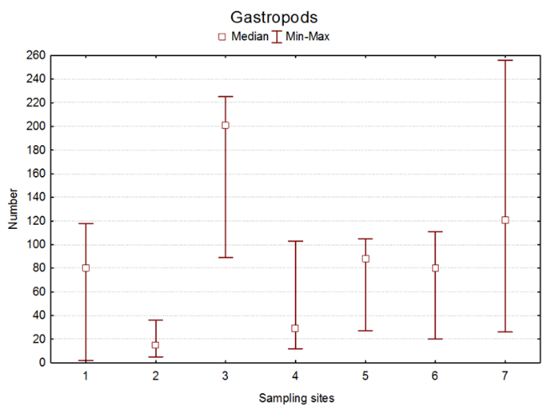
Fig. 9. Sensitive species (left) and disturbance tolerant (right).

Analysis and Results:
The comparative analysis of water quality and macroinvertebrate measurements performed before and after the eruption of the Calbuco volcano (Table 1).
In the years considered, the values of the physical-chemical analyses are similar, only temperature variations are recorded (highest in 2015). Alkalinity and pH (which highlights site 7, with the highest values. Nitrate values were <0.2 mg / l which is the detection limit of the method used. The turbidity was zero in all cases. (Fig. 5 y 6).
During the sampling periods (summer 2015, 2016 and 2017), the river flow declined, being the lowest in 2015. In the spring of 2016 and summer, 2017 there were higher precipitations than in previous years and this has influenced the increase of the flow during 2017. The maximum and minimum temperatures oscillated in similar values. (Fig. 7)
Populations of species sensitive to disturbances such as ephemeroptera, plecoptera and trichoptera (EPT) have had greater variability at sites 1, 6 and 7 replacing as dominant species the gastropods that are tolerant. (Fig. 9)

Analysis of macroinvertebrates by sampling site:
Site 1: The total of macroinvertebrates was increased in each year evaluated, changed the composition of and dominant taxon (from trichoptera to ephemeroptera and finally to gastropods). The EPT percentage decreased. It is a site exposed to winds and has sedimentation. It is used for tourism and sport fishing.
Site 2: The total of macroinvertebrates remained relatively stable, the dominant species (ephemeroptera) was maintained and the percentage of EPT was slightly higher. It is a site visited by anglers. It is an area with very good bank, wooded and repaired of the winds.
Site 3: The total number of macroinvertebrates declined in 2016 and then recovered in 2017 but the dominant species (gastropods) went up and the percentage of EFA remains low. It is a camping site, very visited in summer. It has a nearby gravel road where soil movements were made during 2016 for the construction of a road. This has caused an abundant sedimentation in the river.
Site 4: In 2015, the new coastal was built and ground movements were carried out very close to the river. In 2016 and 2017 an increase in total macroinvertebrates is observed, the dominant species (gastropods) is maintained, EPT % is still low. It is the most visited place of the river during the summer.
Site 5: In 2016, the total number of macroinvertebrates decreases. In this site, the riverbank is almost non-existent, it has a very close road, and there have been constructions with soil movement. There are vacant lots that no one removed the volcanic ash when cleaning in the city of Junín de los Andes. It is probable that by the runoff much of the river has reached it. It is an area visited by bathers. In 2017, the number of macroinvetebrates increases, but the dominant species changes to gastropods, which is more disturbance tolerant, and the percentage of EPT continues to decline.
Site 6: An increase in the total of macroinvertebrates is detected but the dominant species (from ephemeroptera to gastropods) changes, also the percentage of EPT decreases. It is an area visited by bathers. It is exposed to the winds and part of a small cliff detached, widening the river. Sedimentation increased.
Site 7: The total of macroinvertebrates decreases, the dominant species changes (gastropods to ephemeroptera and then to gastropods). The percentage of EPT increased in 2016 but dropped again in 2017. Anglers and bathers visit this area. It is located waters below the sewage drainage to 6.5 km. (from the riverbed). As Junín de los Andes is a tourist town. In some summers, the population is triplicated and this affects the flow of sewers that reaches the river (the disturbance varies according to the number of tourists).

Conclusions:
The data indicate that the volcanic eruption has had a negative impact on macroinvertebrate populations, coinciding with hypothesis 1 (H₁). The greatest impacts occurred in sites with soil movements (construction of the waterfront in 2015 and movement of soils in the provincial route 61), in urban sites or in places visited by tourists. This would indicate that the impact is not entirely attributable to volcanic ash, but also the anthropic impact and the effect of runoff after rain and the winds that redistribute the ash again. Falling ash and land use around the river contributed to greater sedimentation leading to changes in macroinvertebrates populations, coinciding with hypothesis 2 (H₂).
In the long term, populations of macroinvertebrates change but we still cannot verify if they are recovering (Hypothesis 3 - H₃). It is necessary to continue measurements in the following years to assess the resilience of impacted areas.
This work was limited to sampling sites in public areas. For this reason, it could not be verified in other sites with less anthropic impact to attribute the effects to the volcanic eruption.

Discussion:
The sampling of the year 2016 began to take place after 8 months of the eruption of the Calbuco volcano and the one of 2017 after almost 2 years. After the eruption removed much of the ash in urban areas, but there is still a lot of it in the mountains, even today. The greatest rainfall takes place during the winter that drags ashes into the river. In spring, strong winds (with 60 km/h bursts) drag the ashes and generate new deposits.
The physic-chemical parameters of water quality remained relatively stable between the samples of the summers of 2015, 2016 and 2017, which concludes that the ash fall of the Calbuco volcano did not affect the water quality of the Chimehuín River. It should be considered that at the time of the eruption the water changed color increasing its turbidity, but after a period has recovered to normal values. No measurements were made during the eruption period due to the health hazard of ash exposure.
The populations of macroinvertebrates showed changes, the main differences between the samplings were registered in the following sites (they are ordered from greater to smaller impact):
- Site 3 - It maintains the number of macroinvertebrates, continues the gastropods (tolerant to perturbations) like dominant taxon and they increase in number. EPT % remains low. The sedimentation observed would be the cause of these changes.
- Site 4 - Total macroinvertebrates increased, this indicates an improvement after the riot construction on the coast in 2015. However, the EPT % is low. The density of macroinvertebrates is low, the gastropods are the dominant taxon and the last year the number of ephemeroptera (sensitive species) increased.
- Site 1 - It changed the composition of macroinvertebrates of species sensitive to perturbations to tolerant species like the gastropods. Decreased EPT. The decrease of trichoptera by problems of sedimentation was found in Mountain Rivers with the eruption of Chaitén volcano (Miserendino et al., 2012).
- Site 5 - The number of macroinvertebrates decreased and the EPT %, continues ephemeroptera as the dominant taxon. This site is very exposed to the contribution of sediments because it has a very small riverbank and a nearby road. In addition, constructions with soil movement were carried out in surrounding areas.
- Site 6 - It increased the number of macroinvertebrates but changed the dominant taxon from ephemeroptera to gastropods (tolerant species). The EPT % also decreased. Both changes indicate a deterioration of the quality of the environment. It is a much-visited area in summer.

Acknowledgements:
We want to thank our parents for supporting us with facilities, transfers to sampling sites and equipment to run our Science Club and conduct research. Also to the National University of Comahue, especially to the masters of the Master in Science Teaching for guiding us in this research. We also thank Dr. Jack Imhof, Director of Conservation Ecology in Trout Unlimited Canada for guiding us from a distance, videoconferencing with us and providing information for research.

References/Bibliography:
AIC (2015, 2016 y 2017). Informes hidrometeorológicos. Enero, Febrero, Marzo. [Hydrometeorological reports. January February March.] AIC. Cipolletti, Río Negro.
Aigo, E., Arce, M., Porma, J., Porma, J. L. and Prieto, A. (2015). Riberas y calidad del agua en el río Chimehuín. Primer premio. Premio Argentino Junior del Agua 2015. [Riberas and water quality in the Chimehuín River. First prize. Argentine Junior Water Prize 2015]. Ingeniería Sanitaria y Ambiental - Aidis Argentina., 126, pp.10-20.
Annen, C., & Wagner, J. J. (2003). The impact of volcanic eruptions during the 1990s. Natural Hazards Review, 4(4), 169-175.
Balseiro, E., Souza, M., Serra Olabuenaga, I., Wolinski, L., Bastidas Navarro, M., Laspoumaderes, C. and Modenutti, B. (2017). Effect of the Puyehue-Cordon Caulle volcanic complex eruption on crustacean zooplankton of Andean lakes. [online] Available at: https://goo.gl/FYWM5e [Accessed 15 Feb. 2018].
Brand, C. and Miserendino, M. (2014). Biological traits and community patterns of Trichoptera at two Patagonian headwater streams affected by volcanic ash deposition. Zoological Studies, 53(1).
Bruno Cubero, C. (2001). Cuenca del rio Chimehuín estudio de las inundaciones en la localidad de Junín de los Andes. [River basin Chimehuín study of floods in the town of Junín de los Andes]. Cipolletti, Río Negro: AIC, p.103.
Buteler, M., Stadler, T., López García, G. P., Lassa, M. S., Trombotto Liaudat, D., D'Adamo, P., & Fernandez-Arhe, V. (2011). Propiedades insecticidas de la ceniza del complejo volcánico Puyehue-Cordón Caulle y su posible impacto ambiental. [Insecticidal properties of the ash of the Puyehue-Cordón Caulle volcanic complex and its possible environmental impact]. Revista de la Sociedad Entomológica Argentina, 70(3-4), 149-156.
Craig, H., Wilson, T., Stewart, C., Outes, V., Villarosa, G. and Baxter, P. (2016). Impacts to agriculture and critical infrastructure in Argentina after ashfall from the 2011 eruption of the Cordón Caulle volcanic complex: an assessment of published damage and function thresholds. Journal of Applied Volcanology, 5(1).
Craig, H., Wilson, T., Stewart, C., Villarosa, G., Outes, V., Cronin, S. and Jenkins, S. (2016). Agricultural impact assessment and management after three widespread tephra falls in Patagonia, South America. Nat Hazards, 82(2), pp.1167-1229.
Elissondo, M., Baumann, V., Bonadonna, C., Pistolesi, M., Cioni, R., Bertagnini, A., & Gonzalez, R. (2016). Chronology and impact of the 2011 Cordón Caulle eruption, Chile. Natural Hazards and Earth System Sciences, 16(3), 675-704.
Elizalde, L. (2017). Volcanism and arthropods: a review. [online] Available at: https://goo.gl/BWeyMi [Accessed 15 Feb. 2018].
Flueck, W. (2016). The impact of recent volcanic ash depositions on herbivores in Patagonia: a review. Rangel. J. 38(1), pp. 27-34.
Funes, M., Sanguinetti, J., Lacau, P., Maresca, L., García, L., Mazzieri, F., Chazarreta, L., Bocos, D., Lavalle, F., Espósito, P., González, A. and Gallardo, A. (2006). Diagnóstico del estado de conservación de la biodiversidad en el Parque Nacional Lanín: su viabilidad de protección en el largo plazo. Informe final. [Diagnosis of the state of conservation of the biodiversity in the Lanín National Park: its viability of protection in the long term. Final report]. San Martín de los Andes, Neuquén: Parque Nacional Lanín, p.288.
Garcia, R. D., Reissig, M., Queimaliños, C. P., Garcia, P. E., & Dieguez, M. C. (2015). Climate-driven terrestrial inputs in ultraoligotrophic mountain streams of Andean Patagonia revealed through chromophoric and fluorescent dissolved organic matter. Science of the Total Environment, 521, 280-292.
Lallement, M., Juárez, S., Macchi, P. and Vigliano, P. (2017). Puyehue Cordón -Caulle: post-eruption analysis of changes in stream benthic fauna of Patagonia. [online] Available at: https://goo.gl/AUVfXW [Accessed 15 Feb. 2018].
Lallement, M., Macchi, P. J., Vigliano, P., Juarez, S., Rechencq, M., Baker, M., & Crowl, T. (2016). Rising from the ashes: Changes in salmonid fish assemblages after 30months of the Puyehue–Cordon Caulle volcanic eruption. Science of the Total Environment, 541, 1041-1051.
Masciocchi, M., Pereira, A., Lantschner, M. and Corley, J. (2012). Of volcanoes and insects: the impact of the Puyehue–Cordon Caulle ash fall on populations of invasive social wasps, Vespula spp. Ecol Res, 28(2), pp.199-205.
Melekhova, E., Annen, C., & Blundy, J. (2012, April). Origin of modality of volcanism. In EGU General Assembly Conference Abstracts (Vol. 14, p. 2333).
Miserendino, M., Archangelsky, M., Brand, C. and Epele, L. (2012). Environmental changes and macroinvertebrate responses in Patagonian streams (Argentina) to ashfall from the Chaitén Volcano (May 2008). Science of The Total Environment, 424, pp.202-212.
Modenutti, B. E., Balseiro, E. G., Elser, J. J., Navarro, M. B., Cuassolo, F., Laspoumaderes, C., & Villanueva, V. D. (2013). Effect of volcanic eruption on nutrients, light, and phytoplankton in oligotrophic lakes. Limnology and Oceanography, 58(4), pp.1165-1175.
Mulena, C., Allende, D., Puliafito, E. and Lakkis, G. (2012). Estudio de la dispersión de cenizas volcánicas del Puyehue: simulaciones y validación. [Study of Puyehue volcanic ash dispersion: simulations and validation]. Avances en Energías Renovables y Medio Ambiente, 16, pp.7-14.
NASA Goddard, (2016). NASA Tracks Volcanic Ash with Satellites. [Video] Available at: https://youtu.be/zAXvSoo3F8A [Accessed 15 Feb. 2018].
Pepe, M. and Grizack, M. (2015). Benthic macroinvertebrates as bioindicators of water quality - Google Science Fair 2015. [online] Available at: https://goo.gl/PN3v1k [Accessed 15 Feb. 2018].
Pepe, M. (2016). Impacto de la caída de ceniza volcánica en las poblaciones de macroinvertebrados del río Chimehuín. [Impact of volcanic ash fall on the macroinvertebrate populations of the Chimehuín River]. Feria de Ciencias de Google 2016. [online] Available at: https://goo.gl/gAjbjY [Accessed 15 Feb. 2018].
Reckziegel, F., Bustos, E., Mingari, L., Báez, W., Villarosa, G., Folch, A., Collini, E., Viramonte, J., Romero, J. and Osores, S. (2016). Forecasting volcanic ash dispersal and coeval resuspension during the April–May 2015 Calbuco eruption. Journal of Volcanology and Geothermal Research, 321, pp.44-57.
Romero, J., Morgavi, D., Arzilli, F., Daga, R., Caselli, A., Reckziegel, F., Viramonte, J., Díaz-Alvarado, J., Polacci, M., Burton, M. and Perugini, D. (2016). Eruption dynamics of the 22–23 April 2015 Calbuco Volcano (Southern Chile): Analyses of tephra fall deposits. Journal of Volcanology and Geothermal Research, 317, pp.15-29.
Ruggiero, A., & Kitzberger, T. (2014). Special section: Ecological responses of arthropods to volcanism. Ecología austral, 24(1), 1-2.
The GLOBE Program. (2005) Hydrosphere Protocols. En: GLOBE Teacher's Guide. Washington, WA. [online] Available at: www.globe.gov [Accessed 15 Feb. 2018].
Wilson, T., Stewart, C., Bickerton, H., Baxter, P., Outes, V., Villarosa, G., & Rovere, E. (2013). Impacts of the June 2011 Puyehue-Cordón Caulle volcanic complex eruption on urban infrastructure, agriculture and public health. GNS Science Report 2012/20. 88 p.

Huechulafquen Science Club: https://www.facebook.com/Club-de-Ciencias-Huechulafquen-1492382304110520

