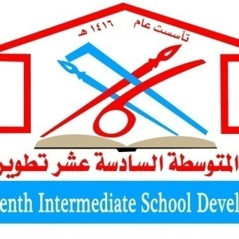
Saudi Arabia
Ministry of education
General Administration of Education in Tabuk
Sixteenth intermediate development
المتوسطة السادسة عشر تطوير

Scientific research on
The effect of well water and soil and its relationship to agriculture in Tabuk

The research is submitted by third graders average
. Raghad Sultan Saud Al-Enezi
. Aryam Rouibeh Al-Rashidi

The second grader is average
. Abdul Hadi Al-Enezi wajd

Supervision of the teacher Globe / Fatima Dhayan Al-Juhani
School leader / Fadila Al-Nazzawi

Research Summary
When intensive modern agriculture began, there were about 500 cubic kilometers of water under the Saudi desert. However, in recent years, it is estimated that about 21 cubic kilometers are pumped to the surface annually for use on farms. These quantities are not compensated for by the rains, because they are extremely rare. According to a study conducted in 2004, Saudis were on their way to using at least 96 cubic miles (400 km3) of groundwater by 2008. Experts estimate that four fifths of Saudi groundwater has been consumed. There are no rivers, lakes, or large areas Of natural plants because the precipitation is minimal. Nevertheless, it is through oases and then desalination plants, and the water that performs this function is pumped from below the surface of the earth, from the layers of groundwater filled for thousands of years, when the climate in Saudi Arabia was more humid. According to National Geographic, "This groundwater in this unlikely place has given the nation hope to achieve its long-awaited goal of feeding itself rather than importing food from other countries." However, this solution has a limited lifespan. Because the water supply is decreasing at a rapid rate and hence the problem of research comes in the importance of agriculture and soil exploitation and its relationship with well water
The research contains the importance of the research
From the scientific point of view, the importance of this research is evident in the fact that it contributes to enriching scientific knowledge in the field of agriculture and soil and its relationship with well water, through its findings; it also highlights Tabuk agriculture by assessing the reality of this experiment. In addition to his scientific contribution as a reference that benefits students and researchers in the field of agriculture and soil. Either in practical or applied terms.

The search contains the objectives of the research
. 1- Learn about agriculture and its development with soil through well water
. 2- Learn about the importance of agriculture and soil
. 3- Learn about the changes that have occurred in agriculture and soil
. 4- Knowing the technological progress in the field of agriculture and its relationship to soil
. 5- Learn about the future of agriculture and soil in Tabuk and its relationship to well water
. 6- Learn about agricultural development in the Tabuk region, "sustainable agriculture".
Theoretical framework
❖ Evolution of agriculture and soil
The importance of agriculture and soil
❖ Agriculture and soil changes
❖ Technological progress in the field of agriculture and its relationship to soil
❖ The future of agriculture and soil in the Tabuk region and its relationship to well water
❖ Agricultural development in the Tabuk region "sustainable agriculture"

