Study titled
"The Impact of soil rot on the agricultural environment in Khassab”

Done by:
Shahad Ali Al Shihhi
Al Anood Abdullah Al Kumzari

Supervised by :
Miss Shamsa Ali Al Sa`adi
Khawla Bint Al Azwar basic Education School (1-9)
The academic year 2018_2019

Contents
Subject | Page
Summary | 3
Basic terminology | 4
Search Questions | 5
introduction | 5
Search methods (search steps) | 6
Study site | 7
Data collection and analysis | 8
Results | 8
Discussion of results | 10
Conclusion | 10
Thanks and appreciation | 11
References | 12

Study titled
"The Impact of soil rot on the agricultural environment in Khassab”
Done by:
Shahad Ali Al Shihhi
Al Anood Abdullah Al Kumzari
Supervised by :
Miss Shamsa Ali Al Sa`adi
Khawla Bint Al Azwar basic Education School (1-9)
The academic year 2018_2019

Summary of the research
The study aims on studying the effect of soil rot on the agricultural environment in Khasab. We noticed the decline in the percentage of green areas in the region. This is weird to us in Khasab since it is an agricultural region and has fertile soil.
Research questions: What is the effect of soil rot on plant growth? What is the impact of climate elements on soil rot? What damage can mold cause in the soil? This is done through the application of the soil protocol on a farm of the study sample containing molded soil, clean soil, laboratory soil samples, laboratory soil and home soil to compare their types and test their suitability to agriculture through the experiment of cultivationو من In the application of the soil protocol it was observed that the rotten, prepared and naturally rotted soils differ from the natural (arable) in their acidity, color and existence of life, which are influenced by natural factors (humidity, heat, lack of sunlight) Lack of awareness and neglect and the use of traditional irrigation methods such as irrigation by drowning, lack of interest in soil cleaning (weeding) and unregulated use of chemical fertilizers all lead to the formation of the surface mold layer that can be disposed of in order to not reach a larger layer and destroy soil properties Exterminate life in A) where the fear lies in their access to the roots of plants. The importance of this research lies in the detection of the impact of soil rot on the agricultural environment in Khasab and to raise awareness of the community to use modern technology and the appropriate methods as well as get exposed to what is suitable for the perfect agriculture land.

Basic terminology:
Mold: It is a group of several varieties of multicell fungi, able to cover some surfaces in spongy forms and usually multiply through the cloning of germs.
Soil: A fragile or fragmented surface layer that covers the Earth's surface and is considered a direct or indirect source of food.
Fertile soil: It is defined as the ability of the soil and its susceptibility to supply plants and crops cultivated in it all the necessary elements and nutrients needed to meet its need for growth, reproduction and the ability to tender, such as nitrogen, potassium, phosphorus, and some other elements needed such as Calcium and copper, which are needed by crops but in a few quantities, in addition to containing some important organic materials for the structure, strength, cohesion and preservation of moisture and nutrients within the soil, which can be obtained with some help from agricultural fertilizers if they are not present in the soil, Fertile arable soils are characterized by a moderate ph of 6 to 7 ph and chemicals can be added to achieve optimum ph of plants.

Research questions:

1. What is the effect of soil rot on plant growth?
2. What is the impact of climate elements on soil rot?
3. What damage can mold cause in the soil?

The Introduction:
Khasab is considered an agricultural area where most of the people of the state have farms and depend on them to cultivate their basic needs. However, the percentage of plant cover has decreased recently due to many reasons.
Soil mold considered one of the main problems which can cause waste of other plants life. It is formulated by creating a layer on the soil that can be formed through different factors like, humidity, heat and lose of sun light. This soil covers the earth as the main surface layer which contains rocks quarries that has living species around, so that helps to hold the plants’ roots, which contain non-organic materials like minerals and that’s known as (inanimate) and organic materials as (living creatures) So, these species can die or live depending on the life that the atmosphere provide. These species contain living plants’ roots and micro- species as bacteria.
The surface of the soil consists of water and gas which lay in the pores of the soil. However, it is really complicated to figure out the soil in depth perhaps because of the main rock formulation of the sediment free of living roots and other biological life. Soil is an active dynamic layer due to the mechanical and chemical reactions of multiple forms, because the climate and vegetation change rapidly from place to place. Mold is a group of multicellular fungi that can cover some surfaces in spongy forms and usually multiply by reproducing germs, forming an insulating layer that prevents sunlight from reaching the soil and causing root rot. Therefore, this topic was selected to study the effect of soil rot on the agricultural environment in Khasab by comparing the samples and conducting the tests by microscopic observation and implementation of the soil protocol on the samples.

Research procedure:
First: Research plan
- Sense of the problem: Note that some refrigerators have completed a long period of time that they got lack inspections and continuous cleaning to ensure the quality of water according to the standards of global health.

- Selection of the research problem: identified by the researcher and discussed with the teacher.
Identification of the study tools: application of the soil protocol, laboratory testing of soil and microscopic observation.

- Visit the farms of the study community and take soil samples. Application of a soil protocol Take measurements (acidity, carbonate ratio and soil color) and observe the samples under the microscope with laboratory technical assistance in the school to see if the mold affects the microorganisms within the soil and then input the data into the program site.
• Experimentation of agriculture in different soil samples under similar conditions.
• Compare results and write recommendations.

The search time schedule is as follows:
Period | Working plan
January/ 2019 | Identify the problem and gather information and read about its causes
February/ 2019 | Collection of samples and application of the soil protocol
February/ 2019 | Note samples through microscope
February/ 2019 | Cultivation of soil samples / continuous observation
March / 2019 | Data entry in the site GlOBE.gov
March / 2019 | Reach conclusions and write research
March / 2019 | Raising awareness of the society and transmitting recommendations
March / 2019 | Submit the research

Second: Location of the study: (Sultanate of Oman, Musandam Governorate), Khasab State, February and March, moderate weather and continuous rain, soil protocol applied.
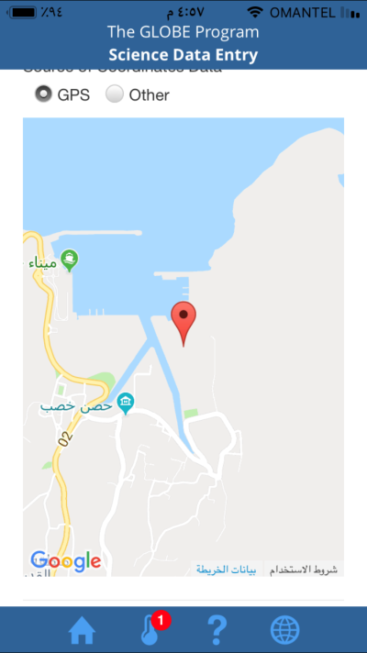
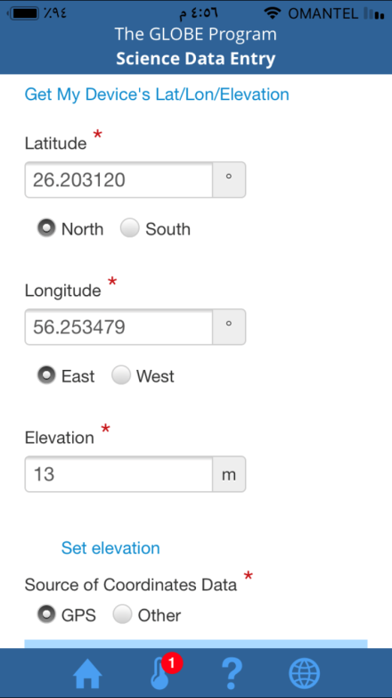

Data collection and analysis results
Data which collected to answer the first question.
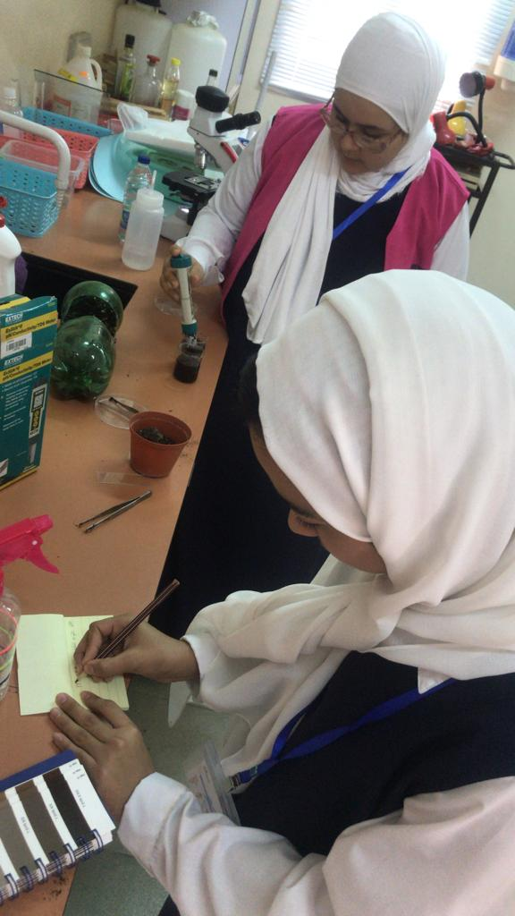
By collecting different soil samples (mold soil, arable soil) from one of the farms of the study community and conducting the soil protocol on them and observed under the microscope.
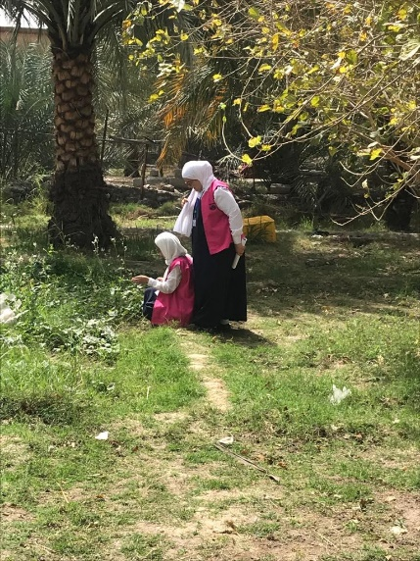
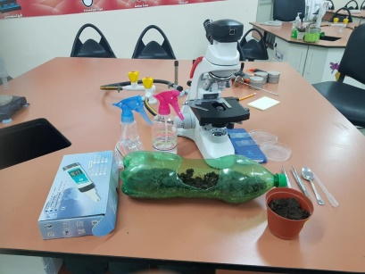

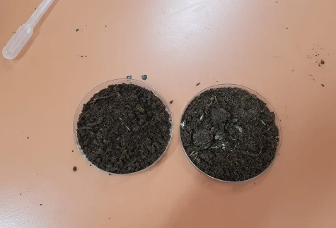

In order to answer the second question in the research, mold conditions were provided to determine the effect of moisture and hygiene on the soil healthy soil sample in the school laboratory.
In response to the third question, four soil samples were planted. (a naturally rotted soil sample of the farm, a sample of arable soil, a sample of laboratory soil, a sample of soil from the garden)

The Result:
As a result of this research, we come up to, the study area suffers from the problem of mold surface soil where we notice differences in pH and color of soil and the existence of life, which is influenced by natural factors (humidity, heat, lack of access to sunlight. In addition to the human factors where the lack of awareness and neglect and the use of traditional irrigation methods such as irrigation by drowning and lack of interest in cleaning the soil (weeding) and the unregulated use of chemical fertilizers all lead to the formation of the layer of surface mold that can be removed by removing them to reach A larger layer destroys the properties of the soil and destroys life. Agricultural soil can also be
Natural soil  (From the farm) | Natural soil (domestic) | Rotting soil (naturally) | Soil that has been moldy | Soil type  Study Tools
6.8  Acidic | 6.5  Acidic | 5.4  More Acidic | 5.2  More Acidic | PH scale
p.g29  10YR 4/2 | p.g30  10YR 3/3 | p.g22  7.5YR 7/1 | p.g23  7.5YR 7/2 | Soil color notebook
Natural brown  (There is life) | Natural brown  (There is life) | Green Gray  (No life) | Green Gray  (No life) | The Color under the microscope
Exist | Exist | Exist | Exist | Existence CO2
Yes | Yes | No | No | Did the plant grow?
conserved by supplying water, suitable fertilizers and sunlight.

(GLOBB.gov) where a new site was added to the selected farm and the soil protocol data collected in the research were entered.
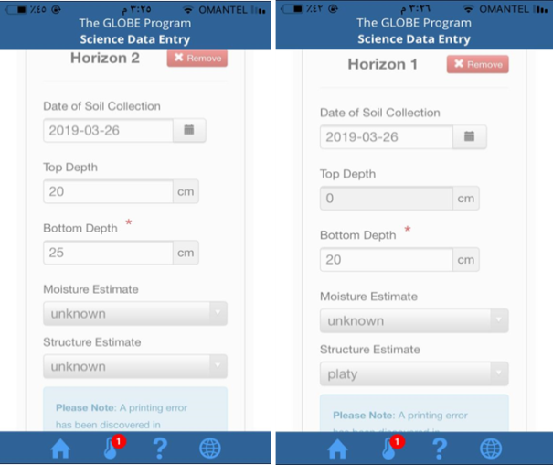

Results Discussion:
The results showed – as answers to the first and third questions- that the soil properties changed as the acidity increased in the soil which was affected by mold . The color of the soil changed as well. Through the experiment of agriculture in the soil samples, it was found that The soil is not suitable for agriculture . in addition, through microscopic observation, the soil is almost free of life forms unlike the fertile soil in which the presence of microorganisms is observed.
After the preparation of the appropriate conditions for the mold (humidity, heat and blocking the sun), it turns out that the mold affects the agricultural soil and kills life in it. The elements of the climate has a great role in the formation of mold. In other words. humidity and heat and the lack of sufficient sunlight are key factors for mold in the soil which answers to the second question.

Conclusion
The field study (farm visits in the study community), observation and scientific experimentation (preparation of moldy soil within the school laboratory) and sample testing (detection of pH, CO 2, observation under the microscope and validation of the soil) show that mold in the soil can affects the agricultural environment in Khassab as it leads to decrease the fertility of the soil and increase the acidity. It also can lead to a change in the colour of the soil. In the coming stages of the research we can study the relation between the mold in the soil and the proportion of vegetation in the study area.

Recommendations
√ Raise awareness of farmers and members of society about the problem of mold in the soil.
√ Encourage farmers to use modern irrigation methods that reduce water depletion.
√ Use fertilizers and pesticides in appropriate amounts of soil in order to reduce their effects.
√ make laws by the authorities and follow-up their application to reduce this problem.
√ Raise awareness among farmers through lectures to introduce them to the importance of conservation and use of modern irrigation methods and the use of fertilizers and pesticides limited to them and to preserve the soil from mold.
√ building specialized laboratories to analyze soil models in order to know the problems that are being dealt with and treated to limit their effects.
√ Follow modern methods of soil conservation and the use of modern techniques in identifying and addressing their problems.
√ allocate a scientific team to follow the soil and take samples for study constantly and know the problems in order to maintain them before aggravating the problem.

Thanks and appreciation
Our thanks and appreciation to Mrs. Ibtisam Lab technician at Khawla Bint Al Azur School for her cooperation with the research team and to create a place in the school laboratory to conduct experiments and train students to use the microscope.

References :
- Books
1. Al-Dulaimi, Khalaf Hussein Ali, Applied Land Formology, (I 1), Amman, Jordan: Dar Safa for Publishing and Distribution.
2. Sahawiya, Fawzi, (2014), Introduction to Geography, (I 1), Jordan: University of Jordan, Dar Wael Publishing.
3. Hussein, Kamal Al-Sheikh, (2003), the science of dust and its types, (I 1), Beirut: House of Mahmel plant, library Ras Al-Naba'a.
4. Ismail, Laith Khalil, soil maintenance Directorate of the University Press Mosul, (without a year printed): Iraq.
Internet Articles
- Wikipedia ،
https://ar.wikipedia.org/wiki/تربة
. Damuki, Mahmoud. (2018, May 6). Soil degradation: what causes and what solutions to address the problemhttps://www.ts3a.com/bi2a

