Cedar Grove Elementary School Research Report
Research Question:
Ms. Janney was our GLOBE mentor. She lives near our school, and she came to work with us in the Math resource closet every other week from the middle of October through the present time. She worked with a group of 7 fourth grade students from 11:30 to 12:15, and then with another group of 8 third grade students from 12:15 to 1 pm. We worked in different groups, but we all took different parts of this report to write, and we used the same data from BWI. Each group took GLOBE data so we would get practice and learn how to do it, and Ms. Janney made a schedule so that each class is responsible for collecting data every other week. We call ourselves the “Weather Watchers”.
When we were learning how to take the GLOBE measurements: current temperature, precipitation, and cloud observations; we noticed that it seemed like we were having much warmer weather than we usually did at this time of year. It was the end of October and almost Halloween, and we knew that usually it was pretty cold and we needed to wear sweaters and coats. But this year it seemed like it was warmer to us. Here is a picture of us from the end of October- notice that we aren’t dressed like it was very cold.
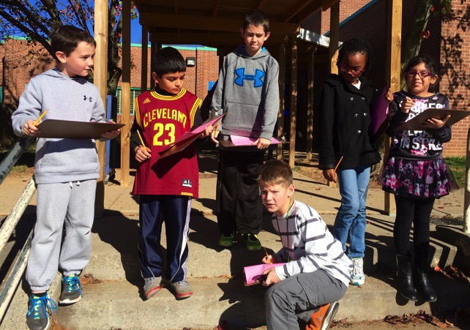
So we talked to Ms. Janney about the differences between weather and climate. She taught us about something called “El Nino” that was happening and that was possibly responsible for changing our usual weather patterns. We saw a movie about it and had a lot of questions about why a change in the ocean currents and wind patterns could affect us all the way in Maryland. Some of us had heard about the El Nino already, and we learned more and went home and taught our parents about it too.
Here are the US maps that we used to help us make our predictions. They are from NOAA.
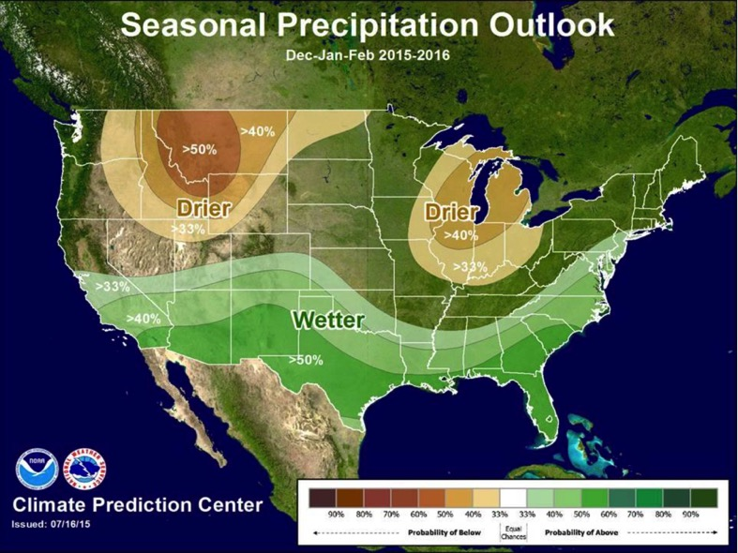
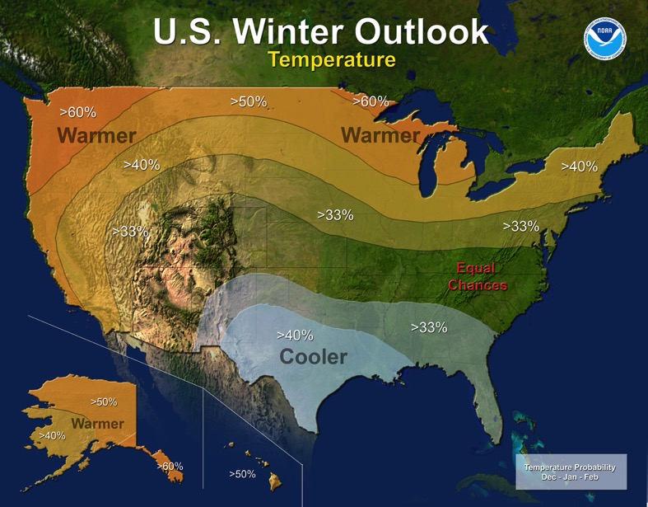
We decided to do a research project to see if we could notice a change in our daily temperature and precipitation, and we would compare it to the typical temperature and precipitation. We found out that for our area, there was a 33% chance that we would have warmer temperatures and more precipitation.
Our testable question was “Did the El Nino change the typical temperature and precipitation patterns in our area during the months of November, December, and January?
Student-led investigation plan
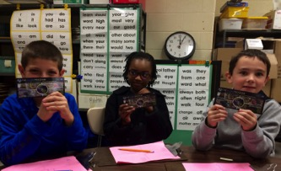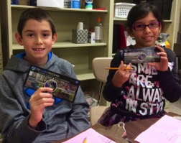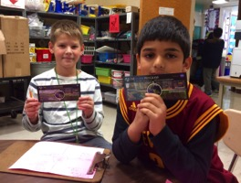
Ms. Janney taught us about the GLOBE Program too, and every day when she came, we would go outside to our weather station. When she wasn’t there, we would try to go out and collect our data too, but that didn’t work very well. One time we broke the key to the instrument box by accident, and another time our instrument box got knocked over by some really strong winds. We also had some snow days and sometimes we forgot. We looked at the GLOBE web site and it says we haven’t done as many counts as we know we have, so Ms. Janney has put in a note to the Help Desk to see why our data hasn’t been added.
After we realized we couldn’t get our data everyday, we came up with a plan for November, December, and January. Ms. Janney would take us out when she came every other week, and we would try to collect data on the days when she wasn’t there as well. We needed to have a way to see what the typical temperature and precipitation patterns were for our area, and to collect temperature and precipitation when we weren’t able to get it ourselves. So Ms. Janney showed us the National Weather Service website, and she showed us the data that was available there for the closest airport to our school, which is the Baltimore Washington Airport, or BWI. She showed us how to read the “Climatological Report” that came out each day, and we learned how to find the maximum, average, and minimum observed temperature, and also to see what the normal values were for that date. The normal values were the average temperatures that were taken at BWI between 1880 and last year, so it was over a very long time. We did the math and found out that it was actually for the past 135 years! Here are some pictures of us collecting the atmosphere data in November, December, and January.
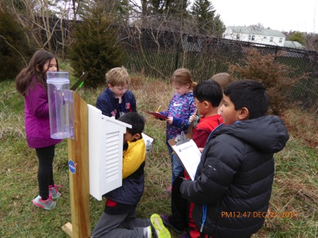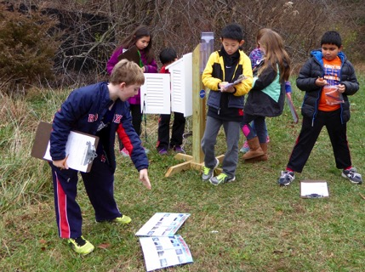
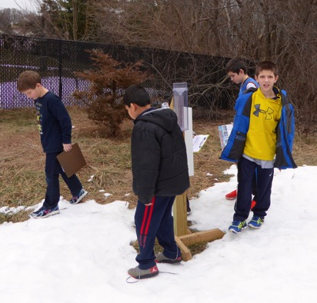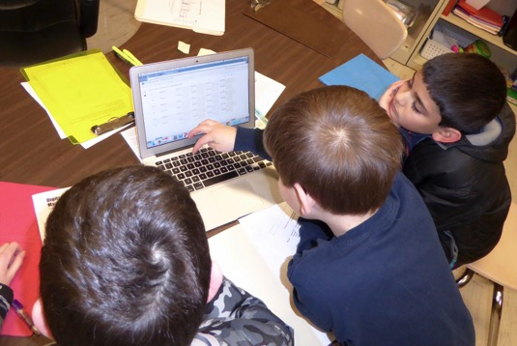

We kept learning more about how the El Nino was predicted to affect weather in different places around the US and even around the world. Here we are working on a map of the US to show the temperature and precipitation changes that meteorologists predicted would occur because of the El Nino.
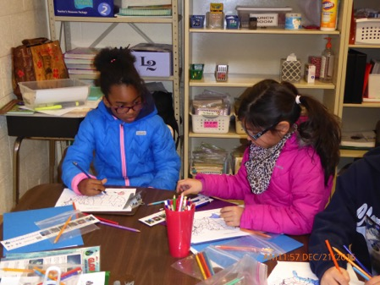
These are the steps we took to complete our project:
1. Go outside and use the GLOBE precipitation, cloud, and air temperature protocols to collect data as often as we can. Report our data to GLOBE so it can be logged into the data system. We had two groups, so we would take turns picking which group would log their data each day.
2. Look at the daily precipitation and maximum, average, and minimum temperatures for each day in Nov., Dec., and Jan. using the “Daily Climatological Report” for BWI. We also would take the normal values from the same report so we could see if the observed weather was different or the same as the normal values for temperature and precipitation.
3. Ms. Janney would help us by putting the data for each two weeks in a data table, and she gave us a graph that had the normal maximum and minimum temperatures in lines on the graph. We would work in pairs and plot the observed maximum and minimum temperatures on the same graph to see if they were different from the normal temperatures.
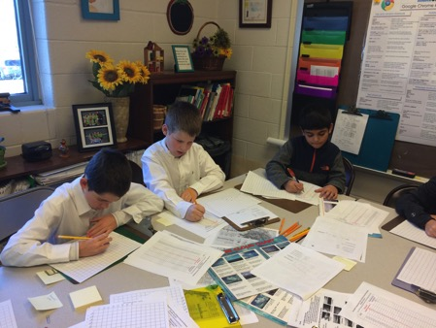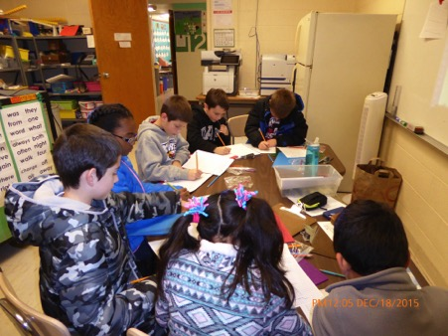
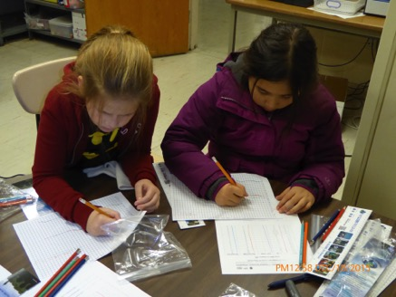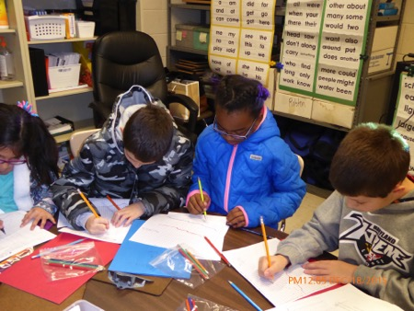
4. We also kept track of how many days the temperature and precipitation values were above, the same, or below normal values.
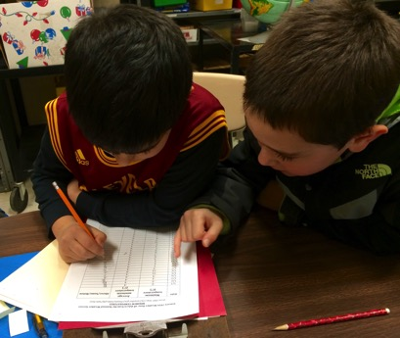
5. We continued to collect this data and analyze it following these steps for the whole months of November, December, and January.
6. In February, we broke up into four groups. Each group was responsible for a different variable to analyze, draw conclusions about, and to report in on. The groups were: maximum temperature, average temperature, minimum temperature, and precipitation. Each group had the data that we had collected for the three months, the graphs we had made, and also the Excel graphs for each month that Ms. Janney made that had all of the data on them for us to use. When we finished our posters, we presented them to the entire group and Ms. Janney took notes about the conclusions we found as a group.
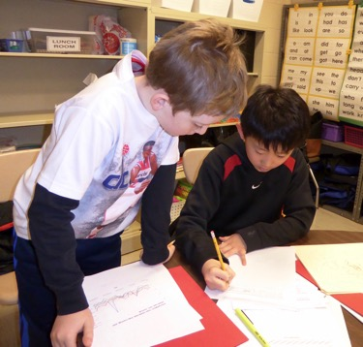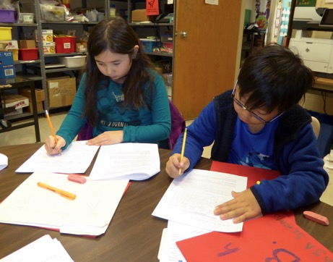
7. We also wanted to see if other places around the US and the world had changing temperature and/or precipitation patterns due to the El Nino. We wrote to Ms. Janney’s GLOBE teacher friends, and many of them sent us their data to look at. When we sent the email to ask if they would share their data, we also sent a picture of us! Here are some of our pictures holding the GLOBE teacher and class we were writing to:
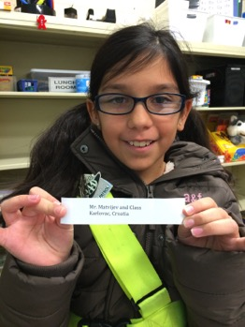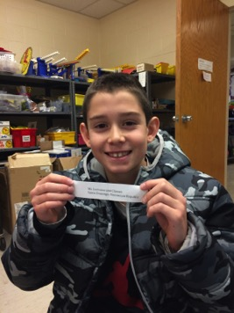
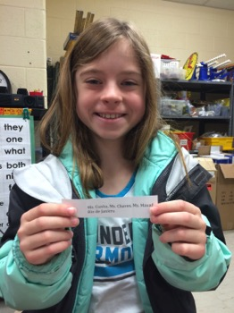
We did hear from many of them, but we haven’t had time yet to look over their data and see if it is different from their usual patterns. We will keep meeting with Ms. Janney, and will have time to do that after we submit this for the Science Fair.
When we collected our GLOBE data using the precipitation, current air temperature, and cloud protocols, we learned how to do these protocols. As we mentioned earlier, we weren’t able to collect the data everyday. We are hoping that now that we won’t have more snow days and we have learned how to collect this data, we can do it on days when Ms. Janney isn’t here.
On the days that we did collect our own data, Ms. Janney would compare what we got for our temperatures and precipitation to what the NWS had gotten at the BWI airport, and we found a few small differences in the exact numbers, but it didn’t affect our final results.

Data summary:
November-
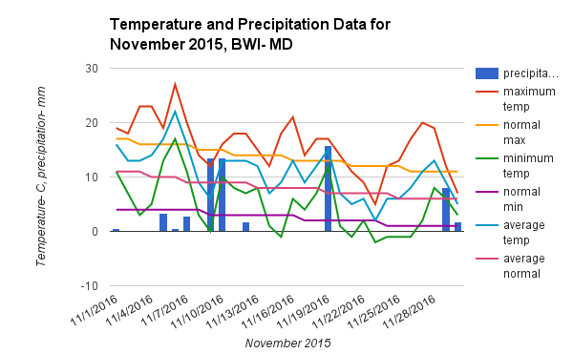
Data Table for Temperature and Precipitation- November 2015
Variable | Range- in C° | Days above normal | Days at normal | Days below normal | Record
Maximum temp. | 5 to 27 | 22/30 | 1/30 | 7/30 | 11/6- 27°
Average temp. | 2 to 22 | 20/30 | 4/30 | 6/30
Minimum temp. | 2 to 17 | 18/30 | 4/30 | 6/30
Number of days with more than a trace of precipitation: 10/30
Total amount of liquid precipitation observed: 83.82 mm
Total average amount of precipitation for November: 87.884 mm
difference: - 23.064 mm

December:
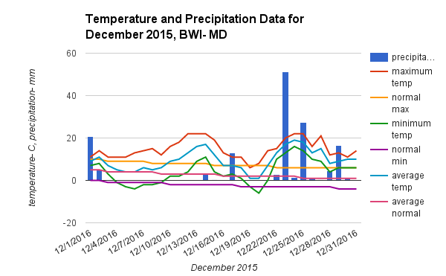
Data Table for Temperature and Precipitation- December 2015
Variable | Range- in C° | Days above normal | Days at normal | Days below normal | Record
Maximum temp. | 6 to 22 | 30/31 | 0/31 | 1/31 | 12/12-22°, 12/13-22°, 12/14- 22°
Average temp. | 21 to 19 | 27/31 | 6430 | 6/30
Minimum temp. | -6 to 16 | 27/31 | 3/31 | 5/31
Number of days with more than a trace of precipitation: 14/31
Total amount of liquid precipitation observed: 148.586 mm
Total average amount of precipitation for December: 85.598 mm
difference: + 62.992 mm

January:
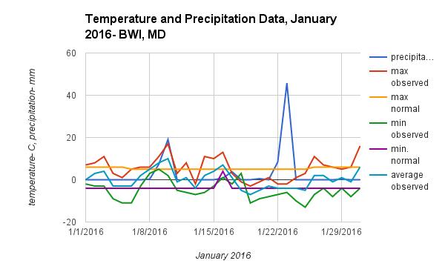
Data Table for Temperature and Precipitation- January 2016
Variable | Range- in C° | Days above normal | Days at normal | Days below normal | Record
Maximum temp. | -2 to 17 | 14/31 | 3/31 | 14/31
Average temp. | -17 to 10 | 13/31 | 3/31 | 15/31
Minimum temp. | -13 to 5 | 11/31 | 3/31 | 17/31
Number of days with more than a trace of precipitation: 5/31
Total amount of liquid precipitation observed: 88.90 mm
Total average amount of precipitation for January: 77.47 mm
difference: + 11.43 mm
Conclusions:
We concluded that our weather in this region was impacted in the way that the meteorologists had predicted: We had warmer than average temperatures and more precipitation than we usually do during the months of November, December, and January.
We found that the daily maximum temperature was higher than normal for 66/92 days, which means that about 72% of the time, the daily maximum temperature was above the normal maximum temperature.
We found that the daily average temperature was above the normal average temperature for 60/92 days, which means that about 65% of the days had above normal average temperatures.
We found that the daily minimum temperature was above normal minimum temperatures for 52/92 days, which means that about 57% of the days had above normal minimum temperatures.
We found that the total amount of precipitation for the three-month period was 321.306 mm. The normal amount of precipitation for this time period is 250.952 mm. The difference between these two amounts is + 70.354 mm, which means we had about 30% more precipitation than we normally do during these three months.

Bibliography-
We used a Google Spreadsheet to make the graphs that show the temperature and precipitation in our Data Summary.
We used NOAA’s National Weather Service Forecast Office- Baltimore/Washington website to collect our daily and normal temperature and precipitation data.
We visited the NASA Space Place website and learned about El Nino.
We also watched the ClimateBits video to learn about El Nino. We also watched the NASA “Observing the 2015 El Nino” video.
We got our maps from the NOAA webpage called “Strong El Nino Sets the Stage for the 2015-2016 Winter Weather”.

