References

Dr. Fahd Al-Khudairi, a research scientist-2020--3
Deng, S. Q., & Peng, H. J. (2020). Characteristics of and Public Health Responses to the Coronavirus -2
Disease 2019 Outbreak in China. Journal of Clinical Medicine, 9(2), 575-1.‏
GLOBE /vis.globe.gov/2019-9
Saudi Ministry of Health-2020-3.4
World Health Organization. "Novel Coronavirus (‎ 2019-nCoV)‎: situation report, 3." (2020).-1-2
Zu, Zi Yue, et al. "Coronavirus Disease 2019 (COVID-19): A Perspective from China." Radiology (2020-4.

figure (1-2) virus structure
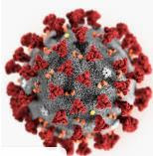
Recommendations
To reduce the spread of virus(2019-nCov), we recommended to increase awareness of its danger and ways to prevent it .
A person must strengthen his immune system to be a defense line against viruses through good nutrition and attention to hygiene and not being in crowded places.

figure (1-1) how virus enteres the respiratory system ?

Effect Of corona and winte
Students research : Ruba Amer Al-Harb - jwaher Talal Al-Hendi - Shahad Fahd Al-Harbi
Supervised by: Tr. Amina Ahmadi
Name of school : secondary 24 in makkah

Name of school : secondary 24 in makkah
The leader of a school : mrs. Ehsan bazumah

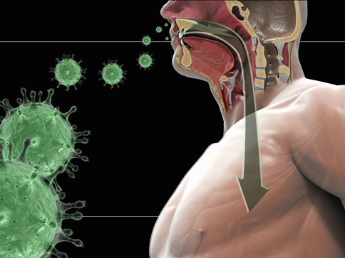

s Research Question
I noticed that viruses reproduces in the winter, which led to an increase in diseases. I asked whether a decrease in temperature affects the formation and reproduction of various viruses?
1- Why has there not been an increase in human cases since 2012 and has now started frighteningly and led to panic?
2-Why did this virus get out of control at this particular time? And he came back stronger than before?
3 - Are there other environmental factors that affect the spread of viruses, especially the mysterious corona?

introduction
The virus is a microorganism smaller in size than bacteria. The virus consists of a genetic material surrounded by protein(Capsid ), fats or glycoprotein.
These microorganisms are found almost everywhere on the face of the earth.
Our research aims to know the causes of the proliferation of the new Corona virus and limit its spread.

