Fire on the Forest Floor

How does fire affect hydrophobicity in soil?

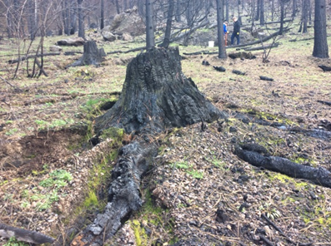

Evan LaFata, Nicholas Brown, Jayden Schumaker, Stella Darling

Cobb School

**Students**: Nicholas Brown, Stella Darling, Evan LaFata, Jayden Schumaker,

Skyla Watters, Chloe Parker, Shyann Pierce, Kassi Boehnen, AJ Griffin, Aydin Mulholland, Tivie Lael, Wesley Hardin,

**Teacher**: Barbara Brodsky-Post

**Date**: 3/1/18

Table of Contents

Abstract………………………………………………………………………....3

Introduction…………………………………………………………………….4

Research Methods……………………………………………………………...5

Screenshots: Data Entry………………………………………………………..7

Screenshots: Data Visualization………………………………………………..8

Data Analysis…………………………………………………………………..9

Conclusion……………………………………………………………………..13

Bibliography…………………………………………………………………...14

Abstract

In our investigation, we set out to study the effects of how wildfire impacts soil hydrophobicity. We studied three burned and unburned sites in the Horse Prairie area. Our hypothesis was if the fire in the area was intense enough to cause hydrophobicity, then soil infiltration would be impeded.

Introduction

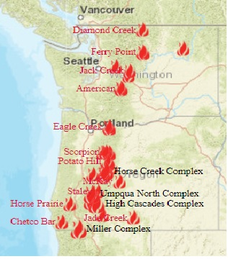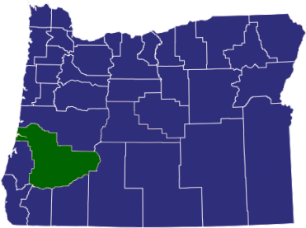Douglas County, Oregon, “The Timber Capital of the Nation” supplies wood for much of the U.S. and abroad. This rural county has approximately three million acres of woodlands. The timber industry is the driving economic force in the county. The woods are also a major recreation resource. Unfortunately, there are an increasing number of wildfires that negatively affect these industries, wildlife, and homes. The most recent fire was the Horse Prairie fire in September 2017 which burned 16,436 acres, and from which we are still recovering today.

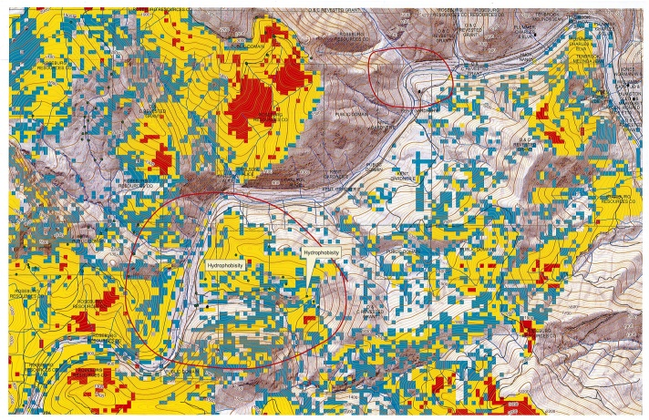In addition to loss of timber, fire can also affect the soil by making it impervious to water infiltration, a condition called hydrophobicity. This led us to our research question: **Was the fire in the Horse Prairie area sufficiently intense to make the soil hydrophobic?** Hydrophobicity is when soil repels water instead of absorbing it due to the effects of wildfires on amino acids, when the amino acids in the soil get heated up by the fire they produce a waxy substance coating the soil, causing them to become hydrophobic. When the soil becomes hydrophobic, then it will be resistant to the drying of organic matter. It can severely impact the environment by causing landslides, mudslides and it can prevent the soil from absorbing water to give plants from getting the nutrients they need. **Our hypothesis was, if this fire in Horse Prairie area was intense enough to cause the soil to be negatively affected and eventually hydrophobic, it would cause water infiltration to be impeded.**

**Fire Intensity: red=intense, yellow=moderate**

Research Methods

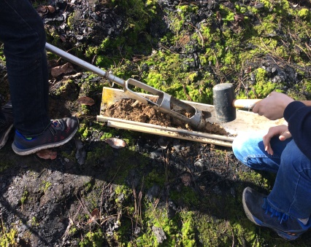The data we collected consisted of how fast the water infiltrated through the soil, along with the characterization of the soil such as color, texture, and consistency, along with how many rocks and roots were in the soil.

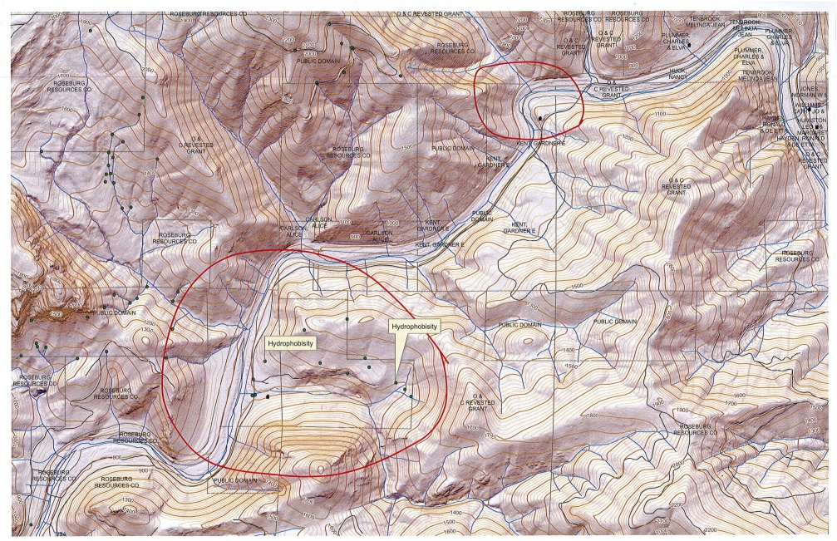

The first time we visited the study sites where we collected data they were very dry and covered in ash. At later visits the sites were very mossy. The ground would have holes from where tree roots burned.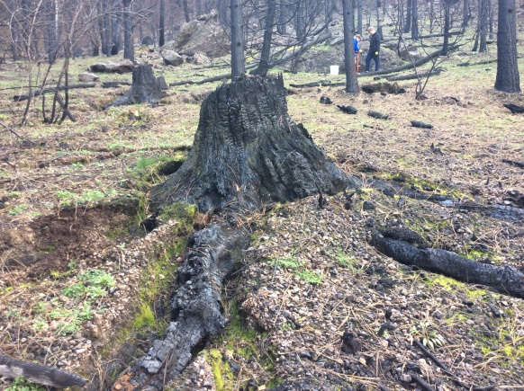 The second time we ventured out, there was a light drizzle.

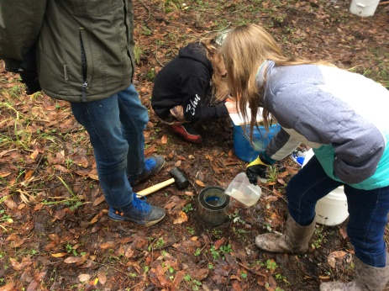There were six paired sites, burned and unburned, from which we collected data, each site giving us three separate samples. We used GLOBE Soil Infiltration protocols which consisted of two cans and timing the rate at which the water infiltrated into the soil at a certain distance. We calculated flow rates using Globe Soil Pedosphere sheets and graphed the midpoint times and flow rates. We used the first infiltration sequences to determine hydrophobicity. Since hydrophobicity testing requires dry soil, the first infiltration sequence would be the most crucial. We then compared the initial infiltration rates to the types of soil in the first horizon at each Horse Prairie Site.

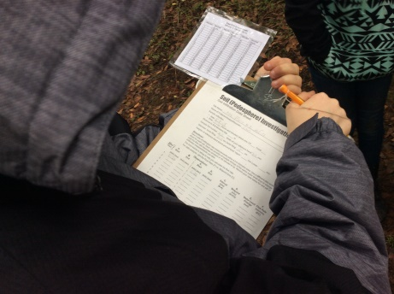

Screen Shots: Data Entry

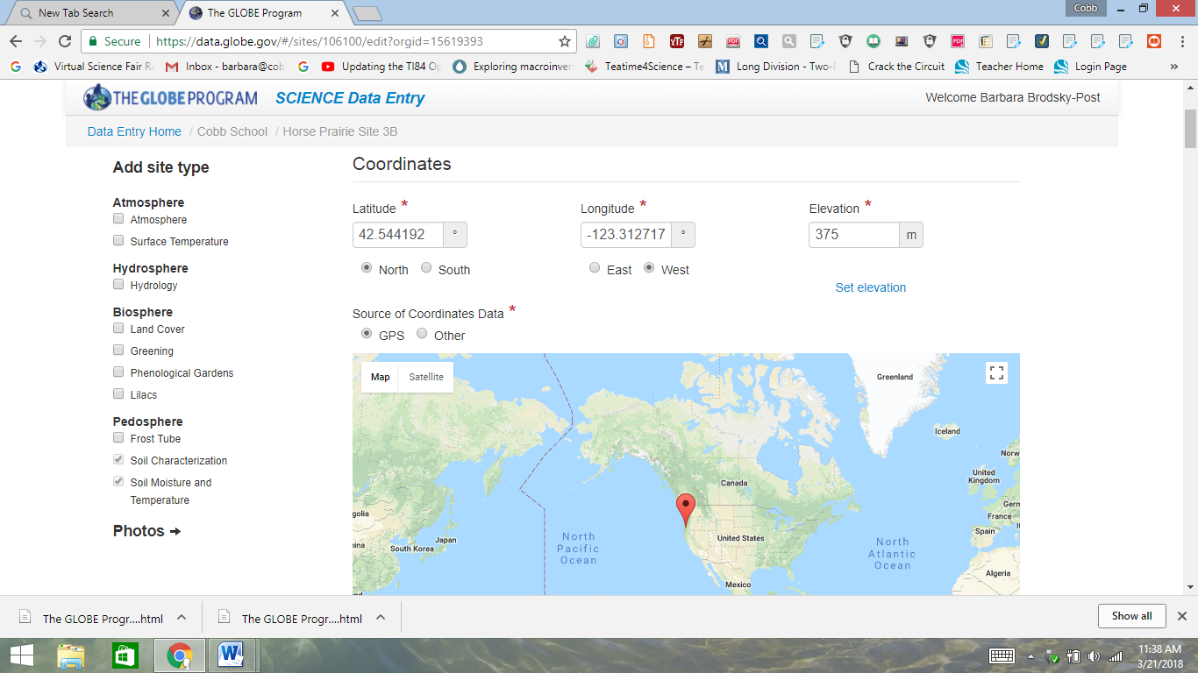

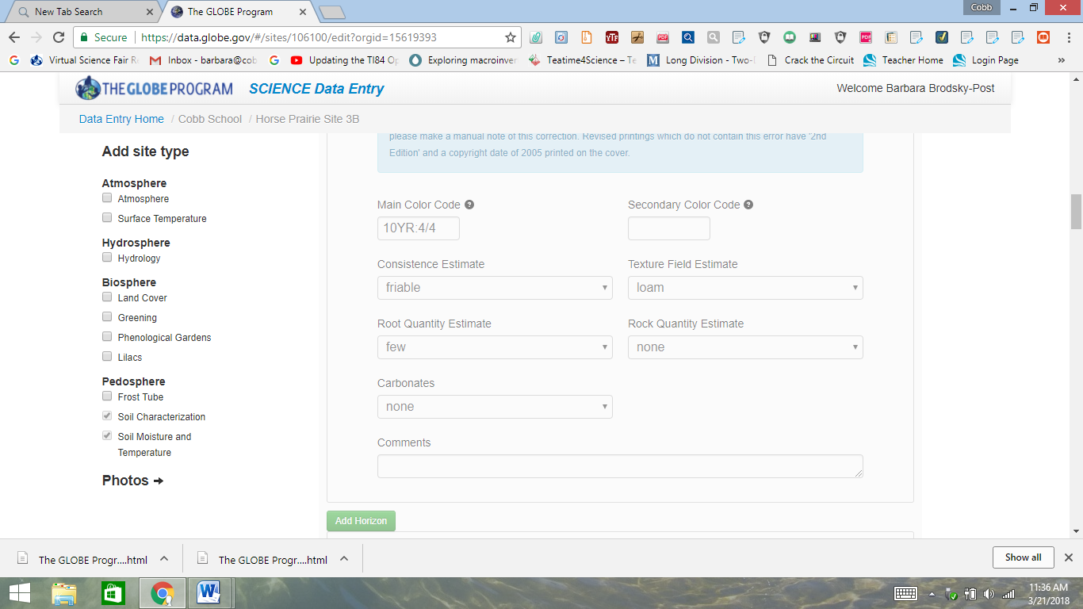

Screen Shot: Data Visualization

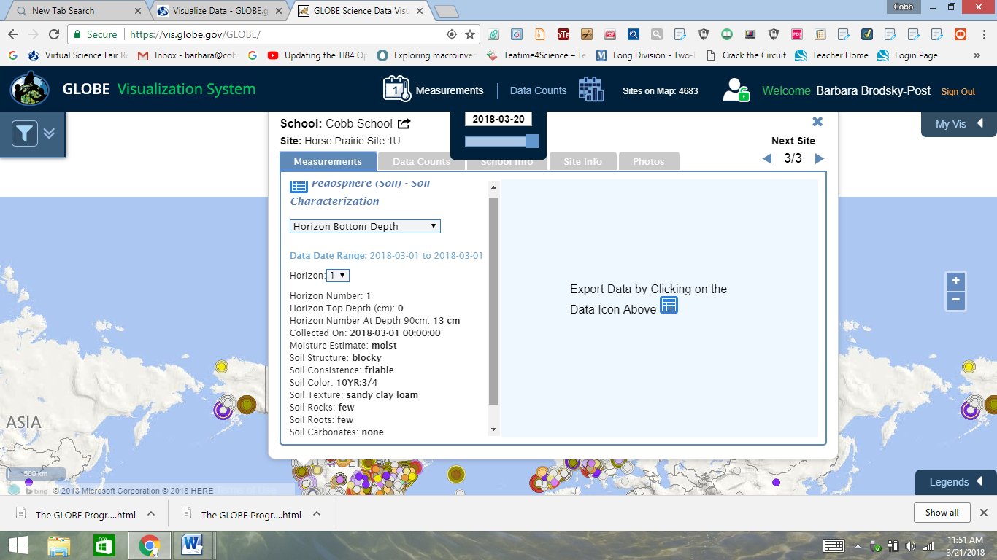

Currently, the GLOBE Data Visualization page does not show soil infiltration data.

Data Analysis

After we averaged our first infiltration rates from all of our burned and unburned sites, we discovered that the Site 3 showed signs of hydrophobicity.

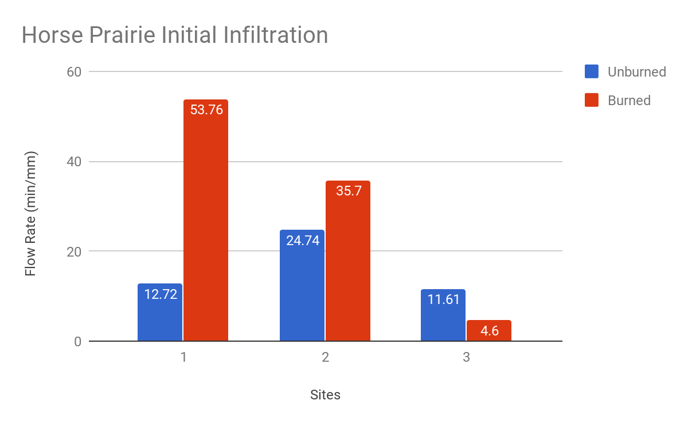

At the first study site, the unburned soil was sandy clay loam, and the burned soil was sandy loam. This data did not make sense because normally, the burned soil would be hydrophobic. We think this may be partially due to human error because this was our first time doing the testing. An alternative explanation would be that the fire wasn't intense enough to cause significant hydrophobicity.

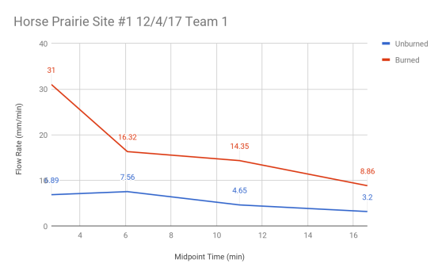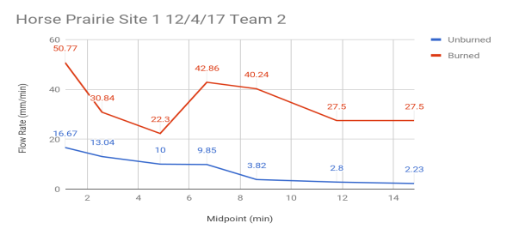

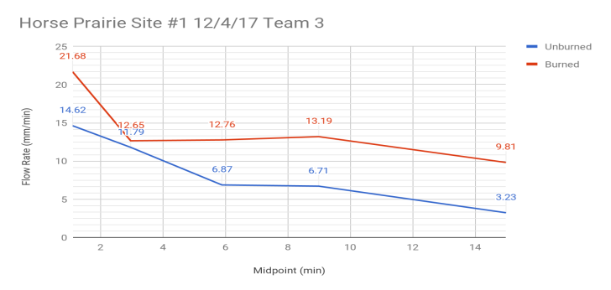

The soils in the two soil sample areas at Site 2 were also similar, but the differences in flow rates were not as great, possibly because the burned area was extremely dry, causing faster initial infiltration rates.

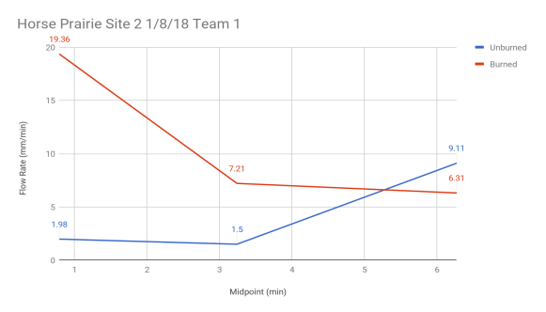

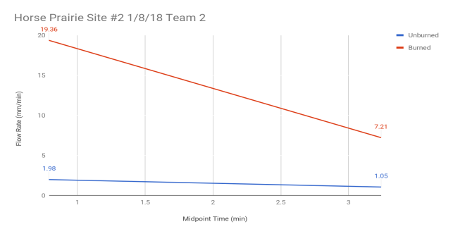

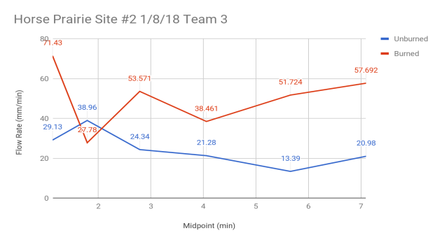

At study Site 3, we noticed that the initial infiltration rate at the burned site was lower in all of the data than the unburned site, in spite of the fact that the unburned soil was clay and the burned soil was loam. In normal conditions, clay would take longer for the water to infiltrate the soil. This led us to believe that the soil is hydrophobic. This would be logical that the soil may have been hydrophobic because the site was at the top of a hill, and fires run uphill, making the effect more intense in these areas.

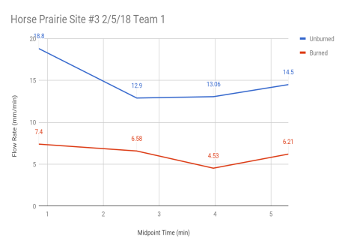

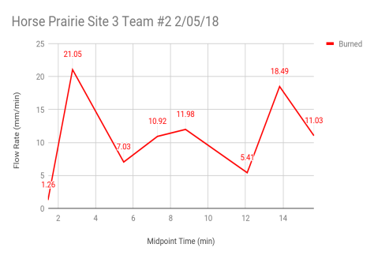

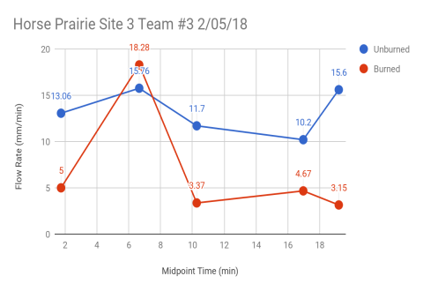

Conclusion

Our conclusion, based on our data which shows possible hydrophobic soil in one of our three burned sites, is that some areas of the Horse Prairie fire were intense enough to cause hydrophobicity. Based on information from geologist Ward Fong and hydrologist Sidney Post, most of Horse Prairie was a low- to moderately-intense fire. However, since the hydrophobic site was located at the top of a hill, the fire would have burned more intensely because fire runs uphill. Some possible factors that may have affected our results were available locations for testing, collecting data over a three-month period which meant it had rained and moss was growing back, and not adding the water-beading test for hydrophobicity.

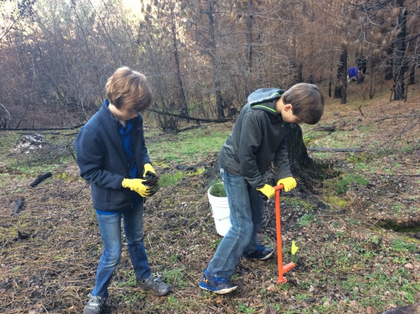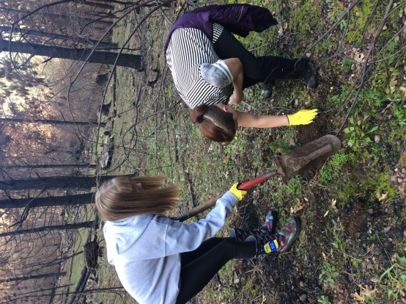 Now we know that fire affects more than just the plant and animal life in forests. If the soil can’t absorb water, then landslides and erosion can follow, causing loss of property and damaging streams. As a class, we returned to our test sites to plant trees for the private property owners who lost most of their forest. It might be informative to revisit this area in the future to see the forest regenerating.

Having a geologist and a hydrologist from the Bureau of Land Management assisting our class in our testing procedures, providing maps of the fire, and finding areas for us to collect our data allowed us to complete our investigation successfully.

**Bibliography**

USDA. “Soil Quality Resource Concerns: Hydrophobicity.” *Iowa State University*, June 2000,

[www.statlab.iastate.edu/survey/SQI/](http://www.statlab.iastate.edu/survey/SQI/).

Parsons, Annette, et al. *Field Guide for Mapping Post-Fire Soil Burn Severity*. *Field Guide for Mapping Post-Fire Soil Burn Severity*.

Neary, Ryan, et al. *Wild Fire in Ecosystems*. vol. 4, *Wild Fire in Ecosystems*.

Fong, Ward. Personal Interview. January 24, 2018

Post, Sydney. Personal Interview. December 4, 2018