**Dark Skies Rangers Contest**

**DETERMINING LIGH POLLUTION USING GLOBE AT NIGHT PROJECT**

**Student: David Damjanoski (14 years old)**

**OOU ,, Koco Racin”**

**Prilep, Republic of Macedonia**

**Mantor: Karolina Damjanoska-Master of metodology of physics education (my mother )**

**(My mother works at SOU ,,Orde Copela” – Vocational High school from Prilep and she teach physics, Optics, Optical measurements and Optical instruments)**

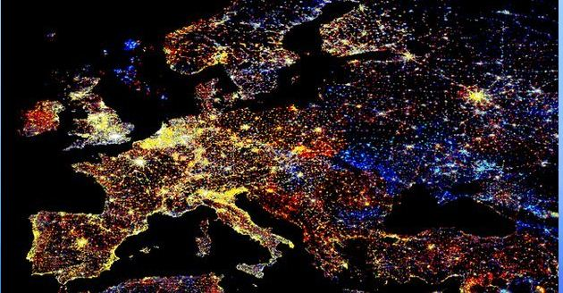

**April, 2014**

**Abstract**

Light pollution is the illumination of the night sky caused by artificial light sources on the ground (streetlights, billboards, etc.). Light pollution is a side effect of industrial civilization.The amount of outdoor lighting increases as a result of the increasing population. Lights, contrast, and glare all impact the number of stars that are visible in a given location.

The GLOBE at Night program (GaN) is an international citizen-science campaign to raise public awareness of the impact of light pollution by inviting citizen-scientists to measure their night sky brightness and submit their observations to a website from a computer or smart phone.

And this year we (me, my brother and my mother) participate in this campaign, watching the sky above Prilep in various locations. We also use Sky Quality Meters (SQM). This year the program is very extended.

 Using lights at night can be helpful, but there are unanticipated effects. We send our results via internet to the GLOBE server and in that way we give our contribution to healthier environment.

**Keywords:**  light pollution, GLOBE at night, SQM

**INTRODUCTION**

What is light pollution? The light disappears without a trace as soon as we turn off the lights. You would probably think that it is impossible to call that pollution!? Unfortunately, the answer is opposite; light can really pollute the environment. Furthermore, light pollution can bring to a negative effect to the total plant and animal life, as well as the human.

Light pollution appears in many types, but most of them include light trespass, glare, and skyglow.

Skyglow phenomenon mostly irritates astronomers. It is a type of light pollution when the light reflects from the little aerosols, typical of most modern polluted and humid conditions, and that same light is redirected by the atmosphere back toward the ground. When these circumstances occur the night sky is as light as a dawn.

Mostly in the highly industrialized, densely populated major cities real white-yellow-orange colored light “mushrooms” emerge which uncontrollably, non-ecologically and uselessly brighten up the night sky. That useless light derives from non-ecological man-made (artificial) light sources mostly misused, thus wasting energy and light. Therefore, the phenomenon skyglow, as a type of light pollution, appears when all the public city lights are directed toward the sky where the rays of light in the atmosphere scatter and reflect from the aerosols back toward the ground.

**HOW CAN LIGHT CAUSE POLLUTION**

Men have artificially lit up everything that has come their way. As a result, today it is practically impossible for us to see the stars. We have been taken away our right of the stars, of nature. The “Milky Way” for us only exists in the fairy tales, because we cannot see it.

In addition, there are health consequences of exposure to artificial light at night some of them are increased headaches, increase in anxiety, and reduced production of hormone leading to cancer.

Space lovers have lost their stage and the astronomical observations are merely impossible.

**Plants and animals**

Light pollution has turned the night into a half-dawn. The lack of night and night rest has proved that light pollution affects the ecosystems. Many plants and animals suffer from the newly risen circumstances, some of them are on the verge of extinction and some are already extinct.

Birds don’t build their nests near the sources of artificial light; they become disoriented at night, light pollution can confuse animal navigation.

Flowers don’t close completely and are therefore exposed to weather conditions.

The proud owners of the “decorative light balls” are unaware of the fact that they have out casted tens of animals and plants from their gardens, thus bringing to their global extinction. In fact, nature acts as it is told by us, the intolerant and ignorant humans.

**Traffic safety**

Everywhere we travel, the streets, the squares, the crossroads are over-illuminated with inappropriate artificial light. Sometimes the glare light redirecting in the eye causes loss of contrast and leads to unsafe driving conditions. Are you aware of the number of driving accidents caused by over-illumination?

**Ecological and non-ecological lighting**

The ecological light sources mainly fulfill their purpose; they light the surface that needs to be lit, they are also traffic -safety and public-safety friendly, cost less and use less energy. Therefore, the light produced has a higher degree of usage (95-99%).

When non-ecological light sources are used they don’t light the required surface, have a negative impact on plants, animals and men, and cost more. While wasting more energy, more light gets wasted, too. As a result the light produced has a lower degree of usage (10-65%).

The problem of light pollution hasn’t been seriously considered so far. Yet, the governments of some countries have brought many laws and regulations concerning the light pollution.

**Problem solution**

Many things can be implied in order to reduce the light pollution. For example, the lighting fixtures should be improved, meaning we should use ecological lights of better quality, which should direct their light more accurately towards where it is needed.

These types of lights are: ecological, safe, economical, can lower the light pollution and they light the surface that needs to be lit, they are also traffic - safety and public - safety friendly, cost less and use less energy. However, we also have to mention the awareness of each human being rationally to use the light and to safe energy in any possible way.

When non-ecological light sources are used they do not illuminate the required surface, have a negative impact on plants, animals and humans and cost more. When more energy is wasted, more light is wasted, too.

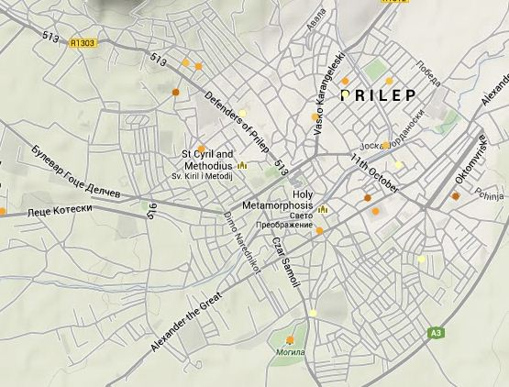**Globe at night observation from february and march 2014 made from my town, Prilep**

The marked points on the map above represent the observation of the illuminated night sky, the lighter the point the lighter the sky is, the darker the point the darker the sky. The lightest point (magnitude 1) can be seen over the major cities. There, only a few stars are visible in the night sky. The darkest point (magnitude 7) can be seen over a national park for example, where there aren’t any city lights. Then, there are a lot of stars (14 000) and it is difficult to tell the constellations apart.

Through Globe at night project, people from all over the world observe the illumination of their night sky, by observing the brightest stars from the constellation Orion or Leo.

Then, all the participants send their results on-line, and a couple of weeks later the organizers present the world map of light pollution in the world.

So far eight Globe at night campaigns have been conducted with a great number of observations.

Through Globe at night, the participants, the teachers, the parents and community members are all surprised by the amount of data while observing the light pollution locally and globally.

It is also important to mention that the scientists themselves, working in the field of light pollution use the data gained from these observations.

**How to catch a star in six easy steps**

1. Determining longitude and latitude. For this purpose we use the GPS-unit and the following web pages: [www.itouchmap.com](http://www.itouchmap.com/) and [www.maporama.com](http://www.maporama.com/) ;
2. Locating the constellation Orion one hour after sunset (8 to 10 o’clock local time)

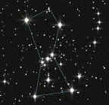

Orion resembles a person. First of all we need to see the belt of Orion, formed of three bright stars set in a straight line. One of the “legs” of Orion is the bright star Rigel, one of the brightest stars in the night sky. Bellatrix and Betelgeuse are “the shoulders of Orion”. Betelgeuse serves as “the right shoulder” of Orion and it is the eighth brightest star in the night sky, it is a red star which is can be seen with a naked eye.

1. Magnitude observation using the magnitude graph by Globe at night Here we compare our night sky to the other magnitudes shown in the graph below in order to decide on the magnitude of our night sky.
2. Using the sky quality meter to measure sky brightness
3. Sending data. In order to observe and fill in the measures we use the forms which can be found on the Globe at night web page [www.globeatnight.org](http://www.globeatnight.org/)
4. Comparing observations with the other thousands of observations around the world



**Using Sky Quality Meter (SQM) to Measure Sky Brightness**

The measurements conducted using the SQM bring to a new prospective in the Globe at night program- the participants in the Globe at night program gain scientific experience, as well as the measurements are more precise. The SQM observations allow the citizen-scientist to mark the different locations in the city, to identify the dark spots in the night sky and to measure the changes that may occur.

The following pictures show the SQM:

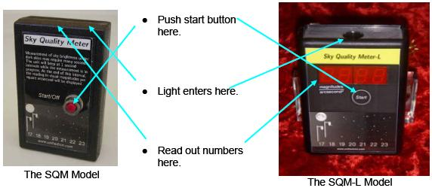

Using the SQM

There are two models of SQM’s. The SQM-L-model is newer, but both of them are easy to use. The newer model SQM-L has a lens for gathering more light from a smaller area (especially for city use), where the nearby buildings and lights can affect the observation. This field of focus is in a shape of a cone ~20 degrees wide, in comparison to the old model which was ~84 degrees wide. Another difference between the models is the location of the display and the power button. On the SQM-L model the power button and the display are on the same side, which means that you wouldn’t have to change the position of the meter in order to observe. On the SQM model the display and the sensor are on the same side.

In order to observe with the SQM we need to set the location, the longitude and latitude using a GPS-unit or certain web pages: [http://www.maporama.com](http://www.maporama.com/) , [http://www.earth.google.com](http://www.earth.google.com/)and [http://www.itouchmap.com](http://www.itouchmap.com/) .

The observations take place outdoors, in the evening, and after sunset (from 7p.m. to 10p.m.). The night sky should be clear before the Moon is set too high, and the sunset occurred at least one hour ago. Otherwise, the glare from the Sun and the Moon will affect the observation.

For best results it is advisable to wait for the astronomic twilight zone in order to get total natural darkness before the observation takes place.

The times of the sunsets can be seen on the following web page: <http://www.suurisesunset.com/customsrsscalendar.asp>.

The SQM is influenced by the outdoor’s temperature, thus it is better to leave it outdoors at least for 5 minutes to adjust to the temperature and then to continue with the observation. The Meter shouldn’t be used near any street lights or any other source of artificial light, nor under the shadows of buildings and trees. Another rule states that the Meter should be away from any facility for at least as the height of the same facility. For example, the SQM should be away from a street light at least 7, 5 meters, if possible.

The SQM should be held above the head pointed towards the zenith, so that the shadow or the reflection of the observer would not influence the observation. Also the instrument should be held firmly, without moving or shaking. The button should be pressed only once in order to start the observation. The SQM will beep every second while collecting the photons. The observation is finished after the last beep, and then the display should be read.

Under the urban sky (in urban areas) the result is shown almost immediately. When the sky is very dark the results appear after a minute or more. Also, the constellation Orion should be observed without an instrument in order to distinguish the magnitude (according to the magnitude graph).

To complete the procedure the serial number of the instrument is required; it will appear if the start button is pressed for one second. Firstly the temperature appears in ºC and ºF, secondly the result from the observation, and thirdly the serial number of the instrument. All the above mentioned results then should be sent via Internet using the following web page: <http://www.globe.gov/Gaiv/report.html> during the Globe at night campaign or in the following two weeks. This year the campaign lasted from 3 to 16 March and we were active participants.

To sum up, the following data is required for the observation to be complete : date of the observation, local time, longitude and latitude, the result shown on the SQM’s display, the SQM’s serial number, comment on the location, comment on the sky quality e.t.c. Multiple observations can be conducted varying in dates and locations. So, our activity does not finish with the Globe at night campaign, it is a continuous process that lasts all year long. There are special forms in Excel where more than 500 observations can be filled in. The various forms and additional information is always available for teachers and family packages on the following web page: <http://www.globe.gov/Gan/analyze.html>.

With my continuous observation I hope that I would contribute to the campaign against light pollution.

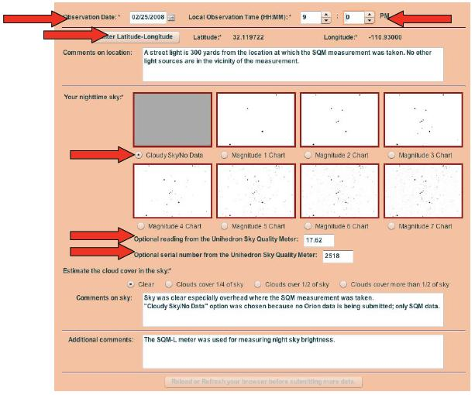

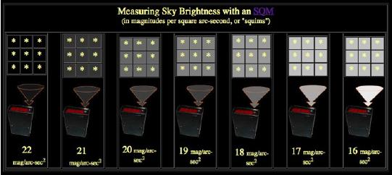SQM and SQM-L measure how much light is registered by the sensor. Then the Meter transforms the quantity of light into magnitude unit on arc-square second. The higher the number shown on the display, the darker the sky. The value of 21,00 presents a very dark sky, but the value of 16,00 presents a light polluted night sky.

In order to compare the observation of SQM-L to the magnitude graph which best matches the following web page is used: <http://www.members.csolutions.net/fisherka/astronote/plan/tlmnelm/html/nelm2bcalc.html/>.

There in the “NELM” box we write the magnitude number chosen from the magnitude graph. Then we click on “calculate” and the value of the SQM-L observation will appear in the right box. Then we continue with the “MPSAS” box, where I fill in the value and click on “calculate”; the limiting magnitude appears and I will know the exact value of the SQM-L. Typically in city the value is magnitude 3 or 4. This value is equal to SQM value of 16,88 on arc square second to 18,04 magnitude arc square second. Currently most of the people live in places with that amount of light pollution and for them is impossible to see above magnitude 6 which best suits 21 magnitude on arc square second and a really dark night sky.

**DEMONSTRATING LIGHT POLLUTION AND PROTECTION**

This demonstration will illustrate the light effects seen in the night sky. We will also use the same demonstration to show how the light pollution can be reduced using protection thus making the lighting more efficient. All the equipment needed can be easily found everywhere.

Equipment

* Planetarium made of cardboard box (with a little opening on one side for the flashlight and very little openings for stars on the other side)
* Plastic cork or similar objects used for protection (cover)
* White surface for the demonstration
* A book or a poster of landscape
* Model cars and people.

**Describing the light pollution**

There are three types of light pollution:

1. Glare - when there is a lot of light in the background. Can you clearly see the faces of the children (me and my brother) who stand in front of the house that is too illuminated?



1. Light trespass- is when unwanted light enters one’s property, for example, shining over a neighbor’s fence. Would you be able to sleep if your bedroom’s window faces the light in the photo below?

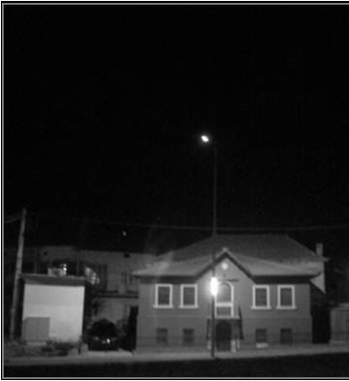

1. Sky glow - as a type of light pollution, appears when all the public city lights are directed toward the sky where the rays of light in the atmosphere scatter and reflect from the aerosols back toward the ground. Would you be able to see the stars in the photo below?

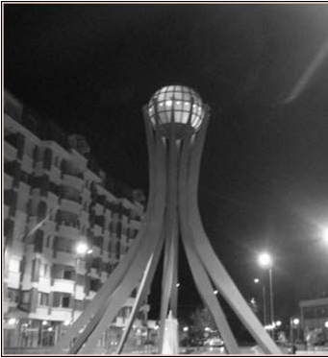

All the photos above illustrate the effect from different types of light pollution made in my town, Prilep.

Lighting

Efficient light should:

* Maximize the wanted effects

1. Good visibility
2. Good atmosphere

* Minimize the unwanted effects

1. Unnecessary energy loss,
2. Glare
3. Unwanted light
4. Skyglow

In order to improve the quality of light:

1. We should pay attention to the effect, not the source
2. The light should be directed down
3. Glare should not be present
4. Light should be used only when and where it is needed
5. There shouldn’t be too much light
6. We should use light sources which use the light in an effective way.

Using shielded texture can maximize the lighting effect, that is we can control the light and minimize the glare, as shown in the photo below.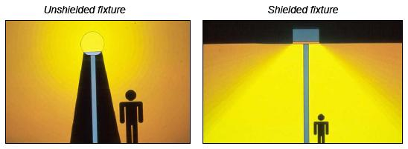

How to demonstrate shielded fixture

We should be in a very dark room with a low ceiling. The desk (surface) needs to be white. If we want to include a landscape we should improvise it with an open book. Then we set the flashlights and we turn them on, they should be set in a vertical position to look as if candles. For example we can use protective caps set on the flashlights. The flashlight is set on an empty bottom on the planetarium.

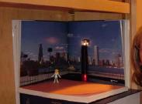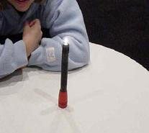

The lights in the room should be turned off and the stars should be projected from the cardboard on the ceiling, using only one flashlight. Now we can see the stars, their visibility and their brightness.

The second flashlight is used as a street lamp set on the desk in front of the landscape. After we turn this second flashlight on, we observe the stars again.

Can you notice any difference? Is the number of the stars the same? Later, we set a cap on the second flashlight so that it presents a shielded fixture. What is the difference between the shielded fixture and the unshielded one? What is the difference towards the stars? What is changed in the area below the fixture?

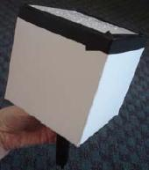

Summary

The audience or the rest of the participants in the observations can discuss the observations and the positive effects of the shielded fixture. Using the shielded fixture the glare is reduced, the stars are more visible in the night sky. The energy is used in a more useful and efficient way because the light is directed downwards and lights the ground, not the night sky.

That is how the life of people improves, as well as the life of all the animals and plants; what’s more it saves money and energy. Not to forget the fact that using this type of lighting our night sky would be darker and “starry”.

My main activity in the above mentioned campaign is to determine the magnitude according to the constellation Orion or Leo, all the other previously mentioned activities and the SQM observations.

I have already sent the results from my observations via Internet, which means they are accessible to scientists, from all over the world, involved in the campaign.

It is very important that the local authorities are familiar with the recent data in order to raise public awareness on the issue of light pollution and darker night sky.

The map with the recent results from the Globe at night campaigns is available on the web page for all the interested citizen-scientists.

**RESULTS FROM THE OBSERVATIONS**

The following table includes the results from some of my recent observations:

|  |  |  |  |  |  |  |  |  |  |
| --- | --- | --- | --- | --- | --- | --- | --- | --- | --- |
| Time | Date | Latitude | Longitude | Location Comments | Mag | Constellation | Cloud cover | Sky Comments | SQM |
| 22:00 | 2/23/2014 | 41.344558 | 21.56111 | Urban location. There are street lights on distance 50 m. | 0 | Orion | 50% | Many clouds (Nimbostratus), and I can not see Orion. | 18,70 |
| 20:30 | 2/19/2014 | 41.35195 | 21.543234 | Urban location-near High school ,,SOU Orde Copela" in the city of Prilep. | 3 | Orion | clear | I can see Orion clearly. | 19,00 |
| 20:30 | 2/20/2014 | 41.570121 | 23.716218 | Many street lights nearby. | 1 | Orion | clear | In the center of the city of Prilep in Macedonia. | 17,50 |
| 21:00 | 2/21/2014 | 41.334585 | 21.55391 | In the park forest. | 4 | Orion | clear | Many stars on the sky. | 18,90 |
| 20:40 | 2/22/2014 | 41.353815 | 21.54529 | Some street lights and lights from the houses but on distance about 100 m. | 4 | Orion | clear | Clear sky. | 19,12 |
| 20:30 | 1/20/2014 | 41.343641 | 21.561922 | Near the stadium in the city of Prilep. | 0 | Orion | > 50% | Cloudy sky | 18,23 |
| 20:40 | 1/21/2014 | 41.352781 | 21.558952 | Urban location. | 0 | Orion | > 50% | So many clouds. | 17,98 |
| 21:45 | 1/22/2014 | 41.344662 | 21.569338 | Light from the houses. | 0 | Orion | > 50% | No any stars. | 18,67 |
| 20:30 | 1/23/2014 | 41.348013 | 21.545563 | Rural location. | 0 | Orion | > 50% | I can not see any stars. | 17,90 |
| 21:40 | 1/24/2014 | 41.354134 | 21.544104 | Near the post office in the city of Prilep. | 0 | Orion | > 50% | No any stars. | 16,98 |
| 20:50 | 2/25/2014 | 41.342278 | 21.556635 | Near the main Church in the city of Prilep in Macedonia. | 0 | Orion | > 50% | Cloudy sky. | 17,67 |
| 20:50 | 2/26/2014 | 41.348335 | 21.562815 | Urban location. | 3 | Orion | 25% | Orion is visible. | / |

**Conclusion**

The SQM is sensitive only to visible light. Its filter, which is situated on the front side of the sensor, blocks the infrared light.

SQM is a precise instrument with a precision of ±10 % (± 0,10 mag/arc sec²). It is also very easy to use. The value is almost immediately shown on the display under urban skies. The observation can last for more than a minute when the night sky is at its darkest, which is when there is no Moon, or when we are far from civilization. The SQM actually measures the brightness of the night sky in the instrument’s view point.

The magnitude arc square second is a logarithmic measuring unit, so when there are great changes in the brightness of the sky there are only a little value alterations shown by the instrument.

The difference of one magnitude is defined as a factor of

(100) (1/5) in received photons. As a result the brightness of the night sky of 5,0 mag/arc sec² equals the declination of degree of photon arrival for 100 factor.

We can transform the SQM-L value from mag/arc/sec² in cd/m² using the following equation:

**[cd/m2] = 10,8· 104 · 10(-0,4 [mag/arc sec² ]**

**Bibliography**

1. This document on citizen-scientists using Sky Quality Meters to monitor light pollution levels in their community was a collaborative effort between Connie Walker at the [National Optical Astronomy Observatory](http://www.noao.edu/#_blank), Chuck Bueter of [nightwise.org](http://nightwise.org/#_blank), Anna Hurst of ASP's [Astronomy from the Ground Up](http://www.astrosociety.org/afgu/index.html#_blank) program, Vivian White and Marni Berendsen of ASP's [Night Sky Network](http://nightsky.jpl.nasa.gov/#_blank) and Kim Patten of the [International Dark-Sky Association](http://www.darksky.org/mc/page.do#_blank) ;

2. Web site [www.globe.gov/GaN/](/C:/Users/Damjanoski/Downloads/www.globe.gov/GaN/) ;

3. Dragan Banjevic, Neda Bokan, Jaroslav Labat, Milan Bozic, Boski Damjanoski “ Scholar Encyclopedia

Драган Бањевиќ, Неда Бокан, Јарослав Лабат, Милан Божиќ, Бошко Дамјаноски, ,,Школска енциклопедија: математика, физика, астрономија и рачунарство,, - Просвета, Београд 1992 ;

4.Antonin Rukl, ,,Constellations et planets,, Zibrairie Grund powr l`alaptalion francaise 1988-Paris;

5. Светлана Ѓорѓева, Катерина Николовска, Проф.др. Ванчо Ѓорѓиев, Корнелија Нушева, Борче Лозановски, Ангел Тодосов, Лилјана Кукунеш, Стојан Манолев, Милан Гугицев, Наталија Ацеска, Каролина Дамјаноска, Прирачник за спроведување на GLOBE програмата, Министерство за животна средина и просторно планирање, ЕВРОПА 92, Скопје, декември 2008.