Discussing the CO₂ in Various Areas of the Campus

LO, CHENG EN
PENG, JIN RUEI
YE, LIAN CIN

New Taipei Municipal
Hsin Tien Senior High School

Teacher: CHEN, CHENG CHANG

The motivation for the study

Due to our natural science classes at school, we've come to understand that both humans and vehicles emit CO₂. Therefore, we want to investigate the levels of CO₂ in various schools to understand how different human activities affect carbon dioxide emissions, and to link this to the issue of global warming.

Research Methods and Materials

Research methods:
We selected six locations on campus for classification: points A, C, and E in the grassy areas; point B by the roadside; and points D and F in the outdoor sports field. Measurements were taken for CO₂ concentration between 4:10 and 5:10. At each location, a CO₂ detector was used to measure for five minutes. We then utilized our custom program to obtain data on the CO₂ variations per second. Finally, we created charts to observe the differences between each location.
Materials:
arduino uno
X-Lan DS-CO2-20 (CO2sensor)

Program development:
To achieve the goal of having the computer read data in terms of time versus carbon dioxide content, I continuously interacted with ChatGPT and modified the code. Finally, I used Putty to automatically convert the data read by the computer into CSV format for output.
Program:
Arduino IDE
Putty

Research Question and Hypothesis

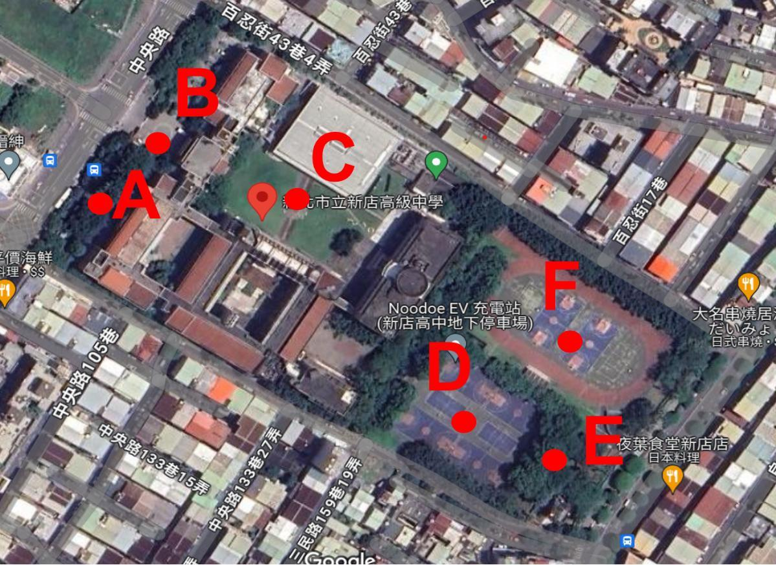
We hypothesize that the CO₂ levels are highest at point B, followed by points D and F, while the lowest levels are observed at points A, C, and E. This is because point B experiences heavy traffic flow, points D and F have 20 to 30 individuals engaging in physical activity, whereas points A, C, and E are generally devoid of people.

Figure 1: Observation site

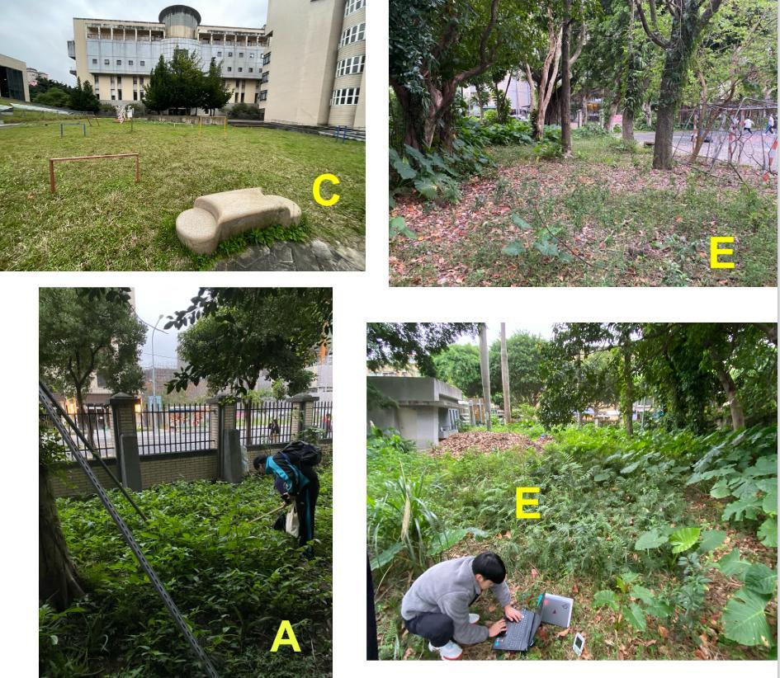
Grassy areas: Points A,
C, E
Number of individuals:
A- 4
C- 4
E- 4
Humidity:70 %
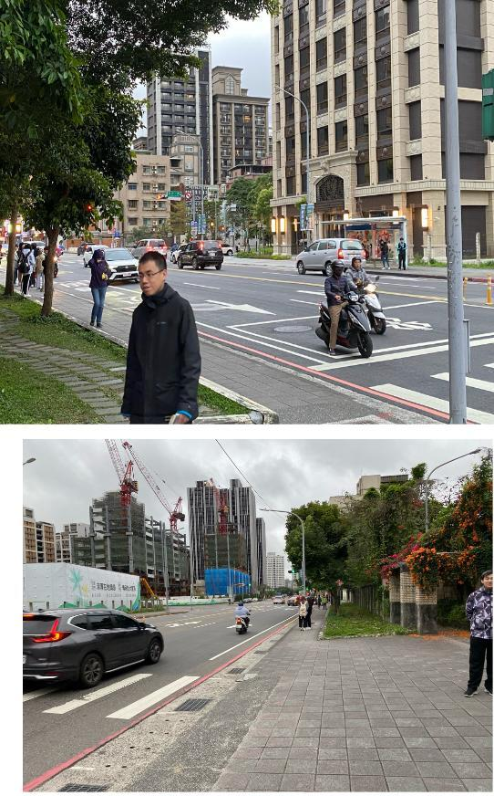
Roadside:Point B
Number of individuals:
about 50 peole
Humidity:70 %

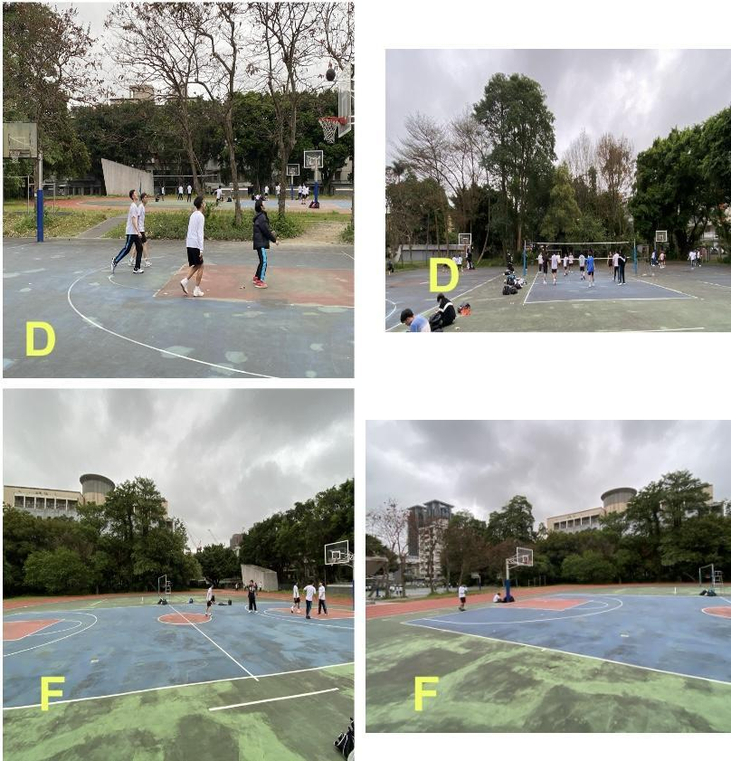
Outdoor sport field:
Points D, F
Number of individuals:
D-57
F-27
Humidity:70 %

Results
Through observation of the chart, it is noticed that the CO₂ content does not remain constant over time but rather fluctuates.
The trend for B_CO₂(ppm) starts from a high point and gradually decreases but ultimately remains at a higher level.
F_CO₂(ppm) and D_CO₂(ppm) are initially higher than points A, C, and E, but subsequently stabilize.
The trends for A_CO₂(ppm), C_CO₂(ppm), and E_CO₂(ppm) are relatively stable, showing slight fluctuations but overall minor changes.
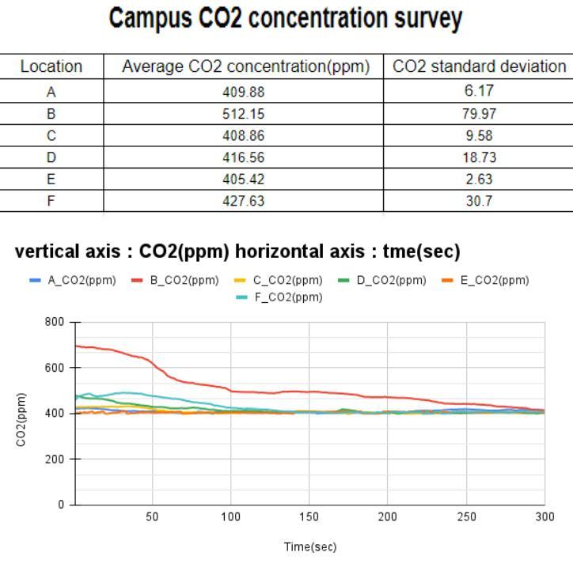
Although initially differing in CO₂ content, all levels show a decreasing trend over time, stabilizing around 150 seconds.

Discussion -
Disparities in CO2 Concentration Across Locations

- In human populations, factors influencing CO₂ concentration may include humidity, environmental temperature, and animal and plant activities. This time, we focus on studying animal and plant activities. Among these factors, we found that the areas with the highest number of automobiles emit the largest initial amounts of CO₂. According to the U.S. Environmental Protection Agency, passenger cars emit approximately 400 grams of CO₂ per mile on average, with a typical passenger vehicle emitting around 4.6 metric tons of CO₂ per year. Additionally, these vehicles also emit carbon monoxide (CO), hydrocarbons (HC), nitrogen oxides (NOx), among other pollutants, all of which are significant contributors to environmental pollution.

- Towards the end of the experiment, as time increases, the atmospheric CO₂ decreases. This reduction can be attributed to atmospheric dispersion.

Discussion -
The Impact of CO₂ on Earth

In recent decades, rapid population growth and industrial development have led to a significant increase in the use of fossil fuels such as coal, oil, and natural gas (as depicted in Figure 2), resulting in the production of CO₂ levels far exceeding those naturally occurring in the past. Additionally, deforestation and the destruction of vegetation, particularly in tropical rainforests, have reduced the opportunity for CO₂ to be converted into oxygen through plant photosynthesis. Because CO₂ is a greenhouse gas, it contributes to trapping infrared radiation near the Earth's surface, leading to rising temperatures, increased melting of polar ice caps, and rising sea levels, thereby posing threats to vulnerable island nations.
In response to these challenges, many countries are aiming to achieve net-zero carbon emissions by 2050. To incentivize emission reduction efforts, policies such as an excess emissions premium have been designed to protect the Earth's habitable environment.
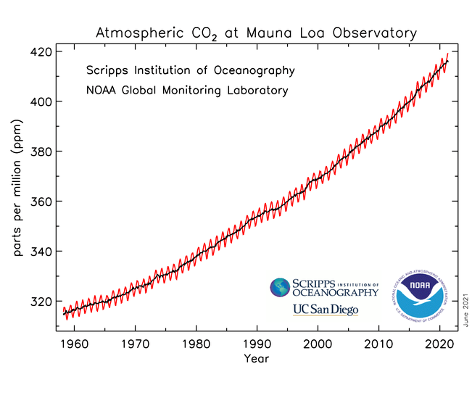

Figure 2:
Changes in CO₂ Concentration Over Time (Years)

Conclusion

- Human activities impact the carbon dioxide emissions in this region.
- Due to air circulation, the concentration of carbon dioxide does not vary significantly over long periods.
- In recent years, there has been a notable increase in carbon dioxide concentration, indicating that carbon dioxide has become a pressing issue in global warming.
- Many countries have begun implementing strategies to achieve net-zero carbon emissions by 2050, including energy transition and an excess emissions premium.

Reference materials

Environmental Information Center https://e-info.org.tw/
Yongjun Green Energy Corporation https://reurl.cc/2zAg6m
Sci-Tech Vista https://reurl.cc/E4Nzga
U.S. Environmental Protection Agency https://reurl.cc/lgbdNE
European Commission Climate Action https://reurl.cc/2zAgla

