Effects of habitat geology and pH value on body color and morphology of Rhinogobius rubromaculatus and species identification

Students: CHANG,WEI-CHIEH
School: New Taipei Municipal Hsin Tien Senior High School
Teacher:CHUNG,I-YING and CHEN,CHENG-CHANG
Email:s010352@htsh.ntpc.edu.tw
23 February 2023

Abstract
Rhinogobius rubromaculatus is a species of fish in the genus Rhinogobius rubromaculatus, a species endemic to Taiwan, distributed in the northern, central and southern streams west of the central mountain range. Due to the disconnection of the inhabited water systems, and the fact that they are terrestrial fish, there is no need to migrate to the sea, and there is no genetic exchange between different groups for a long time, so they have differentiated their own local phenotypes. In this experiment, the appearance and habits of the alligator population in Xindian area will be compared with the appearance characteristics and design experiments will be used to explore the characteristics of the appearance and habits of the alligator population in the Xindian area, and whether it is different from the population in its model locality, so as to confirm whether it belongs to the newly published species Yangmingshan crocodile tiger in taxonomy. The results of this study show that the alligator population in Xindian area is different from the population of its model origin in terms of size and appearance, and is more inclined to Yangmingshan Rhinogobius, so this study believes that the population in Xindian area should belong to Yangmingshan Rhinogobius.

Keywords: Rhinogobius rubromaculatus, species identification, geology and pH

Research question and hypothesis

Research hypothesis
Once when checking the data of the Rhinogobius, I learned in the picture book that the juvenile of Rhinogobius rubromaculatus has no floating period, and can swim just hatched, which is a terrestrial type Rhinogobius, without descending to migrate, and because of this, Rhinogobius rubromaculatus between different watersheds has no gene communication for a long time, so it differentiates into various different phenotypes, and I am attracted by the difference in body color between different watersheds. So embark on a journey to find Rhinogobius rubromaculatus.

Rhinogobius rubromaculatus can often be found in the humble streams along the road when stepping on the green or passing industrial roads in the shallow mountain area, and there are many differences in the individuals collected in different places, and at least two very different ethnic groups can be found in the Xindian area alone. As I saw more and more individuals in different habitats, I found that some individuals from distant but similar habitats were more similar in size and body color than individuals produced in habitats adjacent to habitats or even in the same watershed but with large environmental differences, so I began to think about whether the difference in body size and body color performance of Rhinogobius rubromaculatus was related to the habitat environment, so I used several streams in the mountains near my house as observation points to observe Rhinogobius The correlation between rubromaculatus habitat and body color, I will also use experiments to see if the body color of Rhinogobius rubromaculatus changes due to the difference in the bottom sand of the fish tank. Zhang Daqing and Zeng Weijie pointed out (2014) that "in general, individuals found in small streams under forests are redder, while those in open streams are blacker, which may be the result of long-term evolution in habitat to avoid enemies."。

On September 23 last year (2022), a paper was officially published in the journal Zootaxa, which classified Rhinogobius rubromaculatus in the outer waters of Yangmingshan into a new species Rhinogobius yangminshanensis by differences in genes, head, first dorsal fin markings, and number of second dorsal fin fins (Figures 3 and 4), which is a common fish species in the Yangmingshan stream system." (Chen Yixiong and Chen Tianren, 2018), but the paper does not mention whether the ethnic group in the Xindian area is included, so I also want to observe whether there are differences in the appearance of Rhinogobius rubromaculatus in the Xindian area and individuals in the Taichung Dadu Creek model origin and the outer water system of Yangmingshan through this experiment, so as to distinguish whether the Rhinogobius rubromaculatus in the Xindian area is a new species of Yangmingshan Rhinogobius.

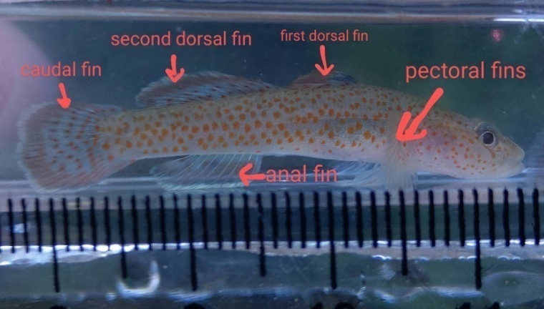
Figure 1. Position and morphology of Rhinogobius rubromaculatus fins

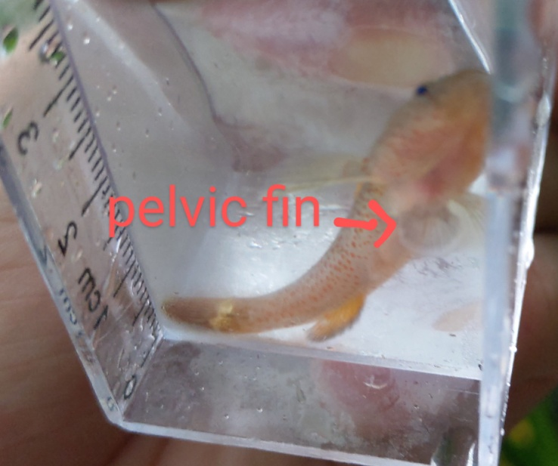
Figure 2. The pelvic fin of the Rhinogobius rubromaculatus is shaped like a suction cup

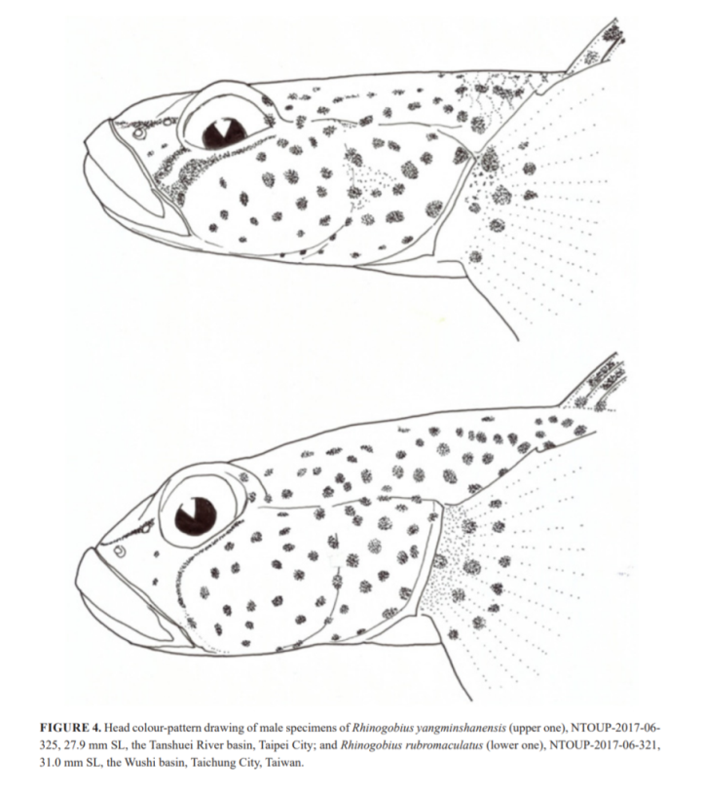
Figure 3. Rhinogobius yangminshanensis (top) and Rhinogobius rubromaculatus (bottom) head differences (image source: cited Chen Yixiong (2022). A new freshwater gobiid species of Rhinogobius Gill, 1859 (Teleostei: Gobiidae) from northern Taiwan。 ZOOTAXA)
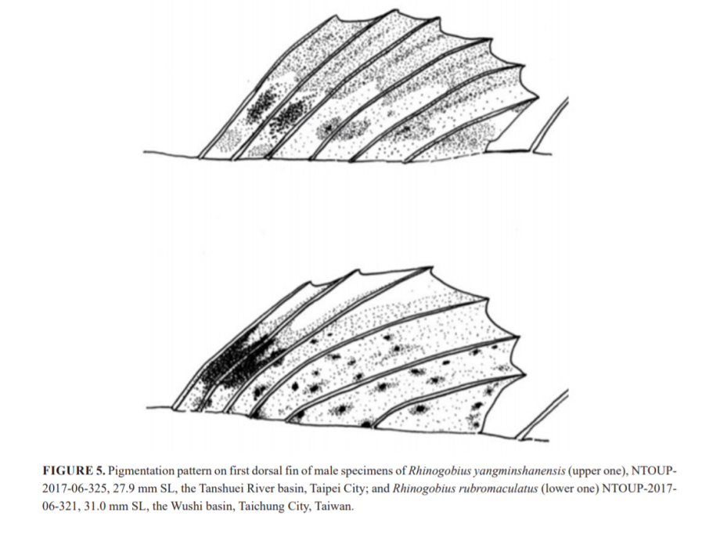
Figure 4. Rhinogobius yangminshanensis (top) differs from Rhinogobius rubromaculatus (bottom) with the first dorsal fin (Image: cited Chen Yixiong (2022). A new freshwater gobiid species of Rhinogobius Gill, 1859 (Teleostei: Gobiidae) from northern Taiwan。 ZOOTAXA)
Research question
- Observe the differentiation of the phenotype of Rhinogobius rubromaculatus in various places and the correlation between water pH
- Observe the effect of environmental differences on the body color of Rhinogobius rubromaculatus in the Xindian area
- Discuss the association between the body size and habitat of Rhinogobius rubromaculatus in the Xindian area
- To explore whether the color of the bottom sand affects the body color of Rhinogobius rubromaculatus in the Xindian area.
- Whether there is a difference in appearance and habit between the Rhinogobius rubromaculatus and the Taichung potbelly creek pattern species in the Xindian area, and I want to know whether it belongs to Rhinogobius yangminshanensis or the alligator of the alligator with an alligator.

Research methods and materials

1. Field observation and collection
The wild habitat of the alligator was observed, and the individuals of the alligator from all over Taiwan were collected for comparison, and the pH value in the water of each habitat was measured to investigate the differentiation of the phenotype of the alligator and whether it was affected by geology and water quality.
In addition, the wild habitat of the alligator in the Xindian area was observed, and the correlation between several different habitats, topography, and companion species and the individual body color produced by its habitat was compared.

Equipment required:
- 2 fishing nets
- 1 pair of rain boots
- 1 observation box

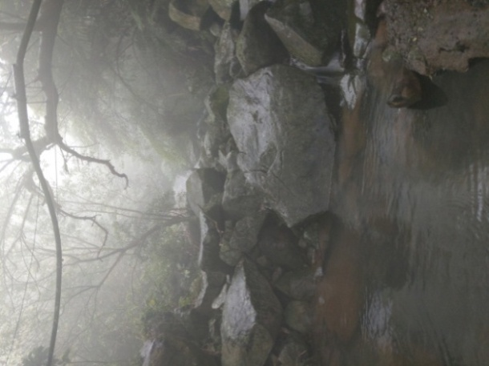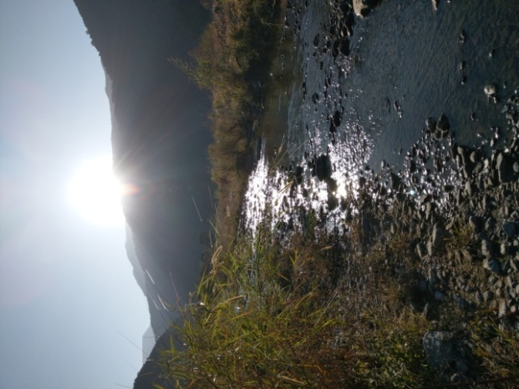
Figure 5. Wild Habitat (Shimen, Northern Taiwan Figure 6. Wild Habitat (Pingtung, Southern Taiwan)
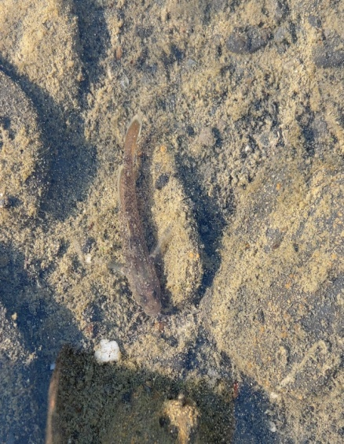
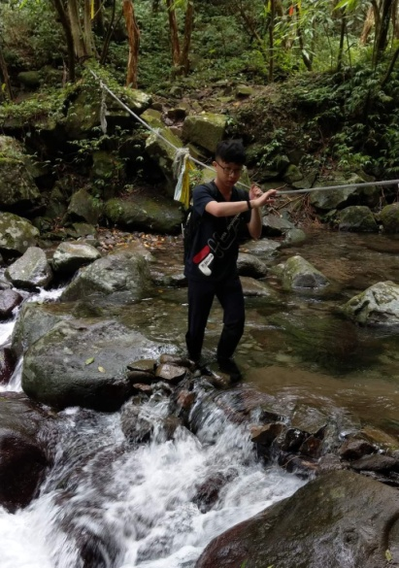
Figure 7. Wild Individual Figure 8. Field Survey

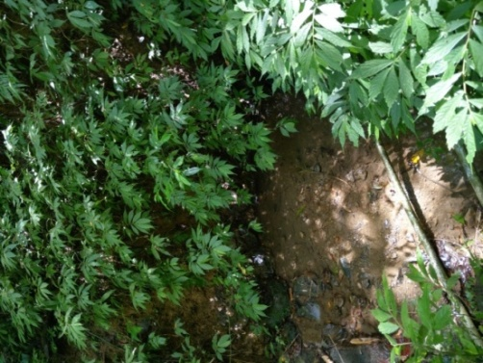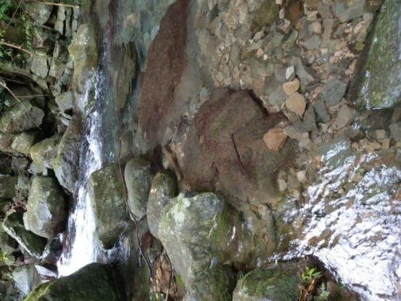
Figure 9. Wilderness habitat(concealed) Figure 10. Wilderness habitat(open water)

2. The color experiment of the bottom sand of the fish tank
Rhinogobius rubromaculatus selected for the cohabitation is placed into a fish tank paved with different bottom sand, and its body color is observed and recorded whether it changes.
- Go to the original habitat to collect Rhinogobius rubromaculatus and the original ground sand.
- Arrange fish tanks, lay three kinds of bottom sand, and erect lamps.
- Measure the water temperature and water quality to confirm whether they are the same
- Put three fish in each tank
- Feed frozen bloodworms regularly every day, and continuously monitor the water temperature and water quality
- And observe the body color change of the fish after one week of feeding

Equipment required
- Fish tank (length 30 cm, width 20 cm) 3 pcs
- Wide test strip 1 copy
- Lamp (60 cm) 1 pcs
- Black sand 1 liter
- Stream sand (original habitat) 1 liter
- White sand and gravel 1 litre
- Thermometer 3 x
- Filter 3 x
- Pump 1 x
- Rhinogobius rubromaculatus 9 pcs

Table 1. Experimental variables
Manipulated variable | Depth of substrate color (dark black gravel, light green jade, natural stream sand)
Controled variable | Water temperature, water quality, origin habitat of fish, lighting, tank size
Response variable | Changes in fish body color.

3. Experiment on liking the environment
In the fish tank, the large stone area and the fine sand area were designed (Figures 7 and 8), and the alligator in the Xindian area and model origin was selected and put into the fish tank, and whether there was a difference in the environment preferred by the all-snouted red-spotted crocodile in the Xindian area and the Taichung Dadu Creek model production area.
- Go to the original habitat to collect short-snouted red-spotted Rhinogobius and native ground sand.
- Arrange fish tanks, lay two kinds of bottom sand, and erect lamps.
- Measure the water temperature and water quality to confirm whether they are the same
- Put in the fish
- Continuously monitor the water temperature and water quality, regularly feed the bloodworms in the right front corner of the fish tank, and time it for one minute, and observe that several alligators with short snouts gather to eat.
- Observe for a week, compare the time when the fish gather in the right front corner of the fish tank to eat, and find out the better environment that the fish prefer, because if the fish only like to inhabit the big rock area, the time to swim to the right front corner of the fish tank to eat will be longer than the fish that prefer to inhabit the fine sand area.
- Remove the fish, replace another batch of alligators from different origins, and repeat steps (1) to (6).

Equipment required:
- Fish tank (length 60 cm, width 30 cm) 1 pcs
- Wide use test strip 1
- computer 1 pcs
- Lamp (60 cm) 1 pcs
- Thermometer 3 pcs
- Upper fine filter 1 pcs
- Fine sand 5 kg
- Large stones
- Rhinogobius yangminshanensis 5 pcs
- Rhinogobius rubromaculatus (new store) 5 pcs
- Rhinogobius rubromaculatus (mode) 5 pcs

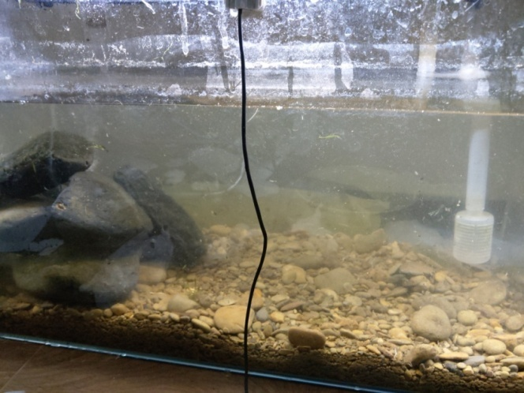
Figure 11. Experimental fish tank

Table 2. Experimental variables
Manipulated variable | Type of substrate (large rocks, fine sand)
Controled variable | Water temperature, water quality, origin habitat of fish, lighting, tank size
Response variable | Differences in the time when fish gather to eat red bugs.

4. Comparison fish
Were collected in the wild habitat of the short-snouted red-spotted crocodile in the Xindian area, the waters around Yangmingshan and the Dadu River model in Taichung, and whether there were differences in the appearance of the alligator of the alligator of different origins.

Equipment required:
- 1 dissecting microscope
- 3 Petri dishes
- 2 forceps
- Rhinogobius yangminshanensis several
- Rhinogobius rubromaculatus (new store) several
- Rhinogobius rubromaculatus (mode) several

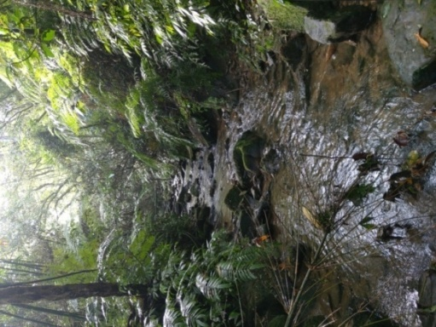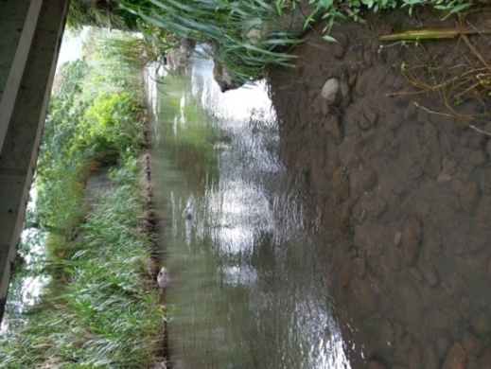
Figure 12. Xindian habitat Figure 13. Habitats around Yangmingshan
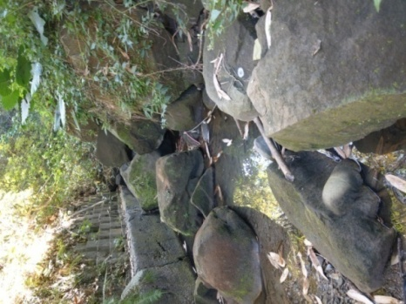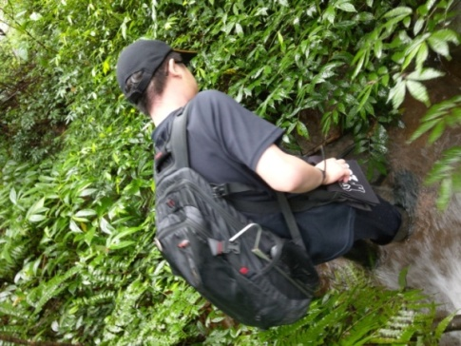
Figure 14. Taichung habitat Figure 15. Collection of Rhinogobius rubromaculatus

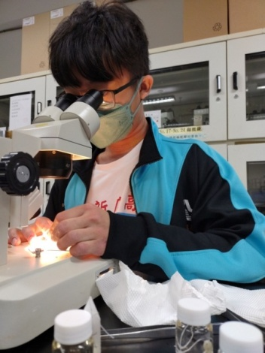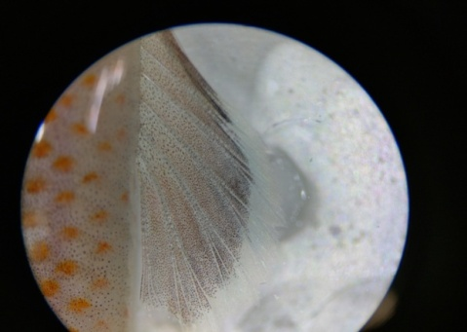
Figure 16. Observation under a dissecting microscope Figure 17. Anal fin rays of the Rhinogobius rubromaculatus under a dissecting microscope

Results

- Observation of phenotypic of Rhinogobius rubromaculatus in different locations
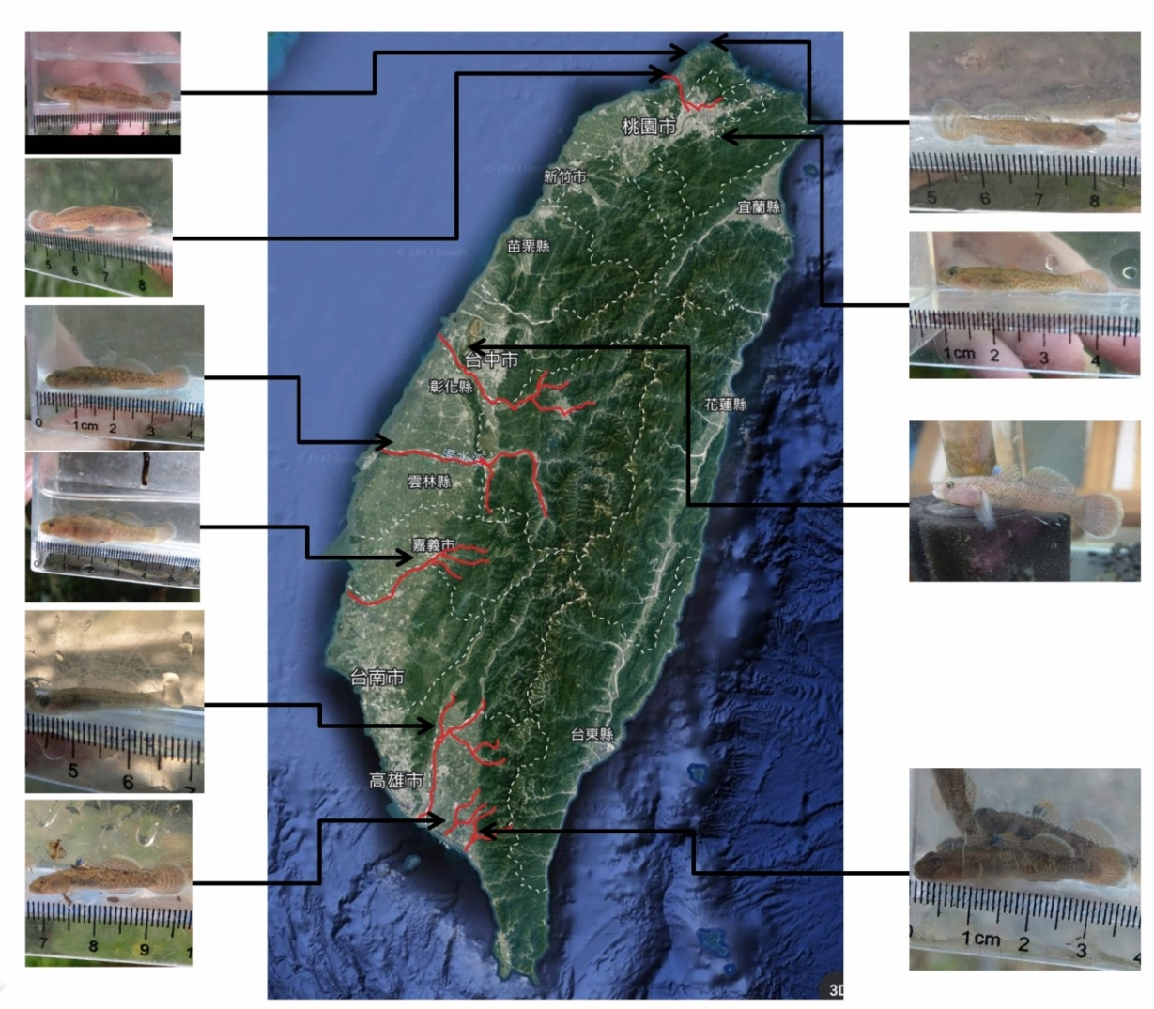
Figure 18. Collecting individuals from each river basin

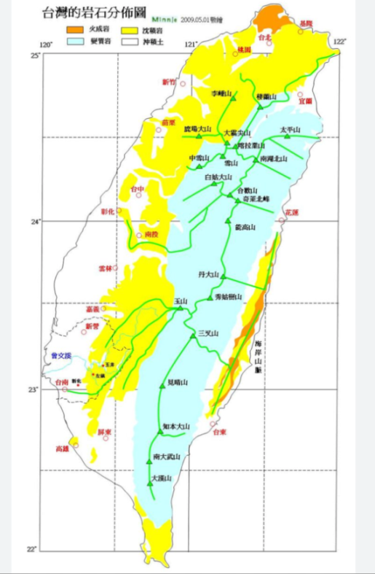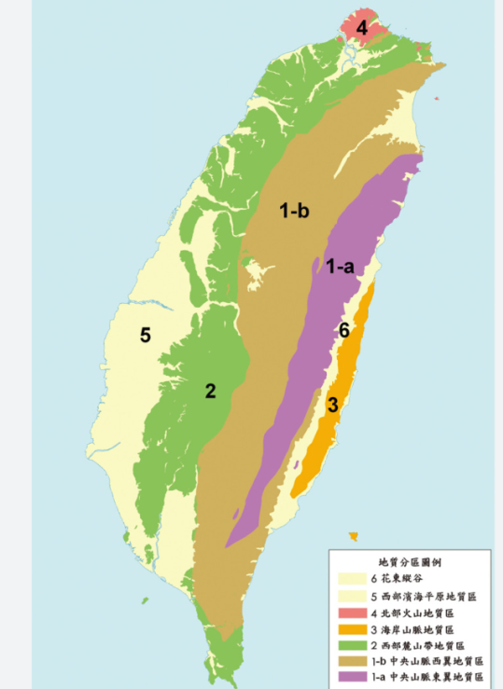
Figure 19. Distribution of rocks in Taiwan - sourced from the internet Figure 20. Geology of Taiwan - sourced from the internet

Table 3. Water quality and geology of rivers in various regions
Location | pH | Geological area | Distribution of rock properties | Distribution of rock types | The body color of the Rhinogobius rubromaculatus (1 to 5 points, from light to dark)
Shimen Xiaokeng Creek | 5 | Geology of Northern Volcanoes | Igneous Rock | Andesite | 1
Sanjhih Unnamed Wild Creek | 6.3 | Geology of Northern Volcanoes | Igneous Rock | Andesite | 2
Tamsui Gongsi Tian Creek | 7.2 | Geology of Northern Volcanoes | Igneous Rock | Andesite | 4
Xindian Meiziliao Creek | 6.5 | Geology of Western Foothills | Sedimentary Rock | Sandstone, Shale | 3
Taichung Wu Creek | 7.5 | Geology of Western Coastal Plain | Alluvial Soil |  | 4
Yunlin Zhuoshui River | 7.7 | Geology of Western Coastal Plain | Alluvial Soil |  | 4
Chiayi Bazhang Creek | 7.3 | Geology of Western Foothills | Sedimentary Rock | Sandstone, Shale | 3
Kaohsiung Gaoping River | 7.7 | Geology of Western Foothills | Sedimentary Rock | Sandstone, Shale | 3
Pingtung Donggang Creek | 7.2 | Geology of Western Coastal Plain | Alluvial Soil |  | 5
Pingtung Linbian Creek | 8.4 | Geology of Western Coastal Plain | Alluvial Soil |  | 5

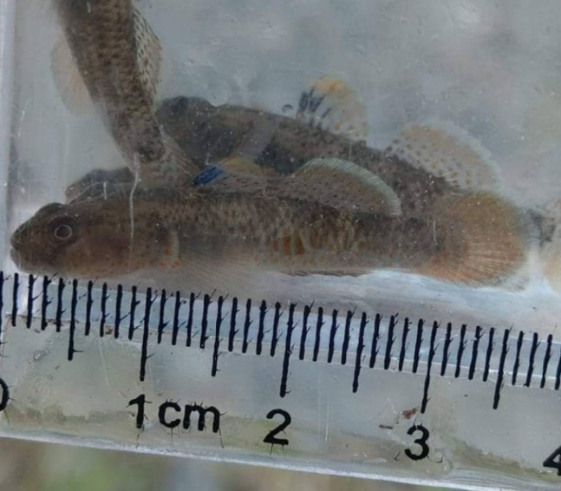
Figure 21. : Collected from PH8 waters

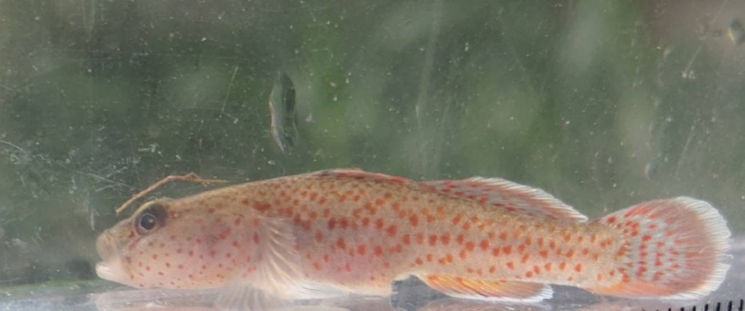
Figure 22. : Collected from PH7 waters

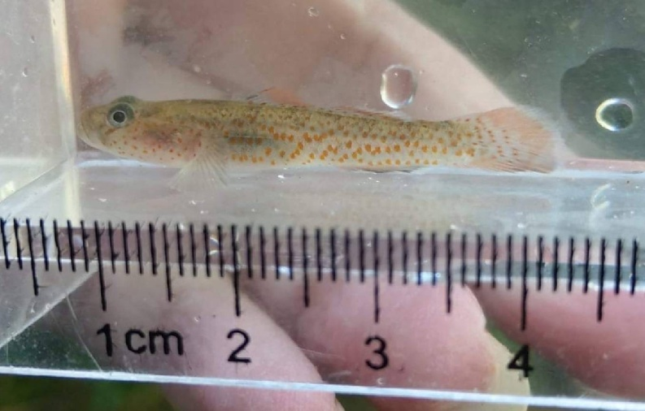
Figure 23. : Collected from PH6 waters

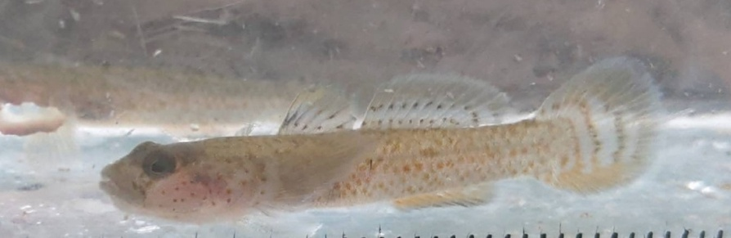
Figure 24. : Collected from PH5 waters

Table 4. Morphological characteristics of Rhinogobius rubromaculatus in different regions
Location | Number of spines in the first dorsal fin | Number of spines in the second dorsal fin | Number of spines in the anal fin | Number of stripes under the eye | Pattern of black spot in the first dorsal fin | Presence of an orange band in the first dorsal fin
Shimen Xiaokeng Creek | 6 | 10 | 9 | 2 | Scattered, light | Yes
Sanjhih Unnamed Wild Creek | 6 | 10 | 9 | 2 | Scattered, light | Yes
Tamsui Gongsi Tian Creek | 6 | 10 | 9 | 2 | Scattered, light | Yes
Xindian Meiziliao Creek | 6 | 10 | 9 | 2 | Scattered, light | Yes
Taichung Wu Creek | 6 | 9 | 8 | 1 | Clustered, deep | No
Yunlin Zhuoshui River | 6 | 9 | 8 | 2 | Clustered, deep | No
Chiayi Bazhang Creek | 6 | 9 | 8 | 2 | Clustered, deep | No
Kaohsiung Gaoping River | 6 | 9 | 8 | 2 | Clustered, deep | No
Pingtung Donggang Creek | 6 | 9 | 8 | 2 | Clustered, deep | No
Pingtung Linbian Creek | 6 | 9 | 8 | 2 | Clustered, deep | No

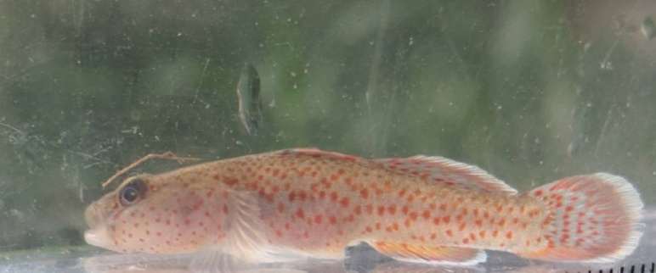
Figure 25. Northern type

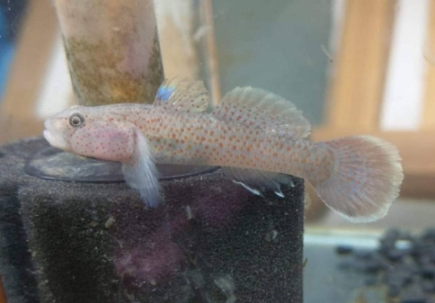
Figure 26. Central type

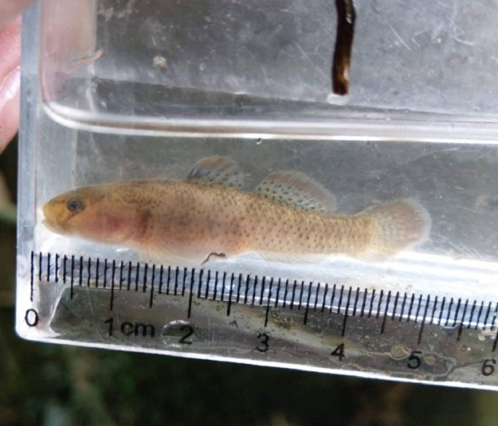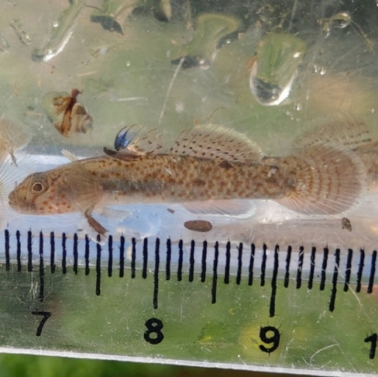
Figure 27. Southern type Figure 27. Pingtung type

- Field observation results in Xindian area

- A Habitat

It is the upper reaches of the stream, the stream bed is mostly gravel, and the amount of sediment is small. The Rhinogobius rubromaculatus mainly inhabits the environment in Figure 30 (the water flow is slow and the river channel is narrow), and the environment in Figure 29 (the water flow is wide and the river channel is wide). No individuals have been found.
This phenomenon is consistent with the habit of "relative to the mainstream, they are more commonly seen in the tributaries" in the literature. The individuals produced in this habitat are between 3.2 and 4.3 cm, and no more than 5 cm have been collected. The 5 cm individual has a darker body color, and the spot color is lighter to orange, and other species have been investigated in the same habitat.

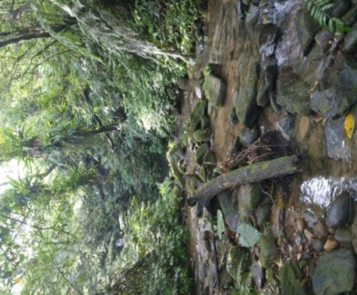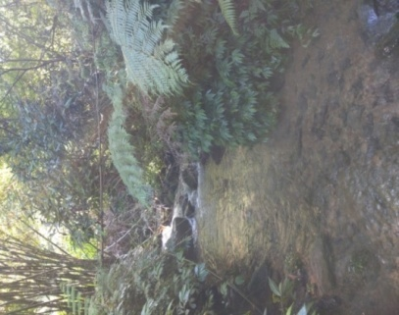
Figure 29. A Habitat Figure 30. A Habitat

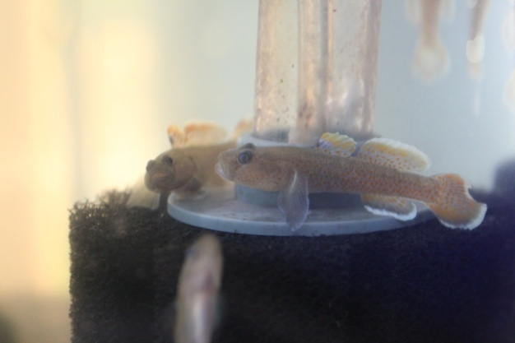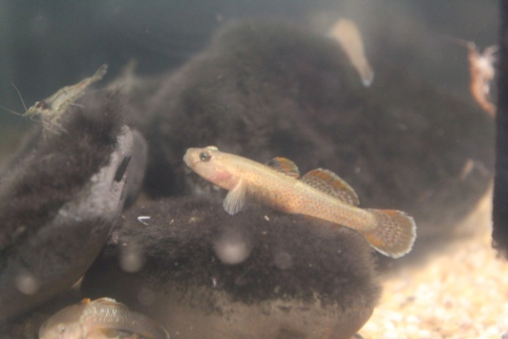
Figure 31. A Habitat male Figure 32. A Habitat female

Table 5. Other species surveyed in the A habitat
Fish: Competitors for the Rhinogobius rubromaculatus
Candidia barbata | Opsariichthys pachycephalus | Opsariichthys evolans
Crustaceans: prey for the Rhinogobius rubromaculatus
Macrobrachium asperulum | Neocaridina denticulata
Aquatic insects: Competitors for the Rhinogobius rubromaculatus
Water squid (not sure about the species)

- B Habitat

It is a ravine, more like a water ditch, with high sediment volume, dense vegetation on both sides, and weak sunlight. The individuals born in this habitat are relatively large in size, generally between 5 and 6.8 cm in both male and female, with bright body color and spot color. Tangerine, while other species have been investigated in the same habitat.

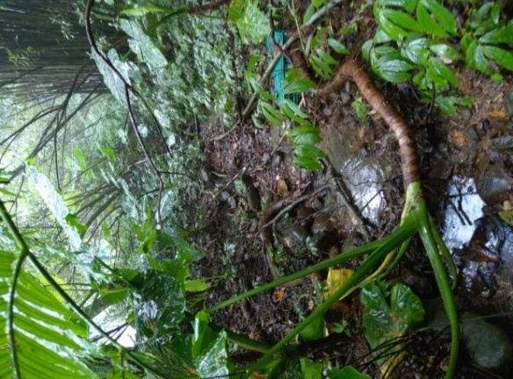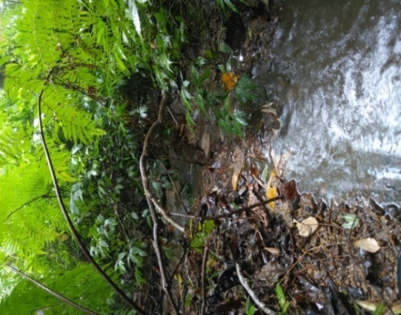
Figure 33. B Habitat Figure 34. B Habitat

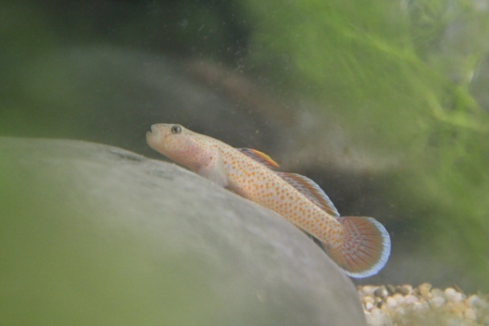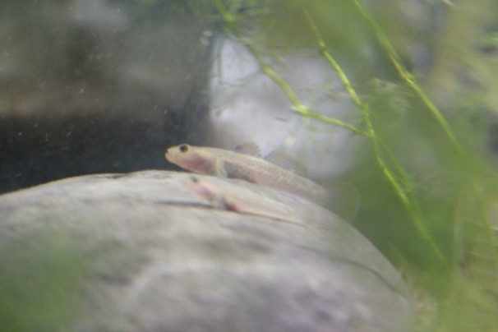
Figure 35. B Habitat male Figure 36. B Habitat female

Table 6. Other species surveyed in the B habitat
Crustaceans: prey for the Rhinogobius rubromaculatus
Caridina formosae | Neocaridina denticulata
Aquatic insects: Competitors for the Rhinogobius rubromaculatus
Water squid (not sure about the species)

- C Habitat

It is a tributary, similar to habitat B, with dense vegetation on both sides, poor sunshine, large amount of sediment, shallow water, and slow flow. The most striking thing is that the female fish produced in this habitat have relatively obvious black horizontal bands on their bodies, and their body size is generally between 4.5 and 5 cm. However, other species have also been investigated in the same habitat, as shown in Table 9.
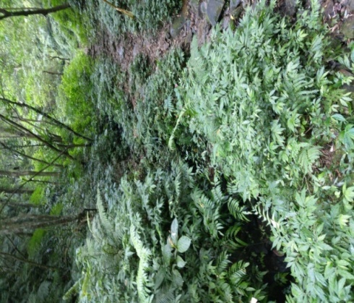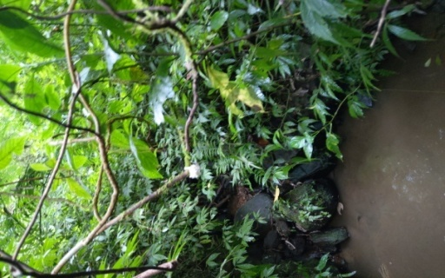
Figure 37. C Habitat Figure 38. C Habitat

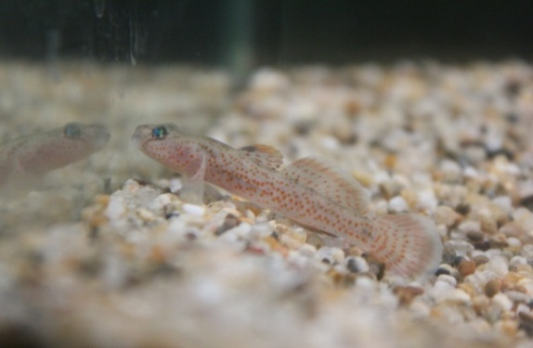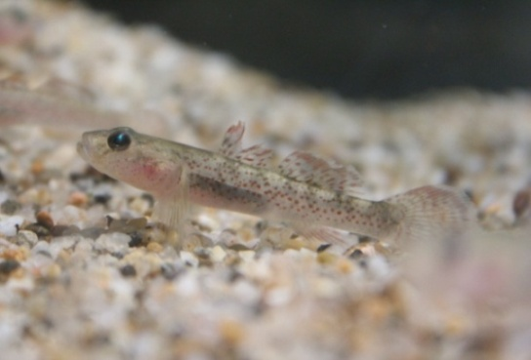
Figure 39. C Habitat male Figure 40. C Habitat female

Table 7. Other species surveyed in the C habitat
Fish: Competitors for the Rhinogobius rubromaculatus
Candidia barbata
Crustaceans: prey for the Rhinogobius rubromaculatus
Macrobrachium asperulum | Geothelphusa candidiensis | Candidiopotamon rathbuni

Table 8. The comparison between the three-habitat environment in Xindian area and the stature of the Rhinogobius rubromaculatus
 | A habitat | B habitat | C habitat
Environment | Upstream | Mountain gully | Tributary
Vegetation | Open | Dense | Dense
Sunlight | Strong | Weak | Weak
Sediment load | Low | High | High
Competitors | 3 type | 1 type | 1 type
Spotted coloration of Rhinogobius rubromaculatus | Tending towards yellow | Tending towards orange | Tending towards red
Body color of Rhinogobius rubromaculatus | Tending towards dark | Tending towards light | Tending towards light
Body shape of Rhinogobius rubromaculatus | 3.2~4.3 cm | 5~6.8 cm | 4.5~5 cm

- The observation results of the fish tank bottom sand color experiment

The six individuals were all from the same river section of the Qingtan River basin in Xindian District, and there was no obvious difference in body color when they were first collected, which was the difference after one week of feeding in a fish tank with the same water temperature and water quality but different bottom sand, it can be found that regardless of the obvious difference in body color and markings between male and female, the individuals raised in the fish tank with dark bottom sand color showed darker body color and more obvious markings, while the individuals in the fish tank with light bottom sand color showed lighter body color and inconspicuous markings.
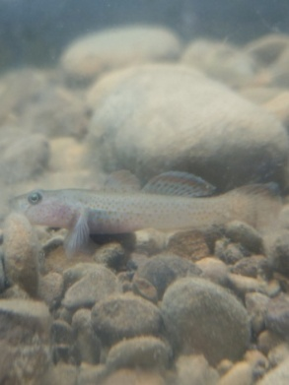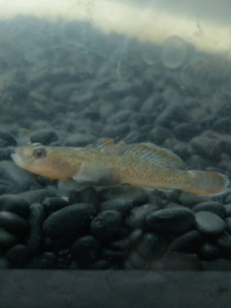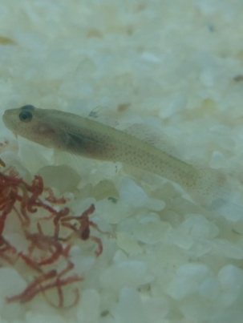
Figure 41. Original Habitat Male Sand Gob Figure 42. Male Sand Goby on Dark Colored Sand Figure 43. Male Sand Goby on Light Colored Sand

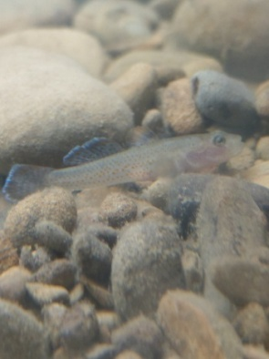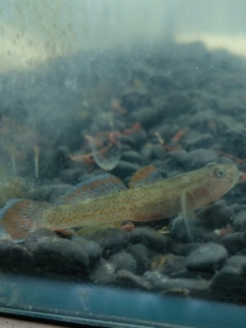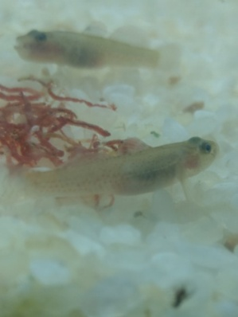
Figure 44. Original Habitat female Sand Gob Figure 42. Female Sand Goby on Dark Colored Sand Figure 43. Female Sand Goby on Light Colored Sand

- Yangmingshan, Xindian and Taichung Dadu Creek individual preference environmental experiment observation results

After experimental observation, it was learned that Rhinogobius rubromaculatus in the Xindian area and the waters around Yangmingshan prefers to inhabit the fine sand area and is less likely to drill into the gaps of large stones, while individuals in Taichung Dadu Creek mode production area hide more in the gaps of large stones, unless lured by bloodworms, otherwise rarely swim to the fine sand area, experimental results can also prove this view, known from the experimental results, In terms of the time required to swim from the hiding place to the right front corner of the fish tank to feed, the time required by the individuals in the type origin is much greater than that of Rhinogobius yangminshanensis and Rhinogobius rubromaculatus in the Xindian area, which indicates that the place where the Rhinogobius rubromaculatus individuals in the type origin are active is in the big stone area, far from the right front corner of the fish tank belonging to the fine sand area.

Therefore, it takes more time to swim over to forage than Rhinogobius yangminshanensis and Rhinogobius rubromaculatus in the Xindian area, and Rhinogobius yangminshanensis and Rhinogobius rubromaculatus in the Xindian area are originally active in the fine sand area, so when the red worms are placed in the right front corner of the fish tank that belongs to the fine sand area, They can come together in a shorter period of time.

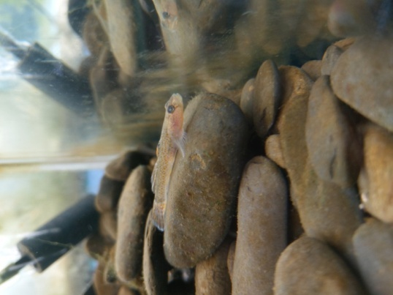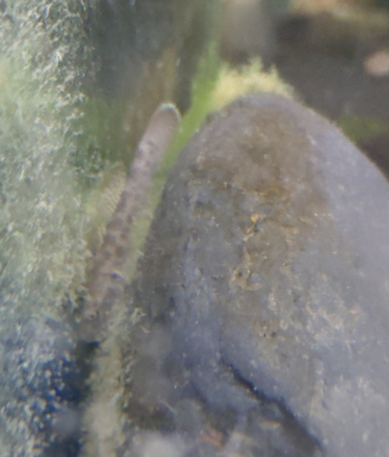
Figure 47. Individual of Xindian Figure 48. Origin individual of Taichung model

Table 9. The time required for a Yangmingshan Rhinogobius individual to swim from the hiding place to the right front corner of the fish tank for food
 | Monday | Tuesday | Wednesday | Thursday | Friday | Saturday | Sunday
5 sec | 0 | 1 | 1 | 1 | 0 | 1 | 2
10 sec | 1 | 1 | 2 | 1 | 3 | 2 | 3
15 sec | 2 | 1 | 2 | 2 | 3 | 4 | 3
20 sec | 2 | 2 | 2 | 3 | 3 | 4 | 3
25 sec | 3 | 2 | 3 | 3 | 4 | 4 | 3
30 sec | 3 | 3 | 4 | 3 | 4 | 4 | 4
35 sec | 3 | 4 | 4 | 5 | 5 | 4 | 4
40 sec | 4 | 5 | 4 | 5 | 5 | 5 | 4
45 sec | 5 | 5 | 5 | 5 | 5 | 5 | 4
50 sec | 5 | 5 | 5 | 5 | 5 | 5 | 5
55 sec | 5 | 5 | 5 | 5 | 5 | 5 | 5
60 sec | 5 | 5 | 5 | 5 | 5 | 5 | 5

Table 10. The time required for a Xindian Rhinogobius individual to swim from the hiding place to the right front corner of the fish tank for food
 | Monday | Tuesday | Wednesday | Thursday | Friday | Saturday | Sunday
5 sec | 0 | 1 | 1 | 2 | 1 | 2 | 1
10 sec | 1 | 1 | 2 | 2 | 1 | 2 | 1
15 sec | 2 | 2 | 2 | 2 | 2 | 3 | 1
20 sec | 2 | 2 | 3 | 2 | 2 | 3 | 1
25 sec | 3 | 4 | 3 | 2 | 2 | 4 | 3
30 sec | 4 | 4 | 4 | 3 | 2 | 5 | 4
35 sec | 4 | 5 | 4 | 3 | 4 | 5 | 5
40 sec | 4 | 5 | 5 | 3 | 5 | 5 | 5
45 sec | 4 | 5 | 5 | 3 | 5 | 5 | 5
50 sec | 4 | 5 | 5 | 4 | 5 | 5 | 5
55 sec | 5 | 5 | 5 | 5 | 5 | 5 | 5
60 sec | 5 | 5 | 5 | 5 | 5 | 5 | 5

Table 11. The time required for a the type locality Rhinogobius rubromaculatus individual to swim from the hiding place to the right front corner of the fish tank for food
 | Monday | Tuesday | Wednesday | Thursday | Friday | Saturday | Sunday
5 sec | 0 | 0 | 0 | 0 | 0 | 0 | 0
10 sec | 0 | 0 | 1 | 0 | 0 | 0 | 0
15 sec | 1 | 0 | 1 | 0 | 0 | 2 | 0
20 sec | 2 | 2 | 1 | 0 | 1 | 2 | 1
25 sec | 2 | 2 | 1 | 1 | 2 | 2 | 1
30 sec | 2 | 3 | 1 | 1 | 2 | 2 | 1
35 sec | 2 | 3 | 1 | 2 | 2 | 2 | 2
40 sec | 2 | 3 | 2 | 2 | 2 | 2 | 2
45 sec | 2 | 3 | 2 | 2 | 4 | 3 | 2
50 sec | 2 | 3 | 2 | 2 | 4 | 3 | 2
55 sec | 3 | 3 | 2 | 3 | 4 | 3 | 2
60 sec | 3 | 3 | 2 | 3 | 4 | 3 | 3

- Compare the appearance of fish

The appearance of Rhinogobius rubromaculatus in the Xindian area, whether in the number of fins, head pattern and pattern and the first dorsal fin spot, is more consistent with the individual type of Rhinogobius yangminshanensis, and is different from the Rhinogobius rubromaculatus Taichung Dadu Creek model origin species.
- Rhinogobius rubromaculatus in the Xindian area has two stripes under the eyes, and the Rhinogobius rubromaculatus model has only one individual
- The Rhinogobius rubromaculatus male in the Xindian area has a mouth split that only reaches the anterior edge of the pupil, and the male fish in the Rhinogobius rubromaculatus model has only reached the anterior edge of the pupil reaches the middle of the eye.
- The first dorsal fin dark spot of the Rhinogobius rubromaculatus individual in the Xindian area is lighter and scattered than that of the Rhinogobius rubromaculatus model origin individual
- The Rhinogobius rubromaculatus individual in the Xindian area has an orange band above the first dorsal fin, which can reach 1/3 of the first dorsal fin area. The first dorsal fin of Rhinogobius rubromaculatus native individuals has no orange band and is translucent.
- The second dorsal fin of the alligator individual in the Xindian area has ten rays, and the first dorsal fin of the Rhinogobius rubromaculatus type individual has only nine dorsal fins
- The fin of the Rhinogobius rubromaculatus individual in the Xindian area has nine fin bars, and the fin of the Rhinogobius rubromaculatus model individual has only eight fins
- Rhinogobius rubromaculatus in the Xindian area has a brown body color, Rhinogobius rubromaculat .

Table 12. The number of rays of each fin of Rhinogobius rubromaculatus
 | Number of pectoral fin rays | Number of first dorsal fin rays | Number of second dorsal fin rays | Number of anal fin rays
A habitat No. 1 individual around Yangmingshan | 16 | 6 | 10 | 9
A habitat No. 2 individual around Yangmingshan | 16 | 6 | 10 | 9
A habitat No. 3 individual around Yangmingshan | 16 | 6 | 10 | 9
A habitat No. 4 individual around Yangmingshan | 16 | 6 | 10 | 9
B habitat No. 1 individual around Yangmingshan | 16 | 6 | 10 | 9
B habitat No. 2 individual around Yangmingshan | 16 | 6 | 10 | 9
B habitat No. 3 individual around Yangmingshan | 16 | 6 | 10 | 9
B habitat No. 4 individual around Yangmingshan | 16 | 6 | 10 | 9
B habitat No. 5 individual around Yangmingshan | 16 | 6 | 10 | 9
A habitat No. 1 individual around Xindian | 16 | 6 | 10 | 9
A habitat No. 2 individual around Xindian | 13 | 6 | 10 | 9
A habitat No. 3 individual around Xindian | 16 | 6 | 10 | 9
A habitat No. 4 individual around Xindian | 16 | 6 | 10 | 9
B habitat No. 1 individual around Xindian | 16 | 6 | 10 | 9
B habitat No. 2 individual around Xindian | 16 | 6 | 10 | 9
B habitat No. 3 individual around Xindian | 16 | 6 | 10 | 9
C habitat No. 1 individual around Xindian | 16 | 6 | 10 | 9
C habitat No. 2 individual around Xindian | 16 | 6 | 10 | 9
C habitat No. 3 individual around Xindian | 16 | 6 | 10 | 9
C habitat No. 4 individual around Xindian | 16 | 6 | 10 | 9
C habitat No. 5 individual around Xindian | 16 | 6 | 10 | 9
Taichung Dadu Creek Model Habitat No. 1 individual | 16 | 6 | 9 | 8
Taichung Dadu Creek Model Habitat No. 2 individual | 17 | 6 | 9 | 8
Taichung Dadu Creek Model Habitat No. 3 individual | 16 | 6 | 9 | 8
Taichung Dadu Creek Model Habitat No. 4 individual | 16 | 6 | 9 | 8
Taichung Dadu Creek Model Habitat No. 5 individual | 16 | 6 | 9 | 8
Taichung Dadu Creek Model Habitat No. 6 individual | 16 | 6 | 9 | 8
Taichung Dadu Creek Model Habitat No. 7 individual | 16 | 6 | 9 | 8

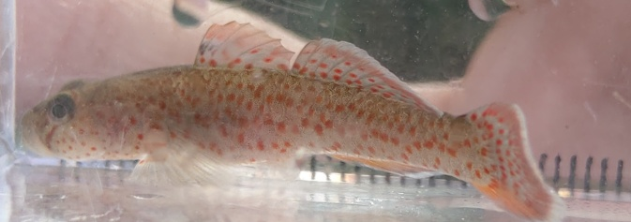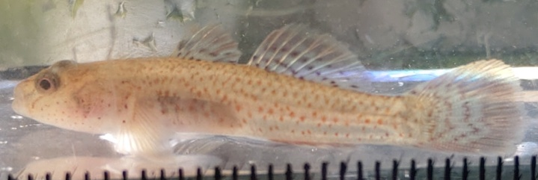
Figure 49. Male Fish in Yangmingshan Surrounding Area Figure 50. Female Fish in Yangmingshan Surrounding Area

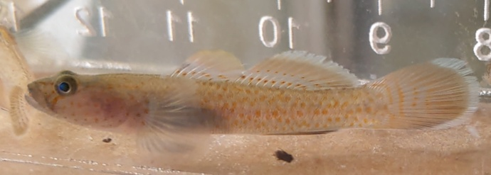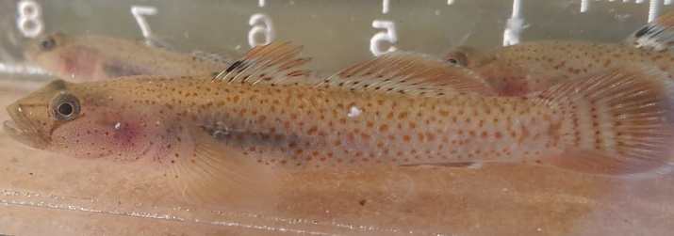
Figure 51. Male Fish in Xindian Area Figure 52. Female Fish in Xindian Area

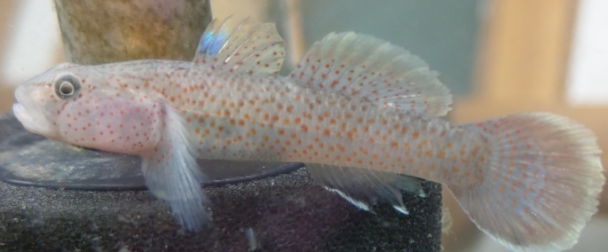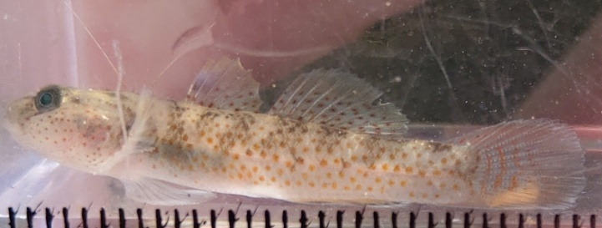
Figure 53. Male Fish in Dadu Creek Breeding Ground in Taichung Figure 54. Female Fish in Dadu Creek Breeding Ground in Taichung

Discussion

1. Differentiation of the Rhinogobius rubromaculatus phenotype in various place

From field collection and observation, it is known that the Rhinogobius rubromaculatus phenotype in Taiwan is slightly differentiated, I think it can be divided into four types according to the appearance, the first is distributed north of Hsinchu, this type has now become a new species Rhinogobius yangminshanensis, characterized by two stripes under the eyes, The first dorsal fin has scattered black spots and is lighter in color, the second dorsal fin has ten fin bars, the fin has nine fin bars, the second is distributed in the north of the cloud forest south of Miaoli, this type is the pattern type of the short-snouted red-spotted crocodile, characterized by a stripe under the eyes, the first dorsal fin black spots are clustered and darker in color, the second dorsal fin has nine fin bars, the fin has eight fin bars, the third is distributed south of Yunlin to the north of Gaoping Creek, characterized by two stripes under the eyes, the first dorsal fin has a concentrated and darker black spot, and the second dorsal fin has nine fin bars, The fin has eight rays, the fourth species is distributed south of Gaoping Creek, this type is similar to the third type, but the body color is dark.

2. The association between the body color of Rhinogobius rubromaculatus and water pH value in various places

From field collection and observation, it was found that in most cases, the body color of Rhinogobius rubromaculatus inhabiting the alkaline water quality will be deeper than that of the individuals living in the acidic water, and through field measurement of water quality, it is known that the water quality of the alluvial soil area is mostly alkaline, and Rhinogobius inhabiting this area Rhinogobius rubromaculatus has the darkest body color, followed by areas of sandstone and shale, and the most acidic is the distribution area of igneous rocks, which is the lightest body color of Rhinogobius rubromaculatus.

3. Effects of environmental differences on the body color of alligator in Xindian area

From this study, it is known that Rhinogobius rubromaculatus in the Xindian area in terms of body color, in addition to the habit of not using sea migration because of the terrestrial type Rhinogobius, so that individuals in different watersheds have no gene communication for a long time, resulting in many distinctive phenotypes between different watersheds, habitat environment is also one of the factors affecting the body color performance of Rhinogobius rubromaculatus, in the more hidden the habitat, Due to the low pressure of predation, the more vivid the body color and markings, on the contrary, in open habitats, Rhinogobius rubromaculatus generally shows a darker body color in order to avoid natural predators, such as individuals collected in habitat A are darker than individuals in B and propylene habitat, and these results are similar to the literature "In general, individuals found in small streams under the forest are redder, and open streams are blacker, which may be the result of long-term evolution in habitat to avoid enemies" (Zhang Daqing, Zeng Weijie, 2014), in the same water temperature and water quality but different shades of bottom sand, Rhinogobius rubromaculatus will form a protective color by changing the body color to the environment by a small amount, such as in the observation of the bottom sand color experiment in the fish tank, the body color of individuals raised in black bottom sand fish tanks is significantly darker than that of individuals in white bottom sand fish tanks of fish reared.

4. The Xindian area Rhinogobius rubromaculatus is associated with body size and habitat

Before starting the study, I thought that a wider river habitat could conserve larger individuals, but the observation was the opposite, the large population in the Xindian area all inhabited smaller water bodies, and these habitats all have some commonalities, hidden and less other species, less competition and predation pressure, so I think the alligator in the Xindian area has nothing to do with the size of the habitat in terms of body size, mainly depends on the habitat environment and the situation of the companion species. In terms of body size, the size of Rhinogobius rubromaculatus in the Xindian area has nothing to do with the size of the habitat and the width of the river, mainly depending on the other species of its habitat, the number of species is smaller and the river channel is narrow, but it is easier to conserve larger individuals, speculating that the reason should be related to the food chain, in some habitats The alligator is the top of its food chain, and there are no other competitors, food is sufficient, so there are many individuals who can continue to grow. In habitats where the number of species is abundant, there are many competitors, the river channel is wide and the concealment is poor, and it is easy to be captured by predators, there are fewer large individuals.

5. To explore whether the color of the bottom sand affects the body color of Rhinogobius rubromaculatus in the new store area

From the fish tank bottom sand color experiment, it was known that under the condition that the water temperature and water quality were the same and there was no interference from other species, Rhinogobius rubromaculatus may be integrated into the environment by changing the body color slightly to form a protective color in the environment with different shades of bottom sand.

- Whether there are differences in appearance and habits between the ethnic groups in the Xindian area Rhinogobius rubromaculatus and the model production area?

Habit
From the experiment of liking the environment, it is known that the Rhinogobius rubromaculatus in the Xindian area prefers to move on fine sand, while the ethnic groups in the Taichung Dadu Creek pattern breeding area prefer to move in the fine slits between the large stones, especially when avoiding enemies, when collecting Rhinogobius yangminshanensis and Rhinogobius rubromaculatus in the area around Xindian and Yangmingshan. Often with hands or feet can drive Rhinogobius rubromaculatus into the fishing net, and when collecting in the Taichung potbelly creek mode production area, the alligator tiger will immediately burrow into the stone crevice when it finds movement, and it is necessary to vigorously turn the stone over to drive it into the fishing net, and during the experiment, it was also accidentally found that the population in the model origin has the habit of preying on fish of one to two centimeters, which is less common in Rhinogobius around Xindian and Yangmingshan In rubromaculatus, I think the above two habit differences should be related to its native habitat, Xindian and Yangmingshan area collection of Rhinogobius yangminshanensis and alligator alligator generally inhabit tributaries or ravines, most of these areas are simpler species, few competitors, and in the middle of the river can often be found in the mainstream of the wide river channel Rhinogobius rubromaculatus population. Therefore, in order to compete with other species in the mainstream, they evolved habits that were different from those of northern populations.

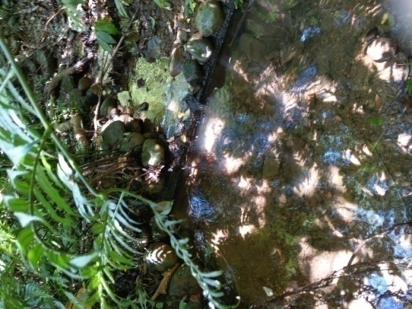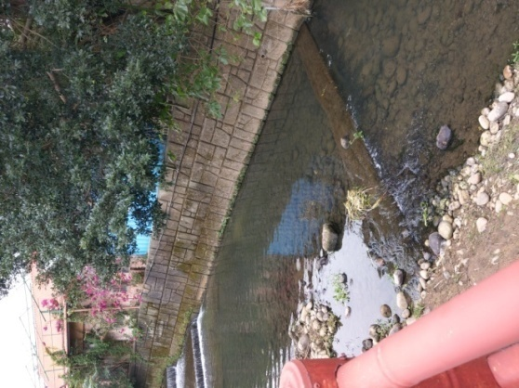
Figure 55. Valley in Xindian area Figure 56. Mainstream of central river

Exterior
The Rhinogobius rubromaculatus ethnic groups in the Xindian area are more inclined to Rhinogobius yangminshanensis in appearance, including two stripes in front of the eyes, the overall body size is slender and slender, the first dorsal fin is spotted, the second dorsal fin has ten fin bars and the fin has nine more fin bars than the type species, etc., which is obviously different from the type species of Rhinogobius rubromaculatus. Therefore, I think that the Rhinogobius rubromaculatus in the Xindian area should be classified as the newly published Rhinogobius yangminshanensis.
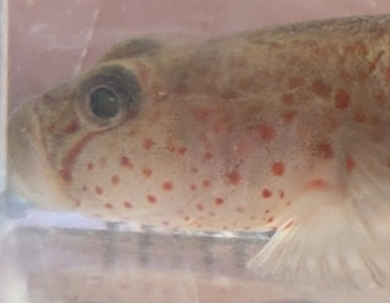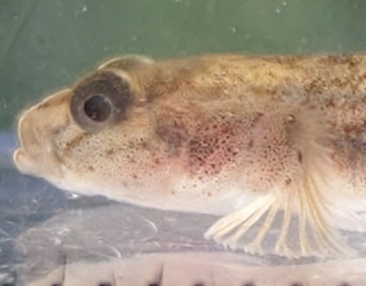
Figure 57. Head of male Rhinogobius from Yangmingshan Figure 58. Head of female Rhinogobius from Yangmingshan

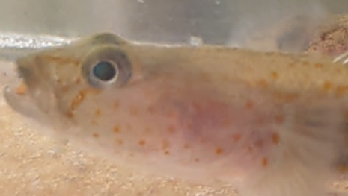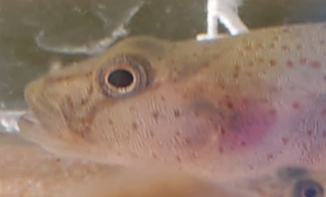
Figure 59. Head of male Rhinogobius rubromaculatus from Xindian Figure 60. Head of female Rhinogobius rubromaculatus from Xindian

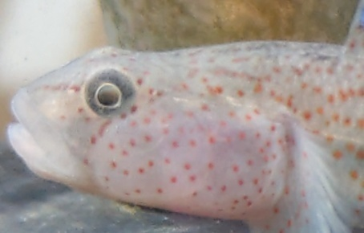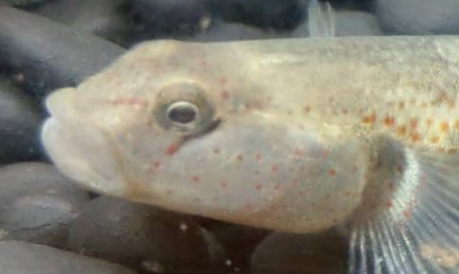
Figure 61. Head of male Rhinogobius from the Taichung Dadu Creek model breed Figure 62. Head of female Rhinogobius from the Taichung Dadu
Creek model breed

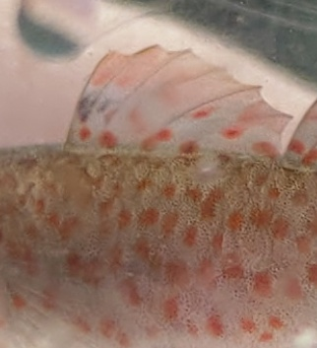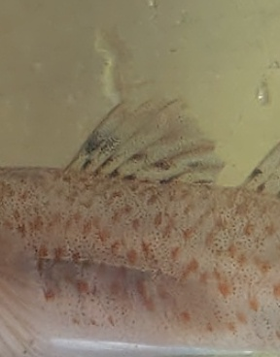
Figure 63. The first dorsal fin of a male Rhinogobius from Yangmingshan Figure 64. The first dorsal fin of a female Rhinogobius from Yangmingshan

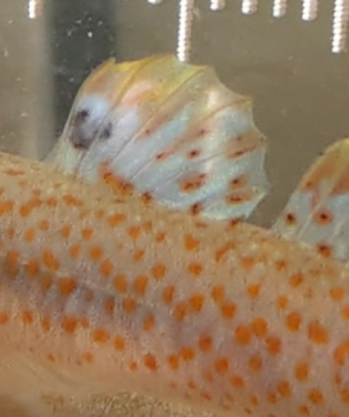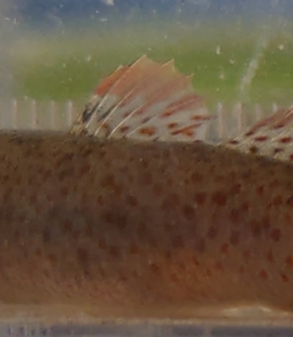
Figure 65. The first dorsal fin of a male Rhinogobius from Xindian Figure 66. The first dorsal fin of a female Rhinogobius from Xindian

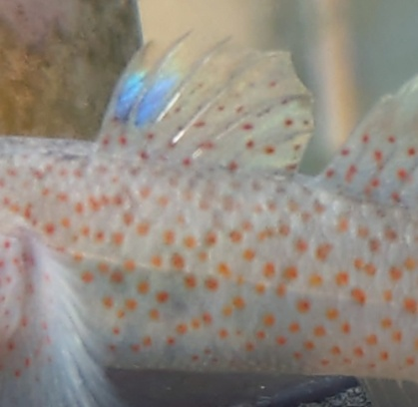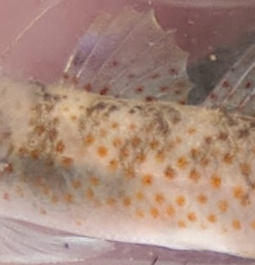
Figure 67. The first dorsal fin of a male Rhinogobius Figure 68. The first dorsal fin of a female Rhinogobius from Taichung Dadu Creek model
from Taichung Dadu Creek model breed breed
Conclusion

- from field observation to know that Taiwan's Rhinogobius rubromaculatus can be roughly divided into four phenotypes, Hsinchu north of the type (now independent into a new species Rhinogobius yangminshanensis), Miaoli south to the north of the cloud forest type, this is the model type, the south of the cloud forest to the north of Gaoping Creek, the south of Gaoping Creek type, and the pH value of the water will also have a resonance on its body color, generally speaking, the more acidic the water quality, the lighter the body color, The alkaline the body color, the darker the color.
- In the more hidden and shady the habitat, due to the low pressure of predation, the more vivid the body color and markings, on the contrary, in the open and sunny habitat, Rhinogobius rubromaculatus generally shows a darker body color to avoid natural predators.
- Rhinogobius rubromaculatus in the Xindian area has nothing to do with the size of the river channel in the Xindian area, but is mainly related to the habitat environment and the situation of the associated species.
- In environments where the water temperature and water quality are the same but the color of the bottom sand is different, Rhinogobius rubromaculatus will form a protective color by changing the body color slightly into the environment.
- Individuals of Rhinogobius rubromaculatus and Taichung potbelly creek type species in various parts of the Xindian area are different in the number of second dorsal fin and fin rays, head pattern and pattern, and first dorsal fin spots, so if classified by type species, it is preliminarily judged that the Rhinogobius rubromaculatus population in the Xindian area should belong to the newly classified Rhinogobius yangminshanensis.

Bibliography and citations

周銘泰、高瑞卿、張瑞宗、廖峻(2020)。臺灣淡水及河口魚蝦圖鑑。晨星出版社。

汪靜明(1993)。臺中縣魚類資源。臺中縣政府。

詹見平(1994)。臺中縣大甲溪魚類誌。臺中縣立文化中心。

林春吉(2007)。臺灣淡水魚蝦大圖鑑(下)。天下文化。

張大慶、曾偉杰(2014)。鰕虎圖典。魚雜誌社。

佐土哲也、關慎太郎、廖德裕、徐瑜芳(2020)。世界溫帶淡水魚圖鑑。臺灣東販出版。

陶天麟(2004)。臺灣淡水魚地圖。晨星出版。

陶天麟(2006)。臺灣淡水魚圖鑑。人人出版。

沈世傑、吳高逸(2011)。臺灣魚類圖鑑。國立海洋生物博物館。

楊正雄、曾子榮、林瑞興、曾晴賢、廖德裕(2017)。臺灣淡水魚類紅皮書。行政院農業
委員會特有生物研究保育中心、行政院農業委員會林務局。

陳義雄、方力行(1999)。臺灣淡水及河口魚類誌。國立海洋生物博物館。

陳義雄、陳天任(2018)。陽明魚蝦蟹。陽明山國家公園管理處

陳義雄(2009)。臺灣河川溪流的指標魚類 第一冊 初級淡水魚類。國立臺灣海洋大學。

I-Seiung Chen,Shen-Chin Wang＆Kwong-Tsao Shao(2022)。A new freshwater gobiid species of Rhinogobius Gill, 1859 (Teleostei: Gobiidae) from northern Taiwan。ZOOTAXA,5189(1),29-44 。file:///C:/Users/lalab/Desktop/47067-Article%20Text-50570-54563-10-20220923.pdf

田口哲(2021)。日本の淡水魚図鑑。誠文堂新光社。

