Finding Microplastics In Campus
Student Names : TSAI, CHIA-EN / SU, CHIH-HUNG
Teacher Name : CHEN, CHENG-CHANG / BAI, PEI-YI
School Name : Hsin Tien Senior High school
Country : Taiwan Partnership
Date : 2022/3/8

Abstract：
Nowadays, due to the dissemination of mass media, people are paying more and more attention to the issue of microplastics.
We want to know through experiments how much microplastics are in the drinking water of the drinking fountains on campus, and whether the height of the floor will affect the microplastics content of the water from the drinking fountains, and what methods can be used to effectively reduce the microplastics content that people eat , and finally discuss our findings.

Research Questions：
1. How much microplastics are in drinking water
2. Does the temperature of the water affect the microplastic content in the water?
3. Whether cleaning the water outlet of the water dispenser can reduce the microplastic content of drinking water
4. Will the water outlet of the water dispenser on different floors have different microplastic content due to different air turbidity?
5. How much microplastics everyone consumes unknowingly from drinking water every day

Hypothesis：
1. The content of microplastics in drinking water should not exceed 10/liter
2. The microplastic content of hot water may be less due to the high temperature
3. Cleaning the water outlet of the water dispenser can reduce the microplastics in drinking water
4. The air on the lower floor may be more turbid, so the content of microplastics attached to the water outlet of the water dispenser is also more.
5. Women may misuse 27 microplastics per day from drinking water, compared to 37 for men(11.5 cups (2.7 liters) a day for women;15.5 cups (3.7 liters) a day for men)

Introduction and Review of Literature：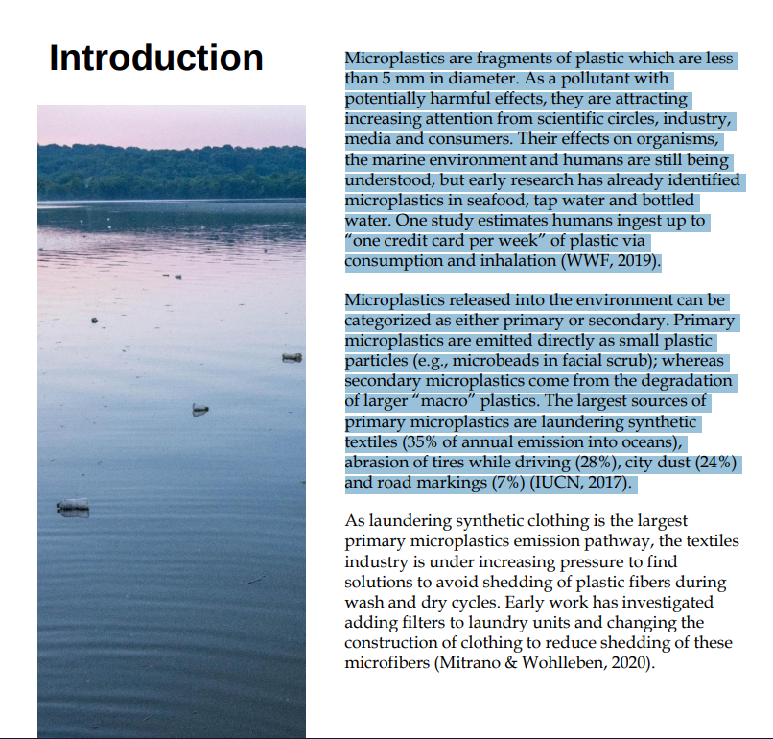

From: Toward eliminating pre-consumer emissions of microplastics from the textile industry

Research Methods and Materials：

0.Preparation before experiment - confirm the microplastic content of distilled water
( 1 ) Materials
- filter * 1
- filter membrane（sample）* 1
- 250ml distilled water
- petri dish * 1
- Beaker * 1
- Small microscope * 1

（2）Method
- Clean the appliance with pure water
- The filter membrane is marked with the midpoint and coordinates, and placed in the middle of the filter
- A beaker filled with 250 ml of distilled water
- Pour water into the sample catchment area above the filter
- Use a syringe to remove the air from the filter to make it a vacuum
- After the water is filtered, take out the filter membrane and put it into the petri dish, cover the petri dish with the lid
- Using a small microscope to observe the microplastic content and its shape and color on the sample
- Record, count microplastic content, and discuss results

1. Experiment 1. Is there any relationship between water temperature and its microplastics?
（1）Materials
- filter*1
- filter membrane（sample）*2
- Distilled water a little
- Petri dish*2
- Beaker*2
- 250ml of hot drinking water
- 250ml cold drinking water
- Small microscope*1

（2） Method
- Clean the appliance with pure water
- The filter membrane is marked with the midpoint and coordinates, and placed in the middle of the filter
- The beakers were filled with 250ml of hot or cold water
- Pour water into the sample catchment area above the filter
- Use a syringe to remove the air from the filter to make it a vacuum
- After the water is filtered, take out the filter membrane and put it into the petri dish, cover the petri dish with the lid
- Using a small microscope to observe the microplastic content and its shape and color on the sample
- Record, count microplastic content, and discuss results

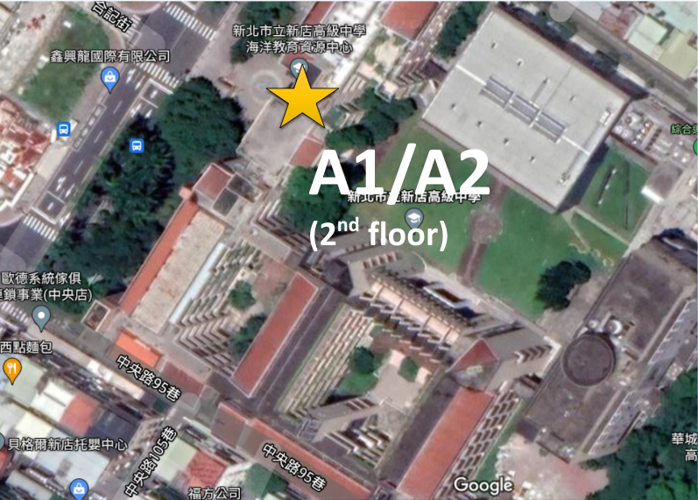

2. Experiment 2. Can the microplastic content in drinking water be reduced by cleaning the water outlet of the water dispenser?
（1）Materials
- filter*1
- filter membrane（sample）*10
- washing bottle * 1
- Distilled water a little
- Petri dish * 10
- Beaker * 4
- Water sample (unwashed water outlet) * 5 (250ml)
- Water sample (washed through the water outlet) * 5 (250ml)
- Small microscope * 1

（2）Method
- Clean the appliance with pure water
- The filter membrane is marked with the midpoint and coordinates, and placed in the middle of the filter
- Take 250ml of drinking water (unwashed or washed)
- Pour water into the sample catchment area above the filter
- Use a syringe to remove the air from the filter to make it a vacuum
- After the water is filtered, take out the filter membrane and put it into the petri dish, cover the petri dish with the lid
- Using a small microscope to observe the microplastic content and its shape and color on the sample

- Record and count microplastic content
- Repeat the above process until 10 samples are done
- Result of discussion
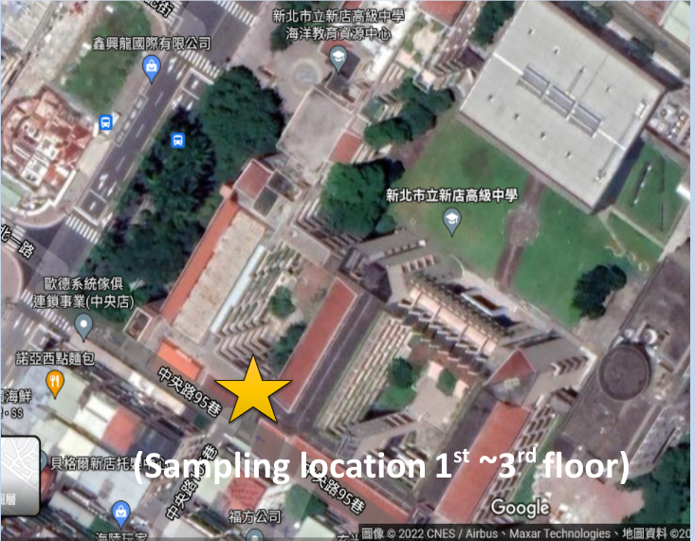

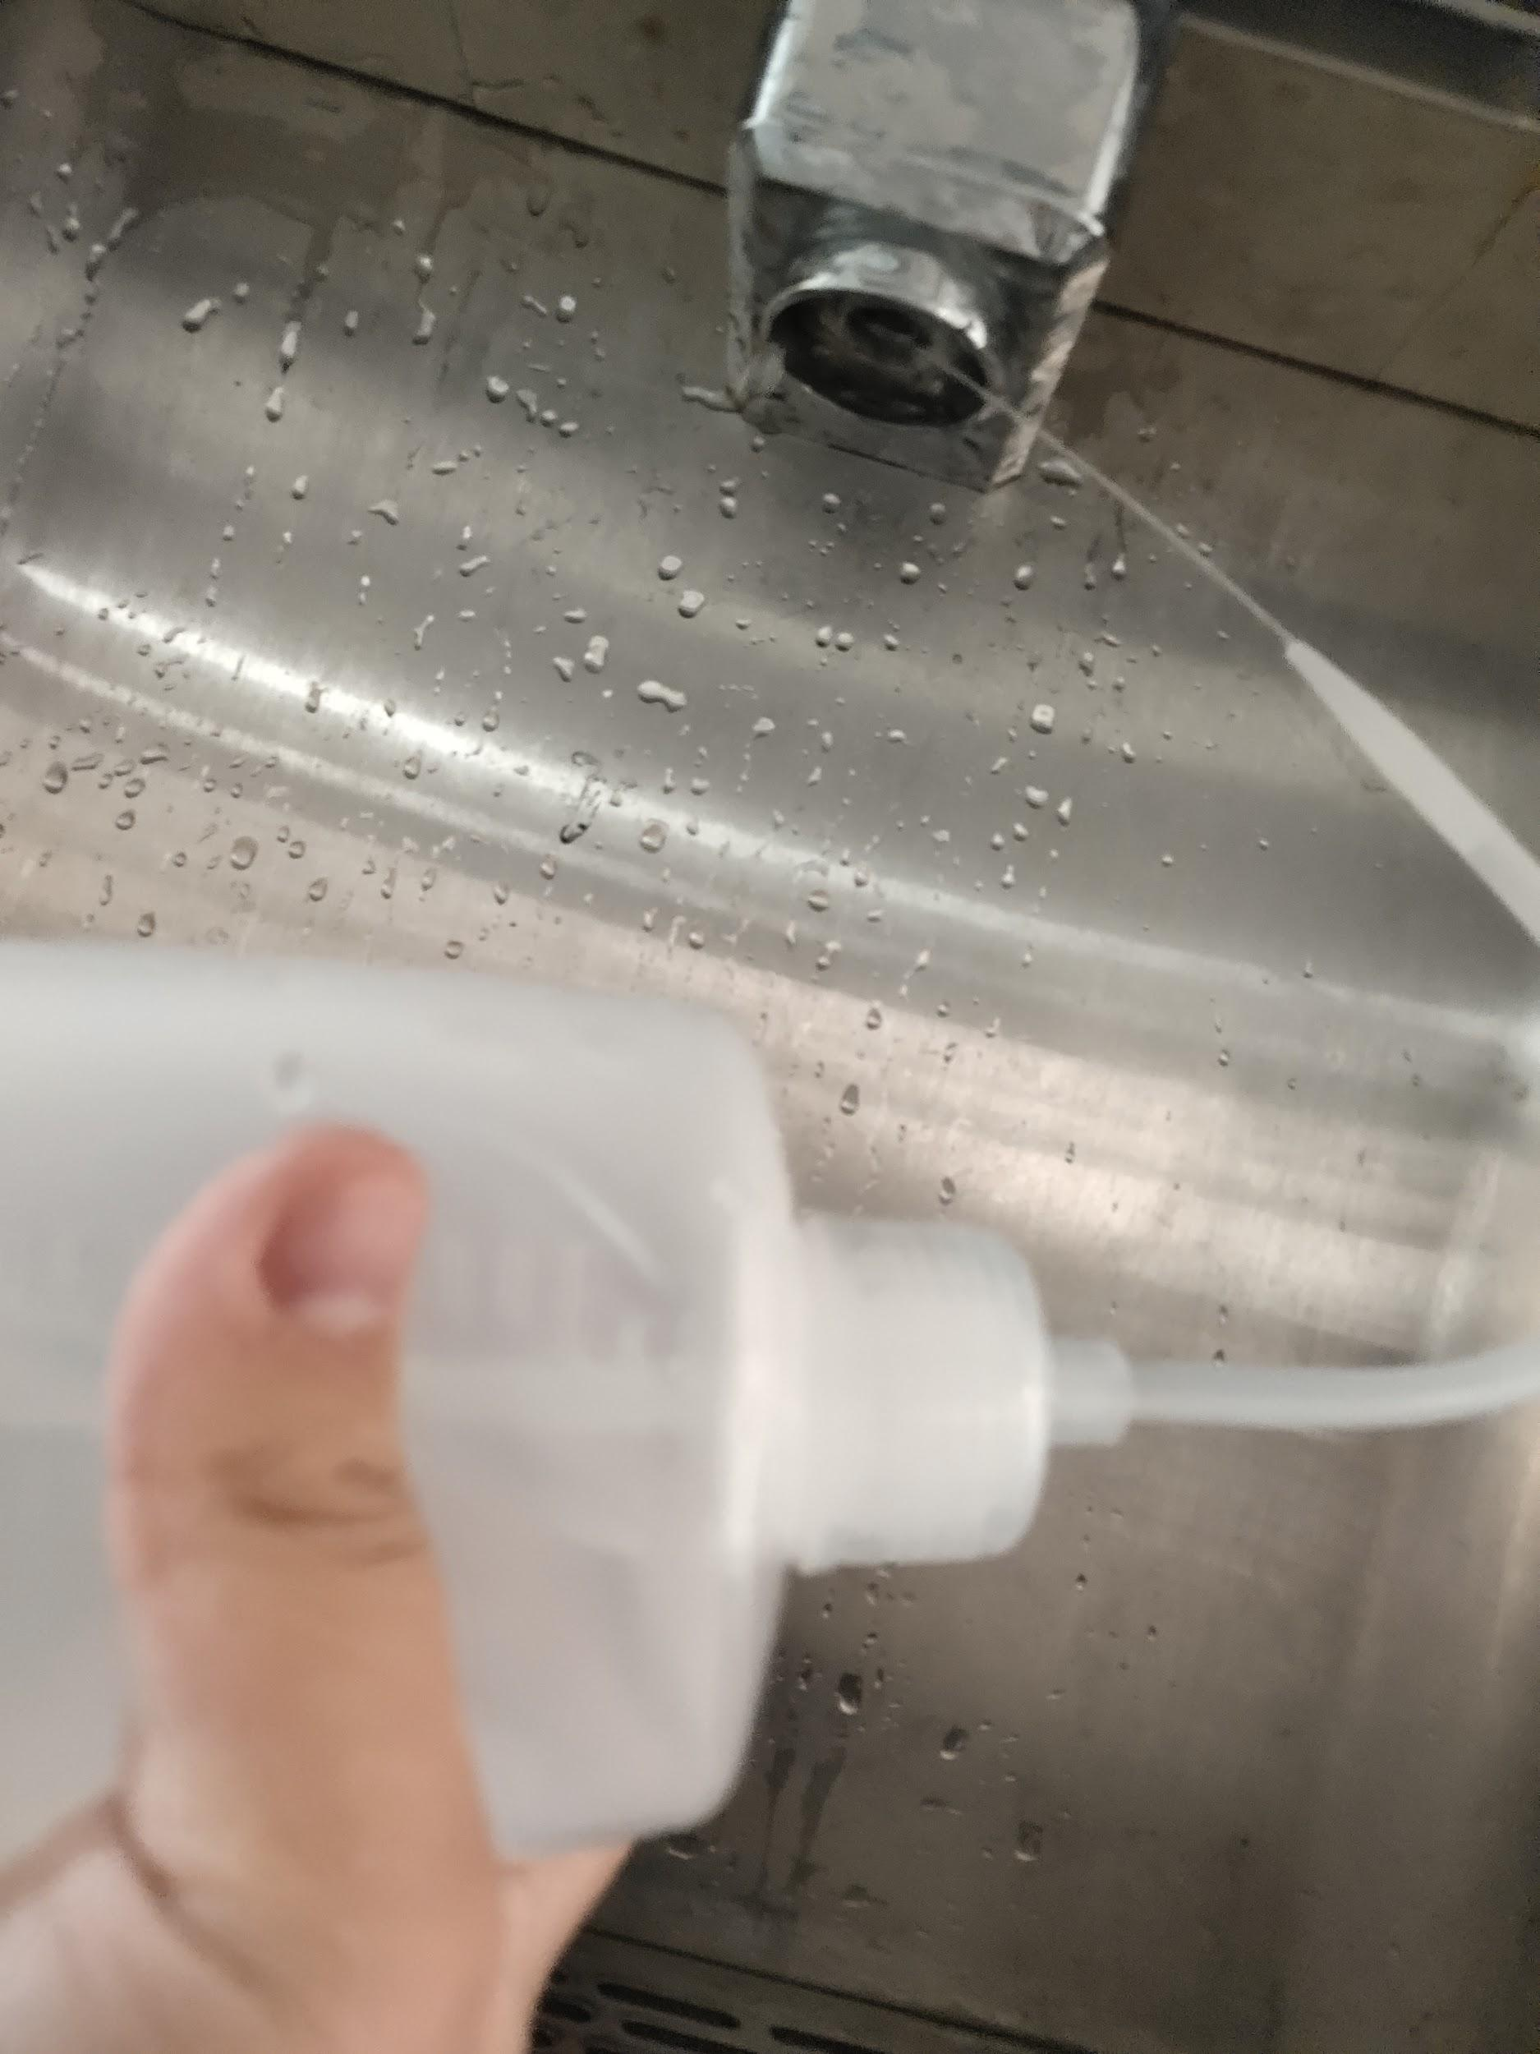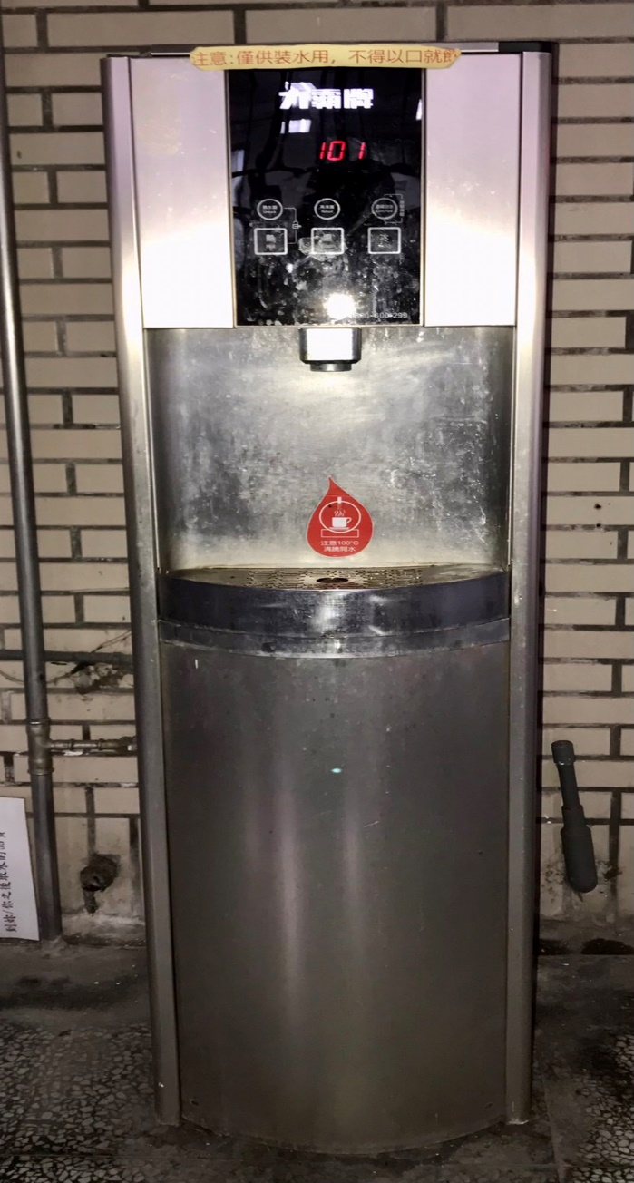

3.Experiment 3. Comparing the microplastic content of water dispensers on different floors
（1）materials
- Experiment 2 data

（2）Method
- The sample data of different floors, the same temperature, and unwashed outlet holes are proposed
- analyze data
- Analyzing data Repeat the above method to analyze the data of the samples with wash-out holes
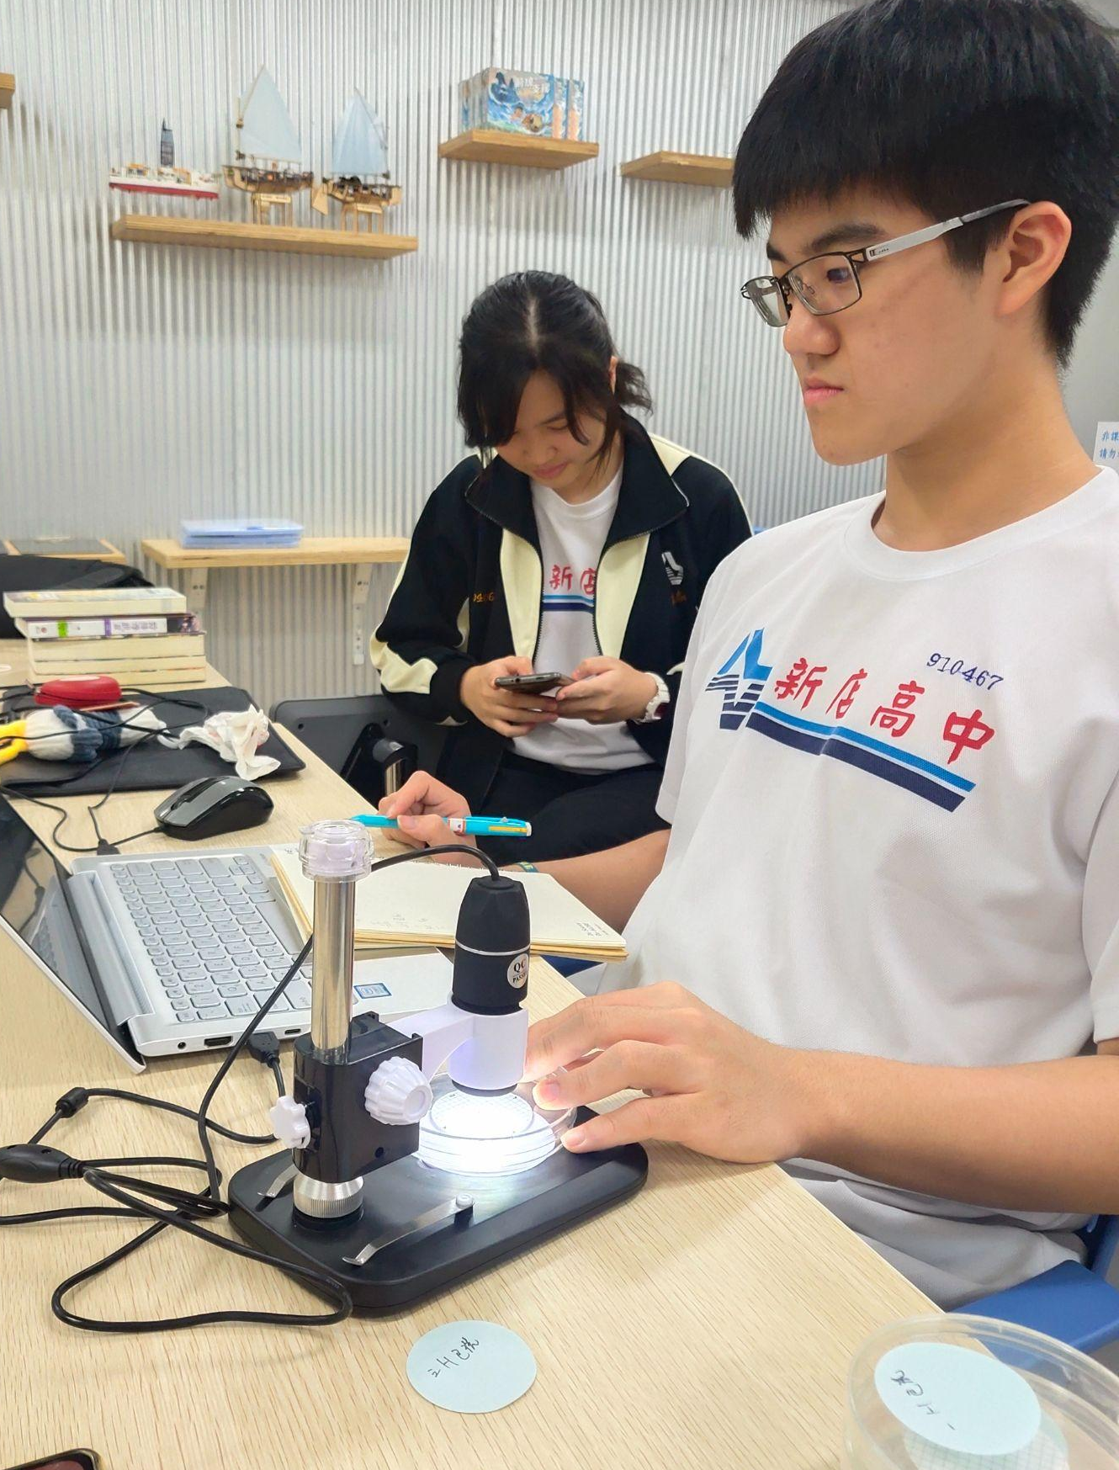
- Result of discussion
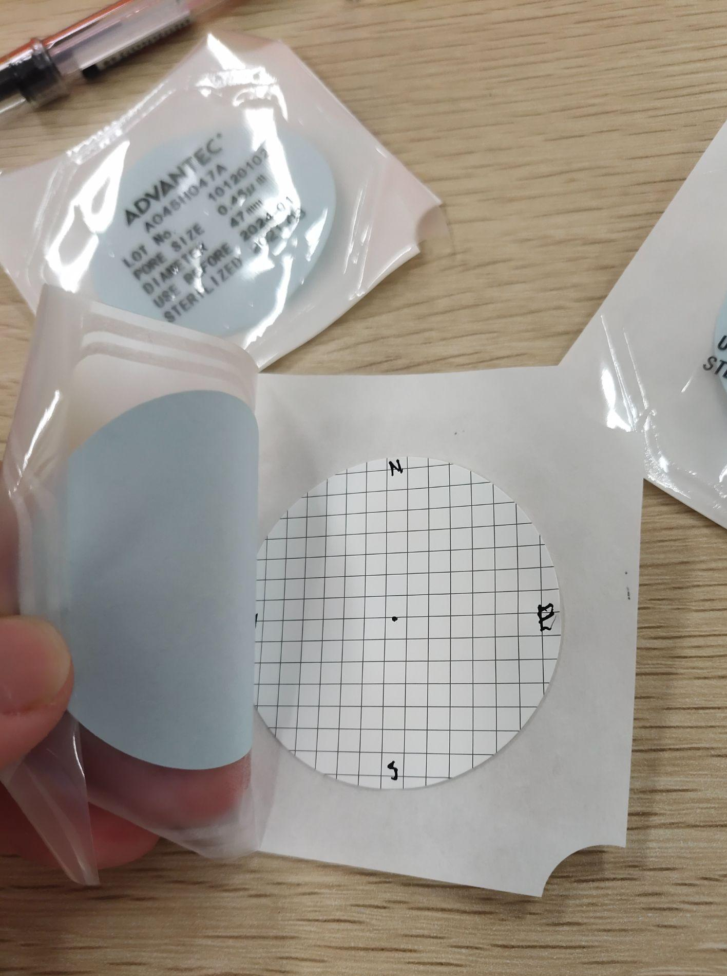

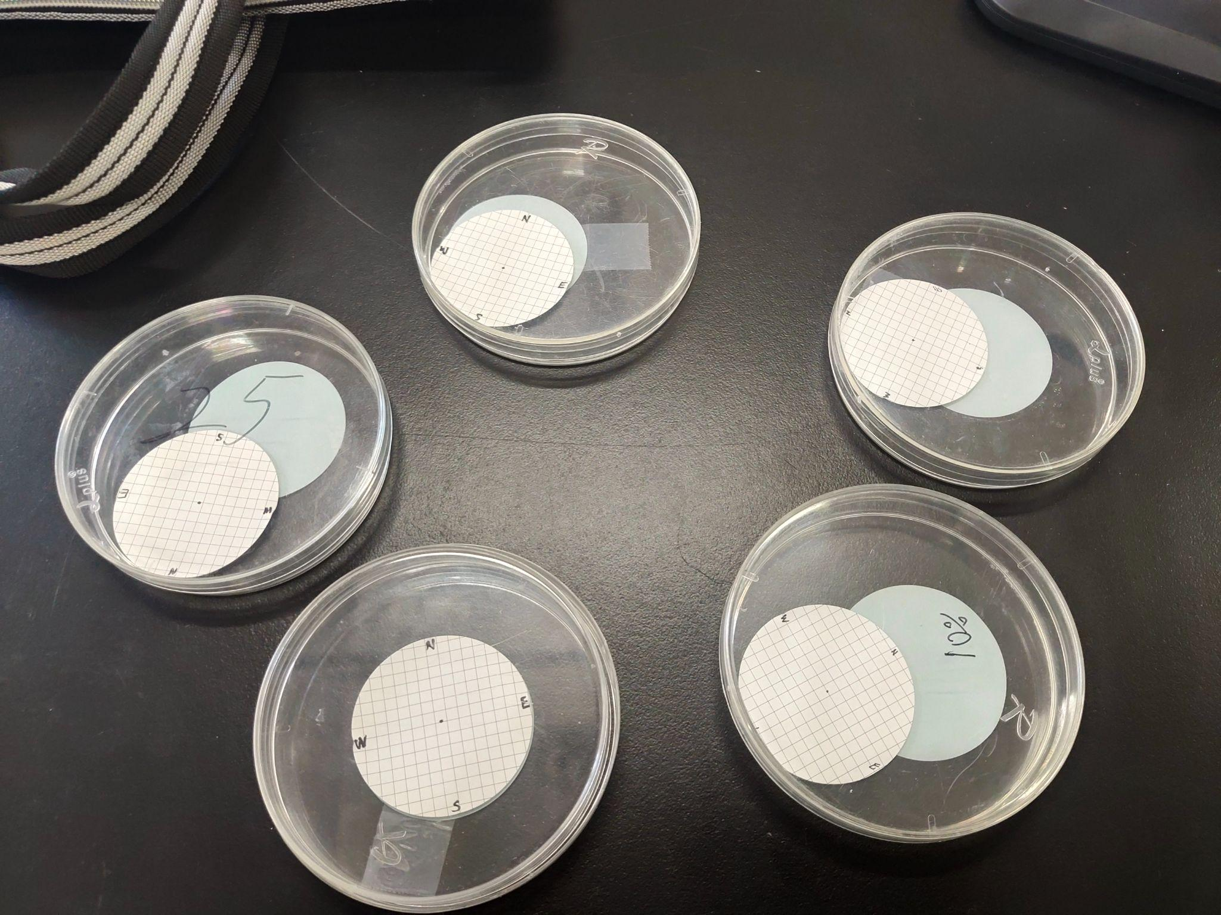
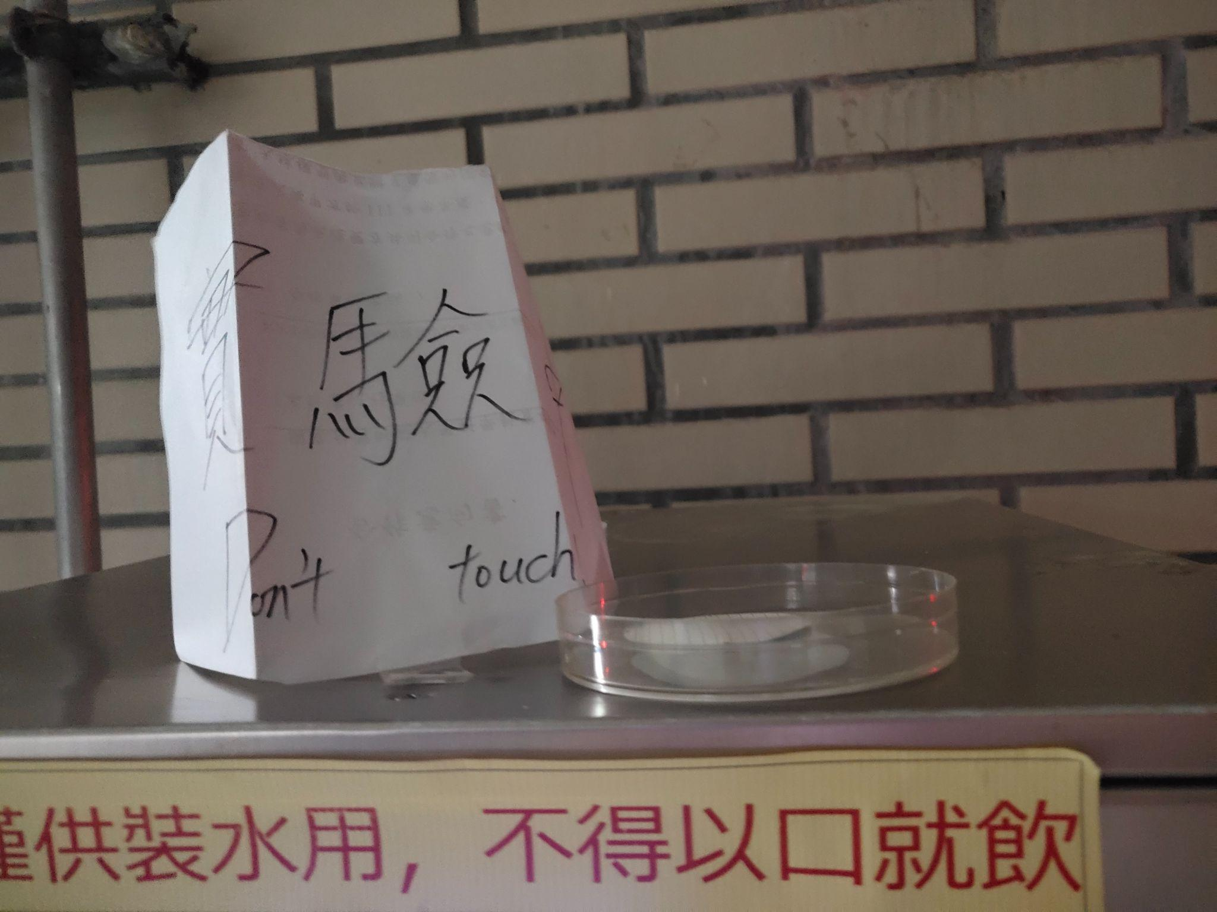

Results：
Experiment 1. Is there any relationship between water temperature and its microplastics?

Sample one (A1) -- cold water (10°C)

Code | Geometry | Coordinates | Color | Surface  Appearance | Our  Assessment
1 | Filament | (7,-2) | Unclear | Rough dirty | Textile flbre
2 | Dot | (1,7) | Yellow | Flat | Cellulose
3 | Filament | (2,3) | Unclear blue | Unknown | Textile fibre
4 | Filament | (1.5,3) | Dark blue | Unknown | Textile flbre
5 | Filament | (3.5,6) | Blue | Thread | Animal hair

Sample Two (A2)--Hot Water (100°C)

Code | Geometry | Coordinates | Color | Surface  Appearance | Our  Assessment
1 | Filament | (2.5,-3) | blue | thread | Textile fibres
2 | Bits of leaf | (4,6) | Brown yellow | shiny | Animal wings
3 | Rubber band | (5,6) | blue | unknown | Textile fibres
4 | filament | (7,-1.5) | Dark blue | unknown | Textile fibres
5 | Flat particle | (-7,4) | yellow | unknown | animal

Compare：

Sample | °C | washed | quantity / L
A1 | 10 | No | 12
A2 | 100 | No | 12

- A1 has three microplastics, one fiber, and one animal hair
- A2 has three microplastics, one biological, and one animal hair

Experiment 2. Can the microplastic content in drinking water be reduced by cleaning the water outlet of the water dispenser?

Sample number naming method：
floor(1F/2F/3F)+
cold/hot water(C/H)+
cleaned/not cleaned the water outlet(1/2)
eg: 1st floor,cold water,didn’t clean the water outlet =1FC2

Code | 1FC2 | 1FH2 | 2FC2 | 3FC2 | 3FH2
Washed | NO | NO | NO | NO | NO
Water Temperature | 10°C | 100°C | 10°C | 10°C | 100°C
Date | 2022/1/10 | 2022/1/10 | 2022/1/5 | 2022/1/10 | 2022/1/10
Filter Membrane | 1 | 1 | 1 | 1 | 1

Code | 1FC1 | 1FH1 | 2FC1 | 3FC1 | 3FH1
Washed | YES | YES | YES | YES | YES
Water Temperature | 10°C | 100°C | 10°C | 10°C | 100°C
Date | 2022/1/10 | 2022/1/10 | 2022/1/5 | 2022/1/10 | 2022/1/10
Fliter Membrane | 1 | 1 | 1 | 1 | 1

(The following are some samples)
CODE | sample | GEOMETRY | COORDINATES | COLOR | SURFACE  APPEARANCE | OUR  ASSESSMENT
2FC2 | 1 | Filament | (2,7) | Gray | Dirty | Animal hair
 | 2 | Unknown | (6,-3) | Black | Unknown | Unknown
 | 3 | Filament | (4,0.3) | Gray | Unknown | Unknown
2FC1 | 4 | Filament | (6,3) | Blue | Unknown | Textiles fibres
 | 5 | Filament | (-6,1) | Gray | Unknown | Unknown

CODE | SAMPLE | GEOMETRY | COORDINATES | COLOR | SURFACE  APPEARANCE | OUR  ASSESSMENT
3FC1 | 1 | Filament | (-7,3) | Gray | Unknown | Animal fibres
 | 2 | Filament | (-5.5,5.3) | Gray | Unknown
 | 3 | Filament | (-3.8,6.5) | Black | Unknown

CODE | SAMPLE | GEOMETRY | COORDINATES | COLOUR | SURFACE  APPEARANCE | OUR  ASSESSMENT
3FC2 | 1 | Filament | (2,-6) | Dark blue | Thread | Textiles fibres
 | 2 | Filament | (3,-5) | Dark blue | Thread | Textiles fibres
 | 3 | Filament | (-7,-8) | Red | Thread | Textiles fibres
 | 4 | Filament | (2.5,3.5) | Red | Thread | Textiles fibres

CODE | SAMPLE | GEOMETRY | COORDINATES | COLOUR | SURFACE  APPEARANCE | OUR  ASSESSMENT
3FH1 | 1 | filament | (7.5,6.5) | gray | unknown | Biological  Filament
 | 2 | filament | (5,-7) | gray | unknown | Textile Fibres
 | 3 | filament | (-6.2,5.5) | black | unknown | Textile Fibres
 | 4 | filament | (-3.5,6) | gray | unknown | Textile Fibres

CODE | SAMPLE | GEOMETRY | COORDINATES | COLOUR | SURFACE  APPEARANCE | OUR  ASSESSMENT
3FH2 | 1 | filament | (4,2.2) | Red | Unknown | Textile Fibres
 | 2 | Dot | (4.3,6) | Green | Unknown | Unknown
 | 3 | filament | (-2.25,7) | Blue | Unknown | Textile Fibres
 | 4 | Dot | (4,4) | Yellow | Unknown | Unknown
 | 5 | filament | (3.5,6) | Red | Unknown | Textile Fibres

Compare：

Sample | °C | washed | quantity/L
1FC2 | 10 | No | 32
1FC1 | 10 | Yes | 32
1FH2 | 100 | No | 36
1FH1 | 100 | Yes | 24

Sample | °C | washed | quantity / L
2FC2 | 10 | No | 12
2FC1 | 10 | Yes | 8
2FH2 | 100 | No | 8
2FH1 | 100 | Yes | 0

Sample | °C | washed | quantity / L
3FC2 | 10 | No | 16
3FC1 | 10 | Yes | 12
3FH2 | 100 | No | 12
3FH1 | 100 | Yes | 12

Experiment 3. Comparing the microplastic content of water dispensers on different floors

Sample One (A1)--Cold Water (10°C). washed

Sample | °C | washed | quantity/L
1F | 10 | Yes | 18
2F | 10 | Yes | 8
3F | 10 | Yes | 6

Sample two (A2)--Cold Water (10°C). Unwashed

Sample | °C | washed | quantity/L
1F | 10 | No | 20
2F | 10 | No | 12
3F | 10 | No | 18

Sample three (A3)--Hot Water (100°C). washed

Sample | °C | washed | quantity/L
1F | 100 | Yes | 24
2F | 100 | Yes | 0
3F | 100 | Yes | 18

Sample Four (A4)--Hot Water (100°C). Unwashed

Sample | °C | washed | quantity/L
1F | 100 | No | 18
2F | 100 | No | 8
3F | 100 | No | 6

Analysis：

Experiment 1.
- The substances contained in the hot and cold water of the same water dispenser are similar, which means that the hot and cold water does not affect the content of plastic particles.
- The hot and cold water in the water dispenser is supplied by different water tanks, resulting in a large difference in the content of plastic particles in the hot and cold water on the second floor.
- The first floor has the most plastic particles, and the second and third floors gradually decrease.

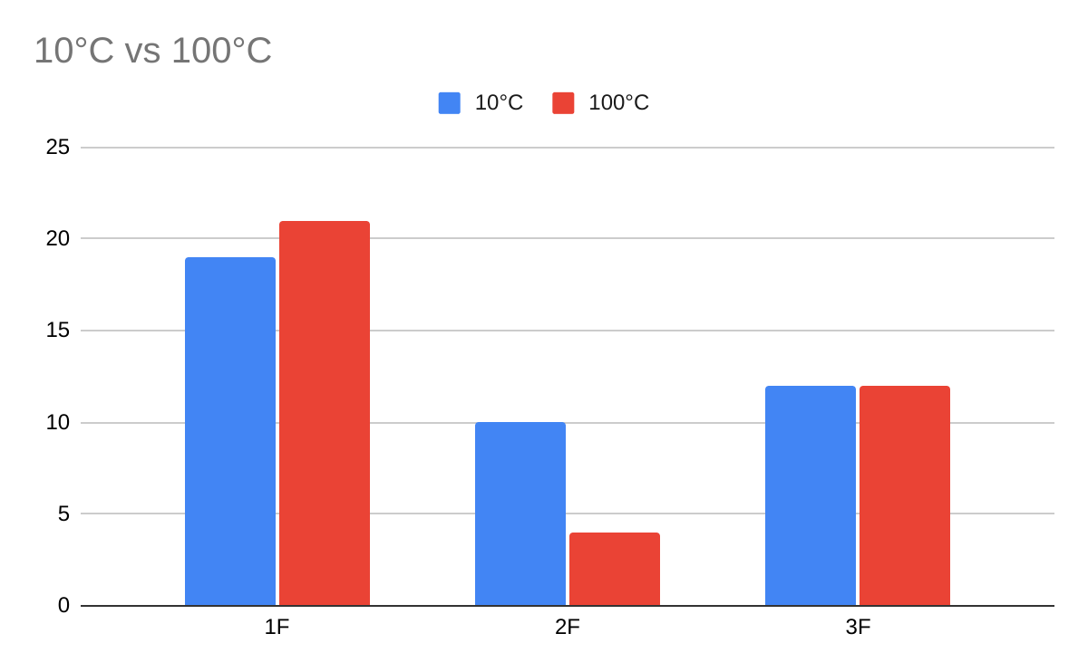

Experiment 2.
- On the first floor, there are more water dispensers after washing than before, on the second floor, before and after washing, and on the third floor, the same amount before and after washing. We infer that because the variable factor is not only the plastic content of the water outlet, but also the water coming out is also different, so there are more plastic particles on the first floor after washing, which may be because there are more plastic particles in the water itself.

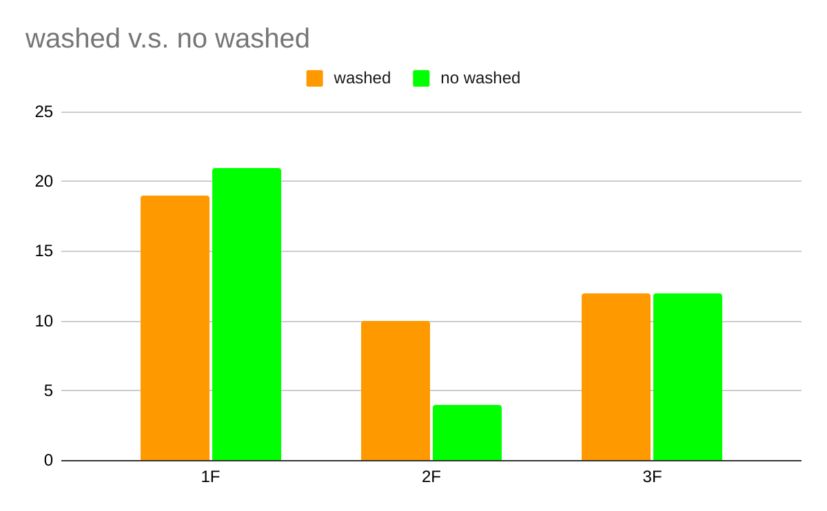

Experiment 3.
- From small and small, one particle has the most plastic particles, and there are many choices on the second and third floors.
- After cleaning, the plastic particles in cold water tend to decrease, while hot water tends to decrease on the second floor, but more on the first and third floors.

Discussion：
- Each control experiment was completed on the same day, humidity, air pressure, air quality... are the control variables.
- The cold water and hot water of the same water dispenser will be slightly different, but the average data difference is not obvious.
- From the data, it can be seen that the drinking water of the water dispenser on the first floor did not decrease or even increase after the water outlet was cleaned, while the microplastic content of the water dispenser on the third floor remained after the water outlet was cleaned.
- In addition to whether to clean the water outlet of the water dispenser, there are many factors that affect the content of microplastics in drinking water that we have not found so far.
- Whether or not to clean the outlet hole does not have much effect on reducing the content of microplastics in drinking water.
- If the data on the second floor is not discussed, other data show that the lower the floor, the higher the microplastic content.

- Combined with the data on the air microplastic content of each floor, the hypothesis that the lower the floor is, the higher the air turbidity is.
- The content of microplastics in the air on the second floor is within the normal range, but the content of microplastics in drinking water is particularly low. Therefore, we infer that the water dispenser on the second floor may have factors that reduce the content of microplastics (for example: new filters.. ...)
- The higher the air turbidity, the higher the microplastics. However, from the previous arguments, it can be inferred that the content of microplastics in drinking water is not much related to the water outlet holes of the water dispenser, so this does not seem to affect the microplastics content of drinking water.
- Identifying other factors that affect the level of microplastics in drinking water and finding ways to reduce the level of microplastics in drinking water are our future prospects.

Conclusion：
- The average microplastic content in drinking water (including cold water, hot water, with/without wash outlet) is 13.0
- The temperature of the water does not affect the microplastic content in the water
- Cleaning the water outlet of the water dispenser has no obvious effect on reducing the microplastic content of drinking water
- The lower the floor, the higher the microplastic content in the air, but the influence of the microplastic content in drinking water is less
- Women ingested an average of 35.1 microplastics per day; men ingested an average of 48.1 microplastics per day

Bibliography / Citations：
- https://www.nationalgeographic.org/encyclopedia/microplastics/
- https://www-healthline-com.translate.goog/nutrition/how-much-water-should-you-drink-per-day?_x_tr_sl=en&_x_tr_tl=zh-TW&_x_tr_hl=zh-TW&_x_tr_pto=op,sc

Badge Descriptions/Justifications：
- Data Scientist : In the report, we use a lot of data to observe and draw conclusions.
- Make an Impact : If we can reduce the microplastics that people accidentally ingest by drinking water every day, it will be beneficial to human health and the maintenance of the environment.

